1. **Three marks** from:

 Diaphragm / cone

 (Voice) coil of wire

 Spider / Suspension

 (Permanent) Magnet

 Basket

 Dust cap

 Outer frame

2.

1. Clock

2. Processor

3. Main memory

4. keyboard controller

5. VDU controller

6. Disk controller

7. Data bus (or Control bus)

8. Control bus (or Data bus)

9. Address bus

10. Keyboard

11. Monitor

12. Secondary storage

3.

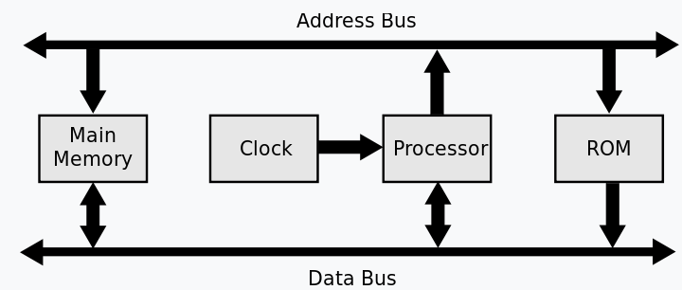

4a

Data bus width

* the width of the data bus determines the number of bits that can be simultaneously同时 transferred
* increasing the width of the data bus increases the number of bits/amount of data that can be moved at one time (or equivalent)
* therefore, the processing speed is increased because fewer transmission times are required.

For example: e.g. double the width of the data bus moves 2x data per clock pulse

Clock speed

* determines the number of cycles the CPU can execute per second
* increasing clock speed increases the number of operations/number of fetch-execute cycles that can be carried out per unit of time
* however, there is a limit on clock speed because the heat generated by higher clock speeds cannot be removed fast enough

4b

* devices automatically detected and configured when first attached/plug and play
* it is nearly impossible to wrongly connect a device
* USB has become an industrial standard
* supported by many operating systems
* USB 3.0 allows full duplex data transfer
* later versions are backwards compatible with earlier USB systems
* allows power to be drawn to charge portable devices