Using the Regulus GUI

The Regulus GUI is a tool which gives developers a window and menu-based view of the Regulus development environment. To start the GUI on a Windows machine, open an Explorer window to the directory $REGULUS/Java, and double-click on run_prolog.bat:

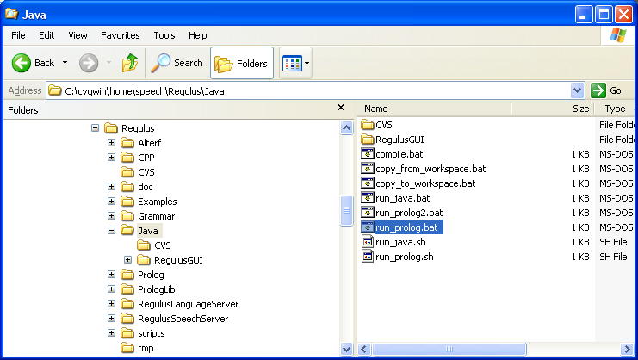

A window like the following should come up:

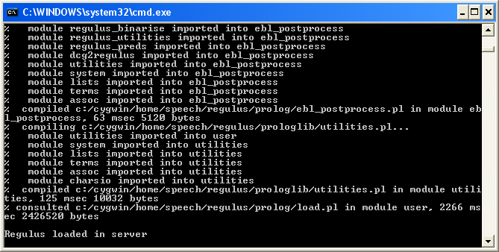

Next, click on run_java.bat in the same directory. This brings up the main RegulusGUI window, which should look something like this:

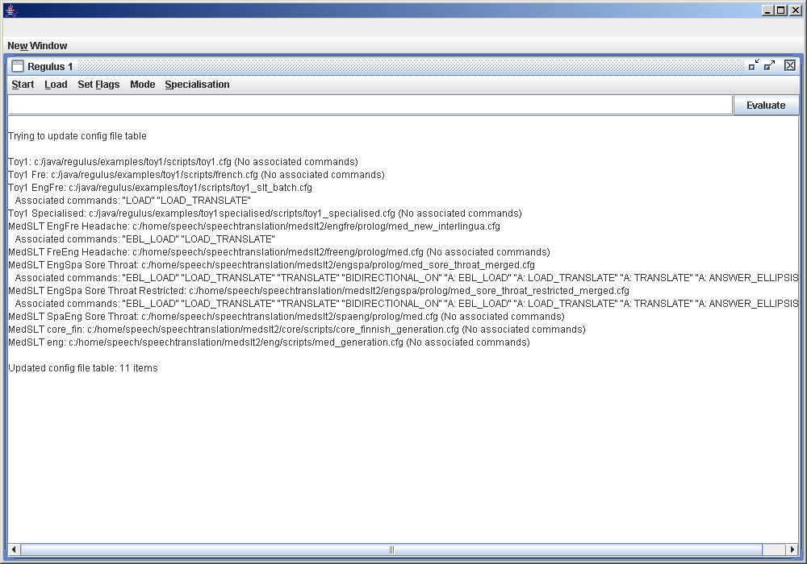

Loading a config file

In order to do any processing within the GUI, you first need to load a Configuration (config) file. Click on the Start menu and select the file you need, as follows:

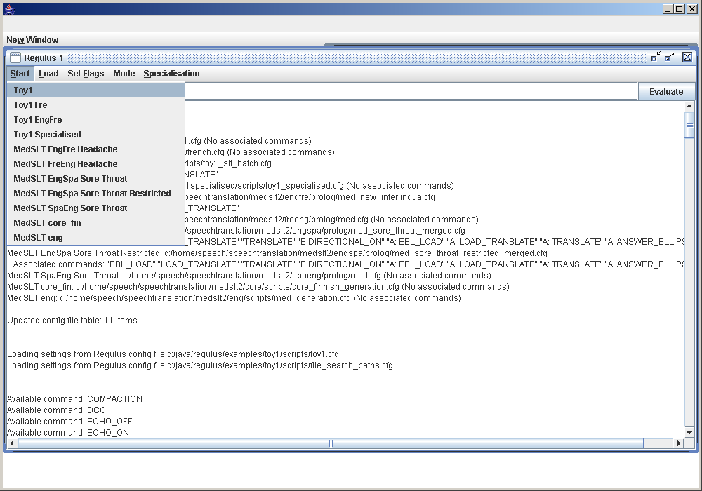

When the file has finished loading, it will give you an information message, telling you if the loading of the config file has succeeded or failed. It will also tell you if the commands which can be attached to the configuration file have been successfully loaded.

This configuration file has been successfully loaded, but had no load commands attached to it.

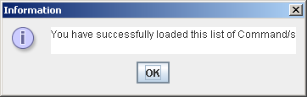

This is an example showing successful loading of a configuration file which has load commands attached.
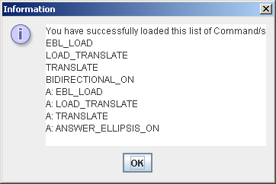

Click on OK after you have read the message.

Loading resources

Depending on have many, if any, load commands were associated with the configuration file you have loaded, you may or may not want to do more Loads. For example, if you are going to use the Translation tool within the GUI, you will need to load Translation resources.
In our example above, after we have selected the Toy1 configuration file we need to do a load the grammar in order to be able to use the Stepper. We do this as follows, using the Load (load grammar) command:

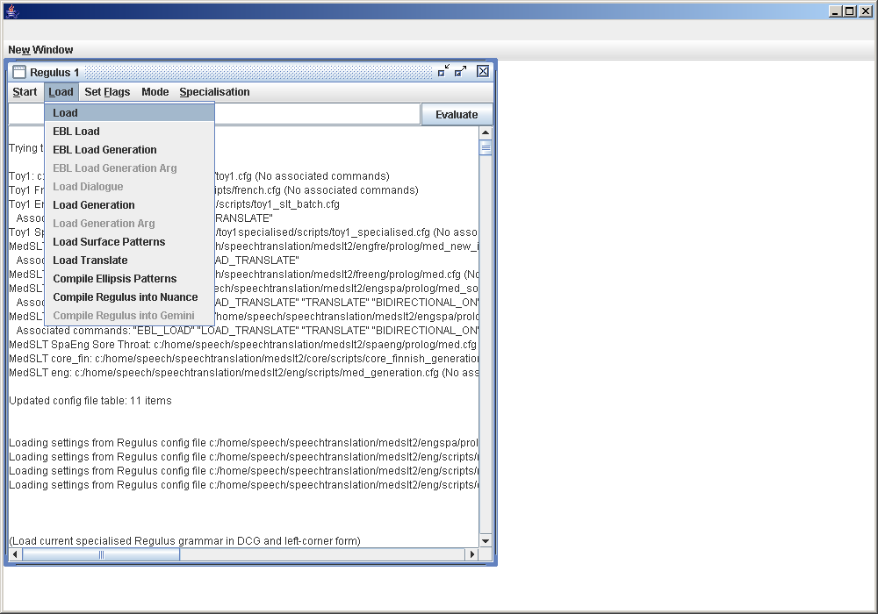

You will get a message telling you if the loading of the grammar has been successful or not.

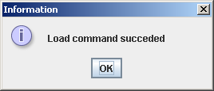
We will show examples of other types of load command later.

The Stepper

The Stepper is a tool that lets you create, examine and manipulate grammatical structures defined by Regulus grammars. To enter the Stepper, click on the Mode menu and choose Start Stepper:

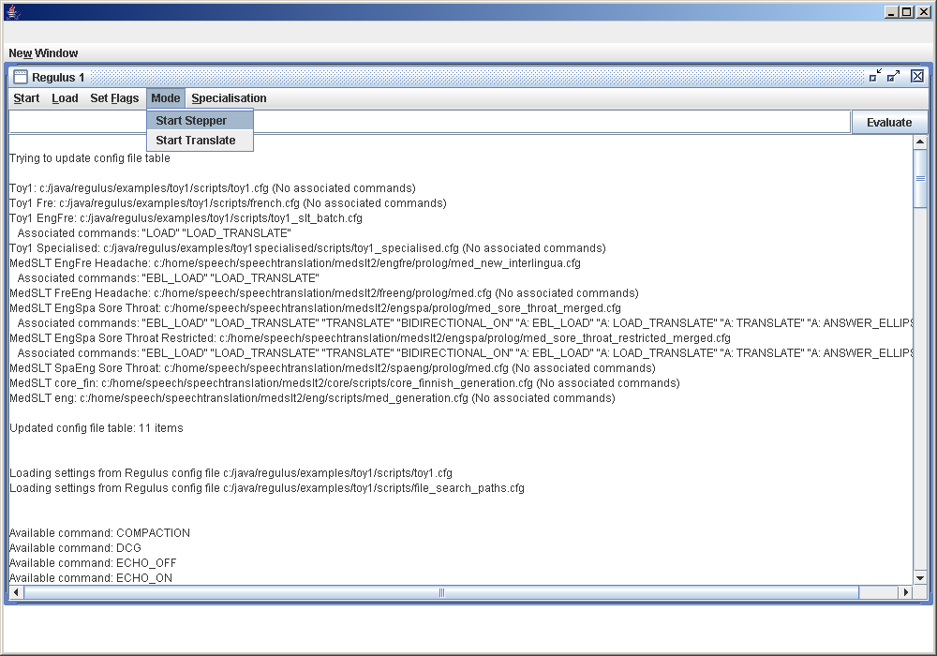

This will bring up a Stepper window.

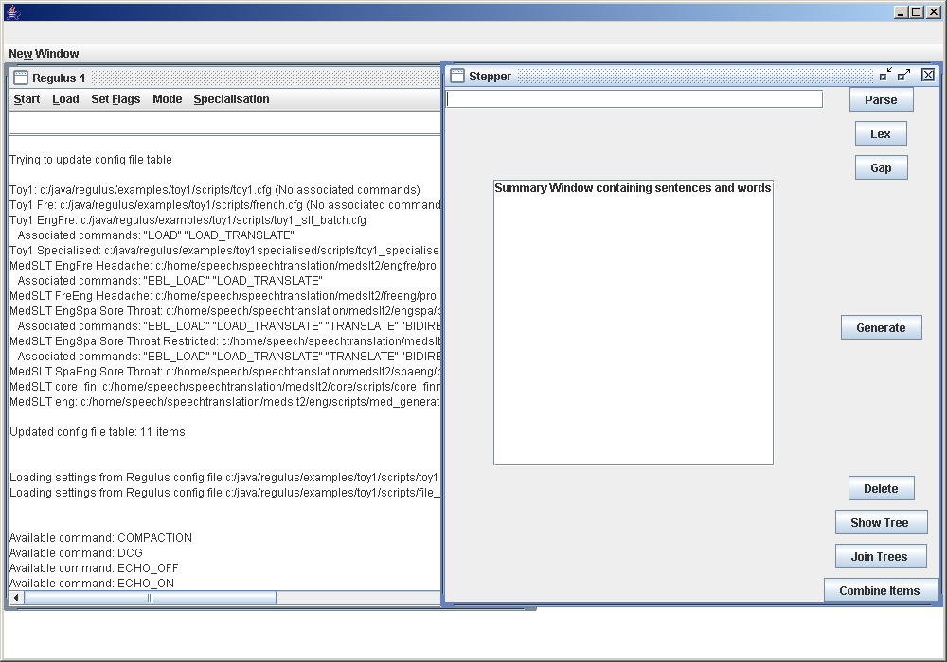
The box at the top of the Stepper window is an input area, where you can enter words or phrases which you want to parse or look up in the lexicon.

The box immediately beneath is the item output area. “Items” hold results of performing Regulus linguistic operations, such as lexical lookup, parsing or generation. Whenever you have successfully done something like parsing or a generating a sentence, this will produce new lines in the item output area. If you select items, you can view them as trees by clicking on the Show Tree button.
The buttons on the right-hand side of the Stepper window have the following functions:

- Parse: This button will parse the sentence you have entered in the input area.
- Lex: Parse the word you have entered in the input area.
- Generate: Select an item in the item output area. Pressing the Generate button will invoke the generation grammar to create new items. A generation grammar must be loaded first.
- Show Tree: Select an item in the item output area. When you press the Show Tree button, a tree representation of the grammatical structure of the selected item will be displayed.
- Join Trees: Select two items in the item output area. When you press the Join Tree button, these two trees will be joined into a third tree which you will find in the item output area.
- Combine Items: For this button you will need to select one or more items in the item output area. When you press the Combine Items button, the stepper will attempt to find a grammar rule which it can use to combine the selected items into a new item which will be added to the items output area. If there is more than one applicable rule, it will show alternatives in a menu.

Parsing a sentence
To parse a sentence, write it in the input window and press the Parse button. In this example, we enter the sentence “switch on the light”.

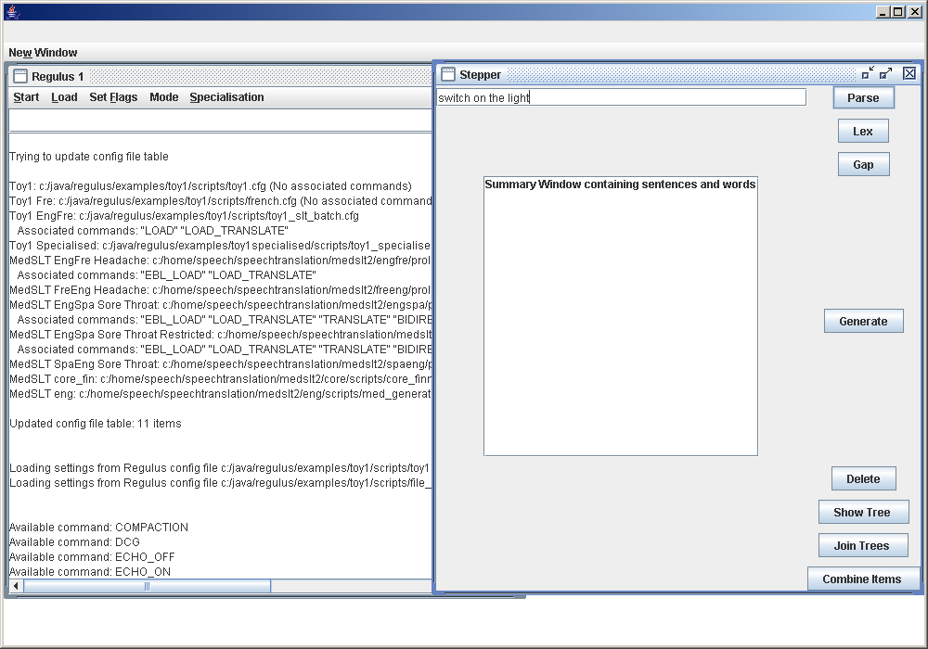

After the parse button is pressed, a message appears showing whether the sentence has been successfully parsed or not. Click on OK.

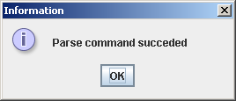
If the sentence has been successfully parsed and you have clicked OK, the sentence will appear as an item in the item window in the stepper window.

Adding lexical items
You can also create Items corresponding to individual lexical entries. To do this, enter the surface form of the lexical item in the input field, just as you did when parsing a sentence, and press the Lex button. If there is more than one item with the given surface form, a menu is displayed.

In this example, we enter the word “on” in the input field.

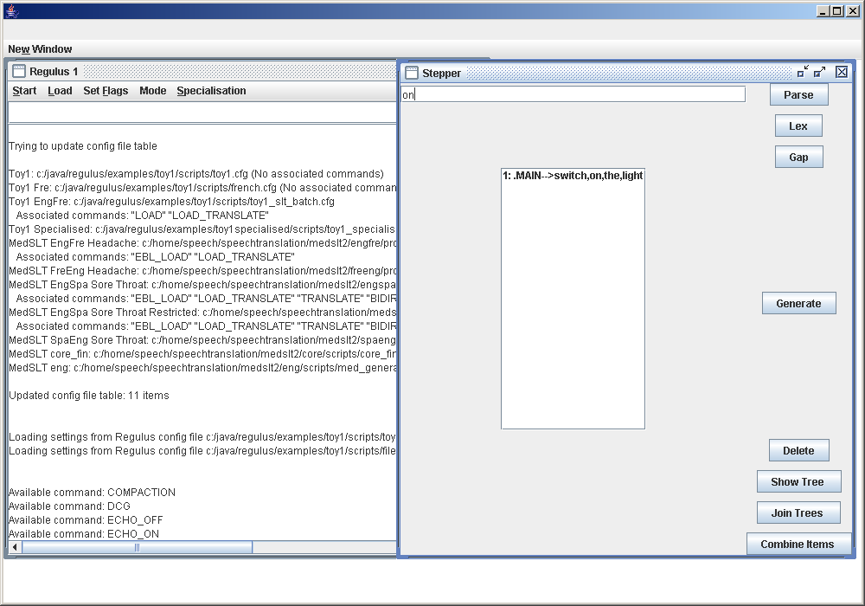
After the Lex button is pressed, you will get a message saying whether the word has been successfully found or not. Click on OK.

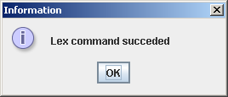
If the word was found, the lexical entry will appear as an Item in the item window.

Generating sentences

To be able to use the Regulus generation capability, you first need to load a generation grammar. You do this by selecting the Load Generation option from the Load menu. The generation grammar
grammar must be defined in the current config file.
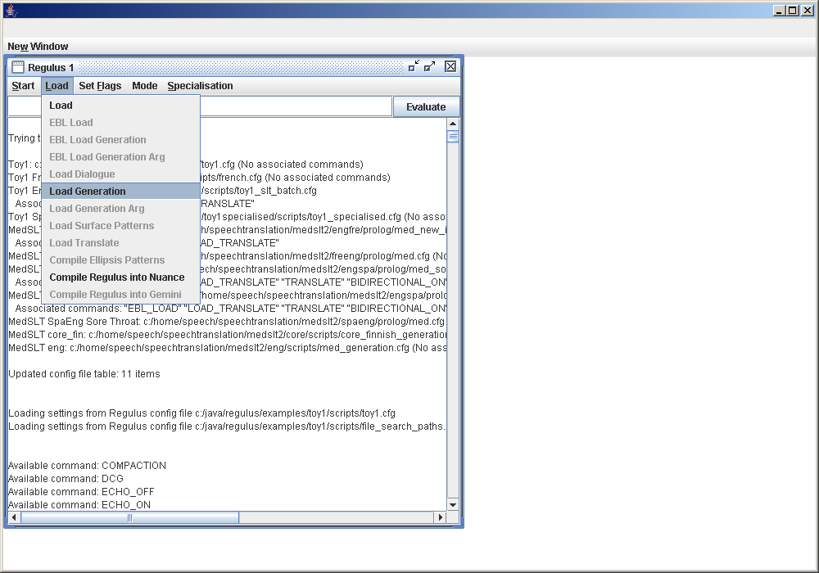

Once you have loaded the generation grammar, you can attempt to perform generation on any item currently in the Item Area.
Here is a Finnish language example, using the Finnish grammar developed by Marianne Santaholma under the MedSLT project. Start by entering the Finnish sentence “tuntuuko kipu otsalla”(is the pain frontal):

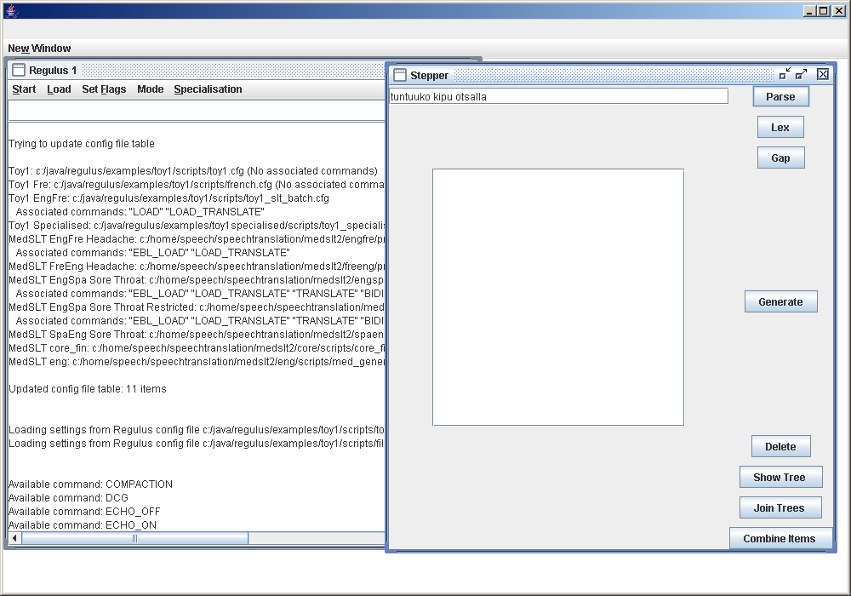
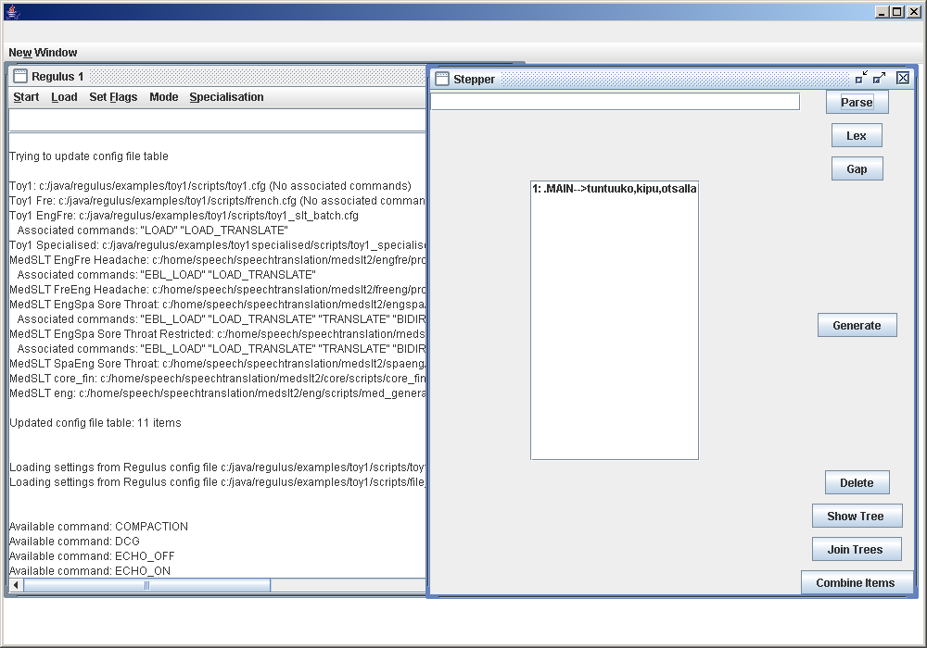
As described above, parse it by pressing the Parse button. This creates a new Item.
Select this sentence in the item window:
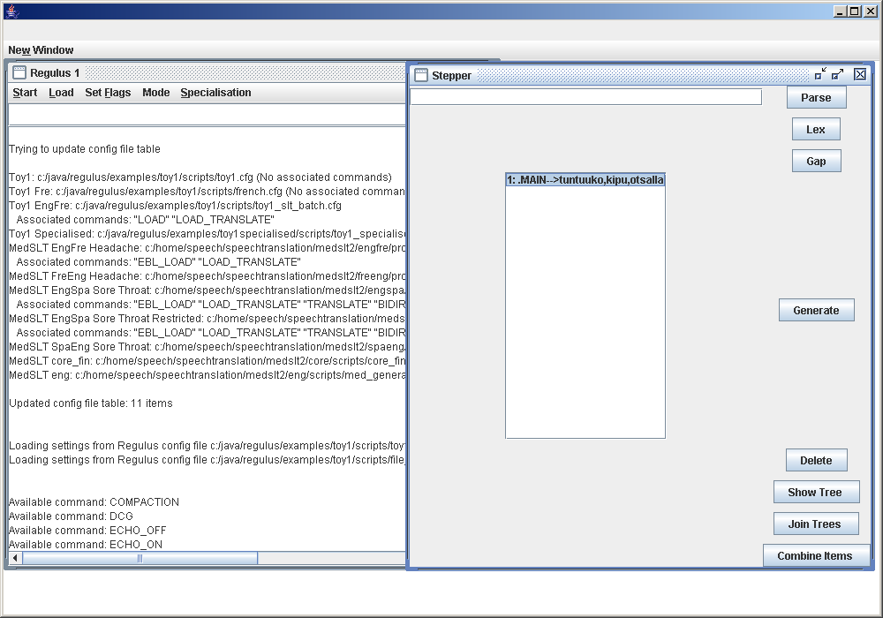

Click on the Generate button in order to generate sentences from the item which you have selected.
The system will tell you if you have been successful in generating items from your selected sentence, and how many items you have generated.

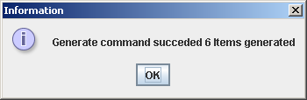

Click on the OK button.
The generated sentences will appear in the Items window.

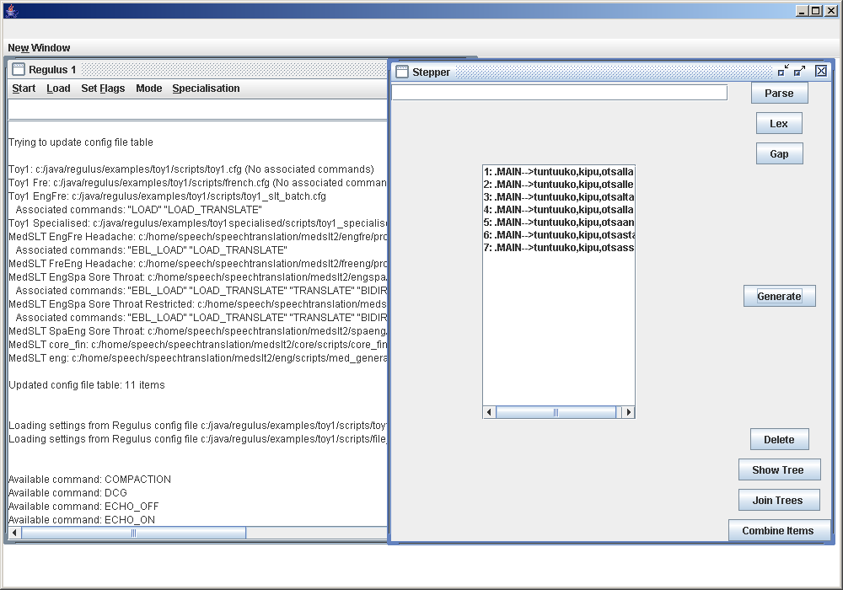

Displaying items

To display an Item, first select it in the Item window:

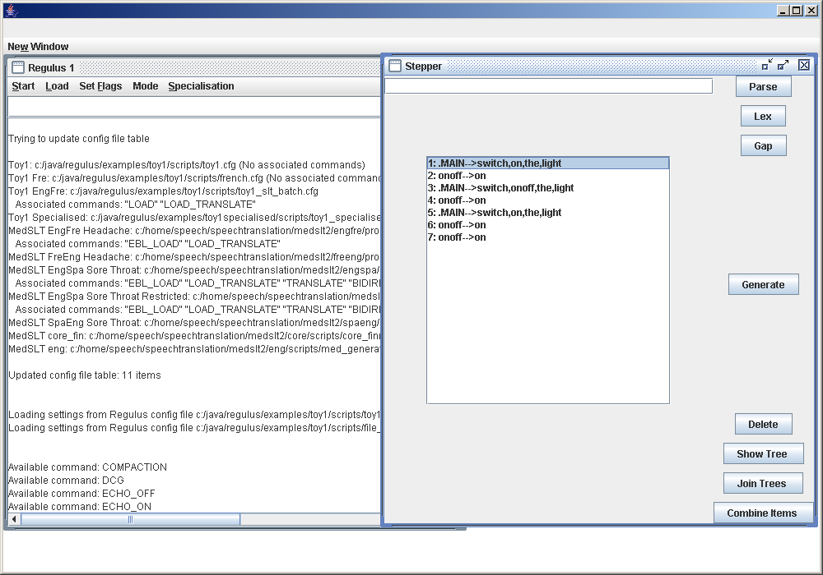

Now press the Show Tree button. A new window will appear with the item's grammatical structure displayed as a tree.
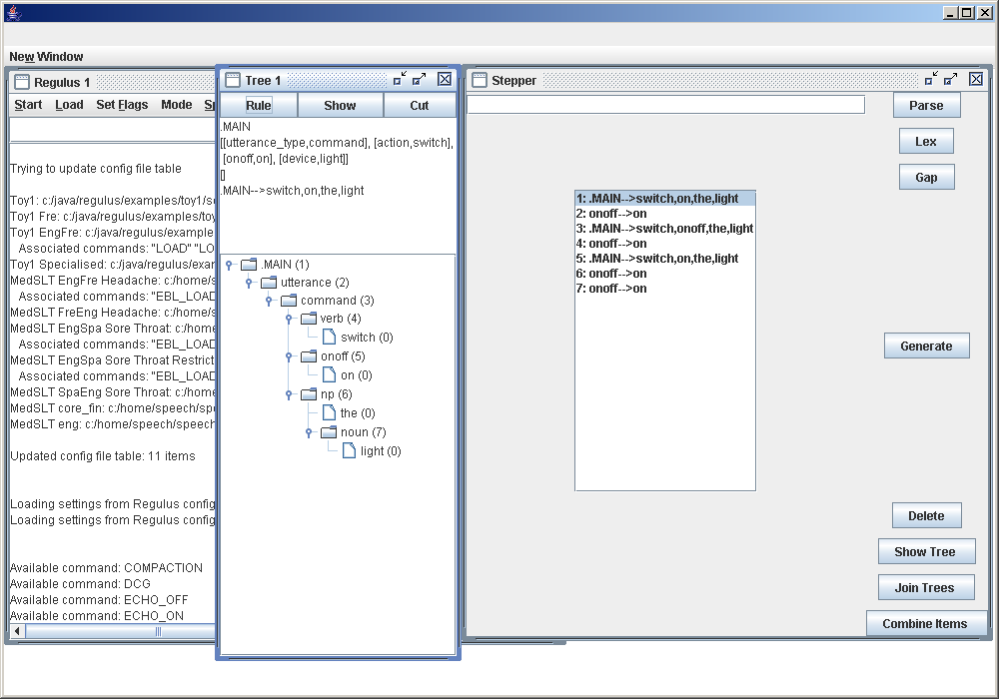

Cutting and Joining Items

One of the most interesting capabilities of the Stepper is that it allows the developer to try to build up new linguistic analyses by combining pieces of structure from existing ones. The Cut and Join buttons are used for this purpose.

Suppose that we trying to find out exactly why the Toy1 grammar is unable to parse the sentence “switch on the kitchen”. We start by using the Parse command to build Items for “switch on the light” and “is the fan in the kitchen switched on”. Our strategy will be to cut out the phrase “the light” from the first sentence and “the kitchen” from the second, and then try to paste “the kitchen” into the hole left in the first sentence.

We use the Show Tree command to display the first Item, and select the NP node for “the light”:

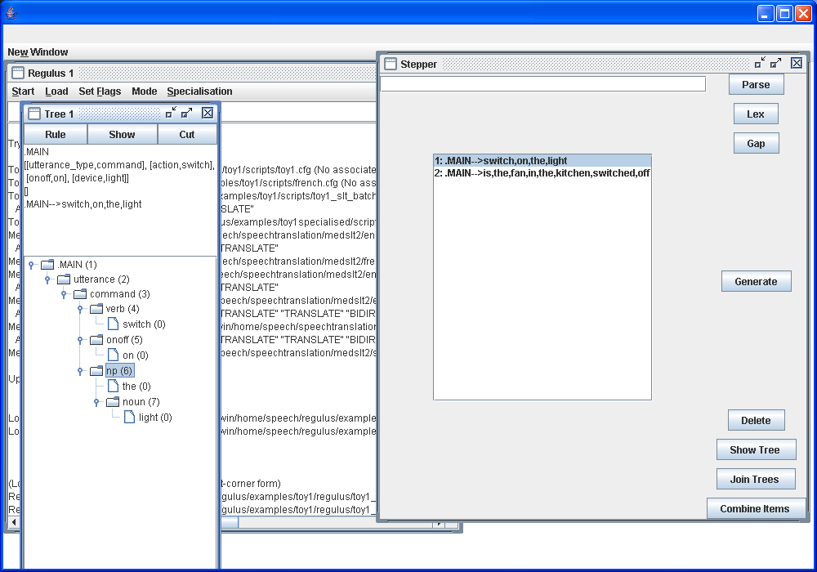

We then press the Cut button. This produces the message

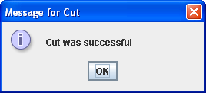

After we press “OK”, we can see that two new Items, 3 and 4, have appeared in the Item Area. Number 3 is marked “.MAIN --> switch,on,np” - this is the version of Item 1 in which “the light” has been cut out, leaving an NP gap. Number 4 is the NP that has been removed.

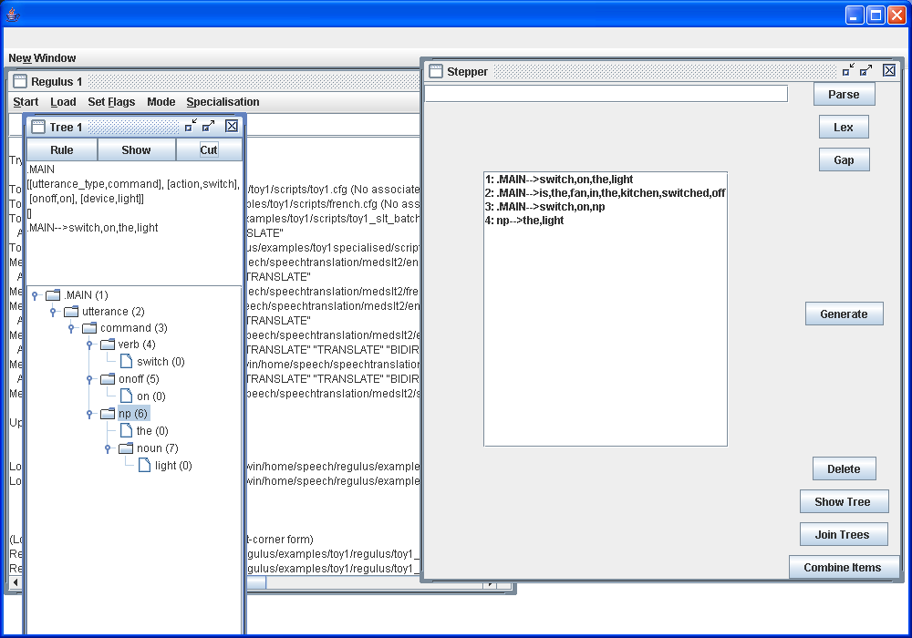

In the same way, we can show the tree for Item 2, “is the fan switched on in the kitchen”, and cut out the NP marked “the kitchen”. This produces two more Items, 5 and 6. As before, the first of these (Item 5) is the original item with an NP hole, and the second (Item 6) is the material that has been removed. Finally, we select Items 3 and 6 (to select more than one item, hold down the Ctrl key and click on the items) and press Join Trees:

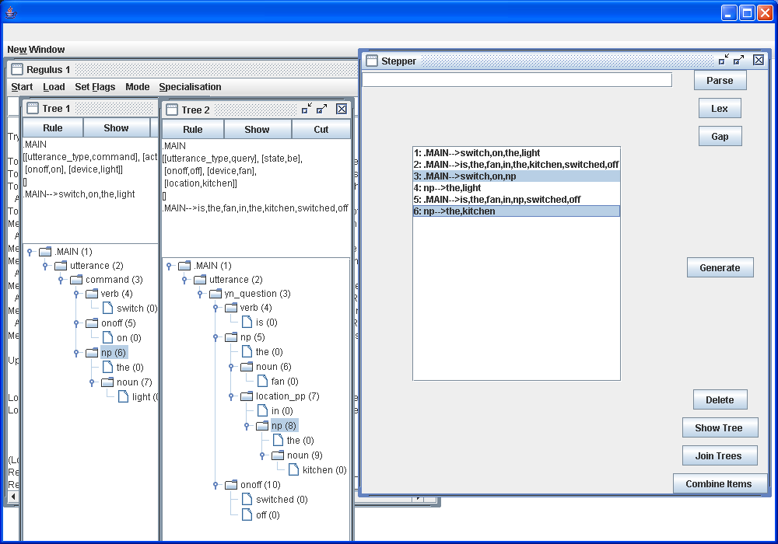
We get the following informative message:

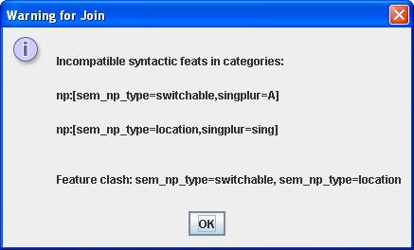
This shows that the incompatibility is specifically in the feature sem_np_type.

We now show an example of the Join command succeeding. In the Tree 2 window, select the NP node marked “the fan in the kitchen”, and press Cut again. We get two more Items, 7 and 8. Select Items 3 (“switch on NP”) and 8 (“the fan in the kitchen”), and press Join:

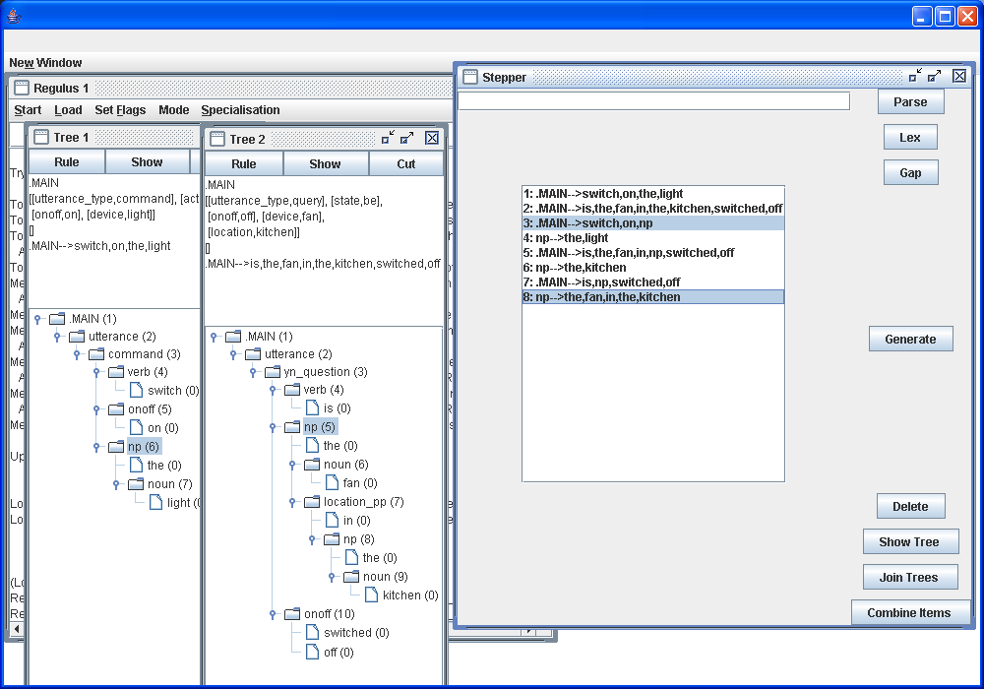
This time, we get the message

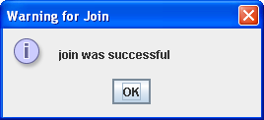

and we find a new Item has been added, for “switch on the fan in the kitchen”.

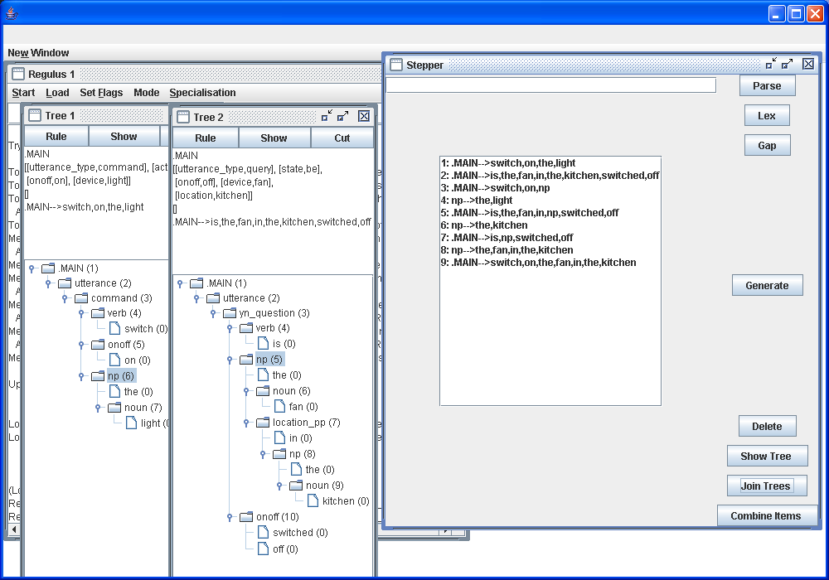

Bottom-up combination of Items
The easiest ways to build up new Items are those we have already seen: parsing, lexical lookup, cutting and joining. If none of these work, however, it is also possible to combine Items bottom-up.

For example, in the Toy1 grammar, suppose we wanted to build up an Item representing the NP “the fan in the living room”. We start by using the Lex command to add Items for the lexical entries “fan” and “living room”, after which the display looks like this:

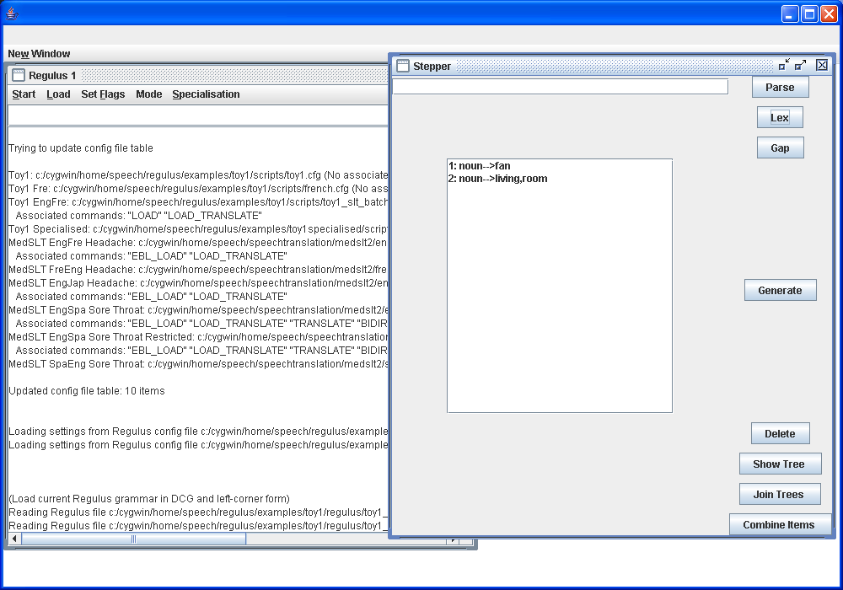

We first build the Item for the NP “the living room”. We press “Combine Items”. A window appears:

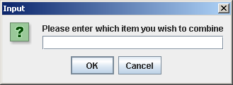
There is a slightly tricky point here: in this grammar, the word “the” in “the living room” is syncategorematic, in other words comes directly from a grammar rule rather from a lexical item. This means that, rather paradoxically, we build “the living room” only out of the Item for “living room”, so we fill in the box as follows:

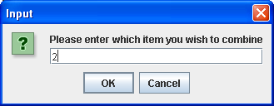
The combine command succeeds:

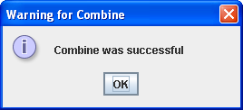

and the new state of the display is

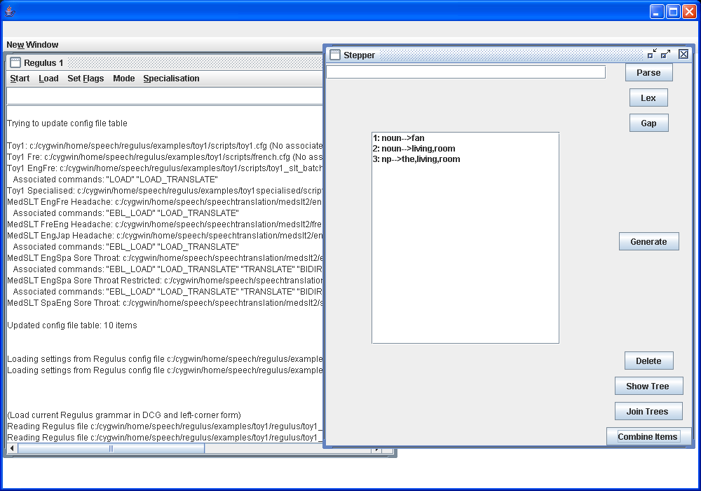
Next, we form the location_pp “in the living room”. In the Toy1 grammar, “in” is also syncategorematic, so the command looks like this:

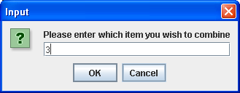

giving the following state of the display:

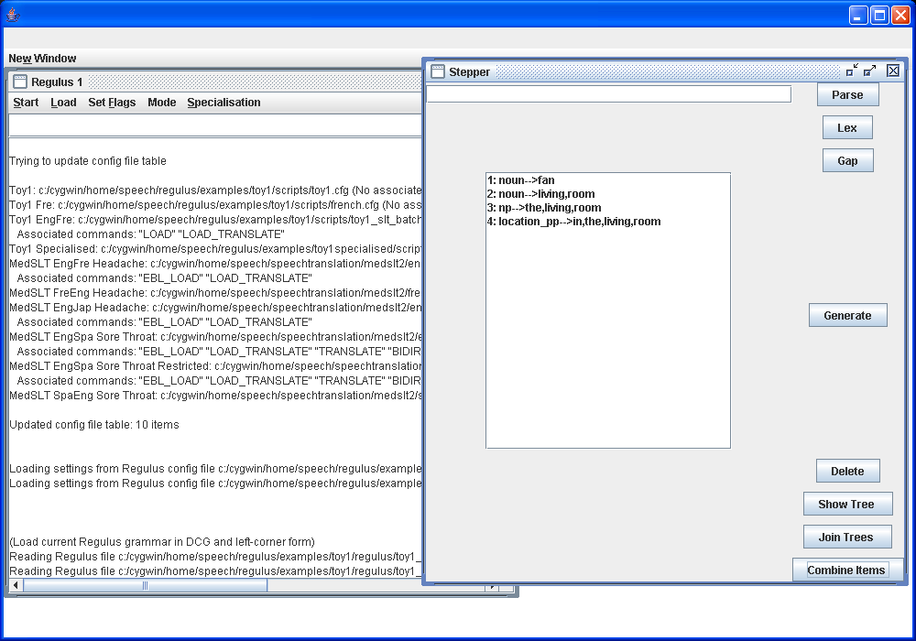
Finally, we build up the phrase “the fan in the living room”. This consists of a syncategorematic “the”, the noun “fan”, and the location_pp “in the living room”. The command is thus:

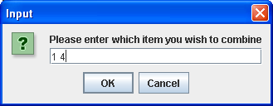

We show the final state of the display, after we have selected the new Item and displayed the associated tree.

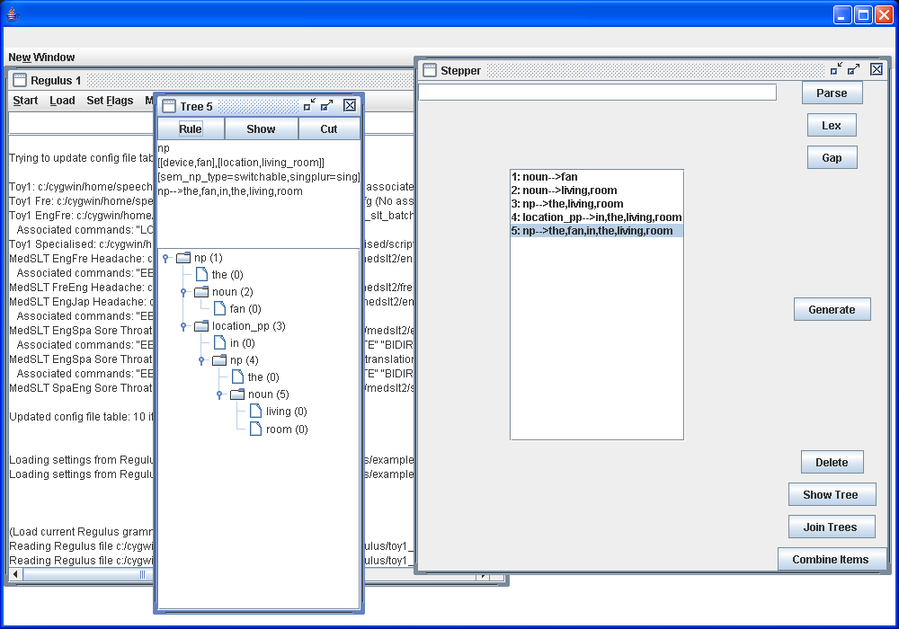

Deleting items

To delete a single item, start by selecting it from the item output area:

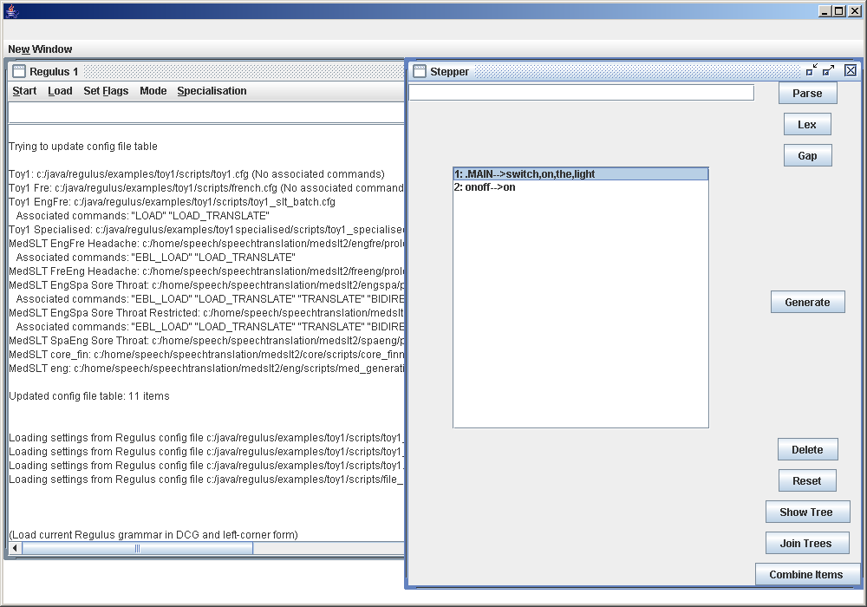

Press the Delete Button. A dialog box appears, asking you if you want to delete the selected item.

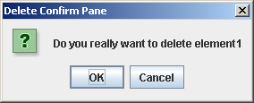

Click on OK . The display shows that the item has been removed; note that the item previously in second place has now been renumbered, so that it has become the new number 1.

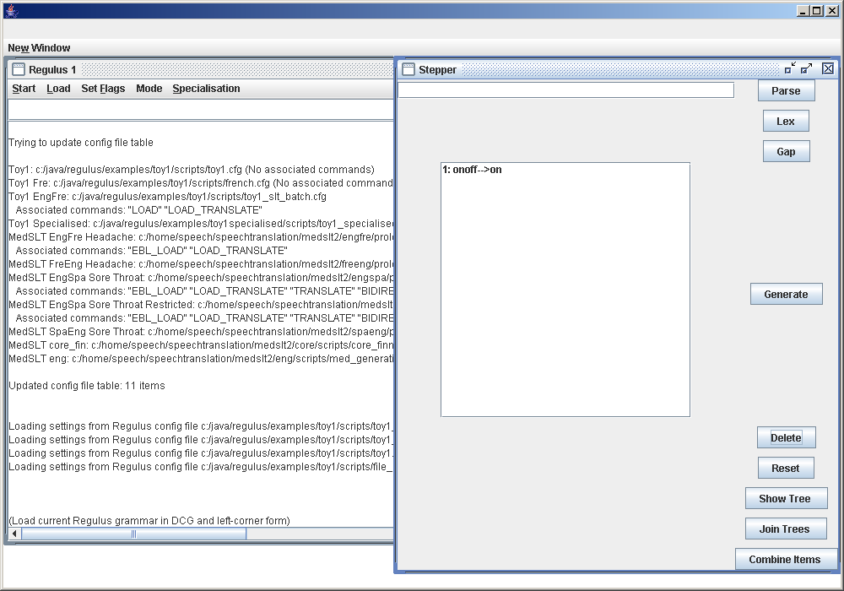

It is also possible to delete several items at once. Select them in turn while holding down the Ctrl key:

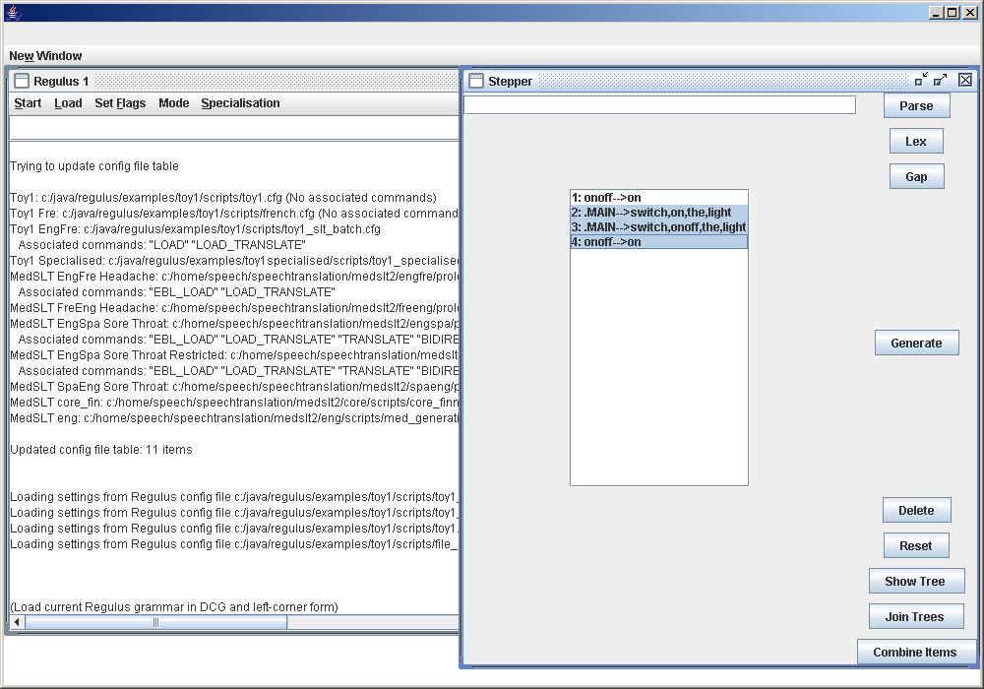

Press the delete button. For every item which you have requested to delete, a dialogue box will appear and you will have to confirm if you really want to delete the item or not.

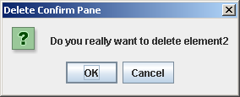
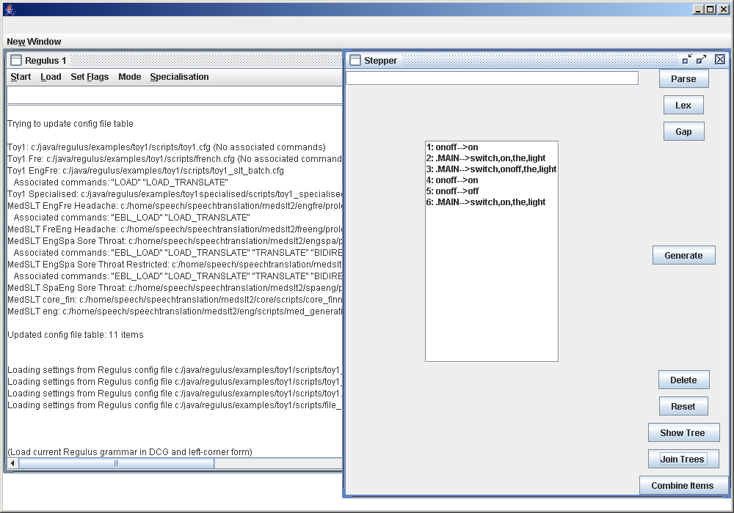

The Translation Window

To be able to use the Translation Window you need to load a config file which holds Translation stuff ####Marianne Manny please explain what stuff precicely#####
You do this by clicking on the Start Menu and selecting this kind of file.
In this example you start the configuration file “MedSLT EngSpa Sore Throat Restricted”.
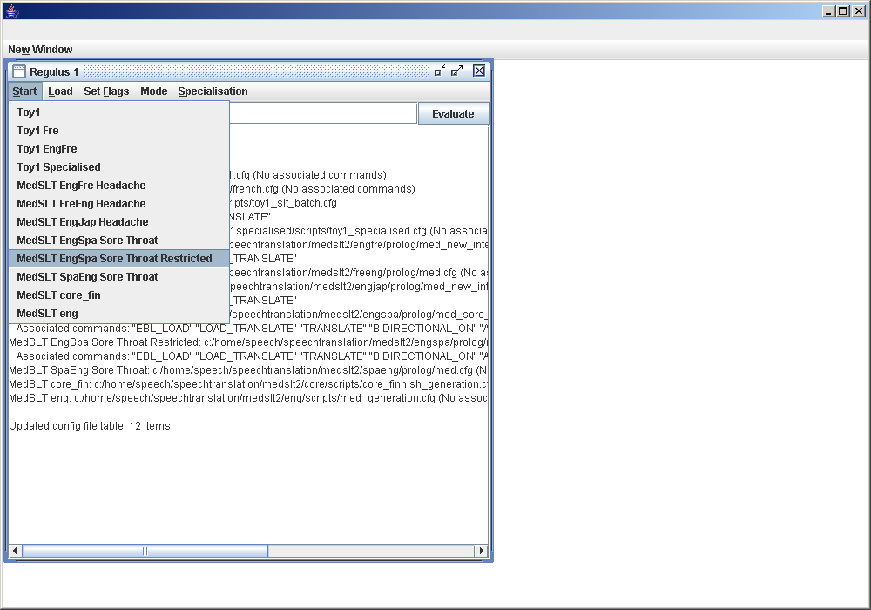
This configutation file has load options put into it. Be especially aware of the load option LOAD_TRANSLATE. It is necessary to do a LOAD_TRANSLATE before using the translation tools.

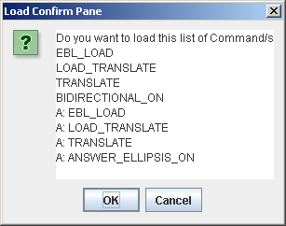

If you click on OK, all these Load options will be carried out.
When all the Load options are successfully completed you get a dialog box like this.
Click on OK.

The Translation Window is a is an area that lets you examine the results of your translations. To enter the Translation window, click on the Mode menu and choose Start Translate:

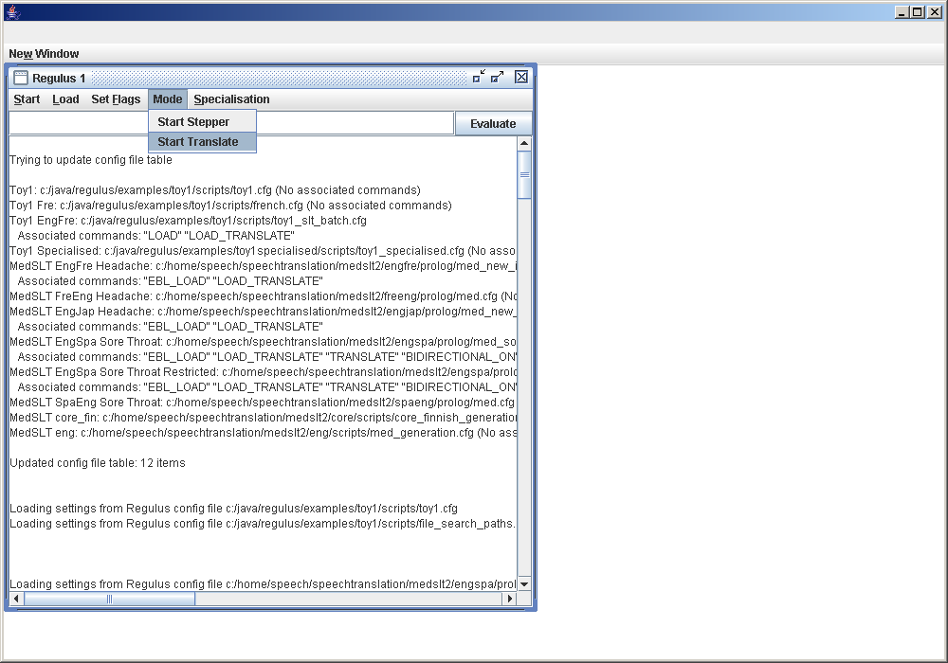
This will bring up a Translate window.

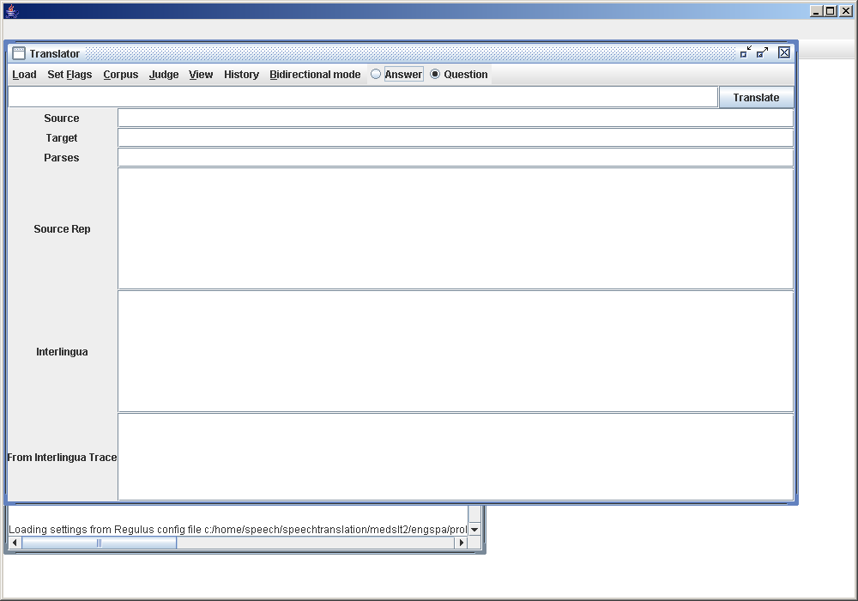

- The box at the top of the Stepper window is an input area, where you can enter phrases which you want to translate.

- The Translate Button should be pressed after you have entered a sentence in the above mentioned input Area.

- After you have pressed the above mentioned button the translated sentence and it's grammatical components ## Marianne Manny what exactly### is displayed in the area beneath the input Area.
You can decide how much information you want to display in this outputArea by selecting or deselecting fields in the View Menu.

The Menu Bar on the Translation window holds the following Menu items and tools

- The Load Menu item which does a Load_Translate.

- The Set Flags Menu Item which decide which Mode you want to be in when you are on the Translation Page. The options are : Answer Ellipsis on/off,Translate Trace on/off.

- The Corpus Menu Item from where you can load corpus data.

- The Judge Menu Item from where you can load judge data.

- The History Menu Item which gives you a list of the last words or sentences which you recently typed in.

- The Bidirectional Mode Menu Item which allowes you to switch on and off the Bidirectional Mode.

Lastly the question and Answer boxes are used when bidirection mode is switched on. In this mode you want to know which language and domain you are in. If you for example have a English/Spanish file loaded you want to know if you are on the question side
-English, or the answer side -Spanish.

Translating a Sentence

To translate a sentence, write it in the input window and press the Translate button. In this example, we enter the sentence “where is the pain”.

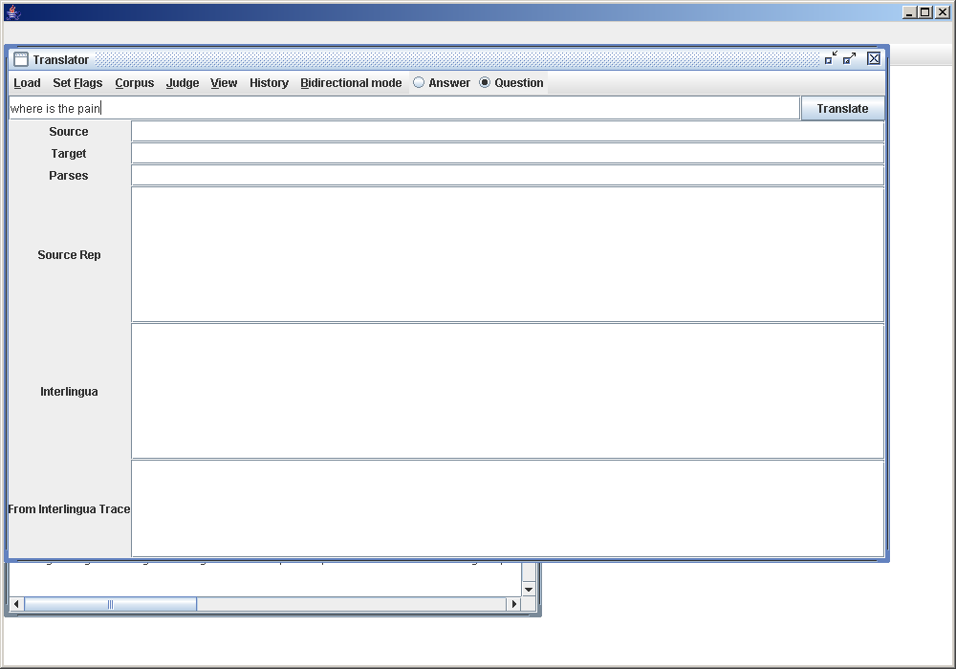

After the Translate button is pressed, the output area below is filled with information showing the actual translation and other information.

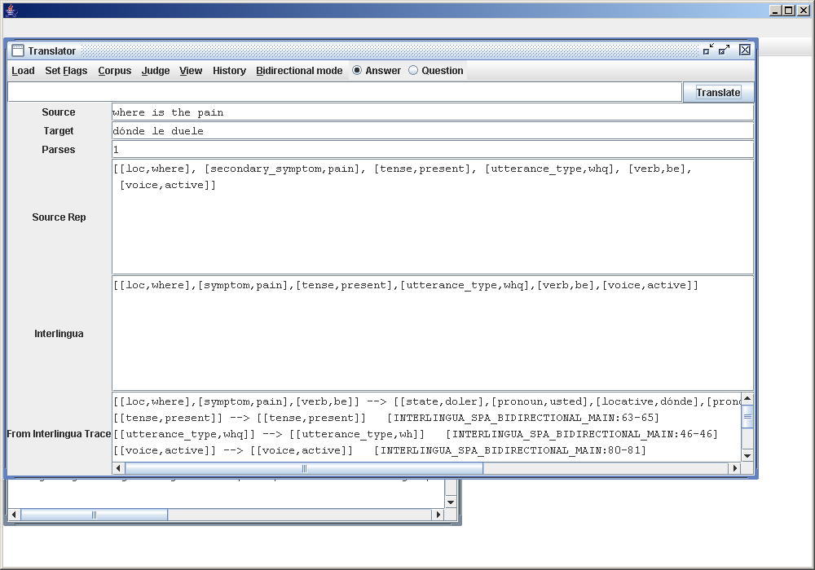

You can regulate how much or little you want to see by choosing the view menu option and selecting or de selecting fields.

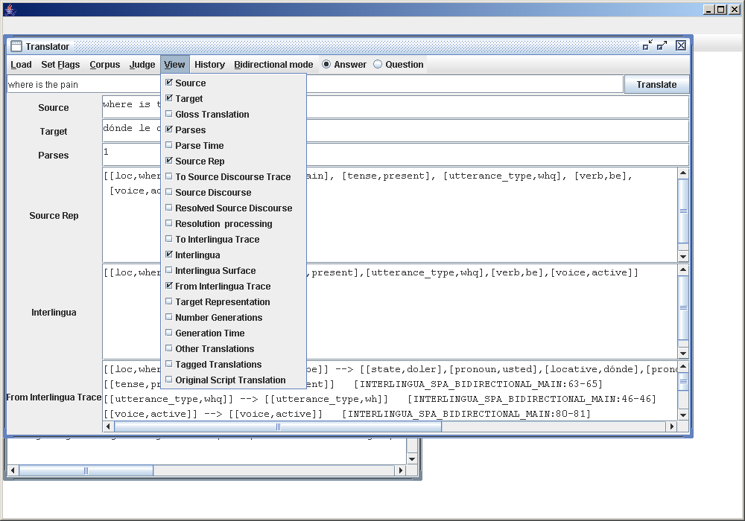
Select To Interlingua Trace.

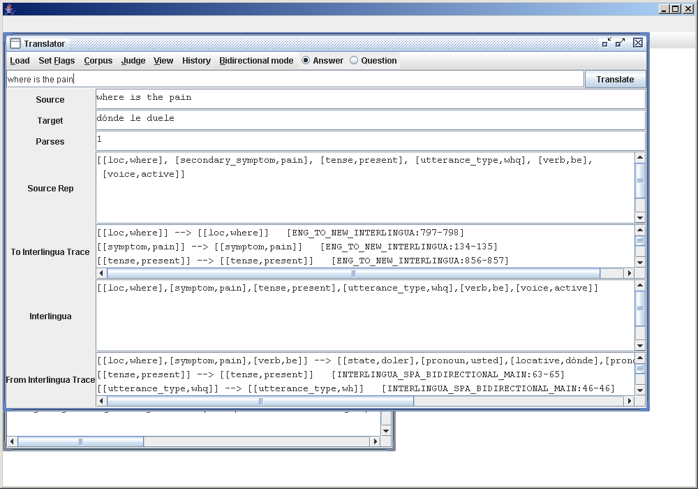
This is what it will look like.

This is a list of the fields that you can look at after you have pressed the Translate button.

Source
Target
Gloss Translation
Parses
Parse Time
Source Representation
To Source Discourse Trace
Source Discourse
Resolved Source Discourse
Resolution Processing
To Interlingua Trace
Interlingua
Interlingua Surface
From Interlingua Trace
Target Representation
Number Generations
Generation Time
Other Translations
Tagged Translations
Original Script Translation

## Manny Marianne please fill in and explain what these field contains.##

The Load Menu

In the Translation Window there is a Load Menu Option. This menu option contains just one item the Load Translate.

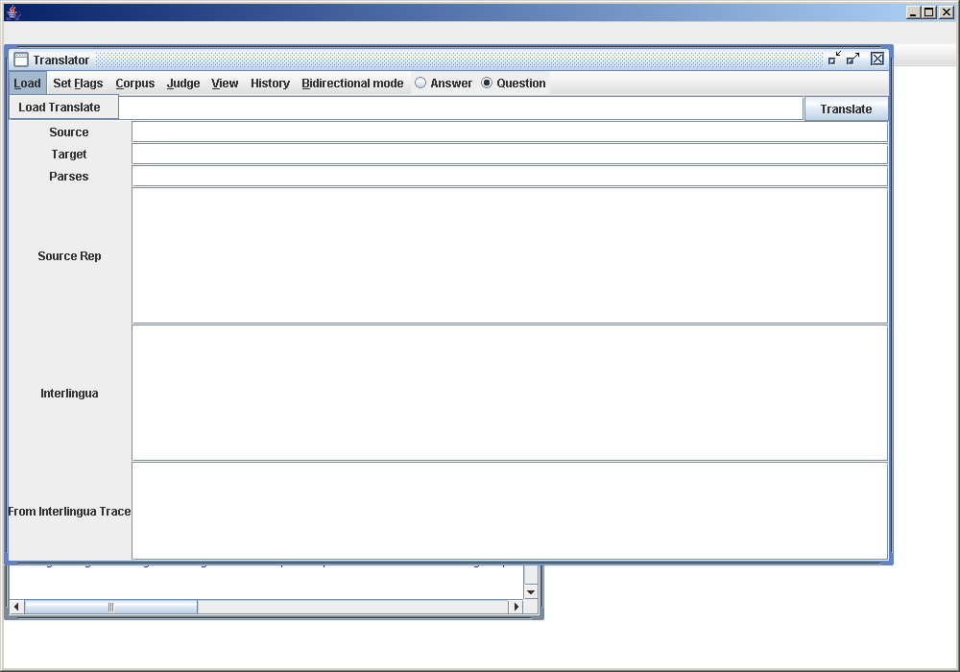
If you click on Load Translate, you will get this message when all the Translation related files are loaded.

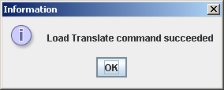
Click OK.

Set Flags Menu

The Set Flags Menu option, holds a Mode sub menu, under this sub menu there are two Menu Items that are flags which can either be switched on or off.
This is the Mode sub Menu option.
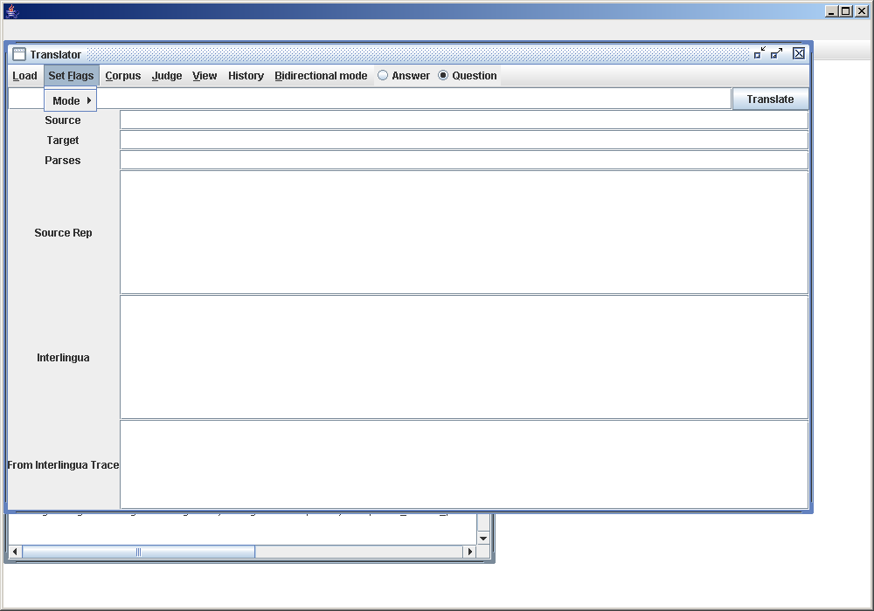
These are the two set of flags that can either be switched on or off.

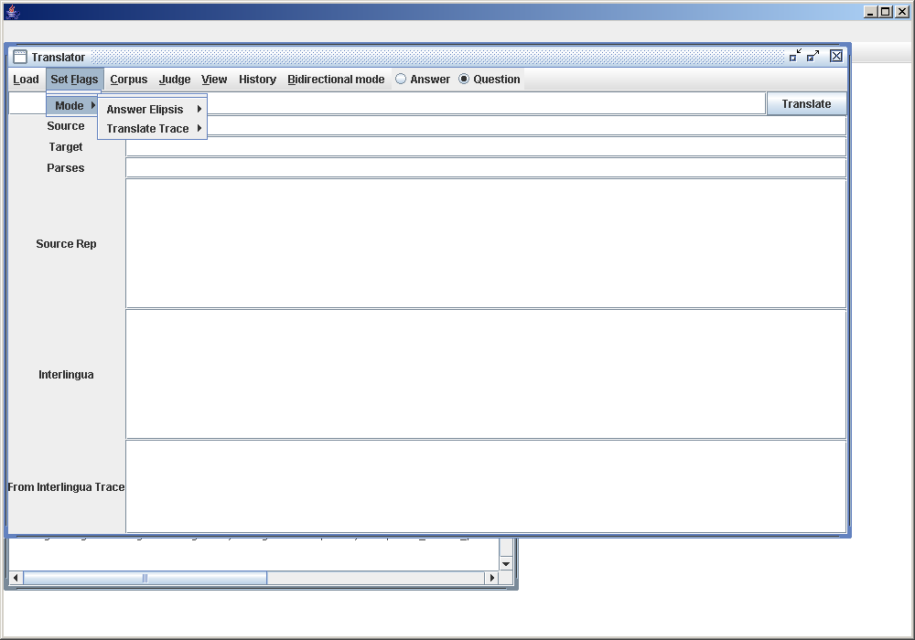
This is where you either switch ellipsis on or off by clicking on the relevant Menu option.

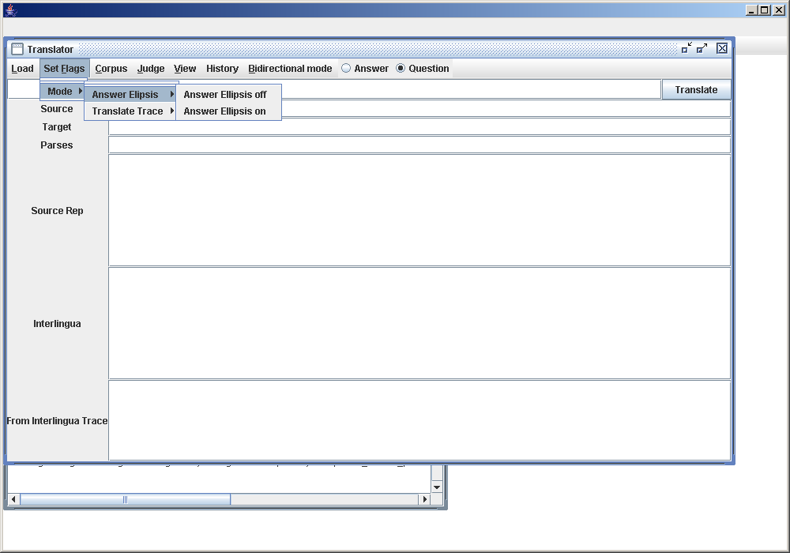

This is where you either switch Translate Trace on or off by clicking on the relevant Menu option.
You can see the translate trace output in the Translation Output field To Interlingua Trace.

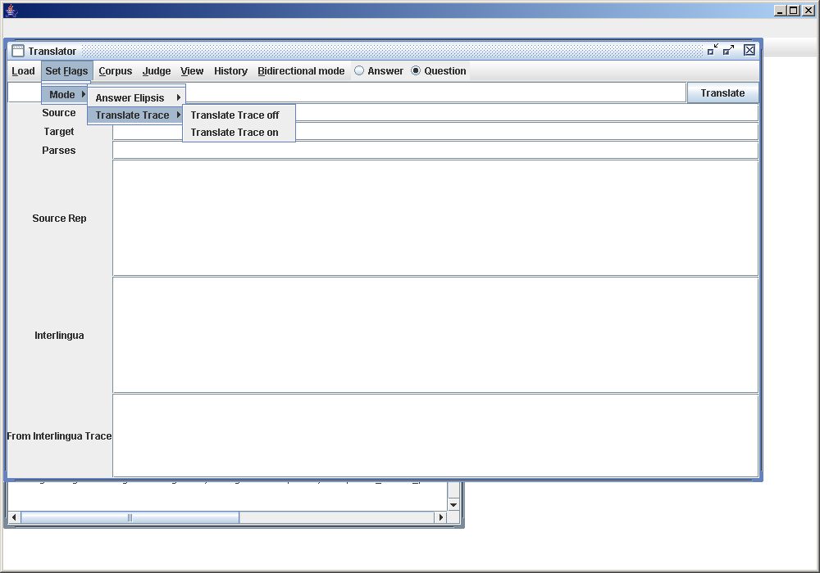
In this example you switch on the Translate Trace by clicking on it.

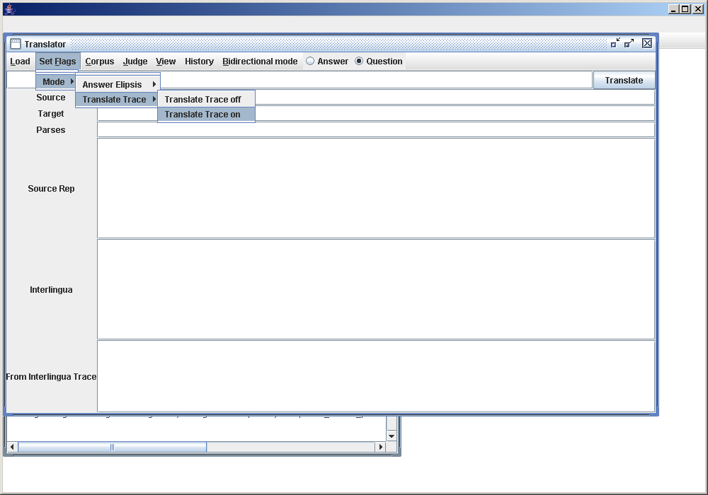
You get this message , if Translate has been successfully switched on.

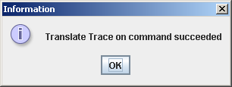
The Corpus Menu

At The Corpus Menu option Menu there are two kind of sub menus. The first kind are the non generic ones. Translate Corpus, Translate Speech Corpus and Translate Speech Corpus Again.
Then there are the generic commands which are the above commands but something is added to them. For example you could have a generic command of Translate Corpus which would be called something like Translate Corpus alternate.
If you want to do Translate Corpus, then select it at the Corpus Menu option.Like this.

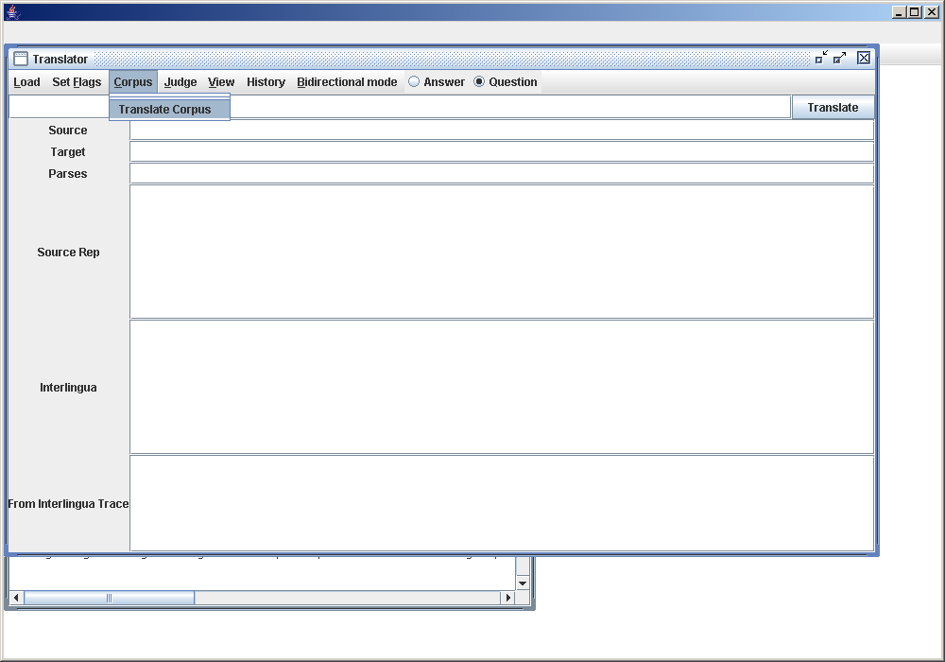

When you clicked on Translate Corpus and everything went okay. This is what you get.

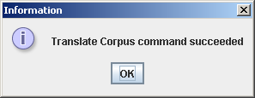

Now click on OK. And below you see the window being displayed with information about the Corpus run.

####Write why the info is important and what it means.

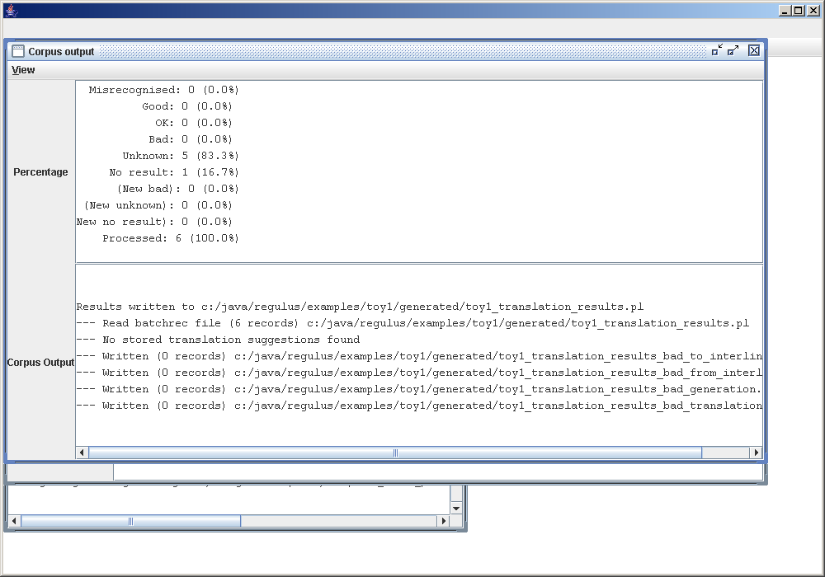
If you want to see what a generic command looks like, then look at this window. We have now selected the generic corpus command Translate_Corpus alternate.We select the command.

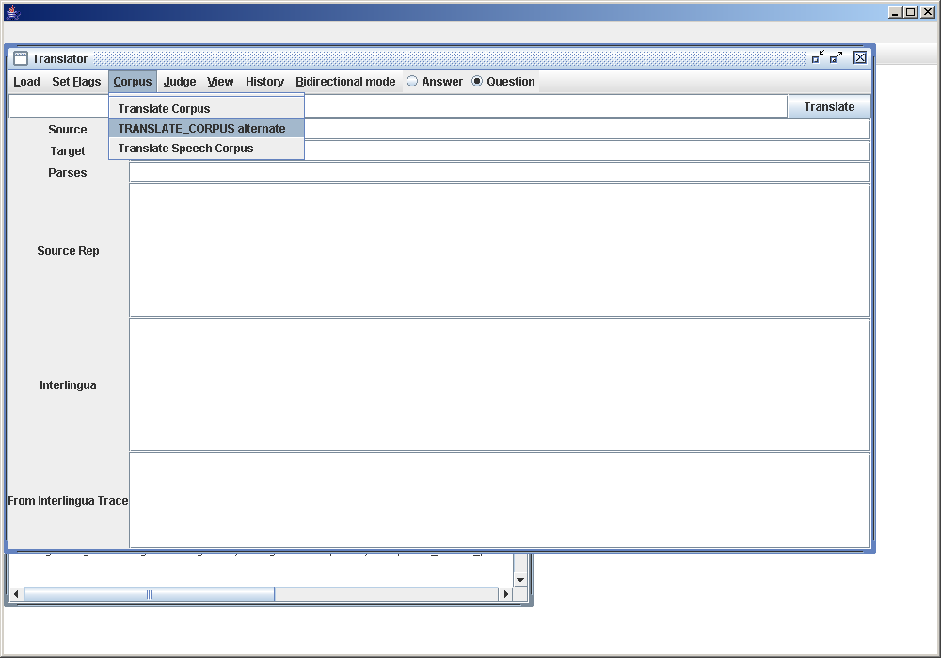

And get this Dialog box.

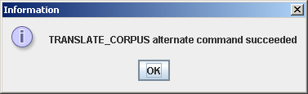

The Judge Menu

The judge Menu resembles the Corpus Menu in the respect that there are static and generic commands.
The static commands are the following Update Recognition Judgements, Update Translation Judgements and Update Translation Judgements Speech.
Then there are the generic commands which are the above commands but something is added to them. For example you could have a generic command of Update Recognition Judgements which would be called something like Update Recognition Judgements alternate.
If you want to do Update Translation Judgements, then select it at the Judge Menu option.Like this.

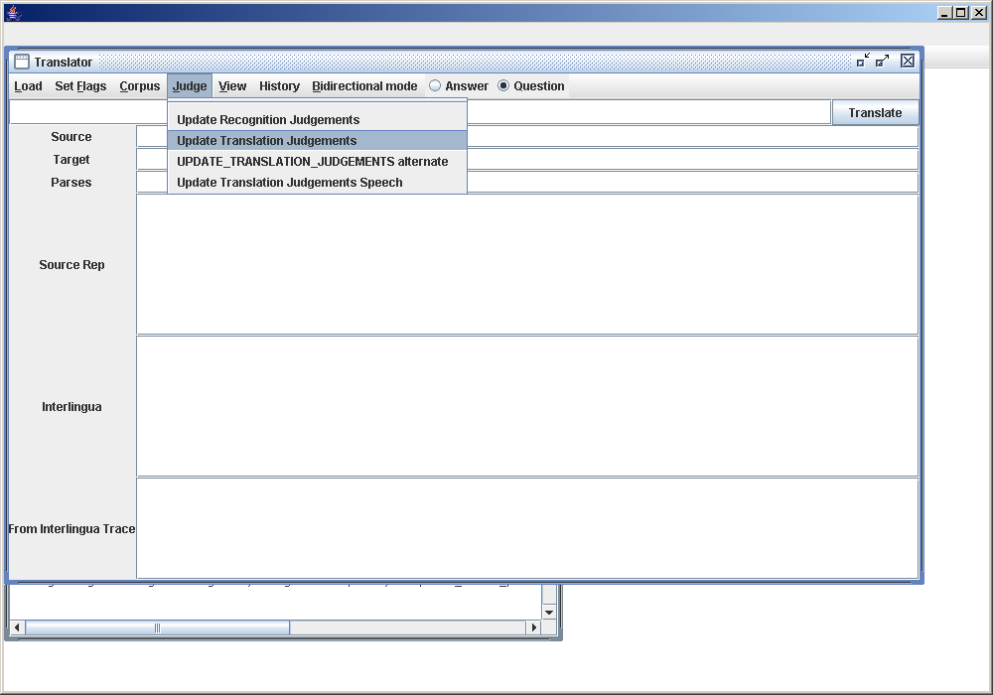

Now click on it. This is what happens.

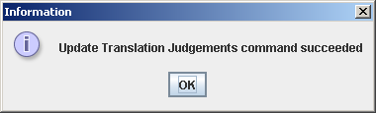

If you want to see what a generic command looks like, then look at the command selected in the window below. We have selected the generic Judge command Update Translation Judgements alternate.We select the command.

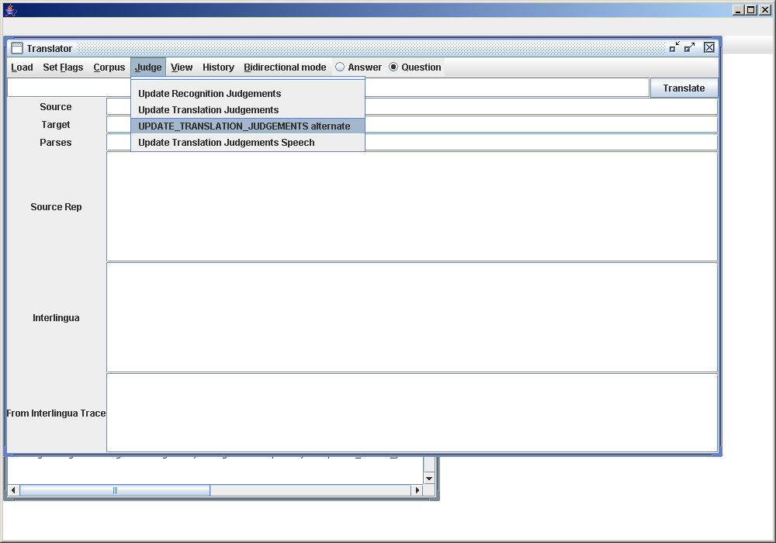
After selecting the above command we click on it and this dialog box appears.

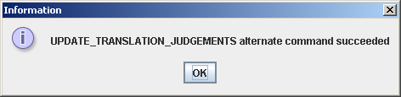

The History Menu

The history Menu is simply an area where the latest entered words and sentences are saved.
When you develop a system you often want to use the same words and sentences again and again to test if the system gets better. To save you a lot of repetative typing use this Menu.
This is how you use it.
In the window below we enter the sentence “where is the pain”.

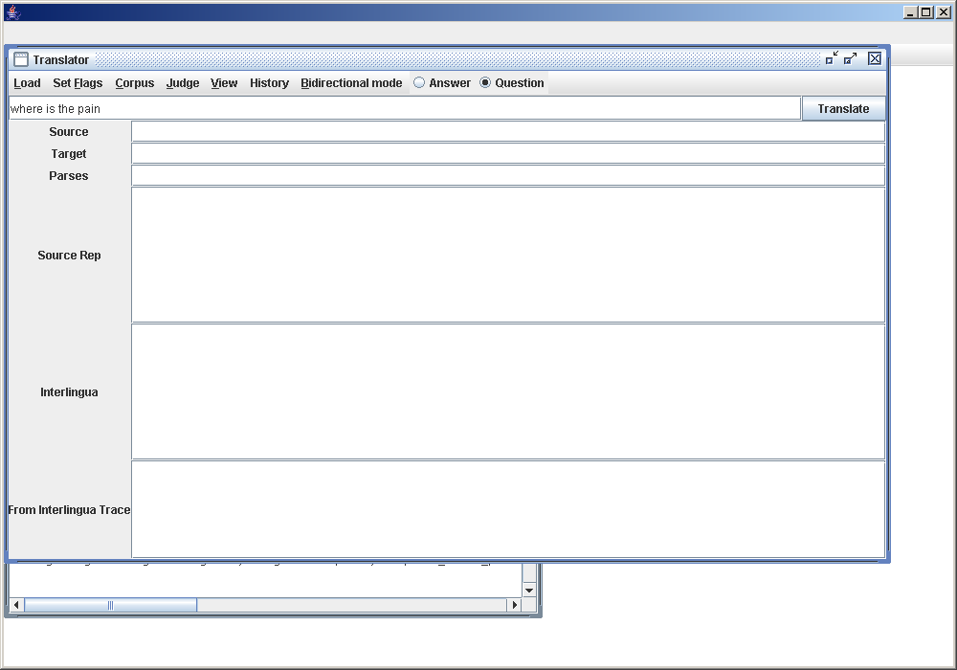

Now press the Translate button and this is the screen you get.

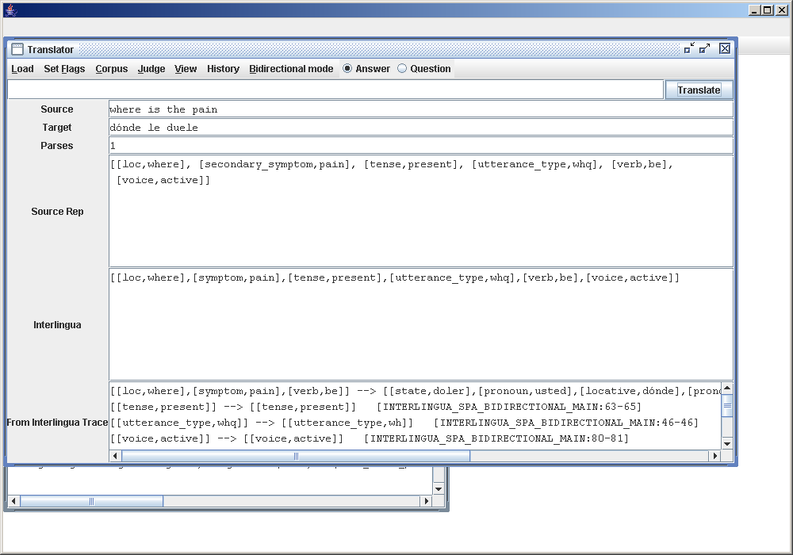

Now, say you want to enter this sentence again. Click on the History Menu.

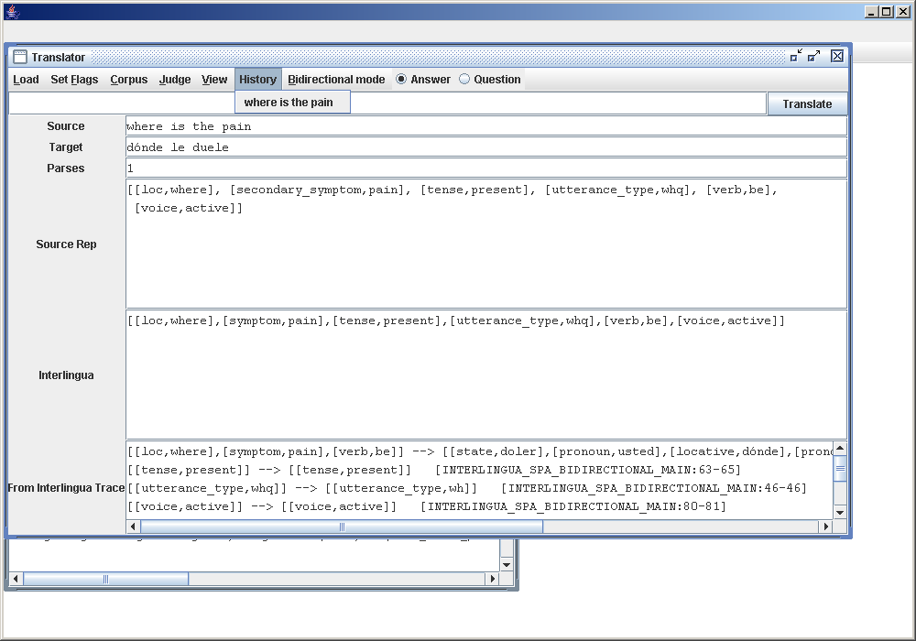

Your sentence appear in the sub menu. If you want to enter this sentence again. Click on it.

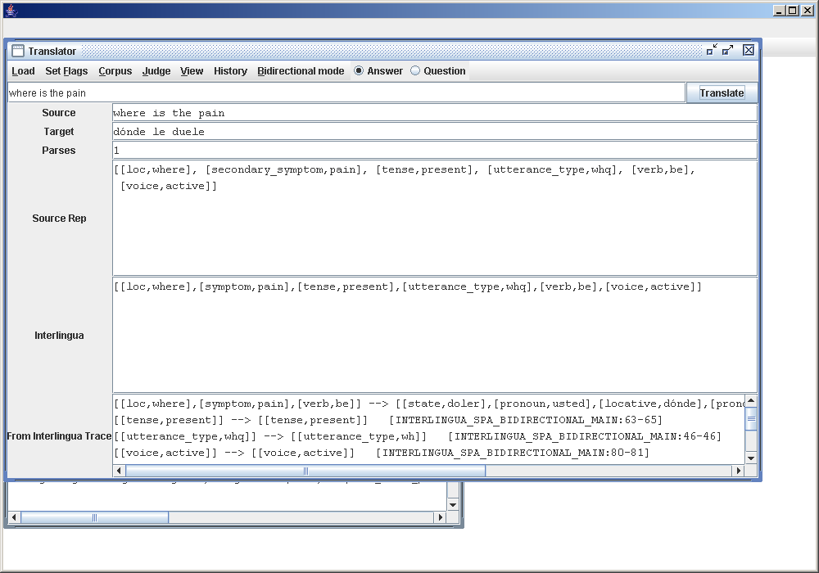

The sentence appears in the input area. If you use this sentence again by clicking the Translate button.

As it is the same sentence it will only occur once in the History Menu

However if you entered a different sentence. In the window below you have just entered “Is the pain frontal”?

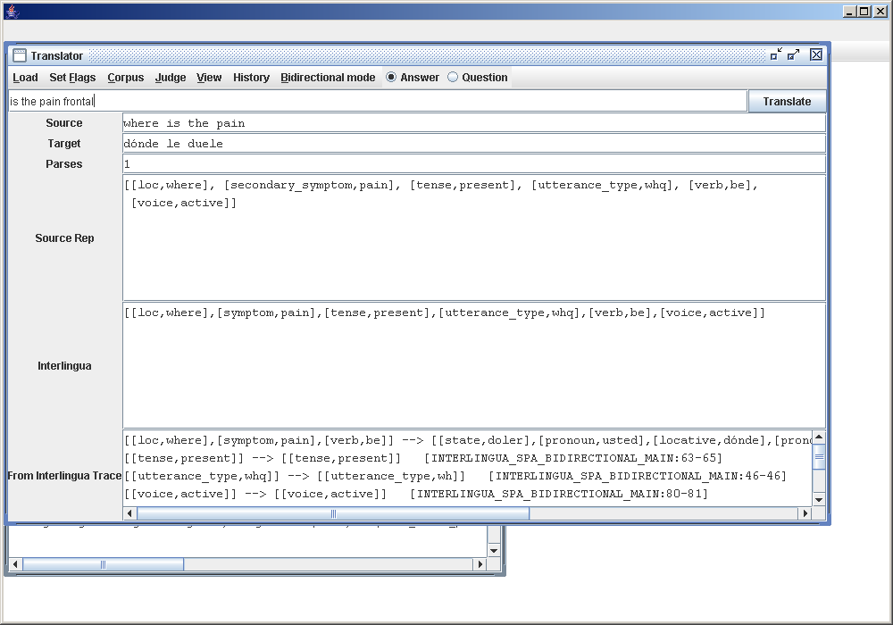

Now look in the history Menu. Both sentences appear there.

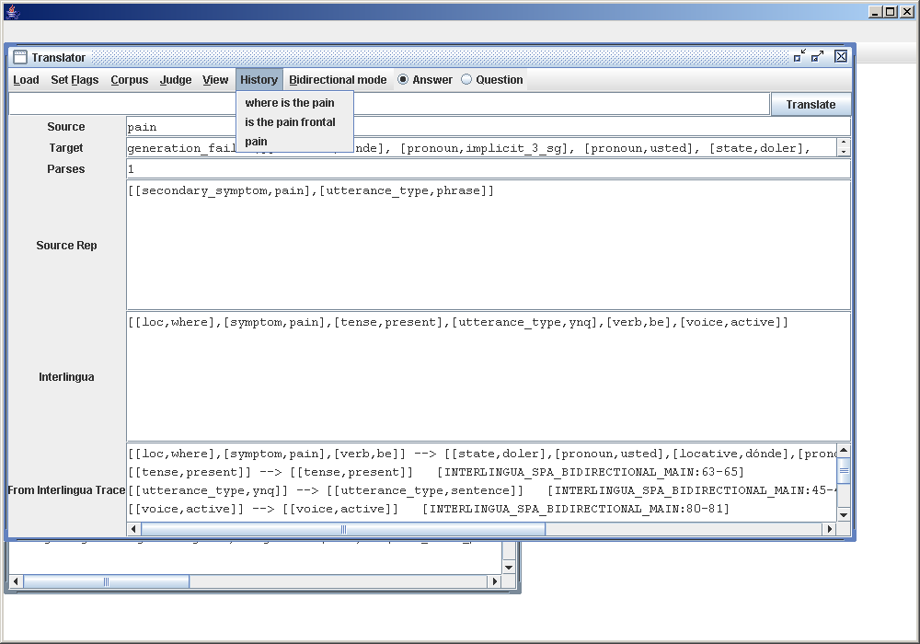

The Radio Buttons Answer and Question

The Answer and question radio button fill a function only when the Translation page has the Bidirectional Mode switched on.
In the bidirectional mode the system functions with having a Question Language and an Answer Language.
You start by entering a question in the first language the Question Langauge, the question gets translated into the second language the Answer Language.During this phase in the bidirectional mode, the radio button shows that the Question is switched on.
The next stage is the Answer stage the system switches on the Answer button and the user enters an answer in the Second Language. This answer gets translated into the First Language.
In this example you start the configuration file “MedSLT EngSpa Sore Throat Restricted”.

Now load all the the extra files and settings In this example pay special attention that Bidirectional Mode is switched on.

Everything loaded OK.

Now enter the Translation Mode.

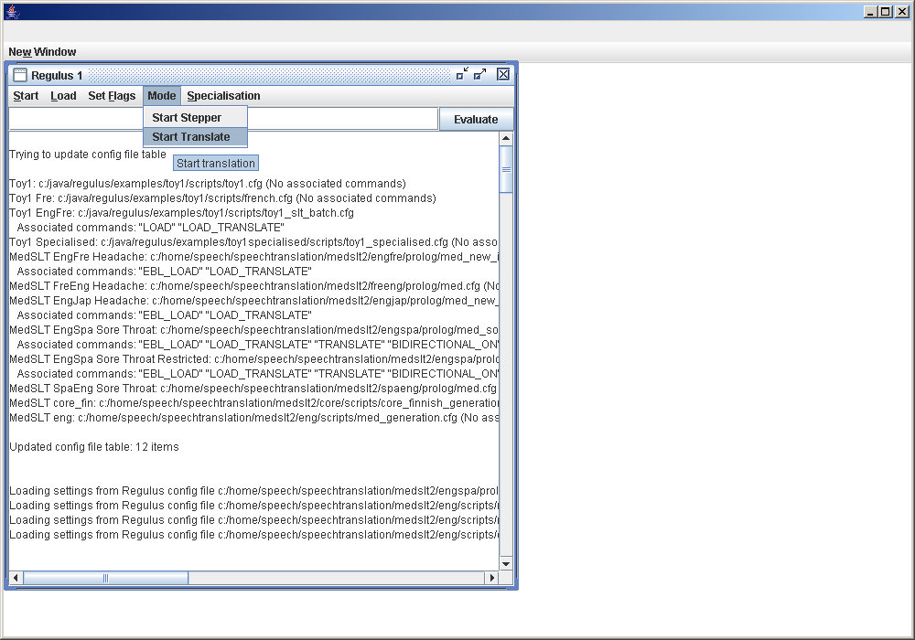

You are in the Translation window. Bidirectional mode is switched on.

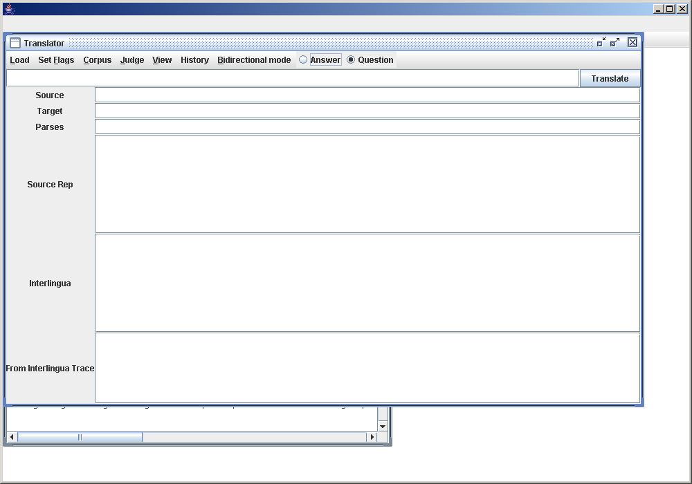

Enter a question in the first language. The Configuration files will be named to give you a hint what the languages are. In this case the file name begins with Eng and Spa. The first language or the question language is english. The second language or the answer language is spanish.
In this example we enter the question “where is the pain”? And Press the Translate button.

Now you want to answer the question. In this example we enter the answer “en la garganta”. I have a sore throat. Press the Translate button.

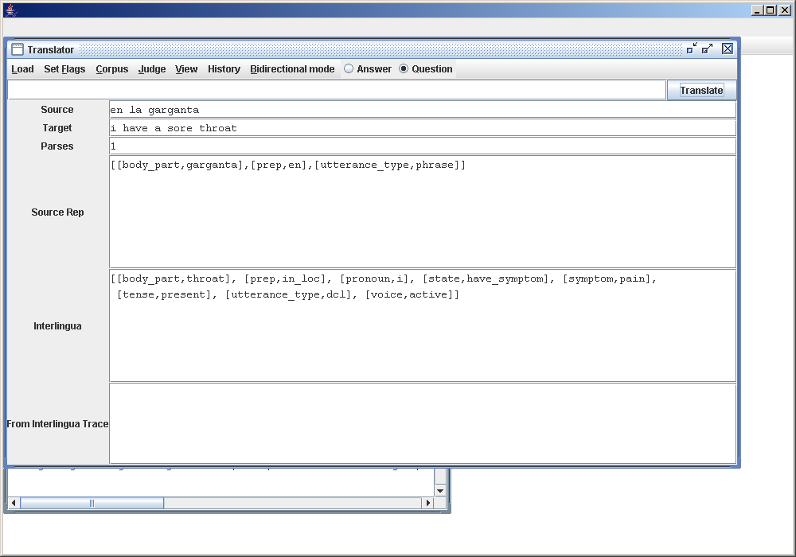
Pay special attention to the fact that the radio button now automatically switched to answer.

