C Coursework – Engduino Pedometer
Matthew Bell, 2015-11-16

The application
The application I've created for the Engduino captures data from the accelerometers via serial and displays it as a graph on the screen, as well as estimating the number of steps that the user made while using it.

Setup
The only prerequisite for the program is the Processing IDE. With the IDE, open the Engduino/processing/processing.pde file. Press the RST button on the Engduino and wait until the red LEDs are showing; this means that it is waiting for user input.
In Processing, play the sketch ('play' button, or CTRL+R) to begin the desktop program. Once it is loaded, press the main button on the Engduino and it will attempt to sync its clock with the program (the LEDs will become orange). If this is successful, you will see two green flashes and then only one green light will be active. This means that the device is now logging the data.
Once you are finished, press the main button again and a graph will appear on the screen, showing the accelerometer data against time, as well as an estimate of the number of steps taken.
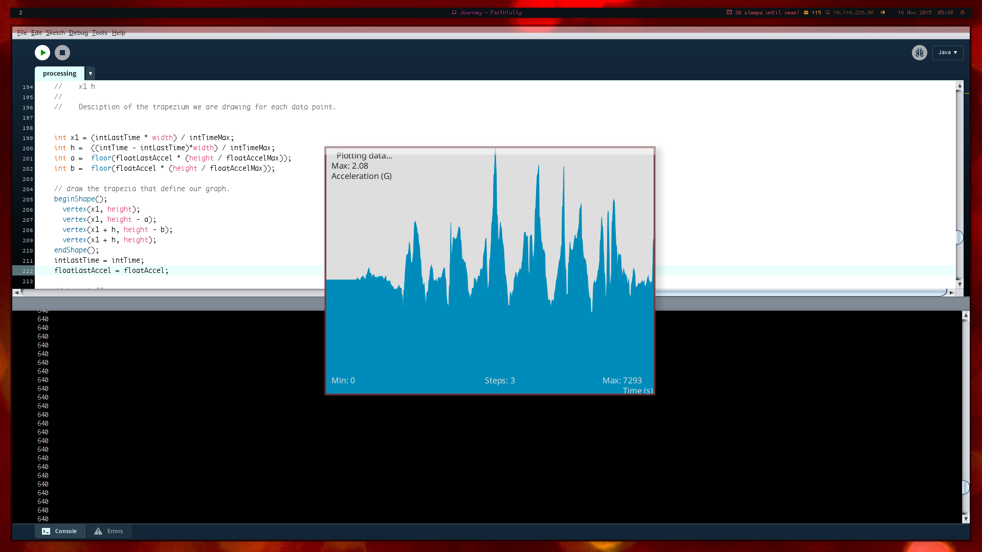
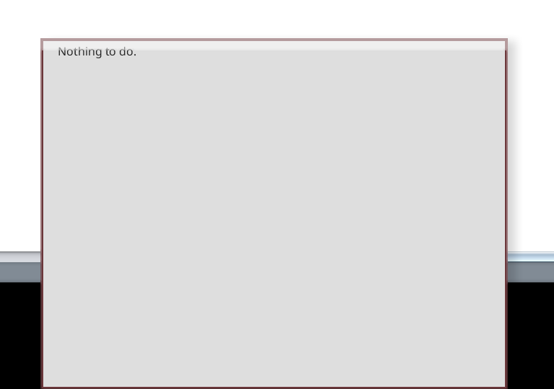

OpenSCAD Design
The OpenSCAD design is intended to be a kind of display case for the device, for instance to be placed upon a flat surface. The incline of the display is enough to prevent the device from falling out of the case, yet also high enough so that the case will not tip.
The dimensions of the Engduino were verified by ruler so that it will definitely fit in the case, and as an extra touch, the words “UCL Engineering” are printed at the bottom.
The case is assembled in two parts, the base and the stand. They are clicked together using the connectors attached to the stand.
