Development Points Need to Take care :

***Creating DAO :***

1. Add annotation **@Repository** (import org.springframework.stereotype.Repository) .
2. Extends with AbstractDAO and add type for which type entity you need add
3. No need to worry about session creation and session close
4. Always use interface base implements

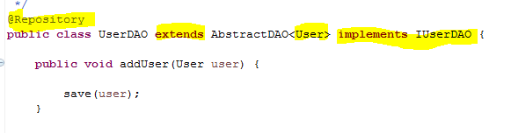

***Creating SERVICE:***

1. For service class add **@Service** cannotation (import org.springframework.stereotype.Service)
2. Use interface base implementation
3. Use **@Transactional**  for transaction handling
4. @Transactional(rollbackFor=Exception.class, propagation=Propagation.REQUIRED, readonly=true)
5. If your service is only fetching data its better to use like

@Transactional(rollbackFor=Exception.class,propagation=Propagation.REQUIRED, readonly=true)

1. If your doing some crud operation (like delete , add , update) than you should use below.

@Transactional(rollbackFor=Exception.class,propagation=Propagation.REQUIRED, readonly=false)

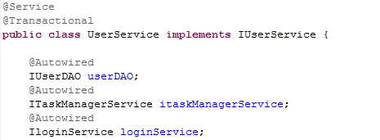

1. For exception handling add below annotation

@ExceptionHandler(Exception.class)

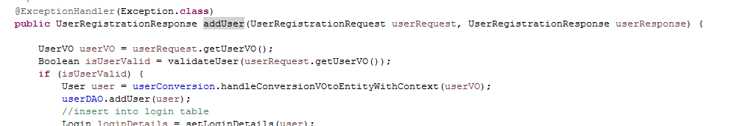

These are basic steps of creation services class and dao class. Please use carefully. If required any help let us know your query.