MINI PROJECT REPORT
STUDENT EXPENSE TRACKER
A Python Desktop Application using Tkinter and SQLite
Submitted in partial fulfilment of the requirements for
MASTER OF COMPUTER APPLICATIONS (MCA)

Submitted by: __________________________________
Registration / UID: ______________________________
Class / Section: _________________________________

Submitted to: ___________________________________
Department: _____________________________________

CHANDIGARH UNIVERSITY
Academic Session: _______________________________

1. Abstract
Student Expense Tracker is a small desktop application designed to help a student maintain a record of daily expenses. The user can enter an expense date, category, description and amount. Saved records are displayed in a table, and the application calculates total spending, current-month spending and the number of recorded expenses. Records can be searched, deleted after confirmation, and exported to a CSV file. Python Tkinter is used for the graphical interface and SQLite is used to store data locally.

2. Problem Statement
Small daily purchases are easy to forget, making it difficult to calculate how much money has been spent over a period. A simple local application can keep these entries in one place and provide totals without depending on an internet connection or an external account.

3. Objectives
- Create a simple graphical interface for entering expenses.
- Store records in a local SQLite database.
- Validate dates, categories, descriptions and amounts before saving.
- Display expense history and allow text-based searching.
- Calculate all-time and current-month spending totals.
- Allow the user to export records to CSV format.

4. Scope and Limitations
The application is intended for one user on one computer. It supports expense recording and basic review of saved data. It does not connect to bank accounts, process payments, synchronize across devices or provide financial advice. The initial demonstration records are sample data and can be removed through the application.

5. Tools and Technologies
Technology | Use in the project
Python | Main programming language and application logic
Tkinter / ttk | Desktop interface, forms, buttons, dialogs and table
SQLite / sqlite3 | Local relational database and SQL queries
csv module | Exporting records to a CSV file
unittest | Automated tests for database operations

6. System Requirements
- Operating system: Windows, macOS or Linux with Python and Tkinter available.
- Python: 3.10 or newer recommended.
- Internet: not required for normal use.
- Third-party packages: none required.

7. Functional Requirements
- Add an expense with date, category, description and amount.
- Reject malformed dates, blank descriptions, unsupported categories and non-positive amounts.
- Show saved expenses ordered by date, with newest entries first.
- Search by date, category or description.
- Delete a selected record only after confirmation.
- Show all-time spending, current-month spending and record count.
- Export saved records to a CSV file selected by the user.

8. System Design

8.1 Application flow
- Start the application and initialize the database table if it does not exist.
- Load the saved expense records and calculate summary values.
- Accept an action from the user: add, search, delete or export.
- For a new expense, validate all fields before inserting the record.
- Refresh the table and summary after a successful change.
- Display a confirmation or error message when appropriate.
- Close the application when the user exits.

8.2 Database design
The application uses one table named expenses. The id field uniquely identifies each row. Amounts must be positive. Dates are stored in ISO format (YYYY-MM-DD), which supports consistent sorting and filtering.
Field | Type | Description
id | INTEGER PRIMARY KEY | Unique identifier generated by SQLite
expense_date | TEXT | Expense date in YYYY-MM-DD format
category | TEXT | Selected expense category
description | TEXT | Short description entered by the user
amount | REAL | Expense amount; must be greater than zero
created_at | TEXT | Timestamp recorded when the row is created

8.3 Module structure
File | Responsibility
app.py | Creates the interface and handles user actions.
database.py | Creates the table, validates data, runs SQL operations, calculates totals and exports CSV.
tests/test_database.py | Runs unit tests against a temporary database.
run_windows.bat | Starts the application on Windows when Python is installed.

9. Implementation Details
The interface is built with Tkinter and ttk widgets. The data layer is kept in a separate Python module so that database operations can be tested without opening the graphical interface. SQL values are passed through parameterized queries. The database is stored locally in the project folder. Input validation is performed before data is inserted, and the delete action asks for confirmation.

10. Testing
The included automated tests use Python unittest and a temporary database so they do not modify the normal application data. The test suite was run during package preparation; all six tests passed in that run. Results may vary if the code is changed, so run the tests again before final submission.
Test | Expected result | Result in the recorded run
Add and list an expense | Saved record appears with correct values | Pass
Reject zero amount | Validation raises an error | Pass
Reject unknown category | Validation raises an error | Pass
Search by text | Matching record is returned | Pass
Delete record | Record is removed; repeat delete returns false | Pass
Calculate summary | Count and total match inserted records | Pass

To repeat the tests, open a terminal in the project folder and run: python -m unittest discover -s tests -v

11. Application Screenshot
The following screenshot was captured from the running application with its sample records. Replace or supplement it with a screenshot from your own laptop if your instructor expects evidence from the submission environment.
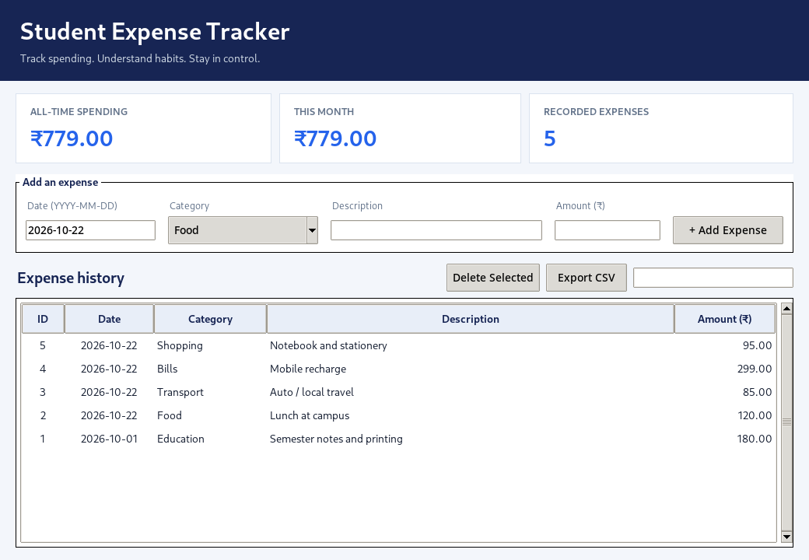
Figure 1: Student Expense Tracker main window

12. Advantages
- Simple interface and small codebase.
- Local storage keeps records on the user’s computer.
- No paid services or third-party packages are needed.
- Input validation helps prevent common data-entry mistakes.
- CSV export allows records to be opened in spreadsheet software.

13. Limitations and Future Enhancements
The current version is a single-user desktop application. Possible future improvements include monthly budget limits, category-wise charts, editing existing records, password protection and optional backup. These features are not part of the current implementation.

14. Conclusion
The Student Expense Tracker demonstrates the use of Python for a practical desktop application. It combines GUI programming, functions, modules, input validation, exception handling, SQL database operations and CSV file handling in a compact project suitable for an introductory programming course.

15. Viva Questions
Why was Python used? Python has readable syntax and includes libraries that support GUI development, database access and file handling.
What is SQLite? SQLite is a relational database engine that stores data in a local file.
What is a primary key? A primary key uniquely identifies each row in a table.
Why use parameterized SQL queries? They keep data values separate from SQL text and help prevent SQL injection.
What is exception handling? It lets a program handle expected runtime problems in a controlled way.
What is CSV? CSV is a plain-text format for tabular data that can be opened in spreadsheet software.
Why are tests run against a temporary database? This keeps tests isolated from the user’s normal expense records.
What happens when the application starts for the first time? The database and expenses table are created; the demonstration setup inserts sample records when the database is empty.

Appendix A. Run Instructions
- Install Python 3 and ensure Tkinter is included.
- Extract the project ZIP file to a folder.
- On Windows, double-click run_windows.bat. Alternatively, run python app.py from the project folder.
- To run the tests, use python -m unittest discover -s tests -v.

Appendix B. Student Review Checklist
- Fill in student name, registration number, class, faculty name and academic session on the cover page.
- Check the title and required report format against your faculty instructions.
- Run the application on the laptop used for demonstration.
- Run the tests again after any code changes.
- Make sure you can explain each module and demonstrate adding, searching, deleting and exporting a record.

