HPC
Experiment 4
Quicksort (Serial and Parallel)
Hrushikesh Pandit
63 TYCSE
Panel F

Code:
Quicksort (Serial):
#include <stdio.h>
#include <stdlib.h>
#include <time.h>

static int size_arr;
static long *iarr;
static void quicksort(int, int);
static int partition(int, int);
static void swap(long*, long*);

int main(void) {
int i = 0;

srand(time(NULL));
(void)printf("What is the size of array?");
(void)scanf("%d", &size_arr);

iarr = (long*) malloc(size_arr * sizeof(long int));
if(iarr == NULL) {
exit(EXIT_FAILURE);
}

*iarr = 0;

(void)printf("Array Input: ");

while(i < size_arr) {
// iarr[i] = rand() % 100;
*(iarr+i++) = rand();
}

quicksort(0, size_arr-1);

(void)printf("Array Sorted: ");
i = 0;
while(i < size_arr) {
(void)printf("%ld ", *(iarr+i++));
}

(void)printf("\n");
free(iarr);

return 0;
}

void swap(long *a, long *b) {
long temp = *a;
*a = *b;
*b = temp;
}

int partition(int low, int high) {
long pivot = iarr[low];
int leftwall = (int)low;
int i;

for(i = low + 1; i <= high; i++) {
if(pivot > iarr[i]) {
swap(&iarr[i], &iarr[leftwall]);
++leftwall;
}
}

swap(&iarr[leftwall], &pivot);

return leftwall;
}

void quicksort(int low, int high) {
if(low < high) {
int pivot = partition(low, high);
quicksort(low, pivot);
quicksort(pivot+1, high);
}
}

Quicksort (Parallel):
#include <stdio.h>
#include <stdlib.h>
#include <omp.h>
#include <time.h>
static int size_arr;
static long *iarr;
static void quicksort(int, int);
static int partition(int, int);
static void swap(long*, long*);

int main(void) {
int i = 0;
srand(time(NULL));
(void)printf("What is the size of array?");
(void)scanf("%d", &size_arr);

iarr = (long*) malloc(size_arr * sizeof(long int));
if(iarr == NULL) {
exit(EXIT_FAILURE);
}

*iarr = 0;

(void)printf("Array Input: ");
#pragma omp parallel num_threads(100)
{
while(i < size_arr) {
*(iarr+i++) = rand();
}
}

quicksort(0, size_arr-1);

(void)printf("Array Sorted: ");
i = 0;
while(i < size_arr) {
(void)printf("%ld ", *(iarr+i++));
}

(void)printf("\n");
free(iarr);

return 0;
}

void swap(long *a, long *b) {
long temp = *a;
*a = *b;
*b = temp;
}

int partition(int low, int high) {
long pivot = iarr[low];
int leftwall = (int)low;
int i;

for(i = low + 1; i <= high; i++) {
if(pivot > iarr[i]) {
swap(&iarr[i], &iarr[leftwall]);
++leftwall;
}
}

swap(&iarr[leftwall], &pivot);

return leftwall;
}

void quicksort(int low, int high) {
if(low < high) {
int pivot = partition(low, high);

#pragma omp parallel sections
{
#pragma omp section
{
quicksort(low, pivot);
}
#pragma omp section
{
quicksort(pivot+1, high);
}
}
}
}

Output:

100k records:
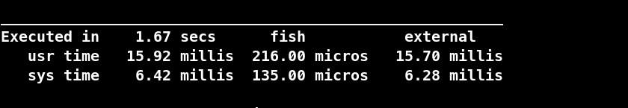
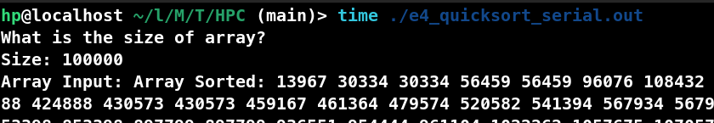
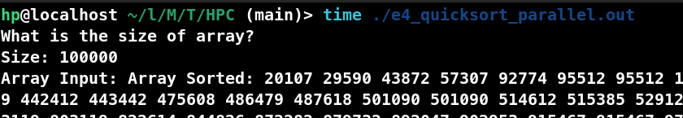
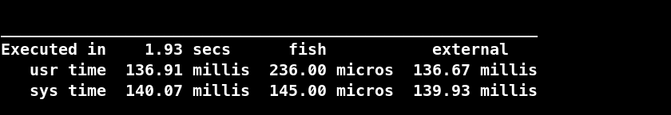
500k records:
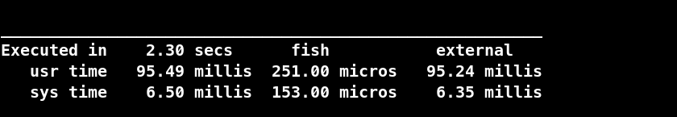
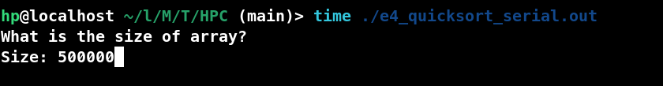

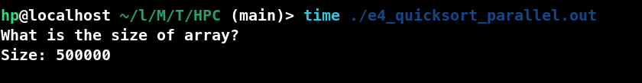
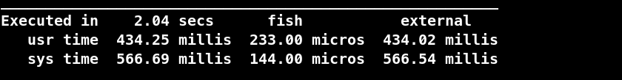
1 Million Records:
Serial:

Parallel:
