Skills System Design Document

1. Background & Goals

1.1 Current Situation & Problems
The current Playground provides basic multi-model conversational capabilities, but has notable limitations in professional task scenarios: output quality is highly dependent on individual users’ prompt-writing skills, leading to inconsistent results for the same task across different users; high-quality prompts and workflows remain trapped in single conversations and cannot be reused, while team domain knowledge (coding standards, review criteria, document templates) lacks a systematic mechanism for organization and sharing; complex tasks involving multi-step tool invocations lack orchestration capabilities, forcing users to either operate step-by-step manually or maintain unwieldy System Prompts.

1.2 Solution Overview
Introduce Skills — a pluggable prompt + toolchain enhancement mechanism that packages task-specific professional instructions, execution workflows, and tool permissions into standardized, reusable units.
Core logic: User intent → Auto-match appropriate Skill → Load instructions into context on demand → LLM executes according to instructions and invokes authorized tools.
Skills do not replace the existing System Prompt and tool invocation capabilities. Instead, they add a task-level knowledge encapsulation and orchestration layer on top. General conversations remain unaffected — enhanced capabilities activate only when a request matches a specific skill.

1.3 Expected Benefits
- Task quality consistency: Standardized execution instructions eliminate output quality variations caused by differences in users’ prompt-writing abilities.
- Token efficiency: Progressive loading avoids injecting all skills at once, significantly reducing context consumption.
- User efficiency: Users no longer need to write professional prompts from scratch — matching a skill delivers expert-level output.
- Knowledge retention: Solidifies team domain expertise, standards, and best practices into reusable, iterable skill assets.

1.4 Project Scope
Included in this project:
- Skill definition specification, storage, and lifecycle management
- Three-level progressive loading mechanism (L1 metadata / L2 instructions / L3 resources)
- Two trigger modes: automatic matching and manual invocation
- Tool permission control mechanism
- Skill Creator (with AI-assisted generation) and Skill Management UI
- Initial seed set of built-in skills (Code Review, PRD generation, etc. — 5–8 skills)

2. Core Concepts

2.1 What Is a Skill
A Skill is an independent, on-demand capability unit that can be loaded by the LLM. It packages task-specific professional instructions, tool permissions, and reference materials into a standardized structure, allowing the LLM to consult it like a professional manual on demand, rather than stuffing all knowledge into the context at once.
An intuitive analogy: if the System Prompt is the LLM’s “job description,” then a Skill is a “task-specific operating manual” — opened only when a relevant task arrives, and closed once complete.

2.2 Skill Composition
Each Skill is logically composed of three layers of content:
Metadata (Identity & Configuration)
Lightweight descriptive information about the skill, fully loaded at system startup for indexing and matching. Core fields include:
- name: Unique identifier, e.g. code-review, prd-generator
- description: Functional description, used directly for automatic matching of user intent; its quality determines trigger accuracy
- allowed-tools: Whitelist of tools the skill is authorized to invoke, e.g. ["read-file", "grep"]
- scope: Hierarchy level (user / project / organization)
Execution Instructions (Operating Manual)
Detailed task instructions in Markdown format, including operational steps, judgment criteria, and output format requirements. This is the core value of a Skill — it codifies expert-level prompt engineering experience into a reusable standard process. Loaded into context only when the skill is activated; a single skill’s instructions should be kept under 5,000 tokens.
Auxiliary Resources (Reference Materials)
Supporting files that may be referenced during execution, categorized into three types:
- reference: Documentation (API specs, coding standards, domain knowledge manuals)
- script: Helper scripts (data processing, format conversion automation)
- template: Template files (document templates, report templates, output format examples)
Resources are loaded on demand during execution to avoid occupying excessive context space upfront.

2.3 Relationship with Playground
Skills serve as a task-level enhancement layer on top of Playground’s existing conversational capabilities, without altering the underlying architecture. Playground’s System Prompt, model selection, multi-turn conversation, and other foundational capabilities remain unchanged. Skills integrate as an add-on module — the L1 skill catalog is appended to the end of the System Prompt, and execution instructions are injected as additional context into the conversation flow. The entire process is fully transparent to conversations that do not involve skills. Users need not change their existing usage habits; enhanced capabilities activate only when a request matches a specific skill.

3. Architecture Design
A Skill goes through five stages from creation to execution: created and saved to the skill library, discovered and matched when a user makes a request, activated by loading execution instructions, executed by the LLM following the instructions, and usage data recorded for continuous optimization.

3.1 Three-Level Progressive Loading
Core principle: rather than stuffing all skill content into the context at once, load in layers on demand, paying only the necessary token cost for the current task.

Level | Content Loaded | When Loaded | Token Cost
L1 Metadata | Skill name + description | Fully loaded at startup, injected into System Prompt | ~100 tokens/skill
L2 Instructions | Complete Markdown execution instructions | When skill is activated, via load_skill() | <5,000 tokens/skill
L3 Resources | Reference docs, scripts, templates, etc. | During execution, via load_skill_resource() on demand | Varies by file size

Efficiency comparison: Injecting all 50 skills costs ~150K tokens/turn; with progressive loading, L1 overhead is ~5K tokens, and only the 2–3 skills actually invoked enter L2, reducing token consumption by over 90%.

3.2 Skill Matching & Triggering
Automatic trigger (primary path): After receiving the user’s request, the LLM autonomously determines whether to activate a skill based on skill descriptions in the L1 catalog. The quality of the description directly determines matching accuracy — descriptions should cover multiple phrasings of the same task (e.g. “code review”, “CR”, “PR review”).
Manual invocation (supplementary path): Users specify a skill explicitly via slash commands (e.g. /code-review), bypassing matching and activating directly.
Multi-skill scenarios: The current version activates only one skill per conversation turn. If a user’s request spans the capabilities of multiple skills, the LLM should select the most relevant one or guide the user to split into separate requests. Multi-skill composition (instruction merging, permission merging, budget allocation) is planned for a subsequent iteration.

3.3 Context Budget Management
All Skills content ultimately enters the conversation context and must be subject to unified token budget management. The context window is divided into three zones:
- Base zone: System Prompt + L1 catalog, approximately 5K–8K tokens
- Conversation zone: Multi-turn history of user messages and LLM responses, occupying the majority of the window
- Skill zone: L2 instructions + L3 resources, recommended upper limit of 20% of total window
Before each L2/L3 load, the system checks the remaining skill zone budget. If insufficient, it prioritizes unloading content from completed tasks; if still not enough, it rejects the load and notifies the user. The current budget status is also injected into the System Prompt so the LLM can independently weigh whether to load additional resources.

3.4 Multi-Level Storage & Priority
Level | Use Case | Example
Organization | Company-wide standards and compliance requirements | Security review standards, data compliance checks
Project | Team shared capabilities, tied to project configuration | Project coding standards, deployment processes
User | Personal workflows, visible only to the individual | Personal writing style, code review preferences

When skills with the same name exist at multiple levels, they are overridden by priority: Organization > Project > User, ensuring enterprise compliance requirements cannot be bypassed by personal preferences. The user’s effective skill set = the union of all three levels, deduplicated according to the override rules.

3.5 Integration with the Conversation API
Skills are embedded into the existing conversation flow through two integration points, minimizing changes to the existing API:
System Prompt injection: Append the L1 skill catalog to the end of the existing System Prompt, informing the LLM of available skills and usage instructions.
Tool function registration: Add load_skill(skill_name) and load_skill_resource(skill_name, resource_name) to the existing tool list. The LLM invokes them via the standard tool-use protocol, requiring no new invocation mechanism.

Typical invocation chain:
User: "Review this Python file"
→ LLM reads L1 catalog, identifies code-review skill
→ Calls load_skill("code-review") to get review instructions (L2)
→ Calls read-file per instructions to read the uploaded file
→ Reviews against each checklist item
→ Calls load_skill_resource("code-review", "style-guide") to load team standards (L3)
→ Outputs structured review report

Throughout this process, the conversation API’s request/response format, streaming output, and message history management remain unaffected.
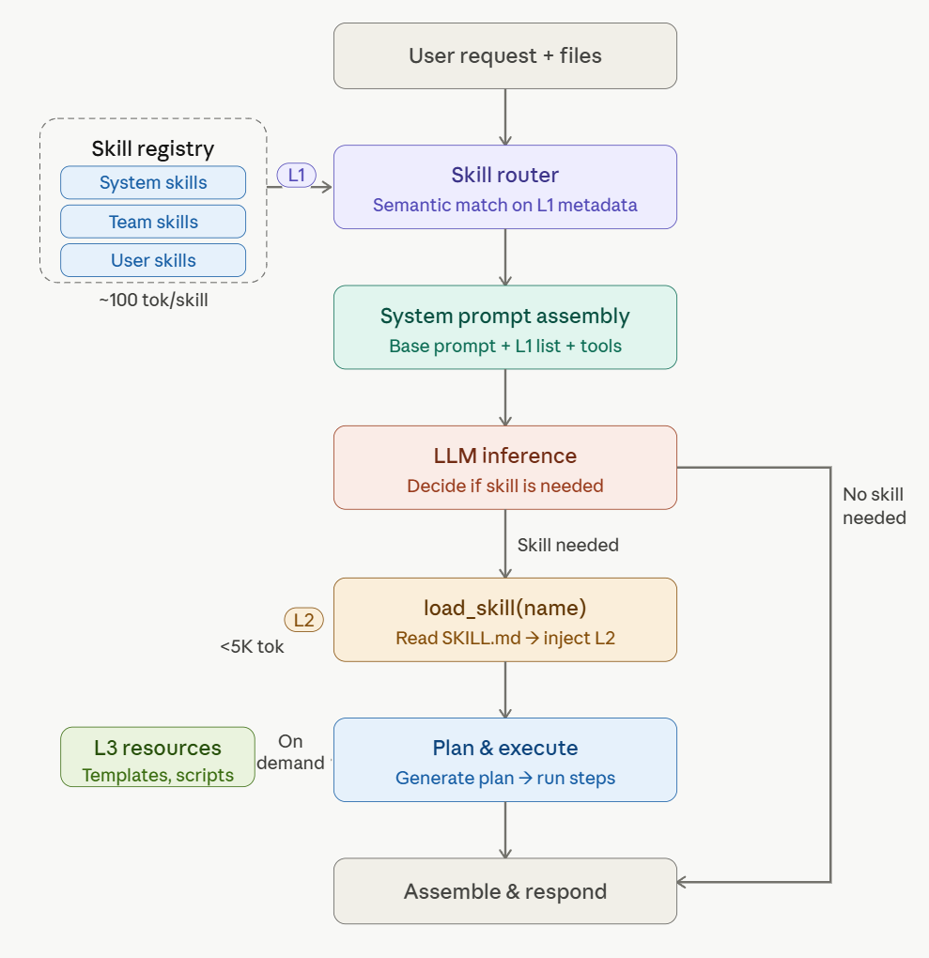

4. Data Model

4.1 Table Schema
Skills table (skills)
Stores skill metadata and execution instructions. The core table of the entire system.

Field | Type | Description
id | TEXT PK | Unique identifier
name | TEXT UNIQUE | Skill identifier, e.g. code-review
description | TEXT | Functional description, used for L1 matching
content | TEXT | Markdown execution instructions (L2)
allowed_tools | JSON | Tool whitelist, e.g. ["read-file", "grep"]
scope | TEXT | user / project / organization
project_id | TEXT | Associated project (required when scope = project, null otherwise)
enabled | BOOLEAN | Enabled status
created_by | TEXT | Creator
created_at | TIMESTAMP | Creation time
updated_at | TIMESTAMP | Last update time

Skill resources table (skill_resources)
Stores L3 auxiliary resources, linked to skills via skill_id.

Field | Type | Description
id | TEXT PK | Unique identifier
skill_id | TEXT FK | Associated skill
name | TEXT | Resource identifier, e.g. style-guide.md
type | TEXT | reference / script / template
content | TEXT | Resource content
created_at | TIMESTAMP | Creation time
 |  | UNIQUE(skill_id, name)

User skill settings table (user_skill_settings)
Stores per-user enable/disable configuration, decoupled from the global enabled flag on the skills table.

Field | Type | Description
user_id | TEXT | User identifier
skill_id | TEXT FK | Associated skill
enabled | BOOLEAN | Whether this user has enabled the skill
 |  | PK(user_id, skill_id)

4.2 Design Notes
Database selected as storage solution. This is a multi-user internal Playground requiring permission isolation by user/project/organization, search and analytics support, and data consistency across multi-instance deployments. File system synchronization and permission management costs are prohibitively high for these scenarios. Import/export capability in SKILL.md format is retained for importing skills from external ecosystems.
allowed_tools uses a JSON column rather than a join table. Tool whitelists are typically short (3–5 items) and always read as a whole — no need for per-tool queries or aggregation. A JSON column is simpler for reads and writes, avoiding an extra JOIN.
Table schema is intentionally minimal. Version management (skill_versions) and usage statistics (skill_usage_logs) tables are not required for Phase 1 and are recommended for introduction when Phase 2 capabilities go live.

5. Key Module Design

5.1 Skill Creator
Skill Creator is the entry point for users to create custom skills:
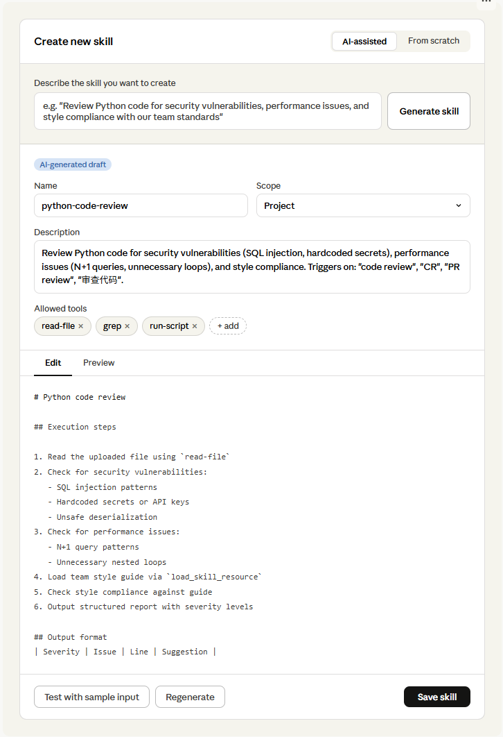

AI-assisted generation: Users describe desired functionality in natural language, and the system invokes an LLM to automatically generate a skill draft, including name, description, allowed_tools, and execution instruction body. The generated result populates the editing area for users to review and modify. Supports Regenerate for rapid iteration.
Manual authoring: All fields start empty; users fill in from scratch. Suited for users with a clear plan for skill structure.
Editing area (shared by both modes): Metadata form (name, description, allowed-tools) on top; Markdown editor (with Edit/Preview toggle) below for writing execution instructions. Tool selection is displayed as pill tags, chosen from the system’s registered tool list.
Test & verify: A “Test with sample input” feature at the bottom lets users enter a simulated request. The system constructs a prompt using the current edit content (no save required) and invokes the LLM, displaying the complete invocation chain — whether load_skill was triggered, how many tokens were consumed, and the final output. Users can verify skill effectiveness before saving.

Related APIs: See Chapter 6.

5.2 Skill Management
Skill Management is the module for users to view, configure, and maintain existing skills, consisting of a skill list and skill detail panel.
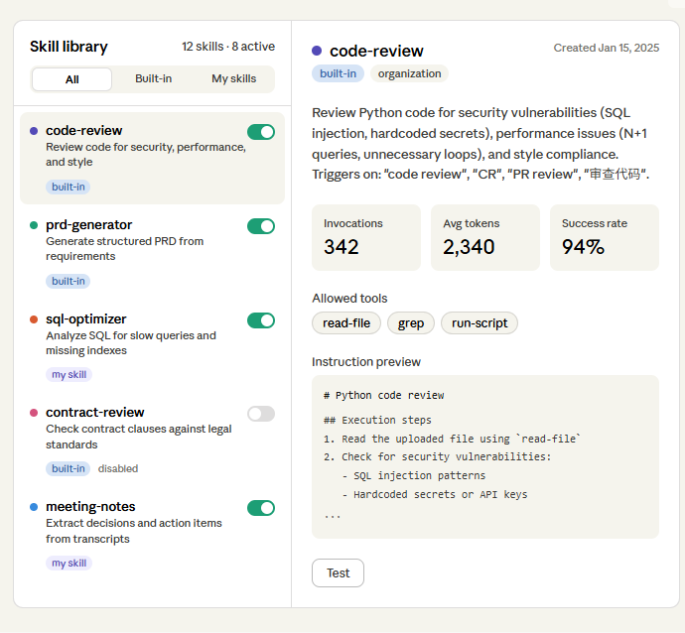

Skill list: Displays total skill count and currently active count at the top. Provides All / Built-in / My Skills filter tabs. Each skill card includes name, description summary, scope tag, and an enable/disable toggle. After toggling, the next conversation’s L1 catalog updates immediately; disabled skills are invisible to the LLM.
Skill detail: Clicking a card expands full information: basic info (full name, scope, complete description, creation date), usage statistics (invocation count, average token consumption, success rate), tool permissions (allowed-tools shown as pill tags), and instruction preview (read-only code block showing the first few lines).

Management actions:
Action | Description | Built-in | My Skill
Edit | Enter editing page to modify metadata and instructions | N/A | Available
Test | Open test panel to verify skill effectiveness | Available | Available
Delete | Delete skill | N/A | Available

Related APIs: See Chapter 6.

5.3 Execution Process Visualization
After a user submits a request, skill matching, loading, and execution involve multiple tool calls. The frontend should optimize the waiting experience.
Step progress bar: The frontend identifies tool call events in the streaming output and displays a step progress bar showing the current execution stage in real time:

✓ Matched skill: code-review
✓ Loaded execution instructions (2,340 tokens)
✓ Read file: main.py
◉ Executing review...
○ Generate report

Each step can be expanded to view details (which skill was loaded, token consumption, which tools were called), providing observability for skill tuning.
Implementation: Built on top of the existing tool_use events in streaming output, the frontend adds an event parsing and UI mapping layer — no additional backend endpoints required. Phase 1 delivers a basic version (step names only); expanded details and token statistics are refined in subsequent iterations.

6. API Design
All endpoints from the modules above are consolidated here, grouped by function. All endpoints follow the existing Playground RESTful conventions and authentication mechanisms.

6.1 Skill CRUD
Method | Path | Description
GET | /api/skills | Get skill list, supports ?scope=builtin|my filter
GET | /api/skills/:id | Get skill details, including instructions, resources, and usage stats
POST | /api/skills | Create skill. Body: { name, description, content, allowed_tools }
PUT | /api/skills/:id | Update skill (own skills only). Body same as create
DELETE | /api/skills/:id | Delete skill (own skills only)

6.2 Skill Configuration
Method | Path | Description
PUT | /api/skills/settings | Update enable/disable status. Body: { skill_id, enabled }

6.3 AI Assistance & Testing
Method | Path | Description
POST | /api/skills/generate | AI-generate skill draft. Body: { description }. Returns: { name, description, content, allowed_tools }
POST | /api/skills/:id/test | Test saved skill. Body: { prompt, files? }
POST | /api/skills/test | Test unsaved draft. Body: { prompt, draft_content, files? }

6.4 Skill Resources
Method | Path | Description
GET | /api/skills/:id/resources | Get skill’s resource list
POST | /api/skills/:id/resources | Add resource. Body: { name, type, content }
PUT | /api/skills/:id/resources/:rid | Update resource
DELETE | /api/skills/:id/resources/:rid | Delete resource

6.5 LLM Tool Functions
The following two interfaces are not exposed directly to the frontend. They are registered as tool-use tools in the LLM invocation chain, invoked autonomously by the LLM during inference.

Tool Name | Parameters | Description
load_skill | skill_name: string | Returns the specified skill’s complete execution instructions (L2)
load_skill_resource | skill_name: string, resource_name: string | Returns the specified skill’s auxiliary resource content (L3)

7. Implementation Plan

Phase 1: Core Capabilities & User-Created Skills (Est. 6 weeks)
Goal: Complete the full pipeline and enable user skill creation. Validate architecture with built-in skills; validate user value with user-created skills.
Deliverables:
- Database schema (skills, skill_resources, user_skill_settings)
- L1/L2/L3 loading mechanism; load_skill and load_skill_resource tool functions integrated into conversation API
- Dynamic L1 skill catalog injection into System Prompt
- Skill Management UI (list, details, enable/disable)
- Skill Creator full functionality (AI-assisted generation + manual authoring + test verification)
- Context budget management (skill zone token cap enforcement)
- 5–8 built-in seed skills (Code Review, PRD generation, SQL optimization, etc.)
- Basic execution process step bar

Acceptance criteria: When a user submits a request, the system can automatically match and load a skill to complete the task. Users can create custom skills via Skill Creator, save after testing, and trigger them in the next conversation.

Phase 2: Multi-Skill Composition (Est. 4 weeks)
Goal: Support activating multiple skills collaboratively in a single conversation turn, covering cross-domain composite task scenarios.
Dependency: Phase 1 completed.
Deliverables:
- Multi-skill matching and ranking mechanism (expanding from top-1 to top-N candidates)
- Instruction merging strategy (concatenation order and conflict resolution for multiple L2 instructions)
- Tool permission merging rules (union set; higher-priority skill takes precedence on conflicts)
- Context budget allocation (token quota distribution across multiple skills)
- Execution chain visualization upgrade (displaying multi-skill parallel/sequential execution)

Acceptance criteria: When a user’s request involves multiple skills (e.g. “Review this PR and generate API docs”), the system can automatically identify and sequentially load and execute the relevant skills, producing merged results.

Appendix

A. High-Value Skill Scenario Examples
The following typical scenarios are organized by business function — they share common traits: fixed processes, repeated use, reliance on internal standards, and need for tool support.
Engineering
- API documentation generation: Read interface definitions from code and automatically generate OpenAPI specification documents, keeping docs in sync with code.
- SQL review & optimization: Analyze SQL statements, identify slow queries, missing indexes, and full table scans, and provide optimization suggestions.
Product & Project Management
- PRD generation: Generate structured product requirements documents from requirement descriptions, following the company’s unified template (background, user stories, acceptance criteria, technical constraints).
- Meeting notes organization: Extract key decisions, action items, and owners from meeting transcript text, outputting standardized meeting minutes.
Data Analysis
- Data report interpretation: Upload CSV/Excel files for automated data cleaning, descriptive statistics, trend analysis, generating visualizations and written insights.
- Competitive analysis reports: Generate analysis reports following the company’s unified framework (feature comparison, pricing strategy, market positioning, SWOT).
Compliance & Legal
- Contract review: Check contract clauses against company legal standards, flag risk items (liability limitations, penalties, IP ownership), distinguishing Blockers from Warnings.
- Data compliance check: Verify whether data processing workflows comply with GDPR / personal data protection requirements, generating compliance checklists.
Daily Assistance
- Summarization: Extract core content from video and document URLs.
- Multilingual translation & localization: Translate according to company glossaries and style guides, maintaining professional terminology consistency.

B. Skill Suitability Criteria
Scenarios well-suited for Skills typically meet all of the following conditions:
- Has a fixed process or standard — clear steps, not open-ended Q&A
- Used repeatedly — daily or periodic work, not one-off tasks
- Depends on domain knowledge — requires internal company standards, templates, or terminology that generic prompts cannot cover
- Requires tool support — not just text generation, but also file reading, data querying, script execution, etc.

Scenarios NOT suited for Skills:
- General open-ended Q&A — “polish this paragraph” or “explain this concept” — basic conversational capability suffices
- One-off tasks — used once and never again; packaging cost exceeds benefit
- No fixed standard — no reference standard or template; output depends entirely on case-by-case judgment
- Pure text generation — no tool invocation, file reading, or external data involved; Skill’s orchestration value is limited

