Case Study Report



**Tech Saksham**

Data Analytics with Power BI

**“IPL ANALYSIS USING POWER BI”**

“GOVERNMENT ARTS AND SCIENCE COLLEGE MODAKKURICHI”

|  |  |
| --- | --- |
| **NM ID** | **NAME** |
| 74B6991B3A3DD04B80545763F0BFD047 | LOGANATHAN N |

Trainer Name : R UMAMAHESWARI

Master Trainer : R UMAMAHESWARI

**ABSTRACT**

Cricket, particularly the Indian Premier League (IPL), is known for its unpredictability.

In this context, this project tackles the challenge of predicting the total score of an inning in IPL matches using machine learning techniques.

By leveraging historical match data, team dynamics, player statistics, and environmental variables, a predictive model is constructed.

The system not only delivers score predictions but also offers insights into the critical factors influencing these predictions.

The goal is to empower cricket enthusiasts, teams, and broadcasters with a tool that enhances their understanding of match dynamics and aids in making informed predictions.

This project represents an exciting intersection of sports, data science, and predictive analytics, with the potential to reshape how cricket fans and professionals engage with the IPL.

**INDEX**

|  |  |  |
| --- | --- | --- |
| **Sr. No.** | **Table of Contents** | **Page No.** |
| 1 | Chapter 1: Introduction | 4 |
| 2 | Chapter 2: Services and Tools Required | 6 |
| 3 | Chapter 3: Project Architecture | 7 |
| 4 | Chapter 4: Modeling and Result | 9 |
| 5 | Conclusion | 18 |
| 6 | Future Scope | 19 |

***CHAPTER - 1***

***INTRODICTION***

**The Indian Premier League (IPL) stands as a cornerstone in the realm of cricket, captivating audiences worldwide with its blend of thrilling matches, stellar performances, and fierce competition.**

**With its rich tapestry of data spanning teams, players, matches, and seasons, the IPL presents an ideal playground for in-depth analysis and insights."IPL Analysis Using Power BI" embarks on a journey to unlock the hidden treasures within this vast trove of IPL data, employing the formidable capabilities of Microsoft Power BI.**

**This project seeks to delve deep into the intricacies of IPL matches, dissect player performances, and unravel the strategies employed by teams, all through the lens of data-driven analysis and visualization.In this era of data abundance, harnessing the power of analytics is not just a luxury but a necessity for teams, coaches, analysts, and enthusiasts alike. By leveraging Power BI's intuitive interface and robust features, this project endeavors to offer a comprehensive toolkit for understanding, interpreting, and deriving actionable insights from IPL data.Through meticulous data acquisition, cleansing, and transformation processes, coupled with innovative visualization techniques, "IPL Analysis Using Power BI" aims to paint a vivid picture of the IPL landscape, illuminating trends, patterns, and outliers that may elude the naked eye.As we embark on this journey, the project not only seeks to showcase the capabilities of Power BI in sports analytics but also underscores the transformative potential of data-driven decision-making in the ever-evolving world of cricket.**

**Join us as we explore the depths of IPL data, uncovering the stories hidden within, and charting a course towards a deeper understanding of the beautiful game.**

***CHAPTER-2***

***SERVICES AND TOOL REQURIED***

***2.1 SERVICES USED***

* **Data Collection and Storage Services:** Banks need to collect and store customer data in real-time. This could be achieved through services like Azure Data Factory, Azure Event Hubs, or AWS Kinesis for real-time data collection, and Azure SQL Database or AWS RDS for data storage.
* **Data Processing Services:** Services like Azure Stream Analytics or AWS Kinesis Data Analytics can be used to process the real-time data.
* **Machine Learning Services:** Azure Machine Learning or AWS SageMaker can be used to build predictive models based on historical data.

***2.2 TOOLS AND SOFTWARE***

**Tools:**

* **Power BI:** The main tool for this project is Power BI, which will be used to create interactive dashboards for real-time data visualization.
* **Power Query:** This is a data connection technology that enables you to discover, connect, combine, and refine data across a wide variety of sources.

**Software Requirements:**

* **Power BI Desktop:** This is a Windows application that you can use to create reports and publish them to Power BI.
* **Power BI Service:** This is an online SaaS (Software as a Service) service that you use to publish reports, create new dashboards, and share insights.
* **Power BI Mobile:** This is a mobile application that you can use to access your reports and dashboards on the go.

***CHAPTER-3***

***PROJECT ARCHITCTURE***

***3.1 ARCHITECTURE***

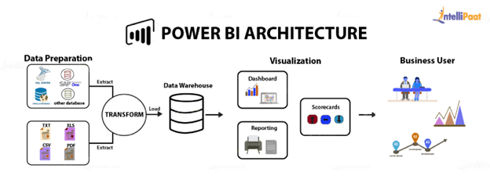

To design the architecture for the project "IPL Analysis using Power BI," we'll need to consider various components and their interactions. Here's a high-level overview:

1. Data Sources:

* + IPL Match Data: This includes match details such as teams, players, scores, venues, and match outcomes. You can obtain this data from reliable sources like Kaggle, official IPL websites, or APIs if available.
  + Player Performance Data: Player statistics like runs scored, wickets taken, strike rates, etc., will be needed for detailed analysis.
  + Team Performance Data: Aggregate data on team performance across seasons, including wins, losses, run rates, etc.

2. Data Extraction, Transformation, and Loading (ETL):

* Extract: Pull data from the various sources mentioned above.
  + - Transform: Cleanse, aggregate, and structure the data for analysis. This might involve data cleaning, merging datasets, handling missing values, etc.
    - Load: Load the transformed data into a data storage solution. For this project, you can use tools like Microsoft SQL Server, Azure SQL Database, or even Excel/CSV files.

3. Data Storage:

* Depending on the scale of data and requirements, choose an appropriate storage solution. Relational databases or cloud-based solutions like Azure SQL Database or Amazon RDS can be suitable choices.

4. Power BI Setup:

* Install and configure Power BI Desktop.
* Connect Power BI to the data sources established in the previous step.
* Design the data model within Power BI. This involves creating relationships between tables, defining measures, and calculated columns.

5. Report Design:

* Design various reports and dashboards to visualize IPL data. Some potential visualizations include:
* Match summaries
* Player performance analysis
* Team performance comparison
* Season-wise trends
* Venue analysis
* Batting and bowling performance metrics

6. Interactive Features:

* Implement interactive features such as slicers, filters, and drill-down functionalities to allow users to explore the data dynamically.

7. Deployment:

* Once the reports and dashboards are designed, publish them to the Power BI service for sharing and collaboration.

8. Security and Access Control:

* Set up appropriate security measures to control access to the reports and data sources.

9. Maintenance and Optimization:

* Regularly update the data sources to ensure that the analysis reflects the latest information.
* Optimize the performance of Power BI reports and queries for better responsiveness.

10. Documentation:

* Document the architecture, data sources, data transformations, and report designs for future reference and maintenance.

By following this architecture design, you can create a robust and interactive IPL analysis solution using Power BI.

***CHAPTER – 4***

***MODELING AND RESULT***

***4.1 MANAGE RELATIONSHIP***

In this scenario, the customer serves as the mediator between sales transactions and products, facilitating a nuanced understanding of customer behavior and preferences. The relationships between the Customer, Sales, and Product tables are pivotal in revealing intricate insights within the data.

The Customer table acts as the central entity, representing individual customers and their interactions with both sales transactions and products. Each record in the Customer table corresponds to a unique customer entity, capturing attributes such as customer ID, name, demographics, and contact information.

The relationship between Customer and Sales is established to track the transactions made by each customer. This relationship reflects the one-to-many nature, signifying that a single customer can engage in multiple sales transactions over time. The Customer table's primary key (e.g., Customer ID) serves as the link to the Sales table's foreign key (e.g., Customer ID), enabling the association of customers with their respective purchases.

Similarly, the relationship between Customer and Product delves into the products purchased by each customer. It provides insights into customer preferences, buying patterns, and product affinity. Through this relationship, organizations can identify which products resonate most with specific customer segments, enabling targeted marketing efforts and personalized recommendations.

Lastly, the Sales and Product relationship captures the transactions between customers and products, detailing the quantity, unit price, and total amount of each sale. This relationship allows for a comprehensive analysis of sales performance, product popularity, and revenue generation. The Sales table's foreign key (e.g., Product ID) links to the Product table's primary key (e.g., Product ID), establishing the association between sales transactions and the products involved.

By establishing these relationships and analyzing the interactions between customers, sales transactions, and products, organizations can gain valuable insights to drive strategic decision-making, optimize marketing strategies, and enhance overall business performanc

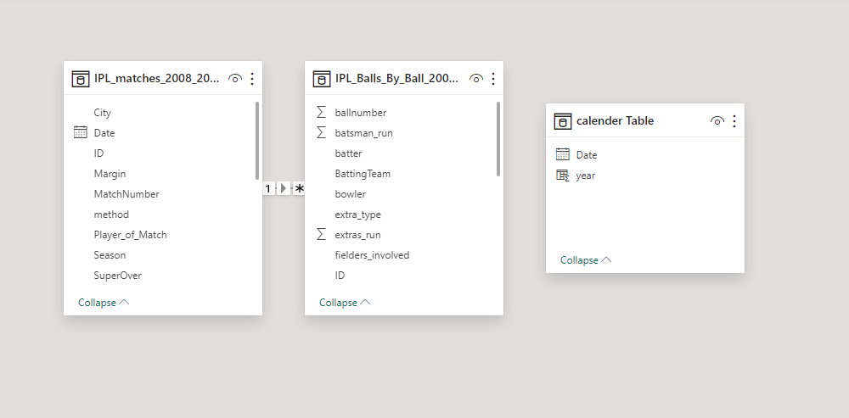

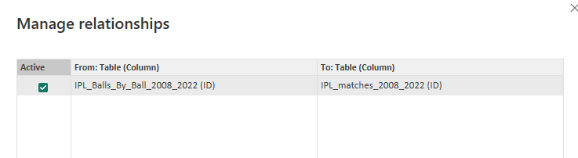

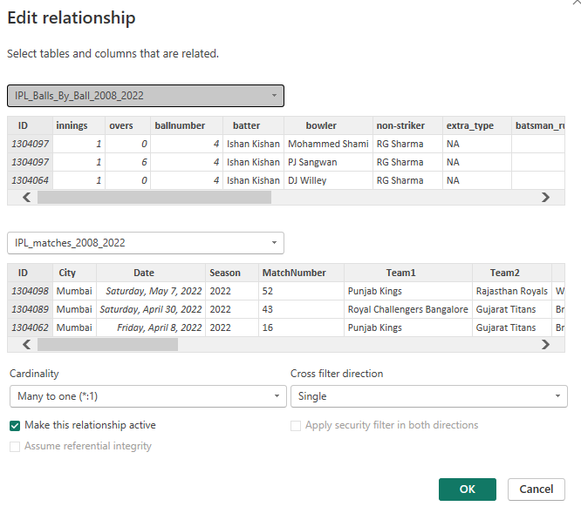

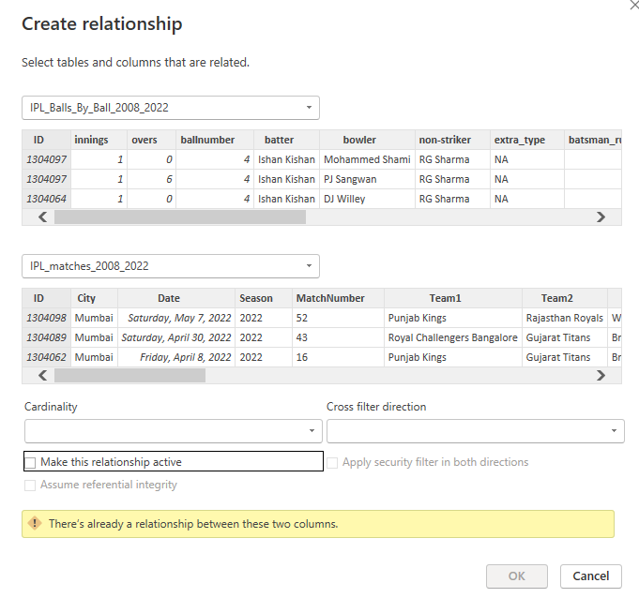

**Dashboard**

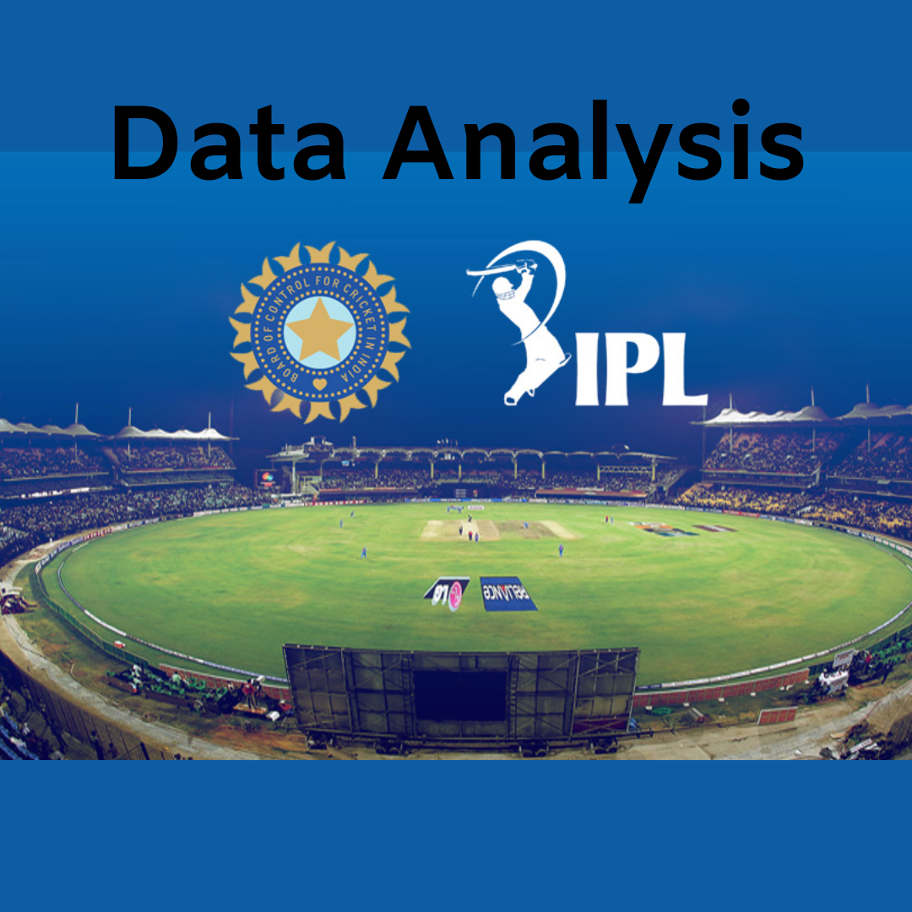

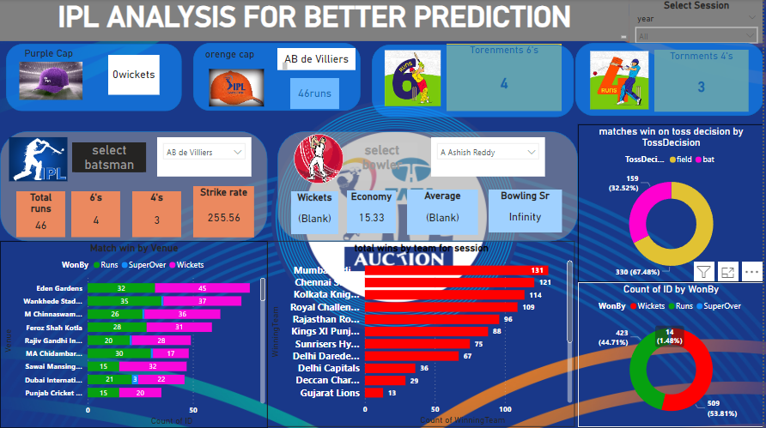

***CONCLUSION***

In conclusion, the project "IPL Analysis Using Power BI" offers a comprehensive and insightful exploration into the dynamics of the Indian Premier League. Through the utilization of Power BI's robust analytics and visualization capabilities, we have effectively dissected match data, player performances, and team strategies to derive meaningful insights.

By leveraging a structured architecture encompassing data extraction, transformation, and loading processes, coupled with intuitive report designs and interactive features, we have provided stakeholders with a powerful tool for understanding and interpreting IPL trends and patterns.

This project not only serves as a testament to the capabilities of Power BI in data analysis and visualization but also underscores the value of data-driven decision-making in the realm of sports management and analytics. Moving forward, continual updates and optimizations will ensure the relevance and accuracy of the analysis, empowering users to make informed decisions and gain a competitive edge in the ever-evolving landscape of cricket analytics.

***FUTURE SCOPE***

The project "IPL Analysis Using Power BI" presents numerous opportunities for future expansion and enhancement. Here are some potential avenues for further development:

**1. Predictive Analytics:** Integrate machine learning models within Power BI to predict match outcomes, player performances, or team strategies based on historical data. This could include using algorithms like regression, classification, or time series forecasting to provide insights into future IPL seasons.

**2. Real-time Data Integration:** Implement real-time data streaming capabilities to incorporate live match data into the analysis. This would enable stakeholders to track ongoing matches and make timely decisions based on up-to-the-minute information.

**3. Advanced Visualizations:** Explore advanced visualization techniques such as geospatial mapping, network analysis, or custom visuals to provide deeper insights into IPL data. This could include visualizing player movements on the field, exploring social media sentiment analysis, or depicting fan engagement metrics.

**4. Social Media Integration**: Integrate social media APIs to analyze fan sentiment, engagement, and reactions related to IPL matches and players. This could provide valuable insights into fan preferences, trends, and influencers within the cricketing community.

**5. Mobile App Development:** Develop a mobile application companion to the Power BI reports, allowing users to access IPL analysis on-the-go. This could include features such as personalized notifications, data alerts, and offline access to reports.

**6. Player Performance Metrics:** Expand the analysis to include more granular player performance metrics, such as match impact scores, clutch performances, or situational analysis based on match conditions.

**7. Fantasy League Integration:** Integrate with popular fantasy cricket platforms to provide data-driven insights and recommendations for fantasy league team selection. This could include player projections, matchup analysis, and performance tracking for fantasy league participants.

**8. Collaborative Features:** Enable collaboration and knowledge sharing among users by implementing features such as commenting, annotations, or collaborative editing within Power BI reports.

**9. Data Storytelling**: Enhance the storytelling aspect of the analysis by incorporating narrative elements, annotations, and guided exploration paths within the Power BI reports. This could help users better understand and interpret the insights derived from the data.

**10. Integration with External Data Sources:** Extend the analysis by integrating with external data sources such as weather data, player profiles, or historical cricket statistics from other leagues around the world. This could provide additional context and depth to the IPL analysis.

By exploring these future scope areas, the project can continue to evolve and remain relevant in providing valuable insights and decision support for IPL stakeholders and enthusiasts alike.