Free Crawler开发文档

引言
网页中有着许许多多的图片资源，传统的方式看到比较好的图片要一张一张的保存，带来诸多不便之处。所以，开发了一款专门有来抓取网页图片的工具（Free Crawler），以便能够快不的获取更多优秀的资源。
编写目的
以方便快捷的方式获取网页中的图片资源。
背景
以当前学习的知识做一个小小的实例，来巩固和提高Java知识的更深入的见解和补充，从而达到一个更高的水平点。

程序结构
功能描述
用户登录
实现类：LoginFrame.java
实现界面：
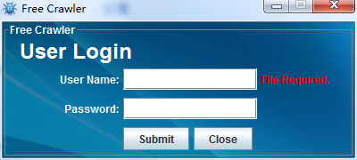
参数设置
实现类：ParamFrame.java
实现界面：
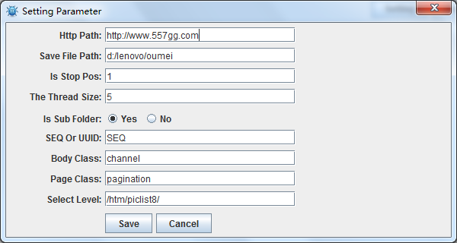
抓取线程与日志：
实现类：CrawlerFrame.java
实现界面：
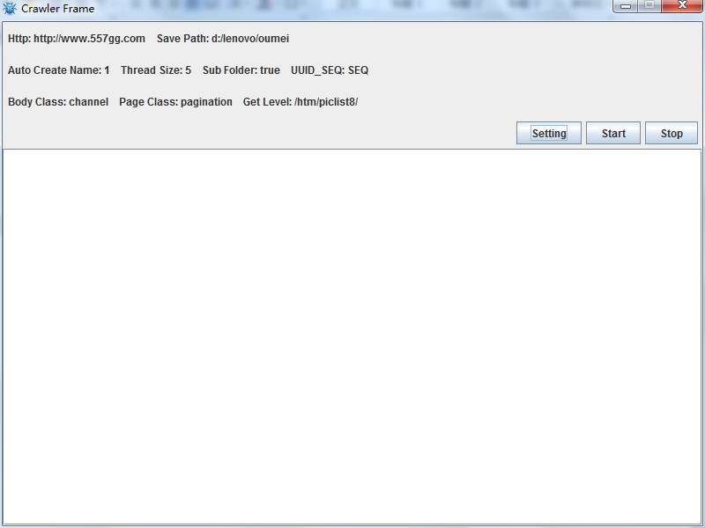

功能实现
登录校验：
public LicenseAction()
{
String hexStr = Util.readFileContent(Constant.LICENSE_PATH_FILE);
String keyStr = new String(Util.hexStringToBytes(hexStr));
try
{
license = Encrypt.decodeString(keyStr);
} catch (UnsupportedEncodingException e)
{
e.printStackTrace();
}
}

/**
* 检测登录是否成功
* @param name
* @param pwd
* @return
*/
public boolean check(String name,String pwd)
{
boolean isOk = true;
String cdate = Util.dateToStr(new Date(), "yyyyMMdd");
String[] lkey = license.split("\\|");
if(lkey!=null && lkey.length==3)
{
String wdate = lkey[2].split(":")[1];
if(cdate.compareTo(wdate)>0)
{
isOk=false;
}

String wname = lkey[0].split(":")[1];
if(!name.equals(wname))
{
isOk = false;
}

String wpwd = lkey[1].split(":")[1];
if(!pwd.equals(wpwd))
{
isOk = false;
}
}else
{
isOk = false;
}
return isOk;
}

网络抓取：

/**
* 抓取网页图片列表信息
* @throws ClientProtocolException
* @throws IOException
*/
private void saveFile() throws ClientProtocolException, IOException
{
HttpGet hget = new HttpGet(uri);
logger.info("Loading url:[" + uri + "] List For Images...");
console.log(Constant.LOG_PANEL_CRAWLER, "Loading url:[" + uri + "] List For Images...");
hget.setConfig(reqCfg);
HttpResponse response = hclient.execute(hget);
HttpEntity entity = response.getEntity();
String bodyStr = EntityUtils.toString(entity,"UTF-8");

// JSONP HTML
Document doc = Jsoup.parse(bodyStr);
Elements elst = doc.getElementsByClass(cfg.getPropStr(Constant.PROP_BODY_CLASS));
logger.debug("body list size:"+elst.size());
String http = cfg.getPropStr(Constant.PROP_URL);
if(http.endsWith("/"))
{
http = http.substring(0,http.length()-1);
}
for (Element el : elst)
{
Elements tmplst = el.getElementsByTag("li");
for(Element tmp : tmplst)
{
Elements alst = tmp.getElementsByTag("a");
if(alst!=null && alst.size()>0)
{
Element am = alst.get(0);
String href = am.attr("href");
if(!Util.isEmpty(href))
{
String url = http+href;
parseImageHtml(url);
}
}
}
}

}

/**
* 抓取图片网页信息
* @param uri
* @throws IOException
* @throws ClientProtocolException
*/
private void parseImageHtml(String uri) throws ClientProtocolException, IOException
{
HttpGet hget = new HttpGet(uri);
logger.info("Loading image list url:[" + uri + "]...");
console.log(Constant.LOG_PANEL_CRAWLER, "Loading image list url:[" + uri + "]...");
hget.setConfig(reqCfg);
HttpResponse response = hclient.execute(hget);
HttpEntity entity = response.getEntity();
String bodyStr = EntityUtils.toString(entity,"UTF-8");

String path = cfg.getPropStr(Constant.PROP_SAVE_PATH);
String folder = cfg.getPropStr(Constant.PROP_SUB_FOLDER);

// JSONP HTML
Document doc = Jsoup.parse(bodyStr);
Elements melst = doc.getElementsByTag("title");
String title = "";
if(melst!=null && melst.size()>0)
{
Element me = melst.get(0);
String txt = me.text();
title = Util.trim( Util.trim(txt).split("-")[0]);
}
if ("true".equalsIgnoreCase(folder) && !Util.isEmpty(title))
{
File fp = new File(path+File.separator+title);
if(!fp.exists())
{
fp.mkdirs();
}
path = fp.getAbsolutePath();
}

Elements elst = doc.getElementsByTag("img");
for(Element el : elst)
{
String src = el.attr("src");
if(Util.isEmpty(src))
{
continue;
}
parseImage(src,path);
}

}

/**
* 逐个图片保存
* @param uri
* @param path
* @throws ClientProtocolException
* @throws IOException
*/
private void parseImage(String uri, String path) throws ClientProtocolException, IOException
{
HttpGet hget = new HttpGet(uri);
logger.debug("Get Image Source uri:[" + uri + "]...");
hget.setConfig(reqCfg);
HttpResponse response = hclient.execute(hget);
HttpEntity entity = response.getEntity();

String name = "";
if ("UUID".equalsIgnoreCase(cfg.getPropStr(Constant.PROP_SEQ_UUID)))
{
name = UUID.randomUUID().toString() + ext_app;
} else
{
File fpath = new File(path);
File[] flst = fpath.listFiles();
if (flst == null)
{
name = Util.leftFillZero(String.valueOf(0), 5) + ext_app;
} else
{
name = Util.leftFillZero(String.valueOf(flst.length), 5) + ext_app;
}
}
logger.debug("The image name is:[" + name + "]....");
// 文件输出
OutputStream out = new FileOutputStream(path + File.separator + name);
byte[] tmp = new byte[1024 * 4];
int len = 0;
InputStream in = entity.getContent();
while ((len = in.read(tmp)) != -1)
{
out.write(tmp, 0, len);
}
in.close();
out.close();
}

运行
启动：
直接运行图片中run.bat文件即可。
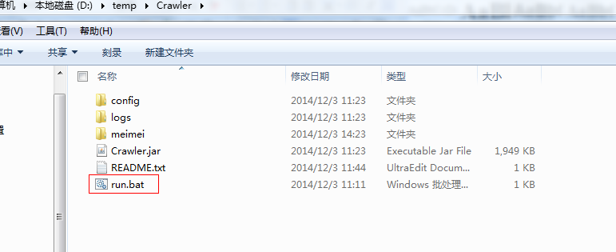

总结
能够基本实现一些网页图片的抓取。总得来说还是可以使用的啦。

