CYCLISTIC BIKE-SHARE
CASE STUDY ANALYSIS
How Do Annual Members and Casual Riders
Use Cyclistic Bikes Differently?

Prepared for: Lily Moreno, Director of Marketing
Cyclistic Marketing Analytics Team
Analysis Date: 2026-01-26
Data Period: Q1 2019 and Q1 2020

Executive Summary
This analysis examines 791,264 bike trips from Cyclistic's Q1 2019 and Q1 2020 data to understand how annual members and casual riders use the bike-share service differently. The goal is to inform marketing strategies to convert casual riders into annual members.
Key Finding: Casual riders take significantly longer trips (averaging 36.5 minutes) compared to members (11.4 minutes), suggesting different usage patterns: members primarily commute while casual riders use bikes for leisure.

1. Statement of the Business Task
Objective: Analyze Cyclistic historical bike trip data to understand how annual members and casual riders use bikes differently, in order to design targeted marketing strategies to convert casual riders into annual members.
Business Context: Cyclistic's finance analysts have determined that annual members are significantly more profitable than casual riders. Rather than targeting new customers, the marketing team believes there is a strong opportunity to convert existing casual riders—who are already aware of and using the service—into annual members.
Key Questions to Answer:
- How do annual members and casual riders use Cyclistic bikes differently?
- Why would casual riders buy Cyclistic annual memberships?
- How can Cyclistic use digital media to influence casual riders to become members?

2. Description of Data Sources
The analysis uses Cyclistic's historical trip data from two quarters:
- Divvy_Trips_2019_Q1: January-March 2019 (365,069 trips)
- Divvy_Trips_2020_Q1: January-March 2020 (426,887 trips)
Data Credibility (ROCCC):
- Reliable: Data is collected directly from Cyclistic's bike-share system
- Original: First-party data from Motivate International Inc.
- Comprehensive: Contains complete trip records with timestamps and user types
- Current: Data from recent quarters (Q1 2019 and Q1 2020)
- Cited: Public data available under license from Motivate International Inc.

3. Documentation of Data Cleaning
The following data cleaning and transformation steps were performed:

3.1 Data Harmonization
- Standardized column names between 2019 and 2020 datasets (different schemas)
- Mapped user types: 'Subscriber' → 'member', 'Customer' → 'casual'
- Combined datasets into unified format with 791,956 total records

3.2 Data Transformation
- Converted datetime strings to proper datetime objects
- Created ride_length column: calculated as (ended_at - started_at) in minutes
- Created day_of_week column: extracted from started_at (1=Sunday, 7=Saturday)
- Added hour and month columns for temporal analysis

3.3 Data Validation
- Removed 692 invalid rides (negative duration or over 24 hours)
- Final clean dataset: 791,264 rides

4. Summary of Analysis

4.1 User Distribution
Of the 791,264 rides analyzed:
User Type | Number of Rides | Percentage
Annual Members | 720,126 | 91%
Casual Riders | 71,138 | 9%

4.2 Ride Duration Analysis
The most striking difference between user types is ride duration:
Metric | Value
Member Average Duration | 11.4 minutes
Casual Rider Average Duration | 36.5 minutes
Difference | 25.1 minutes (219.6% longer)

4.3 Usage Patterns
Temporal Analysis by Day of Week:
- Members: Ride volume peaks on weekdays (Tuesday-Thursday), indicating commute usage
- Casual Riders: Higher proportion of weekend rides, especially Sunday, suggesting leisure usage
Hourly Patterns:
- Members: Clear commute peaks at 8AM and 5PM
- Casual Riders: More evenly distributed throughout the day, peaking in early-mid afternoon (2-4PM)

5. Supporting Visualizations and Key Findings

Finding 1: Members dominate total rides, but casual riders take much longer trips
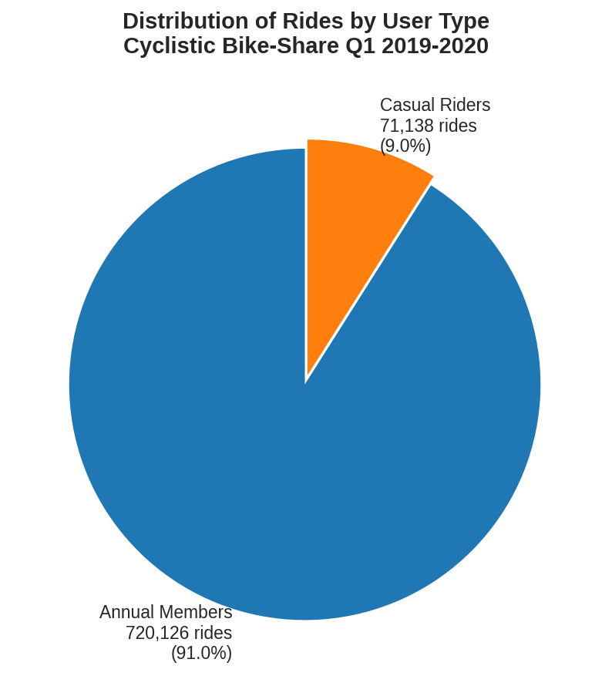
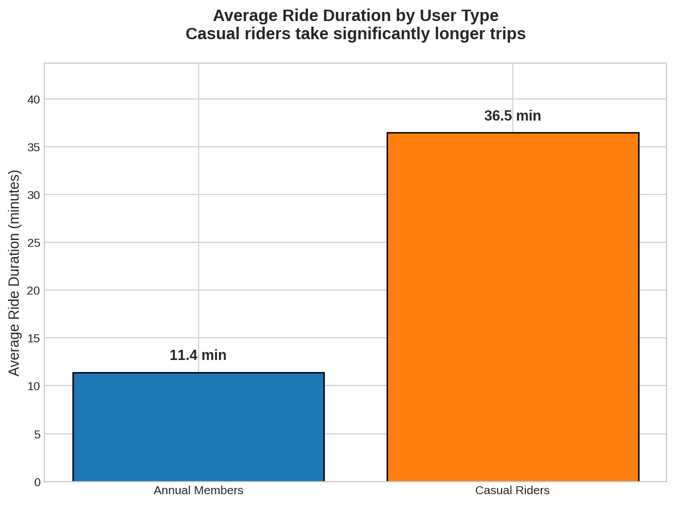

Finding 2: Members ride more on weekdays; casual riders increase on weekends
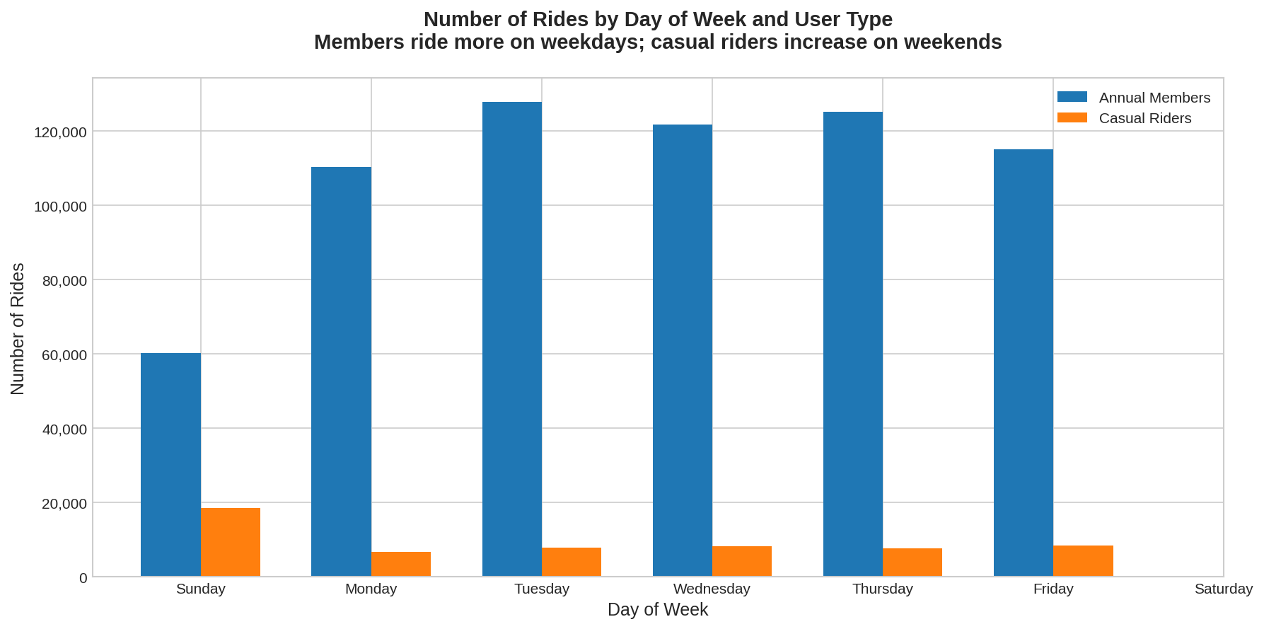

Finding 3: Casual riders take longer trips, especially on weekends
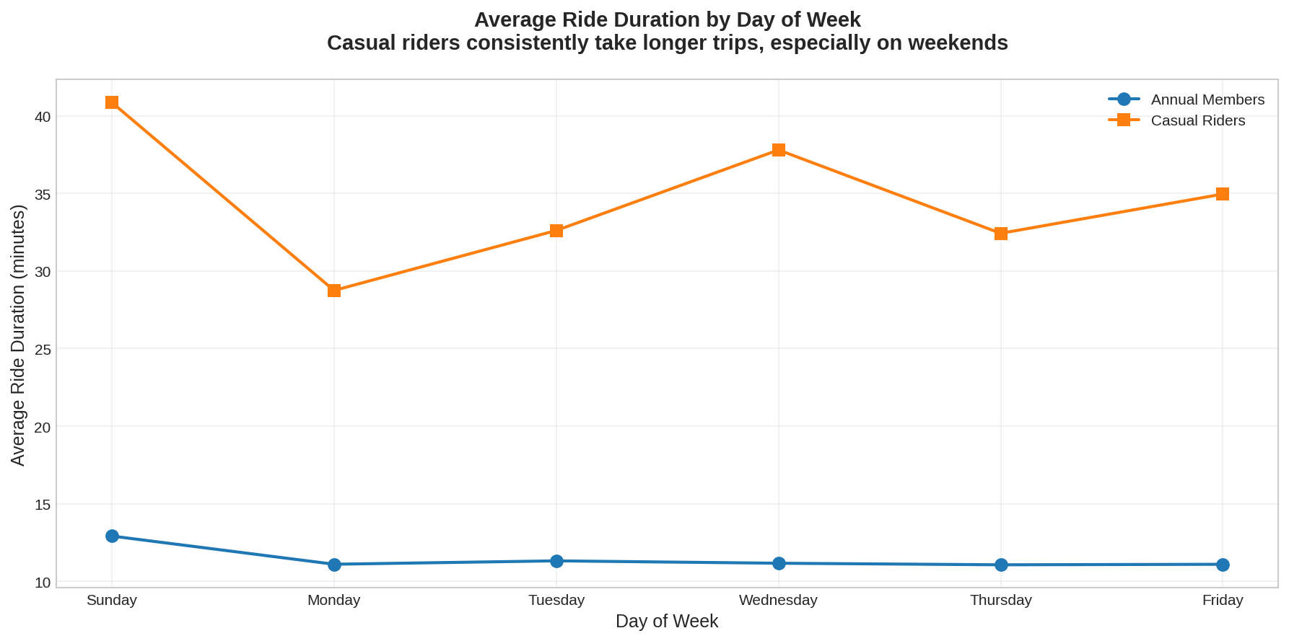

Finding 4: Members show clear commute patterns
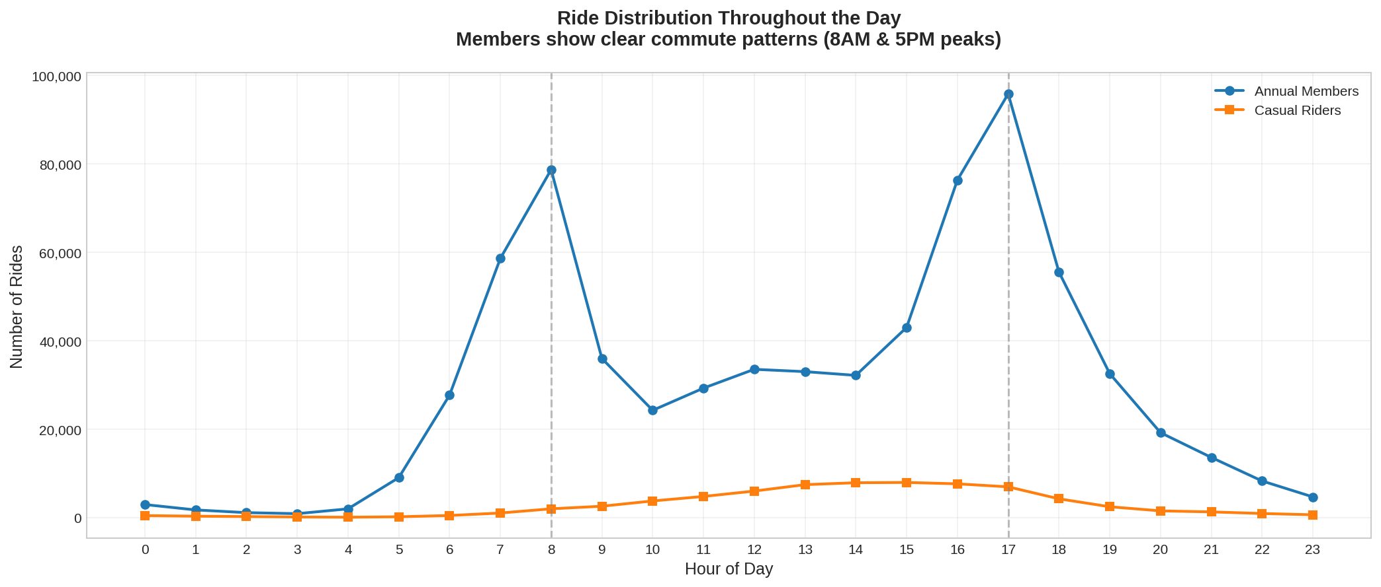
The hourly distribution clearly shows that members use bikes primarily for commuting (peaks at 8AM and 5PM), while casual riders have a more leisure-oriented pattern with gradual increase throughout the day.

6. Top Three Recommendations
Based on the analysis findings, here are three strategic recommendations to convert casual riders into annual members:

Recommendation 1: Weekend Membership Promotions
Rationale: Casual riders significantly increase their usage on weekends (especially Sundays) and take much longer trips. This indicates they are frequent users who could benefit from membership savings.
Action: Launch targeted weekend membership promotions that highlight cost savings for frequent weekend riders. Show clear ROI calculations: 'If you ride 3+ times per weekend, annual membership saves you $X per year.'

Recommendation 2: Commuter Benefits Partnership Program
Rationale: Members show clear commute patterns (8AM and 5PM peaks). Some casual riders may not realize how cost-effective membership is for daily commuting.
Action: Partner with local businesses to offer corporate membership discounts as employee benefits. Promote bike-share as an eco-friendly, cost-effective, and healthy commute alternative.

Recommendation 3: Digital Engagement and Cost Comparison Campaign
Rationale: Casual riders take trips that are 220% longer than members on average. This extended usage pattern means they are paying significantly more per ride than members would.
Action: Use targeted digital marketing (social media, email, app notifications) to show casual riders personalized cost comparisons based on their actual usage patterns. Create a 'membership calculator' feature in the app that shows potential savings.

Conclusion
The analysis reveals clear behavioral differences between annual members and casual riders. Members use Cyclistic primarily for short, routine commutes, while casual riders take longer trips that suggest recreational use. These insights provide a strong foundation for targeted marketing strategies.
The key opportunity lies in demonstrating value to casual riders: they are already frequent users who spend more time on bikes. By showing them the cost savings and convenience of annual membership—particularly for their weekend leisure rides—Cyclistic can effectively convert this engaged user base into profitable long-term members.
— End of Report —

