**Explore Anatomical Insights and body dynamics in dance (Kuchipudi) through Yoga**

Lakshmi Aparna Logisetti

Kuchipudi, University of Silicon Andhra

GKD507

Anupama Kailash

2nd Feb 2024

**Chapter One**

# **Anatomical Body Insights - Yoga – Kuchipudi**

## **Chapter 2.1: Anatomical Foundations of Dance**

Dance is the embodiment of rhythmic and expressive body movement, often orchestrated into a cohesive pattern. It's a form of artistic expression that transcends cultural boundaries and resonates deeply with human experience. The fundamental steps of dance are rooted in the basic movements of mankind, such as walking, running, jumping, hopping, and skipping. Over time, these movements have evolved into traditional dance steps, which are often stylized and incorporated into various dance forms including Kuchipudi.

Anatomy and the study of body movements play a crucial role in the creation of dance. Each limb, muscle, and organ are meticulously researched and studied, with a deep understanding of biomechanics and kinetics. This knowledge allows dancers to execute movements with precision, grace, and fluidity, enhancing the overall aesthetic and emotional impact of their performance

In the ancient Indian text NatyaShastra, the oldest known treatise on performing arts, detailed descriptions of body movements, known as "Angika Abhinaya," are provided. Every aspect of the body, from the placement of the fingers to the tilt of the head, is meticulously analyzed and codified to create a comprehensive system of movement in dance.

Bharata. (n.d.). Nāṭyaśāstra (Chapter VIII, Chapter IX, Chapter X, Chapter XI)

### **Overview of Body Movements in Kuchipudi**

Bharata in NatyaShastra have profound understanding of the human anatomy in relation to dance. Before commencing any dance performance, Bharata meticulously detailed the correct posture of the body, focusing on the alignment of various anatomical elements such as the spine, torso, shoulders, wrists, elbows, knees, and feet. This body preparation, known as "Saushthavam", emphasized the importance of proper alignment and balance, ensuring that dancers could execute movements with grace, precision, and fluidity.

Sauṣṭhava is emphasized for those engaging in exercises within aṅgahāras, as it plays a crucial role in enhancing the beauty of both dramatic and dance performances. Without sauṣṭhava, the limbs lack the radiance necessary to captivate an audience effectively. The proper presentation of sauṣṭhava involves maintaining a state of stillness, relaxation, and balanced posture, avoiding extremes of either excessive upright or overly bent positions. Achieving sauṣṭhava requires ensuring that the waist, ears, elbows, shoulders, and head are naturally aligned, known as Sama, while also lifting the chest. In essence, sauṣṭhava embodies a harmonious balance and ease of movement, essential for conveying beauty and authenticity in performance art (Bharata. (n.d.). Nāṭyaśāstra (Chapter X, Verse 88)).

*Kāti Karṇa samāyathra*

*Kūrpara aṃśa śīrasthathā*

*Samunnatham ūraschaiva*

*Śauṣṭhavam nāma tath bhavet*

Bharata. (n.d.). Nāṭyaśāstra (Chapter IV, Verse 60). (Sanskrit text)

By incorporating anatomical principles into the practice of dance, Bharata Muni laid the foundation for a holistic approach to performance art, where physical alignment and expressive movement harmoniously coalesce to create a captivating and enriching experience for both dancers and spectators alike. Below are the different stances and postures proposed by Bharata in the text.

**Mandala (Elegant Poses and Stances)**: At the core of Kuchipudi lies its graceful postures and stances, referred to as mandala. Dancers effortlessly shift between various positions, exuding a sense of equilibrium and composure. These poised poses serve as the foundation of the choreography, imbuing performances with refinement and visual allure.

**Bhramaris(Graceful Spinning):** A hallmark of Kuchipudi is its agile spins and rotations, known as bhramaris. Dancers execute these swift rotations with finesse and accuracy, injecting a dynamic dimension into their performances. The bhramaris symbolize the fluidity of movement and provide captivating interludes within the choreography.

**Nritta Hasta (Pure Dance Hand Gestures):** Nritta hasta involves the use of hand gestures primarily for pure dance sequences. Dancer’s craft geometric patterns and rhythmic formations with their hands, enhancing the visual appeal of the performances. Abhinaya Hasta: Expressive Hand Gestures

**Abhinaya Hasta (Expressive Hand Gestures):** Hand gestures, known as "Hasta Mudras," play a pivotal role in Kuchipudi. Dancers use a rich vocabulary of mudras to convey specific meanings, emotions, or objects, adding a layer of sophistication and symbolism to their performances.

**Natya (Expressive Facial Movements):** Kuchipudi places a strong emphasis on facial expressions, known as "Abhinaya." Dancers skillfully convey a myriad of emotions, characters, and narratives through the subtle movements of their eyes, eyebrows, and facial muscles.

**Shiro Bheda (Fluid Head Movements):** The dance form incorporates a variety of head movements, from gentle tilting to intricate turns and nods. These movements not only add a layer of expressiveness but also contribute to the overall fluidity and grace of the performance.

**Griva Bheda(Artistic Neck Movements):** The neck movements in Kuchipudi complement the head movements, adding elegance and refinement to the dancer's portrayal. These movements are crucial in creating a harmonious flow and enhancing the aesthetic appeal of the performance.

**Kati Bheda (Dynamic Torso Movements):** Kuchipudi involves intricate movements of the torso, including bending and twisting. These dynamic torso movements contribute to the dance's dynamism, allowing the dancer to convey a wide range of emotions and characters with finesse.

**Pada Bheda (Rhythmic Footwork):** One of the distinguishing features of Kuchipudi is its intricate footwork, known as "Adugulu." Dancers create rhythmic patterns using their feet, producing a melodic and percussive element that enhances the overall auditory experience of the dance.

**Ardhamandali (Semi-Seated Posture):** Ardhamandali stands as a distinctive posture in Kuchipudi, where dancers adopt a semi-seated stance with one leg bent and the other extended. This posture underscores the dancer’s suppleness and poise, facilitating seamless transitions between movements and poses, enriching the overall aesthetic of the performance.

Mastering the body movements of Kuchipudi requires rigorous training and precise control, as well as a heightened awareness of every subtle gesture and expression. It is through this meticulous attention to detail and dedication to refining body movement that dancers can truly embody the essence of this rich and captivating dance form

### **Exploration of Physical Anatomy**

Exploration of physical anatomy in terms of body movement delves into the intricate relationship between the human body's structure and its capability for movement. This exploration involves a comprehensive study of the musculoskeletal system, understanding how bones, muscles, joints, and connective tissues work together to produce various movements. By dissecting the body's anatomical components, dancers and movement practitioners gain insights into biomechanics, kinetics, and proprioception—the body's sense of its own position and movement in space. Such exploration enables dancers to refine their technique, optimize efficiency, prevent injuries, and enhance expressiveness in their performances. Additionally, a deep understanding of physical anatomy empowers dancers to consciously manipulate their bodies, unlocking new possibilities for artistic expression and creative movement exploration. Through continuous exploration and refinement of physical anatomy, dancers expand their movement vocabulary, enriching their artistic practice and deepening their connection with the transformative power of movement.

The fluidity of hand gestures, known as hasta mudras, relies on the intricate coordination of muscles and tendons within the hands and wrists. Dancers must develop strength, flexibility, and control in these anatomical structures to convey subtle nuances of emotion and narrative through their gestures. Similarly, the rhythmic footwork characteristic of Kuchipudi hinges on the coordination and strength of muscles and ligaments in the feet, ankles, and lower legs. By understanding the anatomical mechanics of their lower extremities, dancers can execute intricate foot patterns with agility and precision, enhancing the rhythmic complexity of their performances. By cultivating awareness of spinal alignment, pelvic positioning, and core engagement, dancers can achieve a strong and stable foundation from which to execute dynamic movements with ease.

An understanding of anatomical principles empowers dancers to prevent injuries and optimize their physical conditioning regimen. By recognizing potential areas of weakness or imbalance, dancers can implement targeted exercises and stretches to enhance muscular strength, flexibility, and endurance, thereby minimizing the risk of injury and maximizing performance potential.

In Physical Anatomy, fundamental notion is, there is interconnectedness and interdependence among all elements. Any disruption or misalignment in one area of the body reverberates throughout the entire organism. Below are the basic anatomy movement of body which compares to posture or stances of Kuchipudi dance (reference to Nāṭyaśāstra)

Before delving in to Anatomy, below are the different planes and axis to describe the body and movement:

**Sagittal Plane:** Divides the body into left and right halves, enabling flexion and extension movements along a front-to-back axis.

**Coronal Plane:** Divides the body into front and back halves, facilitating abduction and adduction movements along a side-to-side axis.

**Transverse/Axial Plane:** Divides the body into upper and lower halves, allowing rotational movements like internal and external rotation along a horizontal axis.

**Sagittal Axis:** An imaginary line perpendicular to the sagittal plane, facilitating movements in the frontal plane such as abduction and adduction.

**Coronal Axis:** An imaginary line perpendicular to the coronal plane, enabling movements in the sagittal plane like flexion and extension.

**Vertical Axis:** An imaginary line passing vertically through the body, facilitating rotational movements in the transverse plane such as internal and external rotation.

**Flexion and Extension**: When we mention flexion and extension, we typically describe these movements as they occur around the coronal axis and within the sagittal plane. Flexion involves reducing the angle of a joint, while extension involves returning the joint angle to its resting anatomical position.

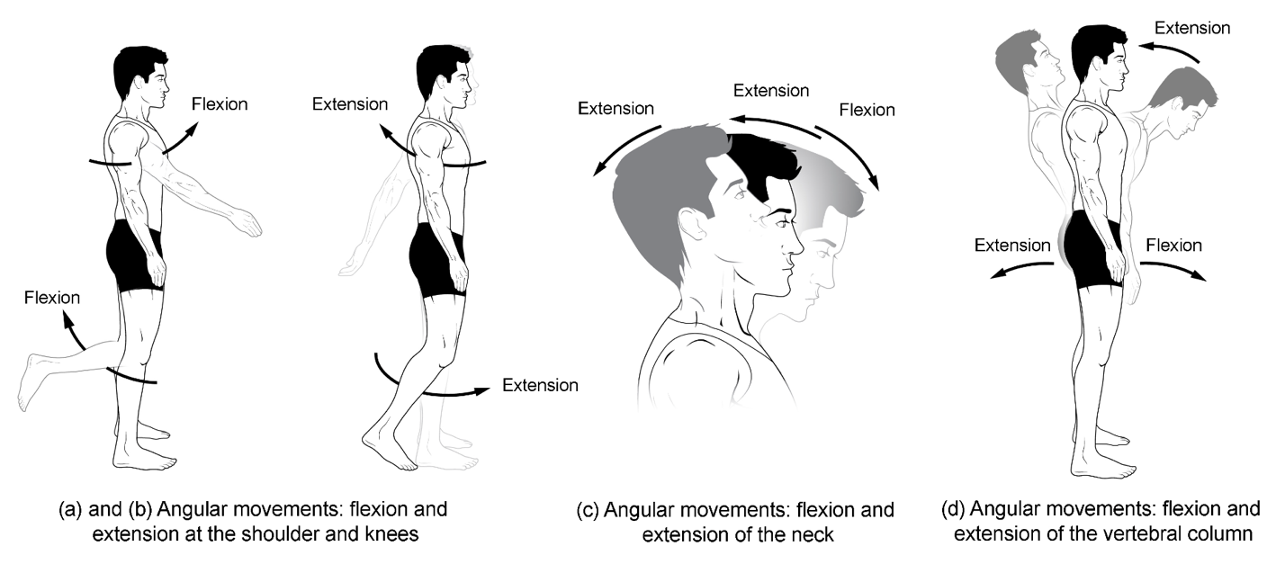

**Figure 1. Flexion and extension.** (a)–(b) Flexion and extension motions are in the sagittal (anterior–posterior) plane of motion. These movements take place at the shoulder, hip, elbow, knee, wrist, metacarpophalangeal, metatarsophalangeal, and interphalangeal joints. (c)–(d) Anterior bending of the head or vertebral column is flexion, while any posterior-going movement is extension.

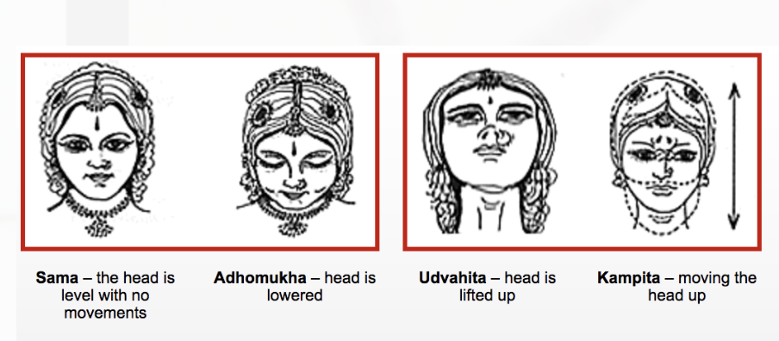

**Figure 2.**Head Movements showing flexion and extension of the neck

**.** 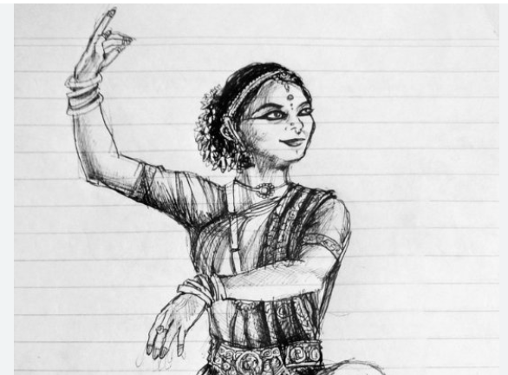

**Figure 3.**Flexion of hand in a dance posture

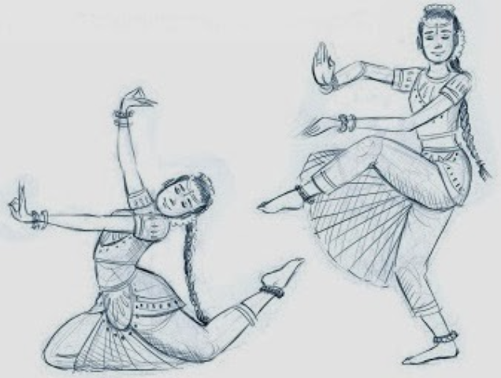

**Figure 4.**Angular Movements in a dance posture

#### **Abduction, adduction and Circumduction:** Abduction and adduction involve movements around a sagittal axis within the coronal plane. Abduction entails moving a body part away from its natural anatomical position in the coronal plane, while adduction involves bringing it back to its original resting position (which may include 'hyperadduction'). Circumduction is a complex motion exclusive to ball-and-socket joints, capable of executing various types of movements.

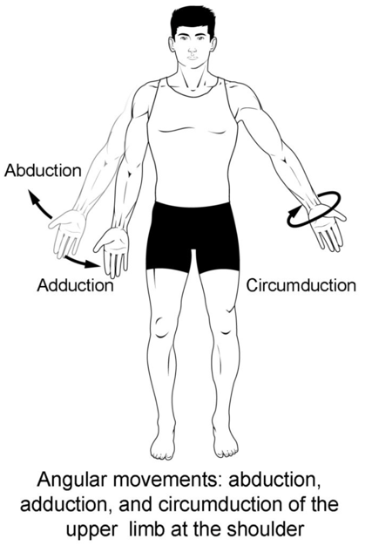

**Figure 5.** Abduction, adduction, and circumduction.

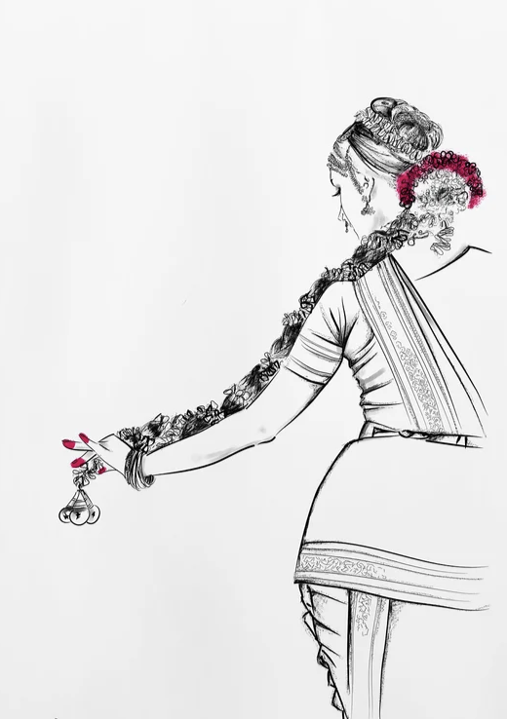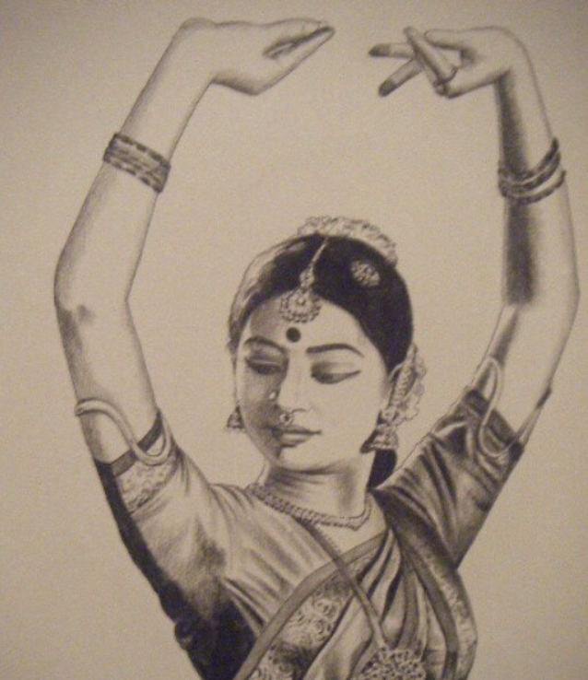

**Figure 6.** Beautiful gesture of holding Jada (braided hair) showing Abduction movement. Also shows the circumduction with wrist movement in both poses

**Elevation and depression, Opposition and re-position**: Elevation signifies lifting, while depression denotes lowering. These actions are limited to specific body regions and arise from movement within the coronal plane. Opposition and reposition are specialized movements exclusive to the human hand, enabling fine dexterity for grasping objects. These actions occur primarily at the thumb and little finger, each possessing dedicated muscles for precise control. Opposition involves bringing the pads of the thumb and little finger together at the hand's midline. Notably, the thumb can oppose each of the other fingers individually on the same hand. Repositioning, conversely, entails returning the thumb and little (or other) fingers to their resting anatomical position.

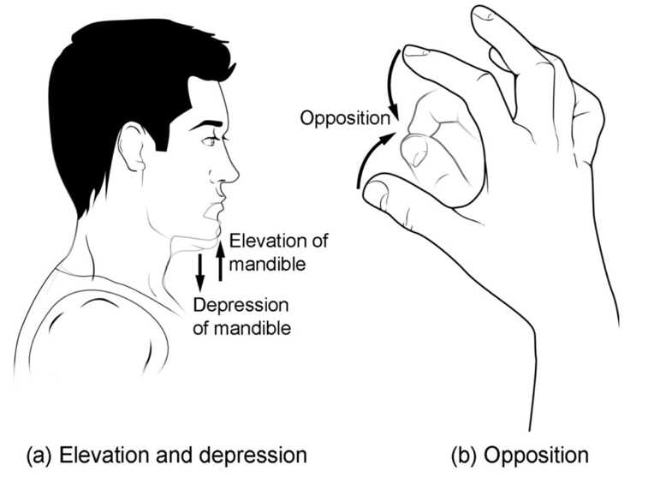

**Figure 7. Depression, elevation, and opposition.** (a) Depression of the mandible opens the mouth, while elevation closes it. (b) Opposition of the thumb brings the tip of the thumb into contact with the tip of the fingers of the same hand and reposition brings the thumb back next to the index finger.

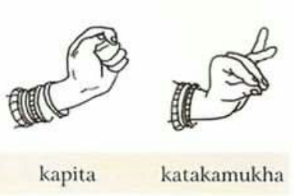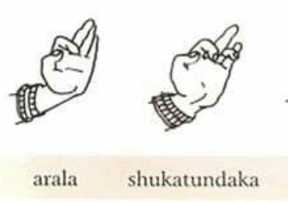

**Figure 8.** SingleHand gestures representing elevation and depression of fingers Anatomy

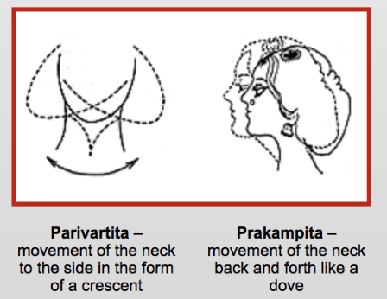

**Figure 9.** Head Movement Prakampitha showing the elevation and depression movement

**Rotation**: Rotation involves movements around the longitudinal axis within the transverse plane. Internal rotation entails rotating a joint towards the midline, while external rotation involves rotating a joint away from the midline.

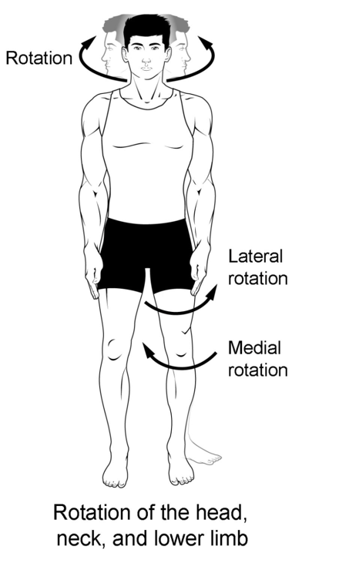

**Figure 10.** Rotation

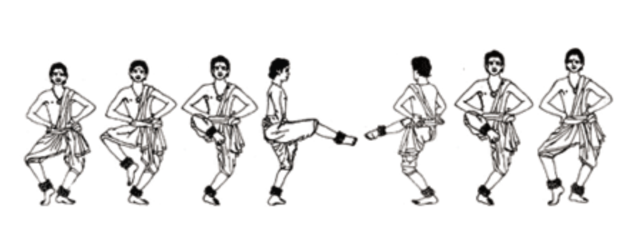

**Figure 11.** Akasiki Charis showing Apakrantha which has movement sideways either in clockwise or anticlockwise direction representing Rotation Anatomy

**Pronation and supination:** Pronation and supination take place primarily at pivot joints, such as the radiohumeral joint (joint between the radius and the humerus bones in the forearm) where the radius and ulna join via the interosseous membrane.

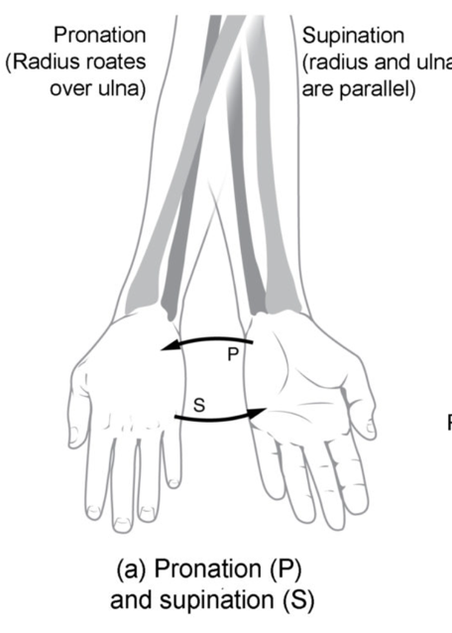

**Figure 12. Supination and pronation.** Supination of the forearm turns the hand to the palm forward position in which the radius and ulna are parallel, while forearm pronation turns the hand to the palm backward position in which the radius crosses over the ulna to form an “X.”

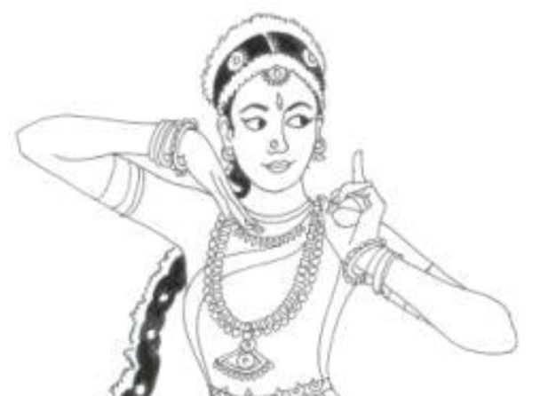

**Figure 13.** Anchita and Kunchita palm movement usage in a dance posture showcasing the Anatomy of Supination and pronation

**Dorsiflexion and plantarflexion:** The foot exhibits four distinct movements. The initial two, dorsiflexion and plantarflexion, pertain to the foot's motion around the coronal axis within the sagittal plane. Dorsiflexion involves bringing the dorsum (back) of the foot toward the tibia, initiating a motion where the toes begin to point upwards, contributing to high ankle stability. Conversely, plantarflexion entails extending the foot away from the tibia and downward towards the ground.

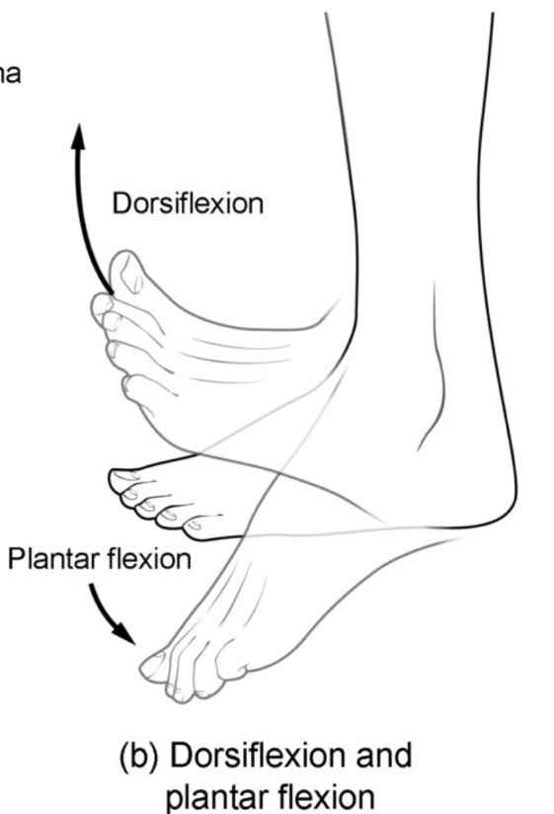

**Figure 14.** Dorsiflexion of the foot at the ankle joint moves the top of the foot toward the leg, while plantar flexion lifts the heel and points the toes

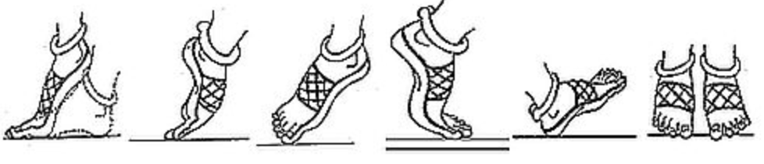

**Figure 15.** Pada Bedha inclusing Anchita and Kunchita postures representing Dorsiflexion of the foot and plantar flexion lifts the heel and points the toe

**Eversion and inversion:** The foot presents another pair of distinctive movements: eversion and inversion. These actions revolve around the sagittal axis within the coronal plane. Eversion involves outwardly turning the soles of the feet away from the body's midline. Conversely, inversion entails inwardly turning the soles of the feet toward the body's midline and each other.

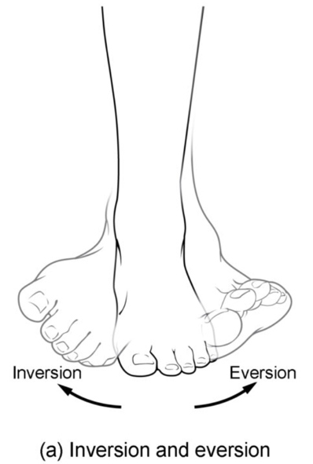

**Figure 16. Inversion, eversion.** Eversion of the foot moves the bottom (sole) of the foot away from the midline of the body, while foot inversion faces the sole toward the midline.

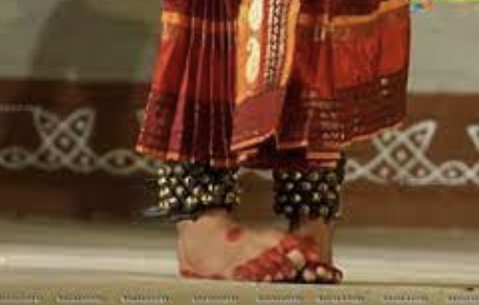

**Figure 17.** Kuchipudi foot work in Tarangam Item which represents the Inversion

**Protraction and retraction:** Protraction and retraction manifest in two significant regions of the body: the scapula and the mandible. Protraction involves the act of protruding or extending outward, while retraction entails bringing together or pulling inward.

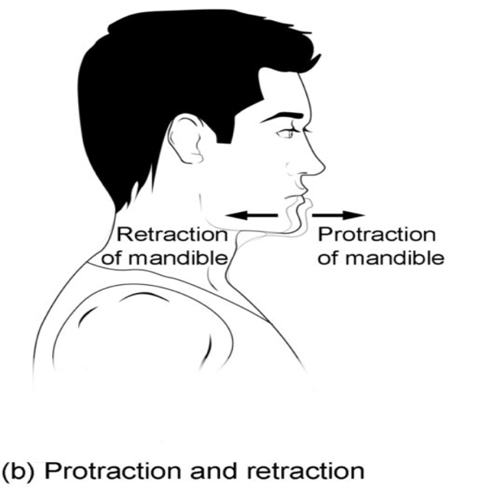

**Figure 18. Protraction, and retraction.**  Protraction of the mandible pushes the chin forward, and retraction pulls the chin back.

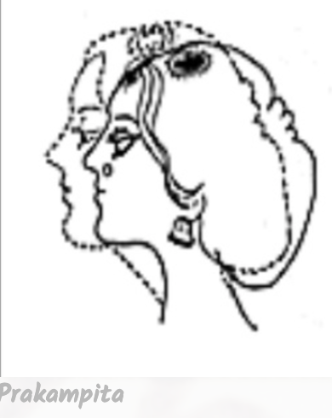

**Figure 19.** Prakampitha in Neck Movement showing the Protraction, and retraction movement

**Integration of Yoga Principles in Dance:** Unveiling the harmonious fusion of Kuchipudi and Yoga, this sub-subtitle explores the intentional integration of yogic principles into the dance form, showcasing how mindfulness, breath, and posture seamlessly weave into the expressive tapestry of Kuchipudi performance.

**Theoretical Framework:** Establishing a robust theoretical framework, this section lays the conceptual groundwork for the study, intertwining principles from dance theory, yogic philosophy, and anatomical science to provide a comprehensive lens through which the symbiotic relationship between Kuchipudi and Yoga can be understood.

**References**

<https://www.markedbyteachers.com/as-and-a-level/music/dance-is-rhythmic-and-expressive-body-movement-usually-coordinated-into-a-pattern-and-performed-with-music.html>

<https://www.indianetzone.com/18/style_technique_kuchipudi.htm>

<https://india.serenademagazine.com/dance/kuchipudi-graceful-narratives-in-motion/>

<https://saathee.com/a-comprehensive-view-of-kuchipudi/>

<http://www.hindustaniclassical.com/dances/kuchipudi>

<https://www.raagaleena.org/classes/>

<https://cargocollective.com/Jessicaheinonen/Kuchipudi>

<https://sreenivasaraos.com/tag/sausthava/>

<https://archive.org/details/dli.pb.natyashastra.1/Natyashastra.1_1.m4v>

Pullela, S. (2014). *Bharatamunipraṇītam Nāṭyaśāstram*. Andhra Bhasha vyakya balanandi.

<https://www.kenhub.com/en/library/anatomy/types-of-movements-in-the-human-body>

<https://www.thebodylab.au/lab-blog/introductory-exploration-of-anatomy-in-motion>

<https://courses.lumenlearning.com/suny-ap1/chapter/types-of-body-movements/>

<https://littlebanyantreekids.wordpress.com/2019/01/04/head-and-neck-movements-in-bharatanatyam/>

<https://deepikasingh89.blogspot.com/2013/08/>

<https://www.kuchipudi.com/grammar/kapittha/>

<https://www.pinterest.com/pin/wanna-draw-this--510314201503840244/>

<https://teachmeanatomy.info/the-basics/anatomical-terminology/terms-of-movement/>