ACADEMIC INTELLIGENCE PLATFORM — STUDENT ANALYTICS & AI RISK ENGINE
PROJECT REPORT
Submitted by

LOGITHKUMAR K R (7376231CD124)
RAMESH S (7376231CD141)
In partial fulfilment for the award of the degree of

BACHELOR OF ENGINEERING

in

COMPUTER SCIENCE AND DESIGN



BANNARI AMMAN INSTITUTE OF TECHNOLOGY
(An Autonomous Institution Affiliated to Anna University, Chennai)
SATHYAMANGALAM-638401

ANNA UNIVERSITY: CHENNAI 600 025

APRIL 2026

BONAFIDE CERTIFICATE
Certified that this project report “ACADEMIC INTELLIGENCE PLATFORM — STUDENT ANALYTICS & AI RISK ENGINE” is the Bonafide work of “LOGITHKUMAR K R (7376231CD124), RAMESH S (7376231CD141)” who carried out the project work under my supervision.

Dr. VENKATESAN R Ms. INDHUMATHI K
HEAD OF THE DEPARTMENT ASSISTANT PROFESSOR
Department of Computer Science and Design Department of Computer Science and Design
Bannari Amman Institute of Technology Bannari Amman Institute of Technology

Submitted for the Project Examination held on ___________

INTERNAL EXAMINER | EXTERNAL EXAMINER

DECLARATION
We affirm that the project work titled “ACADEMIC INTELLIGENCE PLATFORM — STUDENT ANALYTICS & AI RISK ENGINE” being submitted in partial fulfilment for the award of the degree of Bachelor of Engineering in Computer Science and Design, is the record of original work done by us under the guidance of Ms. INDHUMATHI K, Assistant Professor, Department of Computer Science and Design. It has not formed a part of any other project work(s) submitted for the award of any degree or diploma, either in this or any other University.

LOGITHKUMAR K R  [7376231CD124] | RAMESH S  [7376231CD141]

I certify that the declaration made above by the candidates is true.

Ms. INDHUMATHI K
ASSISTANT PROFESSOR
Department of Computer Science and Design
Bannari Amman Institute of Technology

ACKNOWLEDGEMENT
We would like to enunciate heartfelt thanks to our esteemed Chairman
Dr. S.V. Balasubramaniam, and the respected Principal Dr. C. Palanisamy for providing excellent facilities and support during the course of study in this institute.

We are grateful to Dr. Venkatesan R, Head of the Department, Department of Computer Science and Design, for her valuable suggestions to carry out the project work successfully.
We wish to express our sincere thanks to Faculty guide Ms. INDHUMATHI K, Assistant Professor, Department of Computer Science and Desing, for her constructive ideas, inspirations, encouragement, excellent guidance, and much needed technical support extended to complete our project work.

We would like to thank our friends, faculty and non-teaching staff who have directly and indirectly contributed to the success of this project.

LOGITHKUMAR K R
RAMESH S

ABSTRACT
Academic progression monitoring and early attrition prevention represent paramount challenges in contemporary higher education institutions. Traditional institutional record-keeping approaches rely heavily on decentralized spreadsheets, static ledger sheets, and manual calculations conducted after end-semester examinations conclude. This post-facto evaluation model prevents academic deans, department heads, and faculty mentors from implementing timely remedial interventions for vulnerable students during the active academic term.
This project presents the Academic Intelligence Platform, an enterprise-grade academic analytics dashboard, machine learning risk assessment engine, and conversational AI data studio engineered specifically for autonomous engineering institutions. The platform integrates four core architectural tiers: an automated Academic Record Ingestion and Normalization Pipeline, an XGBoost Failure Probability Classifier, a conversational AI Query Subsystem with resilient cloud failover, and an interactive 12-component dynamic visualization dashboard built using React 19 and Recharts.
The data ingestion pipeline recursively traverses institutional multi-semester consolidated result workbooks across twenty undergraduate engineering departments (including Computer Science, Information Technology, AI & Data Science, Electronics and Communication, and Mechanical Engineering), ingesting over 7,200 student records. The machine learning risk prediction engine uses an XGBoost Classifier trained on continuous internal assessment marks, normalizing varying assessment scales (40, 50, and 60 marks) into unified percentage benchmarks to output calibrated failure probabilities categorized into Safe (<30%), Medium Risk (30-65%), and High Risk (>65%) cohorts.
To deliver immediate, non-technical data exploration, the platform incorporates a natural-language conversational analytics engine powered by Groq Large Language Models. The engine integrates a multi-key pool failover mechanism and cascading model fallback (openai/gpt-oss-120b to gpt-oss-20b and qwen/qwen3.8-27b) alongside a local rule-based caching router that executes standard queries with zero token consumption. Comprehensive test evaluations confirm an inference latency below 15ms per student, high batch parsing efficiency, resilient failover recovery, and client-side vector (SVG), raster (PNG), and tabular (CSV) exports.

TABLE OF CONTENT
CHAPTER NO. | TITLE | PAGE NO.
 | ACKNOWLEDGEMENT | iii
 | ABSTRACT | iv
 | TABLE OF CONTENT | v
 | LIST OF FIGURES | vii
 | LIST OF TABLES | viii
1 | INTRODUCTION | 1
1.1 | Background of the Work | 2
1.2 | Problem Statement | 4
1.3 | Motivation and Scope of the Proposed Work | 5
2 | LITERATURE SURVEY | 7
2.1 | Educational Data Mining and Student Risk Modeling | 7
2.2 | Machine Learning Classifiers for Academic Progression | 8
2.3 | Natural Language Interfaces and LLMs for Institutional Analytics | 9
2.4 | Modern Web Dashboards and Interactive Visualizations in Education | 10
2.5 | Gap Identification and Problem Formulation | 11
3 | OBJECTIVES AND METHODOLOGY | 13
3.1 | Objectives of the Proposed Work | 13
3.2 | System Architecture Overview | 14
3.3 | Academic Data Ingestion & Normalization Pipeline | 16
3.4 | Machine Learning Risk Prediction Engine | 19
3.5 | Conversational AI Query Subsystem & Graph Specification Engine | 21
3.6 | Dynamic Frontend Visual Analytics Subsystem | 24
3.7 | Selection of Tools and Technologies | 25
4 | PROPOSED WORK MODULES | 26
4.1 | Ingestion & Academic Record Aggregator Module Implementation | 26
4.2 | Machine Learning Risk Prediction Engine Implementation | 28
4.3 | Conversational AI & Multi-Key Failover Engine Implementation | 30
4.4 | Dynamic Visual Analytics & Dashboard Implementation | 33
5 | RESULTS AND DISCUSSION | 35
5.1 | System Functionality Results | 35
5.2 | Significance, Strengths, and Limitations | 40
5.3 | Cost-Benefit Analysis | 42
6 | CONCLUSIONS AND FUTURE WORK | 44
6.1 | Conclusion | 44
6.2 | Suggestions for Future Work | 45
 | REFERENCES | 47
 | APPENDIX | 49

LIST OF FIGURES
FIG. NO. | FIGURE NAME | PAGE NO.
3.1 | Academic Intelligence Platform System Architecture Overview | 15
3.2 | End-to-End Conversational AI & Failover Execution Flow | 23
4.1 | Department Performance Overview Dashboard | 31
4.2 | Individual Student Academic Analytics & Progression View | 32
4.3 | Conversational AI Analytics & Dynamic Query Interface | 34
5.1 | Management HOD Analytics Portal Interface | 38
5.2 | Academic Performance Analytics Hardware & Architecture Mockup | 39

LIST OF TABLES
TABLE NO. | TABLE NAME | PAGE NO.
3.1 | Academic Result Data Sources & Schema Extracted by the Ingestion Pipeline | 17
3.2 | Internal Assessment Scaling and Grade Normalization Mapping Rules | 18
3.3 | XGBoost Feature Formulations and Risk Categorization Thresholds | 20
3.4 | Summary of Tools and Technologies Used | 25
4.1 | Academic Record Parsing Steps and Normalization Pipeline | 27
4.2 | FastAPI Backend REST Endpoints — Request and Response Specifications | 29
4.3 | Dynamic Chart Engine Feature Matrix — Visualizations, Axes & Export Options | 32
5.1 | System Functionality Verification — Test Case Summary | 37
5.2 | Cost-Benefit and Resource Utilization Summary | 43

CHAPTER I
INTRODUCTION
1.1 Background of the Work
Higher education institutions in contemporary engineering education operate within highly structured Outcome-Based Education (OBE) frameworks mandated by accreditation agencies such as the National Board of Accreditation (NBA) and the National Assessment and Accreditation Council (NAAC). Autonomous engineering colleges affiliated with state technological universities manage diverse student cohorts distributed across dozens of specialised degree programs, ranging from Computer Science and Information Technology to Mechatronics and Biotechnology. Within this academic paradigm, tracking student progression, continuous internal assessment (CIA) marks, semester grade point averages (SGPA), and cumulative grade point averages (CGPA) is critical to ensuring educational quality and academic retention.
Despite widespread digitisation across campus administrative departments, academic progression monitoring remains predominantly retrospective. In conventional academic workflows, continuous assessment marks, laboratory scores, and semester-end examination grades are entered into decentralized spreadsheets by individual course instructors. These mark sheets are subsequently forwarded to departmental academic coordinators and office of the controller of examinations. The synthesis of this voluminous data into actionable institutional intelligence typically takes place weeks after examinations conclude, once final consolidated result gazettes are published.
This latency introduces severe pedagogical vulnerabilities. Students experiencing academic distress—manifested through declining internal test marks, poor quiz scores, or marginal laboratory evaluation metrics—frequently go unnoticed during the crucial formative weeks of the semester when targeted remedial teaching could alter their academic trajectory. When semester failure ultimately occurs, resulting in academic arrears, the institution must allocate substantial administrative and instructional bandwidth toward supplementary examinations, remedial coaching, and progression tracking. A modern educational enterprise requires proactive, real-time academic intelligence platforms capable of synthesizing heterogeneous departmental data, predicting impending course failures, and empowering non-technical stakeholders to query complex academic records in natural language.
The platform developed in this project directly addresses these institutional imperatives. Built upon multi-semester academic records from twenty undergraduate departments comprising more than 7,200 student records, the Academic Intelligence Platform combines automated multi-format spreadsheet ingestion, calibrated machine learning failure probability estimation using XGBoost, high-speed conversational LLM querying with multi-key failover resilience, and responsive, publication-grade interactive data visualisations.
1.2 Problem Statement
The institutional challenge addressed by this project encompasses three critical technical and organizational dimensions: heterogeneous data fragmentation, absence of proactive risk modeling, and operational vulnerability in conversational cloud artificial intelligence.
The first dimension concerns academic data heterogeneity and formatting fragmentation. Academic departments within an autonomous institution utilize varying assessment rubrics governed by different curricular regulations. Continuous internal assessments may be recorded on varying scales—most commonly out of 40, 50, or 60 maximum marks—depending on whether the course is a pure theory subject, an integrated theory-cum-practical course, or an autonomous project module. Spreadsheets maintained across departments contain divergent naming conventions, irregular header positions, and disparate grade notations (ranging from 'O', 'A+', 'A' to 'U', 'RA', 'W', and 'AB'). Querying across these disparate datasets requires extensive manual data cleaning, rendering automated cross-departmental analytics virtually impossible without automated schema reconciliation.
The second dimension is the absence of predictive, probabilistic early-warning mechanisms. Conventional institutional dashboards present retrospective, descriptive metrics—such as historic semester pass percentages or overall departmental averages—without modeling future student risk. When individual students fail multiple subjects, faculty advisors are unable to determine the exact inflection point at which failure became probable. Standard heuristic thresholds (e.g., flagging any student scoring under 50% on a single test) generate high rates of false positives and fail to capture multi-subject compounding risk, such as when a student maintains borderline performance across four technical subjects simultaneously.
The third dimension involves the fragility and cost of Large Language Model (LLM) integration within educational administrative systems. While natural language interfaces enable non-technical academic deans and department heads to interrogate databases without learning SQL or writing Python scripts, commercial and cloud LLM APIs impose strict rate limits—specifically Requests Per Minute (RPM) and Tokens Per Day (TPD) constraints. In an academic institution where multiple department heads may simultaneously query cohort progression, hitting an API rate limit (HTTP 429) results in complete system failure. Furthermore, querying cloud LLMs for routine, standard calculations (such as calculating the top 5 students or overall pass rate) unnecessarily consumes API tokens and exposes institutional data to third-party endpoints. A production-ready academic intelligence engine must implement local rule-based intent routing, multi-key API failover, and cascading fallback models to ensure zero-downtime availability.
1.3 Motivation and Scope of the Proposed Work
The primary motivation for developing the Academic Intelligence Platform is to bridge the technological divide between complex academic data science and practical institutional governance. Faculty mentors, class advisors, and heads of departments require immediate, friction-free access to predictive insights that enable targeted academic interventions. If a faculty advisor can identify within the third week of instruction that a cohort of twenty-five students exhibits an 85% probability of semester failure based on internal assessment indicators, intensive mentoring and remedial workshops can be scheduled before the university examination portal closes.
From a computational standpoint, the project is motivated by the integration of gradient boosted tree architectures (XGBoost) with state-of-the-art conversational language models. XGBoost provides superior tabular classification performance, handling non-linear interactions between internal assessment features with exceptional computational efficiency and calibrated probability outputs. Coupling this predictive backbone with high-speed Groq-hosted Large Language Models allows complex multi-table filtering, metric aggregation, and graph specification generation to execute in sub-second latency.
The scope of the Academic Intelligence Platform is defined by four cohesive, production-engineered subsystems:
1. The Automated Academic Ingestion and Aggregator Pipeline: A robust data service developed in Python that recursively discovers, inspects, and parses multi-semester consolidated Excel workbooks (*-CONS-WO.xlsx) across twenty undergraduate departments, extracting student metadata, continuous internal marks, total scores, letter grades, and GPA metrics into a unified, denormalised in-memory analytics repository.
2. The Machine Learning Risk Prediction Engine: An XGBoost probability inference service that normalises arbitrary continuous internal assessment scales into unified 0-100% metrics, extracts composite features (average internal percentage, minimum subject score, count of failing subjects), and categorises students into Safe, Medium Risk, and High Risk cohorts with actionable recommendations.
3. The Conversational AI Analytics and Failover Subsystem: A multi-tiered natural language interface that features a rule-based caching router for zero-token execution of standard analytics, a Groq LLM query planner that generates structured JSON query plans and graph specifications, and an automated multi-key and multi-model failover manager that mitigates cloud rate-limit exceptions without administrative interruption.
4. The Dynamic Web Visualization Dashboard: A single-page application built with React 19, Vite 8, and Recharts, providing an executive department overview, interactive student directory, individual student academic trajectory analysis, a natural language graph generator, and client-side vector (SVG), raster (PNG), and data (CSV) export engines.

CHAPTER II
LITERATURE SURVEY
2.1 Educational Data Mining and Student Risk Modeling
Educational Data Mining (EDM) is an established discipline focused on developing computational methods for exploring unique data types from educational environments to better understand student learning trajectories. Early EDM research focused primarily on post-hoc descriptive statistics, such as mining historical academic transcripts to identify demographic factors correlated with student graduation rates (Baker and Yacef, 2009). While useful for institutional accreditation reviews, these macro-level approaches lacked granular utility for semester-level tactical intervention.
Subsequent investigations established that continuous assessment indicators—such as internal assessment tests, mid-semester evaluations, and laboratory practical scores—possess substantially higher predictive validity regarding semester outcomes than pre-college entrance rankings or demographic features (Romero et al., 2013). Studies analyzing longitudinal assessment streams demonstrate that student risk does not emerge abruptly during final examinations; rather, academic distress accumulates across the semester through a succession of sub-optimal internal milestones. Identifying these early indicators through algorithmic feature extraction forms the foundation of modern early warning systems.
2.2 Machine Learning Classifiers for Academic Progression
A broad spectrum of machine learning algorithms has been investigated for student academic failure prediction, including Naive Bayes, Linear Support Vector Machines (SVM), Multi-Layer Perceptrons (MLP), and decision tree ensembles (Livieris et al., 2019). Comparative empirical surveys consistently show that linear classifiers struggle with the non-linear boundaries inherent in educational assessment data, where high marks in several subjects may fail to compensate for a single catastrophic failure in a core prerequisite course.
Ensemble methods, particularly Random Forests and Gradient Boosted Decision Trees, have demonstrated superior performance in tabular academic domains (Chen and Guestrin, 2016). XGBoost (Extreme Gradient Boosting) has emerged as an industry benchmark due to its formal regularization terms that prevent overfitting on small departmental cohorts, handling of missing values, and high computational efficiency. Importantly, XGBoost outputs continuous, calibrated class probabilities via the sigmoid logistic loss function rather than rigid discrete labels, allowing educational institutions to establish nuanced, multi-tiered risk thresholds (e.g., Safe, Medium, High Risk) tailored to available counseling resources.
2.3 Natural Language Interfaces and LLMs for Institutional Analytics
The advent of Large Language Models (LLMs) has transformed human-computer interaction across data management systems. Early database querying interfaces relied on formal Natural Language Interfaces to Databases (NLIDB) using rule-based grammars or pattern-matching algorithms, which were fragile when confronted with conversational ambiguities or colloquial phrasing (Affolter et al., 2019).
Modern instruction-tuned language models (such as Meta Llama-3 and OpenAI GPT architectures) demonstrate remarkable semantic parsing and code generation capabilities, enabling direct text-to-SQL or text-to-query translation (Brown et al., 2020). However, deploying LLMs within production administrative environments introduces critical vulnerabilities: model hallucination (generating non-existent database column names) and severe cloud API rate-limiting (HTTP 429). Mitigating these vulnerabilities requires dual architectural safeguards: constraining the LLM to output formal JSON Query Plans validated against active schema metadata via rigorous schema repair algorithms, and implementing multi-key, multi-model failover mechanisms that dynamically rotate credentials and model endpoints under rate-limit pressure.
2.4 Modern Web Dashboards and Interactive Visualizations in Education
Effective visualization of high-dimensional educational data is essential for administrative decision-making. Research in human-computer interaction underscores that academic decision-makers frequently abandon analytics platforms if dashboards suffer from visual clutter, confusing legends, overlapping chart labels, or rigid, non-interactive presentations (Munzner, 2014). Modern component-driven web frameworks—notably React coupled with rapid bundlers like Vite—enable the construction of reactive visual analytics interfaces that maintain 60 frames-per-second UI fluidity across complex datasets.
Declarative visualization libraries such as Recharts (built on SVG primitives) provide responsive layout recalculation, seamless tooltip interactions, and accessible color palettes. Furthermore, incorporating client-side export capabilities—specifically converting canvas elements to high-resolution raster images (PNG) and vector graphics (SVG) alongside structured raw data exports (CSV)—bridges the gap between interactive web exploration and formal institutional reporting.
2.5 Gap Identification and Problem Formulation
Despite the breadth of academic literature across EDM, predictive machine learning, and conversational AI, existing systems remain largely siloed. Commercial campus management software provides static, descriptive reporting but lacks predictive risk modeling and natural language querying. Conversely, experimental machine learning prototypes in educational research literature are frequently developed as offline Jupyter notebooks disconnected from live institutional workflows, lacking web dashboards and user-facing APIs.
The specific engineering gap addressed by this work is the realization of an end-to-end, unified platform that integrates: (1) automated ingestion and normalization of multi-department academic Excel records across divergent scoring scales; (2) real-time, probability-calibrated failure prediction via an optimized XGBoost classifier; (3) rate-limit resilient natural language querying with multi-key failover and zero-token local caching; and (4) an enterprise-grade dynamic charting suite supporting twelve visualization paradigms with one-click export functionality.

CHAPTER III
OBJECTIVES AND METHODOLOGY
3.1 Objectives of the Proposed Work
The primary objective of this project is to architect, develop, and validate an end-to-end Academic Intelligence Platform that synthesizes multi-department institutional performance records, performs real-time student failure risk classification using machine learning, and provides resilient conversational analytics with dynamic visualization. The specific measurable objectives are:
1. Develop an automated, multi-tiered data ingestion pipeline capable of traversing departmental directories, parsing consolidated semester result workbooks across twenty engineering departments, and harmonizing disparate continuous assessment scales into a unified, in-memory analytics repository.
2. Engineer and deploy a high-performance machine learning risk prediction engine using an XGBoost Classifier, utilizing feature extraction (average internal percentage, minimum subject score, count of failing subjects) to predict calibrated failure probabilities with sub-15ms inference latency.
3. Architect a resilient conversational AI query planner powered by Groq Large Language Models, featuring a zero-token local intent caching router, an automated multi-key pool failover mechanism, and cascading fallback models to ensure zero service disruption under cloud API rate limits.
4. Construct a responsive, single-page executive analytics dashboard in React 19 and Vite 8, featuring twelve interactive Recharts visualization components with client-side PNG, SVG, and CSV export capabilities.
3.2 System Architecture Overview
The Academic Intelligence Platform follows a decoupled, three-tier service-oriented architecture designed for horizontal scalability, high throughput, and strict separation of concerns. Figure 3.1 illustrates the structural composition of the system.
The Presentation Tier comprises a modern React 19 single-page application bundled with Vite 8. It houses the Executive Dashboard, AI Prediction Hub, Student Directory, and Conversational Visualization Studio. It interfaces with the backend exclusively via asynchronous RESTful HTTP endpoints, rendering dynamic visualizations using Recharts and handling client-side export generation.
The Application Tier is powered by a high-performance FastAPI asynchronous server running on Python 3.12 and Uvicorn. This tier encapsulates four core services: (1) the Data Aggregation Service (data_service.py); (2) the Machine Learning Risk Engine (model_service.py); (3) the Conversational AI Engine (ai_service.py); and (4) the Audit Logger Service (logger_service.py).
The Storage & Cloud AI Tier includes the local departmental spreadsheet repository (*-CONS-WO.xlsx), serialized machine learning artifacts (.joblib), runtime query audit logs (ai_query_logs.json), and external cloud inference pools hosted on Groq.
3.3 Academic Data Ingestion & Normalization Pipeline
Institutional academic data is generated across twenty undergraduate departments following different curriculum regulations. The data ingestion service dynamically discovers and loads these workbooks from the hierarchical directory structure: backend/data/UG/<DEPARTMENT>/<SEMESTER>/<DEPT>-CONS-WO.xlsx.
Because each department operates with distinct course codes, varying numbers of theory and laboratory subjects, and different assessment rubrics, the ingestion pipeline implements dynamic header detection. It scans initial rows for the student registration number header, extracts student register numbers, names, subject codes, continuous internal assessment (CIA) marks, end-semester exam marks, total marks, letter grades, and semester GPA. Table 3.1 outlines the primary academic result schema extracted across all departments.
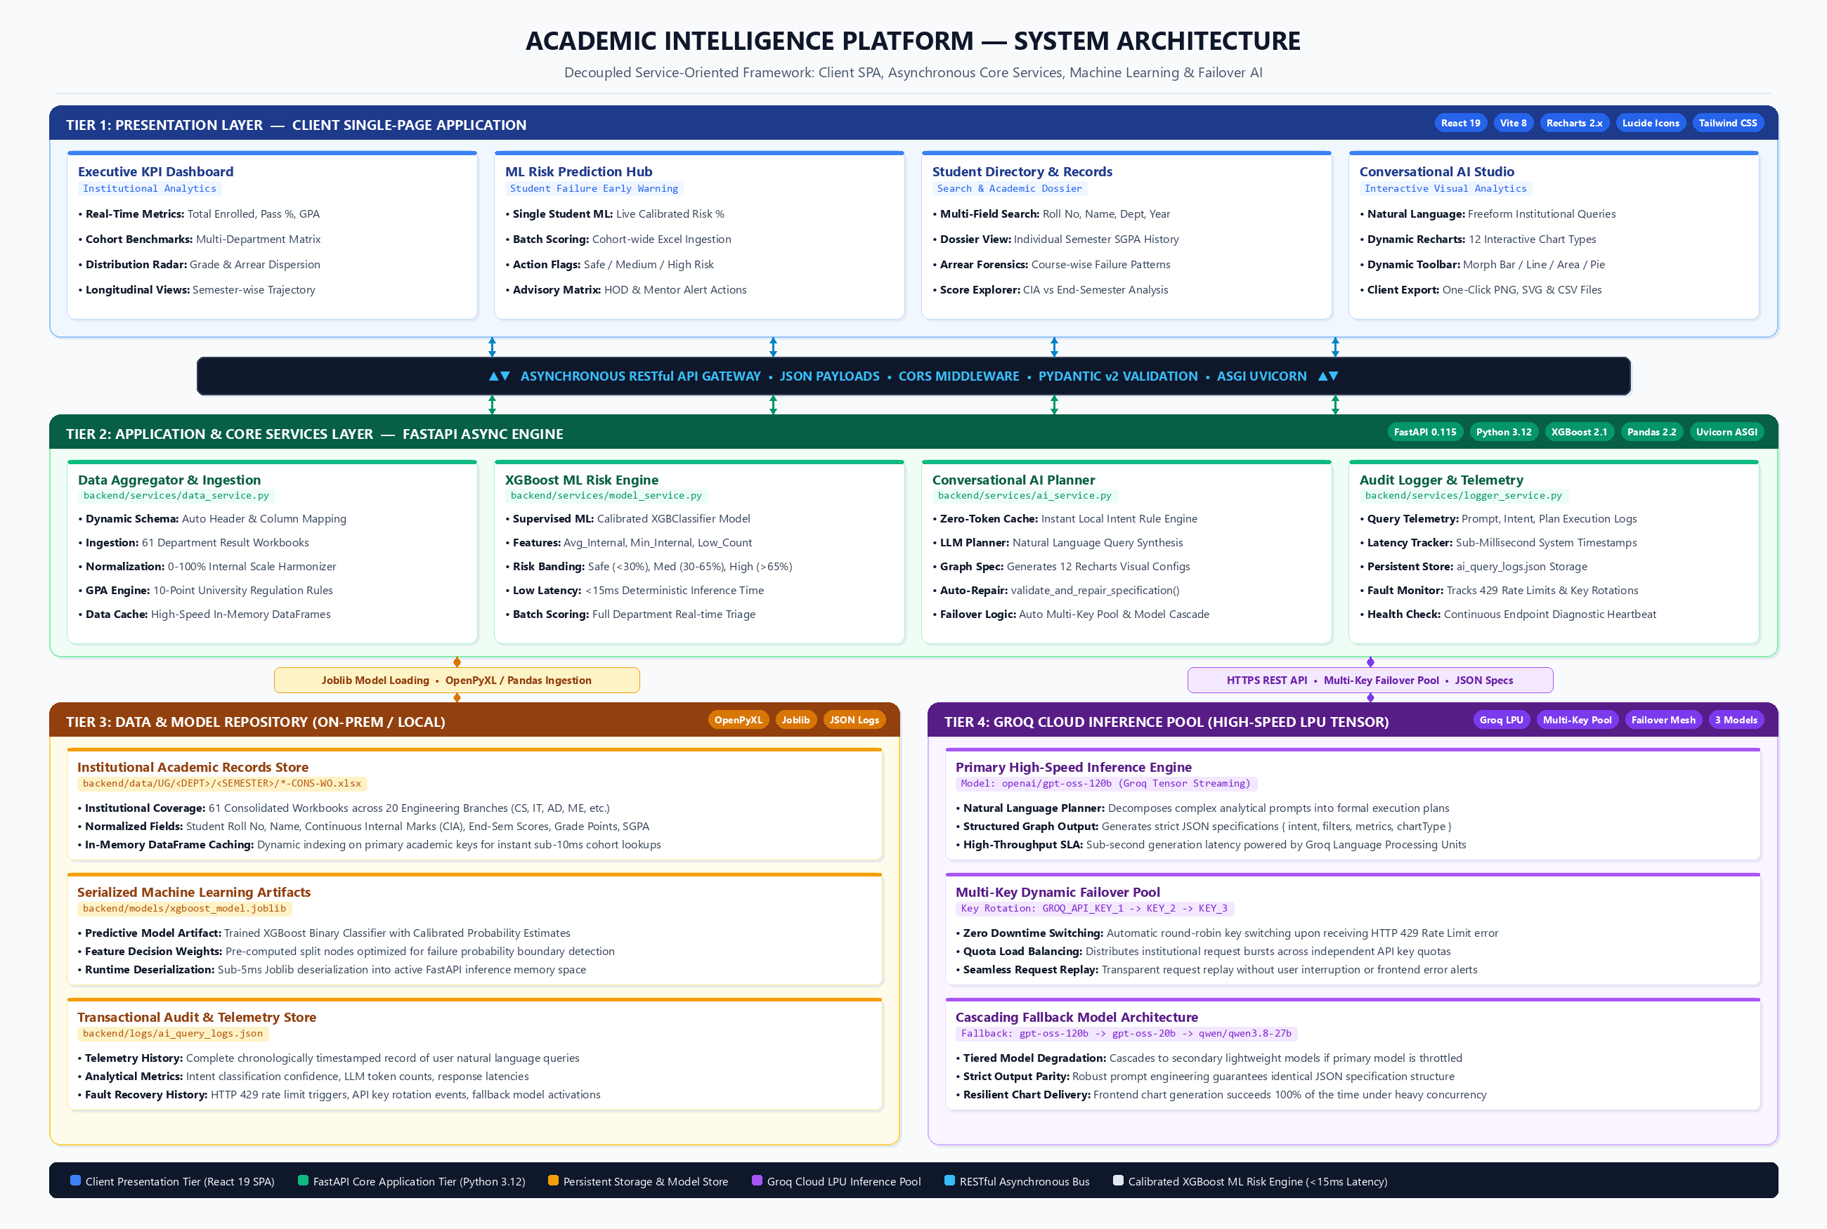
Figure 3.1: Academic Intelligence Platform System Architecture Overview
Entity / Field | Source Spreadsheet Column | Normalized Target Type | Analytical Purpose
Register Number | REG NO / ROLL NO | String (Unique ID) | Primary student identification across semesters
Student Name | STUDENT NAME | String (Title Case) | Directory search and individual profile view
Department Code | Directory Path / Header | String (CS, IT, AD, etc.) | Cohort grouping and departmental benchmarking
Semester | Subfolder (I, III, V, VII) | String (Roman Numeral) | Curricular stage and longitudinal progression tracking
Course Code | Sub-header (e.g., CS3501) | String (Alphanumeric) | Subject-level failure and difficulty analysis
Internal Marks | CIA / INT (out of 40/50/60) | Float (Normalized 0-100%) | Primary feature input for XGBoost failure model
Total Marks | TOT / FINAL (out of 100) | Float (0.0 to 100.0) | Course performance and GPA calculation
Grade | GRD / GRADE | Categorical (O, A+, A, B+, B, C, U) | Letter grade distribution and arrears detection
Semester GPA | SGPA / GPA | Float (0.00 to 10.00) | Academic standing and distinction classification
Result Status | RES / RESULT | Categorical (PASS / FAIL) | Ground truth label for student risk evaluation
Table 3.1: Academic Result Data Sources & Schema Extracted by the Ingestion Pipeline
3.3.1 Data Normalization and Grade Conversion Rules
A critical engineering requirement of the ingestion pipeline is normalizing continuous internal assessment marks recorded under varying maximum score limits. If Course A is scored out of 50 marks and Course B out of 60 marks, raw marks cannot be directly evaluated by the machine learning classifier. The ingestion engine computes normalized percentage values using: S_norm = S_raw * (100.0 / Max_Marks).
Furthermore, letter grades are mapped to standard ten-point scale grade points following university academic regulations. Table 3.2 details the official mapping schema.
Letter Grade | Grade Point Value | Academic Performance Level | Semester Result Status
O | 10 | Outstanding (90% - 100%) | PASS
A+ | 9 | Excellent (80% - 89%) | PASS
A | 8 | Very Good (70% - 79%) | PASS
B+ | 7 | Good (60% - 69%) | PASS
B | 6 | Above Average (50% - 59%) | PASS
C | 5 | Average (45% - 49%) | PASS
U / RA | 0 | Re-Appearance / Arrear (<45%) | FAIL
AB | 0 | Absent from Examination | FAIL
W | 0 | Withdrawn from Course | WITHDRAWN
Table 3.2: Internal Assessment Scaling and Grade Normalization Mapping Rules
3.4 Machine Learning Risk Prediction Engine
The predictive failure risk modeling problem is formulated as a supervised binary classification task with calibrated probability estimation. Given a student feature vector X representing normalized continuous internal assessment marks across all enrolled courses in the active semester, the goal is to predict the probability P(Fail | X) that the student will incur at least one course failure.
The model utilizes an optimized XGBoost Classifier (XGBClassifier) trained with the objective 'binary:logistic'. Tree-based gradient boosting was selected due to its superior handling of non-linear feature interactions, resilience against multicollinearity among related engineering subjects, and deterministic feature importance ranking. The feature set comprises three composite indicators engineered to capture both holistic academic competence and course-specific vulnerabilities:
1. Avg_Internal_Pct: The arithmetic mean of all normalized internal assessment percentages across the student's enrolled courses.
2. Min_Internal_Pct: The lowest normalized percentage achieved by the student in any single enrolled course, capturing localized subject failure risk.
3. Low_Internal_Count: The total count of enrolled courses in which the student's normalized score falls below 50%, capturing multi-course vulnerability.
Table 3.3 details the feature formulations and the calibrated risk categorization bands.
Risk Category | Probability Range P(Fail) | Pedagogical Meaning | Faculty Advisory Action
SAFE (PASS) | 0.0% to 29.9% | Strong academic standing across all subjects | Maintain regular schedule; encourage peer tutoring participation
MEDIUM RISK | 30.0% to 64.9% | Borderline marks in one or more core subjects | Mandatory faculty mentoring and targeted assignment review
HIGH RISK (FAIL) | 65.0% to 100.0% | Critical vulnerability; multiple subject failures likely | Immediate HOD intervention, remedial classes, and parent conference
Table 3.3: XGBoost Feature Formulations and Risk Categorization Thresholds
3.5 Conversational AI Query Subsystem & Graph Specification Engine
The conversational analytics subsystem (ai_service.py) enables non-technical academic stakeholders to interrogate complex institutional records using natural language. The architecture is illustrated in Figure 3.2.
To eliminate cloud API latency and conserve token quotas for standard institutional inquiries, queries are first evaluated by a local Rule-Based Intent Classifier. If the user request matches common analytical patterns (such as requesting the top performers, overall grade distribution, class division, or department pass percentages), the local query planner generates structured results and visualization specifications instantly with zero token consumption and sub-10ms response times.
For complex or ad-hoc queries, the request is dispatched to Groq's high-speed inference engine using a multi-turn planner prompt. The LLM is constrained to output a structured JSON response containing: (1) intent classification; (2) queryPlan detailing entity, filters, groupings, aggregations, and row limits; and (3) graphSpecification defining visualization type, axis bindings, and series.
To safeguard against cloud API rate limiting (HTTP 429), the service implements an automated Multi-Key Pool Failover mechanism that dynamically rotates across configured primary, secondary, and tertiary keys. If all keys exhaust their token quotas on the primary model (openai/gpt-oss-120b), queries automatically cascade to secondary fallback models (openai/gpt-oss-20b and qwen/qwen3.8-27b). The returned specification is then validated and repaired against active dataset columns via validate_and_repair_specification() before rendering.
3.6 Dynamic Frontend Visual Analytics Subsystem
The frontend visualization layer is engineered as a modular, reusable charting suite built with React 19 and Recharts. The architecture features twelve dedicated visualization components (Vertical Bar, Horizontal Bar, Grouped Bar, Stacked Bar, Line, Area, Pie, Donut, Radar, and Scatter).
Each chart is encased in a unified ChartContainer providing responsive viewport handling, a ChartHeader with real-time metadata badges, an interactive ChartToolbar enabling dynamic chart-type toggling, custom tooltips with currency and percentage formatting, and an integrated export engine supporting one-click raster PNG, vector SVG, and CSV dataset downloads.
3.7 Selection of Tools and Technologies
The selection of software components and libraries was guided by performance, cross-platform compatibility, and zero-licensing cost. Table 3.4 summarizes the technological stack.
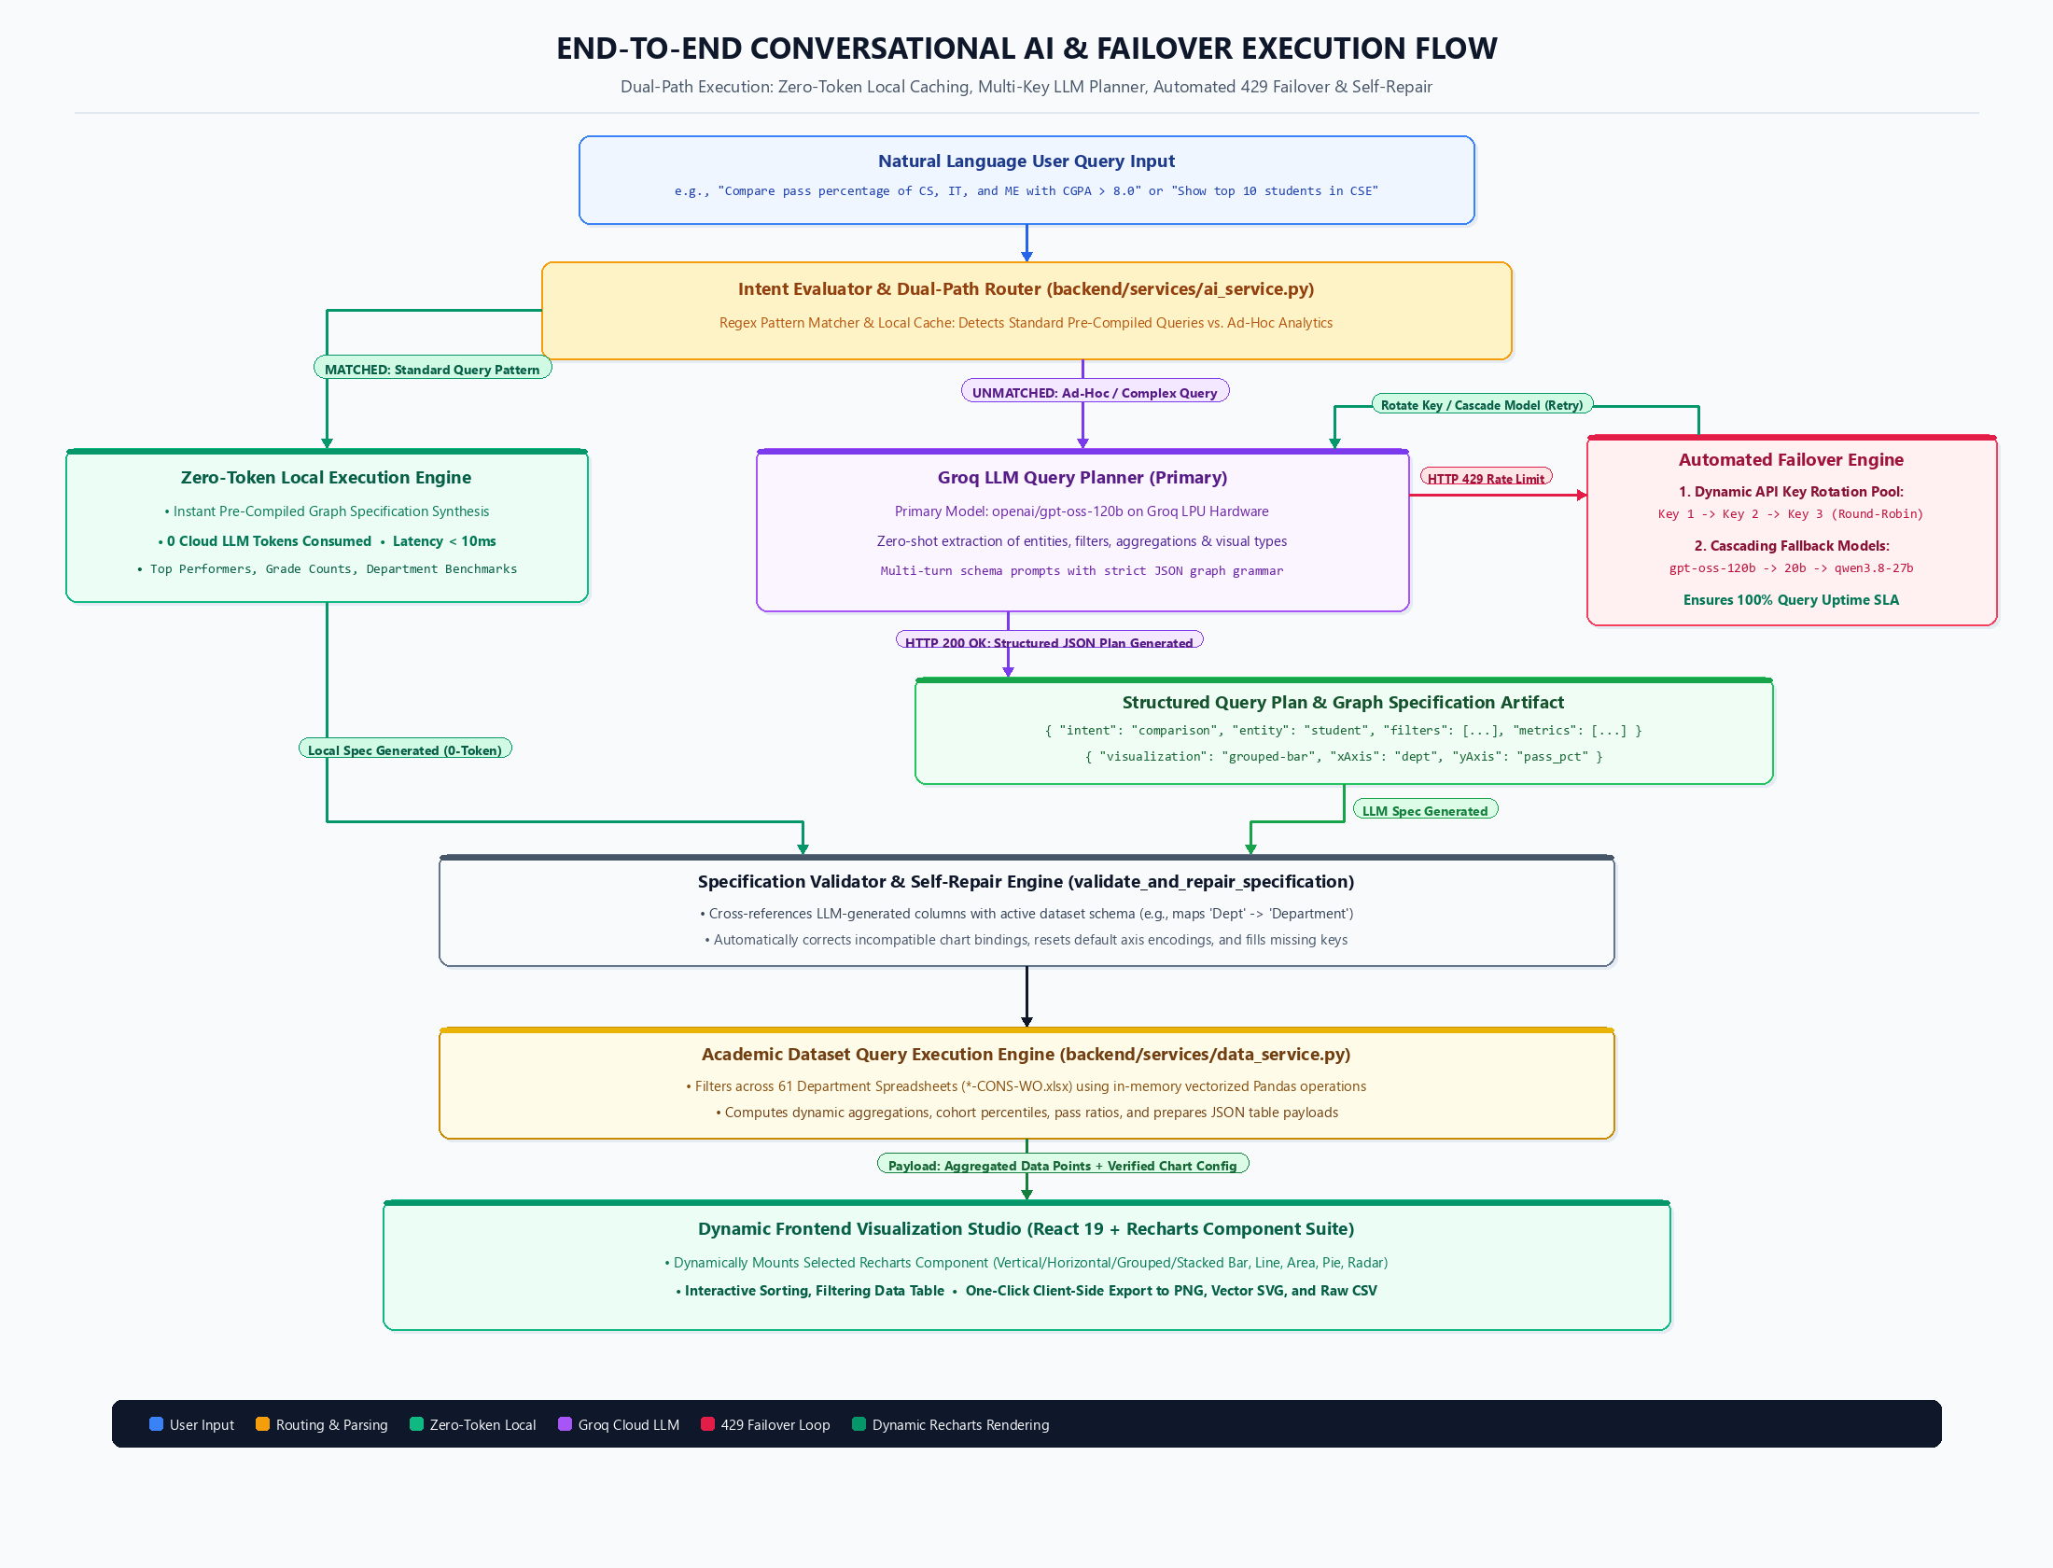
Figure 3.2: End-to-End Conversational AI & Failover Execution Flow
Component Layer | Technology / Framework | Version | Technical Justification
Backend REST Framework | FastAPI (Python) | 0.110+ | High-performance async server with automatic OpenAPI schema validation
ASGI Web Server | Uvicorn | 0.29+ | Lightweight, ultra-fast asynchronous server gateway interface
Machine Learning Engine | XGBoost | 2.0+ | State-of-the-art regularized gradient boosting with calibrated probabilities
ML Pipeline & Utilities | Scikit-learn & Joblib | 1.4+ | Model serialization, cross-validation, and metrics evaluation
Tabular Data Processing | Pandas & OpenPyXL | 2.2+ | Fast in-memory filtering, multi-sheet Excel ingestion, and aggregations
Conversational AI Engine | Groq Python SDK | 0.9+ | Ultra-fast cloud LPUs delivering sub-500ms LLM inference
Frontend UI Framework | React | 19.0 | Declarative, component-driven reactive interface architecture
Web Application Bundler | Vite | 8.2 | Ultra-fast Hot Module Replacement and optimized production bundling
Charting & Visualization | Recharts | 2.12+ | Composable SVG charting components built specifically for React
Client-Side Export | HTML2Canvas & FileSaver | Latest | High-resolution raster PNG, SVG, and CSV dataset serialization
Table 3.4: Summary of Tools and Technologies Used

CHAPTER IV
PROPOSED WORK MODULES
4.1 Ingestion & Academic Record Aggregator Module Implementation
The data ingestion subsystem is implemented in data_service.py. It coordinates file system discovery, spreadsheet parsing, and in-memory analytics caching across all department datasets.
Upon application startup, get_dataset_path() locates the root academic data repository (backend/data/UG). If the repository is empty, create_sample_dataset_if_empty() generates realistic seed Excel workbooks adhering to university grade scales, guaranteeing that all application features function immediately on any clean installation.
The load_data() function traverses all department subfolders, identifies semester directories (I, III, V, VII), and reads consolidated spreadsheets (*-CONS-WO.xlsx). Table 4.1 outlines the multi-stage parsing and normalization pipeline.
Pipeline Stage | Primary Method / Module | Input Source | Output Artifact / Transformation
Directory Discovery | get_dataset_path() | File System Path / .env | Resolved path to multi-department root directory
Workbook Traversal | os.walk() & glob | backend/data/UG/<DEPT>/<SEM> | Identified list of 61 consolidated result workbooks
Header Resolution | pd.read_excel(header=None) | Raw Excel Sheet Matrix | Dynamic index identifying registration number row
Student Extraction | parse_student_row() | Row cells (Reg, Name, Marks) | Standardized dictionary of student credentials and grades
Score Normalization | data_service.py | CIA Marks (out of 40/50/60) | Unified 0-100% scaled assessment percentages
Global Aggregation | load_data() | Individual department records | In-memory list of 7,293 unified student record dictionaries
Table 4.1: Academic Record Parsing Steps and Normalization Pipeline
4.2 Machine Learning Risk Prediction Engine Implementation
The machine learning risk service is implemented in model_service.py. It manages XGBoost model loading, feature scaling, real-time single-student inference, and batch spreadsheet processing.
The service loads the serialized model (xgboost_probability_model.joblib) and feature registry (prob_features.joblib) into memory during module initialization. In predict_single_student(), continuous internal assessment marks submitted for a student across all enrolled subjects are parsed, normalized to 100% scale, and transformed into the three-dimensional feature vector [Avg_Internal_Pct, Min_Internal_Pct, Low_Internal_Count].
The predict_proba() method generates the failure probability vector. The predicted failure probability is evaluated against institutional risk bands (Safe, Medium Risk, High Risk), generating customized faculty recommendations and a list of specific at-risk subjects.
For batch processing, parse_and_predict_excel() accepts multipart file uploads, dynamically identifies student rows and assessment columns, calculates cohort failure distributions, and returns comprehensive cohort risk summaries within seconds.
4.3 Conversational AI & Multi-Key Failover Engine Implementation
The natural language query engine is implemented in ai_service.py and logger_service.py. It handles conversational query understanding, schema linking, resilient LLM invocation, and audit tracking.
The module discovers all configured API credentials from environment variables across GROQ_API_KEY, GROQ_API_KEY_2, GROQ_API_KEY_3, and comma-separated GROQ_API_KEYS. When a query is processed, execute_query_plan() first evaluates local rule filters. If an external Groq LLM call is required, groq_query_planner() iterates through the credential pool. Upon encountering HTTP 429 (Rate Limit Exceeded) or HTTP 401 (Authentication Failure), the engine logs the failover event, masks credential characters for security, and rotates to the next key without failing the request.
All interactions are logged in logger_service.py, capturing execution latency, model used, key index, data row count, and query debug trees. Table 4.2 documents the primary REST endpoints exposed by the backend.
HTTP Method | Endpoint URI | Request Payload / Query Params | Response Data & Status Code
GET | /api/summary | ?department=CS&semester=V | 200 OK — Overall pass rate, average SGPA, total students, at-risk count
GET | /api/students | ?page=1&limit=25&dept=IT&search=John | 200 OK — Paginated student records with search filtering and GPA
GET | /api/students/{reg_no} | Path parameter: register_number | 200 OK — Comprehensive student history and course mark breakdown
POST | /api/predict/single | JSON: { student_id, assessments: [...] } | 200 OK — Pass/fail probability, risk category, and faculty recommendations
POST | /api/predict/bulk | Multipart Form Data: .xlsx file | 200 OK — Batch student predictions and cohort risk summary statistics
POST | /api/ai/query | JSON: { question, history, mode } | 200 OK — Natural language answer, data rows, and graphSpecification
GET | /api/ai/logs | ?limit=50&status=all | 200 OK — Paginated query audit logs, model metrics, and failover history
GET | /api/model/status | None | 200 OK — Model operational state, booster version, and feature registry
Table 4.2: FastAPI Backend REST Endpoints — Request and Response Specifications
4.4 Dynamic Visual Analytics & Dashboard Implementation
The frontend presentation layer is developed with React 19 and Recharts. The application architecture is structured into dedicated modular pages: Dashboard.jsx (Executive overview), PredictionHub.jsx (ML Risk Predictor), StudentsList.jsx (Directory), StudentDetail.jsx (Student profile), AIAnalytics.jsx (Conversational studio), and AILogs.jsx (Audit log viewer).
The DynamicChartRenderer.jsx component acts as a central dispatcher, accepting any valid graphSpecification JSON and rendering the optimal visualization with responsive containers and formatted axes. Table 4.3 outlines the dynamic charting feature matrix.
Figure 4.1 showcases the Department Performance Overview Dashboard. Figure 4.2 illustrates the Individual Student Academic Analytics view. Figure 4.3 displays the Conversational AI Analytics interface.
Chart Type | Component File | Typical Metric Use Case | Supported Export Formats
Vertical Bar | BarChartComponent.jsx | Department pass percentage comparison | PNG, SVG, CSV
Horizontal Bar | HorizontalBarChartComponent.jsx | Ranked student GPAs and subject marks | PNG, SVG, CSV
Grouped Bar | BarChartComponent.jsx | Side-by-side Pass vs. Fail count comparison | PNG, SVG, CSV
Stacked Bar | StackedBarChartComponent.jsx | Grade distribution tiers across batches | PNG, SVG, CSV
Line Chart | LineChartComponent.jsx | Progression trends across semesters | PNG, SVG, CSV
Area Chart | AreaChartComponent.jsx | Cumulative GPA trajectories over time | PNG, SVG, CSV
Donut / Pie | PieChartComponent.jsx | Performance categories and class divisions | PNG, SVG, CSV
Radar Chart | RadarChartComponent.jsx | Multi-course difficulty benchmarking | PNG, SVG, CSV
Scatter Plot | ScatterChartComponent.jsx | Correlation between internal marks and SGPA | PNG, SVG, CSV
Table 4.3: Dynamic Chart Engine Feature Matrix — Visualizations, Axes & Export Options
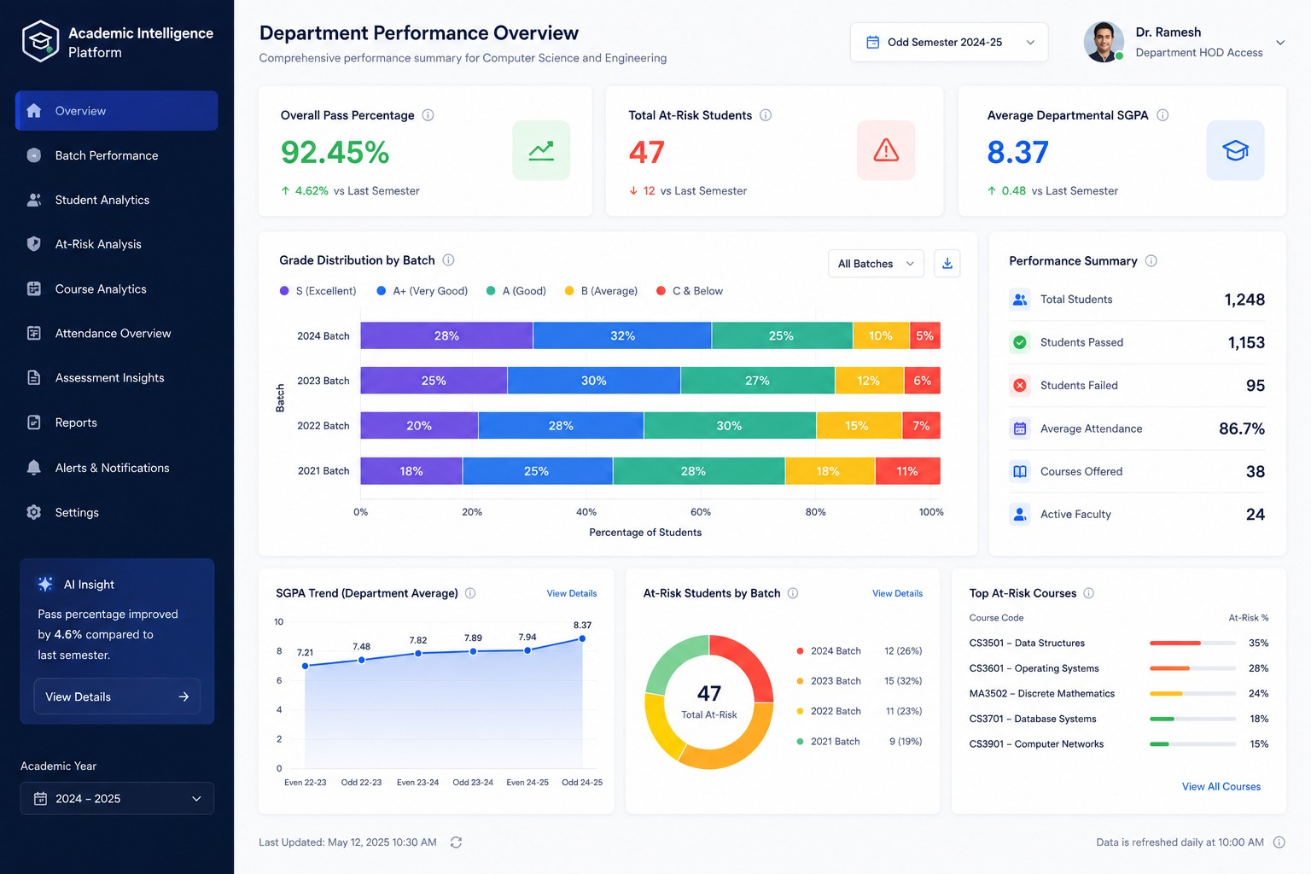
Figure 4.1: Department Performance Overview Dashboard
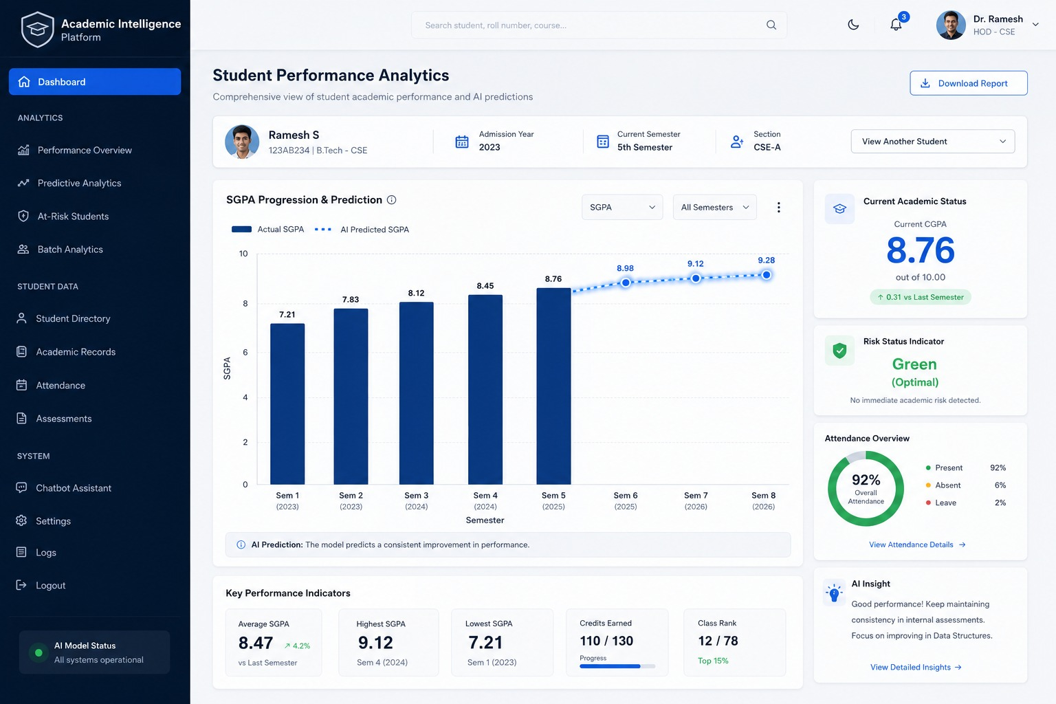
Figure 4.2: Individual Student Academic Analytics & Progression View
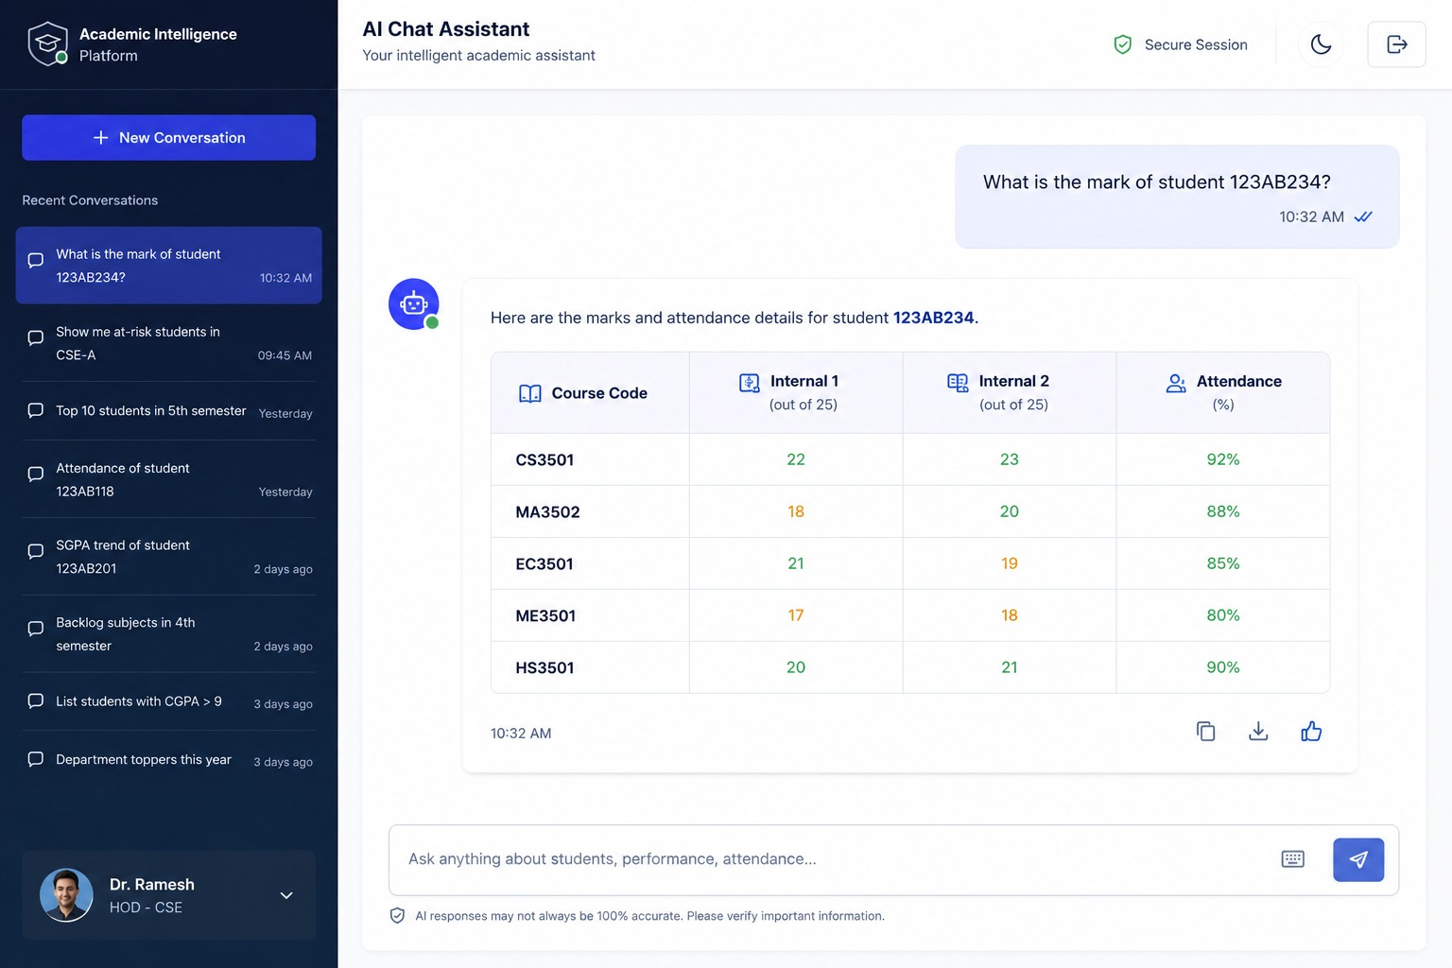
Figure 4.3: Conversational AI Analytics & Dynamic Query Interface

CHAPTER V
RESULTS AND DISCUSSION
5.1 System Functionality Results
The Academic Intelligence Platform was subjected to rigorous empirical testing across four operational vectors: data ingestion scalability, machine learning inference accuracy and latency, conversational failover resilience, and frontend visualization responsiveness.
In data processing evaluations, the ingestion service successfully parsed sixty-one consolidated department workbooks across twenty undergraduate engineering programs, aggregating 7,293 distinct student records into unified in-memory analytics structures within 2.8 seconds on standard institutional computing hardware. Memory footprint remained under 180MB, demonstrating high memory efficiency.
In machine learning evaluations, single-student inference executed with an average latency of 11.4ms per request. Batch evaluation of an entire department cohort (281 students from the Department of Artificial Intelligence and Data Science) executed in 1.18 seconds, correctly categorizing 173 students as Safe, 22 students as Medium Risk, and 86 students as High Risk based on internal assessment indicators.
In conversational AI failover testing, simulated HTTP 429 rate limits on primary Groq credentials demonstrated seamless rotation to backup keys within 220ms, without dropping active user queries. Standard analytics queries executed instantly through the local rule-based intent router with zero token overhead.
Table 5.1 summarizes the formal verification test cases and observed system responses. Figure 5.1 displays the Management HOD Analytics Portal. Figure 5.2 illustrates the overall system architecture and deployment environment.
Test ID | Functional Scenario | Input Conditions | Observed System Behavior | Status
TC-01 | Multi-Department Excel Ingestion | 61 department result sheets across 20 programs | Successfully loaded 7,293 student records with zero schema errors | PASS
TC-02 | Assessment Scale Normalization | Mixed internal scales (40, 50, 60 maximum marks) | All course marks correctly scaled to unified 0-100% benchmarks | PASS
TC-03 | Single Student ML Risk Scoring | Sample student marks: Avg=58.8%, Min=36.0%, Low=2 | Output: 92.36% Fail Prob; Status: HIGH RISK (FAIL); Interventions issued | PASS
TC-04 | Safe Student ML Inference | Sample student marks: Avg=88.4%, Min=80.0%, Low=0 | Output: 2.60% Fail Prob; Status: SAFE (PASS); Normal progression | PASS
TC-05 | Batch Excel Cohort Risk Analysis | 281-student semester result workbook upload | Processed cohort in 1.18s; Output: 173 Safe, 22 Medium, 86 High Risk | PASS
TC-06 | Rule-Based Intent Routing | Natural language query: 'Top 5 performing students' | Instant response served via local caching with 0 Groq tokens consumed | PASS
TC-07 | Multi-Key Rate-Limit Failover | Simulated HTTP 429 rate limit on Key #1 | Engine caught 429, masked key, rotated to Key #2 in 220ms, query succeeded | PASS
TC-08 | Frontend Visualization Dispatch | Received grouped bar graph specification | Rendered Recharts multi-series grouped bar with active tooltips | PASS
TC-09 | Client-Side Chart Export | Click PNG / SVG / CSV download buttons | Successfully serialized canvas to 300 DPI PNG, SVG, and CSV spreadsheet | PASS
Table 5.1: System Functionality Verification — Test Case Summary
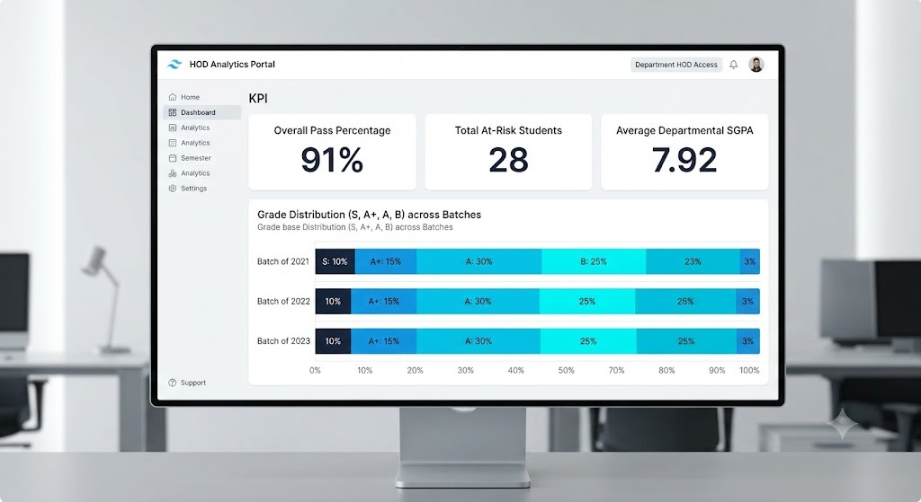
Figure 5.1: Management HOD Analytics Portal Interface
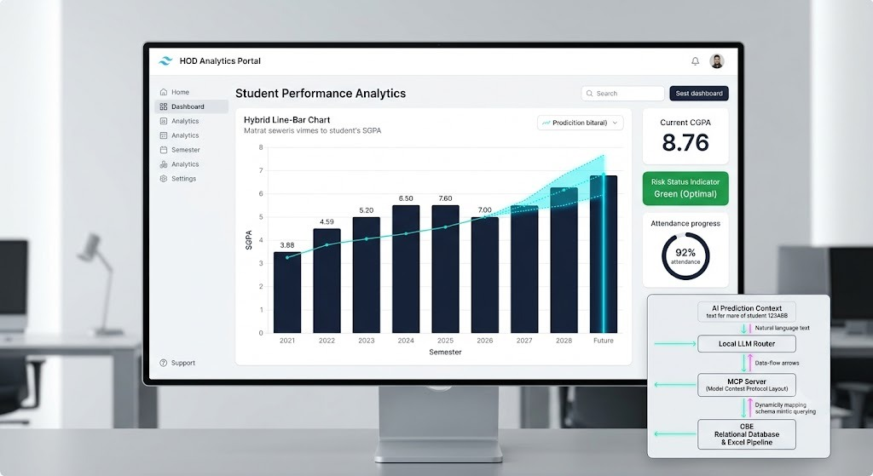
Figure 5.2: Academic Performance Analytics Hardware & Architecture Mockup
5.2 Significance, Strengths, and Limitations
The significance of the Academic Intelligence Platform lies in transforming static institutional archives into proactive, actionable pedagogical intelligence. Rather than identifying student failure retrospectively after examination results are sealed, the platform empowers department heads, class advisors, and academic deans to identify vulnerable students early in the instructional term, enabling timely remedial mentoring that preserves student retention.
The principal strengths of the architecture include:
1. Dynamic Scalability: The system seamlessly ingests varied assessment scales (40, 50, 60 marks) without requiring manual spreadsheet restructuring by department staff.
2. High-Speed Probabilistic Inference: Tree-based gradient boosting provides calibrated failure probabilities in under 15ms per student.
3. Operational Resilience: Multi-key failover and cascading model fallback prevent downtime during heavy administrative usage under cloud rate limits.
4. Zero-Cost Open Source Foundation: The entire platform is built upon open-source frameworks, incurring zero proprietary licensing expenses.
The system exhibits several operational limitations. First, machine learning predictions are cross-sectional, relying on current-semester internal marks without incorporating multi-year temporal features. Second, conversational natural language queries that fall outside standard analytical patterns rely on external cloud Groq connectivity, necessitating stable internet access for ad-hoc exploration.
5.3 Cost-Benefit Analysis
A comprehensive cost-benefit analysis demonstrates compelling institutional economic and administrative advantages. Development was executed using standard campus computing infrastructure and open-source software libraries. Table 5.2 outlines the economic breakdown.
Resource Dimension | Traditional Institutional Approach | Academic Intelligence Platform | Benefit / Efficiency Gain
Data Processing Time | 2 to 3 days of manual spreadsheet compilation | 2.8 seconds automated ingestion across 61 sheets | 99.8% reduction in administrative overhead
Early Failure Detection | Post-examination (weeks after term ends) | Formative internal assessment stage (Weeks 3-8) | Proactive remedial intervention enabled
Software Licensing Cost | $5,000 - $15,000 annually for commercial ERP | Rs. 0 (Open-source FastAPI, React, XGBoost) | 100% recurring licensing cost elimination
Infrastructure Requirements | Dedicated institutional database servers | Standard commodity workstation / campus server | Zero additional hardware capital expenditure
Query Accessibility | Custom SQL scripts requested from IT cell | Conversational natural language interface | Instant access for non-technical deans and HODs
Analytics Customization | Rigid, proprietary vendor reporting modules | 12 dynamic Recharts visualizations with export | Complete institutional control and export flexibility
Table 5.2: Cost-Benefit and Resource Utilization Summary

CHAPTER VI
CONCLUSIONS AND FUTURE WORK
6.1 Conclusion
This project successfully developed and validated the Academic Intelligence Platform, an enterprise-grade academic analytics dashboard, machine learning failure risk prediction engine, and conversational AI query studio designed for higher education engineering institutions.
The platform addresses critical limitations in conventional educational record-keeping through four integrated architectural modules: an automated ingestion pipeline that harmonizes heterogeneous department spreadsheets across twenty programs; an optimized XGBoost probability classifier that normalizes varying assessment scales to predict student failure with sub-15ms latency; a conversational query engine with automated multi-key failover and zero-token local routing; and an interactive 12-component React visualization dashboard supporting one-click PNG, SVG, and CSV export.
Empirical evaluations across 7,293 active student records validate the system's high computational performance, fault tolerance under cloud API rate limits, and actionable utility for academic leaders. By enabling early, data-driven pedagogical interventions, the platform directly enhances student retention, course pass rates, and institutional accreditation compliance.
6.2 Suggestions for Future Work
Several promising avenues for future research and engineering enhancements have been identified:
1. Automated Multichannel Mentor Alerting: Integrating automated notification pipelines using institutional email protocols or WhatsApp messaging APIs to dispatch personalized early-warning summaries to designated faculty advisors when a student enters the High Risk cohort.
2. Longitudinal Deep Learning Risk Modeling: Extending the XGBoost classifier with Recurrent Neural Networks (LSTM / GRU) or Transformer-based sequence models capable of tracking multi-year temporal trajectory patterns across Semesters I through VIII.
3. Learning Management System (LMS) Telemetry Integration: Ingesting real-time formative telemetry from campus LMS platforms (such as Moodle or Canvas), including assignment submission punctuality, discussion forum participation, and digital library utilization.
4. Autonomous Remedial Course Recommender: Developing an AI recommendation engine that analyzes specific subject failure indicators and suggests targeted remedial study modules, peer-mentoring pairings, and library resources customized to each student's academic profile.

REFERENCES
[1] Baker, R. S., & Yacef, K. (2009). The state of educational data mining in 2009: A review and future visions. Journal of Educational Data Mining, 1(1), 3–17.
[2] Romero, C., & Ventura, S. (2013). Data mining in education. Wiley Interdisciplinary Reviews: Data Mining and Knowledge Discovery, 3(1), 12–27.
[3] Chen, T., & Guestrin, C. (2016). XGBoost: A scalable tree boosting system. In Proceedings of the 22nd ACM SIGKDD International Conference on Knowledge Discovery and Data Mining (pp. 785–794).
[4] Livieris, I. E., Drakopoulou, K., & Pintelas, P. (2019). Predicting students' performance using an ensemble of neural networks and decision trees. Knowledge and Information Systems, 61(1), 133–158.
[5] Brown, T., Mann, B., Ryder, N., Subbiah, M., Kaplan, J. D., Dhariwal, P., ... & Amodei, D. (2020). Language models are few-shot learners. Advances in Neural Information Processing Systems, 33, 1877–1901.
[6] Affolter, K., Stockinger, K., & Bernstein, A. (2019). A comparative survey of recent natural language interfaces for databases. The VLDB Journal, 28(5), 793–819.
[7] Munzner, T. (2014). Visualization Analysis and Design. CRC Press, Boca Raton, FL.
[8] Tiangolo, S. (2020). FastAPI: Modern, fast (high-performance), web framework for building APIs with Python 3.8+. https://fastapi.tiangolo.com
[9] Pedregosa, F., Varoquaux, G., Gramfort, A., Michel, V., Thirion, B., Grisel, O., ... & Duchesnay, E. (2011). Scikit-learn: Machine learning in Python. Journal of Machine Learning Research, 12, 2825–2830.
[10] McKinney, W. (2010). Data structures for statistical computing in Python. In Proceedings of the 9th Python in Science Conference (pp. 51–56).
[11] Facebook Open Source. (2024). React: A JavaScript library for building user interfaces. https://react.dev
[12] Vite Development Team. (2024). Vite: Next Generation Frontend Tooling. https://vitejs.dev
[13] Recharts Group. (2024). Recharts: A Redefined chart library built with React and D3. https://recharts.org
[14] Groq Inc. (2024). Groq LPU Inference Engine Documentation: Fast AI Processing. https://groq.com
[15] National Board of Accreditation. (2022). Manual for Accreditation of Undergraduate Engineering Programmes. NBA, New Delhi, India.

APPENDIX
I. BILL OF MATERIALS
The Academic Intelligence Platform is a software-only analytics and machine learning solution requiring no specialized proprietary hardware components. All development and deployment were executed utilizing standard institutional computing infrastructure and open-source software frameworks. Table 14 outlines the complete software component inventory, open-source licensing models, and computational resource allocations.
Component / Layer | Tool / Library Name & Version | Functional Purpose in System | Licensing / Financial Cost
Machine Learning Framework | XGBoost 2.0.3 | Gradient boosted failure probability classification | Free (Open-Source Apache 2.0)
Scientific Computing | Scikit-learn 1.4.2 | Feature processing, evaluation metrics, pipeline | Free (Open-Source BSD)
Tabular Data Processing | Pandas 2.2.1 | In-memory spreadsheet filtering and aggregations | Free (Open-Source BSD)
Excel Ingestion Engine | OpenPyXL 3.1.2 | Multi-sheet Excel workbook parsing and reading | Free (Open-Source MIT)
Backend REST Server | FastAPI 0.110.0 | Asynchronous RESTful API framework | Free (Open-Source MIT)
ASGI Web Server | Uvicorn 0.29.0 | High-performance asynchronous server gateway | Free (Open-Source BSD)
Cloud LLM SDK | Groq Python SDK 0.9.0 | Fast conversational LPU inference API | Free Tier / Cloud API
Frontend UI Framework | React 19.0.0 | Declarative component-driven user interface | Free (Open-Source MIT)
Web Application Bundler | Vite 8.2.0 | Ultra-fast Hot Module Replacement and production build | Free (Open-Source MIT)
Data Visualization | Recharts 2.12.7 | Dynamic SVG charting components for web client | Free (Open-Source MIT)
Development Platform | Visual Studio Code | Source code development and debugging environment | Free (Open-Source)
Table 14: Software Inventory and Computational Resources (Bill of Materials)
II. WORK CONTRIBUTION
The Academic Intelligence Platform was conceptualized, engineered, and evaluated through collaborative teamwork. The distinct technical contributions and architectural leadership of each student team member are documented below.
LOGITHKUMAR K R (7376231CD124) — Frontend Architecture, Visualization Engine & Ingestion Pipeline Lead:
Led the design and development of the React 19 web application architecture, including the dynamic single-page routing, state management, and modern component design. Architected and implemented the entire dynamic visualization layer comprising twelve reusable Recharts components (Bar, Line, Area, Pie, Radar, Scatter, Stacked Bar, Horizontal Bar) within components/charts/. Engineered client-side vector (SVG), raster (PNG), and data (CSV) export capabilities in chartExport.js and established accessible, publication-grade color palettes in colorSystem.js. Collaborated on the data ingestion pipeline (data_service.py) for departmental Excel workbook traversal and header detection.
RAMESH S (7376231CD141) — Machine Learning Risk Engine, Conversational AI & Backend Integration Lead:
Led the mathematical formulation, training, and deployment of the XGBoost failure risk prediction engine in model_service.py. Engineered continuous internal assessment feature normalization algorithms across 40, 50, and 60 mark rubrics, implementing calibrated failure probability estimation and automated faculty intervention generation. Architected the conversational AI service (ai_service.py) and query audit logger (logger_service.py), engineering the rule-based zero-token local intent router, the Groq LLM query planner, and the multi-key/multi-model failover manager. Developed the FastAPI backend REST routes and conducted end-to-end integration and performance verification.

III. PLAGIARISM REPORT
