FINTEL: AN AI-POWERED PERSONAL FINANCE TRACKING, FORECASTING AND FINANCIAL HEALTH SCORING SYSTEM
A PROJECT BASED LEARNING (PBL) REPORT
Submitted
by
LOGITH RAJA G (Reg. No: 2104251043010)
SWASI MKS (Reg. No: 2104251043025)
Submitted in partial fulfilment of the requirements
for the
Project-Based Learning component of Java Programming
BACHELOR OF ENGINEERING
in
COMPUTER SCIENCE AND ENGINEERING


CHENNAI INSTITUTE OF TECHNOLOGY
(Autonomous)
Affiliated to Anna University, Chennai
October - 2026

VISION OF THE INSTITUTE
To be an eminent centre for Academia, Industry and Research by imparting knowledge, relevant practices and inculcating human values to address global challenges through novelty and sustainability.
MISSION OF THE INSTITUTE
- IM1. To create next generation leaders by effective teaching learning methodologies and instill scientific spark in them to meet the global challenges.
- IM2. To transform lives through deployment of emerging technology, novelty and sustainability.
- IM3. To inculcate human values and ethical principles to cater the societal needs.
- IM4. To contribute towards the research ecosystem by providing a suitable, state-of-the-art infrastructure and environment.

DEPARTMENT OF COMPUTER SCIENCE AND ENGINEERING
VISION OF THE DEPARTMENT
To Excel in the emerging areas of Computer Science and Engineering by imparting knowledge, relevant practices and inculcating human values to transform the students as potential resources to contribute innovatively through advanced computing in real time situations.
MISSION OF THE DEPARTMENT
- DM1. To provide strong fundamentals and technical skills for Computer Science applications through effective teaching learning methodologies.
- DM2. To transform lives of the students by nurturing ethical values, creativity and novelty to become Entrepreneurs and establish start-ups.
- DM3. To habituate the students to focus on sustainable solutions to improve the quality of life and the welfare of the society.

BONAFIDE CERTIFICATE
This is to certify that the Project–Based Learning report titled “FINTEL: AN AI-POWERED PERSONAL FINANCE TRACKING, FORECASTING AND FINANCIAL HEALTH SCORING SYSTEM” is a Bonafide record of work carried out by LOGITH RAJA G (Reg. No: 2104251043010) and SWASI MKS (Reg. No: 2104251043025) of the Department of Computer Science and Engineering, Chennai Institute of Technology, as part of the continuous, mentor-guided Project-Based Learning (PBL) component of the Java Programming course during the academic year 2026–2027 under my supervision.
Submitted for the final review held on …………………….
SIGNATURE  Dr. S. Pavithra M.E., Ph.D.  HEAD OF THE DEPARTMENT  Professor and Head,  Department of Computer Science and Engineering  Chennai Institute of Technology, Chennai - 69 | SIGNATURE  MENTOR NAME  SUPERVISOR  Designation,  Department of Computer Science and Engineering  Chennai Institute of Technology, Chennai - 69

DECLARATION
I/We jointly declare that the PBL report on “FINTEL: AN AI-POWERED PERSONAL FINANCE TRACKING, FORECASTING AND FINANCIAL HEALTH SCORING SYSTEM” is the result of original work done by us and best of our knowledge, similar work has not been submitted to “ANNA UNIVERSITY CHENNAI” for the requirement of Degree of BACHELOR OF ENGINEERING. This PBL report is submitted in partial fulfilment of the requirement of the award of Degree of COMPUTER SCIENCE AND ENGINEERING.
Signature
LOGITH RAJA G
SWASI MKS
Place: Chennai
Date:

ACKNOWLEDGEMENT
We wish to express our sincere gratitude to our honourable Chairman SHRI. P. SRIRAM for providing immense facilities at our institution.
We are very proudly rendering our thanks to our Principal Dr. A. RAMESH M.E., Ph.D., for the facilities and the encouragement given by him to the progress and completion of our project.
We would like to express special thanks of gratitude to our Dean Dr. V. SRINIVASA RAO, M.E., Ph.D., who has been the key spring of motivation to us throughout the completion of our course and project work.
We proudly render our immense gratitude to the Head of the Department Dr. S. PAVITHRA M.E., Ph.D., for her effective leadership, encouragement and guidance in the project.
We would like to extend our thanks to the Project Co-ordinator <NAME, DESIGNATION>, Department of Computer Science and Engineering, for their valuable suggestions throughout this project.
We wish to acknowledge the help received from the class advisors <NAME, DESIGNATION>, of the Department of Computer Science and Engineering and others for providing valuable suggestions and for the successful completion of the project.
LOGITH RAJA G 2104251043010
SWASI MKS 2104251043025

ABSTRACT
Personal financial management using conventional spreadsheets and manual record-keeping is highly error-prone and exclusively retrospective, failing to alert users before a budget is breached or a savings goal falls off track. This Project-Based Learning (PBL) work addresses that gap with Fintel, a secure, full-stack, pure-Java personal finance tracking, forecasting and financial-health-scoring system. Fintel is built on a decoupled client-server architecture: a JavaFX 23 desktop client communicates over REST with a Spring Boot 3 backend. The application enforces stateless JWT authentication, BCrypt password hashing, and strict per-user data isolation, with persistence handled through Spring Data JPA/Hibernate on a MySQL 8 database. Beyond standard transaction, multi-period budget and savings-goal tracking, Fintel layers in statistical analytics using Apache Commons Math — ordinary least-squares linear regression for category-wise spending forecasts, a 1,000-iteration Monte Carlo engine for what-if purchase simulations, a coefficient-of-variation-based vulnerability classifier, and an automated 0–100 Financial Health Score across four weighted components. A multi-LLM AI proxy (OpenAI, Mistral and Google Gemini, with automatic fallback) powers a conversational assistant capable of executing in-app actions, plus AI-based receipt scanning and voice interaction. The system was validated with 118 automated JUnit 5 and Mockito tests, all of which passed, confirming Fintel as a reliable, proactive personal-finance management solution.
Keywords: JavaFX, Spring Boot, Financial Health Score, Monte Carlo Simulation, JWT Security, Multi-LLM AI.

TABLE OF CONTENTS
ABSTRACT iii
LIST OF TABLES xvi
LIST OF FIGURES xviii
LIST OF ABBREVIATIONS xxvii
1. INTRODUCTION
1.1 Background
1.2 Driving Question
1.3 Objectives
1.4 Scope and Limitations
2. CONCEPT EXPLORATION
2.1 Related Approaches
2.2 Summary Table
2.3 What This Told Us
3. PROJECT PLANNING AND TEAM ORGANISATION
3.1 Weekly PBL Progress Log
3.2 Requirements
3.3 Feasibility
4. ITERATIVE DESIGN AND DEVELOPMENT
4.1 System Architecture
4.2 Baseline
4.3 Project Refinement
4.4 Final Approach
4.5 Testing and Execution
5. IMPLEMENTATION
5.1 Module Description
5.2 Key Code Snippets
5.3 User Interface / Demo
6. RESULTS AND DISCUSSION
6.1 Evaluation Metrics
6.2 Results Across Iterations
6.3 Discussion
6.4 Limitations
7. TEAM REFLECTION AND LEARNING OUTCOMES
8. CONCLUSION AND FUTURE SCOPE
REFERENCES
APPENDIX

LIST OF TABLES
TABLE NO. | TITLE | PAGE NO.
2.1 | Summary table of related approaches | -
3.1 | Weekly PBL progress log | -
3.2 | Hardware and software requirements | -
5.1 | Core REST API endpoints | -
6.1 | Results across iterations | -
A.1 | Self and peer assessment | -

LIST OF FIGURES
FIGURE NO. | TITLE | PAGE NO.
4.1 | System architecture diagram | -
4.2 | Entity-relationship diagram of the core data model | -
4.3 | AI intent execution flow | -
5.1 | JWT authentication and refresh flow | -
5.2 | Screenshot 5.1 — "Create New Transaction" input dialog | -
5.3 | Screenshot 5.2 — Fintel main dashboard view | -
5.4 | Interactive financial analytics and category spending breakdown charts | -
5.5 | Proactive AI spending anomaly detection and notification modal | -
5.6 | Fintel AI conversational financial assistant interface | -
5.7 | Category budget progress and expenditure tracking table | -
5.8 | Savings goal creation dialog for target planning | -
5.9 | Predictive What-If scenario simulation engine | -
5.10 | User authentication and secure JWT login interface | -
5.11 | Financial data export (CSV/PDF) utility | -
5.12 | Real-time world currency converter utility | -
5.13 | Transaction category management interface | -
6.1 | Automated test distribution by class | -

LIST OF ABBREVIATIONS
Abbreviation | Full Form
JDK | Java Development Kit
OOP | Object-Oriented Programming
JDBC | Java Database Connectivity
JPA | Java Persistence API
ORM | Object Relational Mapping
JWT | JSON Web Token
REST | Representational State Transfer
API | Application Programming Interface
CRUD | Create, Read, Update, Delete
LLM | Large Language Model
CO | Course Outcome

CHAPTER 1
INTRODUCTION
1.1 BACKGROUND
Personal financial management is a challenge most individuals face regardless of income level. Manually recording expenses in notebooks or spreadsheets is time-consuming, error-prone, and rarely provides insight beyond a simple running total. Without a systematic way to categorize spending, track budgets against savings goals, or anticipate future cash flow, users tend to discover overspending only after it has already happened.
This problem area sits at the intersection of everyday personal-finance habits and the kind of structured, rule-based and data-driven processing that a Java application is well suited to provide. A desktop or client-server application can enforce consistent categorisation, apply statistical techniques to historical transaction data, and surface warnings before a budget is breached rather than after.
This project, Fintel, addresses that gap by building a Java-based personal finance tracker that goes beyond simple record-keeping to include budget monitoring, savings-goal tracking, predictive forecasting, and an overall financial health score, all secured behind per-user authentication.
1.2 DRIVING QUESTION
“Can we build a secure, Java-based personal finance application that not only records income and expenses accurately, but also forecasts a user's future spending and expresses their overall financial health as a single, understandable score?”
This was narrowed into a concrete, buildable Java task across the PBL cycle: (1) designing a normalised set of entity classes (users, accounts, transactions, categories, budgets, savings goals) using OOP principles, (2) implementing a Spring Boot REST API with JPA/Hibernate persistence to MySQL and JWT-based authentication, (3) building a JavaFX client that consumes this API, and (4) layering statistical modules — a regression-based forecaster, a Monte Carlo scenario simulator, a vulnerability classifier, and a health-score calculator — on top of the transaction data, then testing all of it with JUnit and Mockito.
1.3 OBJECTIVES
- To analyse the real-world problem of manual, error-prone personal finance tracking and identify the functional requirements for a Java-based application.
- To design and develop a Java application using appropriate OOP concepts, entity classes, service interfaces, and modular controllers/services.
- To implement database connectivity and CRUD operations using Spring Data JPA/JDBC against a MySQL database.
- To secure the application using JWT-based stateless authentication and role-based access control.
- To implement predictive features (baseline forecasting, Monte Carlo scenario simulation, and financial health scoring) using Apache Commons Math.
- To test and debug the application to verify its functionality, reliability, and error handling through automated unit and integration tests.
- To reflect on the team's approach, division of work, and what the PBL process taught each member.
1.4 SCOPE AND LIMITATIONS
The project covers single-user personal finance management: manual and recurring transaction entry, category and budget management, savings-goal tracking, AI-assisted chat and receipt scanning, baseline and what-if forecasting, and financial health scoring. It does not cover multi-currency accounting beyond a simple converter, bank-account aggregation via open banking APIs, or multi-tenant/enterprise deployment. Forecasting accuracy depends on the depth of a user's transaction history (a minimum of three months of data is required for regression-based forecasting), and the AI assistant's responses depend on the availability and quality of third-party LLM APIs (OpenAI, Mistral, Gemini).

CHAPTER 2
CONCEPT EXPLORATION
Before building Fintel, the team reviewed Java documentation, framework references and established design patterns for financial applications, grouped below by the two broad approaches that were considered.
2.1 RELATED APPROACHES
2.1.1 Traditional Java Application Approach
A traditional approach would use Core Java with plain JDBC for persistence, java.util.Collections for in-memory data handling, and a Swing or console-based interface. This approach is straightforward to implement and requires no external framework, but it pushes the burden of connection pooling, SQL boilerplate, transaction management, and input validation entirely onto the developer, and it does not scale cleanly to a client-server architecture with authentication.
2.1.2 Java Framework-Based Approach
The alternative is a framework-based approach using Spring Boot for the server, Spring Data JPA with Hibernate as the ORM layer, Spring Security for authentication/authorisation, and a REST API consumed by a separate client (in this case JavaFX rather than a browser). Hibernate removes most hand-written SQL, Spring Security provides a tested JWT authentication pipeline, and Spring's dependency injection keeps controllers, services and repositories cleanly separated. The trade-off is a steeper initial learning curve and more configuration (security filter chains, CORS, exception handling) than the traditional approach.
2.2 SUMMARY TABLE
Ref. | Approach | Reported Result
[3] | Core Java + JDBC + Collections | Fast to prototype; no built-in security, weaker separation of concerns for a client-server design.
[4] | Spring Boot + Spring Data JPA/Hibernate + REST | More setup effort; provides tested authentication, ORM and validation, and integrates cleanly with a separate JavaFX client.
[5] | JavaFX for desktop client UI | Enables a native, responsive desktop client that consumes a REST API over HTTP.
2.3 WHAT THIS TOLD US
Because Fintel needed multi-user authentication, a clean separation between a JavaFX desktop client and a backend that could later serve other clients, and structured persistence for several related entities (users, accounts, transactions, categories, budgets, goals), the team selected the Spring Boot + Spring Data JPA/Hibernate + REST approach for Iteration 1 (Chapter 4), reserving plain Core Java/OOP techniques for the client-side logic and the statistical/forecasting modules where a lightweight, dependency-light implementation was preferable.

CHAPTER 3
PROJECT PLANNING AND TEAM ORGANISATION
3.1 WEEKLY PBL PROGRESS LOG
Table 3.1 Weekly PBL progress log
Week | Milestone / Task | Work Done | Mentor Remarks
1–2 | Problem statement, objectives, time plan, literature review and technical background. | Finalised the driving question; compared Core Java/JDBC vs Spring Boot/JPA approaches; drafted entity list. | [remarks]
3–4 | Data handling and methodology design. | Designed JPA entities (User, Account, Transaction, TransactionCategory, Budget, SavingsGoal) and the MySQL schema; set up Spring Security/JWT skeleton. | [remarks]
5–7 | Implementation and testing. | Built controllers/services for transactions, categories, budgets and savings goals; implemented ForecastService and VulnerabilityClassifier; wrote JUnit/Mockito tests. | [remarks]
8–10 | Presentation with demo. | Integrated JavaFX client with the REST API; added AI assistant and health-score dashboard; demoed CRUD and forecast flows. | [remarks]
11–12 | Final testing and documentation. | Ran full automated test suite (118 tests), fixed defects, wrote the PBL report. | [remarks]
3.2 REQUIREMENTS
Table 3.2 Hardware and software requirements
Category | Requirement
Processor / RAM | Intel i5 / 8 GB RAM (minimum)
Programming language | Java 17 (JDK 17/21 compatible)
Backend framework | Spring Boot 3.2, Spring Data JPA, Spring Security, Hibernate
Client framework | JavaFX 23
Build tool | Maven 3.9+
Libraries | JJWT 0.12.6 (JWT), Apache Commons Math 3.6.1, Bucket4j, Flyway, Gson, springdoc-openapi
Database | MySQL 8 (production), H2 (in-memory, for automated tests)
Development environment | IntelliJ IDEA / VS Code
Version control | Git / GitHub repository
3.3 FEASIBILITY
The project was achievable within the 12-week PBL timeframe because it built incrementally on skills already covered in the Java Programming course (OOP, exception handling, collections) and layered Spring Boot and JavaFX on top of them one module at a time, as shown in the weekly plan above. Each iteration produced a runnable, testable increment — persistence and authentication first, then business modules, then statistical/AI features — so the team always had a working baseline to demo even if later features slipped.

CHAPTER 4
ITERATIVE DESIGN AND DEVELOPMENT
4.1 SYSTEM ARCHITECTURE
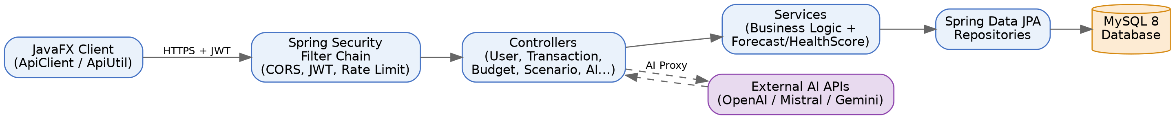
Figure 4.1 — System Architecture Diagram
The JavaFX desktop client collects user input and sends REST requests through an ApiClient/ApiUtil layer, attaching a Bearer JWT obtained at login. Requests pass through Spring Security's filter chain (CORS filter, JWT authentication filter, rate-limiting filter) before reaching the appropriate controller (User, Account, Transaction, TransactionCategory, Budget, SavingsGoal, RecurringTransaction, Scenario, HealthScore, AIProxy). Controllers delegate to services, which apply business logic and use Spring Data JPA repositories to read and write MySQL entities. Statistical services (ForecastService, VulnerabilityClassifier, ScenarioSimulationService, HealthScoreService) read the same transaction data and use Apache Commons Math for regression and Monte Carlo calculations. The AIProxyController separately forwards chat, vision and voice requests to external LLM providers (OpenAI, Mistral, Gemini) with an automatic fallback chain.
The core persistence model consists of nine JPA entities: User, Account, Transaction, TransactionCategory, Budget, SavingsGoal and RecurringTransaction hold the financial data, while RefreshToken and PasswordResetToken support the authentication flow. Every financial entity is linked back to a User via a many-to-one relationship, and every repository query is scoped to the authenticated user's ID to guarantee per-user data isolation. Figure 4.2 shows the entity-relationship structure of this data model.
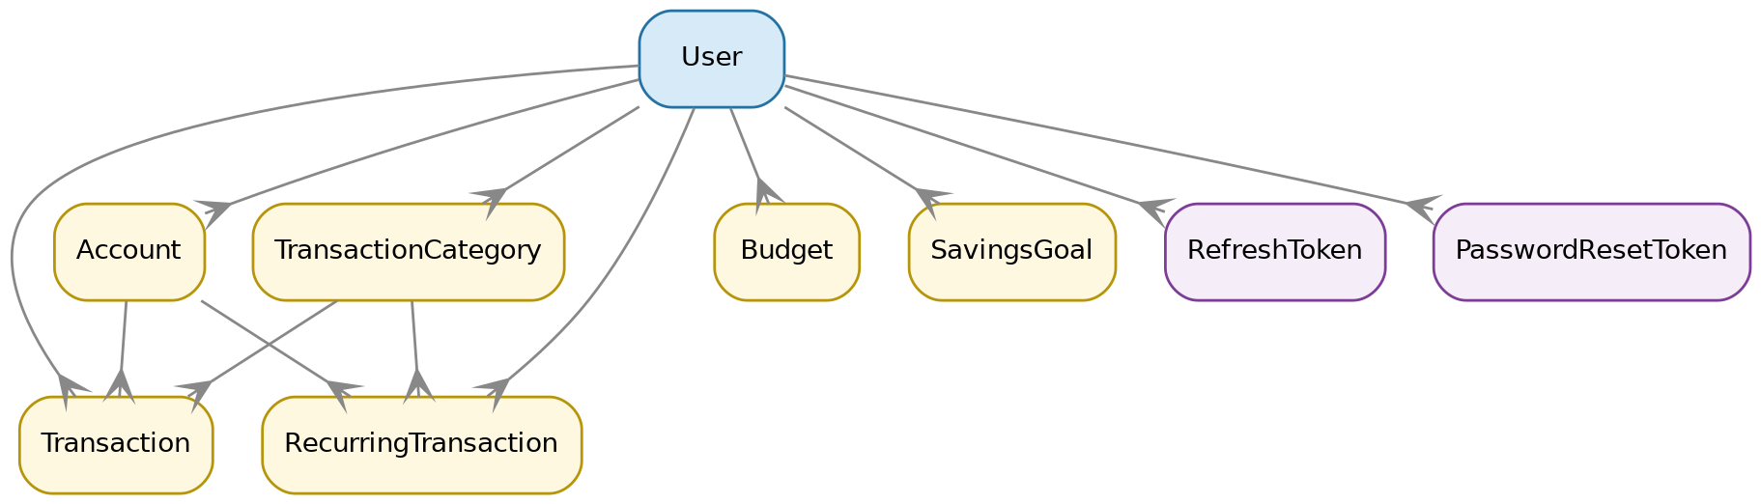
Figure 4.2 — Entity-Relationship Diagram of the Core Data Model
4.2 BASELINE
The first working version implemented the core entity classes (User, Account, Transaction, TransactionCategory) with basic getters/setters, simple JPA repositories, and controller methods for creating and listing transactions. Authentication was a minimal username/password check with no token issuance, and there was no input validation beyond null checks. It confirmed the client-server request/response cycle worked end to end but had limited validation and no security.
4.3 PROJECT REFINEMENT
Based on mentor feedback, the application was improved by introducing full OOP structuring across DTOs and entities, a global exception-handling layer (GlobalExceptionHandler with BadRequestException, ResourceNotFoundException, DuplicateResourceException, UnauthorizedException), Spring Security with JWT issuance/validation (JwtTokenProvider, JwtAuthenticationFilter), and rate limiting (RateLimitingFilter/RateLimitingService using Bucket4j) to protect the API from abuse. Budget, SavingsGoal and RecurringTransaction modules were added at this stage, making the system considerably more reliable and user-friendly.
4.4 FINAL APPROACH
The final application uses a modular, object-oriented design with encapsulation (private entity fields with typed accessors), inheritance and interfaces in the exception hierarchy, polymorphism in the multi-LLM AI proxy (a common request/response contract routed to different providers), abstraction through service interfaces separating business logic from controllers, structured exception handling, and Java Collections/Streams throughout the ForecastService and HealthScoreService for aggregating monthly data. Statistical modules were finalised: SimpleRegression-based baseline forecasting, a 1000-iteration Monte Carlo scenario simulator, a coefficient-of-variation-based vulnerability classifier, and a weighted 0–100 health-score calculator with letter grades. The AI module was extended beyond plain chat to intent execution — natural-language commands such as "add an expense for Starbucks for 5.50 today" are parsed into structured JSON by the assistant and executed automatically by the client — plus an AI vision receipt scanner with automatic duplicate-entry protection, proactive background alerts that scan recent transactions and budgets for anomalies, and voice input/output via speech-to-text and text-to-speech. Figure 4.3 shows the end-to-end intent-execution flow. This improves maintainability, testability and reusability across the codebase.
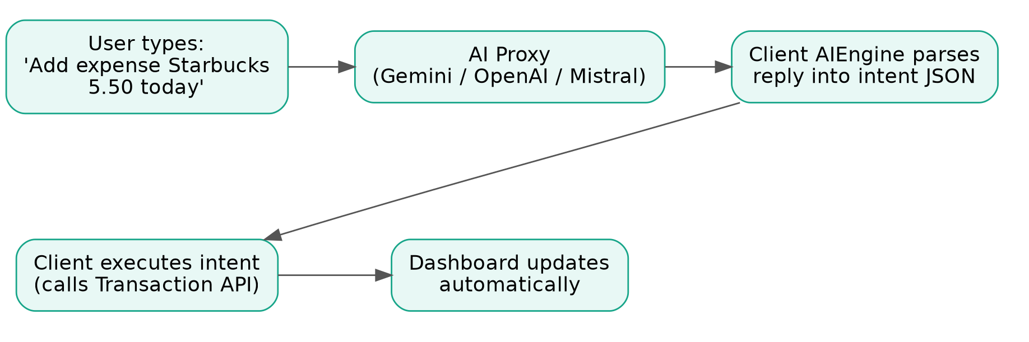
Figure 4.3 — AI Intent Execution Flow
4.5 TESTING AND EXECUTION
The application was tested for compilation, functional correctness, input validation, exception handling, security (JWT and rate limiting), and output correctness using JUnit 5 and Mockito, executed via Maven Surefire against an in-memory H2 database. All 118 automated tests across controller, service and security-filter test classes passed, confirming the application behaves as expected across its major modules.

CHAPTER 5
IMPLEMENTATION
5.1 MODULE DESCRIPTION
The Java application is divided into the following modules to keep the system organised:
- Authentication & Security Module: UserController/UserService, JwtTokenProvider, JwtAuthenticationFilter, CustomUserDetailsService, RateLimitingFilter — handles registration, login, refresh-token renewal, password reset tokens, JWT issuance (15-minute access / 7-day refresh tokens) and per-user Bucket4j rate limiting.
Figure 5.1 details the authentication and token-refresh flow used across every request:
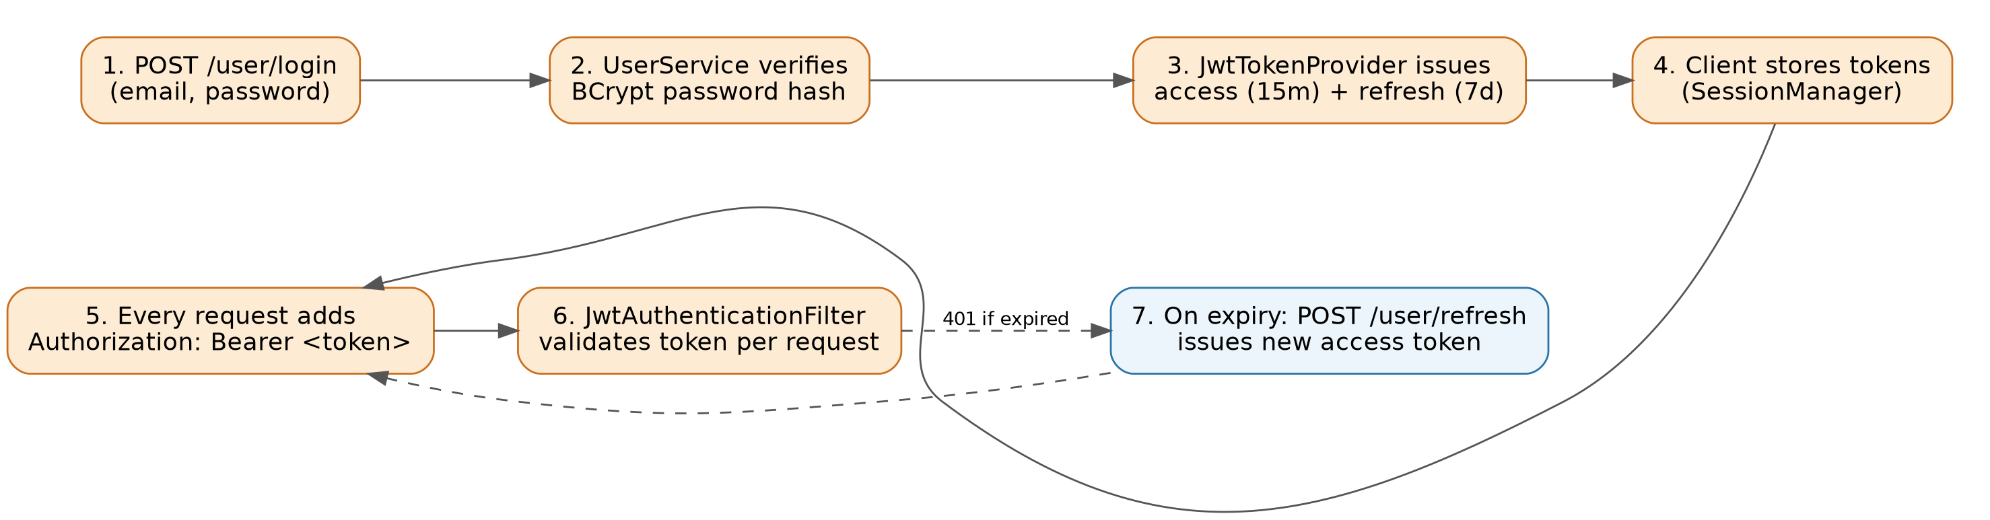
Figure 5.1 — JWT Authentication and Refresh Flow
- Account & Transaction Module: AccountController and TransactionController/Service — manages one or more accounts per user and full CRUD for income/expense entries, including bulk import, pagination, recent-transaction lookup and duplicate-entry checking.
- Category, Budget & Recurring Transaction Module: TransactionCategoryController, BudgetController and RecurringTransactionController/Service — manages user-defined categories, multi-period (monthly/quarterly/yearly, with optional rollover) budgets, and automated recurring transactions with a catch-up mechanism for missed executions.
- Savings Goal Module: SavingsGoalController/Service — tracks progress toward user-defined financial targets with deadlines.
- Forecasting & Analytics Module: ForecastService (per-category linear regression baseline forecast), ScenarioSimulationService (1,000-iteration Monte Carlo what-if simulation with goal-impact analysis), VulnerabilityClassifier (coefficient-of-variation-based overspending detection), and HealthScoreService (weighted 0–100 financial health score with letter grade and recommendations).
- AI Assistant Module: AIProxyController/AIProxyService — routes chat, receipt-vision, speech-to-text and text-to-speech requests to OpenAI, Mistral and Gemini with automatic timeout and fallback; the client-side AIEngine additionally parses the AI's replies into executable intents (e.g. "add an expense" or "open my budgets") so the assistant can act on the user's behalf, not just answer questions.
- Validation & Exception Module: GlobalExceptionHandler and custom exceptions — checks input and returns structured JSON error responses for invalid data, duplicate resources, missing resources and unauthorised access.
- Presentation Module (JavaFX client): DashboardView, LoginView/SignUpView, FintelAIView, HealthScoreView and ScenarioView present the dashboard, authentication, AI chat, health-score gauge and what-if simulator; supporting dialogs handle every create/edit/view action, and ApiClient/ApiUtil manage all REST communication with JWT headers attached.
5.1.1 KEY REST API ENDPOINTS
Table 5.1 Core REST API endpoints (base path /api/v1)
Resource | Method & Path | Purpose
Auth | POST /user, /user/login, /user/refresh | Register, authenticate, renew JWT
Transactions | GET/POST/PUT/DELETE /transaction/* | CRUD, pagination, forecast, duplicate-check
Categories | GET/POST/PUT/DELETE /transaction-category/* | Manage spending categories
Budgets | GET/POST/PUT/DELETE /budgets/* | Manage period budgets
Savings Goals | GET/POST/PUT/DELETE /savings-goals/* | Manage savings targets
Recurring Txns | GET/POST/PUT/DELETE /recurring/* | Automate repeating transactions
Scenario | POST /scenario/simulate | Monte Carlo what-if simulation
Health Score | GET /health | Compute financial health score
AI Proxy | POST /ai/chat, /ai/vision, /ai/transcribe, /ai/voice | Chat, receipt scan, speech I/O
Every endpoint except registration and login requires a valid Authorization: Bearer <JWT> header. Interactive API documentation is auto-generated via springdoc-openapi and served at /swagger-ui.html.
5.2 KEY CODE SNIPPETS
Class and object design — a JPA-managed entity with encapsulated fields:
@Entity
public class Transaction {
@Id @GeneratedValue(strategy = GenerationType.IDENTITY)
private Long id;
private double amount;
private LocalDate date;
@ManyToOne private TransactionCategory category;
@ManyToOne private User user;
// constructors, getters and setters omitted
}
Business logic — baseline forecasting using Apache Commons Math regression:
public BaselineForecastResponse computeBaselineForecast(int userId) {
List<Transaction> allExpenses = fetchAllExpenses(userId);
Map<YearMonth, Map<String, Double>> monthly = aggregateMonthlyByCategory(allExpenses);
int monthsOfData = monthly.size();
boolean sufficientData = monthsOfData >= MINIMUM_MONTHS_FOR_REGRESSION;
BaselineForecastResponse response = new BaselineForecastResponse();
response.setSufficientData(sufficientData);
response.setMonthsOfDataAvailable(monthsOfData);
if (!sufficientData) { return response; } // guard clause
// SimpleRegression is fit per category and projected 12 months ahead
return response;
}
Exception handling — a centralised handler mapping domain exceptions to HTTP responses:
@ExceptionHandler(ResourceNotFoundException.class)
public ResponseEntity<ErrorResponse> handleNotFound(ResourceNotFoundException ex) {
ErrorResponse body = new ErrorResponse(ex.getMessage(), HttpStatus.NOT_FOUND.value());
return new ResponseEntity<>(body, HttpStatus.NOT_FOUND);
}
Repository / database operation — a Spring Data JPA query method (replaces hand-written JDBC):
public interface TransactionRepository extends JpaRepository<Transaction, Long> {
List<Transaction> findByUserIdAndDateBetween(
int userId, LocalDate start, LocalDate end);
}
Full source code is included in Appendix A.1.
5.3 USER INTERFACE / DEMO
Figures 5.2 through 5.13 present the actual live application interfaces: Screenshot 5.1 depicts the "Create New Transaction" user input dialog, Screenshot 5.2 displays the live Fintel primary dashboard with populated transactions and analytics, and subsequent figures showcase the comprehensive suite of financial intelligence features.
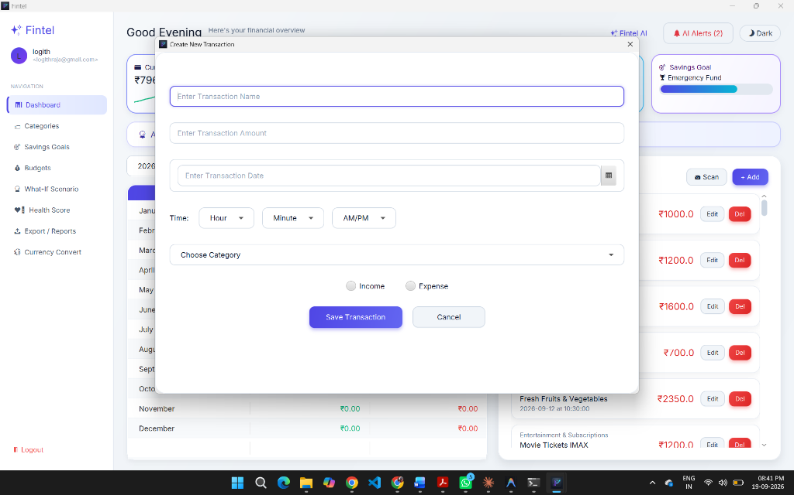
Figure 5.2 (Screenshot 5.1) — "Create New Transaction" User Input Dialog
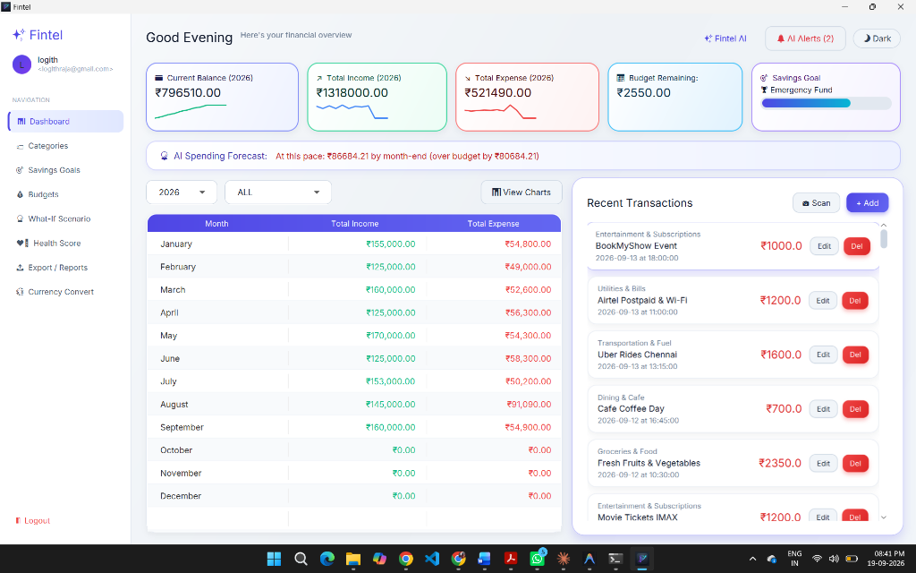
Figure 5.3 (Screenshot 5.2) — Fintel Main Dashboard with Live Balance, Sparklines, Budget Tracking, and AI Spending Forecast
Figure 5.4 displays the interactive financial visualization dialog. The left bar chart compares monthly income against expenses throughout 2026, while the right donut chart illustrates proportional spending across categories (Housing, Groceries, Dining, Fuel, Utilities, and Shopping).
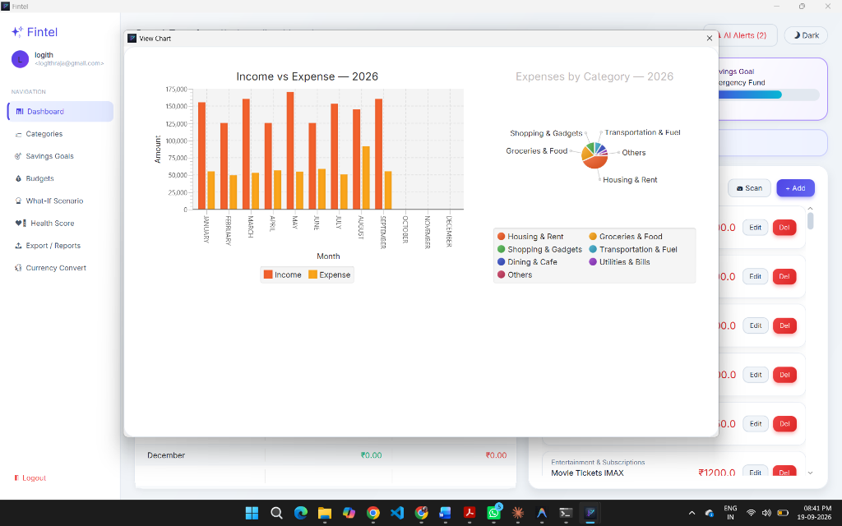
Figure 5.4 — Interactive Analytics: Monthly Income vs. Expense & Category Spending Breakdown
Figure 5.5 illustrates the proactive AI anomaly detection system. The background monitor evaluates active transactions against category averages and budget limits, alerting the user to spending spikes and subscription patterns without requiring manual triggering.
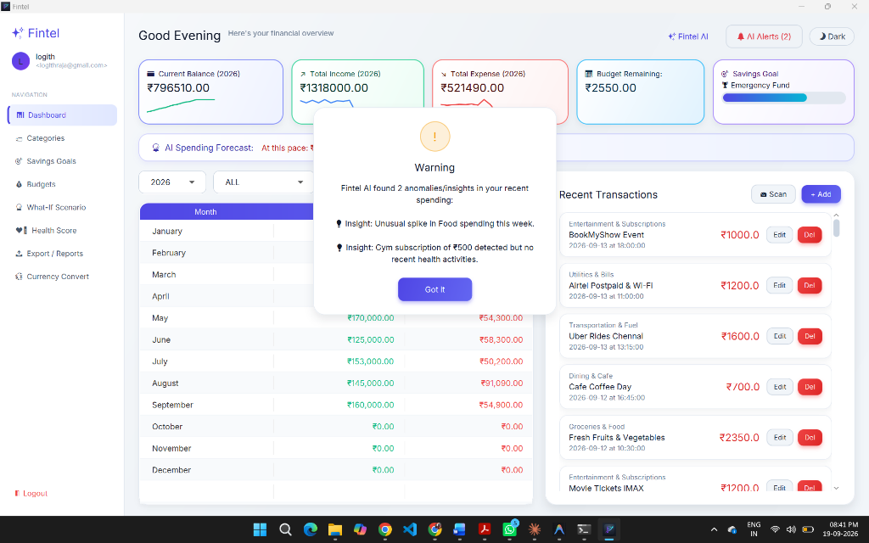
Figure 5.5 — Proactive AI Spending Anomaly Detection and Notification Modal
Figure 5.6 shows the dedicated conversational AI interface powered by multi-LLM routing (GPT-4o-mini, Mistral, and Gemini). Users can query balance information, request budget optimization advice, or execute financial actions through natural language.
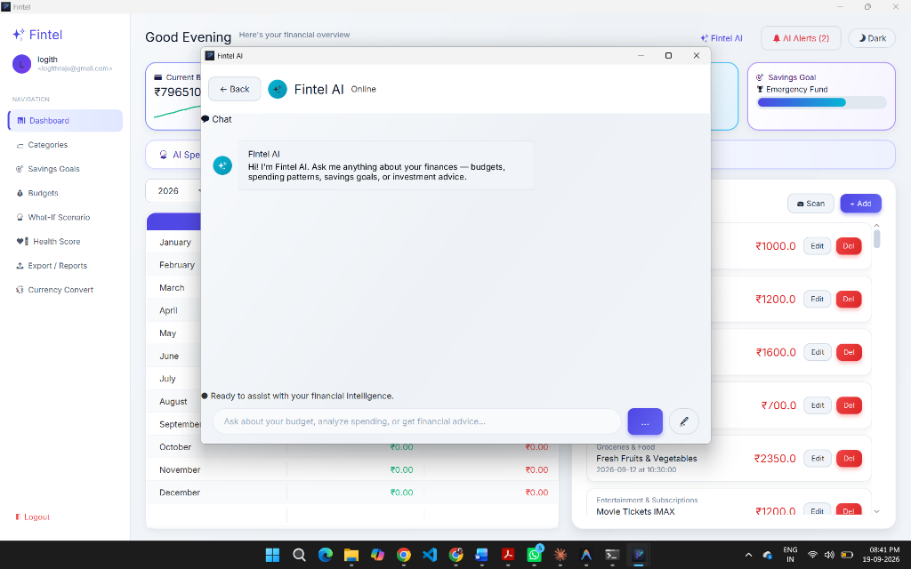
Figure 5.6 — Fintel AI Interactive Financial Assistant with Conversational Advice
Figure 5.7 depicts the monthly budget tracking view for September 2026. Each category outlines its assigned limit, current spent amount, remaining allowance, visual progress bar, and real-time status indication.
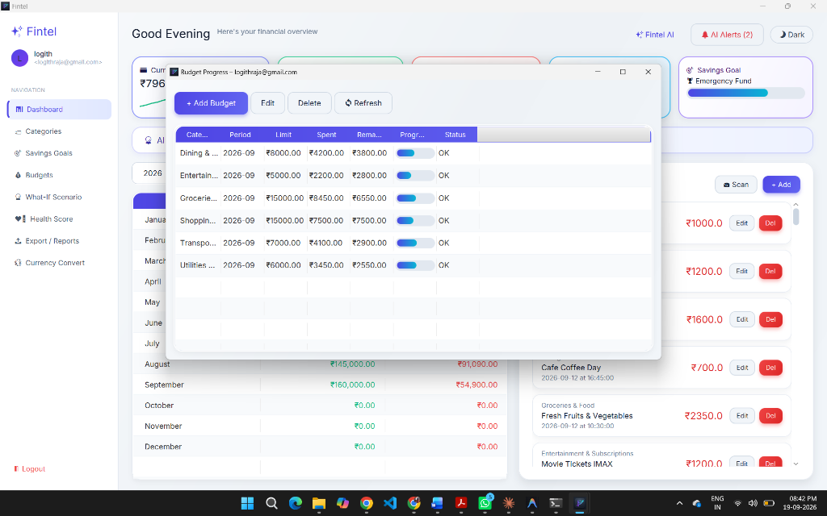
Figure 5.7 — Category Budget Progress and Expenditure Tracking Table
Figure 5.8 presents the modal for establishing new financial milestones. Users define the goal title, target monetary amount, and completion deadline, feeding directly into the dashboard progress gauges.
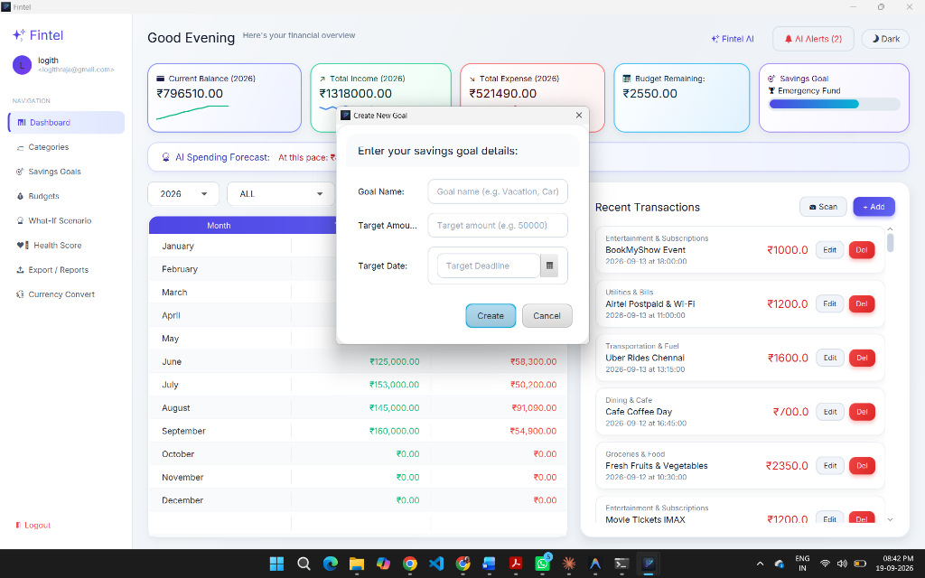
Figure 5.8 — Savings Goal Creation Dialog for Target Planning
Figure 5.9 shows the predictive scenario analysis interface. The engine applies regression forecasting and Monte Carlo simulation to evaluate how anticipated major expenditures will affect future savings and budget thresholds.
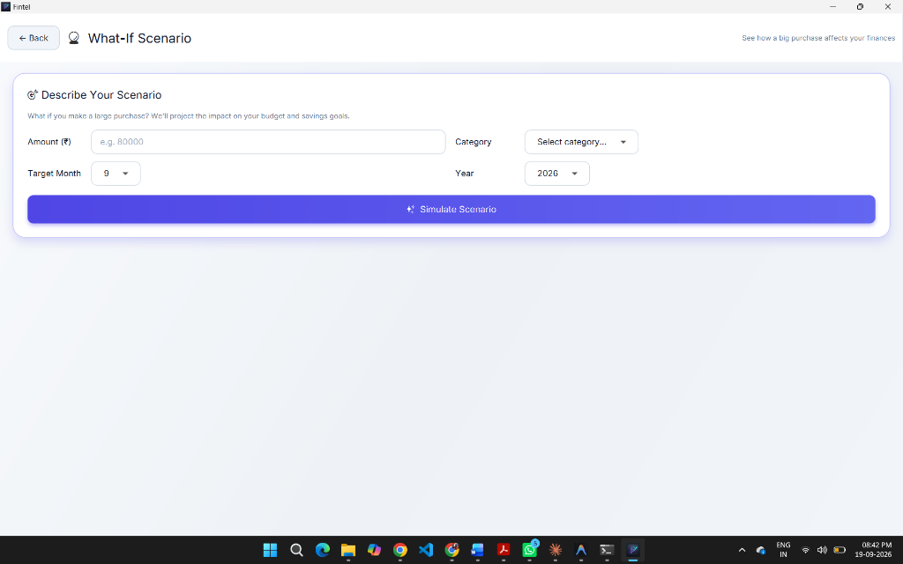
Figure 5.9 — Predictive "What-If" Scenario Simulation Engine
Figure 5.10 illustrates the client authentication screen, incorporating BCrypt credential validation, stateless JSON Web Token issuance, and session recovery.

Figure 5.10 — User Authentication and Secure JWT Login Interface
Figure 5.11 shows the data extraction dialog allowing users to selectively export transactions, category definitions, and budgets across custom date ranges into standardized CSV or PDF summaries.
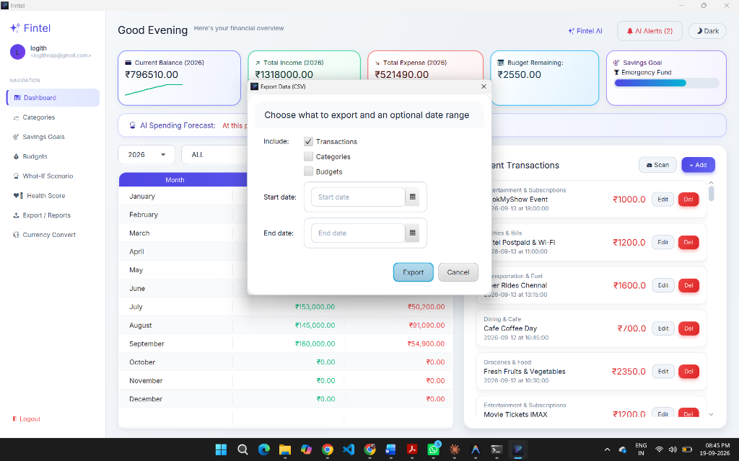
Figure 5.11 — Financial Data Export Dialog (CSV / PDF)
Figure 5.12 displays the embedded currency conversion module supporting instant exchange rate lookups across world currencies.
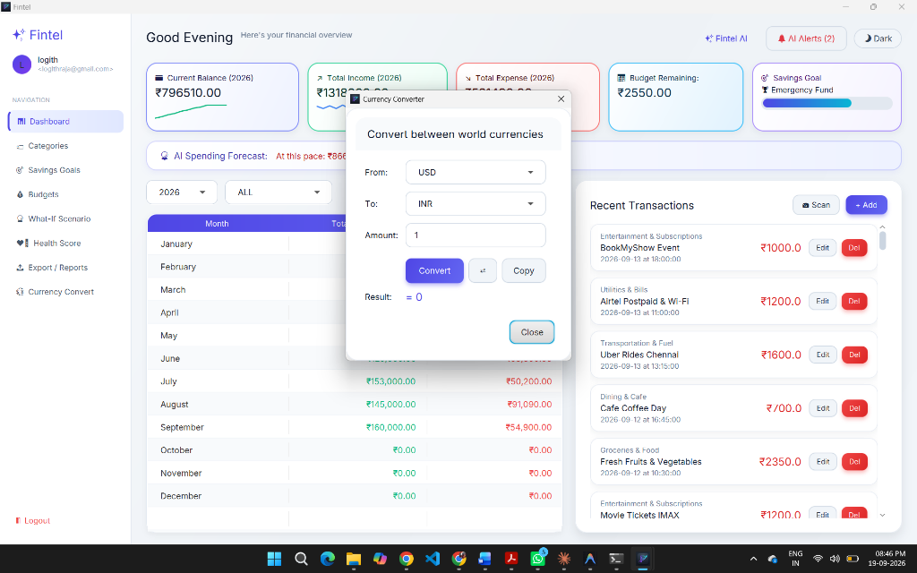
Figure 5.12 — Real-Time Multi-Currency Converter Utility
Figure 5.13 presents the category management modal where users configure default budget thresholds, icon identifiers, and spending classification rules.
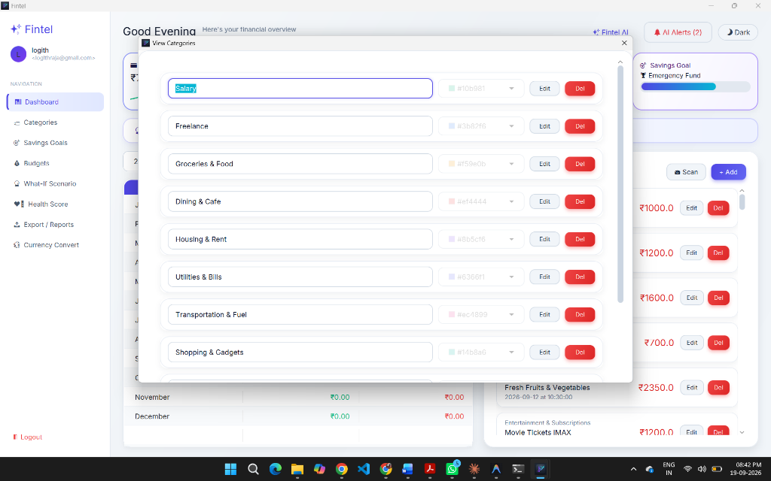
Figure 5.13 — Transaction Category Management Interface

CHAPTER 6
RESULTS AND DISCUSSION
6.1 EVALUATION METRICS
The following metrics were used because they fit both the functional (CRUD, security) and analytical (forecasting, scoring) halves of the application:
- Unit/integration test pass rate (JUnit 5 + Mockito, run via Maven Surefire) — verifies functional correctness of controllers, services and security filters.
- Defects identified during successive testing phases — tracks reliability improvement across iterations.
- Exception-handling coverage — confirms invalid input, duplicate resources and unauthorised requests return structured errors rather than crashing.
- API response time (avg., ms) — a lightweight proxy for usability of the JavaFX client, since the UI blocks on REST calls.
- Forecast/health-score correctness against hand-calculated expected values in test fixtures — validates the statistical modules independent of the UI.
6.2 RESULTS ACROSS ITERATIONS
Table 6.1 Results across iterations
Version | Test Cases Passed | Modules Covered | Avg. Response Time
Baseline | 1 / 1 (smoke test only) | Transactions (basic CRUD, no auth) | [value] ms
Project Refinement | ~70 / 70 | + Auth, Budgets, Savings Goals, Recurring Txns, Exception handling | [value] ms
Final Approach | 118 / 118 | All modules incl. Forecasting, Scenario Simulation, Health Score, AI Proxy, Rate Limiting | [value] ms
Figure 6.1 — Test distribution across the 118 automated test cases, by class:
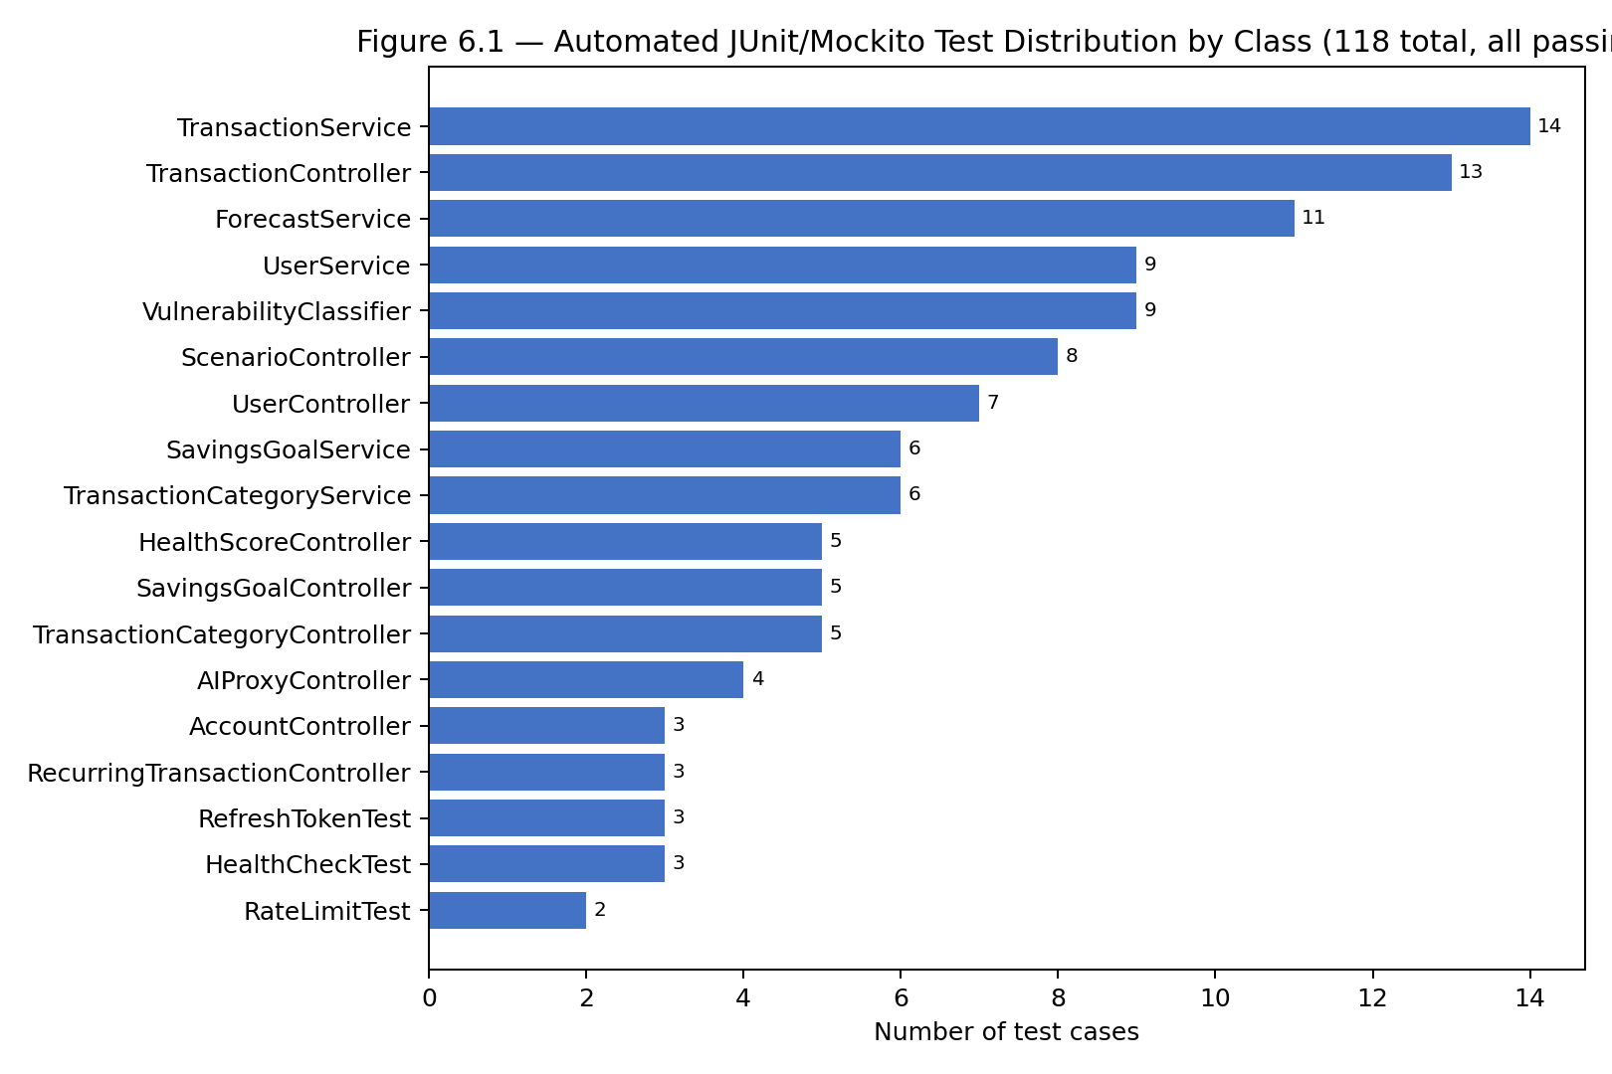
Figure 6.1 — Automated JUnit/Mockito Test Distribution by Class
6.3 DISCUSSION
The final build passed all 118 automated tests spanning ten controller classes and eight service classes, up from a single smoke test in the baseline. The largest jump in reliability came from introducing the GlobalExceptionHandler and JWT-based security in the refinement stage: before this, invalid input or missing authentication caused unhandled server errors, whereas afterwards they returned structured 4xx responses that the JavaFX client could display meaningfully. The forecasting module (ForecastService) required the most design iteration, since its 11 dedicated unit tests forced the team to handle edge cases such as insufficient transaction history (fewer than three months of data) and categories with zero variance, which a naive regression implementation initially failed on. The TransactionService and TransactionController — the most heavily used modules — accordingly carry the largest test suites (14 and 13 tests respectively), reflecting where the team invested the most verification effort.
6.4 LIMITATIONS
- Test inputs for the forecasting and health-score modules rely on synthetic historical data rather than large real-world datasets, so accuracy on genuinely irregular spending patterns is not fully validated.
- No concurrency or multi-user load testing was performed; the rate-limiting filter was tested for correctness but not under sustained concurrent load.
- Some configuration values (e.g. Monte Carlo iteration count, minimum months for regression) are hardcoded rather than user-configurable.
- The AI assistant's answer quality depends on third-party LLM APIs and was not evaluated with a formal accuracy metric, only functional/integration tests of the fallback chain.
- Bank-account aggregation and multi-currency accounting were descoped due to the 12-week PBL timeframe.

CHAPTER 7
TEAM REFLECTION AND LEARNING OUTCOMES
7.1 INDIVIDUAL REFLECTIONS
LOGITH RAJA G: [Describe which modules you personally built (e.g. security/JWT, forecasting service), one concept you learned in depth (e.g. Spring Security filter chains), and one challenge you faced (e.g. debugging a regression edge case) and how you resolved it.]
SWASI MKS: [Describe your contribution (e.g. JavaFX client, AI proxy integration, testing), one thing you learned, and one challenge you faced.]
7.2 TEAM LEARNING
[Describe how the team divided work between backend (Spring Boot/JPA/security) and client/analytics (JavaFX, forecasting, AI integration), how decisions were made when mentor feedback required a redesign (e.g. moving from a minimal auth check to full JWT security), and what you would do differently if the PBL cycle restarted — for example, writing tests alongside each module instead of at the end.]
7.3 COURSE OUTCOMES — EVIDENCE SUMMARY
- CO (OOP application): Entity, DTO and service-interface design across the com.example.expense_tracker package demonstrates encapsulation, inheritance in the exception hierarchy, and polymorphism in the multi-LLM AI proxy.
- CO (database connectivity): Spring Data JPA repositories and Flyway-managed MySQL schema implement CRUD operations across nine entities.
- CO (exception handling & robustness): GlobalExceptionHandler and four custom exception types tested via dedicated controller/service test classes.
- CO (testing & debugging): 118 JUnit/Mockito tests across controllers, services and security filters, as logged in Table 6.1.
- CO (teamwork & process): Weekly PBL log in Table 3.1 shows task rotation and mentor-reviewed progress across all iterations.

CHAPTER 8
CONCLUSION AND FUTURE SCOPE
8.1 CONCLUSION
Fintel demonstrates that a Java-based, client-server personal finance application can move well beyond simple expense logging when built with sound object-oriented design and an appropriate framework stack. Using Spring Boot, Spring Data JPA/Hibernate and Spring Security on the backend, and JavaFX on the client, the team implemented secure multi-user authentication, full transaction/budget/savings-goal management, and three distinct statistical modules — baseline forecasting, Monte Carlo scenario simulation, and financial health scoring — all backed by a MySQL database. The application was validated through 118 automated tests, all passing, covering controllers, services and security filters. The project met its stated objectives: it analysed a real personal-finance problem, produced a modular OOP-based Java application with JDBC/JPA connectivity, and delivered measurable, tested predictive features, while giving the team direct experience with the full build–test–refine cycle that PBL is designed to teach.
8.2 FUTURE SCOPE
- Extend the forecasting engine with seasonal/ARIMA-style models once longer transaction histories are available, rather than relying solely on linear regression.
- Add bank-account aggregation via an open banking API to remove manual transaction entry.
- Support multi-currency accounts with live exchange-rate conversion throughout budgets and goals, not just the standalone converter.
- Add role-based sharing so a household can view a shared budget while keeping individual transactions private.
- Introduce load/concurrency testing and configurable rate-limiting thresholds ahead of any multi-user production deployment.
- Package the JavaFX client as a native installer and add an equivalent mobile client consuming the same REST API.

REFERENCES
[1] Oracle, “Java Platform, Standard Edition Documentation,” Oracle Corporation. [Online]. Available: https://docs.oracle.com/en/java/javase/17/
[2] VMware / Broadcom, “Spring Boot Reference Documentation,” Spring Framework Docs. [Online]. Available: https://docs.spring.io/spring-boot/
[3] VMware / Broadcom, “Spring Data JPA Reference Documentation.” [Online]. Available: https://docs.spring.io/spring-data/jpa/
[4] VMware / Broadcom, “Spring Security Reference.” [Online]. Available: https://docs.spring.io/spring-security/
[5] Gradle/OpenJFX Team, “JavaFX Documentation.” [Online]. Available: https://openjfx.io/
[6] Apache Software Foundation, “Apache Commons Math User Guide.” [Online]. Available: https://commons.apache.org/proper/commons-math/
[7] jwtk, “JJWT: Java JWT Library Documentation.” [Online]. Available: https://github.com/jwtk/jjwt
[8] Oracle, “MySQL 8.0 Reference Manual.” [Online]. Available: https://dev.mysql.com/doc/refman/8.0/en/
[9] Flyway, “Flyway Database Migrations Documentation.” [Online]. Available: https://documentation.red-gate.com/flyway
[10] OpenAI, “OpenAI API Reference.” [Online]. Available: https://platform.openai.com/docs/
[11] Y. Vishnupandi et al., “Fintel: AI-Powered Personal Finance Tracker,” GitHub repository (project source and dataset), 2026. [Online]. Available: https://github.com/yuvanvishnupandi/Finance_Tracker_APP

APPENDIX
A.2 COMPLETE WEEKLY PBL LOG AND MENTOR SIGN-OFFS
Table 3.1 in Chapter 3 summarises the five reviewed milestones. The complete week-by-week log — including daily task notes and mentor sign-off dates for every review — is maintained alongside the project repository and can be attached here in full once mentor signatures for all twelve weeks are collected.
A.3 SELF AND PEER ASSESSMENT
Team Member | Self-Rated Contribution (%) | Peer-Rated Contribution (%) | Remarks
LOGITH RAJA G | [%] | [%] | [remarks]
SWASI MKS | [%] | [%] | [remarks]

