A

SYNOPSIS REPORT

On

SMART CLASSROOM & TIMETABLE SCHEDULER
Submitted in partial fulfilment of the requirements of the degree of
Bachelor of Technology


Submitted by

[Harsh Sharma] | [2200330100100]
[Harshit Verma] | [2200330100103]
[Kshitij Yadav] | [2200330100127]
[Khushi Dwivedi] | [2200330100122]

DEPARTMENT OF COMPUTER SCIENCE & ENGINEERING
RAJ KUMAR GOEL INSTITUTE OF TECHNOLOGY, GHAZIABAD
Affiliated to
DR.A.P.J. ABDUL KALAM TECHNICAL UNIVERSITY, LUCKNOW
SEPTEMBER 2025
DEPARTMENT OF COMPUTER SCIENCE & ENGINEERING

INDEX
S.NO. | CONTENTS | PAGE NO.
1 | Introduction | 3
2 | Literature Review | 4
3 | Objective and Scope | 6
4 | Hardware Requirements | 7
5 | Software Requirements | 7
6 | Methodology/ Planning of Work | 7
7 | Testing Technologies | 9
8 | Expected Outcome | 10
9 | References | 10
This project focuses on developing an intelligent web-based timetable scheduling system powered by optimization algorithms that dynamically generates clash-free, resource-efficient schedules for higher education institutions, ensuring optimal utilization of classrooms, balanced faculty workload, and improved learning outcomes.
Introduction
Higher Education institutions often face significant challenges in preparing efficient and conflict-free class schedules. The scheduling process is constrained by limited classroom infrastructure, faculty availability, elective courses, and overlapping departmental requirements. Traditionally, timetables are prepared manually using spreadsheets or basic tools. This manual approach frequently leads to problems such as clashes between classes, underutilization of available classrooms, uneven workload distribution among faculty, and dissatisfaction among both students and teachers.
The complexity of the scheduling task has further increased with the adoption of the National Education Policy (NEP) 2020, which emphasizes multidisciplinary education and flexible learning opportunities. Under NEP 2020, students can choose from a wide range of elective courses across departments, making manual scheduling highly inefficient and prone to errors.
To overcome these challenges, this project proposes the development of an intelligent web-based timetable scheduling system. The system will dynamically generate optimized timetables by considering real-time constraints such as faculty availability, room capacity, teaching load norms, course combinations, and student preferences. Advanced optimization algorithms—including Genetic Algorithms, Constraint Satisfaction Problems (CSP) models, Integer Linear Programming (ILP), and meta-heuristics—will be applied to ensure balanced and conflict-free scheduling.
By automating the scheduling process, the system aims to:
- Maximize classroom and laboratory utilization,
- Minimize workload conflicts among faculty,
- Reduce timetable clashes across departments,
- Support multi-shift and multi-department scheduling, and
- Improve satisfaction levels of students and staff.
In summary, the project addresses the core problems of inefficiency, imbalance, and lack of adaptability in timetable generation by offering an intelligent, adaptive, and scalable solution that aligns with the goals of modern higher education. Furthermore, the system includes a secure login for authorized personnel, multiple optimized timetable options, and a review-and-approval workflow to ensure transparency and control. It also provides smart suggestions for rearrangements and robust support for multi-department and multi-shift scheduling, making it a complete end-to-end solution for modern institutions.
Literature Review
Timetabling has long been recognized as an NP-hard problem due to the large number of constraints, stakeholders, and conflicting objectives involved. Researchers have explored a wide range of optimization techniques, from classical integer programming models to advanced meta-heuristics and AI-driven approaches. The following review presents key contributions from recent literature published after 2021.
Almeida et al. [1] introduced a hybrid meta-heuristic framework that integrates Adaptive Large Neighborhood Search, Guided Local Search, and Variable Neighborhood Search, supported by an instance decomposition strategy. This approach effectively handles large-scale university timetabling problems by breaking them into smaller, solvable components, achieving faster execution times compared to conventional solvers. Wu et al. [2] reframed timetabling as a recommendation problem by applying a Digital Twin of Texas A&M University. Their system combined collaborative and content-based filtering with feedback loops to generate adaptive timetables, thereby improving classroom utilization, faculty convenience, and student satisfaction.
Dofadar et al. [3] presented a hybrid evolutionary algorithm that merges a Local Repair strategy with a Modified Genetic Algorithm for course allocation. The approach demonstrated robustness in real-world environments where faculty availability and subject requirements must be dynamically balanced. Similarly, Moradi [4] applied an Integer Linear Programming (ILP) model for periodic scheduling, focusing on advising sessions and other recurring events. By integrating constraints like minimum intervals and emergency slots, the model ensured equitable schedules and demonstrated efficiency when solved with Gurobi.
In a broader context, Gu et al. [5] published a comprehensive review of 95 timetabling models spanning 1990–2023. They analyzed tools such as CPLEX, Gurobi, and OR-Tools, highlighting the growing role of machine learning in hybrid optimization. Complementing this, Mallari et al. [6] proposed an optimization model for synchronizing multi-department course calendars, addressing overlapping courses and resource conflicts, which is highly relevant in institutions with multiple faculties and elective options.
At the implementation level, Nugraha et al. [7] applied a Genetic Algorithm (GA) to a case study involving 93 courses, 18 lecturers, and 6 classrooms. Their results confirmed that iterative GA runs reduce timetable violations and improve scheduling quality. A broader survey of meta-heuristic methods was presented in [8], which systematically compared approaches like GA, Tabu Search, and hybrid methods, pointing out gaps and open challenges in scalability and adaptability.
Babaei et al. [9] developed a parallel GA combined with local search, which achieved faster convergence and better-quality timetables compared to traditional heuristics. Finally, Bello and Godwill [10] combined hybrid technologies with GA to design scalable and conflict-minimized school lecture timetables. Their fitness function incorporated both resource availability and user preferences, making it practical for real-world adoption.
Together, these studies demonstrate the breadth of approaches being developed for academic timetabling. While hybrid meta-heuristics and AI-based models show strong potential, challenges remain in ensuring real-time adaptability, balancing workload across multiple departments, and integrating student preferences. This highlights the need for intelligent, web-based scheduling solutions that combine optimization techniques with flexible user interfaces—an area where the proposed system aims to contribute.
Author | Research Objective | Methodology | Key Findings | Groups Identified | Future Scope
X. Han (2025) | Optimize university scheduling with GA–DP | Hybrid Genetic Algorithm + Dynamic Programming | Improved stability and scalability in scheduling | Faculty, Courses, Students | Extend to multi-campus and real-time scheduling
F. Dünke et al. (2023) | Develop multi-level, multi-criteria timetabling | Metamodel-enhanced matheuristic with ANN evaluation | Reduced computation time, balanced workload | Multi-level course structures, Faculty workloads | Include student electives and adaptive preferences
A. Bashab et al. (2023) | Review optimization techniques for timetabling | Literature review of 95 models (CSP, GA, heuristics) | Identified dominant methods and benchmarks | Courses, Constraints, Benchmarks | Propose unified frameworks with AI/deep learning
F. P. Diallo (2024) | Optimize teaching activity scheduling | Metaheuristic-based optimization | Balanced faculty workload and fair distribution | Faculty, Rooms, Timetable slots | Expand for cross-department planning and student factors
S. K. Saw et al. (2025) | Create adaptive AI timetable scheduler | Genetic Algorithm + Machine Learning feedback loop | Continuous optimization with user feedback | Faculty, Students, Admins | Improve adaptability using reinforcement learning
H. Km & L. Ying (2021) | GA for computing school timetables | Genetic Algorithm implementation | Reduced conflicts, improved room allocation | Faculty, Courses, Classrooms | Extend GA for multi-department scheduling
M. S. M. Al-Hamadi & A. M. Al-Hasani (2023) | Automate course timetabling with GA | GA applied to higher education dataset | Reduced manual effort, improved fairness | Courses, Faculty, Students | Hybrid GA + constraint programming approaches
A. D. Khedr et al. (2023) | Apply deep reinforcement learning in timetabling | DRL with dynamic environment simulation | Adaptive schedules under dynamic constraints | Faculty, Students, Resources | Scale to large universities with evolving curricula
H. A. Nugraha et al. (2023) | Test GA on real datasets | GA iterations on 93 courses, 18 lecturers | Reduced timetable violations, better quality | Courses, Faculty, Students | Apply GA hybrids for large-scale timetables
R.-W. Bello & J. A. Godwill (2024) | Hybrid GA for lecture timetable generation | Genetic Algorithm + hybrid tech with fitness function | Conflict-free, scalable timetables with preferences | Faculty, Rooms, Students | Cloud-based systems for scalability and flexibility

Objective and Scope
Objectives:
The main objective of the project is to create an intelligent web-based timetable scheduling system that:
- Generates optimized, clash-free timetables for UG and PG programs.
- Maximizes utilization of classrooms, laboratories, and other institutional resources.
- Ensures balanced teaching workload distribution among faculty members.
- Incorporates constraints such as faculty availability, subject requirements, student electives, and fixed-time classes.
- Provides multiple optimized timetable options with rearrangement suggestions in case of conflicts.
- Supports multi-department and multi-shift scheduling.
- Suggestions for suitable rearrangements when optimal solutions are not available
- Review and approval workflow for competent authorities
Scope:
The system can be used by higher education institutions to automate and streamline timetable preparation. It will minimize manual effort, reduce class/faculty clashes, and enhance academic planning efficiency.
By improving resource utilization and scheduling fairness, it aligns with Sustainable Development Goal 4: Quality Education and SDG 9: Industry, Innovation, and Infrastructure, supporting digital transformation in education under NEP 2020.
Hardware Requirements
As the project is primarily web-based, the hardware requirements are minimal:
- A modern laptop or desktop computer (for administrators/faculty).
- Stable internet connection.
- Standard server or cloud hosting infrastructure (for deploying the platform).
Software Requirements
- Frontend: Nextjs/Typescript / HTML5, CSS3, JavaScript
- Backend: Node.js / Django / Flask
- Database: MySQL / PostgreSQL / MongoDB
- Optimization Engine: Python libraries (Google OR-Tools, PuLP, Constraint Programming)
- Web Hosting / Cloud: AWS / Azure / GCP or institutional server
- Authentication: JWT-based login system for authorized personnel
- Optional Integrations: College ERP/website for data import and synchronization
Methodology/ Planning of Work
The project will follow an applied research methodology aimed at solving the complex problem of timetable scheduling in higher education. The methodology integrates requirement analysis, database design, AI-driven optimization, and system testing.
Steps of Development:
- Requirement Analysis – Collect institutional data such as number of classrooms, laboratories, student batches, subjects, faculty availability, workload norms, elective courses, and fixed-slot classes.
- System & Database Design – Define system architecture and design a relational database to store course, faculty, and timetable constraints.
- Optimization Model Development – Implement scheduling algorithms using constraint satisfaction, linear programming, and AI-based optimization techniques (e.g., Google OR-Tools, PuLP).
- Web Application Development – Build a user-friendly interface (React/Angular) connected to a backend (Node.js/Django/Flask) for timetable generation and management.
- Multiple Timetable Generation – Integrate the optimization engine to produce multiple clash-free timetable options with rearrangement suggestions.
- Testing and Validation – Perform unit testing, integration testing, and validation against real institutional data to ensure accuracy, efficiency, and robustness.
- Deployment & Training – Deploy the system on a cloud or institutional server and provide training for authorized users

The flowchart below depicts the overall workflow of the project:

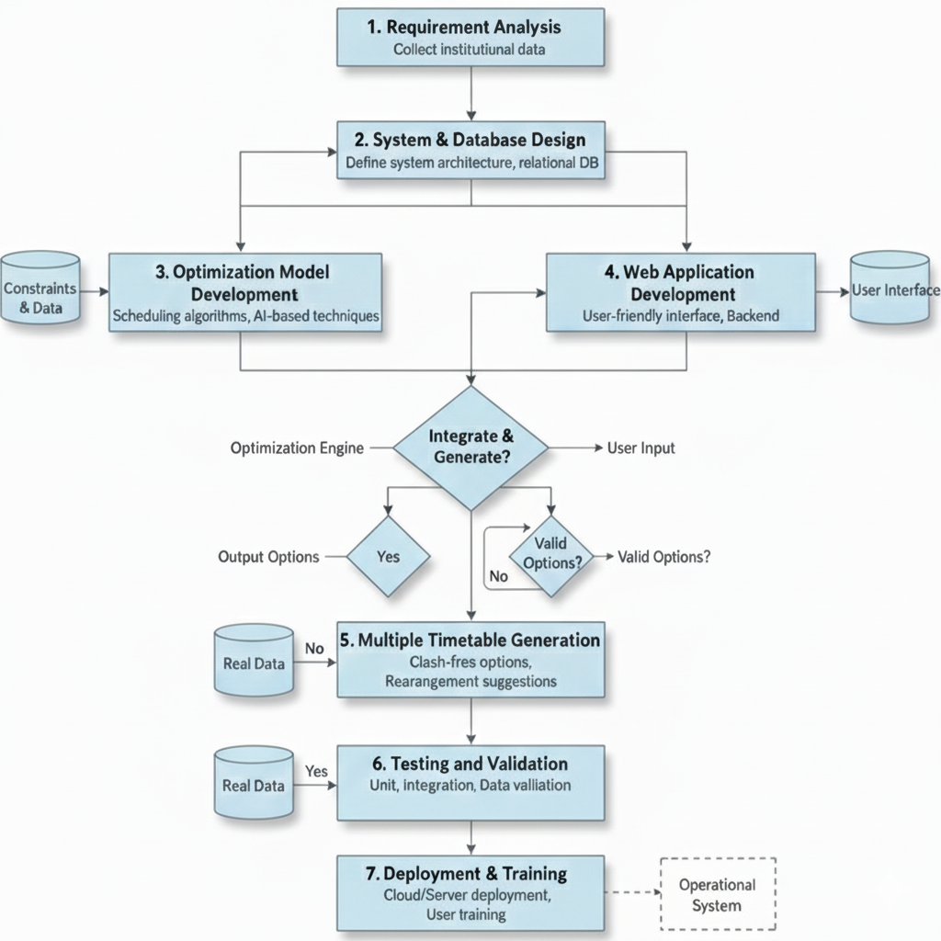
Testing Technologies
To ensure system reliability, accuracy, and usability, the timetable scheduling system will undergo multiple levels of testing. Each module of the system will be tested with the most suitable technique to verify both functionality and performance.
- Login & Authentication Module
  - Unit Testing: To verify that password hashing, JWT token generation, and role-based access control (RBAC) are working correctly.
  - Integration Testing: Ensures the login process works seamlessly with the database and token validation across different modules.
- Timetable Generation Module (Optimization Engine)
  - Unit Testing: Tests the correctness of constraint checks (e.g., no two classes overlap in the same room).
  - System Testing: Validates that the optimization algorithms (GA, OR-Tools, PuLP) generate feasible timetables for real-world inputs.
  - Performance Testing: Checks the time taken by algorithms to generate solutions for small vs. large datasets.
- Review and Approval Workflow Module
  - Unit Testing: Confirms correct state transitions (Draft → Review → Approved → Published).
  - Integration Testing: Ensures the workflow integrates properly with timetable generation and database updates.
- Suggestion & Rearrangement Module
  - Unit Testing: Verifies that local search, simulated annealing, or tabu search provide valid timetable modifications without breaking constraints.
  - System Testing: Ensures rearrangements actually resolve conflicts and do not create new ones.
- Multi-Department & Multi-Shift Scheduling Module
  - Integration Testing: Checks interaction between multiple departments and shifts to avoid shared resource conflicts.
  - Performance Testing: Evaluates how efficiently the system handles large, multi-department datasets.
- User Interface & Access Module
  - User Acceptance Testing (UAT): Faculty and administrators test the interface to ensure ease of use, clarity of timetable views, and proper role-based access.

Expected Outcome
The expected outcome of this project is the development of a fully functional, intelligent, and web-based timetable scheduling system that generates optimized, clash-free schedules for both undergraduate and postgraduate programs. The system will:
- Maximize classroom and laboratory utilization by efficiently assigning available resources.
- Ensure fair distribution of faculty workload, avoiding overloads or underutilization.
- Minimize timetable conflicts across courses, departments, and shifts.
- Provide multiple optimized timetable options from which administrators can select the most suitable schedule.
- Offer intelligent suggestions for rearrangements when strict optimization is not achievable, ensuring flexibility.
- Support multi-department and multi-shift scheduling, making it scalable for large institutions.
- Enable secure login and role-based access for authorized personnel, ensuring controlled management and approval workflows.
- Enhance student and faculty satisfaction by aligning schedules with real-time constraints, elective choices, and institutional policies.
Overall, the system will streamline academic planning, reduce manual workload, improve decision-making, and adapt to the flexibility required under NEP 2020, positioning it as a sustainable solution for modern higher education institutions.

References
[1] X. Han, “Gradual Optimization of University Course Scheduling via a Hybrid GA–DP Approach,” Algorithms, vol. 18, no. 3, p. 158, Mar. 2025. DOI: 10.3390/a18030158.
[2] F. Dünke, F. Rothlauf, M. Schwahn, and H. Wuttke, “A metamodel-enhanced matheuristic framework for multi-level, multi-criteria university timetabling,” International Transactions in Operational Research, 2023. DOI: 10.1111/itor.13409.
[3] A. Bashab, A. Arbaoui, and S. Saoud, “Optimization Techniques in University Timetabling Problem: Constraints, Methodologies, Benchmarks, and Open Issues,” Computers, Materials & Continua, vol. 74, no. 3, pp. 6461–6484, 2023. DOI: 10.32604/cmc.2023.034051.
[4] F. P. Diallo, “Optimizing the Scheduling of Teaching Activities in a Faculty,” Applied Sciences, vol. 14, no. 20, p. 9554, Oct. 2024. DOI: 10.3390/app14209554.
[5] S. K. Saw, P. Mondal, R. Kumar, and D. Singh, “Adaptive Scheduler: AI Optimization of Academic Timetable,” International Journal of Scientific Development and Research, vol. 10, no. 4, Apr. 2025.
[6] H. Km and L. Y. Ying, “Timetable Scheduling System using Genetic Algorithm for School of Computing (tsuGA),” International Journal of Innovative Computing, vol. 11, no. 2, pp. 67–72, Oct. 2021. DOI: 10.11113/ijic.v11n2.342.
[7] M. S. M. Al-Hamadi and A. M. Al-Hasani, “Automated Course Timetabling Using Genetic Algorithm: A Case Study in Higher Education,” International Journal of Computing and Digital Systems, vol. 12, no. 1, pp. 105–115, Jan. 2023. DOI: 10.12785/ijcds/120108.
[8] A. D. Khedr, M. H. Ibrahim, and N. El-Badry, “Deep Reinforcement Learning for Automatic Timetabling in Higher Education Institutions,” Expert Systems with Applications, vol. 225, p. 120093, 2023. DOI: 10.1016/j.eswa.2023.120093.
[9] H. A. Nugraha, K. T. Putra, and N. Hayati, “University Course Timetabling with Genetic Algorithm: A Case Study,” Journal of Electrical Technology UMY, vol. 12, no. 1, pp. 13–20, 2023. DOI: 10.18196/jet.1213.
[10] R.-W. Bello and J. A. Godwill, “Hybrid Technologies and Genetic Algorithms Applied to School Lecture Timetable Generation,” World Scientific News, vol. 189, pp. 288–310, Jan. 2024.

