1. INTRODUCTION TO WBL

Work-Based Learning (WBL) is a structured educational approach that integrates academic study with professional practice in real-world settings. It allows students to translate theoretical knowledge acquired in the classroom into workplace applications, thereby enhancing both technical understanding and practical competency. WBL encompasses various formats, including internships, apprenticeships, cooperative education, or other supervised industry-based training experiences. Although no single definition of WBL has been universally adopted by scholars, its primary objective is to develop workplace readiness by equipping students with relevant experience, strengthening professional attributes, and facilitating a smooth transition from higher education to employment. Through authentic engagement with industry tasks, students acquire skills and perspectives that extend beyond traditional classroom learning and contribute meaningfully to their career development.

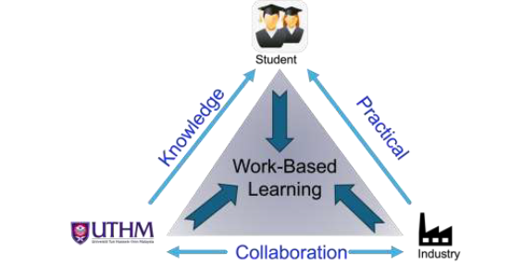
Figure 1: Relationship between students-industries based on the Edmund Model.
(Source: Garis Panduan Pembelajaran Berasaskan Kerja (WBL) UTHM, 2021)

1.1 Aims and Learning Outcomes of WBL
In an increasingly competitive economy, higher education providers (HEPs) and industry partners play a critical role in developing graduates with high-level, industry-relevant skills. Work-Based Learning (WBL) strengthens this collaboration by integrating academic learning with authentic workplace experience, where employers contribute to programme design, learning delivery, student support, assessment, and, in some cases, programme resources. Such collaboration requires clear roles, quality assurance mechanisms, and appropriate staff development to ensure effective learning outcomes.

2. WBL CHECKLIST

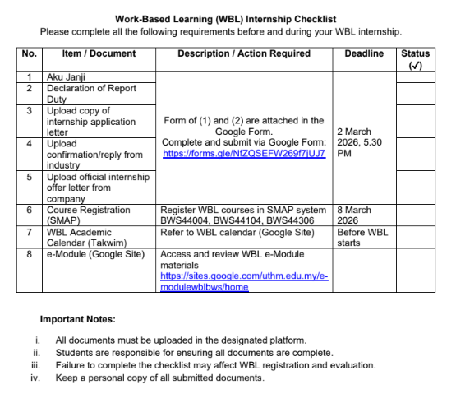

3. IMPLEMENTATION OF WBL

Work-Based Learning (WBL) delivery encompasses the approaches used to ensure that students achieve the prescribed learning outcomes. These include face-to-face instruction, online platforms, and blended learning. Within the academic setting, delivery is scheduled in accordance with the official timetable, whereas industry-based learning allows for greater flexibility, adapting to the nature and scope of the WBL course. The three core components of WBL delivery are presented in Figure 3.
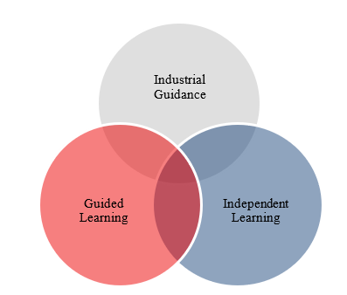
Figure 3: Course Delivery of WBL.

a) Industrial Guidance

Industrial guidance is provided by the Industry Coach (IC), who serves as a mentor to support students in understanding work tasks and related topics. Under this guidance, students gain hands-on workplace experience by applying theoretical knowledge to practical tasks. The effectiveness of this method relies on the expertise and experience of the IC, ensuring that students are able to meet the intended learning outcomes.

b) Guided Learning

Guided learning refers to structured learning activities conducted between lecturers and students, as specified in the official Class Schedule. Delivery follows the Academic Calendar and may take place face-to-face or online. Activities typically include presentations, discussions, question-and-answer sessions, dialogues, and elements of self-directed study.

c) Independent Learning

Independent learning takes place outside the formal class schedule and emphasizes the cultivation of lifelong learning skills. This approach requires students to be proactive and resourceful in expanding their knowledge beyond lecture materials. In the industry setting, this may involve completing additional assignments not specified by the IC. To fulfill such tasks, students are expected to independently source relevant information, deepen their understanding of topics, and engage in peer discussions or collaborative problem-solving.

3.1 Duration
The duration of the Work-Based Learning (WBL) program is one (1) year or 46 weeks, comprising two (2) regular semesters and one (1) short semester. Each regular semester spans 14 weeks, following the UTHM academic calendar for assessment purposes. In certain cases, the specific duration may be adjusted by the faculty.

3.2 Eligibility of WBL
a) Students are permitted to enrol in WBL after successfully completing all university courses. However, students may request consideration and approval from the Head of Department based on justifications that are subject to evaluation.

b) Students are not allowed to register for any other courses during the WBL period.

c) Students must attend the WBL orientation session conducted by the industry department before commencing their WBL placement.

4. ROLES AND RESPONSIBILITIES

4.1 University (UTHM)

- WBL Coordinator (Faculty)

i. Drafting the overall WBL plan after discussions with relevant implementers involved in the training program.
ii. Ensuring the successful implementation of the WBL according to the faculty’s design.
iii. Ensuring that matters related to the implementation of the WBL are conducted in accordance with the relevant quality procedures and requirements.
iv. Developing and coordinating feedback forms for students, industry coach, and university supervisors for the purpose of Continuous Quality Improvement (CQI) in WBL.

- WBL Coordinator (Program)
i. Assisting in the operational aspects of WBL program’s management.

ii. Updating the list of students enrolled in WBL courses and identifying their respective fields.

iii. Updating the list of organizations/industries registered by students.

iv. Serving as an intermediary between university supervisors, industry coach and students.

v. Providing course code information, estimating the number of students, proposing dates, WBL duration, and training venue details to the department.

vi. Creating a schedule for University Supervision.

vii. Conducting briefings on WBL operations for university supervisors and students.

viii. Compiling activity reports for the overall implementation of WBL.

ix. Delivering briefings on instructional materials to instructors and university supervisors.

x. Collecting WBL assessment scores from industry coach.

xi. Maintaining records and reports related to WBL instruction.

xii. Facilitating course alignment sessions with industry coordinator and university supervisors.

xiii. Providing a Study Guide and relevant teaching documents.

- University Course Instructor

i. Conducting teaching and learning activities based on modules and study guides.
ii. Monitoring the progress of students.
iii. Evaluating student compilation of project or task in final portfolio according to course requirement.

- University Supervisor

i. Establishing meeting schedules, whether in-person or online according to the guidelines set by the program.

ii. Assessing the performance and progress of students’ industrial project: proposal

and final year project report.

iii. Coordinating, guiding, and providing mentorship to students undergoing WBL.

iv. Monitoring and identifying challenges faced by students in the organizational/industrial setting.

4.2 Industry

- Industry Coordinator

The WBL Industry Coordinator acts as the Liaison Officer between the UTHM, students, academic staff, and Industry Coaches. Responsibilities include:

i. Identifying and selecting suitable Industry Coach(es).

ii. Assisting students in planning their placement at the industry.

iii. Resolving issues related to WBL students in the workplace.

iv. Maintaining regular and effective communication between university supervisors, industry coach(es), and students.

v. Coordinating the consistency of supervisory methods.

vi. Providing information to the faculty regarding the distribution list of Industry Coach(es) to students.

vii. Serving as an intermediary between the university and organizations/industries.

viii. Coordinating student files.

ix. Coordinating the implementation of teaching and learning (T&L) at the industry.

x. Coordinating the student evaluation process and submitting the reports to the UTHM within the stipulated time frame.

- Industry Coach

i. Provide training and guidance to students according to the course requirements.

ii. Conduct course assessments and monitor students’ progress.

iii. Guide students in their preparation for reports/assignments.

iv. Ensure that assessment reports are submitted to the Industry Coordinator within the stipulated time frame.

v. Ensure that students fully always comply with the safety and health regulations in the workplace.

vi. Review students' log books.

vii. Determine appropriate placements and task details for students.

viii. Provide instruction and guidance regarding assigned tasks.

ix. Evaluate students' performance using university-provided evaluation forms.

x. Submit student evaluations to the university within the specified timeframe.

xi. Inform the industry coordinator and faculty of any issues concerning students during their training in the organization/industry.

xii. Co-supervise the students' final year project course.

- Student
i. Committed to executing every WBL activity during the organization/industry placement.
ii. Adhering to the confidentiality, safety regulations, and codes of conduct of the organization/industry.
iii. Completing all designated learning hours and assessments as outlined by the program.

