**Appendix B**

**Simplified Framework Conceptual Scheme**

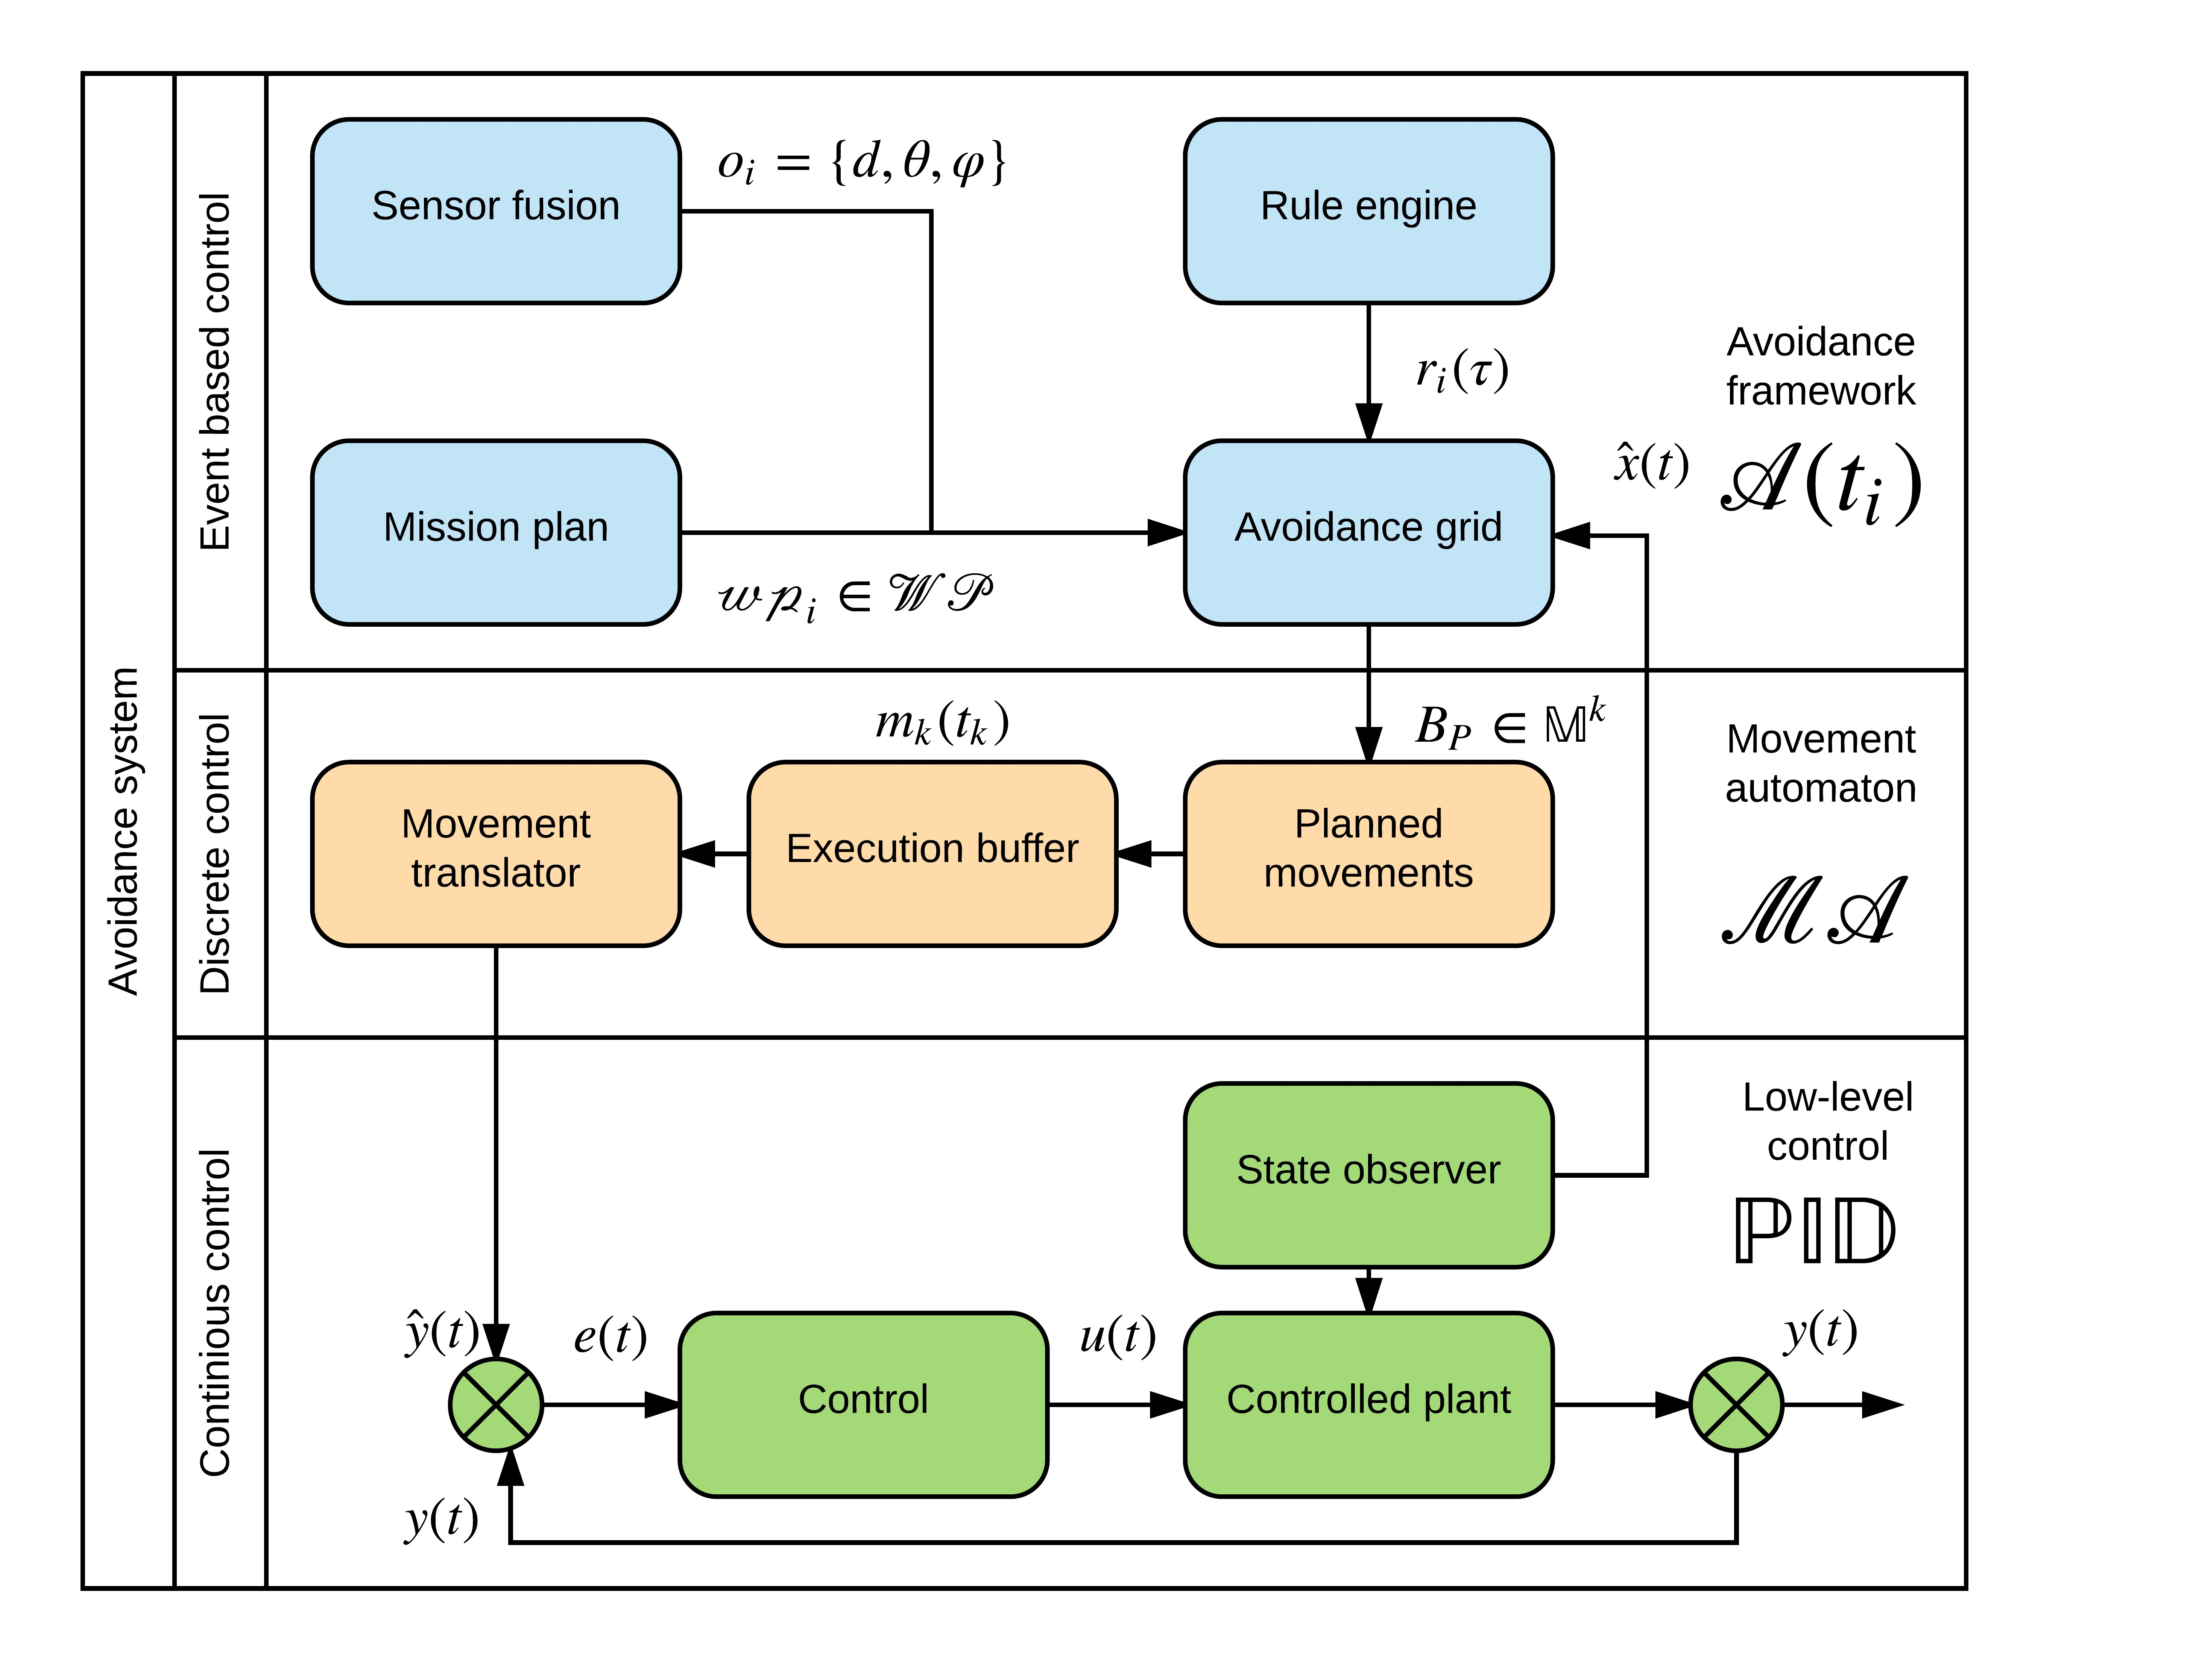

Figure B.1: Obstacle avoidance based on Reach sets concept [1].

**Conceptual scheme:** The overall concept of *Detect and Avoid Framework* (fig. B.1) is taking architecture from LSTS toolchain [2, 3]. The UAS part is based on *LSTS Dune,* and it can be easily integrated in the future.

1. *Continuous control* - is not solved in this work, its kept in the scheme for reference.
2. *Discrete control* - it bridges event based *Detect and Avoid* core functionality with *Continuous control*. Its covered by *Movement Automaton* (sec. **??**).
3. *Event-based control* - covers major functionalists:

1

2 Appendix B. Simplified Framework Conceptual Scheme a. *Sensor (Data) fusion* - the main feed of information, implementation of *sensor fusion* (sec. **??**) and *data fusion* (sec. **??**) contributing the avoidance events, introduced in (sec. **??**).

1. *Mission plan* - feeding actual goal and objectives to *Navigation Algorithm* (sec. **??**) and obeying *UTM directives* (sec. **??**).
2. *Avoidance Grid* - using mainly *Approximation of Reachable Space* (sec. **??**) in *Avoidance Maneuver Estimation*.
3. *Rule engine* - enforcing UTM directives (sec. **??**).

**Surveillance Improvements in Our Work:** *Hierarchical calculation* is addressed in

*Mission Control run* (sec: **??**) where threats are hierarchically applied based on *severity*.

*Source reliability evaluation* is addressed in *Static Obstacles* (sec. **??**) and *Moving Obstacles* **??**). The main rating for *Detected obstacle, Map Obstacle* and *Visibility* of space are established there.

*Clear rating definition* - the *Reachability* of space portion and *Safety* rating for trajectory are established in *Avoidance Grid Run* (sec. **??**)

**Reach Set Improvements in Our Work:** *Limited system dimension* - the discretization due to the higher system dimension and increased maneuver complexity goes hand-in-hand with *pre-calculation* of the *Reach Set*. This shortcoming is addressed in (sec. **??**).

*Real-time optimization* - replaced by *Discrete offline optimization problem*. The *general cost function* is given in (eq. **??**). The optimization problem solved in this work is defined in (eq. **??**).

*Continuous space disparity* - The *pre-calculated reach set estimation* can be valid with a small *marginal error* for some region in *system state space*. The dynamic method for state space segmentation can be used [4]. This aspect is not addressed in this work, because it strongly depends on the system behind movement automaton.

*Trajectory Tracking* - The *movement automaton* (def. **??**) in Control Mode can be used to track a reference trajectory in the form of *Movement Buffer*(def. **??**). Another option is to use *thick waypoint trajectory tracking for UAS* like in [5] or [6]. The work will use only *Movement Automaton* as controller/predictor.

**Bibliography**

1. Alojz Gomola, Jo˜ao Borges de Sousa, Fernando Lobo Pereira, and Pavel Klang. Obstacle avoidance framework based on reach sets. In *Iberian Robotics conference*, pages 768–779. Springer, 2017.
2. Jos´e Pinto, Paulo S Dias, Ricardo Martins, Joao Fortuna, Eduardo Marques, and Joao Sousa. The lsts toolchain for networked vehicle systems. In *OCEANS-Bergen, 2013 MTS/IEEE*, pages 1–9. IEEE, 2013.
3. Jos´e Pinto, Pedro Calado, Jos´e Braga, Paulo Dias, Ricardo Martins, Eduardo Marques, and JB Sousa. Implementation of a control architecture for networked vehicle systems. *IFAC Proceedings Volumes*, 45(5):100–105, 2012.
4. Yasutake Takahashi, Minoru Asada, and Koh Hosoda. Reasonable performance in less learning time by real robot based on incremental state space segmentation. In *Intelligent Robots and Systems’ 96, IROS 96, Proceedings of the 1996 IEEE/RSJ International Conference on*, volume 3, pages 1518–1524. IEEE, 1996.
5. Isaac Kaminer, Antonio Pascoal, Eric Hallberg, and Carlos Silvestre. Trajectory tracking for autonomous vehicles: An integrated approach to guidance and control. *Journal of Guidance, Control, and Dynamics*, 21(1):29–38, 1998.
6. Marina H Murillo, Alejandro C Limache, Pablo S Rojas Fredini, and Leonardo L Giovanini. Generalized nonlinear optimal predictive control using iterative statespace trajectories: Applications to autonomous flight of uavs. *International Journal of Control, Automation and Systems*, 13(2):361–370, 2015.

3