**Chapter 6**

**Approach**

Their levels of *Avoidance* are summarized in (fig. **??**).

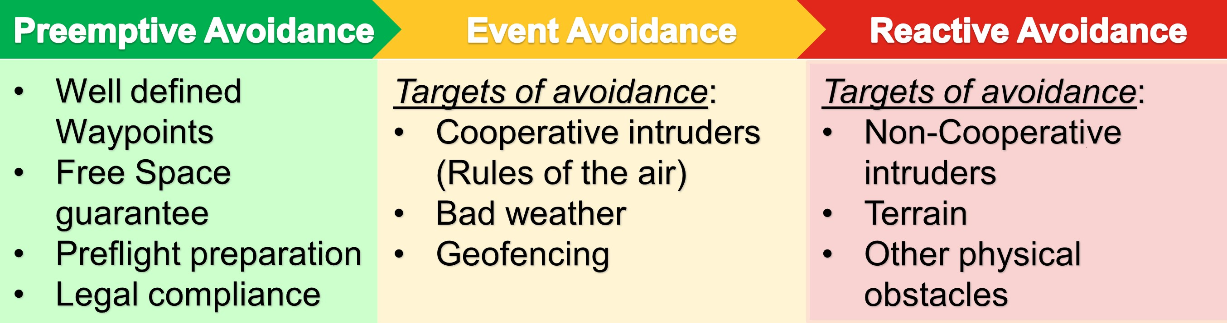

Figure 6.1: Avoidance levels based on reaction time.

This work will focus on handling *Event Avoidance,* and *Reactive Avoidance* and the *Avoidance Path* will be calculated using *Reach set Based Methods*.

The *Preemptive Avoidance* is trying to remove any possible threat before the flight. The risk mitigation is tedious and its done only when necessary. Even the best *preemptive* avoidance could fail.

*Reactive Avoidance* is solving most urgent situations with very short reaction opportunity. This work focus on physical obstacles and terrain. Non-cooperative intruders are partially considered. The adversary behavior was is not considered.

*Event Avoidance* has more opportunity to react. Some threats are known prior the flight (geo-fenced areas, ...). The future UTM implementation is also considered as *Event Avoidance*, due to the time horizon and authority enforcement.

**Basic Idea:** Create deterministic finite-time *Reactive Avoidance* based on *Reach sets* to ensure *trajectory feasibility*. Enhance method with a set of the rules to enable handling more complex situations.

The *Discretization* is the key to ensure calculation in finite time. Finite *partition* of *operational space (Known World)* and finite representation of *Reach set* guarantees finite count of calculation steps. Aircraft conflict prediction mentioned in [**?** ].

1

2 Chapter 6. Approach

# 6.1 Overview

The *Overview* is based on *Existing* Emergency avoidance framework [**?** ] (fig. **??**). To achieve goals defined in *Problem Definition* (sec. **??**, **??**) following *Avoidance Framework Concept* (fig. **??**) is proposed:

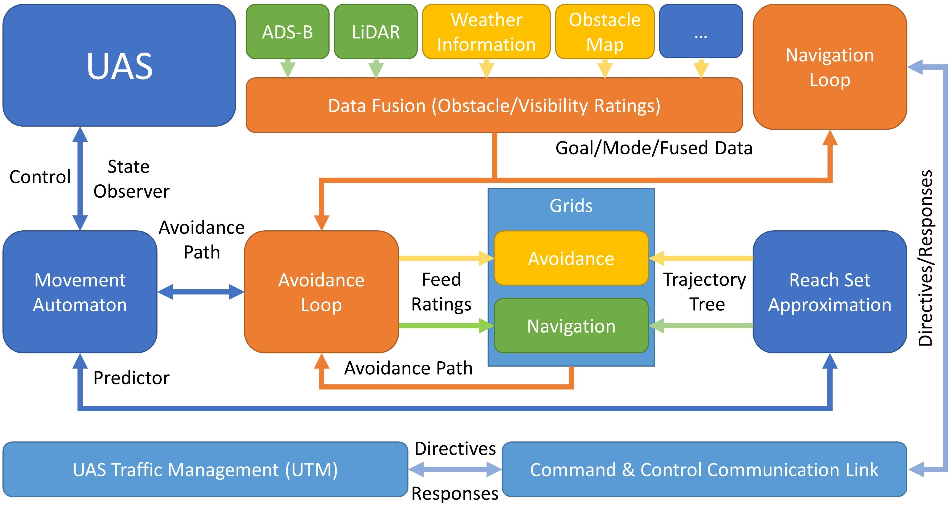

Figure 6.2: Avoidance Framework Concept.

**Structure of Avoidance Framework:**

1. *Unmanned Aircraft System* (UAS) (Role: Controlled Plant) - the *UAS* is controlled via *interface* implemented as *Movement Automaton*. The model used is described in (sec. **??**).
2. *Movement Automaton* (Role: Control Interface/Predictor) - consumes *Discrete Command Chain* to generate discrete *reference trajectory*, it can also be used as a predictor of *future UAS states* (sec. **??**). The movement Automaton used in this work is given in (sec. **??**).
3. *Sensor Field* (Role: Surveillance Providers), the following sensors, were considered in this work:
   * 1. *LiDAR* (Static obstacle detection) - detection of physical obstacles (sec. **??**)
     2. *ADS-B* (Intruder UAS/Plane detection) - detection of intruders who are broadcasting their position and sometimes heading with plans and additional parameters. The *intersection models* are given in (sec. **??**, **??**, **??**, **??**).

6.1. Overview 3

1. *Information Sources* (Role: Known World Information Enhancers):
   * 1. *Obstacle Map* (Static Restriction Source) - imposing static soft/hard constraints on *Known Word*/*Operational Space*. Static constraints are given in (sec. **??**).
     2. *Weather Information* (Static/Dynamic Restriction Source) - imposing static/moving soft/hard constraints on *Known World*/*Operational Space*. Moving constraints are given in (sec. **??**).
     3. *Other Airspace Restrictions* - like restricted airspace, geo-fencing, and other future constraint sources, all of them are covered by *Static/Dynamic Constraints* for now.
2. *Data Fusion* (Role: Sensor Input Interface) - is the unifying interface to asses *Operational State Properties* mainly *Obstacle Rating*, *Visibility*, *Map Obstacle Rating*, *Intruder Rating* for a portion of the space. The partial *ratings* are proposed in related sections. The data fusion procedure with *defuzzification* and final assessment into space sets are outlined in (sec. **??**)
3. *Reach Set Approximation* (Role: Reachability Estimator) - as *data fusion* is providing the situation assessment, the *Reach set* is providing maneuvering capability assessment. The introduction is given in (sec. **??**), the properties are defined in (sec. **??**), the approximation methods with constrained expansion are outlined in (sec. **??**, **??**, **??**, **??**). The reach set estimation is the main contribution of this work.
4. *Grids: Navigation/Avoidance* (Role: Operation Space Segmentation & Situation Evaluation) - space discretization in polar coordinates grid, different reach sets are used for different grid type, defined in (sec. **??**).
5. *Avoidance loop* (Role: Short Term Decision Maker) - using data from *Sensor fusion* in *Avoidance/Navigation Grid* trimming *Reachable Space* approximated by *Reach Set* generating feasible *Avoidance Path*. *Avoidance Path* is fed to controlling *Movement Automaton*. The Goal is given by *Navigation Loop*. Avoidance loop is given in (sec. **??**).
6. *Navigation loop* (Role: Long Term Decision Maker) - using data from *Avoidance Loop*, *Mission plan* and *UTM* directives defines the current long term navigation goal. Details are given in (sec. **??**).
7. *Command and Control Communication Link* (C2 Link) (Role: Communication Link) - standard communication link with sufficient reliability.
8. *UAS Traffic Management* (UTM) (Controlled Airspace Authority) - checking possible collisions and enforces counter-measurements. Details are given in (sec. **??**).

4 Chapter 6. Approach

**Communication in Avoidance Framework:**

1. *UAS* ↔ *Movement Automaton* - sharing *actual system state*, commanding the UAS platform.
2. *Reach Set* ↔ *Movement Automaton* - predicting a set of feasible trajectories for the given situation.
3. *Reach Set* ↔ *Grids* - providing trajectory set depending on the active mode (Navigation/Emergency Avoidance).
4. *Avoidance Loop* ↔ *Data Fusion* - assessing the situation in *operational space* based on sensor readings/information sources.
5. *Avoidance Loop* ↔ *Navigation Loop* - determining long term goal based on situation assessment and UTM directives.
6. *Avoidance Loop* → *Grids* - feeding assessment data and constraints into selected operational space Grid.
7. *Grids* → *Avoidance Loop* - returning feasible and *cost-effective* avoidance path after situation assessment and *Reach set* pruning.
8. *Avoidance Loop* → *Movement Automaton* - issuing and monitoring movement commands based on actual *avoidance strategy*.
9. *Navigation Loop* ↔ *C2 Link* ↔ *UTM* - communication to receive directives and send fulfillment.