**Appendix E**

**Intruder Probabilistic Models**

# E.1 Linear Intersection

**Idea:** There are *small intruders* which have body *smaller* than average *celli,j,k* cell size. Its trajectory will stick to *linear trajectory* prediction with high probability.

**Space Intersection Rate:** The *Space Intersection Rate* for *celli,j,k* is implemented as simple point cloud intersection. Where *sufficiently thick* point cloud is defined along *line* (eq. E.1):

*position*(*time*) = *position*(*time*0) + *velocity* × *time, time* ∈ [0*,*∞[ (E.1)

Then there exist projection function from local Euclidean coordinates to local polar coordinates (eq. E.2. The function projects intruder trajectory (eq. E.1) to planar coordinates [*distance, horizontal*◦*, vertical*◦] as a set of sufficiently thick point cloud.

*polarSet* : *position*(*t*) → {[*distance,horizontal*◦]*,vertical*◦} (E.2)

The *space intersection rating SpaceIntersection*(◦) for line type is given as (eq. E.3). If there exist non empty intersection of *polarSet* ∩ *celli,j,k* there is space intersection rate equal to 1, if intersection *polarSet* ∩ *celli,j,k* = ∅ then the rate is zero.



!

*Intruder,* 1 : ∃*point* ∈ *polarSet*(*eq.E.*2) : *point* ∈ *ci,j,k*

*space* = (E.3)

*cell,j,k* 0 : otherwise

*Note.* The *intruder intersection rate* is multiplication of *space intersection rate* and time intersection rate. The *intersection rate* is calculated for *every intruder* and *selected intersection model* separately.

1

# E.2 Body-volume Intersection

**Idea:** The *Intruder* has body volume greater than *average celli,j,k* volume. The *intruder body* is considered as the ball moving along *intruder position*. The *intersection* of the intruder body is realized as sufficiently thick *point-cloud intersection*.

**Space Intersection Rate - Body Volume:** The *body volume mass* with center at *position*(*t*) is moving along intruder trajectory prediction (eq. E.4) in time interval [0*,*∞[:

*position*(*time*) = *position*(*time*0) + *velocity* × *time* (E.4)

The body *Volume ball Body*(*position*(*t*)*,radius*) (eq. E.5) is defined as set of points in R3 euclidean space. The center is moving along the *position(t)*. The body *volume ball* is a set of points sufficiently thick including also inner points. The *thickness* is guaranteed by existence of neighbour point which is close enough.

  k*position*(*t*) − *point* ≤ *radius*

 3 

*Body*(*position*(*t*)*,radius*) = *point* ∈ R : ∀*pointi*∃*pointj*6=*i,*

 *distance*(*pointi,pointj*) ≤ *thickness*

(E.5) The *polar volume ball polarBody* (eq. E.6) is projection of body volume ball set *Body*(*position*(*t*)*,radius*) to a set of planar coordinates in avoidance grid coordinate frame:



The *space intersection rate for vehicle body space*(*Intruder,celli,j,k*) (eq. E.7) is calculated as intersection of polar body volume ball and *celli,j,k*. If intersection is non empty then base probability is one, zero otherwise:



!

*Intruder,* 1 : ∃*point* ∈ *polarBall*(*eq.E.*6) : *point* ∈ *ci,j,k*

*space* = (E.7)

*celli,j,k* 0 : otherwise

**Intersection Time:** The *intersection time* id depending on point cloud (eq. E.6) where each point *have intersection time* given as *body-center position* time (eq. E.4).

*Note.* The *body-volume* intersection model can insert the *multiple intersection times* into one *celli,j,k*. The *interval length* considers all of these for intersection rates (eq. **??**).

# E.3 Maneuverability Uncertainty Intersection

**Idea:** The *intruders* are not bullets they are not sticking to predicted linear paths. The *intruder* maneuverability is given as horizontal and vertical spread. Therefore *intruder reach set* will form an *elliptic cone*. This cone can be transformed into *finite discrete* point-cloud, each *point* should have assigned *severity* impact value. The point cloud intersection with *Avoidance Grid* will give us space impact of an *uncertain* intruder.

*Note.* The following section will use condensed notation, due to the equation complexity. The *terminology* is consistent with the rest of the section.

**Space Intersection Rate - Body Volume Intersection:** *PT* (*ik*(*xs,v,θ,ϕ*)*,ci,j,k*) computation is less straight-forward than other space intersection rates. First let us define the linear intruder *ik* positions *x* at time *t* (eq. E.8) model, where *x*(*t*) defines intruder position in *avoidance grid euclidean coordinate frame* at time *ti*, *v* defines intruder velocity, and *t* is a time offset.

*x*(*t*) = *xs* + *vI.t* (E.8)

Intruder *horizontal spread θ* and *vertical spread ϕ* are introduced. These spreads represents intruder deviation limits along from linear trajectory prediction *x*(*t*) ∈ R3. The example is given by (fig. E.1) where the intruder starts at point *xs* with fixed velocity *v*, the linear trajectory prediction is outlined by blue line. The *predicted intruder position* at time *t* = 10*s* is given by *x*(10) (blue point). The ellipsoidal space *E*(*x*) is projected on the plane *D*(*x*(*t*)). The plane *D* (eq. E.9) for point *x*(*t*) and velocity *v* is defined as an orthogonal plane to velocity vector *v* ∈ R3 with origin at intruder position *x*(*t*).

 (E.9)

To construct ellipsoidal space boundary on orthogonal plane *D*(*x*(*t*)*,v*) some parameters are defined in (eq. E.10). The *scalar distance ddx*(*t*) is simple Euclidean norm, *maximal horizontal offset dθ*(*xt*) is given as product of sinus of horizontal offset angle *θ* and scalar distance *dd*, and *maximal vertical offset dϕ*(*x*(*t*)) is given a product of sinus of vertical offset angle *ϕ* and scalar distance *dd*.

*dd* = *dd*(*x*(*t*)*,xs*) = k*x*(*t*) − *xs*k2

*dθ*max = *dθ*(*x*(*t*)) = sin*θ*(*ik*)*.dd*(*x*(*t*)) (E.10)

*dϕ*max = *dϕ*(*x*(*t*)) = sin*ϕ*(*ik*)*.dd*(*x*(*t*))

The *Ellipsoid E*(*x*(*t*)*,v*) (eq. E.11) for fixed intruder position *x*(*t*) and fixed intruder velocity *v* is given as constrained portion of orthogonal plane *D*(*x*(*t*)*,v*). The constraint is defined by an internal coordinate frame *p* ∈ R2 which is space reduction of plane *D*(*x*(*t*)*,v*).

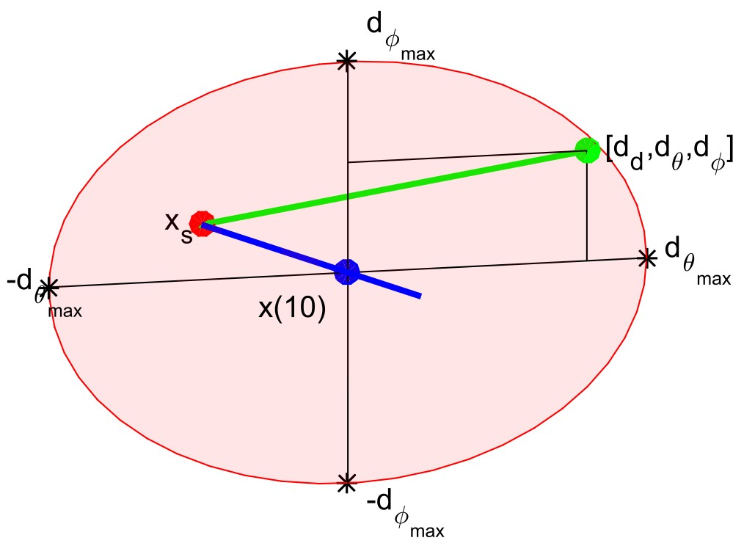

Figure E.1: One rate position [*dd,dθ,dϕ*] (green). deviated from linear trajectory (blue line) at point *x*(10).(blue) with initial position *xs* (red)

The internal coordinate frame *p* ∈ R2 has origin in *x*(*t*) → R2. The points of plane *p* are bounded by projection *p* = (*b* − *x*(*t*)) → R2, where *b* ∈ *D*(*x*(*t*)*,v*). The point of ellipsoidal *p* is then given as standard ellipse boundary with vertical span *dθ*(*x*(*t*)) and horizontal span *dϕ*(*x*(*t*)).

The 2D *Ellipsoid E*(*x*(*t*)*,v*) for specific time *t* = 10*s* example is portrayed as red ellipsoid (in fig. E.1).

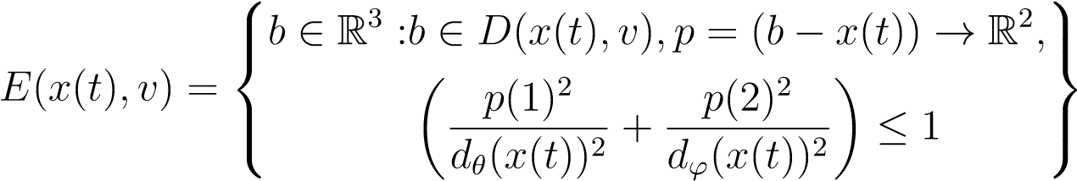 (E.11)

The expected behavior of an intruder *ik* is to stick to predicted linear trajectory *x*(*t*) (E.8). The probability of deviation should be decreasing with distance from the ellipse center (fig. E.2.).

*Probability density function* for ellipsoid *E*(*x*(*t*)*,v*)defined in (eq. E.11) is depending on maximal horizontal spread *dθ*(*x*(*t*)), maximal vertical spread *dϕ*(*x*(*t*)), defined by (eq. E.10).

Two standard probabilistic distributions are established N(*µθ,σθ*) (eq. E.12) for horizontal spread *θ*(*x*(*t*)) and N(*µϕ,σϕ*) (eq. E.13) for vertical spread *ϕ*(*x*(*t*)). The means *µθ* and *µϕ* are set to zero, and internal coordinate frame *p* ∈ R2 where *x*(*t*) → R2 is frame center. The variances *σθ* and *σϕ* are set as maximal distances on horizontal/vertical spread axes *dθ*(*x*(*t*)) and *dϕ*(*x*(*t*)).

*P*(*x*(*t*)*,dθ*) = N(*µθ,σθ*) = N(0*,dθ*(*x*(*t*))) (E.12)

*P*(*x*(*t*)*,dϕ*) = N(*µϕ,σϕ*) = N(0*,dϕ*(*x*(*t*))) (E.13)

The combined *probability density function* for maximal spreads *dθ* and *dϕ* is given by (eq. E.14). Because probability density function is defined for internal space *p* ∈ R2 and one may need to calculate impact rate for cell space *ci,j,k* ∈ R3.

The reduction from two parameter probability distribution function to scalar rate distribution function is needed. A scalar rate distribution function *P*(*x*(*t*)*,dθ,dϕ*) over ellipsoid *E*(*x*(*t*)*,v*) is defined as (eq.E.14), where the final rate is given as an average of two partial probabilities.

Final space intersection rate *P*(*x*(*t*)*,dθ,dϕ*) needs to be normalized to hold *normal distribution condition* (eq. E.15). Normal distribution condition value (eq. E.15) is given as surface integral over ellipsoid *E*(*x*(0)*,v*) with rate distribution function *P*(*x*(*t*)*,dθ,dϕ*). 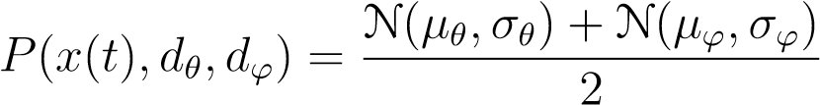 (E.14)

ZZ

*P*(*x*(*t*)*,dθ,dϕ*)d*dθ* d*dϕ* = 1 (E.15)

*E*(*x*(*τ*))

Final space intersection rate *P*(*x*(*t*)*,ci,j,k,θ,ϕ*) (space portion, time portion is calculated in (eq.**??**) is given by (eq. E.17). Its mean value of all intersection rates *P*(*x*(*τ*)*,ci,j,k,θ,ϕ*) where *τ* ∈ [*ie*(*ci,j,k*)*,il*(*ci,j,k*)] is fixed point in intersection time interval.

An *P*(*x*(*τ*)*,ci,j,k,θ,ϕ*) (E.16) is integration of rate density function *P*(*x*(*τ*)*,dθ,dϕ*) (eq. E.14) in surface *E*(*x*(*τ*)*,v*) to cell *ci,j,k* volume intersection.

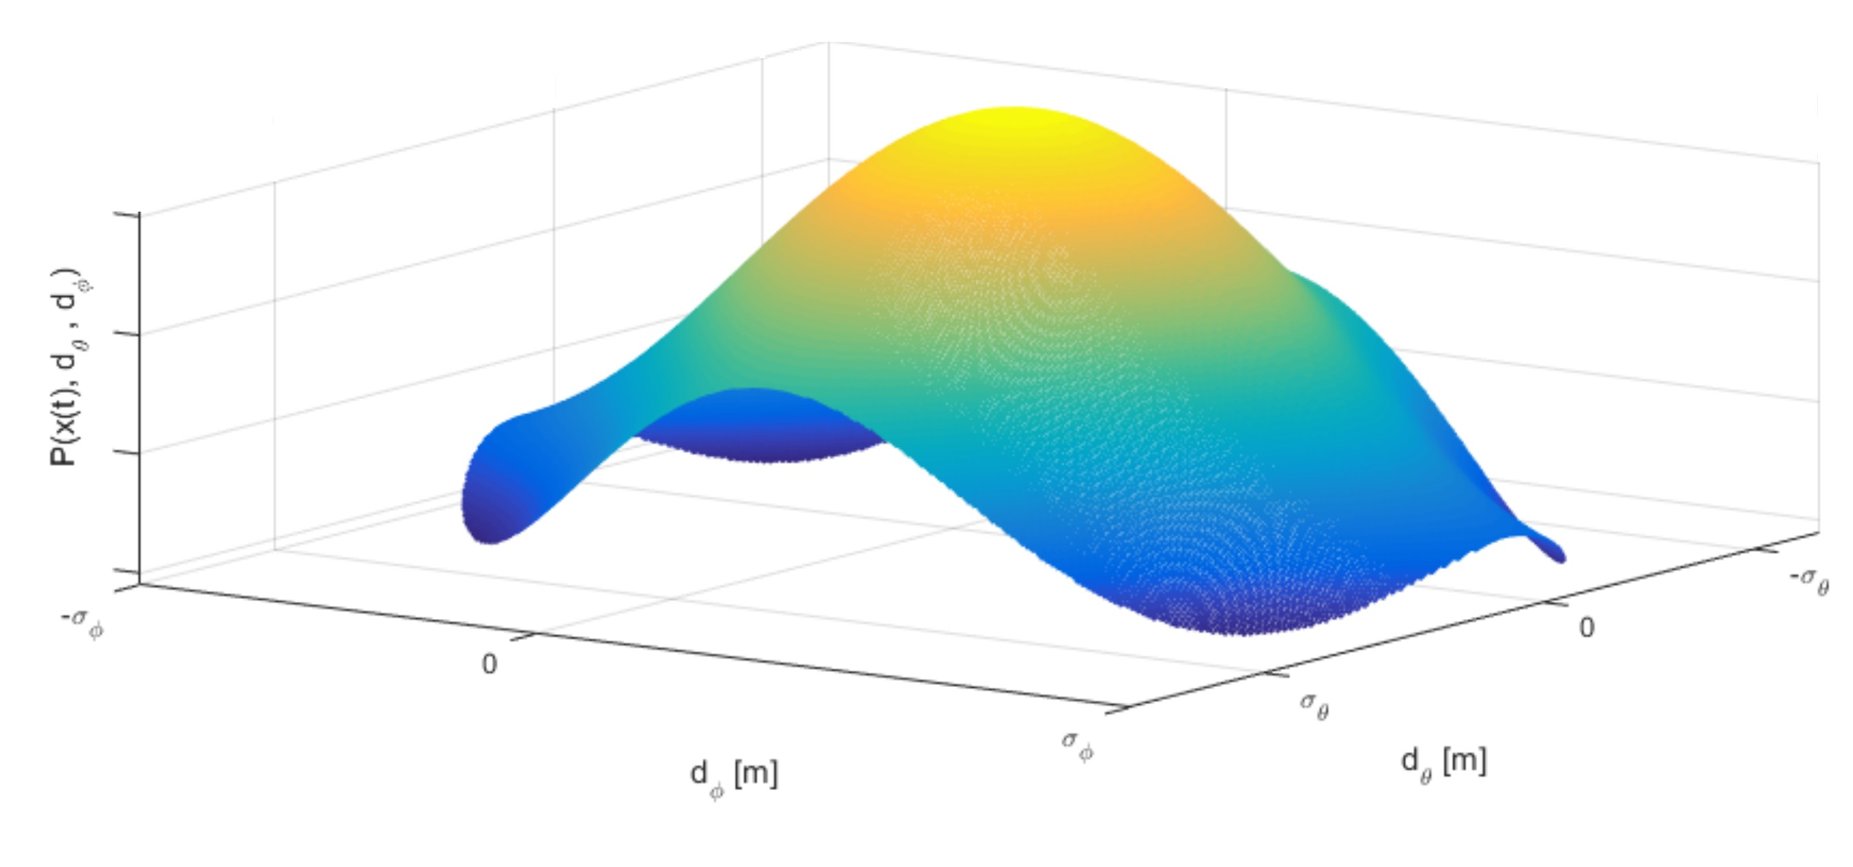

Figure E.2: Probability of intruder *ik* position in ellipsoid *E*(*x*(*t*)*,v*)

To get a volume integration partial rate in surface intersection must be integrated and normalized in time interval *τ* ∈ [*ie*(*ci,j,k*)*,il*(*ci,j,k*)], the *base intersection probability PT* (*ik*(*xs,v,θ,ϕ*)*,ci,j,k*) is given by (eq. E.17). Example of intersection of intruder *ir* uncertain ellipsoid cone with avoidance grid A(*ti*) is given in (fig. E.3).

ZZ

|  |  |  |
| --- | --- | --- |
| *P*(*x*(*τ*)*,ci,j,k,θ,ϕ*) = | *P*(*x*(*τ*)*,dθ,dϕ*)  *E*(*x*(*τ*)*,v*)∩*ci,j,k* | (E.16) |

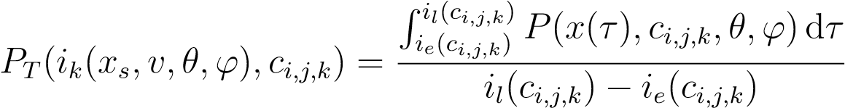 (E.17)

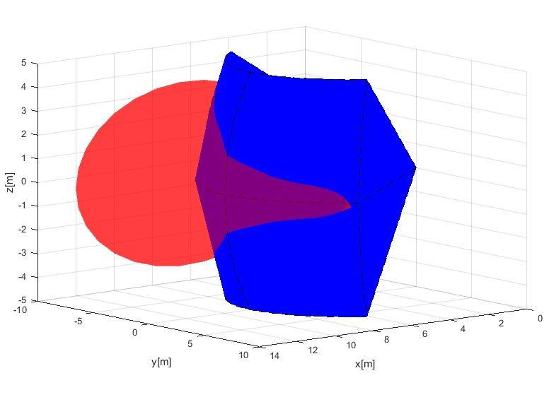

Figure E.3: Avoidance grid A(*ti*) (blue) intersection with elliptic cone intruder *ik*(*x,v,θ,ϕ*) (red) example.

A *numeric approximation* of space intersection rate *PT* (*ik*(*xs,v,θ,ϕ*)*,ci,j,k*) is more implementation feasible than symbolic calculation due to the multiple intersection constraints and bad intersection algorithm complexity.

Let us define a homogeneous discrete subset of real numbers R which is a non empty subset of real numbers R. The set R (eq. E.18) is homogeneous that means for an equal interval (*i,i* + 1]*,i* ∈ Z subset the count of members is equal to some positive natural number *k*. The parameter *k* can be understood as *unit approximation density*.

Similarly, the power sets R2 ⊂ R2, R3 ⊂ R3, ... R*i* ⊂ R*i,i* ∈ N+ keeps homogeneous distribution.

R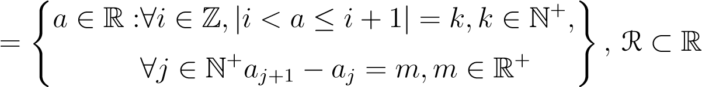 (E.18)

The orthogonal plane for *x*(*t*)*,v,t* ∈ R is defined by (eq. E.9). The orthogonality property is also kept for any subspace R*n* ∈ R*n,n* ∈ N+. Numeric approximation of *D*(*x*(*t*)*,v*) is given as *DD*(*x*(*t*)*,v*) (eq. E.19).

The only difference is that discrete approximation is countable |*DD*| = *m,m* ∈ N+, but continuous representation |*D*| ≈ ∞ is uncountable. Because ellipsoid is a subset of orthogonal plane it keeps its countability property; therefore *ED* is also countable and must contain at least one member.

R (E.19)

The *base ellipsoid E*(*x*(*t*)*,v*) for continuous-space is given by (eq. E.11). Every element, expect the base of internal projection R2 and orthogonal plane *DD* is same in discrete case *ED*(*x*(*t*)*,v*) (eq. E.20).

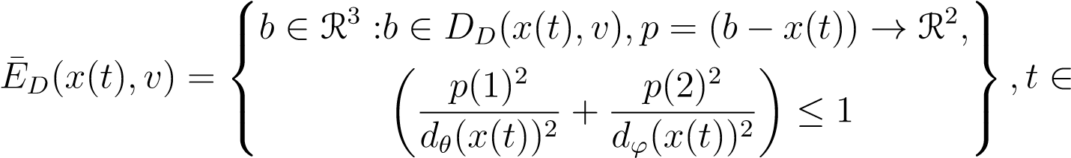R (E.20)

The *numeric calculation disproportion* can occur in case that ellipsoid *E*¯*D*(*x*(*t*)*,v*) (E.20) in case of *dθ*(*x*(*t*)) ≈ 0 and *dϕ*(*x*(*t*)) ≈ 0. The count of ellipsoid members can be |*E*¯*D*(*x*(*t*)*,v*)| = 0, which is in contradiction with assumption |*E*¯*D*(*x*(*t*)*,v*)| 6= 0.

Let assume for discrete times *τ* = {*t*1*,t*2*,...,ti*}, *i* ∈ N+ there exists ellipsoids *E*¯*D*(*x*(*t*1)*,v*),*E*¯*D*(*x*(*t*1)*,v*), *...*, *E*¯*D*(*x*(*ti*)*,v*) which are non empty and in space R2 in internal coordinate frame and space R3 in avoidance grid A(*ti*) coordinate frame. The intersection of these partial ellipsoids in both spaces is equal to:

*E*¯*D*(*x*(*t*1)*,v*) ∩ *E*¯*D*(*x*(*t*2)*,v*)··· ∩ *...E*¯*D*(*x*(*ti*)*,v*) = ∅ (E.21)

An *empty intersection* enables us to keep homogeneity property of ellipsoids by adding points so it is safe to add specific point *x*(*t*) into empty ellipsoid. But only one, because it does not impact probability density functions N(*µθ,σθ*) and N(*µϕ,σϕ*), neither space intersection rate density function *P*(*x,dθ,dϕ*).

The final ellipsoid used forward *ED*(*x*(*t*)*,v*)(eq. E.22) is keeping all properties of ellipsoid *E*(*x*(*t*)*,v*) (eq. E.22).

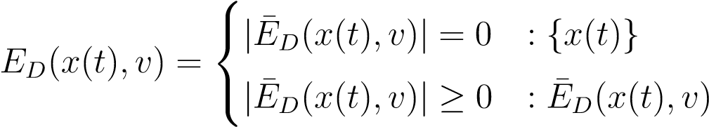 (E.22)

The normal distribution condition for rate distribution function *PD*(*x*(*t*)*,dθ,dϕ,p*), which is instance of to rate density function *P*(*x*(*y*)*,dθ,dϕ*) (eq. E.14) is used. This rate distribution must be normalized according to (eq. E.23).

X +

*PD*(*x*(*t*)*,dθ,dϕ,p*) = 1*,*∀*t* ∈ R (E.23)

*p*∈*ED*(*x*(*t*))

The equations for *space intersection rate* are similar to (eq. E.16, E.17). For cell *ci,j,k* there exist intruder entry time *ie*(*ci,j,k*) its the earliest intersection with ellipsoid *ED*(*x*(*ie*(*ci,j,k*)))*,v*. Same situation occurs with intruder leave time *il*(*ci,j,k*). Because *ED* is countable set, it means additional attributes can be attached to each point *p* ∈ *ED*.

Based on system dynamic (eq. **??**) the *Time Of Arrival* (TOA) can be calculated. The example of TOA is given in fig. E.4.

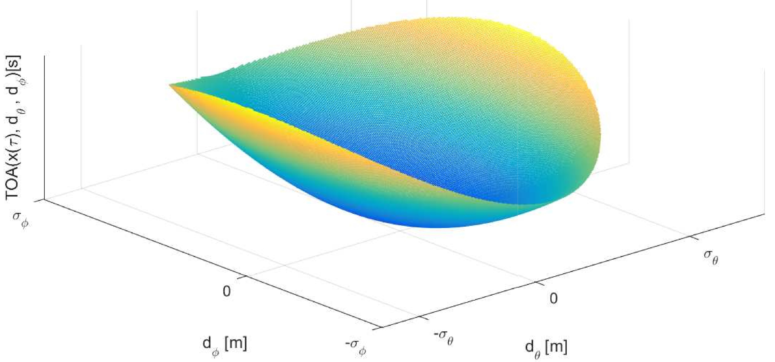

Figure E.4: Time Of Arrival (TOA) for one ellipsoid *ED*(*x*(*τ*)*,v*).

The intersection rate *PD*(*x*(*τ*)*,ci,j,k,θ,ϕ*) for one time sample *τ* is given by (eq. E.24), which has similar notation to (eq. E.16), sums are used instead of integrals and discrete rate density function *PD*(*x*(*τ*)*,dθ,dϕ,p*) for points form ellipse and cell intersection are used as iterator base set *p* ∈ {*ED*(*x*(*τ*)*,v*) ∩ *ci,j,k*}.

*PD*(*x*(*τ*)*,ci,j,k,θ,ϕ*) = X *PD*(*x*(*τ*)*,dθ,dϕ,p*) (E.24)

*p*∈{*ED*(*x*(*τ*)*,v*)∩*ci,j,k*}

The *space intersection rate PTD*(*ik*(*xs,v,θ,ϕ*)*,ci,j,k*) (eq. E.25) is given as mean intersection rate of partial intersections *PD*(*x*(*τ*)*,ci,j,k,θ,ϕ*) where step set *T* = { *ie*(*ci,j,k*), *...*, *il*(*ci,j,k*)} contains all viable intersection times with ellipsoids *E*(*x*(*τ* ∈ *T*)*,v*). The denominator is basically count of samples in sample time set *T*.

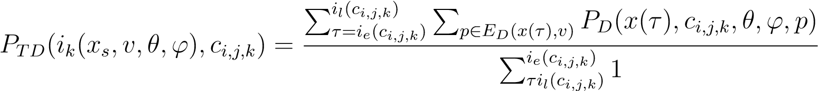 (E.25)

An *intersection of intruder cone and cell ci,j,k* cell is defined by (eq. E.26) The set of point *p* ∈ R3 where condition of intersection between ellipsoids *ED*(*x*(*τ*)*,v*) for times *τ* ∈ R+ and cell space *ci,j,k* is met.

P (E.26)

An *intruder time of entry ie*(*ik,ci,j,k*) (eq. E.27), for intruder *i,k* and cell *ci,j,k* is approximated for discrete point set P(*ik*(*xs,v,θ,ϕ*)*,ci,j,k*) (eq. E.26) as minimal time of arrival *tTOA*(*p*) of member points *p*.

*ie*(*ik,ci,j,k*) ≈ min{*tTOA*(*p*) : *p* ∈ P(*ik*(*xs,v,θ,ϕ*)*,ci,j,k*)} (E.27)

An *intruder time of leave il*(*ik,ci,j,k*) (eq. E.28), for intruder *i,k* and cell *ci,j,k* is approximated for discrete point set P(*ik*(*xs,v,θ,ϕ*)*,ci,j,k*) (eq. E.26) as maximal time of arrival *tTOA*(*p*) of member points *p*.

*il*(*ik,ci,j,k*) ≈ max{*tTOA*(*p*) : *p* ∈ P(*ik*(*xs,v,θ,ϕ*)*,ci,j,k*)} (E.28)

**Combined intersection model:** The *combined intersection model POI*(*ik,ci,j,k,l,b,s,τ*) is defined for intruder *ik* with parameters:

1. *Starting position xs* - expected position of intruder *ir* in 3D space at time of avoidance *ti* in avoidance grid frame A(*ti*).
2. *Velocity vector v* - oriented velocity of intruder *ir* at time of avoidance *ti* in avoidance grid frame A(*ti*).
3. *Horizontal uncertainty spread θ* - defines how much can intruder *ir* deviate on horizontal axis of intruder local coordinate frame (if X+ is the main axis, then Y is horizontal axis in right-hand euclidean coordinate frame), due the properties of intersection definition, the horizontal uncertainty spread can have following values *θ* ∈ [0*,π/*2].
4. *Vertical uncertainty spread ϕ* -defines how much can intruder *ir* deviate on vertical axis of intruder local coordinate frame (if X+ is the main axis in local right-hand euclidean intruder coordinate frame, then Z is horizontal-vertical axis), due the intersection definition, the vertical uncertainty spread can have following values *ϕ* ∈ [0*,π/*2].
5. *Body volume radius r* - defines the body volume of an intruder in meters and it has R+ value.

The *flag vector l,b,s,τ* ∈ {0*,*1} is a parametrization of rate calculation: *l* stands for the *lined intersection*, *b* stands for *body intersection*, *s* stands for the *spread intersection*, *τ* stands for *time account*.

The *space intersection for line PL*(*ik,ci,j,k*) is defined as *PT* (*ik*(*x,v*)*,ci,j,k*), where *ik* is intruder with properties of initial position *x*, velocity vector *v* and *ci,j,k* is target cell.

(eq. E.3).

The *space intersection rate for body volume PB*(*ik,ci,j,k*) is defined as *PT* (*ik*(*x,v,r*)*,ci,j,k*) (eq. E.7), where intruder *ir* has additional property of the intruder body volume radius *r*.

The *space intersection probability for maneuverability uncertainty PS*(*ik,ci,j,k*) is defined as *PTD*(*ik*(*xs,v,θ,ϕ*)*,ci,j,k*) (eq. E.25), where intruder properties *θ*, *ϕ* stands for intruder horizontal and vertical uncertainty spread.

The *time intersection rate Pτ,x*(*ik,ci,j,k*) ∈ [0*,*1] is defined in (eq. **??**). This probability has two calculation modes, first is for 1D intersection (line), second is for volume intersection (body volume, spread elliptic cone).

UAS cell entry time *te* and cell leave time *tl* time for a vehicle in avoidance grid A(*ti*) is given by (eq. **??**) and (eq. **??**).

Intruder leave and entry time for 1D intersections is trivial and is omitted in this section. Intruder entry *ie* and intruder leave *il* for 3D intersection is given by (eq. E.27, E.28).

All partial rates with respective definition references are summarized in (eq. E.29)

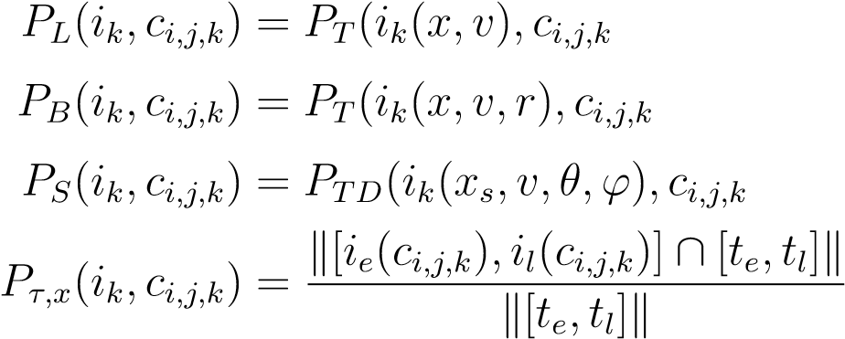 ) (*E.*3)

) (*E.*7)

(E.29)

) (*E.*25)

(**??**)

With definition of all space and time intersection rates (eq. E.29) and given flag vector *l,b,s,τ* ∈ {0*,*1} one can formulate combined intersection rate *POI*(*ik,ci,j,k,l,b,s,τ*) (eq. E.30) for intruder *ik* and cell *ci,j,k*. The principle is following: *maximum of selected rates product based on flag vector is final intersection rate of intruder ik in the cell*.

The time-use flag *τ* is adding time intersection rate *Pτ,x*(*ik,ci,j,k*), where time intersection rate is defined by *x* = {*L,B,S*} for line, body volume, spread ellipse time intersections (*Pτ,L*(*ik,ci,j,k*) 6= *Pτ,B*(*ik,ci,j,k*) =6 *Pτ,B*(*ik,ci,j,k*) for one intruder *ik*).

|  |  |  |
| --- | --- | --- |
|   *τ* = 0  *POI*(*ik,ci,j,k,l,b,s,τ*) =  *τ* = 1 |    *PL*(*ik,ci,j,k*)*.l*     : max *PB*(*ik,ci,j,k*)*.b*  *PS*(*ik,ci,j,k*)*.s*     *P*   *τ,L*(*ik,ci,j,k*)*.PL*(*ik,ci,j,k*)*.l*  : max *Pτ,B*(*ik,ci,j,k*)*.PB*(*ik,ci,j,k*)*.b*  *Pτ,S*(*ik,ci,j,k*)*.PS*(*ik,ci,j,k*)*.s* | (E.30) |

**Bibliography**

11