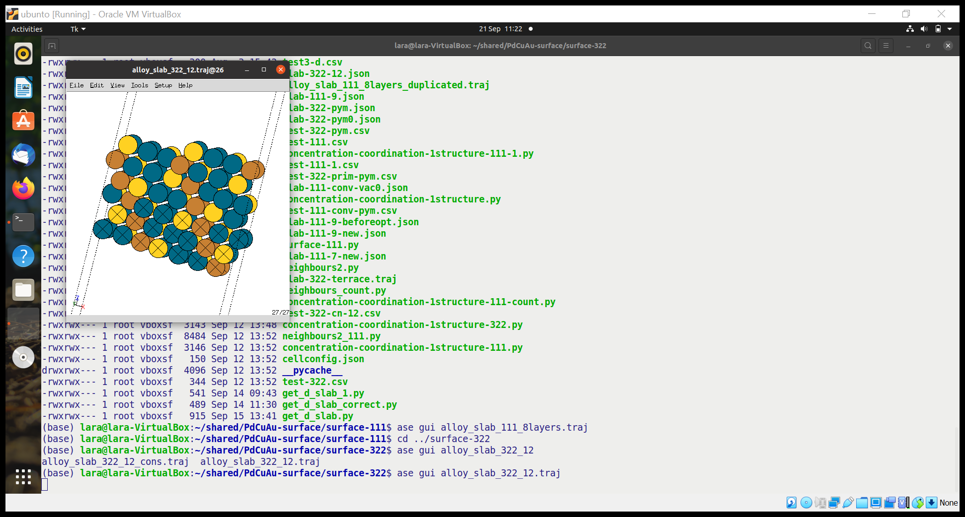

Divide the structure into different layers and calculate the average distance between the atoms of each layers