**Unearthing The Environmental Impact Of Human Activity: A Global CO2 Emission Analysis**

**INTRODUCTION**

Global warming is one of the biggest challenges currently being faced by the human race, although correlation is not causation, a likely cause of global warming is due to increased atmospheric carbon dioxide from human activities. **CO2 Emission** refers to the Carbon Dioxide emitted throughout the world. For this analysis we will be focusing on CO2 Emissions and its effect on the world we live in as well as some key factors and stats that may play a role in the emission of CO2 globally. Fossil fuel use is the primary source of CO2. The data throws light onto how much fossil fuels are burnt, per year per nation, which amounts to an increase in CO2 every year. This will help researchers and environment experts to predict global warming. So countries should set a goal to decrease this amount yearly.

**DESIGN THINKING**

Analysing Global Co2 Emission across countries from 1975 to 2020. This dataset contains a record of Co2 Emission by each Country and Region of Earth, here we are going to analyse and visualise Country wise, Region wise and Overall Co2 Emission on Earth.

The business requirements for analysing the Co2 Emission Globally over time, identifying affecting factors, creating interactive dashboards and reports, identifying areas for improvement, making data-driven decisions, comparing to countries average and creating forecasting models for future performance. The ultimate goal is to gain insights and reduce the emission through data visualization techniques.

A literature survey is a method of researching existing literature and studies related to a specific topic. In the context of analyzing the Global Co2 Emission, a literature survey would involve reviewing studies and articles that have been published on the topic of Emission, as well as studies specific to Co2.The literature survey would include sources such as academic journals, industry reports, and online articles. It would aim to identify different internal and external factors that are responsible and commonly used to determine Co2 Emission, as well as any best practices or strategies that have been identified for reducing emission.The literature survey would also explore any existing research on Co2 Emission specifically, and would aim to identify any challenges or opportunities that the Countries can opt to reduce emission.

**Social Impact:** Carbon dioxide emissions are the primary driver of global climate change. It’s widely recognised that to avoid the worst impacts of climate change, the world needs to urgently reduce emissions.

**Business Model/Impact:** By conducting an analysis the countries can identify areas for improvement and take steps to reduce factors that are responsible for Co2 Emission for environmental sustainability by improving the efficiency and transitioning to low carbon alternatives.

**Dataset**

Dataset consists CO2 emissions in metric ton per capita of every country around the world.  The data is collected from 1975 to 2020. In this dataset Countries and regions are included. Data is initially pre-processed using excel.

The dataset contains

* *Country- Country for which Co2 is Recorded*
* *Year- Year the data was recorded*
* *Co2 Emission (In Million Metric Tons )*
* *Co2 Growth per Capita*
* *Co2 Per Capita*
* *Cumulative Co2*
* *Several Fossil Fuels rate of Emission*

**RESULT**

**To Understand- Total World Emission, Co2 Emission Over Time, Total Emission By Continents**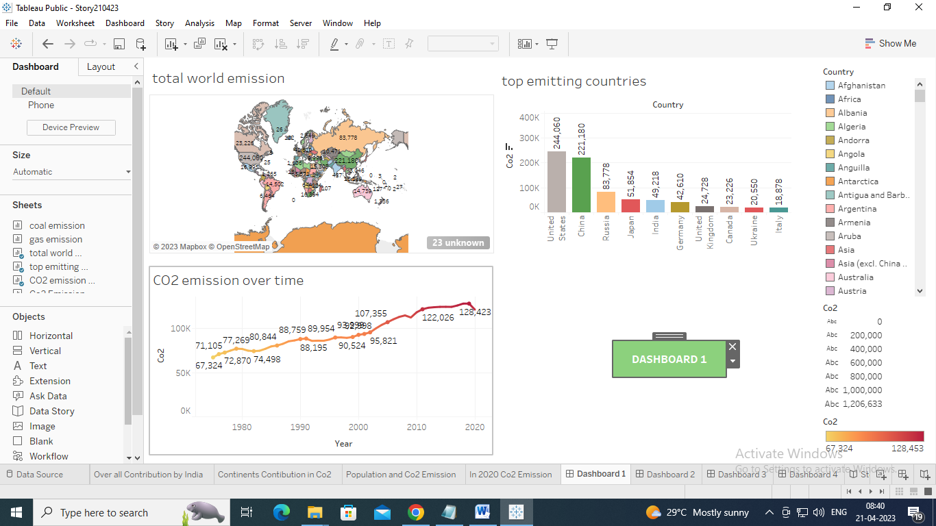

### To Understand- Co2 Emission Per Capita, Co2 Emission By International Factors, Emission Rate Over Years

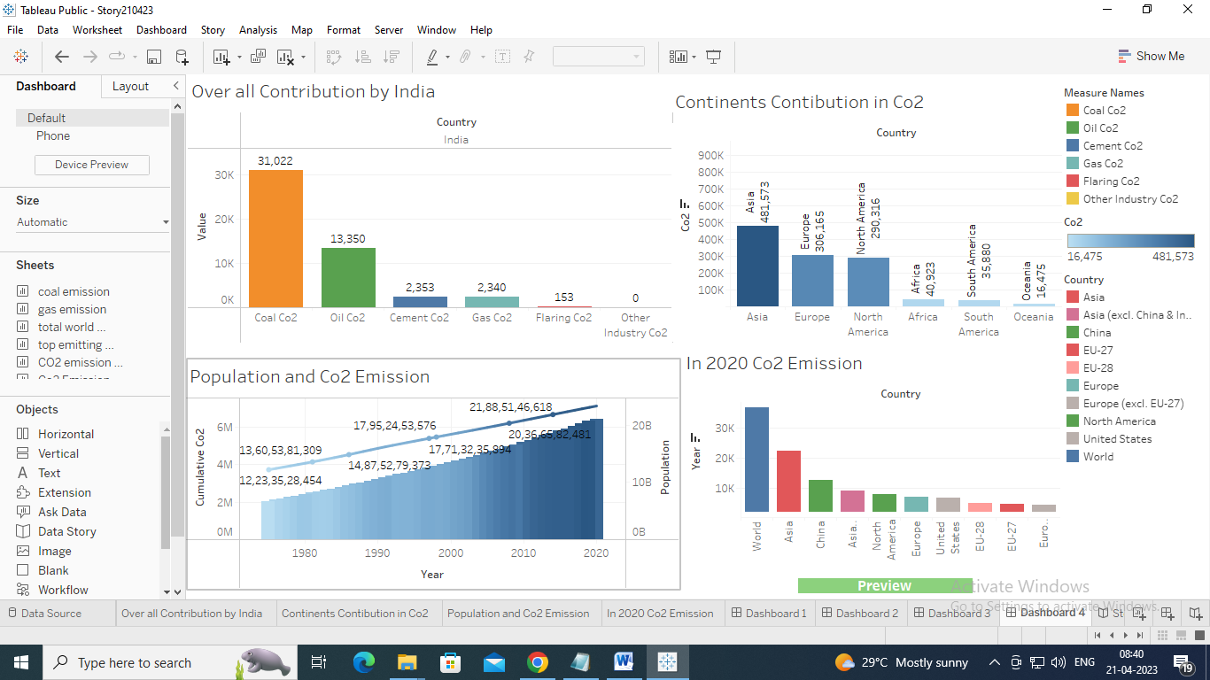

Dashboard link: <https://public.tableau.com/views/Dashboard200423/Dashboard1?:language=en-US&:display_count=n&:origin=viz_share_link>

Story link :

<https://public.tableau.com/views/Story210423/Story1?:language=en-US&:display_count=n&:origin=viz_share_link>

video link :

<https://drive.google.com/file/d/1H06w-dJeRuOQPGPTOAAcg3bG6HBdw7VU/view?usp=drivesdk>

APPENDIX

Dataset collect from: https://drive.google.com/file/d/1n764uDPT_ZF7kzGFLtpxkwBBsDBScbWm/view?usp=sharing