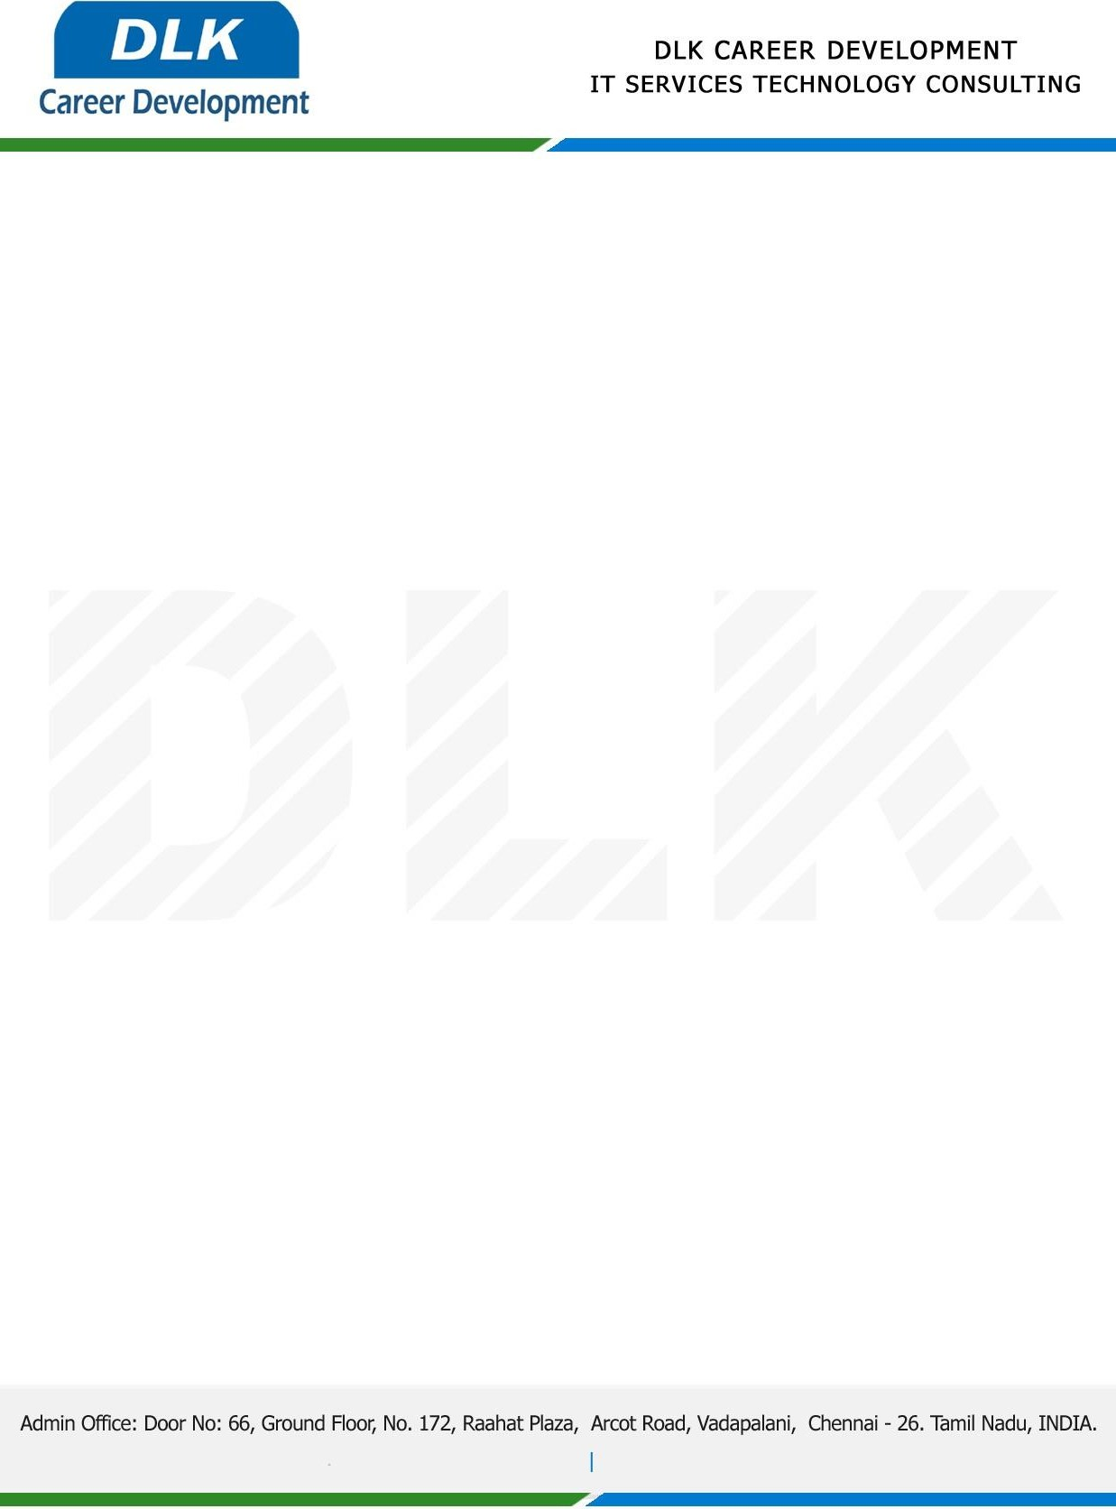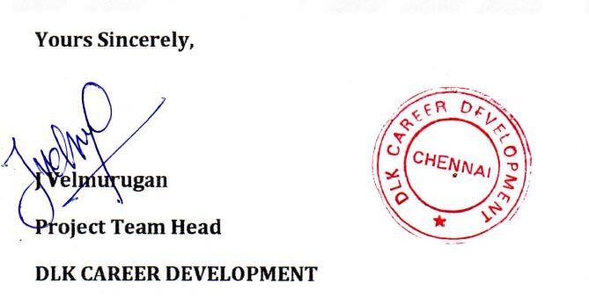

# Date: 4/January/ 2023

SUB: PROJECT COMPLETION LETTER

This is to certify that **MR SAIRAM E (REG NO: 214012101171) MCA- Master of Computer Application**, Final Year Student at **DR.M.G.R. Educational and Research Institute, Chennai** has Successfully Completed her PROJECT WORK under the domain of **Cloud Computing** in our organization during the Period **(December 2022 to March 2023).**

**Topic:** Fake Product Identification by QR Code Using Blockchain

We appreciate your interest in **DLK CAREER DEVELOPMENT**

# “Best Wishes for Your Future Endeavors “