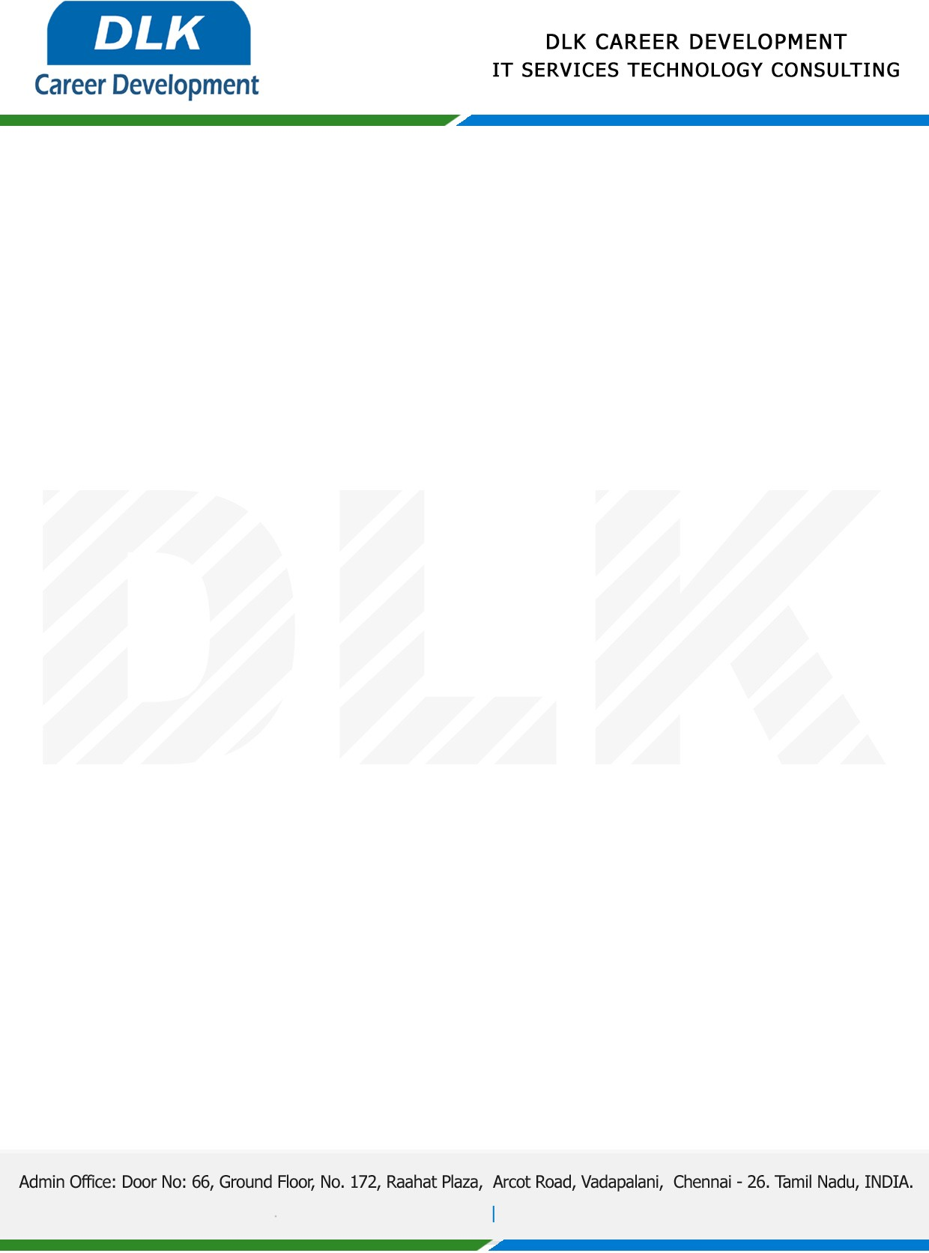

**Date: 13 February 2023**

**COURSE COMPLETION CERTIFICATE**

**Name:** MR ARUN A

**Reference Number:** 5580 0912 2352

**College Name:** M.Sc- Cyber Forensics and Information Security, DR. MGR

University, Chennai-600078

**Batch ID:** 2021 – 2023

**Program language:** Python Technology

*{Basic of Python, Machine learning,* *Deep learning,*Artificial Intelligence*}*

**Duration:** December 2022and January 2022 **(2 Months)**

**MR ARUN A (213182101005),** displayed professional traits during the Course period and managed to complete all assigned tasks as required. He was Hardworking, dedicated and committed it was a pleasure with us in this short period.

**We** **Wish all the best for your future.**

For **DLK CAREER DEVELOPMENT**

**HR Manager**

**VELMURUGAN J**