Critical Analysis

Bottleneck Evolution
As optimizations progress, the computational bottleneck shifts:

Backward-Facing Step (XS) - 287 nodes
Implementation | Primary Bottleneck | Secondary Bottleneck
CPU Baseline | Assembly (68%) | Post-Proc (20%)
CPU Threaded | Assembly (51%) | Post-Proc (25%)
CPU Multiprocess | Assembly (50%) | Post-Proc (49%)
Numba CPU | Solve (55%) | BC (16%)
Numba CUDA | Solve (88%) | Assembly (6%)
CuPy GPU | Solve (72%) | BC (23%)
Time Distribution:
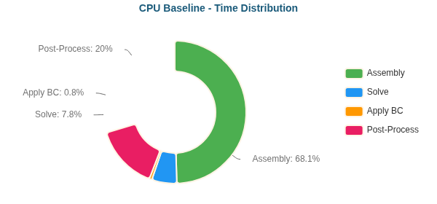
CPU Baseline - Time Distribution
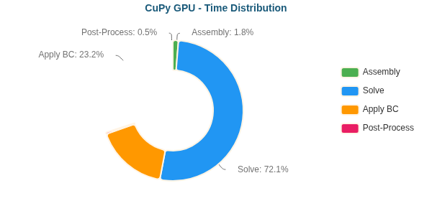
CuPy GPU - Time Distribution
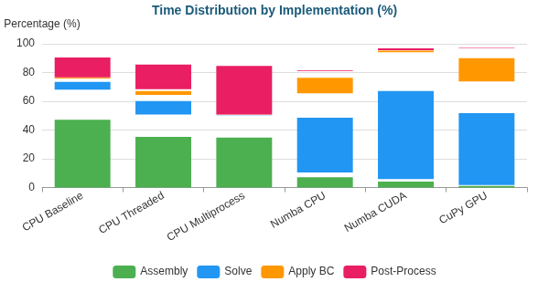
Time Distribution by Implementation (%)

Backward-Facing Step (M) - 195,362 nodes
Implementation | Primary Bottleneck | Secondary Bottleneck
CPU Baseline | Assembly (50%) | Solve (36%)
CPU Threaded | Solve (56%) | Assembly (28%)
CPU Multiprocess | Solve (78%) | Assembly (12%)
Numba CPU | Solve (94%) | BC (4%)
Numba CUDA | Solve (50%) | Assembly (27%)
CuPy GPU | Solve (88%) | BC (12%)
Time Distribution:
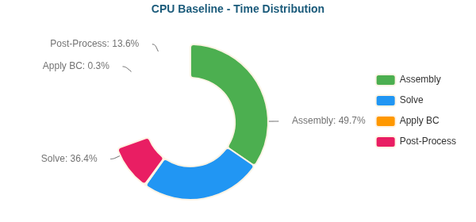
CPU Baseline - Time Distribution
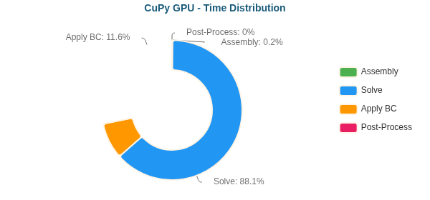
CuPy GPU - Time Distribution
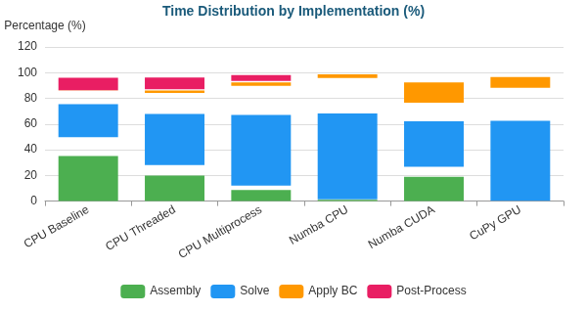
Time Distribution by Implementation (%)

Elbow 90° (XS) - 411 nodes
Implementation | Primary Bottleneck | Secondary Bottleneck
CPU Baseline | Assembly (71%) | Post-Proc (20%)
CPU Threaded | Assembly (59%) | Post-Proc (24%)
CPU Multiprocess | Assembly (50%) | Post-Proc (49%)
Numba CPU | Solve (53%) | BC (22%)
Numba CUDA | Solve (87%) | Assembly (6%)
CuPy GPU | Solve (74%) | BC (22%)
Time Distribution:
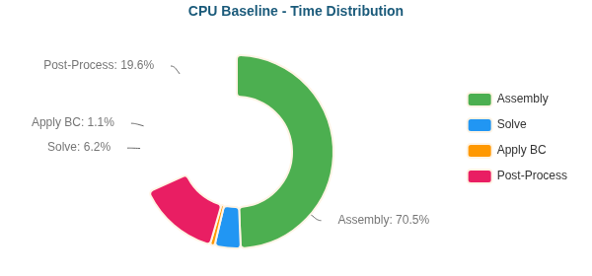
CPU Baseline - Time Distribution
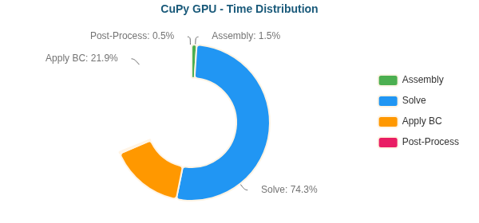
CuPy GPU - Time Distribution
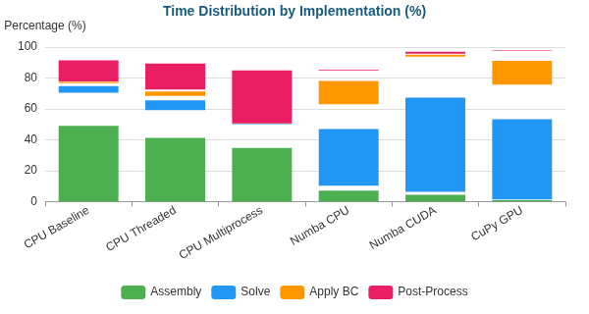
Time Distribution by Implementation (%)

Elbow 90° (M) - 161,984 nodes
Implementation | Primary Bottleneck | Secondary Bottleneck
CPU Baseline | Assembly (47%) | Solve (40%)
CPU Threaded | Solve (51%) | Assembly (31%)
CPU Multiprocess | Solve (73%) | Assembly (15%)
Numba CPU | Solve (94%) | BC (4%)
Numba CUDA | Solve (48%) | Assembly (28%)
CuPy GPU | Solve (81%) | BC (19%)
Time Distribution:
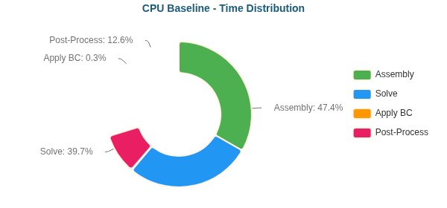
CPU Baseline - Time Distribution
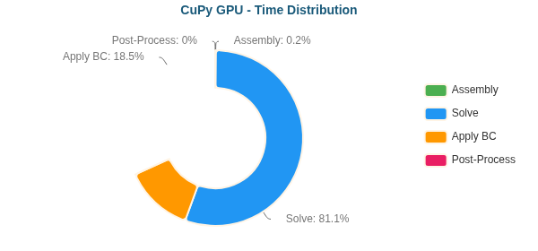
CuPy GPU - Time Distribution
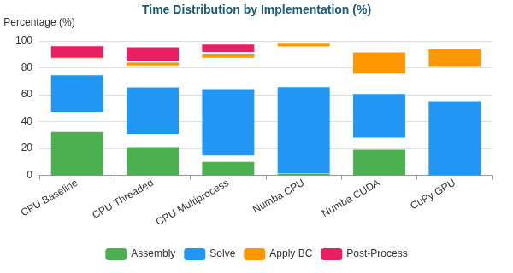
Time Distribution by Implementation (%)

S-Bend (XS) - 387 nodes
Implementation | Primary Bottleneck | Secondary Bottleneck
CPU Baseline | Assembly (69%) | Post-Proc (19%)
CPU Threaded | Assembly (50%) | Post-Proc (20%)
CPU Multiprocess | Assembly (50%) | Post-Proc (49%)
Numba CPU | Solve (52%) | BC (21%)
Numba CUDA | Solve (89%) | Assembly (5%)
CuPy GPU | Solve (72%) | BC (23%)
Time Distribution:
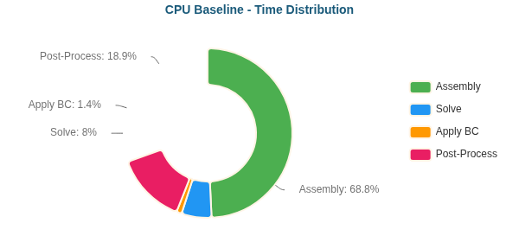
CPU Baseline - Time Distribution
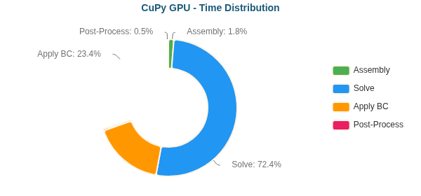
CuPy GPU - Time Distribution
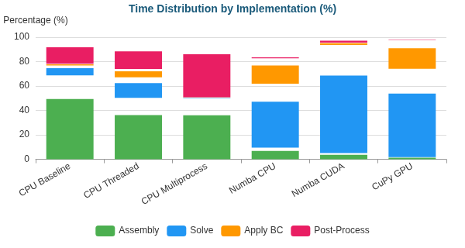
Time Distribution by Implementation (%)

S-Bend (M) - 196,078 nodes
Implementation | Primary Bottleneck | Secondary Bottleneck
CPU Baseline | Assembly (46%) | Solve (41%)
CPU Threaded | Solve (58%) | Assembly (26%)
CPU Multiprocess | Solve (80%) | Assembly (11%)
Numba CPU | Solve (95%) | BC (4%)
Numba CUDA | Solve (52%) | Assembly (26%)
CuPy GPU | Solve (87%) | BC (12%)
Time Distribution:
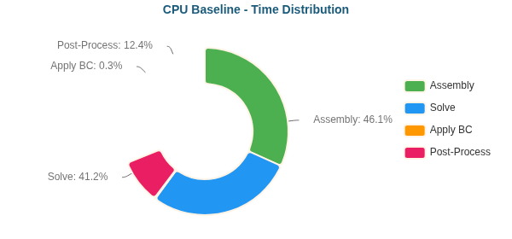
CPU Baseline - Time Distribution
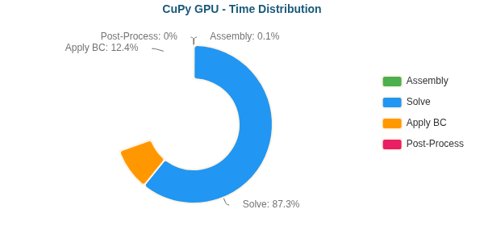
CuPy GPU - Time Distribution
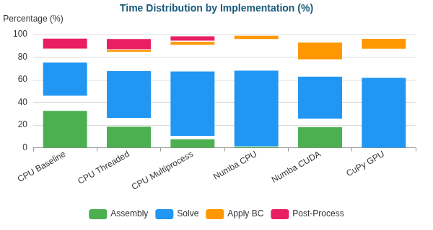
Time Distribution by Implementation (%)

S-Bend (L) - 765,441 nodes
Implementation | Primary Bottleneck | Secondary Bottleneck
CPU Baseline | Solve (73%) | Assembly (21%)
Time Distribution:
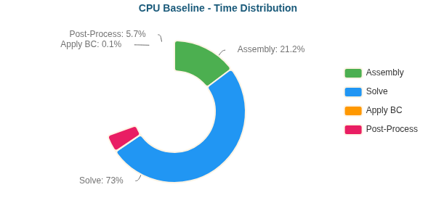
CPU Baseline - Time Distribution

S-Bend (XL) - 1,286,039 nodes
Implementation | Primary Bottleneck | Secondary Bottleneck
CPU Baseline | Solve (97%) | Assembly (2%)
Time Distribution:
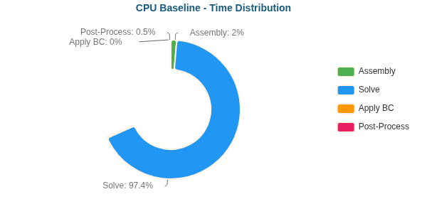
CPU Baseline - Time Distribution

T-Junction (XS) - 393 nodes
Implementation | Primary Bottleneck | Secondary Bottleneck
CPU Baseline | Assembly (71%) | Post-Proc (19%)
CPU Threaded | Assembly (53%) | Post-Proc (24%)
CPU Multiprocess | Assembly (51%) | Post-Proc (48%)
Numba CPU | Solve (59%) | BC (17%)
Numba CUDA | Solve (88%) | Assembly (6%)
CuPy GPU | Solve (74%) | BC (22%)
Time Distribution:
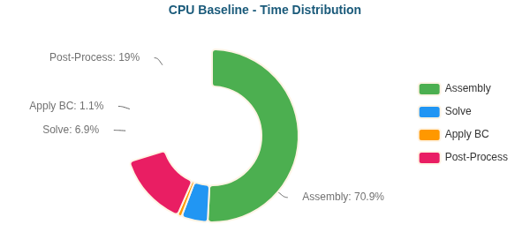
CPU Baseline - Time Distribution
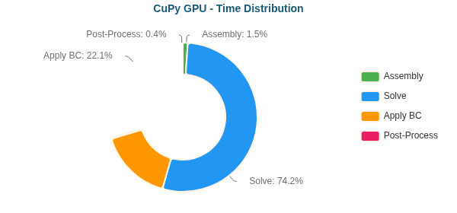
CuPy GPU - Time Distribution
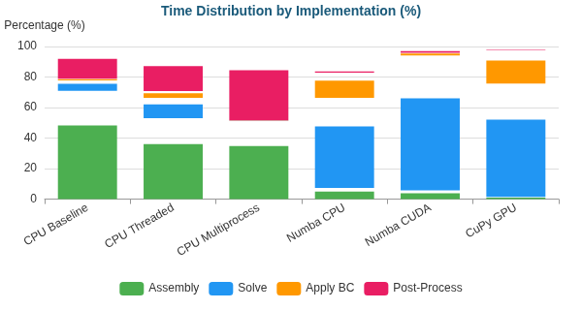
Time Distribution by Implementation (%)

T-Junction (M) - 196,420 nodes
Implementation | Primary Bottleneck | Secondary Bottleneck
CPU Baseline | Assembly (49%) | Solve (37%)
CPU Threaded | Solve (57%) | Assembly (28%)
CPU Multiprocess | Solve (79%) | Assembly (11%)
Numba CPU | Solve (95%) | BC (4%)
Numba CUDA | Solve (51%) | Assembly (27%)
CuPy GPU | Solve (87%) | BC (13%)
Time Distribution:
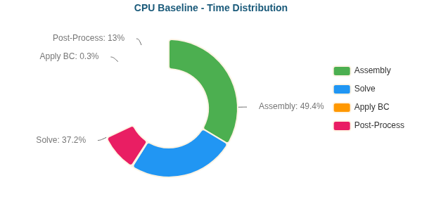
CPU Baseline - Time Distribution
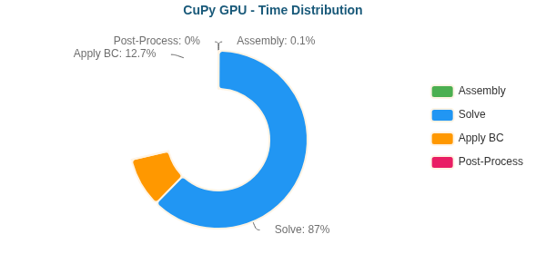
CuPy GPU - Time Distribution
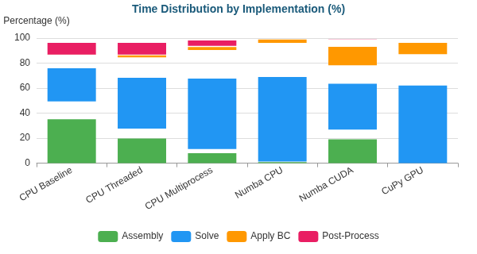
Time Distribution by Implementation (%)

T-Junction (L) - 768,898 nodes
Implementation | Primary Bottleneck | Secondary Bottleneck
CPU Baseline | Solve (90%) | Assembly (8%)
Time Distribution:
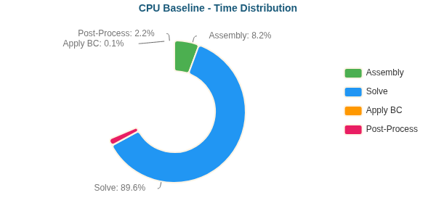
CPU Baseline - Time Distribution

Venturi (XS) - 341 nodes
Implementation | Primary Bottleneck | Secondary Bottleneck
CPU Baseline | Assembly (69%) | Post-Proc (19%)
CPU Threaded | Assembly (51%) | Post-Proc (24%)
CPU Multiprocess | Assembly (50%) | Post-Proc (49%)
Numba CPU | Solve (49%) | BC (21%)
Numba CUDA | Solve (87%) | Assembly (6%)
CuPy GPU | Solve (67%) | BC (29%)
Time Distribution:
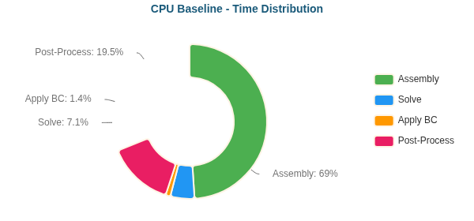
CPU Baseline - Time Distribution
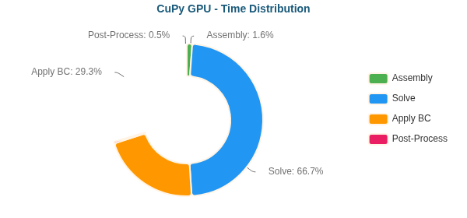
CuPy GPU - Time Distribution
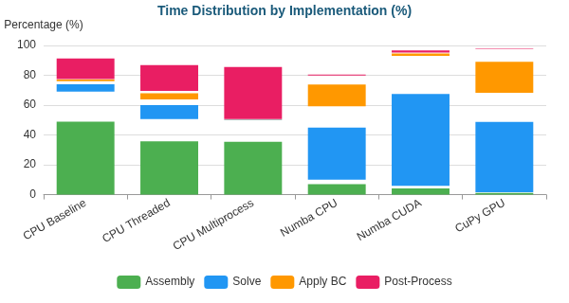
Time Distribution by Implementation (%)

Venturi (M) - 194,325 nodes
Implementation | Primary Bottleneck | Secondary Bottleneck
CPU Baseline | Assembly (48%) | Solve (39%)
CPU Threaded | Solve (55%) | Assembly (29%)
CPU Multiprocess | Solve (78%) | Assembly (12%)
Numba CPU | Solve (94%) | BC (5%)
Numba CUDA | Solve (49%) | Assembly (28%)
CuPy GPU | Solve (79%) | BC (21%)
Time Distribution:
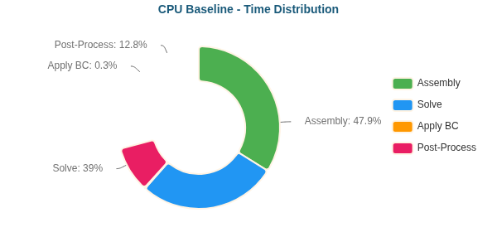
CPU Baseline - Time Distribution
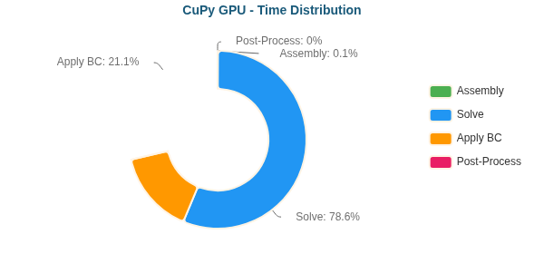
CuPy GPU - Time Distribution
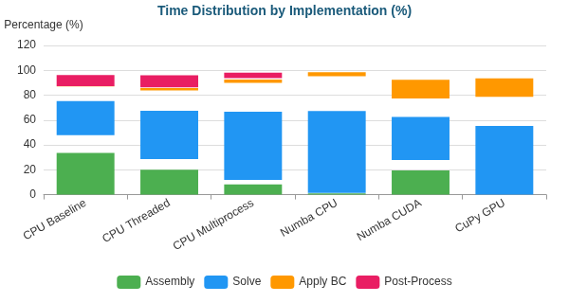
Time Distribution by Implementation (%)

Venturi (L) - 763,707 nodes
Implementation | Primary Bottleneck | Secondary Bottleneck
CPU Baseline | Solve (71%) | Assembly (23%)
Time Distribution:
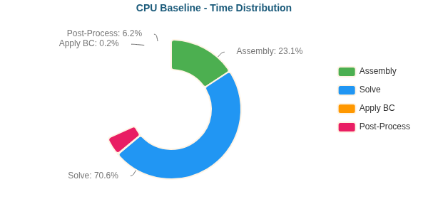
CPU Baseline - Time Distribution

Venturi (XL) - 1,284,412 nodes
Implementation | Primary Bottleneck | Secondary Bottleneck
CPU Baseline | Solve (81%) | Assembly (15%)
Time Distribution:
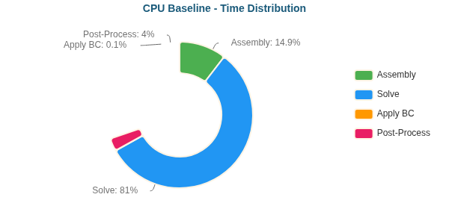
CPU Baseline - Time Distribution

Y-Shaped (XS) - 201 nodes
Implementation | Primary Bottleneck | Secondary Bottleneck
CPU Baseline | Assembly (63%) | Post-Proc (20%)
CPU Threaded | Assembly (44%) | Post-Proc (26%)
CPU Multiprocess | Assembly (51%) | Post-Proc (49%)
Numba CPU | Solve (52%) | BC (15%)
Numba CUDA | Solve (86%) | Assembly (6%)
CuPy GPU | Solve (61%) | BC (34%)
Time Distribution:
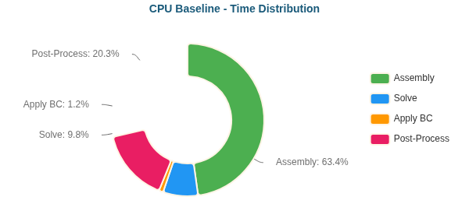
CPU Baseline - Time Distribution
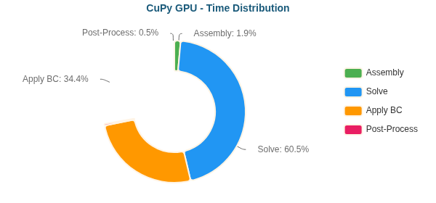
CuPy GPU - Time Distribution
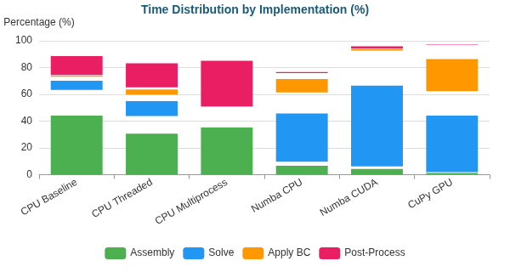
Time Distribution by Implementation (%)

Y-Shaped (M) - 195,853 nodes
Implementation | Primary Bottleneck | Secondary Bottleneck
CPU Baseline | Assembly (46%) | Solve (41%)
CPU Threaded | Solve (59%) | Assembly (26%)
CPU Multiprocess | Solve (79%) | Assembly (10%)
Numba CPU | Solve (93%) | BC (6%)
Numba CUDA | Solve (48%) | BC (26%)
CuPy GPU | Solve (79%) | BC (20%)
Time Distribution:
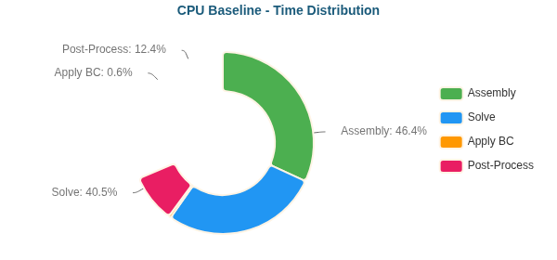
CPU Baseline - Time Distribution
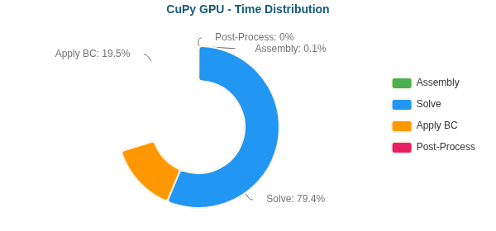
CuPy GPU - Time Distribution
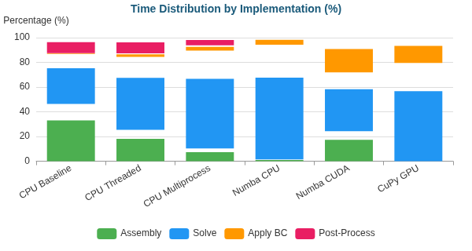
Time Distribution by Implementation (%)

Y-Shaped (L) - 772,069 nodes
Implementation | Primary Bottleneck | Secondary Bottleneck
CPU Baseline | Solve (57%) | Assembly (34%)
Time Distribution:
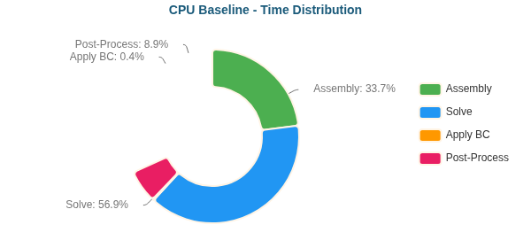
CPU Baseline - Time Distribution

Y-Shaped (XL) - 1,357,953 nodes
Implementation | Primary Bottleneck | Secondary Bottleneck
CPU Baseline | Solve (67%) | Assembly (25%)
Time Distribution:
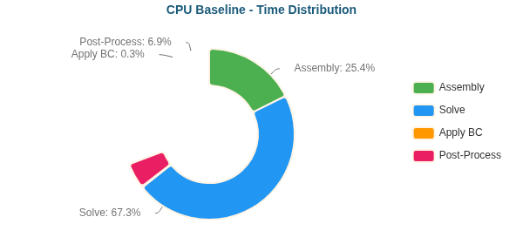
CPU Baseline - Time Distribution

Why Each Optimization Helps
Transition | Reason
Baseline → Threaded | Limited by Python GIL; threads only help for I/O
Threaded → Multiprocess | Bypasses GIL via separate processes; IPC overhead limits gains
Multiprocess → Numba CPU | JIT compilation eliminates interpreter overhead; true parallel loops
Numba CPU → Numba CUDA | GPU parallelism: thousands of threads vs dozens of CPU cores
Numba CUDA → CuPy GPU | CUDA C kernels more optimized than Numba-generated PTX

