


High-Performance GPU-Accelerated Finite Element Analysis
António Cruz (140129), Bruno Santos (140586), Pedro Miranda (129268), Ricardo Kayseller (95813)

ANNEX B - APPLICATION INSTALLATION MANUAL
High-Performance GPU-Accelerated
Finite Element Analysis

Annex B - FEMulator Pro Installation
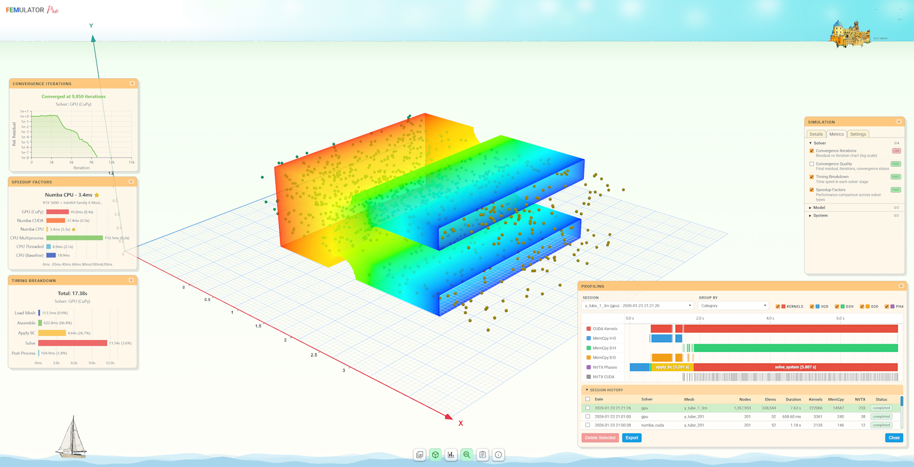
Figure 1: FEMUlator Pro application screenshot upon running simulation and profiling sessions.

1. Online Access (Recommended for Evaluation)
For project evaluation purposes, FEMulator Pro is available online at:
https://logus2k.com/fem
No installation required - simply access the URL above to use the application with full GPU acceleration.
If you prefer to run the application locally, follow the installation instructions below.

2. Run Locally using Docker (single command)
The simplest way to get FEMulator Pro running locally is with one single docker run command.
This command has the same effect as the docker-compose.yml configuration shown later.
docker run -d --name femulator --hostname femulator --gpus all -p 5868:5868 logus2k/femulator
Notes: - --gpus all -> tries to use all available NVIDIA GPUs (ignored gracefully if no GPU or no NVIDIA support) - First run will automatically pull the latest image from Docker Hub - Access the application at: http://localhost:5868

3. Run Locally using Docker Compose

1. Prerequisites
- Docker Desktop (Windows / macOS) or Docker Engine + Docker Compose plugin (Linux)
- Install Docker here if not already installed

2. Create docker-compose.yml
Create a folder anywhere on your computer and save the following content as docker-compose.yml:
services:
femulator:
image: logus2k/femulator:latest
container_name: femulator
hostname: femulator
restart: unless-stopped
deploy:
resources:
reservations:
devices:
- driver: nvidia
count: "all"
capabilities: [gpu]
logging:
options:
max-size: "10m"
max-file: "3"
ports:
- "5868:5868"
networks:
- femulator_network
networks:
femulator_network:
driver: bridge

3. Launch the Application
Open a terminal/command prompt in the folder containing docker-compose.yml and run:
docker compose up -d
(or older syntax: docker-compose up -d)
The image will be downloaded automatically, and the container will start in the background.
-> Access the application at http://localhost:5868

Management Commands (Docker Compose)
Action | Command
Start (or restart) | docker compose up -d
Stop and remove container | docker compose down
View logs (live) | docker logs -f femulator
Pull latest image & restart | docker compose pull && docker compose up -d
Stop, remove & clean up | docker compose down --rmi all

4. Platform-Specific Helper Scripts (Advanced/Development)
For users who prefer not to manage docker-compose.yml manually or who are working with local source code, the project provides ready-to-use helper scripts.
Important:
- Windows users -> use only files ending in .bat
- Linux users -> use only files ending in .sh
Purpose | Windows | Linux
Start application | start.bat | ./start.sh
Stop application | stop.bat | ./stop.sh
Update (soft rebuild) | update.bat | ./update.sh
Full rebuild | rebuild_all.bat | ./rebuild_all.sh
Complete removal | remove_all.bat | ./remove_all.sh

First-Time Setup (Linux only)
chmod +x *.sh

Typical Usage Flow
- First start / daily use
Windows: start.bat
Linux: ./start.sh
- Stop when finished
Windows: stop.bat
Linux: ./stop.sh
- Update after code changes
Stop -> Update -> Start
(Windows: stop.bat -> update.bat -> start.bat)
- Full reset (when something is broken)
Windows: rebuild_all.bat then start.bat
Linux: ./rebuild_all.sh then ./start.sh
- Completely uninstall
Windows: remove_all.bat
Linux: ./remove_all.sh

CPU vs GPU Behavior
- CPU mode -> always available, used by default
- GPU mode -> automatically enabled only if:
  - NVIDIA GPU is present
  - NVIDIA Container Toolkit / WSL2 GPU support is properly configured
  - The --gpus all flag or deploy.resources.reservations.devices is present
No manual choice is required - the container will use GPU if possible, otherwise, fallback to CPU.

Notes
- The official pre-built image is hosted on Docker Hub:
-> logus2k/femulator:latest
- The single docker run command and the docker-compose.yml file are functionally equivalent
- All management can be done with the helper scripts or with plain Docker / Compose commands - choose whatever is more convenient for you
Enjoy using FEMulator Pro!

