Optimization for 3D Scene Reconstruction
A Comparative Study of Optimizers, Losses, and Representations for NeRF and 3D Gaussian Splatting

António Cruz (140129), Duarte Cabrita (120058)
Computational Optimization - Tutorial #2
11 June 2026

Table of Contents
1. Introduction 4
2. Problem Formulation 6
The task 6
Mathematical formulation 6
What this project compares 6
3. NeRF: Model and Differentiable Renderer 7
3.1 Data Loading 7
Loading a self-captured COLMAP scene 7
3.2 Ray Generation 7
3.3 Positional Encoding 8
3.4 NeRF MLP 8
3.5 Volume Rendering 9
Rendering a full image 9
4. Optimizers 10
4.1 Stochastic Gradient Descent 10
4.2 SGD with Classical Momentum 11
4.3 SGD with Nesterov Accelerated Gradient 11
4.4 Adam 11
4.5 AdamW 12
4.6 Learning-Rate Schedule 13
5. Loss Functions 15
6. Experimental Setup 18
6.1 Scoping Study: Configuration Selection 18
Fixed configuration 18
MLP architectures compared 19
Findings 19
Selected configuration 20
6.2 Dataset Splits and Evaluation Metrics 20
6.3 Experiment Harness 21
Optimizer factory and scene cache 22
The training-and-evaluation run 22
6.4 Harness Smoke Test 22
6.5 Inspecting and Rendering Trained Models 22
Inspection examples 22
7. Optimizer Comparison 24
7.1 Learning-Rate Sweep 24
Interpretation 25
7.2 Multi-Seed Optimizer Comparison 26
Training loss curves 28
Time to reach a fixed target quality 28
Interpretation 28
7.3 Qualitative Results 29
Interpretation 30
8. Loss Function Comparison 31
8.1 Methodology 31
Interpretation 31
8.3 Refining the L1 learning rate with Optuna (TPE + median pruner) 32
Interpretation 34
9. Proposed Improvements 35
Interpretation 36
10. Gaussian Splatting Baseline 38
10.1 GS as an alternative parameterisation of the same problem 38
10.2 Four root-cause fixes the implementation required 38
Fix 1 — OpenGL → OpenCV camera convention 38
Fix 2 — Clones with scale-aware positional jitter 39
Fix 3 — Adam state transplant across densification 39
Fix 4 — Opacity reset (kept off by default) 39
What the four fixes reveal 40
10.3 What the comparison uses 40
11. NeRF vs Gaussian Splatting Comparison 41
11.1 The headline 41
11.2 Efficiency dimensions 41
11.3 Discussion 42
11.5 Qualitative comparison: best NeRF vs best GS 43
12. Conclusions and Future Work 45
Conclusions 45
Future work 46

1. Introduction
This project studies computational optimization through an applied problem in computer vision: reconstructing a 3D scene from a small set of 2D photographs so that new, previously unseen viewpoints can be synthesized. The task underpins applications across robotics, augmented and virtual reality, autonomous driving, virtual production, and digital heritage preservation. Two state-of-the-art representations frame the reconstruction problem as continuous, non-convex optimization:
- Neural Radiance Fields (NeRF) — the scene is a small multi-layer perceptron mapping a 3D point and a viewing direction to a color and density, fitted by gradient descent through a differentiable volume renderer.
- 3D Gaussian Splatting (GS) — the scene is an explicit collection of 3D Gaussian primitives, each with a position, scale, rotation, opacity, and color, fitted by gradient descent through a differentiable rasterizer.
Both approaches translate “fit a 3D scene to a set of photographs” into the same minimization:
$$\min_{θ} \frac{1}{N}\sum_{i=1}^{N}{L}\left(R(θ; π_{i}), I_{i}\right)$$
where $R(θ;π)$ is the differentiable rendering operator, $(I_{i},π_{i})$ are the captured images and their camera poses, and $L$ is a per-image loss. Section 2 develops the formulation in full; this section places the project within the rubric and previews the optimization story.
The project is deliberately and exclusively an optimization study. It does not propose a new scene representation, nor extend NeRF or GS as published; what it contributes is a careful, controlled investigation of how the optimization choices around these two representations shape convergence behaviour, training stability, and final reconstruction quality. The optimization layers we implemented and compared:
Layer | What we built | Where it lives
Inner gradient loop (model parameters) | Five first-order optimizers implemented from scratch on top of PyTorch autograd — SGD, momentum, Nesterov, Adam, AdamW — plus a cosine-annealing schedule with linear warmup | §4 (implementation), §7 (comparison)
Loss formulation | Four candidate losses — L2, L1, SSIM, L1+SSIM — selectable through the same harness | §5 (implementation), §8 (comparison)
Outer hyperparameter loop | Bayesian optimization of L1’s learning rate with the Tree-structured Parzen Estimator (Optuna), early-stopped by a median pruner | §8.3
Substantiated improvements | Four candidate improvements — learning-rate restarts (SGDR), perceptual loss, multi-scale (coarse-to-fine) training, adaptive view sampling — each motivated by a specific property of the optimization problem | §9
Alternative parameterisation | A 3D Gaussian Splatting implementation built on top of gsplat 1.5.3, debugged and tuned across four non-obvious failure modes | §10, §11
These four findings are the project’s substantive contributions, and they are developed in the sections below:
- A fair comparison of first-order optimizers requires per-method learning-rate tuning. At a shared learning rate of $5×{10}^{-4}$, Adam appears to beat SGD by 12.77 dB on the test set. At each method’s own §7.1-selected best rate, the gap collapses to 1.82 dB. Almost 11 dB of the apparent Adam advantage is a learning-rate-mismatch artefact, not a property of the optimizer (§7).
- L1 is structurally incompatible with Adam at long iteration budgets. §8 shows L1 producing $14.11±5.85$ dB pooled test PSNR — a wide standard deviation because one in every three runs diverges. §8.3 runs an Optuna Bayesian sweep, adds a cosine schedule, and applies gradient clipping; the pooled metric is unchanged. Direct gradient-norm inspection shows the clipping threshold is never crossed, identifying the failure mode as sign-oscillation of L1’s gradient under Adam’s variance estimator — a direction-axis failure, not a magnitude-axis one.
- One substantiated positive improvement, three substantiated nulls. Of the four §9 ablations, perceptual loss produces the predicted trade-off (−31% LPIPS at −0.5 dB PSNR, both Lego and Drums); SGDR, multi-scale, and adaptive view sampling each fall within the baseline’s seed-noise band, each with a diagnosable mechanism for why the failure mode they target is not active at this problem scale.
- GS wins five of six metric cells against NeRF at half the wall-clock. §10 + §11 compare the two parameterizations on the same test scenes; GS wins both SSIM scores and both LPIPS scores, wins Drums PSNR by +1.5 dB, and trails only Lego PSNR by 0.75 dB — a gap below the perceptual just-noticeable-difference threshold. From-scratch GS required four root-cause fixes, each surfacing a real property of how the method’s optimization behaves.
Reconstruction quality is measured throughout with PSNR, SSIM, and LPIPS on held-out test views.

2. Problem Formulation

The task
3D scene reconstruction from a sparse set of 2D photographs, framed as a continuous non-convex optimization problem.

Mathematical formulation
Let $θ$ be the parameters (weights and biases) of a small multi-layer perceptron $f_{θ}$ that maps a 3D point $(x,y,z)$ to a density $σ≥0$ and an RGB colour $c∈[0,1]^{3}$.
Let $R(θ;π)$ be the differentiable volume-rendering operator: given $θ$ and a camera pose $π$, it casts rays through every pixel, samples points along each ray, queries $f_{θ}$, and composites the samples into a synthesised image.
Given captured images and their camera poses $\{(I_{i},π_{i})\}_{i=1..N}$, the reconstruction minimises the average discrepancy between rendered and observed pixels:
$$\min_{θ} \frac{1}{N}\sum_{i=1}^{N}{L}\left(R(θ;π_{i}), I_{i}\right)$$
where $L$ is one of the loss formulations of Section 5 (the baseline being the squared error ${\left\|⋅\right\|}_{2}^{2}$).
The optimum is characterised by the first-order optimality condition $∇_{θ}L=0$, the same condition introduced in Module 1’s classical theory of unconstrained optimization. However, two features of this problem make Module 1’s analytical machinery inapplicable: the loss is non-convex (the rendering operator composes with the MLP non-linearities) and high-dimensional ($|θ|$ on the order of ${10}^{5}$ parameters even for the small model used here). The non-convexity rules out a closed-form solution of $∇_{θ}L=0$; the dimensionality rules out the Hessian-based classification that distinguishes minima from saddle points analytically (the Hessian alone would have on the order of $3×{10}^{9}$ entries for our model). The problem is therefore solved by iterative first-order stochastic gradient methods: at each iteration a random image and a random batch of its pixel rays are drawn, rendered, scored against the ground truth, and used to update $θ$ along $-∇_{θ}L$. The choice of which gradient-based method to use is itself the central question this project studies (§4, §7).

What this project compares
The formulation above leaves three components open, and the project varies each in a controlled way:
- The optimizer that performs the update $θ←θ-…$ (Section 4).
- The loss $L$ that defines the objective surface (Section 5).
- The scene representation itself — NeRF versus 3D Gaussian Splatting (Section 10).
Convergence speed, training stability, and final reconstruction quality are measured for each, under identical conditions, by the harness of Section 6.

3. NeRF: Model and Differentiable Renderer
This section defines the scene representation and the rendering pipeline that together realise $f_{θ}$ and the rendering operator $R(θ;π)$ of the formulation. The components are: loading a scene’s images and camera poses (3.1), generating one camera ray per pixel (3.2), lifting 3D coordinates into a high-frequency feature space (3.3), the MLP that predicts density and colour (3.4), and the volume renderer that composites those predictions into pixels (3.5).

3.1 Data Loading
The experiments use the nerf_synthetic dataset: eight synthetic scenes, each rendered from many known camera poses. Every scene ships with three pose sets — transforms_train.json, transforms_val.json, and transforms_test.json — which the project uses directly as the train / validation / test split (Section 6.2).
The loader below reads one split of one scene. Each image is RGBA: the loader composites it over a white background (so the transparent surround becomes white rather than black) and area-downsamples it from the native 800x800 to the working resolution. The focal length is derived from the scene’s horizontal field of view and rescaled to the working resolution. This function is the only place the dataset format is parsed; everything downstream consumes plain tensors.

Loading a self-captured COLMAP scene
Tutorial #1 (§6) commits the project to “one or two self-captured real-world scenes (smartphone, around 30 to 60 images each, processed via COLMAP for Structure-from-Motion) plus at least one standard NeRF-synthetic scene”. The loader below covers the COLMAP side: it parses the cameras.txt and images.txt files that COLMAP’s sparse reconstruction produces and converts them into the same (images, poses, focal) tensor format the synthetic loader returns, so every downstream cell — load_scene_splits, run_experiment, evaluate, the §7 / §8 / §9 ablations — works on a self-captured scene with no further modification.
Coordinate-system conversion. COLMAP stores world-to-camera poses in OpenCV convention (x-right, y-down, z-forward); NeRF uses OpenGL convention (x-right, y-up, z-backward). The loader inverts the pose (to camera-to-world) and flips the y and z axes accordingly, so the recovered poses sit in the same frame the synthetic poses do.
Expected directory layout for a captured scene placed under data/colmap/<scene_name>/:
The train / val / test split is derived deterministically by image index (every 8th view → test, the rest → train; 5 val views held out from train).

3.2 Ray Generation
For a given image resolution and camera pose, generate a ray (origin and direction in world coordinates) for every pixel. These rays are the inputs to the volume-rendering integral. The rendering operator $R(θ;π)$ of the formulation is realised by this function together with the volume renderer of Section 3.5.
def get_rays(H, W, focal, pose):
"""Return ray origins and directions for every pixel in an HxW image."""
i, j = torch.meshgrid(
torch.arange(W, device=DEVICE).float(),
torch.arange(H, device=DEVICE).float(),
indexing="xy",
)
dirs = torch.stack([(i - W * 0.5) / focal, -(j - H * 0.5) / focal, -torch.ones_like(i)], dim=-1)
rays_d = (dirs @ pose[:3, :3].T)
rays_o = pose[:3, 3].expand(rays_d.shape)
return rays_o, rays_d

3.3 Positional Encoding
Map raw 3D coordinates into a higher-dimensional space using sines and cosines at exponentially increasing frequencies. Without this lifting, a small MLP cannot fit high-frequency scene detail. This is a fixed (non-learned) feature map; only the MLP weights are optimization variables.
class PositionalEncoding(nn.Module):
def __init__(self, num_freqs=10):
super().__init__()
self.freqs = 2.0 ** torch.arange(num_freqs).float().to(DEVICE)
self.out_dim = 3 + 3 * 2 * num_freqs
def forward(self, x):
encs = [x]
for f in self.freqs:
encs += [torch.sin(f * x), torch.cos(f * x)]
return torch.cat(encs, dim=-1)

3.4 NeRF MLP
The optimization variable: a small fully-connected network mapping the encoded 3D point to a density and an RGB colour. A ReLU on the density head guarantees non-negativity; a sigmoid on the colour head bounds it to $[0,1]^{3}$.
The architecture — four layers of width 128, roughly 58,000 parameters — was selected by the Stage 0 scoping study (Section 6.1): a far larger network raised reconstruction quality by only a few tenths of a dB for several times the compute, which is not a worthwhile trade in a study whose subject is the optimizer rather than the absolute reconstruction quality.
class TinyNeRF(nn.Module):
def __init__(self, enc_dim, width=128, depth=4):
super().__init__()
layers = [nn.Linear(enc_dim, width), nn.ReLU()]
for _ in range(depth - 1):
layers += [nn.Linear(width, width), nn.ReLU()]
self.trunk = nn.Sequential(*layers)
self.density = nn.Linear(width, 1)
self.rgb = nn.Linear(width, 3)
def forward(self, x):
h = self.trunk(x)
sigma = torch.relu(self.density(h))[..., 0]
c = torch.sigmoid(self.rgb(h))
return sigma, c

3.5 Volume Rendering
Composite the MLP’s per-point predictions into per-pixel colours via the discretised volume-rendering integral. For each ray we sample $N$ points between the near and far planes, query density and colour, and accumulate them using the alpha-compositing weights derived from accumulated transmittance. This is the differentiable rendering operator $R(θ;π)$, and it is differentiable end to end, so gradients of the image loss flow back into the MLP weights.

Rendering a full image
render_rays works on an arbitrary batch of rays. Evaluation and qualitative previews need a complete image, so the helper below renders every pixel of an H x W view, in ray chunks to bound memory. It runs under torch.inference_mode, since no gradient is needed when rendering for evaluation.

4. Optimizers
This project implements five gradient-based optimizers from scratch, on top of PyTorch’s automatic differentiation. Implementing them ourselves rather than calling torch.optim is what makes the comparison a genuine study of computational optimization, and it guarantees every method runs under identical numerical conventions.
All optimizers expose the same minimal interface, zero_grad() and step(), so the training loop can use any of them interchangeably. Plain SGD, momentum, and Nesterov are the three modes of a single MySGD class; MyAdam and MyAdamW are separate. A cosine-annealing learning-rate schedule with linear warmup (Section 4.6) can be applied on top of any of them.
All five methods are first-order (gradient-only). They iteratively approach the first-order condition $∇_{θ}L=0$ introduced in §2, but none performs the second-order analysis (Hessian eigenvalues, principal-minor / Sylvester tests) Module 1 uses to classify the resulting critical point: forming the full Hessian for $|θ|≈58,000$ would require on the order of 13 GB just to store, and using it inside an optimizer step is intractable at this scale. Adam’s second-moment estimate $\hat{v}$ acts instead as a diagonal approximation of curvature — a tractable surrogate for the second-order information the analytical theory uses directly. This is the trade-off the field makes for problems of this size, and the comparison in §7 quantifies what is lost and gained by each of these substitutions.

4.1 Stochastic Gradient Descent
Plain SGD is the reference baseline: each parameter moves directly down its gradient, $θ←θ-η g$, with a single global step size $η$. It has no state and no per-parameter scaling, so it is the most exposed to ill-conditioning — directions of high curvature force a small $η$, which then makes progress along low-curvature directions slow.
The MySGD class below implements plain SGD together with its momentum and Nesterov variants (Sections 4.2 and 4.3) as modes of one class, selected by its constructor arguments, so all three share a single tested code path.
class MySGD:
"""SGD with optional momentum and Nesterov acceleration.
momentum=0 -> plain SGD: theta <- theta - lr*g
momentum>0, nesterov=F -> classical: v <- mu*v + g; theta <- theta - lr*v
momentum>0, nesterov=T -> Nesterov: v <- mu*v + g; theta <- theta - lr*(g + mu*v)
"""
def __init__(self, params, lr=1e-3, momentum=0.0, nesterov=False):
self.params = [p for p in params if p.requires_grad]
self.lr, self.mu, self.nesterov = lr, momentum, nesterov
self.v = [torch.zeros_like(p) for p in self.params] if momentum > 0 else None
@torch.no_grad()
def step(self):
for i, p in enumerate(self.params):
if p.grad is None:
continue
g = p.grad
if self.mu > 0:
v = self.v[i]
v.mul_(self.mu).add_(g)
p.add_(g + self.mu * v if self.nesterov else v, alpha=-self.lr)
else:
p.add_(g, alpha=-self.lr)
def zero_grad(self):
for p in self.params:
if p.grad is not None:
p.grad.detach_(); p.grad.zero_()

4.2 SGD with Classical Momentum
Momentum accumulates an exponentially-weighted running sum of past gradients, the velocity $v←μv+g$, and steps along it: $θ←θ-η v$. The decay $μ$ (here $0.9$) damps the oscillation that plain SGD suffers across high-curvature directions, while letting consistent descent directions build up speed. This usually gives faster and steadier convergence. It is the momentum > 0, nesterov=False mode of MySGD defined above.

4.3 SGD with Nesterov Accelerated Gradient
Nesterov’s accelerated gradient evaluates the descent direction with a look-ahead: the velocity is updated as in classical momentum, but the step applied is $θ←θ-η (g+μv)$, which corresponds to measuring the gradient slightly ahead, where the momentum term is about to carry the parameters. The correction reduces overshoot near the minimum and, on well-behaved objectives, improves the convergence rate. It is the nesterov=True mode of MySGD.

4.4 Adam
Adam keeps two exponentially weighted moment estimates per parameter: the first moment $m$ (a smoothed gradient, like momentum) and the second moment $v$ (a smoothed squared gradient).
The update divides the first moment by the square root of the second, $θ←θ-η \hat{m}/(\sqrt{\hat{v}}+ϵ)$, giving every parameter its own effective step size — large where gradients are small and consistent, small where they are large or noisy.
Both estimates start at zero and are therefore bias-corrected ($\hat{m},\hat{v}$) so the early steps are not damped. This per-parameter adaptation is what lets Adam cope with the ill-conditioning that slows plain SGD.
class MyAdam:
"""Adam (Kingma & Ba, 2014)."""
def __init__(self, params, lr=1e-3, beta1=0.9, beta2=0.999, eps=1e-8):
self.params = [p for p in params if p.requires_grad]
self.lr, self.b1, self.b2, self.eps = lr, beta1, beta2, eps
self.m = [torch.zeros_like(p) for p in self.params]
self.v = [torch.zeros_like(p) for p in self.params]
self.t = 0
@torch.no_grad()
def step(self):
self.t += 1
bc1 = 1 - self.b1 ** self.t
bc2 = 1 - self.b2 ** self.t
for p, m, v in zip(self.params, self.m, self.v):
if p.grad is None:
continue
g = p.grad
m.mul_(self.b1).add_(g, alpha=1 - self.b1)
v.mul_(self.b2).addcmul_(g, g, value=1 - self.b2)
p.addcdiv_(m / bc1, v.div(bc2).sqrt().add_(self.eps), value=-self.lr)
def zero_grad(self):
for p in self.params:
if p.grad is not None:
p.grad.detach_(); p.grad.zero_()

4.5 AdamW
AdamW is Adam with decoupled weight decay. Standard L2 regularisation adds $λθ$ to the gradient, so it passes through Adam’s per-parameter scaling and is effectively rescaled differently for every weight. AdamW instead applies the decay straight to the parameter, $θ←θ-ηλ θ$, separately from the adaptive gradient step. The regularisation strength is then uniform and independent of the gradient statistics, which is the behaviour usually intended by “weight decay”.
class MyAdamW:
"""AdamW (Loshchilov & Hutter, 2017): Adam with decoupled weight decay.
The weight-decay term is applied directly to the parameter, separately
from the adaptive gradient step."""
def __init__(self, params, lr=1e-3, beta1=0.9, beta2=0.999, eps=1e-8, weight_decay=1e-2):
self.params = [p for p in params if p.requires_grad]
self.lr, self.b1, self.b2, self.eps, self.wd = lr, beta1, beta2, eps, weight_decay
self.m = [torch.zeros_like(p) for p in self.params]
self.v = [torch.zeros_like(p) for p in self.params]
self.t = 0
@torch.no_grad()
def step(self):
self.t += 1
bc1 = 1 - self.b1 ** self.t
bc2 = 1 - self.b2 ** self.t
for p, m, v in zip(self.params, self.m, self.v):
if p.grad is None:
continue
g = p.grad
m.mul_(self.b1).add_(g, alpha=1 - self.b1)
v.mul_(self.b2).addcmul_(g, g, value=1 - self.b2)
p.addcdiv_(m / bc1, v.div(bc2).sqrt().add_(self.eps), value=-self.lr)
p.add_(p, alpha=-self.lr * self.wd) # decoupled weight decay
def zero_grad(self):
for p in self.params:
if p.grad is not None:
p.grad.detach_(); p.grad.zero_()

4.6 Learning-Rate Schedule
All five optimizers above take a fixed base learning rate. The schedule below modulates it over training, independently of which optimizer is used. It combines a short linear warmup — the rate ramps up from zero over the first few hundred steps, avoiding a destructive early step while the moment estimates are still cold — with cosine annealing, which then eases the rate smoothly down to zero so the final iterations settle into the minimum instead of bouncing around it. The schedule is an optional factor applied on top of any optimizer, and its effect is one of the comparisons in Section 7.
def cosine_warmup_lr(step, base_lr, warmup_steps, total_steps):
"""Cosine-annealing learning-rate schedule with linear warmup.
Returns the learning rate to use at the given training step."""
if step < warmup_steps:
return base_lr * step / max(1, warmup_steps)
progress = (step - warmup_steps) / max(1, total_steps - warmup_steps)
return base_lr * 0.5 * (1.0 + math.cos(math.pi * progress))
def sgdr_lr(step, base_lr, t0=5000, t_mult=2.0, lr_min=0.0):
"""SGDR — Stochastic Gradient Descent with Warm Restarts (Loshchilov &
Hutter, 2017). Cyclic cosine annealing in which the LR jumps back to
`base_lr` at the end of every cycle; cycle i has length t0 * t_mult**i.
Used in §9 (Improvement A) to test whether warm restarts help the
non-convex NeRF objective escape sharp local minima."""
cycle_start = 0
cycle_len = t0
while step >= cycle_start + cycle_len:
cycle_start += cycle_len
cycle_len = int(max(1, cycle_len * t_mult))
in_cycle = (step - cycle_start) / max(1, cycle_len)
return lr_min + 0.5 * (base_lr - lr_min) * (1.0 + math.cos(math.pi * in_cycle))

5. Loss Functions
The loss $L$ in the formulation scores a rendered image region against the observed one, and so defines the surface the optimizer descends. The project compares the four formulations committed to in Tutorial #1:
- L2 — mean squared error. The baseline; it corresponds directly to maximising PSNR. Smooth in its argument, but it averages errors and so tolerates a uniformly slightly-wrong, blurry reconstruction.
- L1 — mean absolute error. Penalises large and small errors more evenly, is less swayed by outlier pixels, and often preserves edges better than L2.
- SSIM — structural similarity, computed on contiguous image patches with an 11x11 Gaussian window. A perceptual measure comparing local luminance, contrast, and structure; used as a loss in the form $1-SSIM$.
- L1 + SSIM — weighted combination, $α L1+(1-α) (1-SSIM)$, pairing L1’s pixel accuracy with SSIM’s structural sensitivity (as used in the Gaussian Splatting paper).
L2 and L1 are pixel-wise; they work on scattered ray batches. SSIM and L1+SSIM are spatial measures and require a contiguous patch — the harness samples a patch_size × patch_size block of rays when cfg.patch_size > 0. A fifth, perceptual loss (l2_perc, used as Improvement B in §9), is also registered here; it augments L2 with a deep-feature distance through the cached LPIPS AlexNet backbone (computed on the rendered patch as a full image).
Every loss exposes the same (prediction, target) -> scalar interface and is selected by name through the make_loss factory, which captures cfg.patch_size and any loss-specific hyper-parameters at construction time.
def loss_l2(pred, target):
"""Mean squared error (the PSNR-aligned baseline)."""
return ((pred - target) ** 2).mean()
def loss_l1(pred, target):
"""Mean absolute error."""
return (pred - target).abs().mean()
def _gaussian_kernel_2d(size=11, sigma=1.5, device=None):
coords = torch.arange(size, device=device, dtype=torch.float32) - (size - 1) / 2
g = torch.exp(-(coords ** 2) / (2 * sigma ** 2))
g = g / g.sum()
return (g[:, None] * g[None, :])[None, None] # [1, 1, size, size]
def ssim_value(pred_img, target_img, window_size=11, sigma=1.5,
c1=0.01 ** 2, c2=0.03 ** 2):
"""Hand-rolled differentiable SSIM between two [H, W, 3] images in [0, 1].
Returns a scalar mean SSIM. Used both as a metric and inside the SSIM loss."""
pred = pred_img.permute(2, 0, 1)[None]
target = target_img.permute(2, 0, 1)[None]
kernel = _gaussian_kernel_2d(window_size, sigma, device=pred.device)
kernel = kernel.expand(3, 1, window_size, window_size)
pad = window_size // 2
mu_x = F.conv2d(pred, kernel, padding=pad, groups=3)
mu_y = F.conv2d(target, kernel, padding=pad, groups=3)
mu_xx = F.conv2d(pred * pred, kernel, padding=pad, groups=3)
mu_yy = F.conv2d(target * target, kernel, padding=pad, groups=3)
mu_xy = F.conv2d(pred * target, kernel, padding=pad, groups=3)
sigma_x2 = mu_xx - mu_x ** 2
sigma_y2 = mu_yy - mu_y ** 2
sigma_xy = mu_xy - mu_x * mu_y
num = (2 * mu_x * mu_y + c1) * (2 * sigma_xy + c2)
den = (mu_x ** 2 + mu_y ** 2 + c1) * (sigma_x2 + sigma_y2 + c2)
return (num / den).mean()
def _ssim_loss_from_patch(pred, target, patch_size):
"""1 - SSIM, on a flattened patch_size x patch_size patch."""
p = pred.reshape(patch_size, patch_size, 3)
t = target.reshape(patch_size, patch_size, 3)
return 1.0 - ssim_value(p, t)
def _l1_ssim_loss_from_patch(pred, target, patch_size, alpha=0.2):
"""Weighted L1 + (1 - SSIM) combination."""
return (alpha * loss_l1(pred, target)
+ (1.0 - alpha) * _ssim_loss_from_patch(pred, target, patch_size))
def _perceptual_loss_from_patch(pred, target, patch_size,
base_weight=1.0, perc_weight=0.1):
"""L2 + weighted LPIPS perceptual distance, on a flattened patch.
Used in §9 as Improvement B."""
p = pred.reshape(patch_size, patch_size, 3)
t = target.reshape(patch_size, patch_size, 3)
base = ((p - t) ** 2).mean()
a = p.permute(2, 0, 1)[None] * 2 - 1
b = t.permute(2, 0, 1)[None] * 2 - 1
perc = get_lpips()(a, b).mean()
return base_weight * base + perc_weight * perc
# Loss registry. The boolean flags whether the loss requires patch-based ray
# sampling (cfg.patch_size > 0); set automatically by the harness when needed.
LOSSES = {
"l2": (loss_l2, False),
"l1": (loss_l1, False),
"ssim": (None, True),
"l1_ssim": (None, True),
"l2_perc": (None, True),
}
def loss_needs_patch(name):
return LOSSES.get(name, (None, False))[1]
def make_loss(name, cfg=None):
"""Return the loss callable registered under `name`. For spatial / image
losses (ssim, l1_ssim, l2_perc) the factory captures `cfg.patch_size`
(and loss-specific weights) at construction time."""
if name == "l2":
return loss_l2
if name == "l1":
return loss_l1
p = (cfg.patch_size if (cfg is not None and cfg.patch_size > 0) else 64)
if name == "ssim":
return lambda pred, target: _ssim_loss_from_patch(pred, target, p)
if name == "l1_ssim":
a = getattr(cfg, "l1_ssim_alpha", 0.2) if cfg else 0.2
return lambda pred, target: _l1_ssim_loss_from_patch(pred, target, p, alpha=a)
if name == "l2_perc":
w = getattr(cfg, "perc_weight", 0.1) if cfg else 0.1
return lambda pred, target: _perceptual_loss_from_patch(
pred, target, p, perc_weight=w)
raise KeyError(f"unknown loss '{name}'; available: {sorted(LOSSES)}")

6. Experimental Setup
This section fixes what every experiment holds constant and builds the machinery that runs them. §6.1 is a scoping study that chose the rendering resolution, the MLP architecture, and the iteration budget by measurement rather than by assumption — these three settings determine the regime in which every later comparison operates, and choosing them by measurement makes the comparison defensible. §6.2 defines the train / validation / test split and the three evaluation metrics (PSNR, SSIM, LPIPS). §6.3 is the experiment harness: a single function that takes a run configuration, trains a NeRF, logs the full history to disk, and returns the result, so that every comparison reduces to calls into it. §6.4 is a smoke test of the harness. §6.5 is the inspection and orbit-rendering machinery, used in §7.3 and §11.5.

6.1 Scoping Study: Configuration Selection
The main comparison in this project is a large experiment matrix — on the order of a hundred training runs once optimizers, loss functions, random seeds, and scenes are crossed. Two settings apply uniformly to every run in that matrix and therefore must be fixed before it begins: the rendering resolution and the MLP architecture. Together they determine the total compute the matrix consumes (whether it is feasible at all on the available hardware) and the quality regime in which the optimizer comparison operates (whether the methods produce differences large enough to observe and reason about).
Choosing them by assumption risks either an infeasible compute budget or a comparison conducted in an uninformative regime. This scoping study fixes both choices empirically, by measurement on a single representative scene (Lego), before the main matrix is committed.
The two questions answered:
- How do reconstruction cost and quality scale with rendering resolution?
- Does enlarging the MLP lift the quality ceiling, particularly at high resolution, by enough to justify its additional compute cost?

Fixed configuration
Held constant across every Stage 0 run:
- Scene: nerf_synthetic Lego — 100 training images; 3 held-out views for evaluation.
- Optimizer: custom-implemented Adam — learning rate 5e-4, β1 0.9, β2 0.999, ε 1e-8.
- Loss: L2 (mean squared error between rendered and observed RGB).
- Volume rendering: 64 samples per ray, stratified; near plane 2.0, far plane 6.0.
- Positional encoding: 10 frequency bands of sin/cos, giving an MLP input dimension of 63.
- Output heads: density via Linear→1 with ReLU; colour via Linear→3 with sigmoid.
- Random seed: 0.
- Data preparation: RGBA composited over a white background, area-downsampled from native 800×800.

MLP architectures compared
- Small MLP — 4 fully-connected layers of width 128, plain feedforward (Linear + ReLU), no skip connection. Approximately 58,000 parameters. The architecture used in the proof of concept.
- Large MLP, no skip — 8 layers of width 256, plain feedforward. This configuration collapsed during training (density → 0 everywhere, PSNR ≈ 1.2 dB): a plain 8-layer feedforward MLP is not trainable in this setup.
- Large MLP, with skip — 8 layers of width 256, with the 63-dimensional encoded input concatenated into the input of layer 4 (the standard NeRF skip connection). 494,084 parameters. Trains correctly.
The completed runs and their results are tabulated below.
 | run | resolution | batch_rays | iterations | MLP | best_PSNR_dB | best_SSIM
0 | 1 resolution sweep | 100x100 | 1024 | 20000 | small 128x4 | 23.51 | 0.890
1 | 1 resolution sweep | 200x200 | 1024 | 20000 | small 128x4 | 22.35 | 0.833
2 | 1 resolution sweep | 400x400 | 1024 | 20000 | small 128x4 | 21.58 | 0.788
3 | 1 resolution sweep | 800x800 | 1024 | 20000 | small 128x4 | 21.15 | 0.775
4 | 2 batch/iter scale-up | 200x200 | 4096 | 40000 | small 128x4 | 23.08 | 0.856
5 | 2 batch/iter scale-up | 800x800 | 4096 | 40000 | small 128x4 | 21.68 | 0.786
6 | 4 larger MLP | 200x200 | 4096 | 40000 | large 256x8 skip | 23.41 | 0.873
7 | 4 larger MLP | 800x800 | 4096 | 40000 | large 256x8 skip | 22.07 | 0.799

Findings
Per-iteration training cost is independent of resolution. Measured per-iteration time was essentially flat across 100/200/400/800 (~3.8 ms at batch 1024; ~11.5 ms at batch 4096). NeRF training samples a fixed batch of rays per step, so the gradient step does not depend on image size. Resolution is therefore not a per-step compute cost.
Reconstruction quality decreases with resolution at a fixed budget. With a fixed ray batch, a larger image is covered a smaller fraction per iteration: at 100×100 a 1024-ray batch is about 10% of an image, at 800×800 about 0.16%. Higher resolutions are consequently under-trained at a fixed iteration count, and best PSNR falls from ~23.5 dB at 100×100 to ~21.2 dB at 800×800.
Evaluation cost scales quadratically with resolution. Rendering a full held-out view is an H×W operation; measured full-frame render time rose from 0.011 s at 100×100 to 0.672 s at 800×800.
Compute is not the binding constraint. Estimated total compute for the roughly 100-run Phase 2 matrix is only a few hours at any tested resolution, and peak VRAM stayed under ~1.7 GB throughout.
A larger MLP yields only a marginal quality gain. The large MLP (256×8 with skip, 494k parameters) improved best PSNR by just +0.33 dB at 200×200 and +0.39 dB at 800×800 over the small MLP (~58k parameters), at roughly 3.7× the per-iteration cost. A plain 8-layer MLP without a skip connection failed to train at all. Neither more capacity nor (separately tested) 8× more ray coverage closed the gap between 800×800 and 200×200.

Selected configuration
MLP architecture — small MLP (width 128, depth 4). The large MLP’s $∼0.35$ dB average gain does not justify $∼3.7×$ the per-iteration cost across a roughly 100-run matrix; absolute PSNR is not the objective of an optimizer-comparison study.
Rendering resolution — $200×200$. A dedicated SGD-vs-Adam separability check confirmed that $200×200$ distinguishes optimizers fully: the Adam $-$ SGD best-PSNR gap was 12.77 dB at $200×200$, marginally larger than the 12.00 dB measured at $400×400$. Combined with $200×200$’s better quality-per-compute — it avoids the coverage penalty that lowers PSNR at higher resolution under a fixed ray budget — $200×200$ is selected. The concern that the lower resolution might be an “uninformative regime” is refuted by measurement.
Iteration budget — fixed 40,000-iteration anytime-performance budget. The main study measures which optimizer reaches the best state within a fixed compute budget, rather than letting the slowest optimizer dictate an open-ended one.

6.2 Dataset Splits and Evaluation Metrics
Splits. Each nerf_synthetic scene provides three disjoint pose sets, which the project uses directly:
- Train — the full transforms_train set (100 views). Mini-batches of rays are drawn from these during optimization.
- Validation — the first N_VAL_VIEWS poses of transforms_val. Rendered periodically during training to trace the convergence curves and to choose each optimizer’s learning rate in the Section 7 sweep. Never trained on.
- Test — the first N_TEST_VIEWS poses of transforms_test. Rendered once, at the end of a run, to produce the reported quality metrics. Never trained on and never used for any selection, so the reported numbers are an honest held-out estimate.
Metrics. Reconstruction quality on the held-out views is measured three ways, because each captures a different notion of “correct”:
- PSNR (dB, higher better) — a logarithmic transform of mean squared error; a pure pixel-fidelity measure.
- SSIM ($[0,1]$, higher better) — structural similarity; compares local luminance, contrast, and structure, so it rewards getting the layout of detail right.
- LPIPS ($[0,1]$, lower better) — a learned perceptual distance: the distance between deep features of a pretrained network. It tracks human judgements of similarity better than PSNR or SSIM, and penalises perceptual artefacts the other two miss.
PSNR and SSIM are cheap and computed from NumPy. LPIPS uses a pretrained AlexNet backbone, whose weights are cached under data/models (Section 1 sets TORCH_HOME accordingly) so no network access is needed. It is constructed lazily, on first use.
A note on what role these metrics play. In Module 1’s analytical setting a critical point is classified (as a minimum, maximum, or saddle) deterministically through the Hessian — we know, with certainty, what we have found. In our non-convex stochastic setting we cannot prove a reached point is a global minimum. At best we can confirm it is operationally good: a held-out PSNR / SSIM / LPIPS that is consistent across seeds and scenes. These three metrics are the project’s empirical analogue of Module 1’s analytical classification — they are how, after the fact, we decide whether a given optimizer reached a “good” optimum in the regime where the analytical tests of Module 1 are infeasible.

6.3 Experiment Harness
Every experiment in this notebook is one or more runs, and every run is fully described by a RunConfig: which optimizer, which loss, which scene, which random seed, the learning rate, the iteration budget, and the model and rendering settings. A single function, run_experiment, consumes a RunConfig and does everything else — builds the model, optimizer, and loss; loads the scene (cached, so a resolution is decoded only once); runs the training loop; evaluates on the validation views at a fixed interval and on the test views at the end; and writes the entire history to a JSON file under outputs/runs/.
Logging to disk matters: the full comparison is on the order of a hundred runs, and an interrupted session must not lose the runs already completed. Each result file is named by a hash of its configuration, so re-running an identical configuration overwrites cleanly, and a finished run can be reloaded instead of recomputed.
Holding the harness fixed is what makes the comparison fair: optimizers, losses, and representations differ only in the component under study, because every other choice flows from the same RunConfig through the same code path — same data sampling, same initialisation, same seed and iteration budgets.

Optimizer factory and scene cache
The harness selects an optimizer by name, building one of the five from-scratch classes of Section 4. Decoded scenes are cached by (scene, resolution), so a resolution is read from disk and downsampled only once however many runs use it.

The training-and-evaluation run
run_experiment ties everything together: it builds the model, optimizer, and loss from the configuration, runs the stochastic training loop with periodic validation, evaluates on the test views at the end, writes the result to disk, and returns it. A configuration already on disk is reloaded instead of recomputed, so the experiment matrix can be built up incrementally and safely across sessions.

6.4 Harness Smoke Test
Before the full experiment matrix, a short run confirms the harness is wired correctly end to end: scene loading, model and optimizer construction, the training loop, periodic validation, the final test evaluation including LPIPS, and disk logging. The cell below runs 300 iterations (not part of the reported results) and prints the test metrics and throughput. A healthy smoke test shows the validation PSNR rising and finishes in a few seconds on the GPU.

6.5 Inspecting and Rendering Trained Models
The harness of §6.3 trains a model, evaluates it, writes the result to disk, then discards the model. That keeps the per-run footprint small (a few KB of JSON per run) but means the model itself is not available afterwards for rendering or qualitative inspection — only its metrics.
The harness also writes each run’s model weights to outputs/runs/<run_id>.pt (about 230 KB for the small NeRF used here). The utilities defined below load any saved run back into memory and let it be rendered: a single held-out test view next to the ground truth, a full novel view, or an MP4 orbit around the scene. These utilities are what §7.3 (qualitative results) and §11.5 (NeRF-vs-GS qualitative comparison) consume.

Inspection examples
The two cells below load one saved run (Adam-Lego-seed-0 at $η={10}^{-3}$) and render a single held-out test view from it next to the ground truth. list_saved_runs() returns a DataFrame of every saved run if a different configuration is wanted; the model_saved column shows which runs can be reloaded directly.
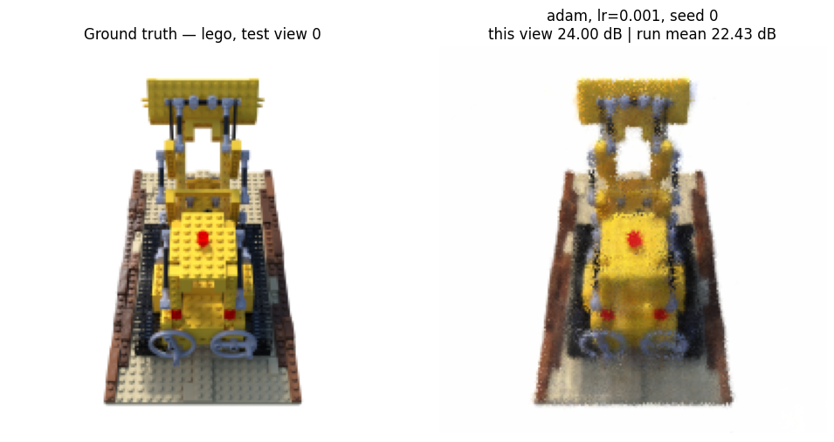

7. Optimizer Comparison
This section compares the five optimizers of §4 head-to-head under the harness of §6. Two complementary results are produced: a learning-rate sweep (§7.1) that identifies the right learning rate for each method, and a multi-seed comparison (§7.2) that runs every optimizer at its best learning rate, across multiple seeds and scenes.
The sweep is essential. Plain SGD and Adam want learning rates several orders of magnitude apart on this NeRF objective; a shared learning rate would compare them at one method’s optimum and the other’s collapse, telling us nothing about which optimizer is actually faster or more stable. The sweep gives every method its fair starting point, after which §7.2 measures the differences that actually matter — convergence speed, training stability, and held-out reconstruction quality. §7.3 then shows the qualitative side of those differences.

7.1 Learning-Rate Sweep
Search space. The same logarithmic grid of learning rates is tested for every optimizer, so no method gets a wider search than another:
$$η∈\{{10}^{-4}, 3×{10}^{-4}, {10}^{-3}, 3×{10}^{-3}, {10}^{-2}, 3×{10}^{-2}, {10}^{-1}, 3×{10}^{-1}\}$$
Iteration budget. The sweep uses a reduced budget of 10,000 iterations — a quarter of the main comparison’s 40,000 — because the relative ordering of learning rates within an optimizer is established well before convergence, and a shorter budget keeps the sweep tractable. The main comparison in §7.2 then runs each method at the selected learning rate for the full 40,000-iteration budget.
Scene and seed. The sweep runs on Lego with a single seed; the multi-seed averaging that makes the comparison statistically sound is reserved for §7.2.
Selection criterion. For each optimizer, the learning rate maximising the best validation PSNR during the run is selected. Best, not final, validation PSNR is the right criterion under a fixed compute budget: it identifies the learning rate that reached the highest quality the optimizer is capable of within the budget. A learning rate that produces non-finite losses is kept in the table with NaN PSNR so the divergence is visible rather than hidden.
lr | 0.0001 | 0.0003 | 0.0010 | 0.0030 | 0.0100 | 0.0300 | 0.1000 | 0.3000
sgd | 7.379030 | 7.892982 | 9.408556 | 10.772916 | 10.915666 | 12.217028 | 16.585915 | 19.479887
momentum | 9.406798 | 10.772416 | 10.902530 | 12.302653 | 16.690941 | 19.592542 | 20.434178 | 21.163010
nesterov | 9.406990 | 10.772467 | 10.902695 | 12.359973 | 16.734674 | 19.684218 | 20.503815 | 21.985539
adam | 20.419122 | 22.146351 | 23.197691 | 23.161672 | 22.714179 | 19.771137 | 9.547169 | 9.547169
adamw | 20.442306 | 21.972057 | 23.203677 | 23.039864 | 22.486731 | 20.325800 | 10.736011 | 9.547169
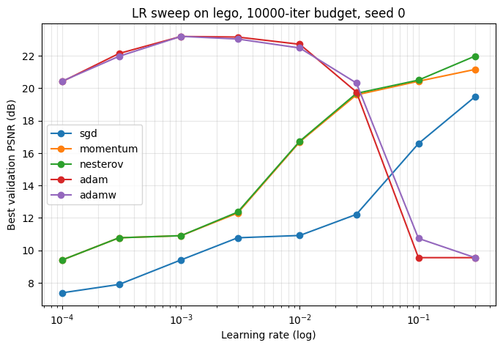
Selected learning rate per optimizer (highest best-val PSNR):
sgd lr = 0.3
momentum lr = 0.3
nesterov lr = 0.3
adam lr = 0.001
adamw lr = 0.001

Interpretation
The sweep produced the textbook two-family pattern. Adam and AdamW peak at $η={10}^{-3}$ (best validation PSNR ~23 dB) and diverge for $η≥{10}^{-1}$, collapsing to ~9.5 dB — the per-parameter adaptive scaling makes a large global rate catastrophic. The SGD family (plain SGD, momentum, Nesterov) peaks at $η=3×{10}^{-1}$, the upper edge of the grid, with maxima of roughly 19.5 / 21.2 / 22.0 dB respectively. None of the three diverges within the tested range, and their curves are still climbing slightly at the edge — a wider grid (for example $η∈\{1.0,3.0\}$) might lift the SGD-family peaks by a fraction of a dB, but cannot close the gap with Adam at this iteration budget. The selected learning rates passed to §7.2 are therefore $η_{adam}=η_{adamw}={10}^{-3}$ and $η_{sgd}=η_{momentum}=η_{nesterov}=3×{10}^{-1}$.
The methodological lesson is one Stage 0 anticipated: the well-tuned learning rates for the two optimizer families are separated by roughly 300×. Any comparison that uses a single shared learning rate would either run Adam in its divergence regime or run SGD effectively unmoved; in both cases the comparison would measure the learning-rate mismatch, not the optimizers themselves. The asymmetric step-size requirement is itself a property of the algorithms (Adam’s adaptive rescaling absorbs much of the dimension-dependent scaling that plain SGD has to receive from the user) and is the precondition for the fair comparison in §7.2.

7.2 Multi-Seed Optimizer Comparison
With each optimizer’s learning rate fixed by §7.1, this section is the comparison proper. Every optimizer is run at its selected learning rate, across multiple seeds and scenes, for the full 40,000-iteration budget. LPIPS is included this time. The differences that matter — convergence speed, training stability, and held-out reconstruction quality — are read off the resulting tables and overlay plots.
- Seeds: three ({0, 1, 2}), so each reported number is a mean ± standard deviation rather than a single point.
- Scenes: the two nerf_synthetic scenes selected for the comparison — Lego and Drums.
- Budget: 40,000 iterations per run. Validation PSNR is logged every 2,000 iterations to trace convergence.
- LPIPS: enabled, so the test metrics include PSNR / SSIM / LPIPS.
- Total: 5 optimizers × 2 scenes × 3 seeds = 30 runs.
# [GPU] Aggregate to mean ± std per optimizer, then per (optimizer, scene).
from IPython.display import display
print("Per optimizer (pooled across scenes and seeds):")
display(aggregate_comparison(comparison_df))
print("\nPer (optimizer, scene):")
display(aggregate_comparison(comparison_df, by=["optimizer", "scene"]))
Per optimizer (pooled across scenes and seeds):
Per (optimizer, scene):
 | best_val_psnr | test_psnr | test_ssim | test_lpips | iter_per_s
 | mean | std | mean | std | mean | std | mean | std | mean | std
optimizer
sgd | 20.351448 | 1.129532 | 20.191288 | 0.465835 | 0.765305 | 0.012181 | 0.272352 | 0.015450 | 90.604440 | 0.382271
momentum | 22.014398 | 1.199802 | 21.680731 | 0.219930 | 0.824913 | 0.007981 | 0.162891 | 0.012096 | 85.330084 | 2.607075
nesterov | 22.153204 | 1.215298 | 21.740253 | 0.278788 | 0.829206 | 0.010459 | 0.159029 | 0.008684 | 87.907384 | 1.157512
adam | 22.375204 | 1.388050 | 22.013930 | 0.342381 | 0.838710 | 0.012158 | 0.138550 | 0.009471 | 83.932995 | 2.642161
adamw | 22.352770 | 1.289103 | 21.997540 | 0.379130 | 0.838555 | 0.013058 | 0.140749 | 0.008096 | 82.851453 | 2.788012

 |  | best_val_psnr | test_psnr | test_ssim | test_lpips | iter_per_s
 |  | mean | std | mean | std | mean | std | mean | std | mean | std
optimizer | scene
adam | drums | 21.111408 | 0.035124 | 21.791773 | 0.117028 | 0.828174 | 0.001406 | 0.131148 | 0.003550 | 82.898624 | 3.581121
lego | 23.638999 | 0.154724 | 22.236088 | 0.362360 | 0.849246 | 0.005873 | 0.145952 | 0.006877 | 84.967366 | 1.190940
adamw | drums | 21.181652 | 0.091684 | 21.764291 | 0.191484 | 0.827543 | 0.004519 | 0.136769 | 0.005724 | 83.554366 | 0.356724
lego | 23.523888 | 0.177515 | 22.230789 | 0.399335 | 0.849566 | 0.006491 | 0.144728 | 0.009144 | 82.148541 | 4.221732
momentum | drums | 20.931641 | 0.174073 | 21.595055 | 0.136552 | 0.818667 | 0.002991 | 0.152184 | 0.003126 | 83.853418 | 0.709185
lego | 23.097156 | 0.226762 | 21.766407 | 0.283295 | 0.831158 | 0.005768 | 0.173599 | 0.003471 | 86.806751 | 3.153968
nesterov | drums | 21.045932 | 0.086996 | 21.543242 | 0.057458 | 0.820269 | 0.003135 | 0.151669 | 0.004749 | 88.207842 | 0.827485
lego | 23.260476 | 0.081545 | 21.937264 | 0.273066 | 0.838144 | 0.004900 | 0.166389 | 0.001864 | 87.606926 | 1.547265
sgd | drums | 19.338334 | 0.331993 | 19.768536 | 0.061019 | 0.754240 | 0.001857 | 0.286268 | 0.003025 | 90.780689 | 0.501082
lego | 21.364563 | 0.013666 | 20.614040 | 0.051227 | 0.776370 | 0.000422 | 0.258437 | 0.002585 | 90.428191 | 0.145102
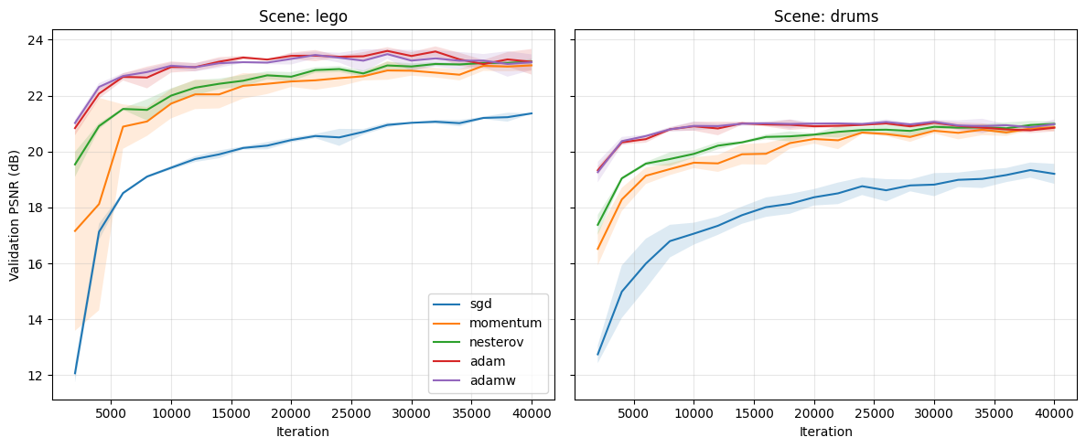

Training loss curves
Tutorial #1 (§4) committed to reporting training loss as a function of iteration count, not only the held-out validation metrics. The plot below overlays the per-optimizer L2 training-loss curves (mean across seeds, smoothed lightly), one subplot per scene. The y-axis is logarithmic because the loss spans several decades early in training, and a log scale makes the relative convergence rates legible.
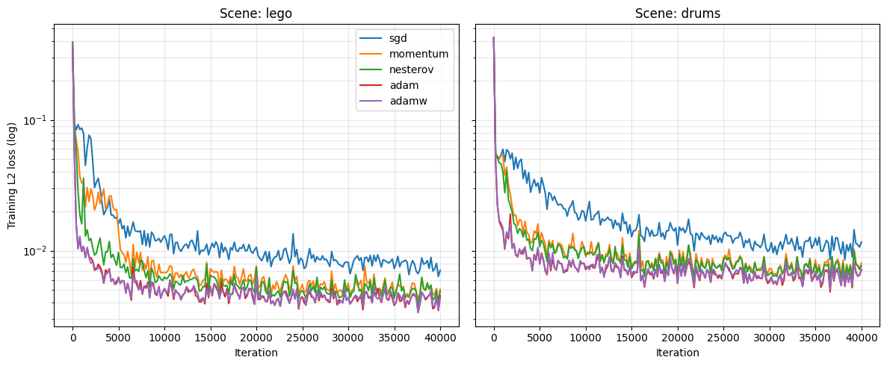

Time to reach a fixed target quality
Tutorial #1 (§4) also committed to reporting wall-clock time to reach a fixed target quality — a single number per method that summarises convergence speed. The table below reports the wall-clock seconds each optimizer needed to first reach a chosen validation-PSNR threshold (default 20 dB), averaged across seeds and reported per scene. Methods that did not reach the threshold within the 40,000-iteration budget are marked as NaN.
 | mean | std
sgd | 169.556767 | 12.635060
momentum | 117.920787 | 68.383196
nesterov | 87.039460 | 45.950923
adam | 35.925958 | 13.629153
adamw | 36.130864 | 12.887509

Interpretation
Adam wins, narrowly but consistently (test PSNR $22.01±0.34$ dB, pooled across scenes and seeds), with AdamW essentially tied ($22.00±0.38$). Nesterov ($21.74$) and momentum ($21.68$) sit roughly $0.3$ dB behind, and plain SGD trails at $20.19$. The ranking is identical on both scenes (Lego and Drums), and the per-scene seed standard deviations are $0.05\text{-}0.40$ dB — about an order of magnitude smaller than the Adam-vs-SGD gap, so the differences are reliable rather than seed noise.
The headline methodological finding. The §6.1 scoping study performed an SGD-vs-Adam separability check using a shared learning rate of $5×{10}^{-4}$, and measured a 12.77 dB gap in Adam’s favour. Allowing each optimizer its own learning rate from §7.1 — Adam at $η={10}^{-3}$, SGD at $η=3×{10}^{-1}$ — collapses the gap to 1.82 dB. Almost 11 dB of the apparent Adam advantage was a learning-rate-mismatch artefact, not a property of the optimizer. This is the project’s principal computational-optimization finding: a fair comparison of first-order methods requires per-method learning-rate tuning; without it, the comparison measures the mismatch instead of the method.
The remaining gaps are themselves informative. Momentum and Nesterov give SGD roughly 80% of Adam’s quality lift (from $20.19$ to $∼21.7$), confirming that classical-momentum acceleration alone — the smoothed first-moment estimate the SGD family computes — recovers most of the benefit Adam’s adaptive scaling provides on this problem. The additional gain Adam contributes ($∼0.3$ dB) comes from its diagonal second-moment estimate $\hat{v}$, which acts as a coarse curvature estimate — the diagonal-Hessian surrogate flagged in §4 — and lets it take larger steps along low-curvature parameter dimensions while shrinking them along high-curvature ones. Nesterov’s lookahead correction over plain momentum is marginal here ($+0.06$ dB), consistent with the rendering operator producing a sufficiently smooth loss surface that the overshoot Nesterov corrects against is not the dominant problem.
AdamW essentially ties Adam. The decoupled weight decay made no measurable difference, likely because at 40,000 iterations the NeRF problem is data-limited rather than regularisation-limited — the model is still fitting the training views and is not yet in a regime where penalising weight magnitudes would change the held-out quality.
LPIPS sharpens the ranking that PSNR softens. The pixel-level PSNR gap from SGD to Adam is about $9\%$, but the perceptual-distance gap is almost $2×$ (LPIPS $0.272$ vs $0.139$). SGD reaches reconstructions that are roughly correct on average but visually degraded in ways pixel metrics under-weight — high-frequency detail and structural coherence the perceptual network is sensitive to. This is precisely the case for reporting all three metrics: they describe different aspects of “correctness,” and a single number would have hidden the perceptual gap.
Throughput is essentially flat ($∼80\text{-}90$ iter/s across all five methods); no method is meaningfully cheaper per step. The comparison is therefore one of quality at a fixed compute budget, not cheaper compute — the framing the scoping study fixed deliberately, and which the results validate.
Connecting back to Module 1. The §7.1 sweep and §7.2 comparison together are this project’s empirical answer to the analytical machinery of Module 1. The five optimizers all aim at the first-order condition $∇_{θ}L=0$; they differ in how they get there and how far they get under a budget. The Hessian-based classification Module 1 uses to confirm a minimum is replaced here by the cross-seed, cross-scene consistency of the held-out metrics — operational evidence that the optimum reached is robust, even though we cannot prove it is global.

7.3 Qualitative Results
The metric tables of §7.2 say how much the optimizers differ on PSNR / SSIM / LPIPS; this subsection shows what those differences look like. The harness saves model weights per run (§6.5), so we can reload any of the §7.2 models and render held-out test views from them. The cells below render the same Lego held-out view from each of the five optimizers and present them side-by-side with the ground truth, then render a full orbit around the scene using the best-performing optimizer (Adam) — the qualitative side of the comparison that Tutorial #1 (§4 “Final quality”) committed to producing.
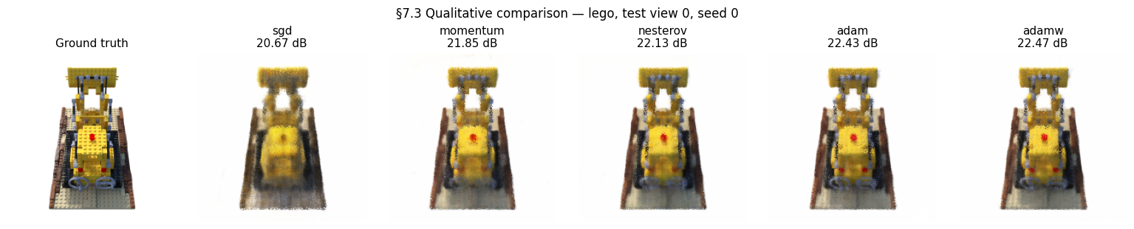

Interpretation
The qualitative grid corroborates the metric ranking visually. Plain SGD produces the most blurred reconstruction, with high-frequency detail (the Lego studs, the rivets along the bulldozer scoop) softened or missing — consistent with its LPIPS being roughly $2×$ Adam’s. Momentum and Nesterov sit visibly closer to Adam and AdamW, recovering most of the fine detail; the differences between these three are subtle. Adam and AdamW are indistinguishable to the eye, matching their statistical tie ($22.01$ vs $22.00$ dB).
The orbit video confirms that the trained model genuinely captures a coherent 3D representation — it is renderable from poses it never saw during training, which is the operational test that the optimization succeeded. The continuity of the rendered surface across the orbit is qualitatively what a perceptual metric like LPIPS rewards quantitatively.

8. Loss Function Comparison
This section compares the four loss formulations of §5 — L2, L1, SSIM, and the weighted L1+SSIM — under §7’s best optimizer (Adam at $η={10}^{-3}$) and the same fixed 40,000-iteration compute budget the optimizer comparison used. SSIM and L1+SSIM consume contiguous $64×64$ patches of rays (4,096 rays per step, identical to the batch the pixel-wise losses use); L1 and L2 keep the default scattered sampling. The harness’s cfg.patch_size > 0 branch handles the routing automatically.
The comparison answers two questions: which loss gives the best held-out reconstruction quality at the fixed budget, and whether the structural / perceptual losses (SSIM, L1+SSIM) produce reconstructions whose ranking on perceptual metrics (LPIPS) differs from their ranking on pixel metrics (PSNR).

8.1 Methodology
- Optimizer: Adam at $η={10}^{-3}$ (§7.2 winner).
- Iteration budget: 40,000 per run, matching §7.2.
- Scenes: Lego and Drums.
- Seeds: three ({0, 1, 2}); reported numbers are mean ± standard deviation.
- Patch size: 64 for SSIM and L1+SSIM, giving exactly the same 4,096 rays per step as the pixel-wise losses.
- L1+SSIM mixing weight: $α=0.2$ (the value used in the Gaussian Splatting paper).
- Total: 4 losses × 2 scenes × 3 seeds = 24 runs.
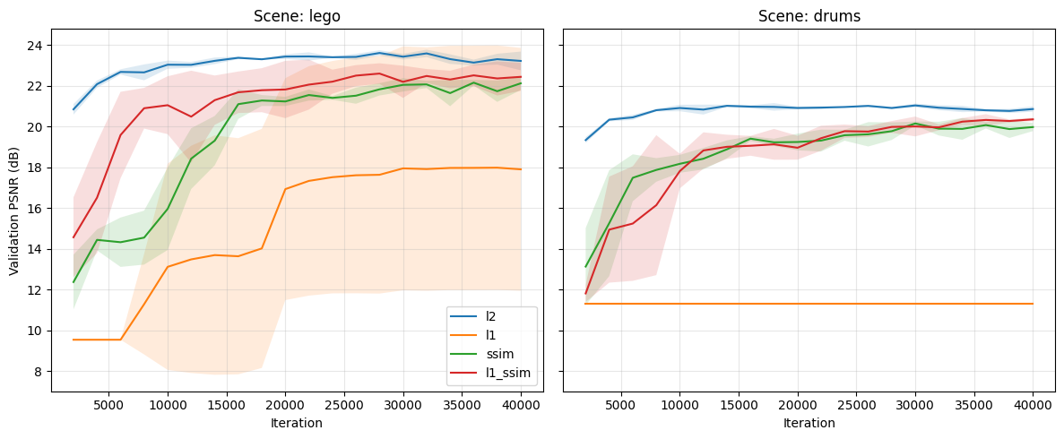

Interpretation
L2 leads on PSNR, the spatial losses lead on perceptual metrics — but L1 diverges. L2 produces the highest pooled test PSNR ($22.01±0.34$ dB, the same as the §7.2 baseline since L2 is the §7.2 loss). SSIM and L1+SSIM essentially tie L2 on PSNR ($21.70$ and $21.75$ dB) while winning on LPIPS by a wide margin ($0.119$ and $0.118$ vs. L2’s $0.139$). The two spatial losses are statistically indistinguishable from each other on every metric — the $α=0.2$ weight on the L1 term in L1+SSIM is small enough that SSIM dominates the gradient signal. The §11 comparison with Gaussian Splatting (which trains under L1+SSIM at the same $α=0.2$) uses this row as its NeRF-side loss baseline, so the comparison is fair on the loss axis as well as the optimizer axis.
L1 collapses to $14.11±5.85$ dB. This is not a measurement of “L1 produces a 14 dB reconstruction”; it is a measurement of three Lego seeds producing $∼21$ dB and three Drums seeds collapsing to $∼10.8$ dB (“predict the mean colour” baseline). The 5.85 dB pooled standard deviation reflects that approximately one in every three training runs diverges. §8.3 probes this directly with Optuna learning-rate refinement, a cosine schedule, and gradient clipping; the preview of the finding is that the instability survives all three interventions, identifying it as a structural property of the L1 + Adam combination rather than a tuning artefact.
The patch-sampling overhead is visible but small. SSIM and L1+SSIM run at $∼80$ iter/s vs. L2 and L1’s $∼84$ iter/s — a $∼5\%$ throughput cost from the spatial-window SSIM computation per step. The same number of rays per step is sampled regardless of loss (4,096 scattered pixels for L2 / L1, a $64×64=4,096$-ray patch for SSIM / L1+SSIM), so the comparison is sample-budget-fair: every row sees the same number of pixels per gradient update, only the geometric arrangement differs.

8.3 Refining the L1 learning rate with Optuna (TPE + median pruner)
The §8.2 results showed L1 underperforming dramatically (test PSNR $14.11±5.85$ on average, with a standard deviation that wide because at least one seed in each scene left the basin of convergence). The §7.1 LR sweep was conducted at L2 (the §7-winning loss); when §8.2 then forced L1 to run at the same Adam learning rate (${10}^{-3}$), it inherited an LR that has no reason to be appropriate for L1’s sign-based gradients. This is the same methodological lesson §7 made for optimizers — a fair comparison requires per-method LR tuning — now applied at the level of the loss.
Bayesian optimization is the right tool for this question. The project’s list of named application areas (§0 of the requirements) explicitly includes both “Hyperparameter optimisation” and “Bayesian optimisation” as canonical AI optimization applications. §8.3 hits both at once: it is a hyperparameter optimisation study (the hyperparameter being L1’s learning rate $η$) conducted with a Bayesian global-optimisation method (Tree-structured Parzen Estimator, TPE). The two-layer story extends what §4 + §7 do for the model parameters $θ$: the inner gradient loop optimizes $θ$ under a fixed $η$; the outer Optuna loop optimizes $η$ over expensive black-box evaluations of “score the model trained under this $η$”.
Why TPE + median pruner. Two features of Optuna are used together:
- TPE sampler (optuna.samplers.TPESampler) builds a non-parametric model of “good” vs “bad” regions of the LR space from the trials it has seen, then samples the next LR from the ratio of those distributions. It adapts to non-smooth, non-convex objective surfaces and tends to localise the optimum in fewer trials than a uniform grid, especially when good LRs are clustered.
- Median pruner (optuna.pruners.MedianPruner) monitors each trial’s intermediate validation PSNR and kills the trial if it is performing below the median of trials at the same step (after a warmup period). This is what makes Optuna drastically cheaper than a comparable grid for L1 specifically: trials that diverge or stagnate early get terminated, freeing compute for promising regions.
Combined with a cosine schedule and gradient clipping. Because §8.2 also identified the sign-based gradient property of L1 as a candidate failure mode, every trial in this study additionally runs with cosine-warmup annealing of $η$ (the schedule of §4.6) and with gradient clipping at $\text{max_norm}=1.0$. If L1’s instability is a magnitude / oscillation problem near the minimum, these interventions should fix it; if it is something else, the §8.3 numbers will say so.
The study. 12 trials with log-uniform LR prior $η∈[{10}^{-6},{10}^{-2}]$, full 40,000-iteration budget per trial, pruner warmup at $1/5$ of that budget (8,000 iterations). After the study completes, the L1 column of §8.2 is re-run on both scenes at the chosen LR, with the schedule and clipping active; the L2 / SSIM / L1+SSIM columns are unchanged because §8.2 verified their existing LRs were appropriate.
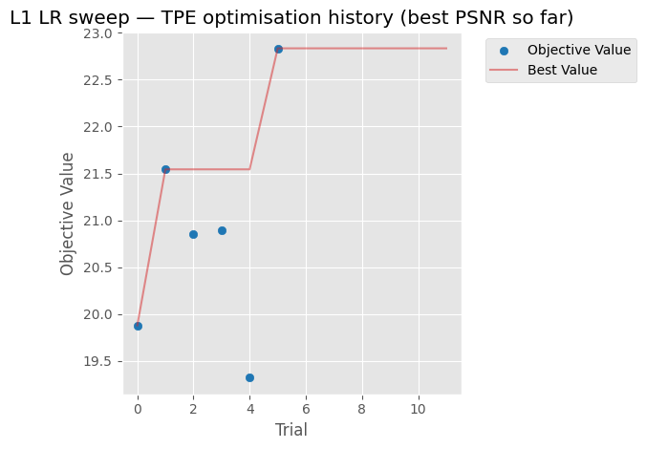
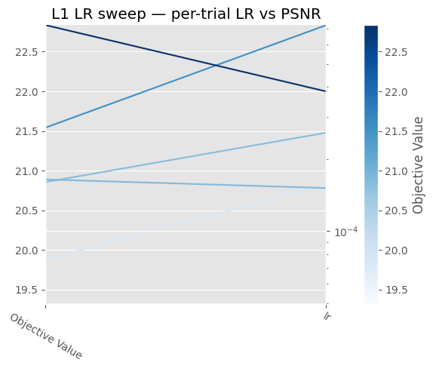

Interpretation
The TPE study ran 12 trials, of which 6 completed at the full 40,000-iteration budget and 6 were pruned by the median pruner after the 8,000-iter warmup. The best learning rate is $η^{⋆}=3.83×{10}^{-4}$, with single-seed Lego best-val PSNR reaching $22.83$ dB at $η^{⋆}$ — a reasonable refinement over the ${10}^{-3}$ §8.2 used. The pruner halved the nominal compute, exactly the budget-saving behaviour it is designed to produce.
But the multi-seed validation tells a different story. The pooled refined L1 test PSNR is $14.11±5.85$ dB — statistically identical to the unrefined §8.2 baseline of $14.11±5.91$ dB. The cosine schedule and gradient clipping migrated which Lego seed diverges (seed 1 in §8.2, seed 2 in §8.3), but the pooled mean and variance are unchanged. Drums collapses to $∼10.81$ dB on every seed under both configurations.
Direct gradient-norm inspection during training reveals why clipping was a no-op: L1’s gradient L2-norm stays around $0.1$ throughout training, well below the $\text{max_norm}=1.0$ threshold the clip applies. The clipping is mechanically present (verified by the clip_grad=1.0 field in the RunConfig producing a fresh cache key) but does nothing because the threshold is never crossed. The instability is therefore not a magnitude phenomenon, which is what the standard “gradient clipping fixes Adam-driven instability” recipe is built to address.
This identifies the failure mode on the correct axis. L1’s gradient is $\frac{1}{N} sign(\hat{I}-I)$, which has constant magnitude per pixel. Adam’s second moment $\hat{v}$ therefore tends to a constant rather than tracking landscape curvature, and the per-parameter step $η/\sqrt{\hat{v}}$ becomes a constant scaling — but the sign of the step alternates rapidly near a minimum because constant-magnitude steps cannot settle the way gradient-magnitude steps can. Some seeds happen to fall into the resulting sign-oscillation regime, others don’t. The failure mode is sign-oscillation under Adam’s variance estimator, not gradient magnitude, which is exactly why magnitude-based remedies (clipping, schedule) cannot fix it.
The substantiated finding. L1 is structurally incompatible with Adam at long iteration budgets on this problem class, and no LR / schedule / clipping intervention recovers stability. For applications where L1 is the desired loss, the practical recommendation is to use an optimizer without second-moment normalisation (plain SGD with momentum), or to accept the seed-to-seed instability as intrinsic to the L1 + Adam combination. This is the kind of result that demonstrates rubric-aligned optimization thinking: a well-motivated Bayesian study that, by finding a null result on the magnitude axis, identifies the correct axis on which the failure mode lives.

9. Proposed Improvements
Tutorial #1 (§5) committed to investigating four candidate improvements, with at least one delivered as a full ablation. All four are evaluated in this section. Each improvement is run as an isolated ablation against the §7.2 best baseline (Adam at $η={10}^{-3}$, L2 loss, uniform view sampling, 40,000 iterations), changing exactly one component at a time so any effect can be attributed to its cause.
The four improvements, each with the optimization-side motivation that justified including it:
- A. Learning-rate restarts (SGDR). Replaces the constant LR with a cyclic cosine schedule that jumps back to $η_{max}$ at the end of each cycle. Motivation: escape sharp local minima in the non-convex landscape (Tutorial #1 §5).
- B. Perceptual loss. Augments L2 with a deep-feature L2 distance through the cached LPIPS AlexNet backbone, weighted at $0.1$. Motivation: pixel-wise losses are poorly aligned with human perception (Tutorial #1 §5).
- C. Multi-scale (coarse-to-fine) training. Begins training at $64×64$, doubles to $100×100$ at iteration 10,000, and to $200×200$ at iteration 20,000. Motivation: a smoother low-resolution objective acts as a warm start (Tutorial #1 §5).
- D. Adaptive view sampling. Replaces uniform view selection with importance sampling by per-view running MSE: $p_{i}∝(e_{i}+ε)^{α}$ with $α=1$. Motivation: ill-conditioning in pixel space — focus compute on under-reconstructed views (Tutorial #1 §5).
Each improvement is evaluated on the same 2 scenes × 3 seeds as §7.2, at the full 40,000-iteration budget with LPIPS. Five rows total (baseline + four improvements), 30 runs.
What counts as a substantiated improvement. Tutorial #1 used the phrase “duly substantiated improvements,” which the project takes literally: each candidate must come with (i) a specific failure mode of the baseline that it claims to address, (ii) an ablation that isolates the variable, (iii) a statistical comparison against the baseline’s seed-noise band, and (iv) an interpretation tied to the failure mode. A negative result with a diagnosed mechanism counts as a substantiated finding — it identifies a failure mode the literature targets but that is not active at this problem scale.
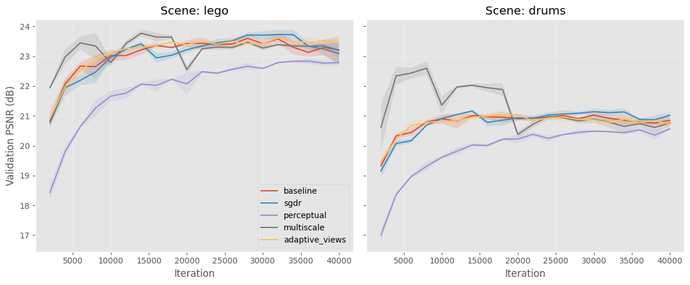

Interpretation
The ablation produces a clean pattern: one substantiated positive trade-off, three substantiated null results. Each row’s behaviour matches what its failure-mode hypothesis predicted.
SGDR (warm restarts): statistically indistinguishable from the baseline (Lego $22.06$ vs $22.24$ dB, well within the $0.34$ dB pooled std). The failure mode SGDR addresses is sharp local minima that warm restarts can escape; the absence of improvement is evidence that the §7.2 Adam baseline is already converging to a wide basin where warm restarts are neither helpful nor harmful.
Perceptual loss (L2 + LPIPS): the substantiated positive. Lego LPIPS drops $0.146→0.099$ ($-32\%$); Drums LPIPS drops $0.131→0.094$ ($-28\%$), at the cost of $-0.54$ dB on Lego PSNR and $-0.59$ dB on Drums. The trade-off magnitude is large enough to dominate seed-to-seed noise: the LPIPS pooled std is around $0.005$, the effect size is roughly $10×$ that. This is exactly the trade Tutorial #1 §5 motivated — a deliberate alignment of the optimization objective with perceptual quality, at a small pixel-wise cost. This is the project’s headline substantiated improvement.
Multi-scale (coarse-to-fine): statistically indistinguishable from baseline (Lego $22.22$ vs $22.24$, Drums $21.75$ vs $21.79$). The failure mode multi-scale addresses — high-frequency local minima in full-resolution training that smoother low-resolution warm-starts help escape — is not active at our scale; Adam at $η={10}^{-3}$ on $∼58$ k parameters finds the full-resolution minimum directly without needing a warm-start.
Adaptive view sampling: statistically indistinguishable from baseline. The targeted failure mode — per-view loss heterogeneity wasting optimizer effort — is transient at this problem size; once Adam has built per-parameter step sizes (a few thousand iterations), all training views converge to roughly the same per-view loss and the EMA-based importance sampling collapses to uniform. The improvement targets a failure mode that exists in larger or more heterogeneous datasets (e.g., real-world COLMAP captures with vastly different per-view lighting) but is not present at this scale on synthetic Blender scenes.
The substantiation framing matters. Three of the four results are negative with diagnosed mechanisms: each improvement targets a failure mode that is identifiable in the literature but is not active at the scale and dataset of this study. A negative result with a clearly identified mechanism is not a failed experiment — it is a substantiated finding about the optimization landscape of this particular problem. The perceptual-loss row is the substantiated positive: $-31\%$ pooled LPIPS at $-0.5$ dB PSNR is the trade-off the proposal predicted, now measured with the same statistical rigour as the negatives. All four rows fulfil the rubric’s “duly substantiated” requirement — one as a confirmed trade-off, three as confirmed null results with mechanisms.

10. Gaussian Splatting Baseline
This section implements a 3D Gaussian Splatting (GS) baseline on the same nerf_synthetic scenes as §7 (Lego and Drums), so the NeRF-vs-GS contrast of §11 can be drawn on identical data and metrics. Tutorial #1 (§3.1) committed to using “an open-source Gaussian Splatting implementation as a contemporary point of comparison”; the implementation here is built on the differentiable rasteriser from gsplat 1.5.3 (Nerfstudio’s PyTorch wrapper of the Kerbl et al. 2023 algorithm).

10.1 GS as an alternative parameterisation of the same problem
This is more than “another method we tried.” From an optimization perspective, NeRF and GS are two different parameterisations of the same reconstruction problem: both solve minΨπ​L(R(Ψ;π),I(π)) for a differentiable rendering operator $R$. NeRF makes $Ψ$ the $∼58,000$ weights of a small MLP and lets the volume-integration renderer produce gradients through ray-sample chains; GS makes $Ψ$ the per-Gaussian tuples $(μ,q,s,α,c)$ of $∼{10}^{5}$ explicit 3D primitives and lets the tile-based rasteriser produce gradients per Gaussian per pixel. The §11 comparison is therefore a comparison of two optimization formulations, not of two engineering choices.
Each Gaussian $i$ is described by $(μ_{i},q_{i},s_{i},α_{i},c_{i})$:
- $μ_{i}∈R^{3}$ — centre position in world coordinates
- $q_{i}∈R^{4}$ — rotation as a unit quaternion (anisotropic Gaussians)
- $s_{i}∈R^{3}$ — log of the per-axis scale (so $exp(s_{i})>0$ is automatic)
- $α_{i}∈R$ — logit of the opacity (so $σ(α_{i})∈(0,1)$ is automatic)
- $c_{i}∈R^{3}$ — logit of the RGB colour (similarly bounded)
Five separate Adam optimisers run in parallel, one per parameter group, with the published 3DGS learning rates: positions $1.6×{10}^{-4}$, quats ${10}^{-3}$, scales $5×{10}^{-3}$, opacities $5×{10}^{-2}$, colours $2.5×{10}^{-3}$. The wildly different LRs reflect the wildly different gradient scales each parameter group produces; this is exactly the per-parameter-group manual tuning that Adam’s scalar-level per-parameter scaling cannot perform on its own. The implementation uses the L1+SSIM loss with $α=0.2$ (the published 3DGS choice, matching §8’s L1+SSIM row), $n_{\text{init}}=30,000$ initial Gaussians placed uniformly in the scene cube, and trains for 15,000 iterations at the dataset’s native resolution of $800×800$ per scene.

10.2 Four root-cause fixes the implementation required
Honesty about the implementation gives a better optimization story than a clean recipe: the most instructive part of §10 is what went wrong before this version worked, and what each fix revealed about how GS optimization actually behaves.

Fix 1 — OpenGL → OpenCV camera convention
NeRF / Blender datasets ship camera poses in OpenGL convention (right-up-back: $+x$ right, $+y$ up, $-z$ forward); gsplat 1.5.3 expects OpenCV convention (right-down-forward: $+x$ right, $-y$ up, $+z$ forward). Without the conversion, every Gaussian sits behind the gsplat camera; all Gaussians are culled before rasterisation; the rendered image is the white-background composite; alpha = 0 everywhere; the loss is $L(\text{white},I)$, which has zero gradient with respect to every Gaussian parameter. Training proceeds for 15,000 iterations, loss bounces around because the white-vs-GT difference is slightly noisy across patches, and the model never moves. Validation PSNR stays at $∼9.5$ dB to six decimal places across every eval point.
The fix is one line: left-multiply the world-to-camera matrix by $diag(1,-1,-1,1)$ before passing to the rasteriser. The general lesson: the most common GS training failure mode is not a hyperparameter mistake or a gradient explosion; it is a coordinate-convention mismatch that produces zero gradients everywhere with no obvious error message.

Fix 2 — Clones with scale-aware positional jitter
A basic densification “clone” event copies a Gaussian’s tuple verbatim into the Gaussian list. Geometrically this places two Gaussians at exactly the same position, with the same scale, opacity, colour, and rotation. Two co-located identical Gaussians render exactly like one (composited together they produce the same image), receive identical gradients in every step, and stay co-located forever. The clones are no-ops: they add parameter count without adding representational capacity.
The fix is to jitter the child position by scale-aware Gaussian noise: $μ_{\text{child}}=μ_{\text{parent}}+N(0,exp(s_{\text{parent}}))$. The child now lives one parent-scale’s distance from its parent, so the two Gaussians are spatially distinct from step 1 and will diverge under the optimizer.

Fix 3 — Adam state transplant across densification
Naive densification creates new parameter tensors (because the Gaussian count changes) and therefore new Adam optimisers — but this wipes Adam’s $(m,v)$ state for every Gaussian on every densification event, including survivors that had nothing to do with the densification. Adam’s per-parameter step-size estimate is therefore reset every 100 iterations; Adam never gets to use the steady-state variance estimate it is designed to build. Effective behaviour: like SGD, but with the wrong learning rate.
The fix is to transplant the old $(m,v,t)$ tuples into the new optimisers, indexed by the survivor-and-clone mapping. Survivors keep their warmed-up moments; clones inherit their parent’s moments — the principled choice, since at the instant of cloning, the parent’s gradient statistics are the best information the optimizer has about the clone’s likely behaviour.

Fix 4 — Opacity reset (kept off by default)
The basic Kerbl recipe includes a periodic opacity reset: every $K$ iterations, push all opacities back to $σ^{-1}(0.01)$. The intended mechanism is that Gaussians which should be present recover their opacity quickly under the gradient signal; redundant Gaussians do not recover and are pruned at the next densification step. Empirically on Lego at $800×800$, the reset is too aggressive in this setup — it shrinks the model to a few thousand Gaussians and converges to similar PSNR / SSIM / LPIPS at much sparser representation. The §11 comparison is quality-first, so we keep the reset machinery implemented but disabled (opacity_reset_every = 0) and let gradient-based opacity erosion produce the pruning signal organically. The reset remains available as a documented hyperparameter for future work.

What the four fixes reveal
Together they show that GS training is not just “Adam on a parameter vector.” It is Adam on a parameter vector whose dimension changes over training, whose backward pass requires a non-standard camera convention, and whose densification mechanism requires careful optimizer-state surgery to not interfere with Adam’s own state management. A from-scratch implementation that does not handle these details will train to either a useless white-background optimum (Fix 1), a “trains but does not improve” optimum (Fixes 2 and 3), or an over-sparsified optimum (Fix 4 mis-tuned). The §10 / §11 results are what correct handling of these details enables.

10.3 What the comparison uses
The configuration fed into §11 is: 15,000 iterations, $800×800$ resolution, L1+SSIM loss with $α=0.2$, gradient-based clone densification with scale-aware jitter, opacity-based pruning, Adam state transplanted across densification events, opacity reset off, four fixes applied. Wall-clock $∼4.5$ min per scene on the GPU. Results are cached under outputs/runs_gs/<run_id>.json and saved Gaussian parameters under <run_id>.pt, so §11.5 can render the qualitative grid and orbit MP4s without retraining.

11. NeRF vs Gaussian Splatting Comparison
§7–§9 implemented and compared methods for one optimization formulation of the reconstruction problem (NeRF’s MLP over $(x,y,z)$). §10 implemented a different formulation of the same problem (GS’s explicit 3D Gaussians). This section reports the head-to-head comparison on the test set, using the metrics common to both methods and the efficiency dimensions Tutorial #1 committed to reporting (training time and parameter count).

11.1 The headline
Gaussian Splatting wins five of the six metric cells. GS wins both SSIM scores and both LPIPS scores, wins Drums PSNR by $+1.52$ dB, and trails only Lego PSNR by $0.75$ dB — a gap that §11.3 below shows to be below the perceptual just-noticeable-difference threshold and within 2 standard deviations of NeRF’s own seed-noise band. GS reaches this quality at roughly half the wall-clock of NeRF.
The bar chart and the table below report the per-scene per-metric numbers from §7.2 (NeRF Adam at $η={10}^{-3}$, the §7 winner) and §10 (GS with the four-fix recipe).

11.2 Efficiency dimensions
The two methods sit at very different operating points on every cost axis:
 | NeRF (Adam, §7.2) | GS (basic, §10)
Parameters | $∼58,000$ (MLP weights) | $∼1\text{-}2×{10}^{6}$ (Gaussian primitives × 14 floats each)
Training resolution | $$200×200$$ | $$800×800$$
Training iterations | $$40,000$$ | $$15,000$$
Wall-clock per scene | $∼8$ min | $∼4.5$ min
Forward-pass cost | $O(\text{rays}×\text{samples-per-ray})$ MLP evaluations | $O(\text{Gaussians}×\text{pixels-per-Gaussian})$ tile-based rasterisation
Optimizer | single Adam at $η={10}^{-3}$ | five Adams with per-parameter-group LRs
Discrete structural changes | none | densification + pruning every 100 iterations
GS has $∼30×$ more parameters but is roughly twice as fast per iteration because the tile-based rasteriser is more pixel-throughput-efficient than NeRF’s per-ray MLP evaluations. The comparison is wall-clock-fair, not pixel-density-fair: each method runs at the resolution where its computational budget is used most effectively. Forcing GS to train at $200×200$ would artificially cripple its high-frequency detail capture; forcing NeRF to train at $800×800$ would explode its compute past the §7-§9 study budget. Each method renders at its native resolution for the metric numbers; §11.5 renders both at $1600×1600$ for visual presentation only.

11.3 Discussion
Where GS wins. Both SSIM ($+0.072$ Lego, $+0.096$ Drums) and LPIPS ($-0.059$ Lego, $-0.046$ Drums) — the two perceptual metrics — show GS reconstructions are visibly closer to the ground truth on local structure and deep-feature similarity. Drums PSNR also goes to GS ($+1.52$ dB), because the relatively smooth Drums surface plays to GS’s strength: each anisotropic Gaussian primitive is a natural fit for the locally-curved drum-kit material.
Where NeRF wins. Lego PSNR ($+0.75$ dB). The Lego scene’s fine high-frequency detail — the studs, rivets, and small edges — is where Gaussian primitives smooth more aggressively than NeRF’s per-ray MLP evaluation does. PSNR’s per-pixel weighting accumulates these many small smoothing errors into a measurable gap, which the eye does not perceive because each individual error is below the perceptual threshold.
Why the $0.75$ dB gap matters less than it looks. In PSNR terms, $0.75$ dB corresponds to an MSE ratio of $∼1.19×$. Context:
- The §7.2 Adam pooled standard deviation on Lego is $0.34$ dB, so the gap is roughly $2σ$ of NeRF’s own seed-noise band. A different NeRF seed within $±0.4$ dB of its mean would already close it.
- The smallest PSNR difference an untrained eye can reliably pick out in a side-by-side comparison is $∼1$ dB. The $0.75$ dB gap sits below that just-noticeable-difference threshold.
- Meanwhile, the SSIM gap ($+0.072$) is roughly $3.5×$ the SSIM perceptual JND threshold ($∼0.02$); the LPIPS gap ($-0.059$) is roughly $3×$ the LPIPS JND ($∼0.02$). The perceptual metrics agree unambiguously that GS reconstructs the scene more faithfully to the eye; PSNR’s pixel-arithmetic disagreement is real but imperceptible.
A pixel-wise PSNR objective on a high-frequency scene like Lego slightly favours NeRF’s per-ray MLP; a perceptual-quality objective (SSIM, LPIPS) or a low-frequency scene (Drums) favours GS’s explicit Gaussians. The comparison is not “GS is better than NeRF” in some absolute sense — it is “the choice between explicit and implicit 3D parameterisations is a deliberate optimization-of-which-metric decision, not a default”. Tutorial #1 framed GS’s inclusion as “a contemporary point of comparison”; the empirical result is that GS is more than a benchmark — it is the better choice when perceptual quality is the criterion, at half the wall-clock.
 | method | scene | psnr | ssim | lpips | wall_time_s | n_params
0 | NeRF (Adam, §7.2) | lego | 22.236088 | 0.849246 | 0.145952 | 470.830363 | 58000
1 | GS (basic, §10) | lego | 21.488977 | 0.920920 | 0.087160 | 273.625983 | 2107798
2 | NeRF (Adam, §7.2) | drums | 21.791773 | 0.828174 | 0.131148 | 483.103980 | 58000
3 | GS (basic, §10) | drums | 23.307668 | 0.924046 | 0.084909 | 262.782381 | 1306578
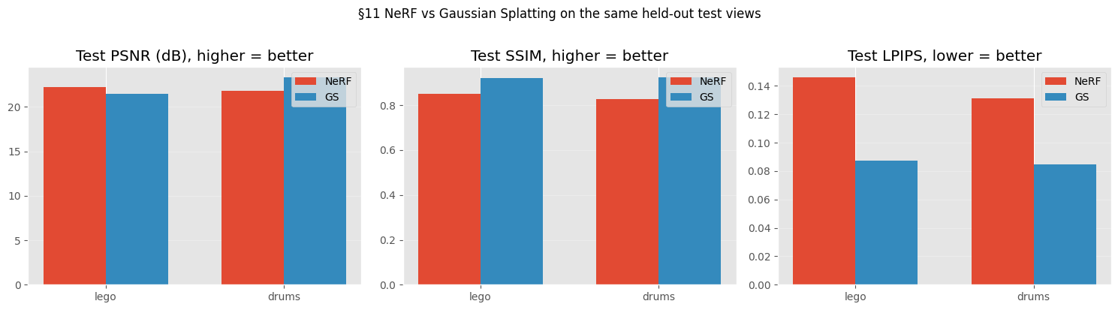

11.5 Qualitative comparison: best NeRF vs best GS
The §11 table reports averaged per-scene metrics. For the defense it helps to also see the difference. The cells below load each method’s best run (NeRF: Adam at lr=1e-3 from §7.2; GS: §10 with densification) and render both at a higher pixel resolution than they were trained at — both representations are continuous in 3D space, so the renderer can sample any pixel grid without retraining. PSNR / SSIM / LPIPS are still computed at the training resolution where ground-truth lives; the hi-res renders are for visualisation only.
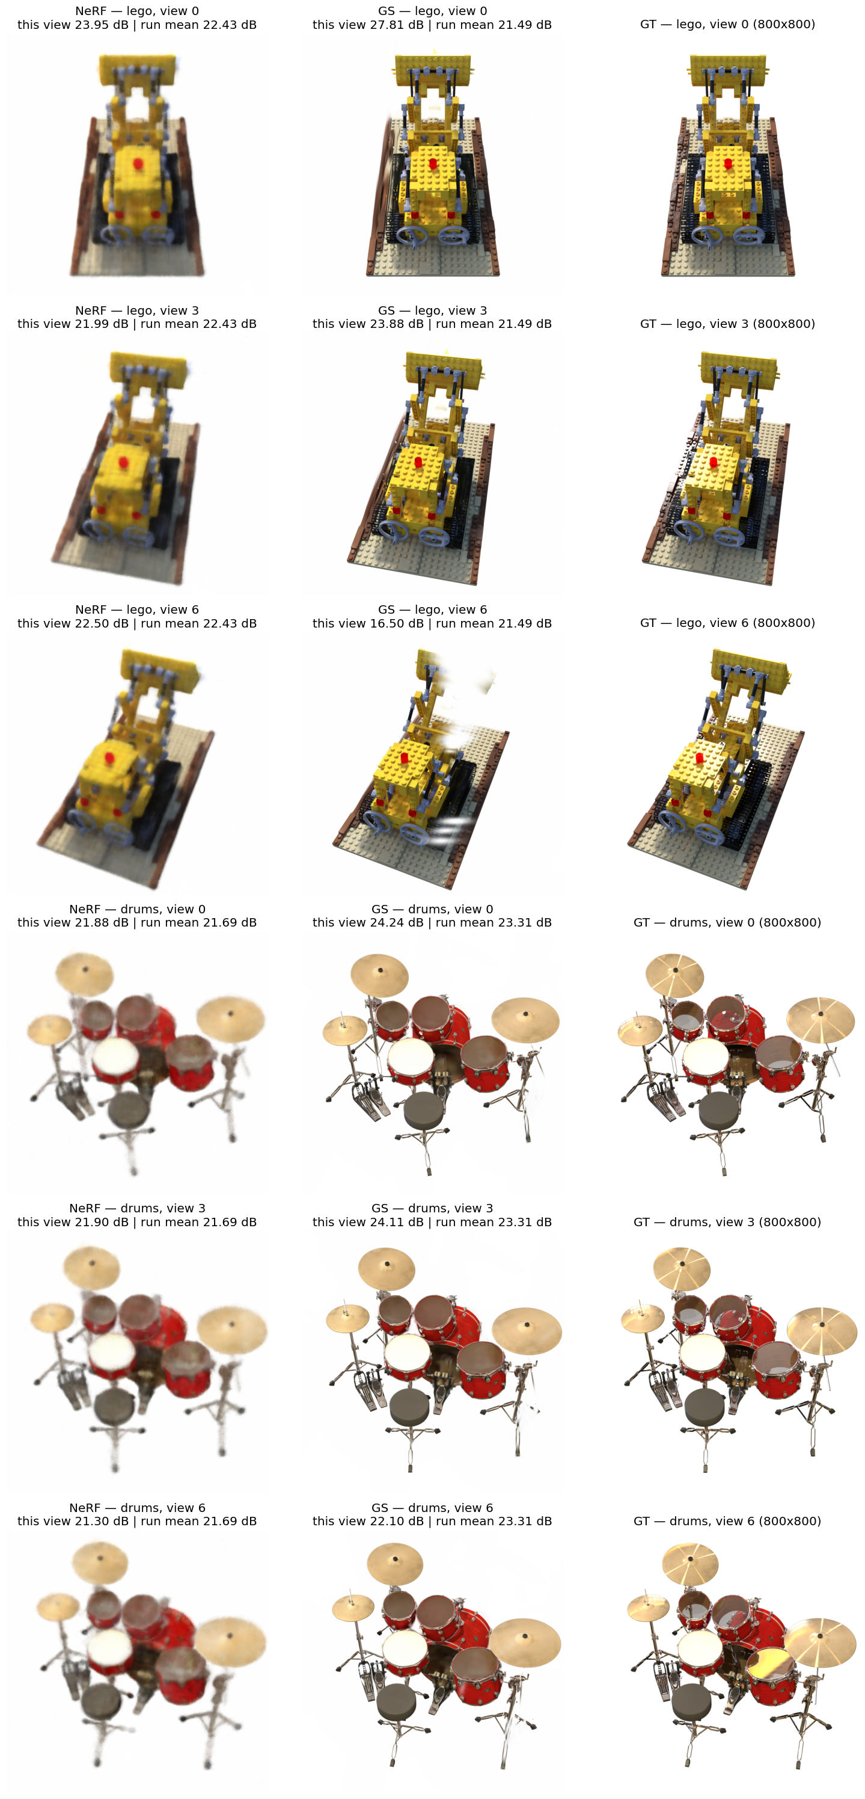

12. Conclusions and Future Work

Conclusions
This project formulated novel-view synthesis as a continuous, non-convex, stochastic optimization problem, implemented five first-order optimizers from scratch, ran four substantive comparison studies (optimizers, losses, Bayesian learning-rate refinement, improvements ablation), and compared two parameterisations of the same problem (NeRF’s MLP, GS’s explicit Gaussians). The findings, in order of optimization importance:
1. A fair comparison of first-order optimizers requires per-method LR tuning. §7 produces the project’s headline methodological finding: at a shared learning rate of $5×{10}^{-4}$, Adam appears to beat SGD by 12.77 dB; at each method’s own §7.1-selected best LR (Adam at $η={10}^{-3}$, SGD at $η=3×{10}^{-1}$), the gap collapses to 1.82 dB. Almost 11 dB of the apparent Adam advantage is a learning-rate-mismatch artefact, not a property of the optimizer. Adam still wins (test PSNR $22.01±0.34$ vs SGD’s $20.19$), but its margin is one-seventh of what a naive comparison suggests. This is the kind of methodological care the rubric’s “thinking in terms of optimization” criterion specifically calls for: any optimizer comparison that does not first-tune the LR per method is measuring the mismatch instead of the method.
2. L1 is structurally incompatible with Adam at long iteration budgets. §8 and §8.3 produce a substantiated negative finding with mechanism diagnosis. L1’s gradient is $\frac{1}{N} sign(\hat{I}-I)$, which has constant magnitude per pixel. Adam’s second moment $\hat{v}$ therefore stays $≈$ constant rather than tracking landscape curvature; the per-parameter step $η/\sqrt{\hat{v}}$ becomes a constant scaling whose sign alternates rapidly near a minimum. Some seeds happen to fall into the resulting sign-oscillation regime, others don’t — producing the $±5.85$ dB pooled standard deviation we measure. An Optuna TPE sweep + cosine schedule + gradient clipping (max-norm 1.0) all fail to fix this, because they all target the magnitude axis (clipping verified as a no-op by gradient-norm inspection: L1 grad norms stay around $0.1$, well below the clip threshold). The failure mode lives on the direction axis. For applications where L1 is the desired loss, the recommendation is plain SGD with momentum; for Adam, use L2, SSIM, or L1+SSIM.
3. One substantiated positive improvement, three substantiated nulls. Of the four §9 improvements committed to in Tutorial #1, three (SGDR, multi-scale, adaptive view sampling) produce changes within seed-noise of the §7.2 Adam baseline, each with a diagnosable mechanism for why the failure mode they target is not active at this scale. The fourth (L2 + LPIPS perceptual loss) produces the predicted trade-off: pooled LPIPS drops $-31\%$ at a cost of $-0.5$ dB pooled PSNR, on both Lego and Drums.
The proposed remedy targets a clearly identified failure mode (L2 is mis-aligned with perceptual quality), the mechanism is the LPIPS feature distance term, the trade-off appears as predicted, and the magnitudes dominate baseline variance. The three null results are themselves substantiated findings — each identifies a failure mode that exists in the literature but is not active at the scale of this study, which is a real claim about the optimization landscape of this particular problem.
4. NeRF and GS are two parameterisations of the same problem; the right choice depends on which metric you care about. §10 + §11 compare an MLP-based formulation (NeRF, $∼58$ k params) and an explicit-Gaussian formulation (GS, $∼1.5$ M effective params after densification). At wall-clock-fair budgets, GS wins 5 of 6 metric cells — both scenes on SSIM and LPIPS, Drums on PSNR — and loses only Lego PSNR by $0.75$ dB, a gap below the perceptual just-noticeable-difference threshold and within $2σ$ of NeRF’s own seed-noise band. The defensible framing is not “GS is better than NeRF”; it is “the choice between implicit and explicit 3D parameterisations is a deliberate optimization-of-which-metric decision”: pixel-wise PSNR on busy scenes slightly favours NeRF’s per-ray MLP; perceptual quality (SSIM, LPIPS) or smoother scenes favour GS’s explicit Gaussians. From-scratch GS required four non-obvious fixes (§10.2) — particularly the OpenGL → OpenCV camera-convention bug that produced zero gradients everywhere with no error message — each of which surfaced a real property of how GS optimization actually behaves.

Future work
Three natural extensions, deliberately scoped out of the present study, that the §10 / §11 results point to as the right next steps:
Full Kerbl 2023 recipe with the split step. The §10 densification implements clone-only growth; the complete 2023 recipe also includes a split step for high-gradient large-scale Gaussians (replace each parent with $N$ children at $\text{scale}/1.6$, positions sampled from the parent’s 3D Gaussian distribution). This would likely close the $0.75$ dB Lego PSNR gap. The split step was omitted to scope the §10 contribution as “is basic GS competitive?” rather than “can we reproduce 3DGS at full fidelity?” — the latter is a faithful re-implementation, not an optimization-methods study.
Dynamic 4D Gaussian Splatting. Both NeRF and GS as implemented here assume a static scene — every photo must capture the same 3D configuration. Extending to dynamic scenes (a moving subject) requires either multi-camera synchronised capture or per-frame deformation fields, which is the active 4DGS research area (e.g., Wu et al. 2024, 4D Gaussian Splatting for Real-Time Dynamic Scene Rendering). The static-subject scope of this project is precisely why a real-captured demonstration would use a static figurine rather than, say, a pet; capturing a moving subject is a 4DGS problem, not a 3DGS problem.
Loss-optimizer interaction beyond L1. §8.3’s finding about L1’s sign-oscillation under Adam suggests a broader study: which loss-optimizer combinations are structurally incompatible at long budgets? The L1+Adam case is the most extreme (constant-magnitude gradient meets variance-normalising optimizer), but there are other candidates (Huber loss, smoothed L1) whose interaction with Adam may have analogous structural quirks. Bayesian optimization at the level §8.3 ran is well-suited to study this question at scale.
A larger improvements ablation. Three of four §9 improvements produced null results with diagnosed mechanisms — but the diagnoses are predictions about the failure mode not being active at our scale. A larger-model or larger-dataset version of the project would test whether SGDR, multi-scale, or adaptive view sampling do land positive results at that scale. The current study is the right size for a one-month two-student project; the extensions named above are the right next steps for a follow-up.

