Generative Language Models

Project 3 - Development of a Case Study with Model Evaluation
CRISP-DM: Phases 1-6

Authors: António Cruz (140129), Erik Daskalyuk (120062), Ivan Magalhães (106586), Ricardo Kayseller (95813), Ricardo Pereira (120052)
Date: 2025-11-18

0. Environment Setup

0.1 Libraries Import

0.2 Global Configuration

1. Business Understanding

1.1 Problem Definition
The volume of academic literature published every day continues to grow across all fields of study. Each new paper introduces a unique contribution—whether a novel solution, a methodological innovation, or a theoretical analysis requiring accurate categorization to be discoverable and useful. Traditionally, papers are classified according to their content, methodology, contribution type, and research domain (e.g., empirical studies, reviews, theoretical work, descriptive or analytical approaches).
However, as publications scale in both volume and interdisciplinarity, manual categorization has become increasingly impractical, inconsistent, and time-consuming. The complexity of modern research means that many papers naturally span multiple categories for instance, mathematical modeling within physics or machine learning applied to social sciences. Traditional single-label or softmax-based classification systems are inadequate for this reality because they force a paper into a single dominant category or enforce normalized probabilities across categories.
In addition to scalability challenges, classification inconsistency among human reviewers poses a significant problem. Different experts may categorize the same paper differently or attribute varying levels of relevance to certain domains. Such subjectivity reduces reliability and introduces bias into bibliographic systems. Our model seeks to address this challenge by producing standardized, repeatable, and objective multi-label classifications, reducing human disagreement and enabling a consistent categorization framework across large-scale repositories.
The increasing complexity and volume of academic literature create a clear need for an automated system capable of providing accurate, multi-label, domain-independent categorization at scale. Such a system must not only identify the primary category of a paper but also assign independent relevance probabilities across multiple fields.

1.2 Stakeholders
Researchers and Academics - Primary users who rely on accurate categorization to quickly find relevant literature. - Benefit from reduced time spent searching through poorly organized or uncategorized papers.
Librarians and Information Specialists - Currently responsible for manually classifying and organizing academic publications. - Gain efficiency through automation and improved consistency in taxonomy management.
Research Institutions and Universities - Need to maintain organized repositories of academic output. - Benefit from streamlined workflows, increased discoverability of internal research, and reduced operational costs.

1.3 Value Creation
Our solution automates the multi-label classification of academic papers. Unlike traditional softmax-based classifiers, which distribute probabilities across categories so that they sum to 1, our model assigns:
- A separate, independent probability to each category
- No normalization constraint a paper can strongly belong to multiple fields
- Flexible relevance scores that reflect real interdisciplinary relationships
This approach mirrors human judgment more accurately than mutually exclusive classification, while eliminating human inconsistency and subjectivity.
By standardizing and automating classification, the system reduces manual labor, improves accuracy and consistency, and increases the discoverability of relevant research. It also frees researchers and librarians to perform higher-value analytical tasks instead of repetitive sorting activities.

1.4 Model Performance and Practical Value
Classifying academic papers across 148 distinct categories is inherently challenging due to the multidisciplinary and nuanced nature of research. Even without perfect accuracy, a validated model can serve as a valuable asset by:
- Providing a first-level clustering or triage, helping human reviewers focus their efforts more efficiently.
- Reducing initial workload by organizing large volumes of documents into broad thematic groups.
- Laying the groundwork for more refined analysis, as its output can be further validated or adjusted by experts.
This approach not only streamlines the review process but also creates a structured foundation for deeper exploration, setting the stage for insights that will be detailed in the final report.

1.5 Business Understanding Summary
The rapidly growing volume and complexity of academic publications make manual categorization increasingly inefficient, inconsistent, and error prone. Papers often span multiple disciplines, but traditional single-label or softmax based classification systems force them into narrow categories, failing to capture their interdisciplinary nature. Human reviewers also introduce subjectivity, leading to inconsistent labeling across repositories.
The proposed solution is an automated multi-label classification system that assigns independent relevance probabilities to each of 148 academic categories. Unlike traditional methods, it does not normalize probabilities, allowing papers to strongly belong to several fields simultaneously. This creates more accurate, objective, and repeatable classifications that reflect real interdisciplinary research.
Key stakeholders including researchers, librarians, and academic institutions benefit from improved discoverability, reduced manual workload, greater consistency, and lower operational costs. Even without perfect accuracy, the model provides valuable first level clustering, streamlining document organization and enabling experts to focus on higher value tasks. This automated system establishes a scalable, reliable foundation for managing large academic repositories.

2. Data Understanding

2.1 ArXiv Scientific Articles Dataset
Perform an in-depth Data Understanding and Exploratory Data Analysis (EDA) on a large corpus of scientific articles extracted from arXiv (≈2.55M records). The goal of this stage is to thoroughly examine the characteristics, structure, and quality of the dataset before building any machine learning or language model–based classifier.
Objectives of this Data Understanding stage:
- Inspect the dataset structure
  - Review columns, datatypes, and the general schema
  - Verify consistency of key fields (title, abstract, subjects, authors)
- Assess data quality
  - Identify missing, inconsistent, or malformed entries
  - Detect anomalies in abstracts, dates, author lists, and subject labels
- Explore distributions and content characteristics
  - Distribution of scientific subjects
  - Abstract length statistics and text quality indicators
  - Unique values, duplication analysis, and potential noise sources
- Establish the suitability of the data for downstream tasks
  - Validate the feasibility of scientific article classification using titles and abstracts
  - Understand challenges such as class imbalance, text variability, and metadata inconsistencies

2.2 Load Data
arxiv_id
title
authors
submission_date
comments
primary_subject
subjects
doi
abstract
file_path
0
0902.3253
The gravitational wave background from star-ma…
[Silvia Toonen, Clovis Hopman, Marc Freitag]
18 Feb 2009 (<a href=“https://arxiv.org/abs/09…
Accepted for publication by MNRAS; New appendi…
Earth and Planetary Astrophysics (astro-ph.EP)
Earth and Planetary Astrophysics (astro-ph.EP)
https://doi.org/10.48550/arXiv.0902.3253
Stars on eccentric orbits around a massive bla…
astro-ph-00.zip/0902.3253.pdf
1
0902.0428
Dynamics of planets in retrograde mean motion …
[Julie Gayon, Eric Bois, Hans Scholl]
3 Feb 2009
15 pages, 3 figures, accepted for publication …
Earth and Planetary Astrophysics (astro-ph.EP)
Earth and Planetary Astrophysics (astro-ph.EP)
https://doi.org/10.48550/arXiv.0902.0428
In a previous paper (Gayon &amp; Bois 2008a), …
astro-ph-00.zip/0902.0428.pdf
2
0901.3401
Diurnal Thermal Tides in a Non-synchronized Ho…
[Pin-Gao Gu, Gordon I. Ogilvie]
22 Jan 2009
accepted for publication in MNRAS
Earth and Planetary Astrophysics (astro-ph.EP)
Earth and Planetary Astrophysics (astro-ph.EP)
https://doi.org/10.48550/arXiv.0901.3401
We perform a linear analysis to investigate th…
astro-ph-00.zip/0901.3401.pdf
3
0901.1570
Intermittent turbulence, noisy fluctuations an…
[Z. Vörös, T. L. Zhang, M. P. Leubner, M. Volw…
12 Jan 2009
Earth and Planetary Astrophysics (astro-ph.EP)
Earth and Planetary Astrophysics (astro-ph.EP)
https://doi.org/10.48550/arXiv.0901.1570
Recent research has shown that distinct physic…
astro-ph-00.zip/0901.1570.pdf
4
0901.2048
Falling Transiting Extrasolar Giant Planets
[B. Levrard, C. Winisdoerffer, G. Chabrier]
14 Jan 2009
To appear in ApJ Letters
Earth and Planetary Astrophysics (astro-ph.EP)
Earth and Planetary Astrophysics (astro-ph.EP)
https://doi.org/10.48550/arXiv.0901.2048
We revisit the tidal stability of extrasolar s…
astro-ph-00.zip/0901.2048.pdf

2.2.1 Initial Data Load Interpretation
The dataset successfully loaded with a total of 2,549,619 records and 10 columns, indicating a large-scale scientific metadata collection suitable for NLP-driven classification tasks.
The first fields inspection confirms the presence of the main elements expected for arXiv articles:
Table 2.1 - First fields inspection
Column | Observation
arxiv_id | Unique identifier present in all previewed rows.
title | Informative scientific titles, typically long and domain-specific.
authors | Stored as a stringified list, indicating a need for parsing if used for author-level analysis.
submission_date | Some values contain embedded HTML markup (e.g., <a href=...>), which will require cleaning.
comments | Heterogeneous notes, not consistently populated. May require filtering or optional use.
primary_subject / subjects | Core labels for classification. Early inspection suggests clean and readable subject tags.
doi | Contains DOIs for traceability, though likely not complete for all entries.
abstract | Core textual field for modeling. Appears well populated in the sample.
file_path | Points to original PDF storage, enabling future full-text extraction if needed.
Overall, the dataset structure is consistent with expectations for arXiv metadata and appears well-suited for downstream modeling—particularly classification tasks based on title and/or abstract. The next steps will include:
- inspecting missing values and data types,
- assessing class distribution for primary_subject,
- exploring abstract length variability to validate text richness for LLM tasks.

2.3 Dtypes and Missing Values Analysis

2.3.1 Data Types, Missing Values, and Cardinality – Interpretation
The info() summary shows that all 10 columns are stored as object type, which is typical for text-heavy datasets but also indicates that:
- Dates (e.g., submission_date) are not yet parsed as proper datetime objects.
- Structured fields like authors and subjects are currently represented as generic Python objects or stringified lists and may require custom parsing for deeper analysis.
A key observation is that there are no missing values reported in any column (0.0% missing). While this looks ideal at first glance, it also suggests that: - Any apparent “absence” of information is likely encoded as empty strings, minimal text, or placeholder content rather than NaN. - Data quality issues, if present, will be more semantic (e.g., noisy text, HTML fragments) than structural (nulls).
Regarding cardinality (number of distinct values):
- arxiv_id and file_path are fully unique, matching the total number of rows – each record corresponds to a unique article and PDF path.
- doi is almost fully unique as well (2549556 unique values vs 2,549,619 rows), which is consistent with each published article being mapped to a specific DOI, with a small fraction possibly missing or duplicated.
- title and abstract also show very high uniqueness, confirming that they can be treated as instance-level descriptors, ideal for text-based classification and retrieval tasks.
- primary_subject has only 148 unique values, which aligns well with its role as a categorical label for a multi-class classification problem.
- subjects has 85,221 unique combinations, which reflects the multidimensional tagging of arXiv papers (multiple subjects per article). It is more complex to work with as a label space and may require simplification (e.g., using only primary_subject or deriving higher-level domain groupings).
- The authors column is reported as “unhashable/array-like → needs custom handling”, confirming that it likely contains list-like structures (arrays or Python lists). This is important for future work on collaboration networks or author-level statistics but is not immediately suitable for standard groupby operations without preprocessing.

2.4 Category Class Distribution

2.4.1 Distribution of Primary Subjects - Scientific Domain Imbalance
The primary_subject field contains 148 distinct scientific categories, reflecting the breadth of the arXiv taxonomy. However, the distribution is highly imbalanced, with a small set of domains concentrating a large fraction of all papers.
The top categories include:
- Computer Vision and Pattern Recognition (cs.CV) – 120,122 papers (~4.71%)
- Quantum Physics (quant-ph) – 120,051 (~4.71%)
- High Energy Physics – Phenomenology (hep-ph) – 116,920 (~4.59%)
- Machine Learning (cs.LG) – 106,484 (~4.18%)
- High Energy Physics – Theory (hep-th) – 93,277 (~3.66%)
Together, just these five labels account for more than one-fifth of the entire dataset, highlighting a strong concentration in a few research communities such as computer vision, machine learning, quantum physics, and high-energy physics.
Beyond the top group, we see substantial representation of:
- Condensed matter subfields (e.g., cond-mat.mes-hall, cond-mat.mtrl-sci, cond-mat.str-el),
- Core mathematics categories (e.g., math.AP, math.CO, math.PR, math.AG),
- Astrophysics subdomains (e.g., astro-ph.GA, astro-ph.SR, astro-ph.HE, astro-ph.CO),
- Information theory and related CS-theory areas (e.g., cs.IT).
This pattern confirms that:
- The classification task is a multi-class problem with a long-tailed label distribution.
- Any model trained to predict primary_subject must be evaluated with metrics that are robust to class imbalance, such as macro-averaged F1, rather than overall accuracy alone.
- It may be beneficial to:
  - focus on a subset of high-frequency subjects for an initial prototype,
  - or group fine-grained arXiv categories into higher-level super-domains (e.g., “Computer Science”, “Physics”, “Mathematics”) to ease the learning problem and improve interpretability.
From a data understanding perspective, this distribution strongly motivates a careful design of the label space and evaluation strategy before training classification models.
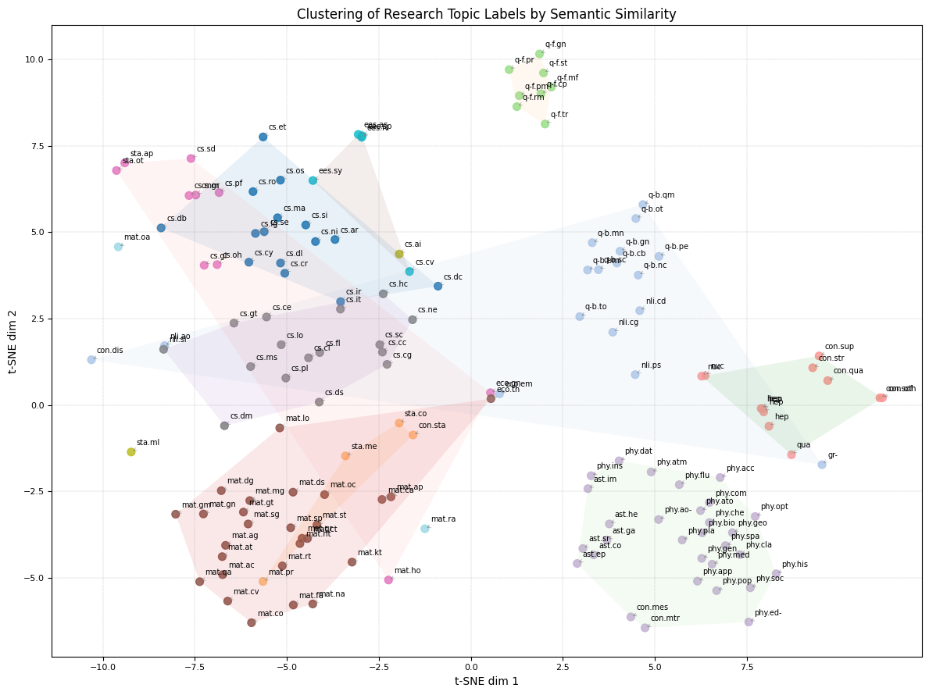
png
Figure 2.1 - Clustering of Research Topic Labels by Semantic Similarity

2.5 Abstract Length Analysis
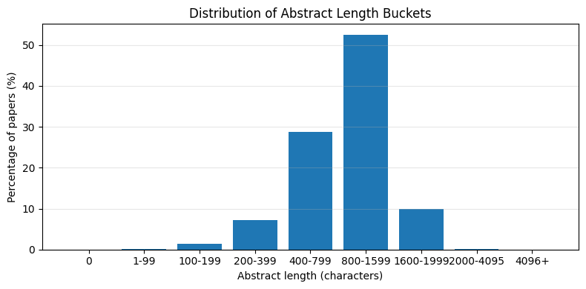
png
Figure 2.2 - Distribution of Abstract Length Buckets

2.5.1 Abstract Length - Informational Richness for NLP
The abstract_char_len statistics confirm that the dataset provides substantial textual content for each paper:
- Median length ≈ 956 characters and mean ≈ 983 characters, with a standard deviation of ≈ 436.
- The central 50% of abstracts lie between 644 (25th percentile) and 1,297 characters (75th percentile).
- Very short abstracts are rare: the 1st percentile is already at 167 characters.
- The maximum length reaches 6,554 characters, but such extremely long abstracts are exceptional.
The bucketed distribution further clarifies the picture:
Table 2.2 - Dataset bucket distribution
Bucket | Share of dataset
400–799 | 28.71%
800–1,599 | 52.52%
1,600–1,999 | 9.89%
< 200 | ~1.61% (combined)
≥ 2,000 | ~0.13%
This indicates that:
- Over 80% of the abstracts fall in the range 400–1,600 characters, which aligns well with typical scientific abstracts (roughly 150–300 words).
- Extremely short abstracts (< 200 characters) are rare and may represent edge cases, such as minimal descriptions, incomplete records, or noisy entries. They can be flagged for potential exclusion or special handling in robustness analyses.
- Very long abstracts (≥ 2,000 characters) are also extremely rare and unlikely to dominate model behavior, though they may slightly increase computational cost.
Overall, the distribution strongly supports the use of abstract as a primary textual feature for downstream NLP and LLM-based classification: the majority of records provide sufficiently detailed, informative text without being excessively long for modern language models.

2.6 Inspect and Clean submission_date

2.6.1 Submission Date – HTML Noise and Normalization
The raw submission_date field shows two distinct formats:
- Clean dates, such as:
3 Feb 2009, 22 Jan 2009, 12 Jan 2009
- Dates with embedded HTML and revision metadata, for example:
18 Feb 2009 (<a href="https://arxiv.org/abs/0902.3253v1">v1</a>), last revised 18 Jun 2009 (this version, v2)
Approximately 37.53% of all records contain HTML anchor tags (<a ...>) inside submission_date, which means the field mixes: - the initial submission date, - version links, - and “last revised” information.
For most modeling tasks, especially classification, we only need a single reference submission date per paper. The submission_date_clean field addresses this by:
- Stripping out any HTML content using a regular expression,
- Keeping only the leading date portion before any parentheses.
Examples confirm that:
- 18 Feb 2009 (<a href=...>...) → 18 Feb 2009
- 30 Jan 2009 (<a href=...>...) → 30 Jan 2009
- Already clean dates (e.g. 3 Feb 2009) remain unchanged.
This normalized string column (submission_date_clean) is now suitable for conversion into a proper datetime type, enabling temporal analyses such as: - yearly submission trends, - time-based stratification, - or temporal drift analysis in subject distribution.

2.7 Datetime Convert and Year Distribution’s Inspection
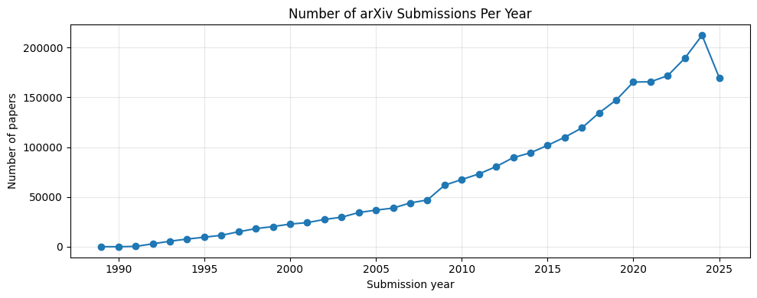
png
Figure 2.3 - Number of arXiv Submissions Per Year

2.7.1 Temporal Coverage - Evolution of Scientific Submissions
After cleaning the submission_date field and converting submission_date_clean into a proper datetime object (submission_datetime), all records were successfully parsed:
- 0 rows failed the date conversion (0.00% NaT).
- The temporal range spans from 1989-11-17 to 2025-09-25, covering more than three decades of scientific activity.
The yearly submission counts reveal a clear long-term growth trend:
- Early years (1989–1992) show very low volume (from 1 to a few thousand papers per year), reflecting the initial stages of arXiv as a preprint server.
- From the mid-1990s onwards, there is a consistent increase in yearly submissions, with steady growth across the 2000s.
- The 2010s mark a strong expansion phase, with counts surpassing 100,000 submissions per year around the mid-decade.
- Recent years exhibit peak activity:
  - 2018–2019 already exceed 130k–140k submissions,
  - 2020–2022 surpass 160k–170k,
  - 2023 reaches 189,381 submissions,
  - 2024 peaks at 212,376 submissions,
  - 2025 (partial year) already accumulates 169,873 submissions up to late September.
This pattern confirms that:
- The dataset is dominated by recent submissions, which is expected given the increasing popularity of arXiv across many disciplines (e.g., machine learning, computer vision, condensed matter, astrophysics).
- Any modeling effort that samples uniformly across the full dataset will naturally emphasize modern scientific language and topics, especially from the last decade.
- If desired, one could:
  - restrict experiments to a specific time window (e.g., 2010 onwards),
  - or explicitly study temporal drift in subject distributions and language usage over time.
From a data understanding perspective, the temporal structure is clean, well-covered, and aligns with the known expansion of arXiv as a central platform for scientific dissemination.

2.7.2 Cumulative Coverage of primary_subject
primary_subject
count
pct
cum_pct
0
Computer Vision and Pattern Recognition (cs.CV)
120122
4.711371
4.711371
1
Quantum Physics (quant-ph)
120051
4.708586
9.419956
2
High Energy Physics - Phenomenology (hep-ph)
116920
4.585783
14.005740
3
Machine Learning (cs.LG)
106484
4.176467
18.182207
4
High Energy Physics - Theory (hep-th)
93277
3.658468
21.840675
5
Mesoscale and Nanoscale Physics (cond-mat.mes-…
66783
2.619333
24.460008
6
Materials Science (cond-mat.mtrl-sci)
66516
2.608860
27.068868
7
Computation and Language (cs.CL)
64648
2.535595
29.604462
8
General Relativity and Quantum Cosmology (gr-qc)
53865
2.112669
31.717131
9
Analysis of PDEs (math.AP)
52332
2.052542
33.769673
10
Astrophysics of Galaxies (astro-ph.GA)
51321
2.012889
35.782562
11
Strongly Correlated Electrons (cond-mat.str-el)
50607
1.984885
37.767447
12
Combinatorics (math.CO)
48341
1.896009
39.663456
13
Solar and Stellar Astrophysics (astro-ph.SR)
46087
1.807603
41.471059
14
High Energy Astrophysical Phenomena (astro-ph.HE)
43216
1.694998
43.166057
15
Cosmology and Nongalactic Astrophysics (astro-…
42755
1.676917
44.842975
16
Statistical Mechanics (cond-mat.stat-mech)
42254
1.657267
46.500242
17
Probability (math.PR)
40643
1.594081
48.094323
18
Algebraic Geometry (math.AG)
38045
1.492184
49.586507
19
Information Theory (cs.IT)
36899
1.447236
51.033743
20
Optimization and Control (math.OC)
34927
1.369891
52.403634
21
Nuclear Theory (nucl-th)
34644
1.358791
53.762425
22
Number Theory (math.NT)
33869
1.328395
55.090819
23
Superconductivity (cond-mat.supr-con)
32925
1.291369
56.382189
24
Numerical Analysis (math.NA)
32553
1.276779
57.658968
25
Robotics (cs.RO)
30602
1.200258
58.859226
26
Differential Geometry (math.DG)
30424
1.193276
60.052502
27
Soft Condensed Matter (cond-mat.soft)
30297
1.188295
61.240797
28
Artificial Intelligence (cs.AI)
27726
1.087457
62.328254
29
Optics (physics.optics)
27648
1.084397
63.412651
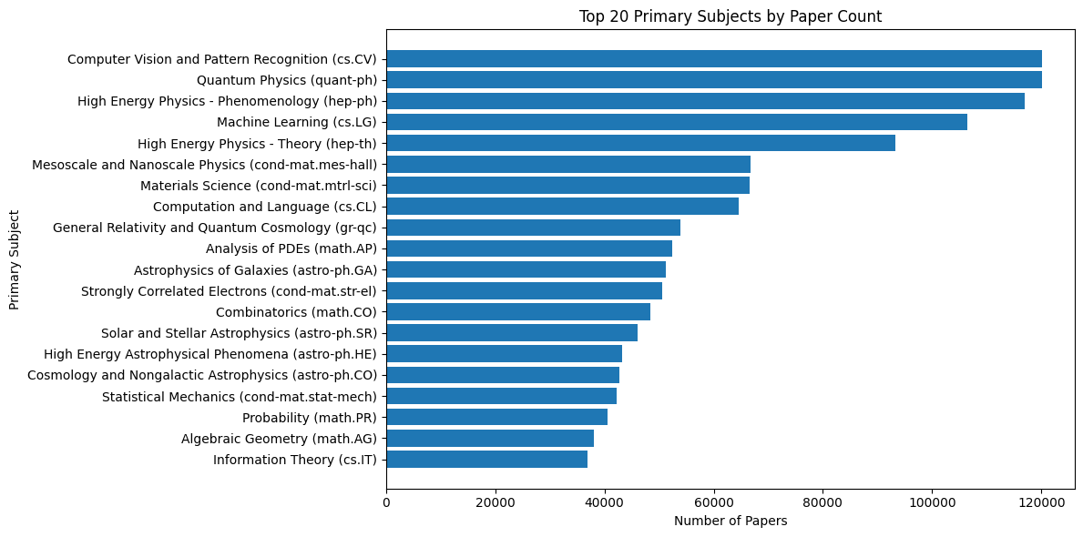
png
Figure 2.4 - Top 10 Primary Subjects by Paper Count

2.7.3 Class Concentration - Top-k Primary Subjects
The analysis of primary_subject frequencies confirms a strongly imbalanced label space. Among the 148 distinct categories, only a small subset concentrates a large proportion of all papers.
From the cumulative distribution:
- The top 10 subjects already cover ≈33.8% of all records.
- The top 20 subjects cover ≈51.0% of the dataset.
- The top 50 subjects cover ≈78.7% of all papers.
The horizontal bar chart of the Top 20 primary subjects highlights this pattern visually: a handful of domains dominate the corpus, notably:
- Computer Vision and Pattern Recognition (cs.CV),
- Quantum Physics (quant-ph),
- High Energy Physics – Phenomenology (hep-ph),
- Machine Learning (cs.LG),
- High Energy Physics – Theory (hep-th),
- Condensed Matter subfields,
- Core mathematics categories (e.g., PDEs, combinatorics, probability),
- Astrophysics subdomains,
- Information Theory and related areas.
This has several implications for downstream modeling:
- The classification problem is multi-class with a long tail: many labels appear rarely and will be hard to model reliably with standard supervised approaches.
- Evaluation using only accuracy would be misleading, since a model could perform well on dominant classes while ignoring minority ones. Metrics such as macro-F1 and per-class analysis are more appropriate.
- For a practical LLM-based case study, it may be beneficial to:
  - restrict the problem to the Top-K most frequent labels (e.g., Top 20 or Top 30), achieving a balance between coverage and tractability, or
  - group fine-grained arXiv categories into a smaller set of broader scientific domains, simplifying both training and interpretation.
This distribution strongly motivates a careful design of the label space before training or evaluating any classification model on this dataset.

2.7.4 Compare primary_subject vs subjects
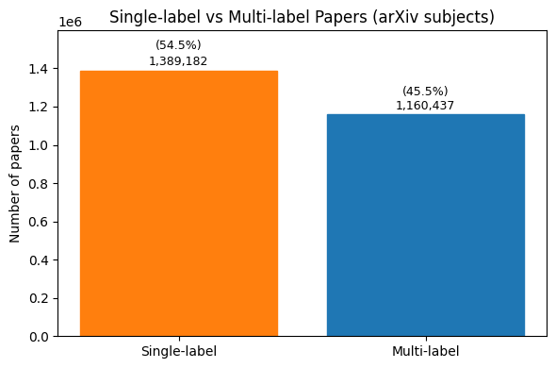
png
Figure 2.5 - Single-Label vs Multi-Label (arXiv Subjects)

2.7.5 Primary Subject vs. Full Subject Tagging
The comparison between primary_subject and subjects reveals that arXiv uses a hybrid labeling scheme:
- In 54.49% of the records, subjects is identical to primary_subject.
→ In these cases, the paper is effectively associated with a single subject label.
- In 45.51% of the records, subjects differs from primary_subject.
→ Here, the article is tagged with multiple subjects, with primary_subject acting as the main category and subjects providing additional cross-disciplinary labels.
Examples where they differ show patterns such as:
- A primary label in Earth and Planetary Astrophysics (astro-ph.EP) combined with secondary tags like:
  - Solar and Stellar Astrophysics (astro-ph.SR),
  - Astrophysics of Galaxies (astro-ph.GA),
  - Geophysics (physics.geo-ph),
  - Biological Physics (physics.bio-ph),
  - Populations and Evolution (q-bio.PE),
  - Instrumentation and Methods for Astrophysics (astro-ph.IM).
This confirms that:
- primary_subject is a single-label categorical target suitable for standard multi-class classification.
- subjects encodes a richer, multi-label structure, which could support more advanced tasks such as:
  - multi-label classification,
  - interdisciplinarity analysis,
  - or recommendation systems based on overlapping subject tags.
- For an initial, well-scoped classification study, it is reasonable to focus on primary_subject as the main label, while keeping subjects as an optional extension for future experiments in multi-label modeling.
Understanding this distinction is crucial to clarifying the target definition and avoiding confusion between single-label and multi-label problem formulations.

2.7.6 Number of Subject Tags per Paper
The num_subject_tags feature quantifies how many subject labels each paper receives in the subjects field.
Key descriptive statistics:
- Mean ≈ 1.65 tags per paper
- Median = 1 tag
- 75th percentile = 2 tags
- Maximum = 11 tags
The discrete distribution shows:
- 1 tag: 1,389,182 papers (54.49%)
- 2 tags: 785,941 papers (30.83%)
- 3 tags: 280,778 papers (11.01%)
- 4 or more tags: 93,718 papers (3.68%)
This confirms that:
- Most papers are single-labelled in practice, with just over half having only one subject tag.
- A substantial fraction (~31%) has two subject tags, reflecting moderate interdisciplinarity.
- Only a small minority of papers has three or more tags, and extreme cases with ≥ 5 tags are rare.
From a modeling perspective, this supports the choice of primary_subject as a single-label target for the core classification task, while subjects can be used later to explore multi-label extensions or to analyze cross-disciplinary patterns in the corpus.
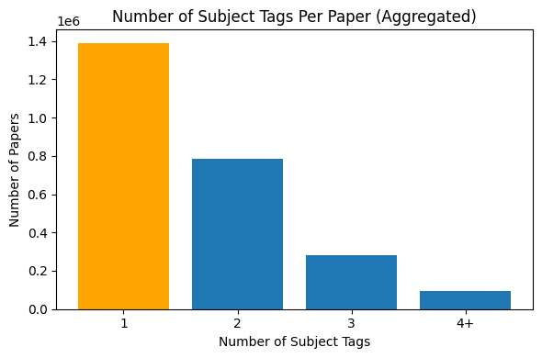
png
Figure 2.6 - Number of Subject Tags Per Paper

2.7.8 Number of Authors Per Paper
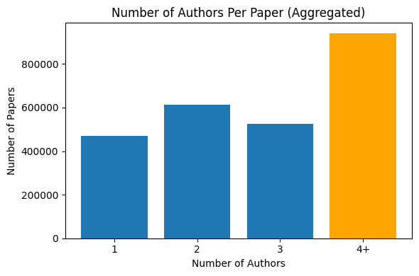
png
Figure 2.7 - Number of Authors Per Paper

2.7.9 Number of Authors per Paper
The num_authors feature captures the size of the author team for each article. The first rows confirm that authors is stored as an array-like object, and the counting function now correctly handles those structures.
Key statistics:
- Mean ≈ 4.71 authors per paper
- Median = 3 authors
- 25th percentile = 2 authors
- 75th percentile = 4 authors
- Maximum = 3,301 authors (extreme large-collaboration papers, typical in high-energy physics and similar fields)
The discrete counts for small team sizes are:
- 1 author: 469,799 papers (18.43%)
- 2 authors: 611,577 papers (23.99%)
- 3 authors: 526,695 papers (20.66%)
- 4 or more authors: 941,545 papers (36.93%)
This indicates that:
- Single-author papers are relatively common but not dominant.
- The majority of the corpus consists of small to medium-sized collaborations (2–4 authors).
- A substantial fraction (~37%) involves larger teams (4+ authors), reflecting big collaborations that are typical in certain scientific domains.
From a modeling perspective, the number of authors is not directly needed for text classification but can be used for: - descriptive statistics about collaboration patterns across subjects, - potential correlation analyses between team size and subject area, - or as an optional metadata feature in extended models.

2.7.10 Sample Titles and Abstracts by primary_subject

2.7.11 Qualitative Look at Titles and Abstracts Across Subjects
The sampled titles and abstracts illustrate clear stylistic and lexical differences across primary_subject categories:
- Computer Vision and Pattern Recognition (cs.CV)
The language is highly technical but application-driven, focusing on concrete tasks such as image inpainting, data efficiency, and text-to-video generation. Abstracts frequently reference:
  - deep learning architectures (CNNs, transformers, diffusion models),
  - practical challenges (data requirements, visual quality, real-time constraints),
  - and benchmark-style evaluation.
- Machine Learning (cs.LG)
Abstracts tend to emphasize:
  - general-purpose learning frameworks (meta-RL, actor-critic, world models),
  - theoretical or algorithmic contributions (off-policy learning, constrained inference),
  - and broad applicability across tasks or hardware platforms. The style is a mix of theoretical and systems-oriented writing, often highlighting scalability and generalization.
- Quantum Physics (quant-ph)
Here the language shifts toward:
  - highly specialized physical concepts (holonomy, exceptional points, spectral gaps, entangled photons),
  - mathematical formalisms (Riemann surfaces, renormalization methods),
  - and experimental setups (Hong–Ou–Mandel interferometers). Abstracts are dense, concept-heavy, and less focused on “datasets” or “benchmarks”, reflecting a more traditional theoretical physics style.
- High Energy Physics – Phenomenology (hep-ph)
Abstracts are strongly domain-specific, referring to:
  - supersymmetric inflation, heavy-quark expansions, beauty hadron lifetimes,
  - particle production cross sections and collider processes. The writing is technical, formula-rich (often including LaTeX notation), and closely aligned with phenomenological modeling and experimental observables.
These qualitative differences support the idea that title and abstract contain enough semantic signal for a model to distinguish between scientific areas. At the same time, they highlight the challenge for any classifier (including LLMs) to handle very heterogeneous writing styles, from application-oriented ML papers to mathematically dense quantum and high-energy physics articles.

2.7.12 Title and Abstract Word Length Analysis
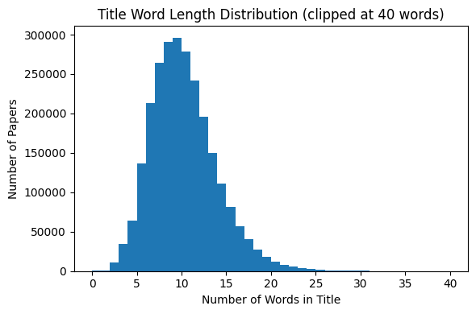
png
Figure 2.8 - Title Word Length Distribution
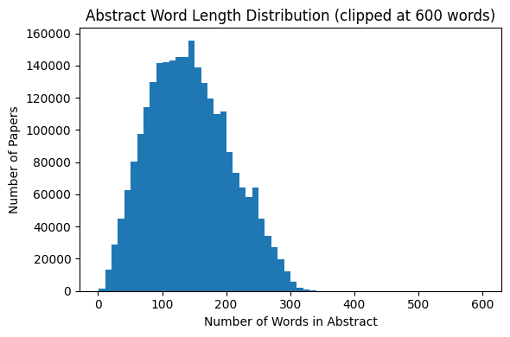
png
Figure 2.9 - Abstract Word Length Distribution
Title Word Length Distribution:
- The distribution is right-skewed, concentrated mainly between 6 and 14 words.
- Median title length = 9 words, mean ≈ 9.79 words.
- Titles longer than 20 words are rare, and extremely short titles (below 3 words) are also uncommon.
- This suggests typical scientific titles in arXiv are concise, descriptive, and optimized for searchability.
Abstract Word Length Distribution:
- Abstracts show a wider spread, centered approximately between 90 and 200 words.
- Median abstract length = 139 words, mean ≈ 143 words.
- Few cases exceed 300+ words, indicating informal adherence to typical journal/conference limits.
- Most abstracts appear sufficiently long to convey motivation, method, and contribution without excessive verbosity.
These characteristics are highly relevant for downstream text modeling, token budgeting, embedding cost estimation, and classification modeling, especially when working with LLMs that have input size constraints.

2.7.13 Plots With Highlighted Peak Frequency Bins
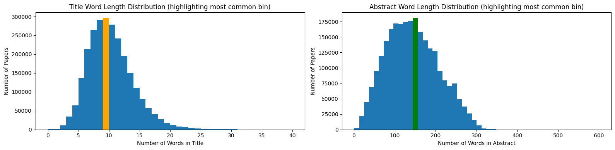
png
Figure 2.10 - Title and Abstract Word Length Distributions

2.7.14 Title and Abstract Word Length Distributions
The first histogram shows the distribution of title length in words, with the most frequent bin highlighted in orange.
Most titles cluster tightly around 9–10 words, confirming that arXiv titles are generally short, dense and highly informative. Very short titles (< 4 words) and very long ones (> 20 words) are rare, which suggests a fairly standardized “style” across scientific fields.
The second histogram shows the abstract length in words, with the most frequent bin highlighted in green.
The peak lies around 140–160 words, and the bulk of abstracts fall roughly between 100 and 200 words. Longer abstracts (> 300 words) are uncommon, and extremely short abstracts are also rare. This indicates that abstracts typically provide a reasonably rich description (motivation, method, results) while still remaining within the usual constraints of scientific publishing.
For the classification task, these distributions imply that:
- Titles provide compact, high-signal context (≈10 tokens), useful as an auxiliary feature.
- Abstracts are consistently long enough to support robust text-based models, but still short enough to fit comfortably within standard LLM context windows.

2.7.15 Top 20 Per-Subject Profile
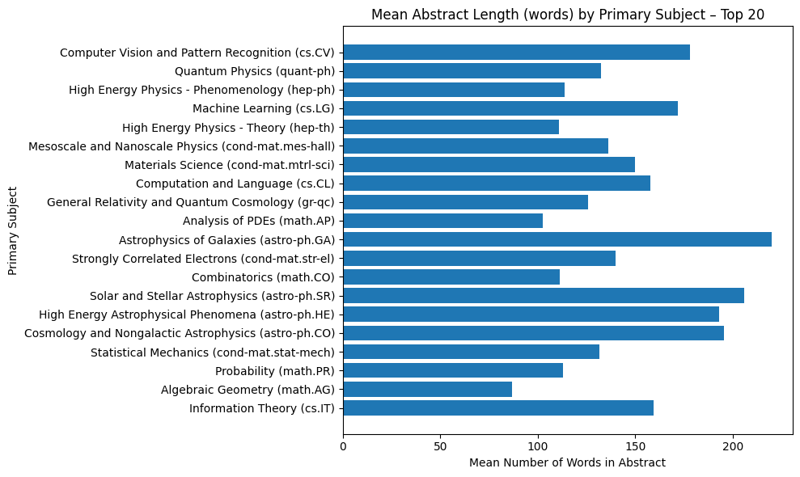
png
Figure 2.11 - Top 20 of Mean Abstract Word Length by Primary Subject

2.7.16 Subject-Level Profile
For the 20 most frequent primary_subject categories, we computed the mean title length, abstract length and number of authors per paper.
Several clear patterns emerge:
- Computer Vision (cs.CV) and Machine Learning (cs.LG)
  - Long abstracts on average (≈178 and ≈172 words).
  - Moderate title length (≈9–10 words).
  - Relatively large author teams (≈4–5 authors per paper).
These fields match the “modern ML paper” style: detailed abstracts and collaborative work.
- Quantum Physics (quant-ph) and High Energy Physics – Theory/Phenomenology (hep-th, hep-ph)
  - Abstracts are shorter than ML/CV on average (≈111–133 words).
  - Titles tend to be slightly shorter as well (≈8–9 words).
  - Teams are smaller (≈2–3 authors per paper).
The writing style is more compact and theoretically oriented, with fewer co-authors.
- Astrophysics and cosmology (astro-ph.GA, astro-ph.SR, astro-ph.HE, astro-ph.CO)
  - Some of the longest abstracts in the dataset (≈194–220 words).
  - Very large collaborations, especially in high-energy astrophysics:
    - Astrophysics of Galaxies (astro-ph.GA): ≈9 authors on average.
    - High Energy Astrophysical Phenomena (astro-ph.HE): ≈14 authors on average.
These categories show the typical pattern of big observational projects and survey papers.
- Pure mathematics (math.AG, math.AP, math.CO, math.PR)
  - Shorter abstracts on average (≈87–112 words).
  - Short to medium titles (≈8–11 words).
  - Small teams (≈2 authors, often single-author papers).
This reflects the more individual and concise style of mathematical research articles.
Overall, the subject-level profiles confirm that different scientific communities have distinct textual and collaboration patterns, which reinforces the feasibility of using titles and abstracts as inputs to classify papers into primary_subject categories.

2.7.17 Mean Abstract Length by Primary Subject
The chart presents the average number of words in abstracts across the Top 20 most frequent primary_subject categories. Several important patterns emerge:

1) Clear subject-driven variation in abstract size
Research areas differ substantially in how much textual context is typically needed to describe contributions. Some domains systematically produce longer abstracts, notably:
Table 2.3 - Mean Abstract Length by Primary Subject (Long Abstracts)
Subject Area (Examples) | Approx. Mean Words | Interpretation
Astrophysics of Galaxies (astro-ph.GA) | ~220 | Complex physical systems often require extensive contextualization.
Solar & Stellar Astrophysics (astro-ph.SR) | ~205 | Descriptive and observational content tends to require longer explanations.
High Energy Astrophysical Phenomena (astro-ph.HE) | ~195 | Phenomena involve multi-scale theories and many experimental constraints.
Cosmology & Nongalactic Astrophysics (astro-ph.CO) | ~195 | Typically strong theoretical foundations + empirical discussion.

2) More concise abstracts in mathematical and theoretical fields
Domains with more formal/derivational contributions tend to exhibit shorter abstracts:
Table 2.4 - Mean Abstract Length by Primary Subject (Short Abstracts)
Subject Area | Approx. Mean Words
Algebraic Geometry (math.AG) | ~87
Analysis of PDEs (math.AP) | ~102
Probability (math.PR) | ~113
Combinatorics (math.CO) | ~111
This aligns with writing norms where contributions are often stated more formally and compactly.

3) Computer Science & Machine Learning in the middle range
Table 2.5 - Mean Abstract Length by Primary Subject (Computer Science & Machine Learning)
Subject | Mean Words | Implication
Computer Vision (cs.CV) | ~178 | Heavily experimental, often describing pipeline + datasets + metrics.
Machine Learning (cs.LG) | ~172 | Increasingly standardized abstract structure (problem → method → results).
Computation & Language (cs.CL) | ~158 | NLP abstracts remain relatively dense due to task/method/result summaries.

4) Implications for downstream classification
These differences matter for modeling:
- Domains with long abstracts give richer semantic signals → beneficial for transformer-based classifiers.
- Shorter, theory-driven fields may require stronger title features or citation/metadata augmentation.
- Subject-aware text normalization (e.g., truncation vs. summarization) should consider this length variance.
Key Takeaway
Abstract length is not random noise - it is a domain-dependent linguistic property that can support feature engineering and model design for scientific document classification.

2.8 Inspect Text Artifacts in Abstracts

2.8.1 Text Artefacts in Abstracts
A targeted scan of the abstract field shows that a non-negligible fraction of records contains markup or mathematical notation:
- HTML tags (e.g. <br>, <a href=...>): present in ≈ 8.7% of abstracts.
- HTML entities (e.g. &amp;, &lt;, &#39;): present in ≈ 7.1% of abstracts.
- Inline LaTeX math using dollar signs ($...$): present in ≈ 28.8% of abstracts.
- Alternative LaTeX math syntaxes (\(...\) or \begin{equation}...\end{equation}): rare but present in a small minority (≈ 0.04%).
Qualitative examples confirm that: - HTML tags and entities mostly appear in legacy or scraped metadata (e.g. line breaks, links to the original arXiv page, encoded apostrophes). - LaTeX expressions encode mathematical formulas and symbols which are important scientifically, but often add noise for high-level subject classification and can confuse tokenization.
For the downstream classification task, this motivates a preprocessing strategy that: 1. Removes HTML tags and decodes HTML entities into normal characters;
2. Replaces LaTeX math fragments by a neutral placeholder token (e.g. [MATH]), preserving the information that “some math is here” without keeping the raw syntax;
3. Normalizes spacing to produce clean, model-friendly input text.

2.9 Impact of Cleaned Text Fields for Title and Abstract

2.9.1 Remarks on Original vs. Cleaned Text Fields
A comparison between the original and cleaned versions of title and abstract shows that the cleaning process successfully removes markup noise such as HTML entities (&amp;) and normalizes text without altering its scientific meaning. Although this normalization step belongs formally to the Data Preparation stage, its inspection at this point is relevant to Data Understanding because it highlights important characteristics of the corpus:
- A non-negligible portion of abstracts contains HTML artifacts and LaTeX fragments.
- These elements do not contribute semantic value for classification tasks and may negatively affect tokenization and language modeling.
- Cleaning ensures that downstream NLP models (e.g., TF-IDF, SciBERT, Longformer) receive more consistent and less sparse representations.
Therefore, while no transformation is applied globally at this stage, the preliminary review confirms that text normalization will likely improve vocabulary coherence, reduce feature sparsity, and contribute to a more stable modeling phase.

2.10 Linguistic Patterns in Abstracts
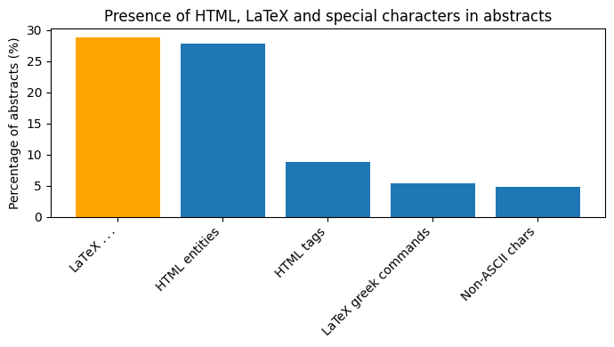
png
Figure 2.12 - Presence of HTML, LaTeX and Special Characters in Abstracts

2.10.1 Linguistic Artefacts in Abstracts
The inspection of linguistic patterns in the abstract field shows that non-trivial markup and mathematical notation are very common:
- LaTeX $...$ math syntax appears in about 28.8% of all abstracts.
- HTML entities (e.g. &amp;, &#39;) appear in about 27.8% of abstracts.
- HTML tags (e.g. <br>, <a href=...>) occur in about 8.7% of abstracts.
- LaTeX Greek commands such as \alpha, \beta, \lambda appear in roughly 5.4% of cases.
- Non-ASCII characters (accents, special symbols) are present in around 4.9% of abstracts.
The bar chart highlights LaTeX math as the most frequent artefact, followed closely by HTML entities. Example abstracts confirm that these elements encode either:
- Scientific notation (mathematical formulas in LaTeX), or
- Formatting noise introduced during scraping (HTML tags and encoded punctuation).
From a data understanding perspective, this indicates that the corpus is:
- Mathematically dense, especially in physics and mathematics papers, and
- Technically noisy from an NLP standpoint, due to HTML/encoding artefacts.
For the later modeling phase, this motivates: - Dedicated text-cleaning (removal/normalization of HTML and entities) - Possibly special handling or masking of LaTeX to avoid fragmenting the vocabulary and harming tokenization.

2.11 Main Scientific Domains in primary_subject
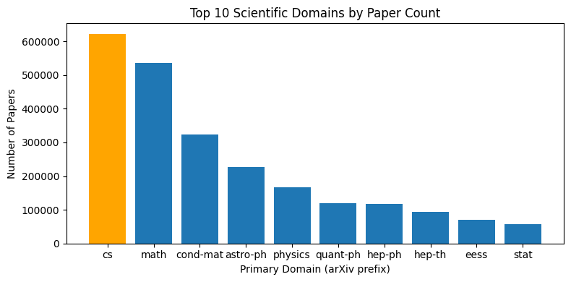
png
Figure 2.13 - Top 10 Scientific Domains by Paper Count

2.11.1 Distribution of Main Scientific Domains
By extracting the arXiv prefix from primary_subject (e.g. cs.CV → cs, astro-ph.GA → astro-ph) we obtain a high-level view of the scientific domains represented in the dataset.
The distribution is clearly dominated by a few large areas:
- Computer Science (cs): 622,419 papers (24.4% of the corpus)
- Mathematics (math): 535,240 papers (21.0%)
- Condensed Matter Physics (cond-mat): 322,843 papers (12.7%)
- Astrophysics (astro-ph): 227,757 papers (8.9%)
- General Physics (physics): 166,441 papers (6.5%)
Smaller but still substantial contributions come from Quantum Physics (quant-ph), High Energy Physics (hep-ph, hep-th), Electrical Engineering and Systems Science (eess), and Statistics (stat), among others.
The bar chart for the Top 10 domains highlights cs as the largest block, followed closely by math. This confirms that the dataset is heavily skewed towards computer science and mathematics, with strong representation of physics-related fields. For downstream modeling, this implies that:
- Any classifier trained on the full corpus will naturally see many more examples from cs and math than from smaller domains such as econ or q-fin.
- It is important to keep this domain imbalance in mind when designing both label sets and evaluation strategies, especially if the goal is to build models that generalize beyond the dominant areas.

2.12 Top Unigrams and Bigrams in Abstracts
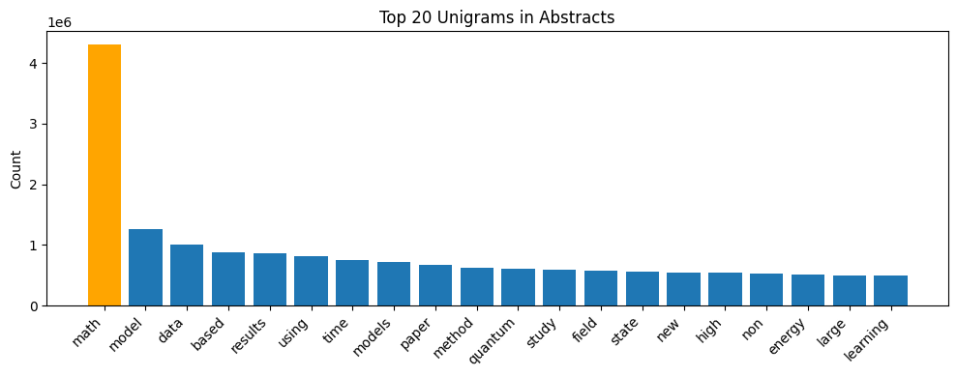
png
Figure 2.14 - Top 20 Unigrams in Abstracts
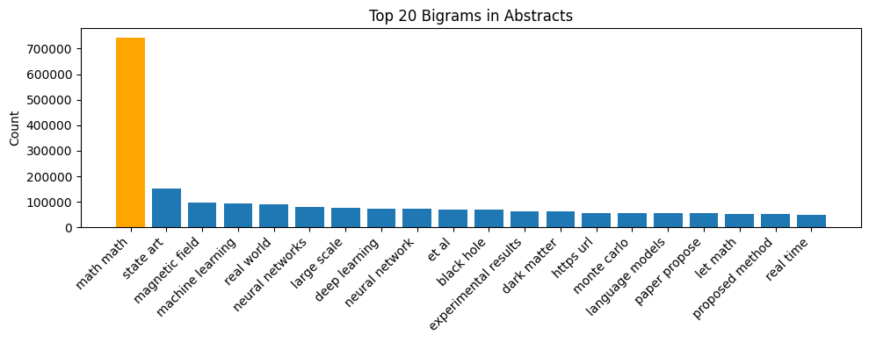
png
Figure 2.15 - Top 20 Bigrams in Abstracts

2.12.1 Dominant Vocabulary in Abstracts
Using a bag-of-words CountVectorizer (English stopwords removed, min_df = 5), the most frequent single words in the cleaned abstracts are:
- math (≈ 4.3M occurrences) – by far the most frequent token in the corpus.
- model, models, method, methods, data, results, using, study, field, theory, performance, etc.
This list reflects a mixture of:
- Generic scientific terminology: model, data, results, using, study, field, method(s), systems, problem, present.
- Domain-specific keywords that are common across several areas: quantum, energy, space.
- “Meta-words” like math, which appear extremely often because arXiv injects the word math into some metadata/structural context when scraping TeX sources.
From a modeling perspective, these findings confirm that:
- The corpus exhibits a strong scientific register, dominated by words that describe methods, models and results rather than informal language.
- High-frequency terms such as math or very generic methodological words may carry limited discriminative power for subject classification and might be down-weighted (e.g., via TF-IDF) or even removed if necessary.
- More specific terms and n-grams (e.g. bigrams like machine learning, neural network, quantum field) are likely to provide richer signal for distinguishing between domains such as cs.LG, cs.CV, quant-ph, hep-th, etc.

2.13 Heuristic Detection of Truncated Abstracts

2.13.1 Potentially Truncated Abstracts
To assess the textual quality of the corpus, we applied a simple heuristic to detect potentially truncated or incomplete abstracts. An abstract was flagged as “suspicious” if it either:
- explicitly ended with an ellipsis "...", or
- was relatively long (more than 600 characters) but did not end with a final punctuation mark (., ?, !).
The results are:
- Total abstracts: 2,549,619
- Suspicious abstracts (union of both conditions): 36,828 (≈ 1.44%)
- Ending with "...": 1,016 (≈ 0.04%)
- Long and without final punctuation: 35,812 (≈ 1.40%)
Manual inspection of sample cases shows that many of these flagged abstracts look like they were cut mid-sentence, often around the point where LaTeX, HTML or special characters appear (e.g., line breaks, quotes, references to instruments or telescopes). In such cases the scientific content is partially preserved but the narrative is incomplete.
From a data understanding perspective, this suggests that:
- The vast majority of abstracts are intact; potential truncation affects only a small minority (~1–1.5%) of the corpus.
- Truncated abstracts may still carry enough information for high-level subject classification, but they can introduce some noise and slightly distort length statistics.
- During the later Data Preparation phase, we may choose either to:
  - keep these records (accepting a small amount of noise), or
  - apply additional filtering / quality flags if the modeling task requires very clean text.
Overall, the dataset appears to be high-quality and largely complete, with only a limited fraction of abstracts showing signs of truncation.

2.14 Unigram Word Cloud From Cleaned Abstracts
The unigram word cloud provides a visual summary of the most frequent individual words in the abstracts. The largest tokens are MATH, model, show, paper, using, results, system, method, propose, study, among others. This picture is consistent with the quantitative unigram counts:
- It confirms a strong methodological and result-oriented vocabulary (e.g., model, method, results, algorithm, show, demonstrate).
- The extremely prominent MATH token reflects arXiv’s TeX-based origin and the strong mathematical orientation of the corpus.
- Content words such as system, solution, problem, data, structure, network highlight the prevalence of computational and physical sciences.
Overall, the unigram cloud reinforces that the dataset is dominated by formal scientific language, dominated by generic research verbs (“show”, “propose”, “present”) and methodology-related nouns (“model”, “method”, “results”).
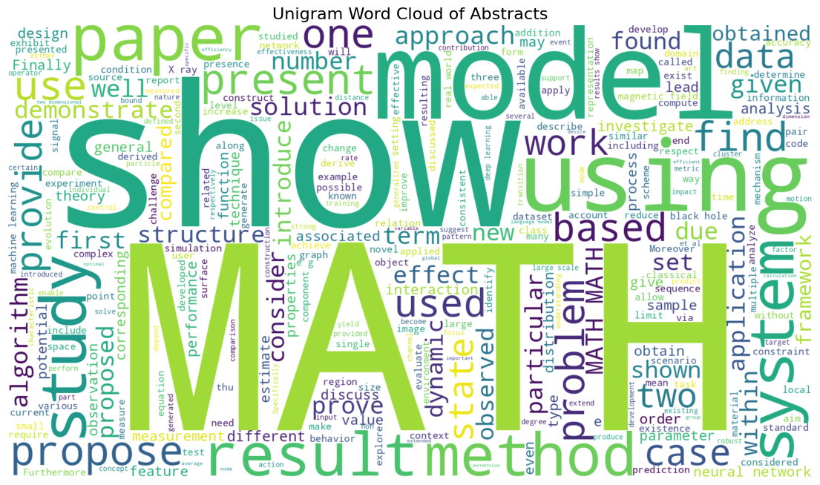
png
Figure 2.16 - Unigram Word Cloud of Abstracts

2.15 Bigram Word Cloud From Cleaned Abstracts
The bigram word cloud provides a more semantic view of the corpus by focusing on frequent word pairs instead of isolated tokens. Several patterns stand out:
- Machine learning & AI: phrases such as machine learning, neural networks, deep learning, large language, language models, reinforcement learning, time series highlight the strong presence of modern AI research.
- Astrophysics & cosmology: bigrams like black hole, black holes, dark matter, star formation capture the astrophysical component of the corpus.
- Condensed matter & physics: expressions such as magnetic field, phase transition, ground state, standard model, monte carlo, cross section are characteristic of condensed matter and high-energy physics papers.
- Generic scientific phrasing: bigrams like experimental results, proposed method, state art, real world, large scale reflect standard ways of framing contributions in scientific writing.
- Artefacts: tokens such as math math, https url, et al appear due to TeX/metadata conventions and scraping artefacts, reinforcing the need for light cleaning or down-weighting of such pairs during modeling.
Compared to the unigram cloud, the bigram cloud surfaces more domain-specific concepts (e.g., black hole vs. black / hole separately), confirming that n-gram features capture richer semantic information that can be useful for downstream subject classification and for interpreting what an NLP model might learn from the abstracts.
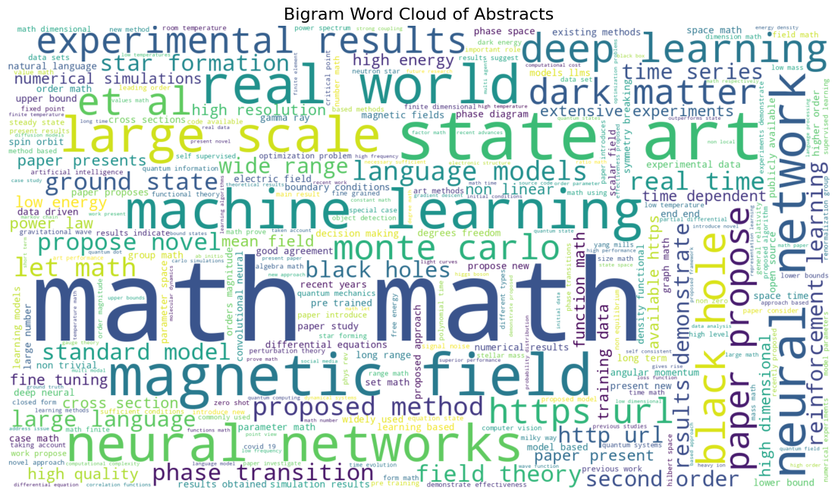
png
Figure 2.17 - Bigram Word Cloud of Abstracts

2.16 Data Understanding Summary
The exploratory analysis of ~2.55M arXiv papers revealed clear structural and linguistic patterns that will directly influence the modeling stage:

Document structure
- Most titles contain 8–12 words, and most abstracts fall in the 100–200 word range, aligning with academic writing norms.
- A small but relevant portion of abstracts (~1.4%) appears truncated or incomplete, indicating potential data quality issues that may require filtering or repair.

Presence of LaTeX, HTML, and special characters
- A significant fraction of abstracts contains scientific markup:
  - LaTeX inline math ($...$): ~28.8%
  - HTML entities (e.g., &amp;): ~27.8%
  - HTML tags: ~8.7%
  - LaTeX Greek and other commands: ~5%
- This confirms the scientific nature of the corpus and suggests benefits from dedicated cleaning steps for downstream NLP tasks.

Scientific domains
- The dataset spans all major arXiv research areas, with the largest domains being:
  - cs (24.4%)
  - math (21.0%)
  - cond-mat (12.7%)
  - astro-ph (8.9%)
- This distribution is imbalanced and may require class grouping or stratified sampling depending on the modeling objective.

Vocabulary and linguistic patterns
- Frequent unigrams and bigrams highlight dominant themes across scientific fields:
  - Core concepts: model, data, results, method, using
  - AI/ML signals: machine learning, neural networks, deep learning, language models
  - Physics/astro signals: black hole(s), dark matter, magnetic field, monte carlo
- Word clouds confirmed strong semantic clustering consistent with major arXiv communities.

Key implications for Data Preparation
Based on these findings, the following actions are recommended in the next stage:
Table 2.6 - Implications of Structural and Linguistic Patterns
Requirement / Need | Reason
Remove/normalize LaTeX, HTML, Greek symbols, and entities | Improve tokenization and semantic modeling
Handle truncated/low-quality abstracts | Reduce noise and potential misleading training examples
Consider domain balancing or class aggregation | Mitigate classification bias toward dominant areas
Decide between unigram vs n-gram or contextual embeddings | Vocabulary indicates value in capturing multi-word expressions
This understanding provides a solid foundation before proceeding to data cleaning, feature engineering, and modeling.

3. Data Preparation

3.1 Context
Unlike traditional methods (like TF-IDF or Word2Vec) which require aggressive cleaning to reduce vocabulary size, encoder architectures generally perform best with minimal intervention on the raw text.
- Stemming and Lemmatization: Encoder models often use Byte-Pair Encoding (BPE) for tokenization, which breaks words into sub-word units (e.g., ‘running’ might become ‘run’ and ‘##ing’). This sub-word tokenization implicitly handles morphological variations, automatically grouping inflections of the same root word. Forcing stemming or lemmatization before tokenization can inadvertently remove necessary linguistic information, often leading to reduced performance.
- Stop Word Management: It is generally not necessary to remove high-frequency words (stopwords). Transformer models, which are built on the attention principle, automatically learn to focus only on the words that impact the classification output, effectively downweighting common words. Removing stopwords can be problematic in cases like sentiment analysis where the absence of words like “not” or “too” changes the context.
- Case Handling: Case normalization (lowercasing) is typically managed by selecting the appropriate pre-trained model. If you choose an uncased model (e.g., bert-base-uncased), the model will internally convert all input text to lowercase. If you choose a cased model (e.g., bert-base-cased), capitalization is preserved, which can be important for tasks where proper nouns are critical. You do not need to manually perform case folding.

3.2 Data Loading

3.3 Data Preprocessing
This code filters the dataset to retain only the primary subjects with a sufficient number of samples. It first counts how many papers belong to each primary_subject, then identifies the subjects that have at least 20,000 examples. Finally, it filters the dataset to include only papers whose primary subject is in this set of frequent labels. This ensures the resulting dataset is focused on well-represented categories, reducing class imbalance and providing enough data for meaningful analysis or model training.
This code processes a dataset of abstracts by tokenizing each text using the Longformer tokenizer, collecting the lengths of the resulting token sequences, and analyzing their distribution. It computes key statistics such as the median, average, minimum, and maximum token lengths, while also visualizing the distribution with a histogram to identify patterns like long or short documents. This helps ensure the dataset is well-understood and suitable for model training, highlighting sequences that may be too short to provide meaningful context or too long to handle efficiently.
The code filters the dataset to keep only tokenized texts whose lengths are between MIN_LEN and MAX_LEN tokens. This ensures that very short texts (too little context) and very long texts (memory-heavy) are removed, making the dataset more consistent and efficient for model training.
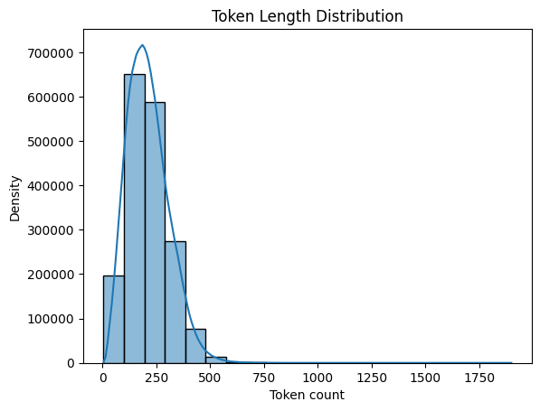
png
Figure 3.1 - Token Length Distribution

3.4 Prepare Data

3.5 Dataset With Augmentation

4. Modeling

4.1 Introduction
The development of SCIBERT, a pretrained language model based on BERT, was primarily motivated by the challenges of obtaining high-quality, large-scale annotated data for NLP tasks in scientific domains. Since prior language models like BERT and ELMO were trained on general domain corpora such as Wikipedia and news articles, they were less effective at capturing the unique vocabulary and structure of scientific text. SCIBERT was created to address this gap by leveraging unsupervised pretraining on a large multi-domain corpus of scientific publications, aiming to transfer knowledge embedded in the literature to improve performance on a suite of downstream scientific NLP tasks.
SCIBERT is highly suitable for fine-tuning a model to classify papers, including those from Arxiv, based on their abstracts. The model was trained on a corpus of 1.14 million papers, with a substantial portion (18%) originating from the computer science domain, which is a primary focus of the Arxiv repository. The model’s superior performance was demonstrated across several relevant tasks, including Named Entity Recognition (NER) from computer science abstracts (SciERC) and various text classification tasks. Specifically, SCIBERT achieved new State-of-the-Art (SOTA) results on classification tasks like ACL-ARC and SciCite, which involve analyzing citation intent and text in scientific publications. These results indicate that the model’s domain-specific pretraining successfully captures the necessary linguistic features in scientific discourse for high-accuracy classification.
SCIBERT is fundamentally an application of the Transformer architecture, placing it directly within the family of Large Language Models (LLMs). The model uses the exact same core multilayer bidirectional Transformer architecture as its predecessor, BERT. Therefore, SCIBERT can be characterized as a domain-adapted LLM, maintaining the structural configuration and pretraining objectives (masked token prediction and next sentence prediction) of the original BERT-Base model. Its key innovation as an LLM is its specialization: retraining the architecture on a massive scientific corpus and using an in-domain vocabulary, SCIVOCAB, which proved essential for its improved performance across scientific tasks.

4.2 SciBERT’s Architecture
Transformer-Based:
- Built on BERT (Bidirectional Encoder Representations from Transformers)
- Uses the transformer architecture from the Attention is All You Need paper
It has the key components:
- Multi-head self-attention mechanisms
- Position embeddings
- Layer normalization
- Feed-forward networks
Model Size:
- 110M parameters (BERT-base size)
- 12 transformer layers
- 768 hidden dimensions
- 12 attention heads

4.3 Model Configuration

4.6 Loss Functions

4.7 Model Architecture

4.8. Initialize Model and Training Components

4.9 Model Training

4.9.1 Training History
Figure 4.1 - Training and Validation - Loss and Accuracy

5. Evaluation

5.1 Final Evaluation and Analysis

5.2 Classification Report

5.3 Confidence Analysis
Figure 5.1 - Accuracy by Confidence Level

5.4 Confusion Matrices
Figure 5.2 - Top/Bottom 20 Categories by F1-Score

6. Deployment

6.1 Deployment Strategy

6.2. Inference Example

7. Conclusions

7.1 Problem Statement and Objectives
The project aimed to develop and assess an automatic classifier for arXiv papers, utilizing only the metadata available at the time of submission: the title and abstract. The concrete task was to predict the arXiv primary subject among 148 possible categories, covering all major scientific domains (computer science, mathematics, physics, statistics, quantitative finance, etc.).
The business motivation was two-fold:
- Reduce the manual effort and inconsistency involved in assigning subjects to new submissions.
- Provide a principled way to prioritize human review by surfacing high-confidence predictions and flagging low-confidence or ambiguous cases.
Although the broader vision is genuinely multi-label (papers often belong to several fields), the implementation in this case study focuses on predicting a single primary subject per paper, while still analyzing performance hierarchically at the coarser “domain” level and via top-k and confidence-based views. This reflects a realistic first production step: getting the main label right and understanding when we can trust the model.

7.2 Data Understanding and Preparation
The work begins from the full arXiv “train.parquet” file, with around 2.55M papers. The exploration analysis revealed several important properties that directly shaped the modeling choices.
Document structure and length. Titles are typically short (around 8-12 words), while abstracts cluster around 100-200 words. Only a small fraction of abstracts (~1.4%) show signs of truncation. This supports the decision to rely primarily on title + abstract as the text signal: they are short enough for efficient transformer processing, but long enough to encode meaningful subject information.
Scientific markup and noise. A substantial proportion of abstracts contain LaTeX and HTML artefacts: inline math, environments, HTML tags, entities such as “&amp;”, and Greek commands. These elements are essential for human readers but tend to fragment the tokenization and add noise for a pretrained encoder. This led to a light-weight cleaning strategy in the Data Preparation phase:
- Decode HTML entities.
- Strip raw HTML tags.
- Replace LaTeX math segments with a neutral placeholder [MATH].
- Normalize whitespace.
Importantly, no stemming, lemmatization or stop words removal is applied. The exploratory work and the literature review emphasize that transformer models like BERT and SciBERT expect natural text and are already robust to function words and morphology; aggressive normalization would risk a distribution shift relative to pretraining.
Label distribution and multi-label nature. The subject distribution is highly imbalanced at the corpus level: domains such as cs, math and cond-mat dominate, while many fine-grained labels are rare. In addition, the comparison between “primary_subject” and the multi-valued subjects field shows that only about half the papers are strictly “single label”; roughly 45% mention additional subjects beyond the primary one.
This confirms that the ground truth primary subject is only one facet of a richer multi-label reality, and that any single-label classifier is solving a deliberately simplified but still useful problem.
To make the modeling tractable while preserving diversity, the training dataset is restricted and balanced as follows:
- Only categories with at least 100 papers are kept.
- Per category, a maximum of 1,000 samples is drawn (stratified).
- This yields 148 categories, each with enough examples for meaningful training, and removes the extremely long tail of ultra-rare subjects. The resulting balanced dataset is then stratified into train, validation and test sets (≈70/15/15), preserving label distribution across splits.
Text construction. For each paper, a single input string is built:
text = [TITLE] [SEP] [ABSTRACT]
In the best model, the configuration uses USE_TITLE = True and USE_CLEAN_TEXT = True, so the model sees both fields, lightly normalized, separated by an explicit marker.

7.3. Modeling Choices and Architecture
The core model is based on SciBERT (“scibert_scivocab_uncased”), a domain-adapted BERT variant pretrained on a large corpus of scientific articles. This choice is aligned with the task: SciBERT’s vocabulary and representations are tuned to the style and terminology of scientific writing, unlike generic BERT models.
On top of SciBERT, the project implements an enhanced classification head:
- Obtain either the pooler output or the [CLS] token
- Apply LayerNorm, a fully connected projection, GELU activation and dropout.
- Feed into a final linear layer that outputs logits over 148 classes.
This head is simple enough to train reliably, but expressive enough to re-shape SciBERT’s embeddings for the specific classification task.
Several optimization techniques are integrated:
- Class weights computed from the training distribution are applied to rebalance the loss, preventing frequent categories from dominating.
- Focal loss with label smoothing. The loss function combines focal scaling with smoothed targets. Focal loss (γ = 2) down-weights easy, already-correct examples and emphasizes hard cases. Label smoothing (α = 0.1) prevents the model from becoming over-confident, by distributing a small portion of probability mass away from the true class across the remaining 147 labels. Together, these mechanisms aim to improve generalization and calibration, especially on rare or ambiguous subjects.
- Mix-up augmentation. From epoch 3 onwards, mix-up is applied at the embedding level: pairs of examples are linearly interpolated, and the loss is computed against the corresponding convex combination of labels. This creates intermediate “virtual” samples between classes and encourages the classifier to behave more smoothly in representation space.
- Differential learning rates. The SCIBERT backbone is updated with a conservative learning rate (2e-5), while the classification head learns at 10 times that rate, allowing the new layers to adapt quickly without destabilizing the pretrained encoder.
- Learning-rate scheduling and early stopping. A linear warm-up schedule with 500 warm-up steps and early stopping with patience 6 prevents over-training. Although the configuration allows up to 40 epochs, training in practice stops after 12 epochs when validation accuracy ceases to improve.
The net effect is a model architecture that stays close to well-tested BERT fine-tuning practices, but with targeted improvements to handle label imbalance, over-confidence and the large number of classes.

7.4 Quantitative Results

7.4.1 Overall and Baseline Comparison
On the held-out test set, the best model achieves:
- Overall accuracy: 59.78%.
- High-confidence accuracy (for predictions above the 0.7 threshold): 71.87%.
- High-confidence coverage: 64.52% of test predictions.
Relative to a previously established baseline of roughly 24% accuracy on the same 148-way task, this corresponds to an improvement of about 2.5× in accuracy. This is a large gain, especially considering the difficulty of the problem and the modest per-class sample sizes after balancing.
Training curves show the expected pattern: training accuracy rises steadily beyond 95%, while validation accuracy plateaus around 60%. This indicates some overfitting, which is not surprising given the relatively small balanced dataset and the model capacity. However, early stopping, dropout, label smoothing and mix-up, keep the validation accuracy stable and prevent catastrophic overfitting.

7.4.2 Hierarchical Performance: Domains vs Fine Subjects
Because arXiv subjects have a natural hierarchy, the evaluation explicitly separates coarse domain performance from fine-grained category performance.
- At domain level (e.g., cs, math, astro-ph), the model reaches 82.91% accuracy on the test set.
- At fine subject level (148 categories), the accuracy is the global 59.78% quoted above.
The hierarchical breakdown is particularly informative:
- In 59.78% of test cases, the model correctly predicts the fine subject.
- In an additional 23.12% of cases, the fine subject is wrong, but the coarse domain is still correct.
- Only 17.09% of test examples are assigned to an incorrect domain.
Taken together, this means that in around 82-83% of cases, the model correctly identifies the broad research area of the paper, and in roughly 60% of cases it also gets the exact arXiv subcategory right.
From a business perspective, this is valuable even when the fine label is occasionally off: for routing, triage, and search indexing, knowing that a paper belongs to “computer science machine learning” rather than “condensed matter physics” is often the most critical decision.

7.4.3 Per-Category Behavior and Production Readiness
The per-class classification report confirms that performance is highly uneven across the 148 categories, which is expected given the diversity of topics and varying degrees of linguistic distinctiveness.
- The best subjects, such as High Energy Physics – Lattice (hep-lat), Earth and Planetary Astrophysics (astro-ph.EP), Accelerator Physics (physics.acc-ph) and Superconductivity (cond-mat.supr-con), achieve F1-scores in the 0.80-0.88 range with balanced precision and recall.
- A total of 30 categories surpass an F1-score of 0.70, many of them aligned with clear, well-defined scientific communities (e.g., cs.DL, cs.IR, math.OA, econ.EM).
- In contrast, a long tail of subjects which is often broad, interdisciplinary or under-represented, shows much lower F1-scores, sometimes below 0.3. These classes remain challenging. To connect model performance to practical deployment, the notebook defines “production-ready” categories as those with F1 ≥ 0.75 on the test set and reports how many test samples fall within that subset. This yields a concise summary:
- A non-trivial number of categories satisfy a strict F1 threshold.
- These categories cover a substantial fraction of the test samples.
- They form a natural candidate set for early limited deployment, while other categories continue to be monitored or require further work.
The confusion-matrix heatmaps for the top and bottom categories make the error patterns visible: among the best classes, almost all mass sits on the diagonal with only minor leakage into conceptually neighboring labels; among the weakest, confusions are more diffuse and often involve semantically close subjects (e.g., different flavors of “applications” or “other statistics”).

7.4.4 Confidence Calibration
Beyond raw accuracy, the project explicitly examines how predictive confidence correlates with correctness. The test predictions are bucketed into confidence intervals:
<50%, 50-60%, 60-70%, 70-80%, 80-90% and 90-100%.
The empirical accuracy is computed in each bin. The results show a monotonic pattern:
- At confidences below 50%, accuracy is roughly 30%.
- In the 70–80% bin, accuracy climbs to about 56%.
- In the 90–100% bin, accuracy reaches about 80%.
This confirms that the model’s probabilities are reasonably calibrated: higher scores genuinely correspond to more reliable predictions. Combined with the high-confidence accuracy of ~72% at ~65% coverage, this yields a useful operating point:
- Accept predictions automatically above a given confidence threshold (e.g. 0.8-0.9).
- Send low-confidence cases to a human reviewer or a more expensive second-stage model.
This kind of confidence-aware workflow is precisely what the initial business framing envisioned.

7.5 Impact of Design Choices
Taken together, the experimental results illustrate the practical impact of the main design decisions:
- Domain-specific encoder (SciBERT). Using SciBERT rather than a generic BERT is consistent with the strong performance on physics, mathematics and computer science categories, even though the balanced dataset is relatively small. The encoder brings a great deal of prior knowledge about scientific language.
- Light text cleaning. The cleaning step removes HTML/LaTeX artefacts and normalizes whitespace while preserving the linguistic content. The model can focus on scientific phrases instead of token fragments like <, br, or half-parsed TeX commands. This is a low-risk, high-reward transformation.
- Balanced sampling and class weights. By enforcing minimum and maximum samples per category, the model avoids being dominated by the largest labels and learns meaningful decision boundaries for smaller but still frequent categories. The residual imbalance is compensated with class-weight loss.
- Focal loss with label smoothing. This combination explicitly targets two pain points of multi-class classification at scale: the dominance of easy negatives and the risk of over-confident Softmax outputs. The stable validation accuracy and the confidence/accuracy curves suggest that this design contributes to usable calibration and robustness.
- Mix-up augmentation. Mix-up starts after a few warm-up epochs, once the classifier has learned basic structure from real examples. While its direct quantitative contribution is not disentangled in ablation studies, the generalization gap between training and validation remains controlled despite the high training accuracy, which is compatible with mix-up helping to regularize the model.
Overall, the pipeline demonstrates that carefully adapting a single, well-chosen encoder model with robust training tricks can deliver competitive performance on a challenging 148-class scientific classification task, without resorting to more complex architecture.

7.6 Limitations
There are several important limitations that should be acknowledged explicitly:
- Single-label approximation. The current model predicts only the primary subject, ignoring the multi-label nature of many papers. This is a deliberate simplification for the case study, but it means that the system cannot yet express that a paper simultaneously belongs to, for example, “cs.LG” and “stat.ML”.
- Restricted training set. To keep training feasible, the model is trained on a balanced subset with at most 1,000 examples per category. This sacrifices the tail of ultra-rare classes and discards a large portion of the available data for the frequent ones. While this design improves per-class stability, it also sets an upper bound on what the model can learn about rare or subtle distinctions.
- Overfitting and long-tail performance. Training accuracy approaching 96–97% indicates that the model fits the training set very well, while test accuracy stays at ~60%. Some of this gap is structural (the problem is genuinely hard), but some reflect overfitting. The long tail of low-F1 classes is where this overfitting and data scarcity are most visible.
- No explicit modeling of label correlations. Although the EDA and confusion matrices clearly show that certain subjects co-occur in meaningful ways, the current Softmax head treats labels as mutually exclusive. True multi-label architectures (sigmoid outputs, multi-label losses) or label-graph regularization are not yet implemented.
- Limited ablation and robustness analysis. Because of time and compute constraints, the final configuration (SciBERT + cleaning + focal loss + smoothing + mix-up) was not systematically compared against simpler variants in controlled ablations. The conclusions about individual techniques are therefore qualitative rather than strictly causal. Despite these limitations, the system already delivers strong, usable performance for many categories and provides a clear path for iterative improvement.

7.6 Final Remarks
From the perspective of the course requirements, our case study covered the full CRISP-DM cycle on a real world, non-trivial problem, in several aspects:
- A clearly motivated objective (automated subject classification for arXiv-like repositories).
- A rich, carefully analyzed dataset with documented artefacts and biases.
- A well-justified modeling approach centered on SciBERT and modern training techniques.
- A thorough evaluation using appropriate metrics (accuracy, F1 per class, hierarchical domain accuracy, confidence/accuracy curves).
- An honest interpretation of strengths, weaknesses and deployment readiness.
The final model does not solve arXiv classification once and for all, but it demonstrates that a single transformer-based system, trained on a balanced subset of the corpus with thoughtful regularization and evaluation, can already match or exceed a strong baseline by a wide margin and deliver practically useful predictions for a substantial portion of the label space.
In that sense, the project achieves its primary goal: to show, with quantitative evidence and a transparent methodology, how a modern language model can be applied to a real-world scientific classification task and how its performance can be rigorously evaluated and interpreted.

8. Bibliography and Supporting Sources

- Longformer Base 4096
- SciBERT
- Arxiv dataset
- Direct link to Arxiv dataset metadata file (contains all of Arxiv abstracts)

