
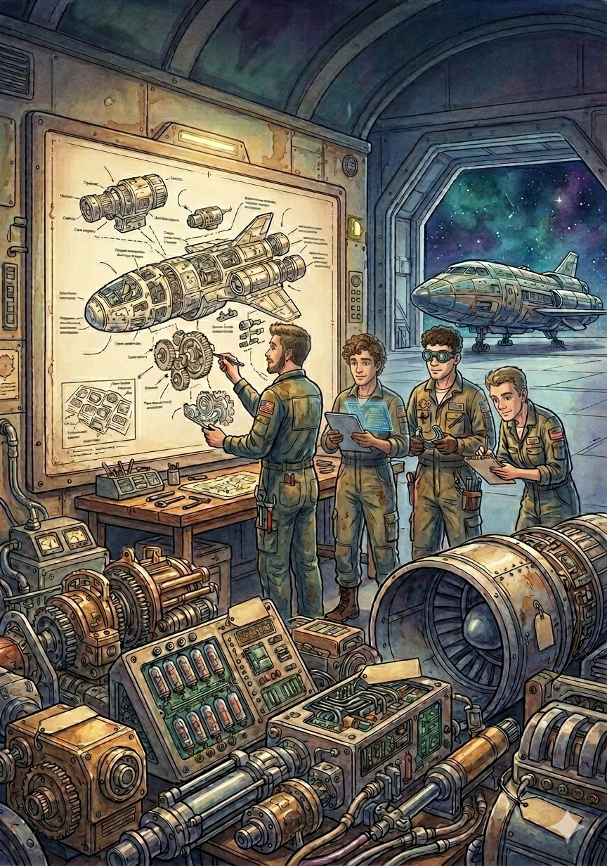

Engineering of Intelligent Models
FINAL DELIVERY
USER MANUAL
NOTED PLATFORM

