
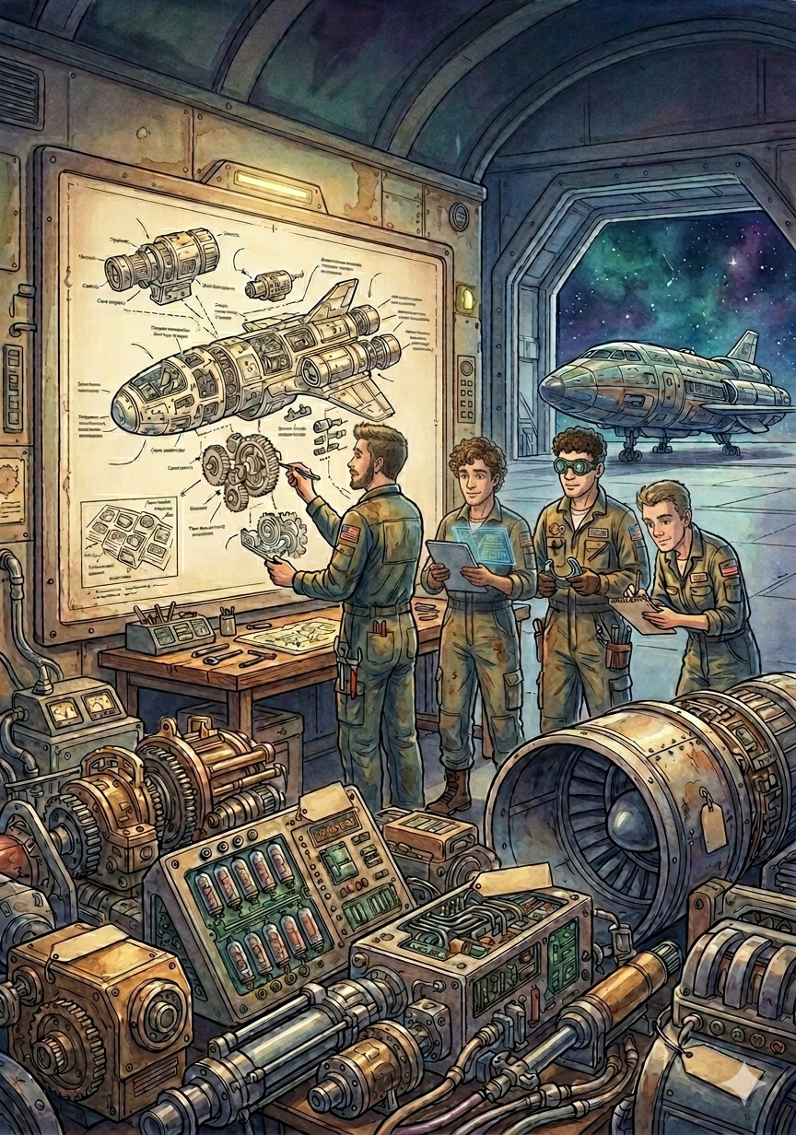

Engineering of Intelligent Models
FINAL DELIVERY
SETUP AND INSTALLATION MANUAL
NOTED PLATFORM

