INSERT YOUR COVER PAGE HERE
Table of Contents
1. Introduction and Objectives 4
1.1 Problem Statement 4
1.2 The noted Platform 4
1.3 Project Scope Alignment 4
2. Infrastructure and Containerization 5
2.1 Docker Compose Architecture 5
2.2 Host Directory Mounts 5
2.3 GPU Support 6
3. Reproducibility and Configuration Management 6
3.1 Reproducibility Guarantees 6
3.2 Hydra Configuration 6
4. Pipeline Orchestration (Apache Airflow) 7
4.1 DAG Architecture 7
4.2 Configuration Integration 8
4.3 Modular Source Code 8
5. Experiment Tracking and Model Registry 8
5.1 MLflow Integration 8
5.2 Experiment Results 9
5.3 Automated Model Registration and Promotion 9
6. Model Serving and Frontend 9
6.1 FastAPI Serving Layer 9
6.2 noted “Try It” Panel 10
6.3 Jena Client Web Application 10
7. AI-Powered Development Assistant 10
7.1 Dual-Backend Architecture 10
7.2 MCP Server (Model Context Protocol) 11
7.3 Tool System 11
7.4 Web Content Fetch 11
8. Demonstration Pipeline: End-to-End Workflow 11
Step 1: Configuration 11
Step 2: Pipeline Trigger 11
Step 3: Live Monitoring 12
Step 4: Verification 12
Step 5: Auto-Promotion 12
Step 6: Prediction 12
Step 7: Evidently Reports 12
9. Conclusion 12
9.1 Summary 12
9.2 Future Enhancements 13

1. Introduction and Objectives

1.1 Problem Statement
Building machine learning models requires operating across a fragmented landscape of tools, each with its own interface and mental model. Notebooks serve interactive exploration but lack built-in versioning or tracking. MLflow tracks experiments but requires switching to a separate UI. DVC versions data but lives in the terminal. Hydra manages configurations but through scattered YAML files. Airflow orchestrates pipelines but demands yet another dashboard. Practitioners spend significant time context-switching between browser tabs, terminals, and dashboards, and configuration drift between experimentation and deployment is a persistent source of production failures.

1.2 The noted Platform
noted is an integrated, web-based MLOps platform that unifies interactive notebooks, data versioning, experiment tracking, configuration management, pipeline orchestration, model governance, and model serving into a single collaborative interface. The underlying tools - MLflow, DVC, Hydra, Apache Airflow, MinIO - remain the engines. noted is the cockpit.
The platform enforces a zero vendor lock-in principle: every artifact noted creates works without noted. Notebooks are standard .ipynb. MLflow runs are standard MLflow runs. DVC tracking uses standard .dvc files. Hydra configs are standard YAML. Airflow DAGs use only standard operators. If noted is removed, the entire MLOps stack continues to run independently.

1.3 Project Scope Alignment
This report demonstrates that the Jena Weather Forecasting project, built on the noted platform, fulfills all final delivery requirements:
Requirement | Implementation
Automated Airflow pipeline with model registration | 6-task DAG with auto-promote to MLflow Registry
FastAPI serving layer with dynamic model loading | noted-serving container loads @champion from registry
Functional frontend for real-time predictions | jena_client web app (FastAPI + socket.io + Chart.js)
End-to-end demonstration pipeline | Hydra config -> Airflow trigger -> MLflow verification -> API query
Docker Compose containerization | 12+ containers with GPU support
Hydra configuration management | 4 config groups (data, model, training, scaler)
DVC data versioning | Jena Climate dataset tracked with MinIO remote
100% reproducibility | DVC hash + Hydra hash + git commit + seed = identical results

2. Infrastructure and Containerization

2.1 Docker Compose Architecture
The platform runs as a multi-container deployment orchestrated via Docker Compose. The architecture separates concerns across 12+ services, each with a single responsibility:
Service | Container | Purpose
noted | noted | FastAPI backend + static frontend (main platform)
MLflow | noted-mlflow | Experiment tracking + model registry
Airflow API Server | noted-airflow-apiserver | Pipeline REST API (Airflow 3.0)
Airflow Scheduler | noted-airflow-scheduler | DAG scheduling
Airflow Worker | noted-airflow-worker | Celery task execution (GPU-enabled)
MinIO | noted-minio | S3-compatible object storage (DVC remote + MLflow artifacts)
PostgreSQL | noted-postgres | Shared metadata (MLflow + Airflow)
Redis | noted-redis | Airflow Celery broker
Model Serving | noted-serving | FastAPI model inference
Evidently | noted-evidently | Data quality and drift monitoring
Agent Server | agent_server | Local LLM inference (Gemma 4)
nginx | noted-nginx | Reverse proxy
All services share a Docker network. The noted container acts as a single proxy to all backend services - secrets (API keys, database credentials) are managed server-side via Infisical and never reach the browser.
Beyond the infrastructure layer, noted presents a unified interface that consolidates every MLOps domain into a single application. Figure 1 shows the platform's VS Code-inspired layout: a persistent icon bar on the left provides one-click access to each workspace section; a collapsible Explorer sidebar exposes the full project tree alongside the complete MLOps artifact hierarchy (Data Catalog, Experiments, Model Registry, Environments, Storage, Orchestration, APIs, Assistant, Knowledge Base); a tabbed center pane hosts notebooks, file editors, pipeline views, and service tabs; and a persistent AI assistant panel occupies the right column with awareness of the active notebook, MLflow runs, DVC datasets, and Airflow DAGs. Notably, the bottom status bar shows the jena_training_pipeline executing in the background, demonstrating that pipeline orchestration and interactive notebook work proceed concurrently within the same session.
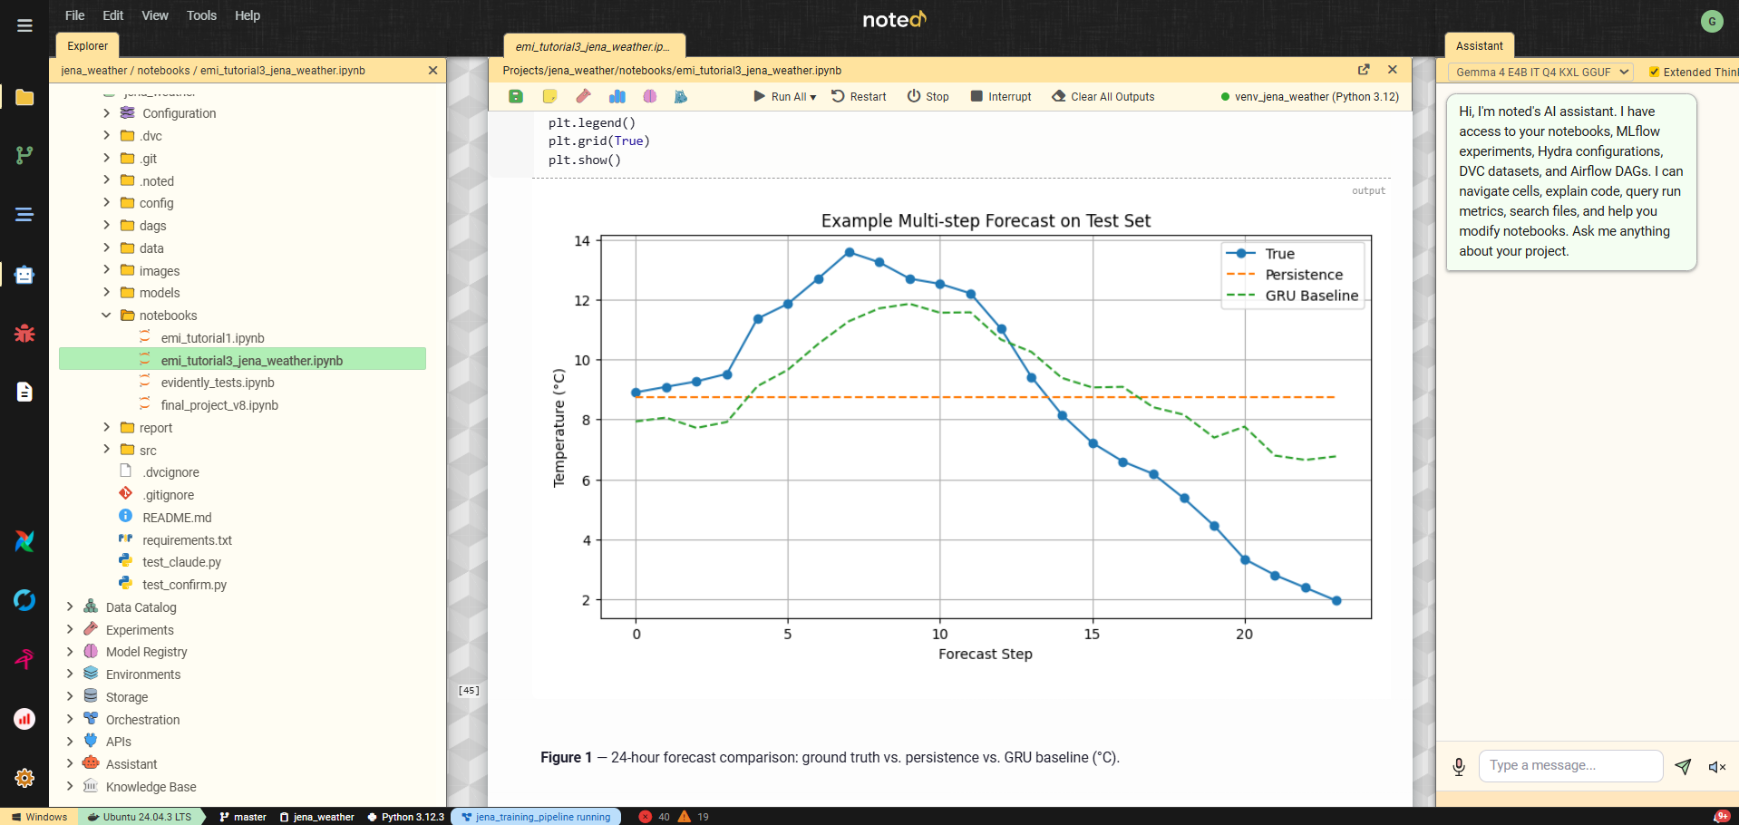
Figure 1 – noted workspace interface with the jena_weather project open.

2.2 Host Directory Mounts
External projects (like the Jena Weather project) are linked into noted via host directory mounts configured in data/NOTED.md. On startup, noted auto-generates docker-compose.mounts.yml with volume entries for both the noted container and all Airflow services, ensuring DAGs in project dags/ folders are automatically discovered by Airflow without manual configuration.

2.3 GPU Support
The deployment includes NVIDIA CUDA runtime support. Training tasks in the Airflow worker container have direct GPU access, enabling accelerated model training with TensorFlow, PyTorch, and other GPU-enabled frameworks.

3. Reproducibility and Configuration Management

3.1 Reproducibility Guarantees
The platform enforces 100% reproducibility through four interlocking mechanisms:
- Data versioning (DVC): The Jena Climate dataset (data/jena_climate_2009_2016.csv, 41.2 MB) is tracked by DVC with MinIO as the remote storage backend. Every training run is tagged with the DVC data hash (dvc_data_hash), linking the model to the exact dataset version that produced it.
- Configuration hashing (Hydra): The resolved Hydra configuration is hashed (SHA-256) and logged as both an MLflow parameter (hydra_config_hash) and tag on every experiment run. This guarantees that two runs with the same config hash used identical hyperparameters.
- Code versioning (Git): All source code, configuration files, and DAG definitions are tracked in Git. Experiment snapshots capture the exact git commit, creating a branch (snapshot/{experiment}_{version}) that preserves the code state.
- Seed control: Random seeds are managed via the Hydra training config (seed parameter) and propagated to TensorFlow, NumPy, and Python’s random module, ensuring deterministic training when combined with the same data and configuration.
To reproduce any experiment: clone the repository, dvc pull the data, load the Hydra config from the run’s hydra_config_hash, and execute the pipeline. The result will match the original MLflow metrics exactly.

3.2 Hydra Configuration
Configuration is managed hierarchically using Hydra with four config groups:
config/
config.yaml # Root config with group defaults
data/
default.yaml # Dataset paths, train/val/test splits
model/
gru_baseline.yaml # GRU architecture (units, dropout, layers)
gru_evolutionary.yaml # Evolved GRU architecture
training/
default.yaml # Epochs, batch size, learning rate, seed
scaler/
standard.yaml # StandardScaler
robust.yaml # RobustScaler
minmax.yaml # MinMaxScaler
The noted interface exposes Hydra's configuration system through a dedicated Configuration Composer panel, shown in Figure 2. Rather than editing YAML files directly, users select options from each config group via dropdowns, dataset parameters, model architecture, scaler type, and training hyperparameters are composed on demand. Clicking "Compose" resolves the full configuration and displays the resulting YAML alongside a SHA-256 hash of the composed output. This hash is automatically logged as both an MLflow parameter and a run tag on every experiment, creating a direct and auditable link between a model's performance and the exact configuration that produced it. The seed override field and templates system allow practitioners to save and reload frequently used configurations, ensuring consistent hyperparameter management across notebook experiments and Airflow pipeline runs alike.
.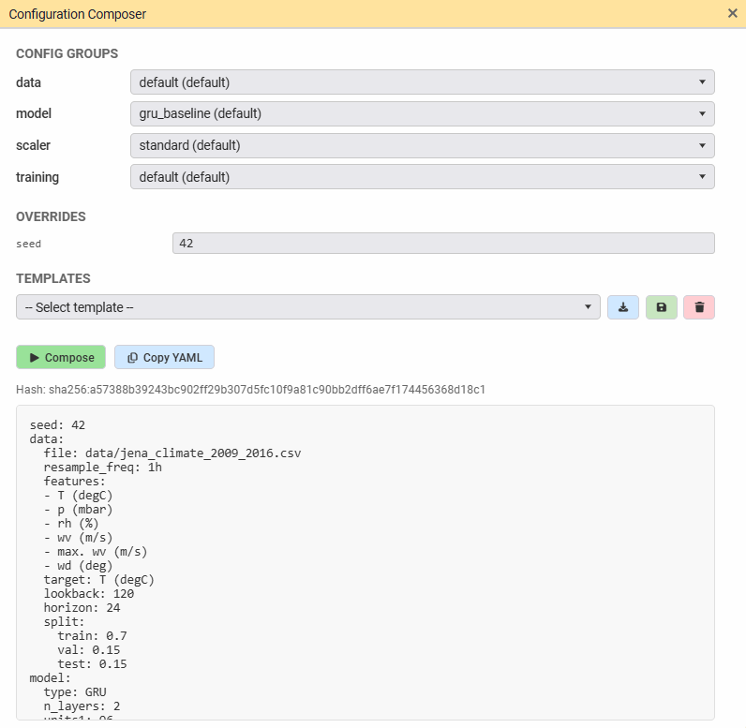
Figure 2 – Hydra Configuration Composer panel.

Pipeline Orchestration (Apache Airflow)

4.1 DAG Architecture
The Jena Weather training pipeline is implemented as an Airflow 3.0 DAG (dags/jena_training_pipeline.py) with six tasks:
ingest_data (1.5s)
|
preprocess_data (0.4s)
|
+-- evidently_quality (4.8s) [parallel branch]
|
+-- train_model_task (192.5s) [parallel branch]
|
+-- promote_model (1.0s)
|
+-- evidently_drift (7.8s)
Task descriptions:
- ingest_data: Loads the raw CSV from DVC-tracked path, validates schema, writes to /tmp parquet for downstream tasks
- preprocess_data: Applies feature engineering (cyclical time features, rolling statistics), scales features using the Hydra-configured scaler, creates sliding windows
- evidently_quality: Runs Evidently data quality report on the preprocessed data (parallel with training)
- train_model_task: Builds and trains the GRU model per Hydra config, logs metrics and artifacts to MLflow (192.5s on GPU)
- promote_model: Compares the new model against the current @champion in the MLflow Registry; promotes if test MAE improves
- evidently_drift: Runs Evidently drift detection comparing train vs test distributions
Figure 3 shows noted's native Orchestration view for the jena_training_pipeline DAG. This purpose-built interface renders the full task graph, surfaces pipeline metadata, exposes execution controls, and maintains a run history, all without opening a separate Airflow browser tab. The parallel branch architecture is clearly visible: after data ingestion and preprocessing, evidently_quality and train_model_task execute concurrently, with promote_model and evidently_drift completing the pipeline. The sidebar tree shows three previous successful executions with their timestamps, confirming the pipeline has been validated across multiple runs. The visual schedule builder at the bottom supports cron-based scheduling through human-readable presets, making recurring pipeline execution accessible without requiring Airflow UI access or cron syntax knowledge.

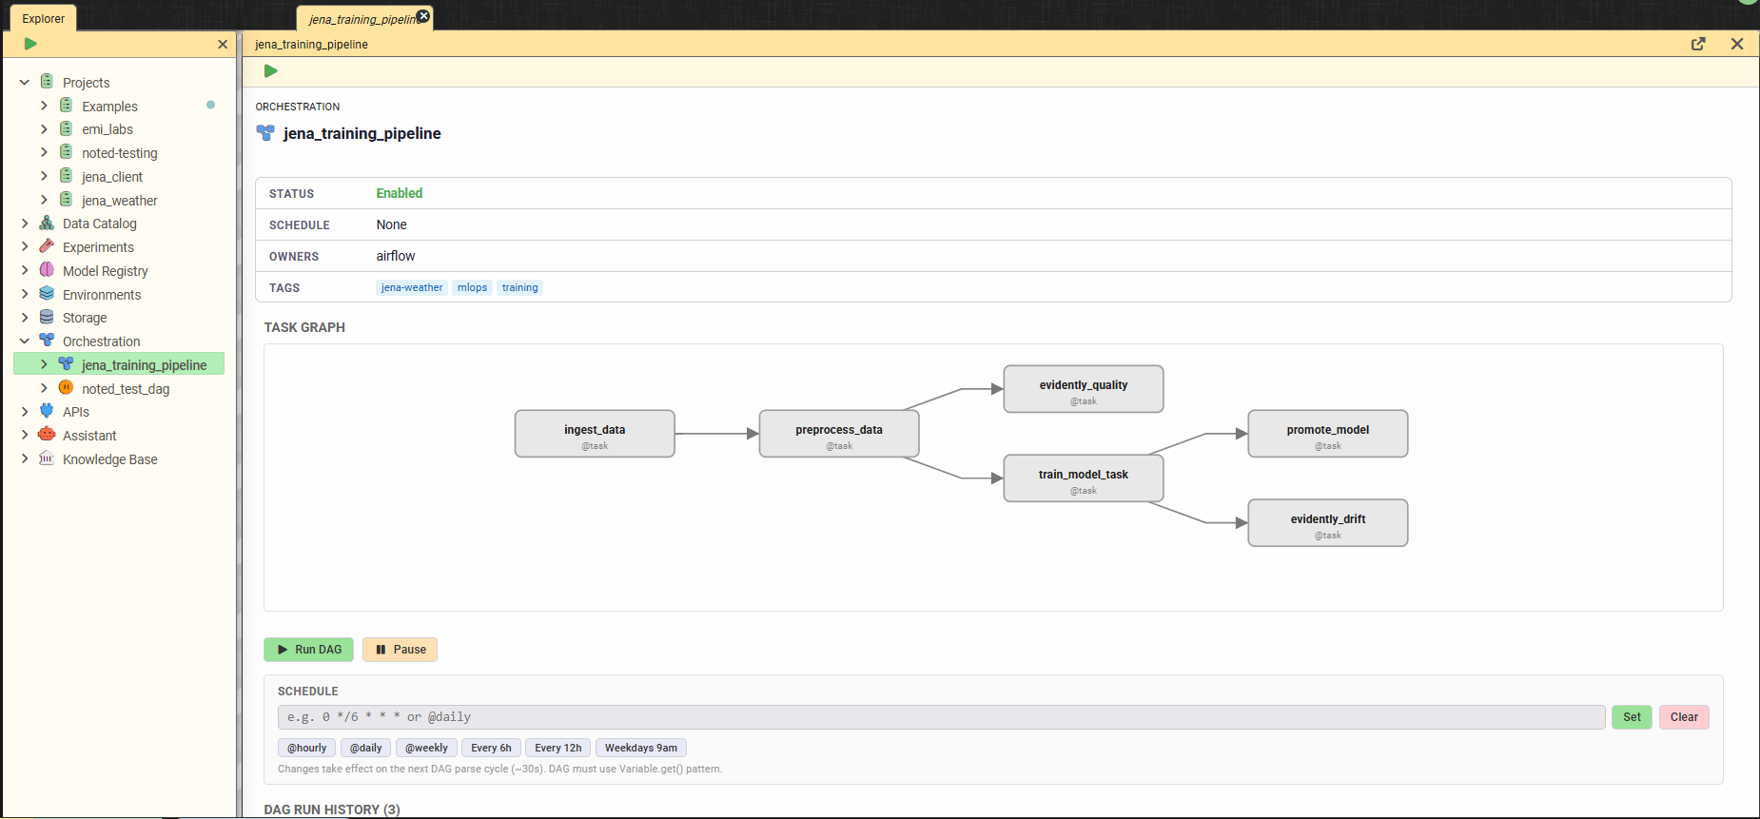

Figure 3 – noted's native Orchestration view for the jena_training_pipeline DAG.

4.2 Configuration Integration
The DAG is parameterized via Airflow DAG params that map directly to Hydra config groups. When triggered from the noted UI, the Configuration Composer panel’s selections are passed as DAG parameters. The DAG tasks read the same Hydra YAML configs that notebooks use, ensuring configuration consistency across interactive and automated execution.

4.3 Modular Source Code
All pipeline logic resides in reusable src/ modules shared between the notebook and the Airflow DAG:
Module | Purpose
src/data/ingestion.py | Data loading and validation
src/data/preprocessing.py | Feature engineering and preprocessing
src/data/preparation.py | Scaling, windowing, train/val/test split
src/training/pipeline.py | Model building, training, MLflow logging
src/evaluation/metrics.py | Test evaluation metrics (MAE, RMSE, R2)
src/evaluation/promote.py | Champion comparison and auto-promotion
This design eliminates code duplication: the notebook calls the same functions that Airflow tasks execute. Changes to data processing logic automatically propagate to both execution paths.

5. Experiment Tracking and Model Registry

5.1 MLflow Integration
noted provides zero-config MLflow connectivity. The MLFLOW_TRACKING_URI is injected into every kernel automatically - import mlflow just works without any boilerplate. The platform supports two complementary tracking modes:
- Auto-instrumentation: The Run Manager UI defines named cell groups as reusable run templates. Executing a run wraps the selected cells in mlflow.start_run()/end_run() automatically, with framework autologging activated for TensorFlow, scikit-learn, and other supported frameworks.
- Pipeline tracking: Airflow DAG tasks call MLflow directly through the src/training/pipeline.py module, logging metrics (test_mae, test_rmse, test_r2), parameters (all Hydra config values), and artifacts (trained model, training history).
Both modes automatically tag runs with the DVC data hash and Hydra config hash, providing full lineage traceability.

5.2 Experiment Results
Figure 4 shows noted's native experiment leaderboard for the Jena Weather Forecasting experiment. Rather than navigating to the MLflow UI, practitioners access a purpose-built comparison view directly within the noted workspace. The leaderboard displays all 8 completed runs with their full metric sets, training loss, MAE, RMSE, scaled variants, and validation metrics, with best values highlighted per column for immediate visual identification of the strongest run. An active filter (model_type=GRU, lr>0.001, epochs>=30) narrows the view to relevant configurations. The run list distinguishes between Airflow pipeline runs and notebook-originated runs by name, and the sidebar tree lists each execution individually with timestamps and completion status. The "Promote Best" action saves the best run's parameters as a reusable Hydra template, directly closing the loop between experiment results and future pipeline configuration.
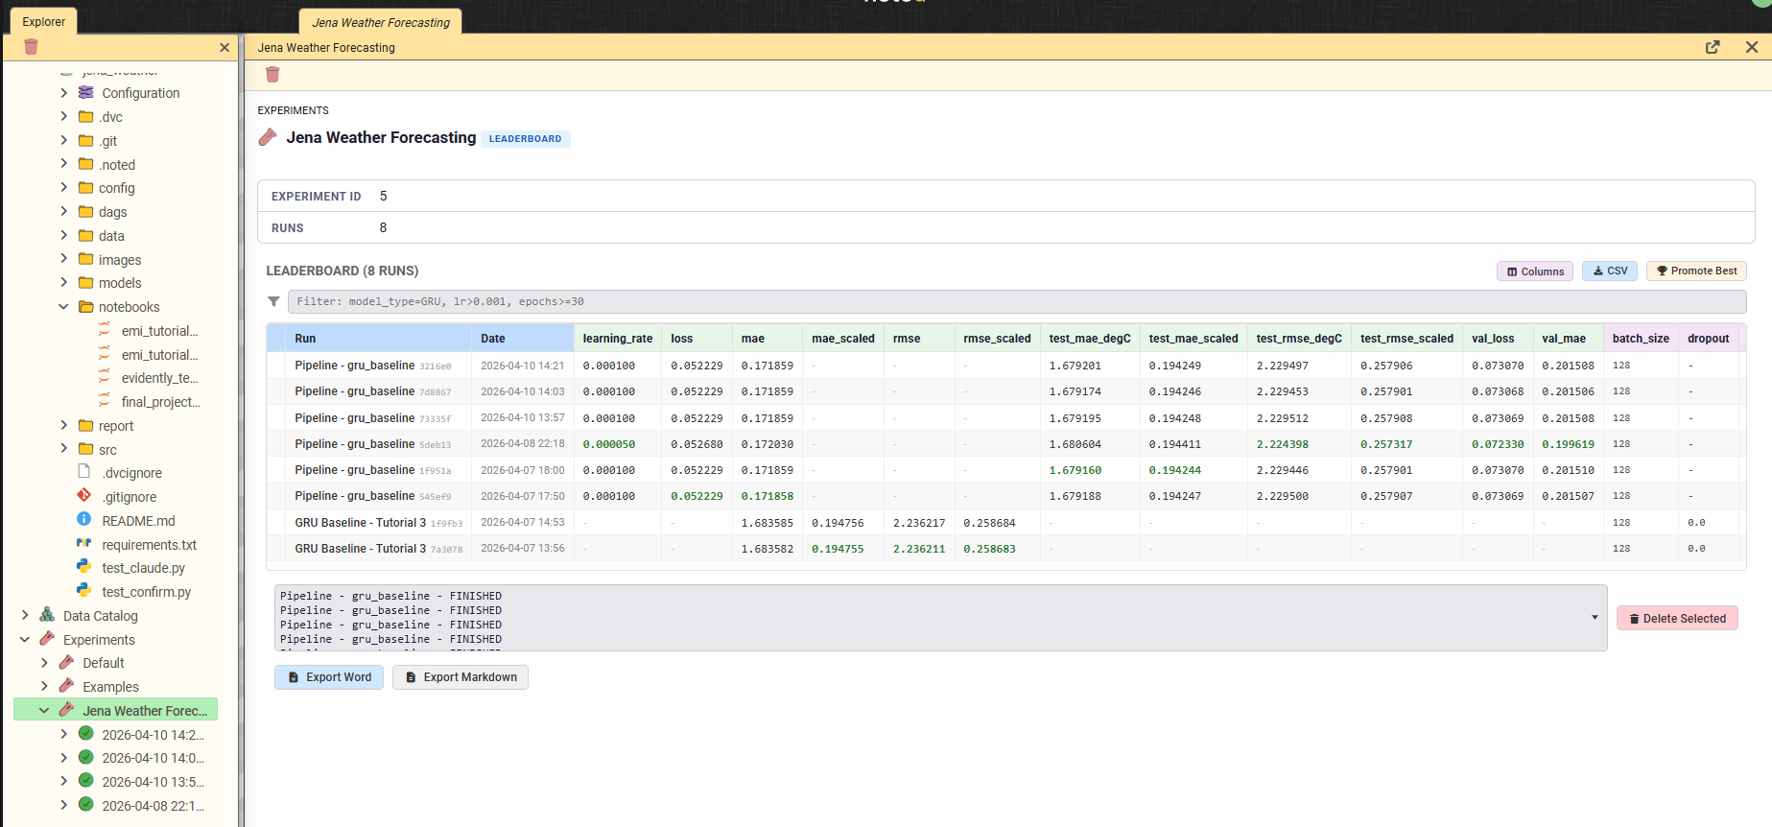
Figure 4 – noted's native experiment leaderboard for the Jena Weather Forecasting experiment (8 runs). Best metric values are highlighted per column - the strongest pipeline run achieves a test MAE of 1.679°C and RMSE of 2.224°C.

5.3 Automated Model Registration and Promotion
The promote_model task in the Airflow DAG implements automatic champion selection:
- After training completes, the new model’s test MAE is compared against the current @champion model in the MLflow Registry
- If the new model improves on the champion’s metric, it is registered as a new version and the @champion alias is reassigned
- The promotion decision is logged as an MLflow tag for audit
This ensures the serving endpoint always loads the best available model without manual intervention.
Figure 5 shows noted's native Model Registry view for the Jena Weather Forecaster. The registry displays all 16 registered model versions, each linked to the MLflow run that produced it via a traceable run ID. Version 9 carries the @champion alias, identifying it as the current production model loaded by the serving container. The alias is managed directly from the noted interface through the "Set alias" action on any version row, with the sidebar tree reflecting the current champion assignment. The breadth of the version history, 16 versions registered across three days of pipeline executions, demonstrates the automated registration and promotion pipeline described in Section 5.3 operating continuously: each successful Airflow pipeline run produces a new candidate version, which is promoted to @champion only if it improves on the current champion's test MAE.
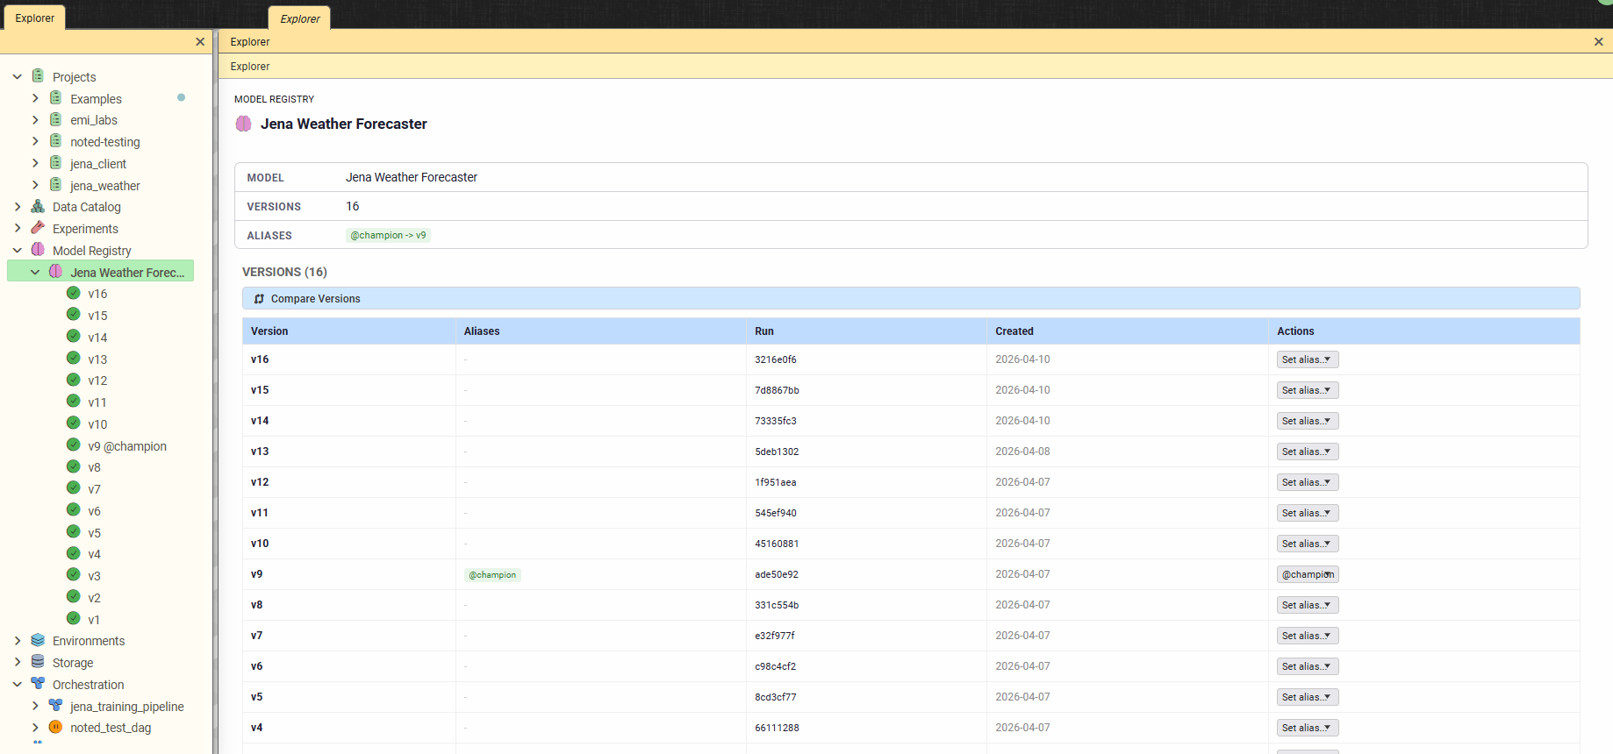
Figure 5 – noted's native Model Registry view for the Jena Weather Forecaster model. 16 versions are registered, each linked to its originating MLflow run. Version 9 holds the @champion alias, visible both in the table and the sidebar tree.

6. Model Serving and Frontend

6.1 FastAPI Serving Layer
The noted-serving container is a dedicated FastAPI service that dynamically loads any registered model from the MLflow Registry on demand. Key capabilities:
- Dynamic model loading: Load any model version by name and version/alias. The @champion alias provides a stable reference to the best model
- Schema-aware input validation: Pydantic schemas derived from the model’s MLflow signature validate incoming JSON requests
- Multi-framework support: Pre-installed TensorFlow, PyTorch, scikit-learn, XGBoost, and LightGBM for model inference
- Health monitoring: /health endpoint with serving status visible in noted’s status bar

6.2 noted “Try It” Panel
Within the noted platform, the Model Registry section provides a “Try It” panel for any registered model. The panel generates a dynamic input form based on the model’s schema signature, sends the request through noted’s backend (which proxies to the serving container), and renders the output as charts (ECharts), tables, or formatted JSON.

6.3 Jena Client Web Application
Beyond noted’s built-in serving interface, a standalone web application (jena_client) demonstrates the model serving for end users:
- Backend: FastAPI + socket.io server that connects to the noted-serving container
- Frontend: Vanilla HTML/CSS/JavaScript with Chart.js for interactive forecast visualization
- Features: Real-time temperature predictions, historical data overlay, dark/light theme toggle
- Deployment: Runs as a separate service, accessible to users who don’t need the full noted platform
This dual approach demonstrates both integrated (Try It panel) and standalone (jena_client) serving patterns.

7. AI-Powered Development Assistant

7.1 Dual-Backend Architecture
noted integrates an AI assistant that understands the full MLOps workspace and can both reason about it and act on it through structured tool calls. The assistant supports two inference backends:
- Gemma 4 E4B (local, via llama-cpp-python): On-premises inference with 128K context window. No data leaves the host. Native tool calling via trained <|tool_call> special tokens
- Anthropic Claude (Sonnet 4.6, Opus 4.6, Haiku 4.5): Cloud API with 200K context window. Native tool calling via Anthropic’s tools array and tool_use content blocks
Both backends use their model-native tool calling mechanisms rather than text-based prompt injection, ensuring reliable structured arguments and eliminating parsing fragility.

7.2 MCP Server (Model Context Protocol)
noted exposes its tool surface through an MCP server at /mcp/, enabling external AI clients (Claude Code, Claude Desktop, Cursor) to discover and invoke noted’s capabilities without the noted UI. The server uses Streamable HTTP transport with the official mcp Python SDK, includes rate limiting (tiered token bucket: read 30/min, write 10/min), and a structured error taxonomy. This transforms noted from a notebook with an AI chat into a headless AI execution engine controllable by any MCP-compatible client.

7.3 Tool System
25 tools provide read and write access to the MLOps stack: MLflow experiments and runs, Airflow DAG status and task logs, DVC tracked files, Hydra configurations, project files, Knowledge Graph entities, notebook cell navigation, web content fetching (via Camoufox anti-detect browser), and lint diagnostics. Write tools (update_cell, insert_cell, create_file) require explicit user confirmation with a diff preview.
A Dynamic Context Router selects only the relevant tool schemas per turn for Claude (typically 5-8 out of 25), reducing token cost while maintaining full tool coverage.
Figure 6 demonstrates the AI assistant's tool system in action. In response to a natural language query requesting the best-performing run and its parameters, the assistant engaged in a clarification dialogue before invoking the get_experiment_runs tool, visible as an orange badge in the response, to query the MLflow tracking backend directly. The assistant identified run 1f951aea as achieving the lowest test_mae_degC of 1.6792°C and returned its full parameter set: model type, architecture config, scaler, lookback window, forecast horizon, training epochs, batch size, and random seed. The leaderboard open simultaneously in the left pane confirms the result, with the identified run highlighted. This interaction illustrates how the assistant bridges natural language queries and structured MLOps data. Practitioners can interrogate experiment results, compare configurations, and retrieve lineage information conversationally, without navigating the UI manually.
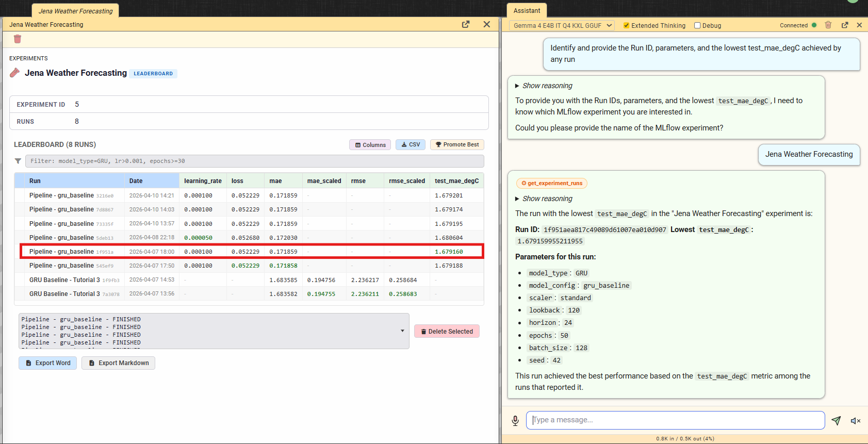
Figure 6 – AI assistant using the get_experiment_runs tool to identify the best-performing run in the Jena Weather Forecasting experiment.

7.4 Web Content Fetch
The fetch_url tool retrieves web content using Camoufox, a persistent anti-detect Firefox browser with C++ level TLS fingerprint spoofing. The browser launches once as a singleton and stays warm for subsequent requests. This enables the assistant to read documentation, API references, or any URL shared by the user and incorporate the content into its analysis.

8. Demonstration Pipeline: End-to-End Workflow
The following walkthrough demonstrates the complete lifecycle within the noted platform, from configuration to prediction:

Step 1: Configuration
Open the Jena Weather project in noted. The Configuration Composer panel shows four Hydra config groups. Select model: gru_baseline, scaler: standard, training: default (30 epochs, batch 256, LR 0.0005, seed 42).

Step 2: Pipeline Trigger
Click “Run as Pipeline” from the notebook bar, or navigate to the Orchestration section and trigger the jena_training_pipeline DAG. The composed Hydra configuration is passed as DAG parameters. The 6-task pipeline begins execution.

Step 3: Live Monitoring
The pipeline status appears in noted’s status bar (blue pill). The Orchestration tree shows real-time task status updates via Socket.IO polling. Training progress is visible in the Live Metrics panel with epoch-by-epoch loss curves.

Step 4: Verification
After completion (total ~3m25s), navigate to the Experiments section. The new run appears with logged metrics (test MAE: ~2.02 C, test RMSE: ~2.56, test R2: ~0.893). The run is tagged with the DVC data hash and Hydra config hash.

Step 5: Auto-Promotion
The promote_model task compared the new model against the existing champion. If the test MAE improved, the model was registered in the MLflow Registry with the @champion alias. The Models section in the Explorer shows the registered model with its version, signature, and lineage chain.

Step 6: Prediction
Open the jena_client web app or noted’s Try It panel. Submit a forecast request with recent climate features. The FastAPI serving container loads the @champion model from the registry and returns temperature predictions. The Chart.js frontend renders the forecast alongside historical data.

Step 7: Evidently Reports
The Evidently UI (accessible from noted’s sidebar) shows two reports generated during the pipeline: a data quality report (from the evidently_quality task) and a drift detection report (from the evidently_drift task, comparing train vs test distributions). 6 of 16 features showed statistically significant drift (37.5%).

9. Conclusion

9.1 Summary
The noted platform successfully abstracts the complexity of disparate MLOps tools into a unified, production-ready workspace. The Jena Weather Forecasting project demonstrates every required component: automated Airflow pipelines, MLflow experiment tracking with model registry, FastAPI model serving, a functional web frontend, and Docker Compose containerization - all integrated within a single interface that eliminates context-switching.
The platform goes beyond the baseline requirements by providing:
- Native AI assistant with two LLM backends (local Gemma 4 + cloud Claude) using model-native tool calling
- MCP Server enabling external AI clients to control noted as a headless execution engine
- Full reproducibility chain: DVC data hashes + Hydra config hashes + git commits + seeds = identical results
- Evidently integration for data quality and drift monitoring
- 25 AI-powered tools for workspace interaction, including web content fetch via anti-detect browser
- Zero vendor lock-in: all artifacts work independently of noted

9.2 Future Enhancements
Planned Phase 5 capabilities include:
- MCP external client access: scoped API keys with read/write permissions for external AI clients
- MCP Resource Layer: noted:// URI scheme for passive environment state access (MLflow metrics, DVC lineage, Airflow status)
- KV cache persistence: save/load llama-cpp-python KV cache state per conversation thread for faster local LLM inference
- Evidently quality gates: pre-pipeline data validation with automatic pipeline abort on quality threshold violation
- Impact analysis: Knowledge Graph-powered “What breaks if I change this?” queries
- Inline code completion: ghost-text suggestions via LLM integration

