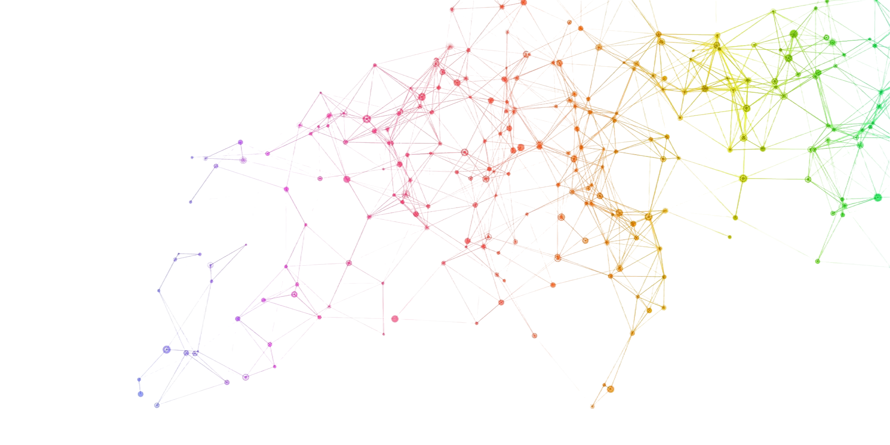


TAAP
Advanced Topics in Deep Learning
MINI-PROJECT 01
Implementing A Conditional
Generative Adversarial NetwOrk
António Cruz (140129), Cátia Brás (120093), Ricardo Kayseller (95813)

