INSERT YOUR COVER PAGE HERE
Table of Contents

DQN & PPO Multi-Seed Report (Best Model Selection)
This notebook loads the best model from each training run (selected by the combined metric mean_reward - std_reward during training) and runs evaluation and visualization.
No training is required — run lab009_v1.ipynb first to generate the model files.
Models are loaded from timestamped run folders: models/{algo}/{timestamp}/best_model.zip

import os, sys
import numpy as np
import pandas as pd
import torch
import matplotlib.pyplot as plt
from scipy import stats
import gymnasium as gym
from stable_baselines3 import DQN, PPO
from stable_baselines3.common.evaluation import evaluate_policy
from stable_baselines3.common.vec_env import DummyVecEnv
from stable_baselines3.common.monitor import Monitor
import imageio
from IPython.display import Image, display
# Configuration
import glob
SEED_LIST = [42, 123, 999]
ALGORITHM_MAP = {
"dqn": DQN,
"ppo": PPO,
}
NOTEBOOK_DIR = os.path.dirname(os.path.abspath("__file__"))
GYMNASIUM_MODEL = "LunarLander-v3"
WIND_ENABLED = False
EVALUATION_EPISODES = 20
TRAJECTORY_EPISODES = 3 # Episodes to visualize per algorithm for trajectory plots
DEVICE = "cpu"
# Session prefix — must match the final model filenames from training
# (e.g. lab009_dqn_42.zip -> SESSION_PREFIX = "lab009")
SESSION_PREFIX = "lab009"
# LunarLander-v3 action labels
ACTION_LABELS = ["Do Nothing", "Fire Left", "Fire Main", "Fire Right"]
def discover_best_models(session_prefix):
"""
Scan models/{algo}/{timestamp}/ folders and return a dict:
{algo: {seed: path_to_best_model}}
Only considers runs whose final model filename starts with session_prefix.
"""
models_root = os.path.join(NOTEBOOK_DIR, "../../../models")
best_models = {}
for algo_name in ALGORITHM_MAP:
best_models[algo_name] = {}
algo_dir = os.path.join(models_root, algo_name)
if not os.path.isdir(algo_dir):
continue
for run_folder in sorted(glob.glob(os.path.join(algo_dir, "????-??-??_??_??_??"))):
best_model_path = os.path.join(run_folder, "best_model.zip")
if not os.path.isfile(best_model_path):
continue
# Find the final model file to extract session and seed
for f in os.listdir(run_folder):
if f.startswith(session_prefix) and f.endswith(".zip") and f != "best_model.zip":
seed_str = f.replace(".zip", "").split("_")[-1]
if seed_str.isdigit():
seed_int = int(seed_str)
if seed_int in SEED_LIST:
best_models[algo_name][seed_int] = best_model_path
break
return best_models
# Discover best models for this session
best_model_paths = discover_best_models(SESSION_PREFIX)
print(f"Session: {SESSION_PREFIX}")
print(f"Algorithms: {list(ALGORITHM_MAP.keys())}")
print(f"Seeds: {SEED_LIST}")
print(f"Wind enabled: {WIND_ENABLED}")
print(f"Evaluation episodes per seed: {EVALUATION_EPISODES}")
print(f"Device: {DEVICE}")
print()
print("Discovered best models:")
for algo_name in ALGORITHM_MAP:
for seed in SEED_LIST:
path = best_model_paths.get(algo_name, {}).get(seed)
status = path if path else "NOT FOUND"
print(f" {algo_name.upper()} seed {seed}: {status}")
Session: lab009
Algorithms: ['dqn', 'ppo']
Seeds: [42, 123, 999]
Wind enabled: False
Evaluation episodes per seed: 20
Device: cpu
Discovered best models:
DQN seed 42: /home/logus/env/iscte/taap_p2/drafts/draft_01/gymnasium/../../../models/dqn/2026-02-21_20_43_20/best_model.zip
DQN seed 123: /home/logus/env/iscte/taap_p2/drafts/draft_01/gymnasium/../../../models/dqn/2026-02-21_21_35_46/best_model.zip
DQN seed 999: /home/logus/env/iscte/taap_p2/drafts/draft_01/gymnasium/../../../models/dqn/2026-02-21_22_27_19/best_model.zip
PPO seed 42: /home/logus/env/iscte/taap_p2/drafts/draft_01/gymnasium/../../../models/ppo/2026-02-21_23_17_45/best_model.zip
PPO seed 123: /home/logus/env/iscte/taap_p2/drafts/draft_01/gymnasium/../../../models/ppo/2026-02-21_23_39_19/best_model.zip
PPO seed 999: /home/logus/env/iscte/taap_p2/drafts/draft_01/gymnasium/../../../models/ppo/2026-02-22_00_03_53/best_model.zip
# Load all best models and evaluate
evaluation_results = {} # {algo: {seed: np.array}}
for algo_name, algo_class in ALGORITHM_MAP.items():
evaluation_results[algo_name] = {}
for seed in SEED_LIST:
load_path = best_model_paths.get(algo_name, {}).get(seed)
if load_path is None:
print(f"SKIPPING {algo_name.upper()} seed {seed} — best model not found")
continue
print(f"Loading and evaluating {algo_name.upper()} seed {seed} (best model)...")
def make_env(s=seed):
env = gym.make(GYMNASIUM_MODEL, render_mode="rgb_array", enable_wind=WIND_ENABLED)
env.reset(seed=s)
return env
model = algo_class.load(load_path, env=DummyVecEnv([make_env]), device=DEVICE)
eval_env = Monitor(gym.make(GYMNASIUM_MODEL, enable_wind=WIND_ENABLED))
eval_env.reset(seed=seed)
rewards, _ = evaluate_policy(
model,
eval_env,
n_eval_episodes=EVALUATION_EPISODES,
deterministic=True,
return_episode_rewards=True
)
evaluation_results[algo_name][seed] = np.array(rewards)
eval_env.close()
print(f"{algo_name.upper()}: evaluation complete.\n")
print(f"All evaluations complete.")
Loading and evaluating DQN seed 42 (best model)...
Loading and evaluating DQN seed 123 (best model)...
Loading and evaluating DQN seed 999 (best model)...
DQN: evaluation complete.
Loading and evaluating PPO seed 42 (best model)...
Loading and evaluating PPO seed 123 (best model)...
Loading and evaluating PPO seed 999 (best model)...
PPO: evaluation complete.
All evaluations complete.

Per-Algorithm Results
# Per-Algorithm: Evaluation Summary Tables
for algo_name in ALGORITHM_MAP:
rows = []
for seed in SEED_LIST:
r = evaluation_results[algo_name][seed]
rows.append({
"Seed": seed,
"Mean Reward": f"{np.mean(r):.2f}",
"Std Dev": f"{np.std(r):.2f}",
"Min Reward": f"{np.min(r):.2f}",
"Max Reward": f"{np.max(r):.2f}",
"Success Rate": f"{(r >= 200).sum() / len(r) * 100:.1f}%"
})
all_r = np.concatenate([evaluation_results[algo_name][s] for s in SEED_LIST])
rows.append({
"Seed": "Overall",
"Mean Reward": f"{np.mean(all_r):.2f}",
"Std Dev": f"{np.std(all_r):.2f}",
"Min Reward": f"{np.min(all_r):.2f}",
"Max Reward": f"{np.max(all_r):.2f}",
"Success Rate": f"{(all_r >= 200).sum() / len(all_r) * 100:.1f}%"
})
print(f"*** {algo_name.upper()} MULTI-SEED EVALUATION SUMMARY ***")
print(f"Episodes per seed: {EVALUATION_EPISODES} | Total: {len(all_r)}")
print(pd.DataFrame(rows).to_string(index=False))
print()
*** DQN MULTI-SEED EVALUATION SUMMARY ***
Episodes per seed: 20 | Total: 60
Seed Mean Reward Std Dev Min Reward Max Reward Success Rate
42 278.51 23.70 228.67 318.97 100.0%
123 283.34 18.19 250.33 319.93 100.0%
999 253.57 68.63 -28.26 305.91 95.0%
Overall 271.80 45.14 -28.26 319.93 98.3%
*** PPO MULTI-SEED EVALUATION SUMMARY ***
Episodes per seed: 20 | Total: 60
Seed Mean Reward Std Dev Min Reward Max Reward Success Rate
42 278.43 14.56 251.45 311.70 100.0%
123 270.83 14.06 242.53 292.55 100.0%
999 284.32 18.77 252.25 317.36 100.0%
Overall 277.86 16.87 242.53 317.36 100.0%
# Per-Algorithm, Per-Seed: Evaluation Convergence Plots
for algo_name in ALGORITHM_MAP:
fig, axes = plt.subplots(1, len(SEED_LIST), figsize=(6 * len(SEED_LIST), 5), sharey=True)
if len(SEED_LIST) == 1:
axes = [axes]
for ax, seed in zip(axes, SEED_LIST):
rewards = evaluation_results[algo_name][seed]
episodes = np.arange(1, len(rewards) + 1)
running_mean = np.cumsum(rewards) / episodes
running_std = np.array([np.std(rewards[:i]) for i in episodes])
ax.scatter(episodes, rewards, color='gray', alpha=0.4, s=20, label='Episode Reward')
ax.plot(episodes, running_mean, color='blue', linewidth=2, label='Running Mean')
ax.fill_between(episodes, running_mean - running_std, running_mean + running_std,
color='blue', alpha=0.15)
ax.axhline(y=200, color='red', linestyle='--')
ax.set_title(f"Seed {seed}")
ax.set_xlabel("Episode")
ax.grid(True, alpha=0.3)
axes[0].set_ylabel("Reward")
fig.suptitle(f"{algo_name.upper()} Evaluation: {EVALUATION_EPISODES} Episodes per Seed", fontsize=14)
plt.tight_layout()
plt.show()
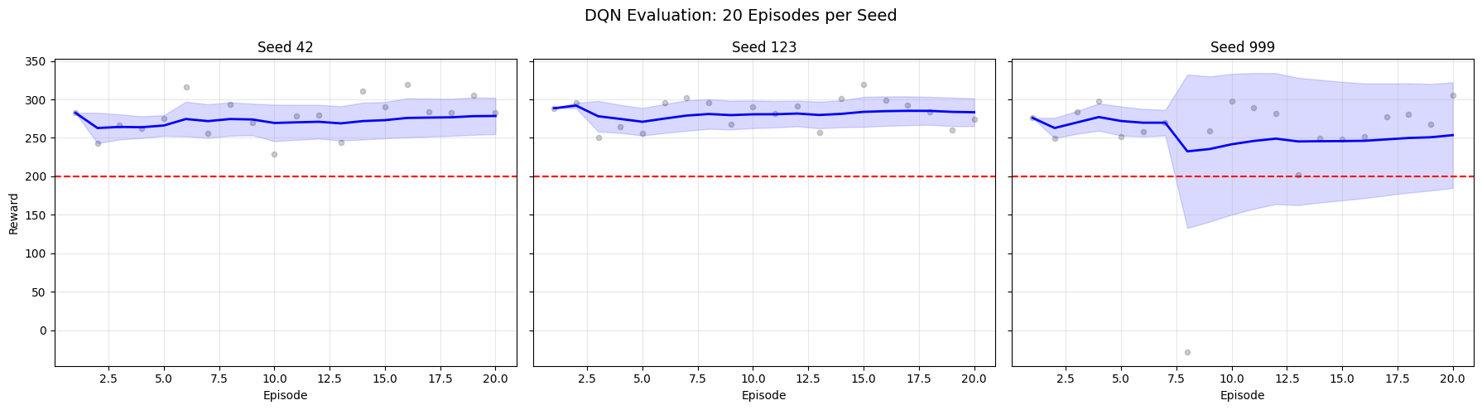
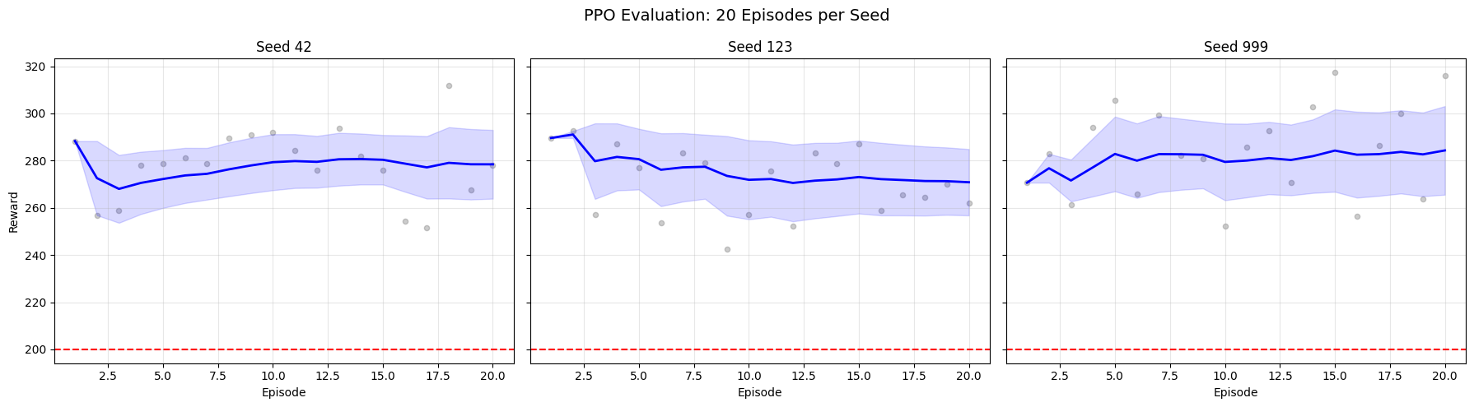
# Per-Algorithm: Evaluation Bar Chart (mean reward per seed with error bars)
seed_colors = list(plt.colormaps["tab10"](range(10))) # type: ignore[arg-type]
for algo_name in ALGORITHM_MAP:
all_r = np.concatenate([evaluation_results[algo_name][s] for s in SEED_LIST])
means = [np.mean(evaluation_results[algo_name][s]) for s in SEED_LIST]
stds = [np.std(evaluation_results[algo_name][s]) for s in SEED_LIST]
labels = [str(s) for s in SEED_LIST]
plt.figure(figsize=(max(8, 3 * len(SEED_LIST)), 6))
plt.bar(labels, means, yerr=stds, capsize=5, color=seed_colors[:len(SEED_LIST)], alpha=0.8)
plt.axhline(y=200, color='red', linestyle='--', label='Solved Threshold (200)')
plt.axhline(y=float(np.mean(all_r)), color='blue', linestyle='-', linewidth=2,
label=f'Overall Mean ({np.mean(all_r):.1f})')
plt.title(f"{algo_name.upper()} Mean Reward per Seed ({EVALUATION_EPISODES} episodes each)", fontsize=14)
plt.xlabel("Seed")
plt.ylabel("Mean Reward")
plt.legend()
plt.grid(True, alpha=0.3, axis='y')
plt.show()
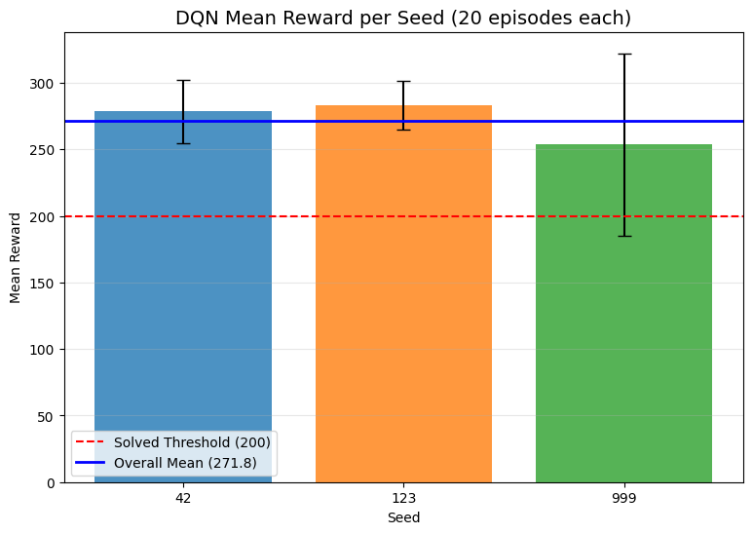
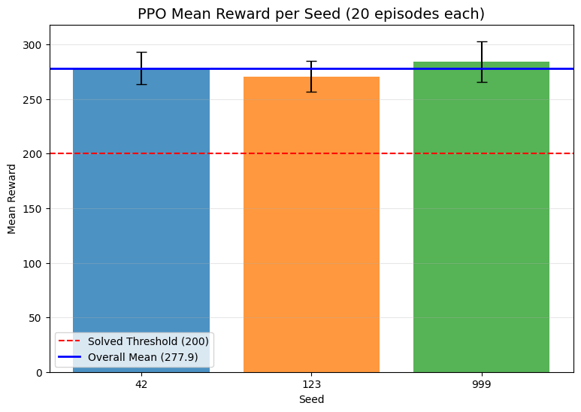
# Per-Algorithm: Reward Distribution Histograms (overlaid per seed)
for algo_name in ALGORITHM_MAP:
all_r = np.concatenate([evaluation_results[algo_name][s] for s in SEED_LIST])
plt.figure(figsize=(12, 5))
for i, seed in enumerate(SEED_LIST):
plt.hist(evaluation_results[algo_name][seed], bins=10, alpha=0.5,
color=seed_colors[i], edgecolor='black', label=f"Seed {seed}")
plt.axvline(x=float(np.mean(all_r)), color='blue', linestyle='-', linewidth=2,
label=f'Overall Mean ({np.mean(all_r):.1f})')
plt.axvline(x=200, color='red', linestyle='--', label='Solved Threshold (200)')
plt.title(f'{algo_name.upper()} Reward Distribution across Seeds')
plt.xlabel('Reward')
plt.ylabel('Frequency')
plt.legend()
plt.grid(True, alpha=0.3)
plt.show()
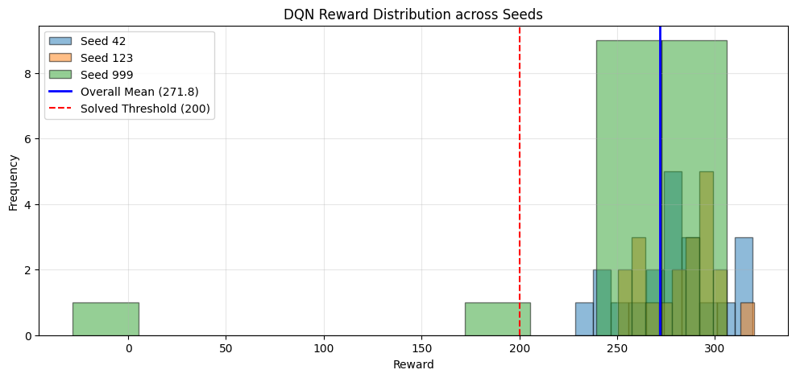
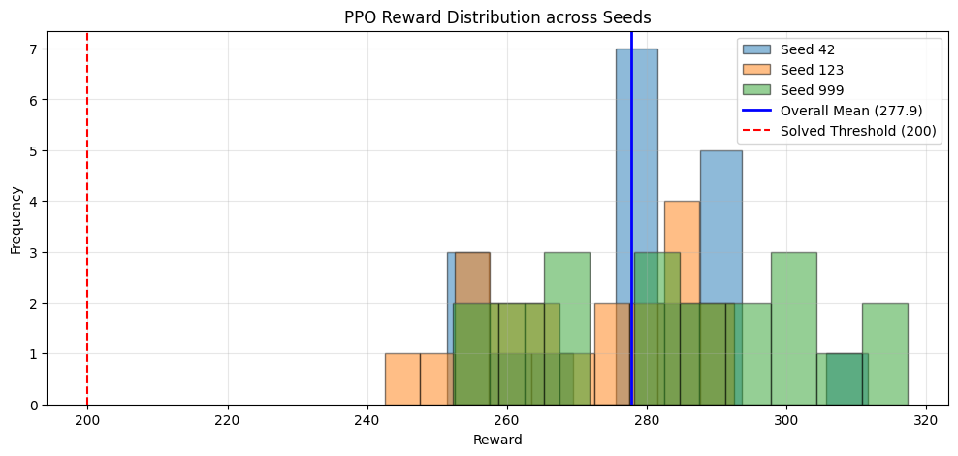

Cross-Algorithm Comparison
# Cross-Algorithm: Combined Summary Table
rows = []
for algo_name in ALGORITHM_MAP:
all_r = np.concatenate([evaluation_results[algo_name][s] for s in SEED_LIST])
rows.append({
"Algorithm": algo_name.upper(),
"Mean Reward": f"{np.mean(all_r):.2f}",
"Std Dev": f"{np.std(all_r):.2f}",
"Min Reward": f"{np.min(all_r):.2f}",
"Max Reward": f"{np.max(all_r):.2f}",
"Success Rate": f"{(all_r >= 200).sum() / len(all_r) * 100:.1f}%"
})
print(f"*** CROSS-ALGORITHM EVALUATION SUMMARY ***")
print(f"Seeds: {SEED_LIST} | Episodes per seed: {EVALUATION_EPISODES}")
print(f"Total episodes per algorithm: {EVALUATION_EPISODES * len(SEED_LIST)}")
print()
print(pd.DataFrame(rows).to_string(index=False))
*** CROSS-ALGORITHM EVALUATION SUMMARY ***
Seeds: [42, 123, 999] | Episodes per seed: 20
Total episodes per algorithm: 60
Algorithm Mean Reward Std Dev Min Reward Max Reward Success Rate
DQN 271.80 45.14 -28.26 319.93 98.3%
PPO 277.86 16.87 242.53 317.36 100.0%
# Cross-Algorithm: Grouped Bar Chart (DQN vs PPO per seed)
algo_names = list(ALGORITHM_MAP.keys())
n_algos = len(algo_names)
n_seeds = len(SEED_LIST)
bar_width = 0.8 / n_algos
x = np.arange(n_seeds)
plt.figure(figsize=(max(10, 3 * n_seeds), 6))
for i, algo_name in enumerate(algo_names):
means = [np.mean(evaluation_results[algo_name][s]) for s in SEED_LIST]
stds = [np.std(evaluation_results[algo_name][s]) for s in SEED_LIST]
offset = (i - (n_algos - 1) / 2) * bar_width
plt.bar(x + offset, means, bar_width, yerr=stds, capsize=4,
label=algo_name.upper(), alpha=0.8)
plt.axhline(y=200, color='red', linestyle='--', label='Solved Threshold (200)')
plt.xticks(x, [str(s) for s in SEED_LIST])
plt.title(f"DQN vs PPO: Mean Reward per Seed ({EVALUATION_EPISODES} episodes each)", fontsize=14)
plt.xlabel("Seed")
plt.ylabel("Mean Reward")
plt.legend()
plt.grid(True, alpha=0.3, axis='y')
plt.show()
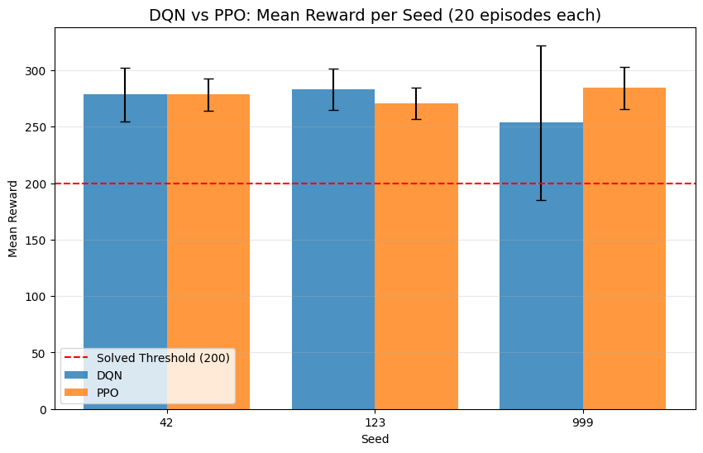
# Cross-Algorithm: Overall Mean Reward Bar Chart
algo_colors = {"dqn": "tab:blue", "ppo": "tab:orange"}
overall_means = []
overall_stds = []
for algo_name in algo_names:
all_r = np.concatenate([evaluation_results[algo_name][s] for s in SEED_LIST])
overall_means.append(np.mean(all_r))
overall_stds.append(np.std(all_r))
plt.figure(figsize=(8, 6))
bars = plt.bar([a.upper() for a in algo_names], overall_means, yerr=overall_stds,
capsize=6, color=[algo_colors[a] for a in algo_names], alpha=0.8)
plt.axhline(y=200, color='red', linestyle='--', label='Solved Threshold (200)')
for bar, mean in zip(bars, overall_means):
plt.text(bar.get_x() + bar.get_width() / 2, bar.get_height() + 5,
f'{mean:.1f}', ha='center', va='bottom', fontweight='bold')
plt.title(f"Overall Mean Reward: DQN vs PPO ({EVALUATION_EPISODES * len(SEED_LIST)} episodes each)", fontsize=14)
plt.ylabel("Mean Reward")
plt.legend()
plt.grid(True, alpha=0.3, axis='y')
plt.show()
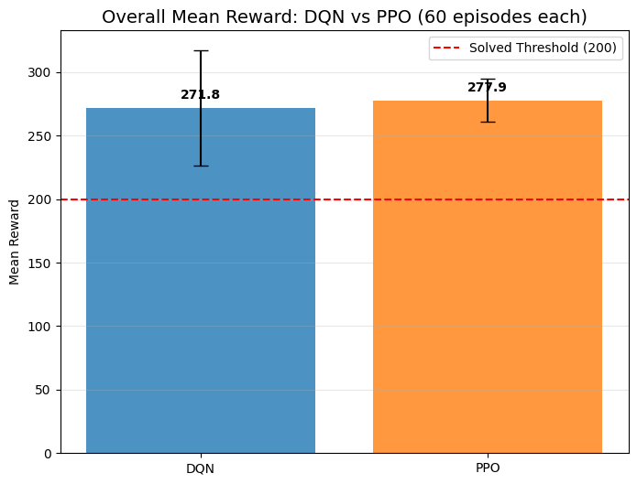
# Cross-Algorithm: Reward Distribution Comparison (overlaid histograms)
plt.figure(figsize=(12, 5))
for algo_name in algo_names:
all_r = np.concatenate([evaluation_results[algo_name][s] for s in SEED_LIST])
plt.hist(all_r, bins=15, alpha=0.5, color=algo_colors[algo_name],
edgecolor='black', label=f"{algo_name.upper()} (mean={np.mean(all_r):.1f})")
plt.axvline(x=200, color='red', linestyle='--', label='Solved Threshold (200)')
plt.title('Reward Distribution: DQN vs PPO (all seeds combined)', fontsize=14)
plt.xlabel('Reward')
plt.ylabel('Frequency')
plt.legend()
plt.grid(True, alpha=0.3)
plt.show()
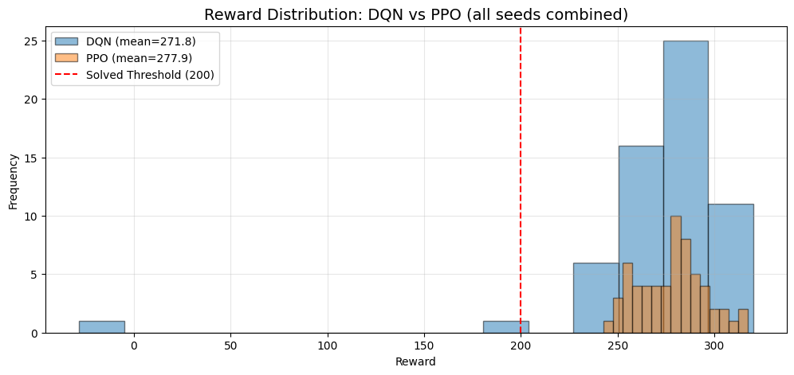
# Cross-Algorithm: Box Plot Comparison per Seed
fig, axes = plt.subplots(1, len(SEED_LIST), figsize=(6 * len(SEED_LIST), 5), sharey=True)
if len(SEED_LIST) == 1:
axes = [axes]
for ax, seed in zip(axes, SEED_LIST):
data = [evaluation_results[algo_name][seed] for algo_name in algo_names]
bp = ax.boxplot(data, labels=[a.upper() for a in algo_names], patch_artist=True)
for patch, algo_name in zip(bp['boxes'], algo_names):
patch.set_facecolor(algo_colors[algo_name])
patch.set_alpha(0.6)
ax.axhline(y=200, color='red', linestyle='--')
ax.set_title(f"Seed {seed}")
ax.grid(True, alpha=0.3)
axes[0].set_ylabel("Reward")
fig.suptitle(f"DQN vs PPO: Reward Distribution per Seed ({EVALUATION_EPISODES} episodes each)", fontsize=14)
plt.tight_layout()
plt.show()
/tmp/ipykernel_86514/3208474440.py:9: MatplotlibDeprecationWarning: The 'labels' parameter of boxplot() has been renamed 'tick_labels' since Matplotlib 3.9; support for the old name will be dropped in 3.11.
bp = ax.boxplot(data, labels=[a.upper() for a in algo_names], patch_artist=True)
/tmp/ipykernel_86514/3208474440.py:9: MatplotlibDeprecationWarning: The 'labels' parameter of boxplot() has been renamed 'tick_labels' since Matplotlib 3.9; support for the old name will be dropped in 3.11.
bp = ax.boxplot(data, labels=[a.upper() for a in algo_names], patch_artist=True)
/tmp/ipykernel_86514/3208474440.py:9: MatplotlibDeprecationWarning: The 'labels' parameter of boxplot() has been renamed 'tick_labels' since Matplotlib 3.9; support for the old name will be dropped in 3.11.
bp = ax.boxplot(data, labels=[a.upper() for a in algo_names], patch_artist=True)
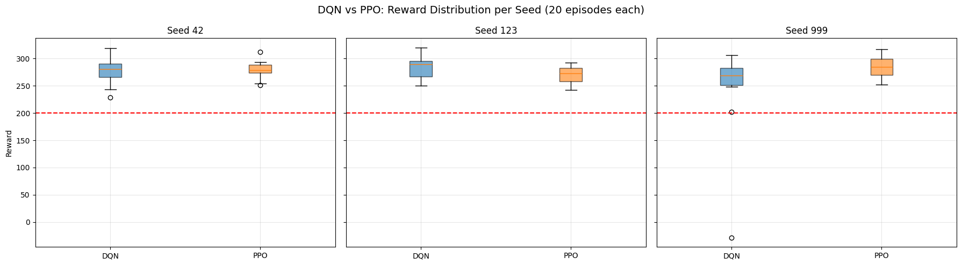

Statistical Significance
# Statistical Significance: Mann-Whitney U Tests
algo_names = list(ALGORITHM_MAP.keys())
# Gather all rewards per algorithm
algo_all_rewards = {}
for algo_name in algo_names:
algo_all_rewards[algo_name] = np.concatenate([evaluation_results[algo_name][s] for s in SEED_LIST])
# --- Reward comparison (Mann-Whitney U) ---
mwu_result = stats.mannwhitneyu(
algo_all_rewards[algo_names[0]],
algo_all_rewards[algo_names[1]],
alternative='two-sided'
)
stat_reward = float(mwu_result.statistic)
p_reward = float(mwu_result.pvalue)
# --- Success rate comparison (Chi-squared) ---
successes = []
totals = []
for algo_name in algo_names:
r = algo_all_rewards[algo_name]
successes.append(int((r >= 200).sum()))
totals.append(len(r))
failures = [t - s for t, s in zip(totals, successes)]
contingency = np.array([successes, failures])
# Chi-squared requires all expected frequencies > 0; skip if any row/col is all-zero
if np.all(contingency.sum(axis=1) > 0) and np.all(contingency.sum(axis=0) > 0):
chi2_result = stats.chi2_contingency(contingency)
chi2 = float(chi2_result[0]) # type: ignore[arg-type] # statistic
p_success = float(chi2_result[1]) # type: ignore[arg-type] # pvalue
chi2_valid = True
else:
chi2, p_success = 0.0, 1.0
chi2_valid = False
# --- Results table ---
chi2_note = "" if chi2_valid else " (skipped: zero row/col)"
rows = [
{
"Metric": "Mean Reward",
f"{algo_names[0].upper()} Value": f"{np.mean(algo_all_rewards[algo_names[0]]):.2f}",
f"{algo_names[1].upper()} Value": f"{np.mean(algo_all_rewards[algo_names[1]]):.2f}",
"Test": "Mann-Whitney U",
"Statistic": f"{stat_reward:.1f}",
"p-value": f"{p_reward:.4f}",
"Significant (p<0.05)": "Yes" if p_reward < 0.05 else "No"
},
{
"Metric": "Success Rate (>=200)",
f"{algo_names[0].upper()} Value": f"{successes[0]/totals[0]*100:.1f}%",
f"{algo_names[1].upper()} Value": f"{successes[1]/totals[1]*100:.1f}%",
"Test": f"Chi-squared{chi2_note}",
"Statistic": f"{chi2:.2f}",
"p-value": f"{p_success:.4f}",
"Significant (p<0.05)": "Yes" if (chi2_valid and p_success < 0.05) else "No"
},
]
print("*** STATISTICAL SIGNIFICANCE TESTS ***")
print(f"Sample size per algorithm: {totals[0]} episodes ({EVALUATION_EPISODES} episodes x {len(SEED_LIST)} seeds)")
print()
print(pd.DataFrame(rows).to_string(index=False))
print()
if not chi2_valid:
print("Note: Chi-squared test skipped because one or both algorithms had 0% or 100% success rate.")
print(" This is expected during smoke tests with few episodes. Full run will have enough data.")
print()
if p_reward < 0.05:
print(f"The reward difference between {algo_names[0].upper()} and {algo_names[1].upper()} is statistically significant (p={p_reward:.4f}).")
else:
print(f"No statistically significant reward difference between {algo_names[0].upper()} and {algo_names[1].upper()} (p={p_reward:.4f}).")
*** STATISTICAL SIGNIFICANCE TESTS ***
Sample size per algorithm: 60 episodes (20 episodes x 3 seeds)
Metric DQN Value PPO Value Test Statistic p-value Significant (p<0.05)
Mean Reward 271.80 277.86 Mann-Whitney U 1780.0 0.9185 No
Success Rate (>=200) 98.3% 100.0% Chi-squared 0.00 1.0000 No
No statistically significant reward difference between DQN and PPO (p=0.9185).

Baseline Comparison
# Random Agent Baseline Evaluation
random_results = {}
for seed in SEED_LIST:
print(f"Running random agent with seed {seed}...")
env = gym.make(GYMNASIUM_MODEL, enable_wind=WIND_ENABLED)
env.action_space.seed(seed)
episode_rewards = []
for ep in range(EVALUATION_EPISODES):
obs, info = env.reset(seed=seed + ep)
total_reward = 0.0
done = False
while not done:
action = env.action_space.sample()
obs, reward, terminated, truncated, info = env.step(action)
total_reward += float(reward)
done = terminated or truncated
episode_rewards.append(total_reward)
random_results[seed] = np.array(episode_rewards)
env.close()
print("Random baseline evaluation complete.")
Running random agent with seed 42...
Running random agent with seed 123...
Running random agent with seed 999...
Random baseline evaluation complete.
# Baseline Comparison: Table + Chart
algo_names = list(ALGORITHM_MAP.keys())
algo_colors = {"dqn": "tab:blue", "ppo": "tab:orange"}
algo_all_rewards = {a: np.concatenate([evaluation_results[a][s] for s in SEED_LIST]) for a in algo_names}
all_random = np.concatenate([random_results[s] for s in SEED_LIST])
rows = [
{
"Agent": "Random",
"Mean Reward": f"{np.mean(all_random):.2f}",
"Std Dev": f"{np.std(all_random):.2f}",
"Min": f"{np.min(all_random):.2f}",
"Max": f"{np.max(all_random):.2f}",
"Success Rate": f"{(all_random >= 200).sum() / len(all_random) * 100:.1f}%"
}
]
for algo_name in algo_names:
all_r = algo_all_rewards[algo_name]
rows.append({
"Agent": algo_name.upper(),
"Mean Reward": f"{np.mean(all_r):.2f}",
"Std Dev": f"{np.std(all_r):.2f}",
"Min": f"{np.min(all_r):.2f}",
"Max": f"{np.max(all_r):.2f}",
"Success Rate": f"{(all_r >= 200).sum() / len(all_r) * 100:.1f}%"
})
rows.append({
"Agent": "Human (ref)",
"Mean Reward": "~200-300",
"Std Dev": "-",
"Min": "-",
"Max": "-",
"Success Rate": "~100%"
})
print("*** BASELINE COMPARISON ***")
print(pd.DataFrame(rows).to_string(index=False))
print()
# Bar chart
agent_labels = ["Random"] + [a.upper() for a in algo_names]
agent_means = [np.mean(all_random)] + [np.mean(algo_all_rewards[a]) for a in algo_names]
agent_stds = [np.std(all_random)] + [np.std(algo_all_rewards[a]) for a in algo_names]
bar_colors = ["gray"] + [algo_colors[a] for a in algo_names]
plt.figure(figsize=(10, 6))
bars = plt.bar(agent_labels, agent_means, yerr=agent_stds, capsize=6,
color=bar_colors, alpha=0.8)
plt.axhline(y=200, color='red', linestyle='--', label='Solved Threshold (200)')
for bar, mean in zip(bars, agent_means):
plt.text(bar.get_x() + bar.get_width() / 2, bar.get_height() + 5,
f'{mean:.1f}', ha='center', va='bottom', fontweight='bold')
plt.title(f"Baseline Comparison: Random vs DQN vs PPO ({EVALUATION_EPISODES * len(SEED_LIST)} episodes each)", fontsize=14)
plt.ylabel("Mean Reward")
plt.legend()
plt.grid(True, alpha=0.3, axis='y')
plt.show()
*** BASELINE COMPARISON ***
Agent Mean Reward Std Dev Min Max Success Rate
Random -205.65 109.48 -420.28 15.45 0.0%
DQN 271.80 45.14 -28.26 319.93 98.3%
PPO 277.86 16.87 242.53 317.36 100.0%
Human (ref) ~200-300 - - - ~100%
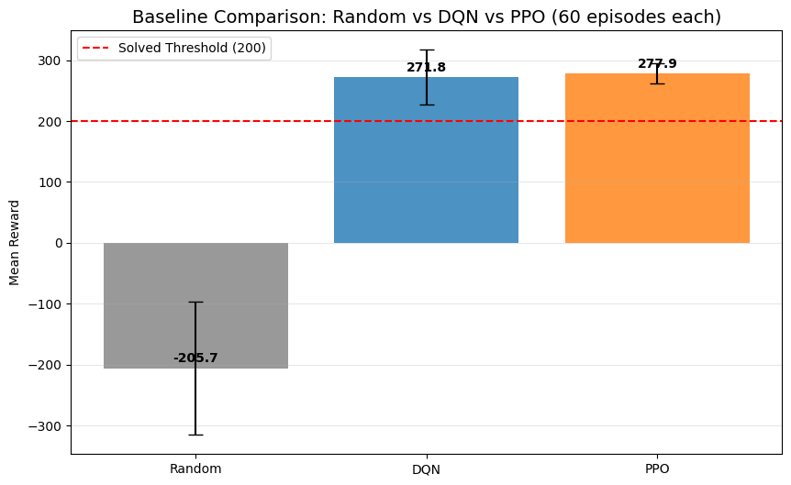

Agent Behavior Analysis
# Collect per-step data: actions and trajectories
action_counts = {} # {algo: np.array of shape (4,)} total action counts
trajectory_data = {} # {algo: list of (x_positions, y_positions)} one per TRAJECTORY_EPISODES
for algo_name, algo_class in ALGORITHM_MAP.items():
action_counts[algo_name] = np.zeros(len(ACTION_LABELS), dtype=int)
trajectory_data[algo_name] = []
for seed in SEED_LIST:
load_path = best_model_paths.get(algo_name, {}).get(seed)
if load_path is None:
continue
def make_env(s=seed):
env = gym.make(GYMNASIUM_MODEL, render_mode="rgb_array", enable_wind=WIND_ENABLED)
env.reset(seed=s)
return env
model = algo_class.load(load_path, env=DummyVecEnv([make_env]), device=DEVICE)
env = gym.make(GYMNASIUM_MODEL, enable_wind=WIND_ENABLED)
for ep in range(EVALUATION_EPISODES):
obs, info = env.reset(seed=seed + ep)
done = False
x_pos, y_pos = [obs[0]], [obs[1]]
while not done:
action, _ = model.predict(obs, deterministic=True)
action_int = int(action)
action_counts[algo_name][action_int] += 1
obs, reward, terminated, truncated, info = env.step(action)
done = terminated or truncated
x_pos.append(obs[0])
y_pos.append(obs[1])
# Keep trajectory for the first TRAJECTORY_EPISODES episodes of the first seed
if seed == SEED_LIST[0] and ep < TRAJECTORY_EPISODES:
trajectory_data[algo_name].append((np.array(x_pos), np.array(y_pos)))
env.close()
total_actions = action_counts[algo_name].sum()
print(f"{algo_name.upper()}: {total_actions:,} total actions collected across {EVALUATION_EPISODES * len(SEED_LIST)} episodes")
print("\nBehavior data collection complete.")
DQN: 17,103 total actions collected across 60 episodes
PPO: 15,857 total actions collected across 60 episodes
Behavior data collection complete.
# Action Distribution: DQN vs PPO
n_actions = len(ACTION_LABELS)
x = np.arange(n_actions)
bar_width = 0.35
fig, (ax1, ax2) = plt.subplots(1, 2, figsize=(16, 6))
# Absolute counts
for i, algo_name in enumerate(algo_names):
offset = (i - 0.5) * bar_width
ax1.bar(x + offset, action_counts[algo_name], bar_width,
label=algo_name.upper(), color=algo_colors[algo_name], alpha=0.8)
ax1.set_xticks(x)
ax1.set_xticklabels(ACTION_LABELS, rotation=15)
ax1.set_title("Action Counts (Absolute)", fontsize=13)
ax1.set_ylabel("Count")
ax1.legend()
ax1.grid(True, alpha=0.3, axis='y')
# Percentage distribution
for i, algo_name in enumerate(algo_names):
pcts = action_counts[algo_name] / action_counts[algo_name].sum() * 100
offset = (i - 0.5) * bar_width
bars = ax2.bar(x + offset, pcts, bar_width,
label=algo_name.upper(), color=algo_colors[algo_name], alpha=0.8)
for bar, pct in zip(bars, pcts):
ax2.text(bar.get_x() + bar.get_width() / 2, bar.get_height() + 0.5,
f'{pct:.1f}%', ha='center', va='bottom', fontsize=9)
ax2.set_xticks(x)
ax2.set_xticklabels(ACTION_LABELS, rotation=15)
ax2.set_title("Action Distribution (Percentage)", fontsize=13)
ax2.set_ylabel("Percentage (%)")
ax2.legend()
ax2.grid(True, alpha=0.3, axis='y')
fig.suptitle(f"DQN vs PPO: Action Distribution ({EVALUATION_EPISODES * len(SEED_LIST)} episodes each)", fontsize=14)
plt.tight_layout()
plt.show()
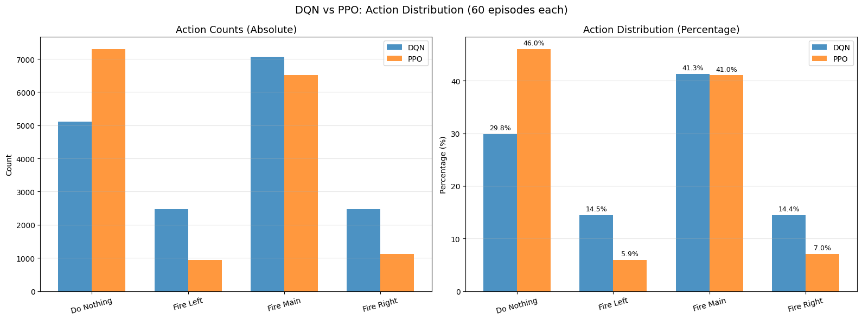
# Trajectory Plots: x-y paths of the lander
fig, axes = plt.subplots(1, len(algo_names), figsize=(8 * len(algo_names), 6), sharey=True)
if len(algo_names) == 1:
axes = [axes]
traj_colors = list(plt.colormaps["Set2"](range(8))) # type: ignore[arg-type]
for ax, algo_name in zip(axes, algo_names):
for i, (x_pos, y_pos) in enumerate(trajectory_data[algo_name]):
ax.plot(x_pos, y_pos, color=traj_colors[i], linewidth=1.5, alpha=0.8,
label=f"Episode {i+1}")
ax.scatter(x_pos[0], y_pos[0], color=traj_colors[i], marker='o', s=60, zorder=5)
ax.scatter(x_pos[-1], y_pos[-1], color=traj_colors[i], marker='x', s=80, zorder=5)
# Landing pad reference
ax.axhline(y=0, color='black', linestyle='-', linewidth=0.5, alpha=0.3)
ax.axvline(x=0, color='black', linestyle='-', linewidth=0.5, alpha=0.3)
ax.scatter(0, 0, color='red', marker='^', s=120, zorder=10, label='Landing Pad')
ax.set_title(f"{algo_name.upper()} Trajectories (seed {SEED_LIST[0]})", fontsize=13)
ax.set_xlabel("X Position")
ax.legend(fontsize=9)
ax.grid(True, alpha=0.3)
axes[0].set_ylabel("Y Position")
fig.suptitle(f"Lander Trajectories: DQN vs PPO ({TRAJECTORY_EPISODES} episodes each)", fontsize=14)
plt.tight_layout()
plt.show()
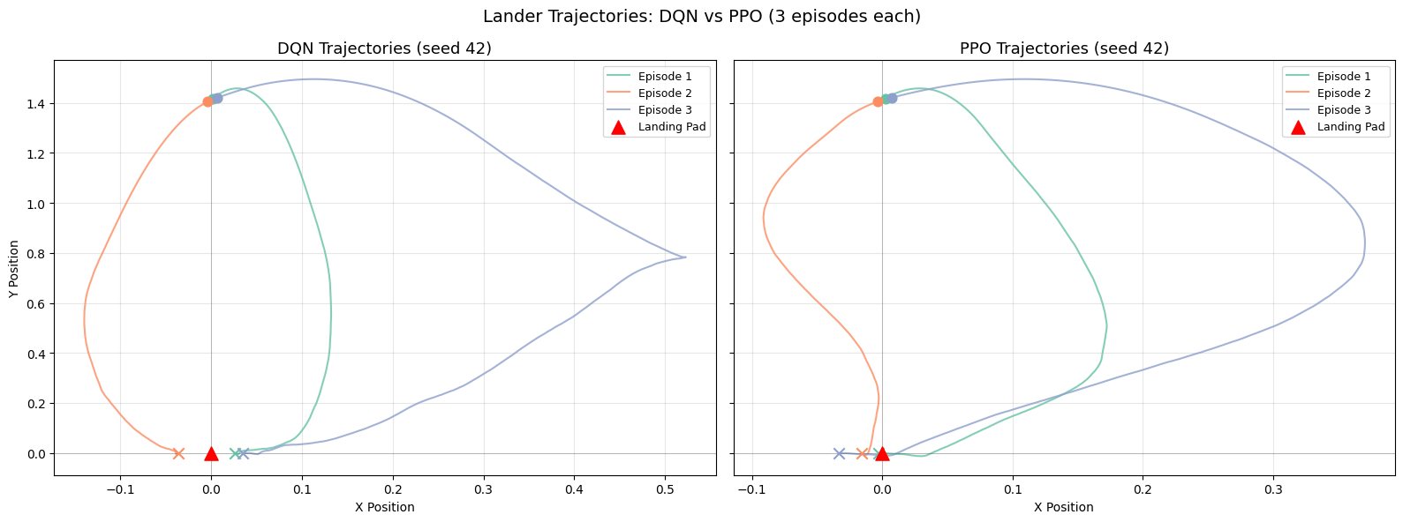
# Trajectory Comparison: DQN vs PPO overlaid on one chart
plt.figure(figsize=(10, 7))
for algo_name in algo_names:
# Plot the first trajectory from each algorithm
x_pos, y_pos = trajectory_data[algo_name][0]
plt.plot(x_pos, y_pos, color=algo_colors[algo_name], linewidth=2, alpha=0.8,
label=f"{algo_name.upper()}")
plt.scatter(x_pos[0], y_pos[0], color=algo_colors[algo_name], marker='o', s=80, zorder=5)
plt.scatter(x_pos[-1], y_pos[-1], color=algo_colors[algo_name], marker='x', s=100, zorder=5)
plt.scatter(0, 0, color='red', marker='^', s=150, zorder=10, label='Landing Pad')
plt.axhline(y=0, color='black', linestyle='-', linewidth=0.5, alpha=0.3)
plt.axvline(x=0, color='black', linestyle='-', linewidth=0.5, alpha=0.3)
plt.title(f"DQN vs PPO: Landing Trajectory Comparison (seed {SEED_LIST[0]}, episode 1)", fontsize=14)
plt.xlabel("X Position")
plt.ylabel("Y Position")
plt.legend(fontsize=11)
plt.grid(True, alpha=0.3)
plt.show()
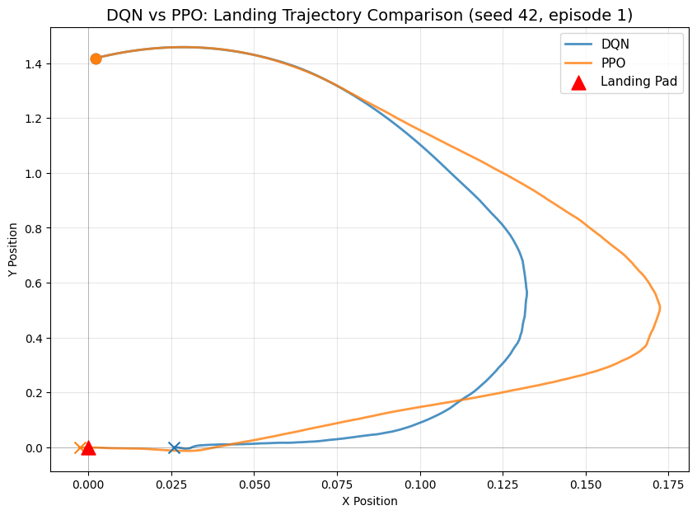

GIF Visualizations
# GIF Visualizations (one per algorithm per seed, best model)
for algo_name, algo_class in ALGORITHM_MAP.items():
output_dir = os.path.join(NOTEBOOK_DIR, "outputs_" + algo_name)
os.makedirs(output_dir, exist_ok=True)
for seed in SEED_LIST:
load_path = best_model_paths.get(algo_name, {}).get(seed)
if load_path is None:
print(f"SKIPPING GIF for {algo_name.upper()} seed {seed} — best model not found")
continue
print(f"Generating GIF for {algo_name.upper()} seed {seed} (best model)...")
def make_vis_env(s=seed):
env = gym.make(GYMNASIUM_MODEL, render_mode="rgb_array", enable_wind=WIND_ENABLED)
env.reset(seed=s)
return env
vis_model = algo_class.load(load_path, env=DummyVecEnv([make_vis_env]), device=DEVICE)
vis_env = gym.make(GYMNASIUM_MODEL, render_mode="rgb_array", enable_wind=WIND_ENABLED)
frames = []
obs, info = vis_env.reset(seed=seed)
done = False
while not done:
action, _ = vis_model.predict(obs, deterministic=True)
obs, reward, terminated, truncated, info = vis_env.step(action)
done = terminated or truncated
frames.append(vis_env.render())
vis_env.close()
gif_path = os.path.join(output_dir, f"{algo_name}_seed{seed}.gif")
imageio.mimsave(gif_path, frames, fps=30)
print(f" Saved: {gif_path}")
display(Image(filename=gif_path))
Generating GIF for DQN seed 42 (best model)...
Saved: /home/logus/env/iscte/taap_p2/drafts/draft_01/gymnasium/outputs_dqn/dqn_seed42.gif
<IPython.core.display.Image object>
Generating GIF for DQN seed 123 (best model)...
Saved: /home/logus/env/iscte/taap_p2/drafts/draft_01/gymnasium/outputs_dqn/dqn_seed123.gif
<IPython.core.display.Image object>
Generating GIF for DQN seed 999 (best model)...
Saved: /home/logus/env/iscte/taap_p2/drafts/draft_01/gymnasium/outputs_dqn/dqn_seed999.gif
<IPython.core.display.Image object>
Generating GIF for PPO seed 42 (best model)...
Saved: /home/logus/env/iscte/taap_p2/drafts/draft_01/gymnasium/outputs_ppo/ppo_seed42.gif
<IPython.core.display.Image object>
Generating GIF for PPO seed 123 (best model)...
Saved: /home/logus/env/iscte/taap_p2/drafts/draft_01/gymnasium/outputs_ppo/ppo_seed123.gif
<IPython.core.display.Image object>
Generating GIF for PPO seed 999 (best model)...
Saved: /home/logus/env/iscte/taap_p2/drafts/draft_01/gymnasium/outputs_ppo/ppo_seed999.gif
<IPython.core.display.Image object>

Appendix: Experimental Setup

Environment Details
Property | Value
Environment | LunarLander-v3 (Gymnasium)
Observation Space | Box(8,) — continuous 8-dimensional vector
Action Space | Discrete(4) — do nothing, fire left, fire main, fire right
Solved Threshold | Mean reward >= 200 over 100 consecutive episodes
Wind | Disabled (enable_wind=False)
Observation vector: [x, y, vx, vy, angle, angular_velocity, left_leg_contact, right_leg_contact]
Reward structure: - Moving toward the landing pad: positive - Moving away: negative - Crash: -100 - Successful landing: +100 - Each leg ground contact: +10 - Firing main engine: -0.3 per frame - Firing side engine: -0.03 per frame
Termination rules: - Terminated (success): The lander comes to rest on the ground with both legs in contact, near-zero velocity - Terminated (crash): The lander body contacts the ground, or the lander moves outside the viewport boundaries - Truncated (timeout): The episode exceeds 1000 timesteps without termination
# Environment inspection
env_tmp = gym.make(GYMNASIUM_MODEL, enable_wind=WIND_ENABLED)
print(f"Environment: {GYMNASIUM_MODEL}")
print(f"Observation space: {env_tmp.observation_space}")
print(f"Action space: {env_tmp.action_space}")
print(f"Wind enabled: {WIND_ENABLED}")
obs, info = env_tmp.reset(seed=42)
print(f"\nSample observation: {obs}")
print(f"Observation labels: [x, y, vx, vy, angle, angular_vel, left_leg, right_leg]")
env_tmp.close()
Environment: LunarLander-v3
Observation space: Box([ -2.5 -2.5 -10. -10. -6.2831855 -10.
-0. -0. ], [ 2.5 2.5 10. 10. 6.2831855 10.
1. 1. ], (8,), float32)
Action space: Discrete(4)
Wind enabled: False
Sample observation: [ 0.00229702 1.4181306 0.2326471 0.3204666 -0.00265488 -0.05269805
0. 0. ]
Observation labels: [x, y, vx, vy, angle, angular_vel, left_leg, right_leg]
# System and library versions
import stable_baselines3
print(f"Python: {sys.version.split()[0]}")
print(f"PyTorch: {torch.__version__}")
print(f"Stable-Baselines3: {stable_baselines3.__version__}")
print(f"Gymnasium: {gym.__version__}")
print(f"NumPy: {np.__version__}")
print(f"Device: {DEVICE}")
print(f"CUDA: {torch.version.cuda if torch.cuda.is_available() else 'Not available'}")
Python: 3.12.3
PyTorch: 2.10.0+cu130
Stable-Baselines3: 2.7.1
Gymnasium: 1.2.3
NumPy: 2.4.2
Device: cpu
CUDA: 13.0

