Vapor Liquid Equilibrium Practice
  - ECH3023 Material and Energy Balances
Five new problems match the five examples in the VLE Toolkit. Work the questions first, then compare with the fully worked solutions. Use the printed data below and keep extrapolation off in the Toolkit.

Model and notation
Assume an ideal liquid solution and an ideal gas vapor. Mole fractions are $x_{\text{i}}$ in liquid, $y_{\text{i}}$ in vapor, and $z_{\text{i}}$ in the overall sample. The vapor fraction is $β=V/F$. Here F is total feed moles, labeled N in the Toolkit; all amounts are molar. At the bubble boundary the liquid has the overall composition; at the dew boundary the vapor has the overall composition. These are different states.
$$y_{\text{i}}P=x_{\text{i}}{P_{\text{i}}}^{sat} P_{\text{b}}=Σ_{\text{i}}x_{\text{i}}{P_{\text{i}}}^{sat} P_{\text{d}}=\frac{1}{Σ_{\text{i}}y_{\text{i}}/{P_{\text{i}}}^{sat}}$$

Antoine data from Table B4
$${\text{log}}_{\text{10}}\left({P_{\text{i}}}^{sat}/\text{mmHg}\right)=A_{\text{i}}−\frac{B_{\text{i}}}{T/°\text{C}+C_{\text{i}}}$$
$$P\left(\text{kPa}\right)=P\left(\text{mmHg}\right)×\frac{101.325}{760}$$
Species | A | B | C | Valid T in °C
Benzene | 6.89272 | 1203.531 | 219.888 | 14.5 to 80.9
Toluene | 6.95805 | 1346.773 | 219.693 | 35.3 to 111.5
Ethylbenzene | 6.95650 | 1423.543 | 213.091 | 56.5 to 137.1
n-Hexane | 6.88555 | 1175.817 | 224.867 | 13.0 to 69.5
n-Heptane | 6.90253 | 1267.828 | 216.823 | 25.9 to 99.3
n-Octane | 6.91874 | 1351.756 | 209.100 | 52.9 to 126.6
Methanol | 8.08097 | 1582.271 | 239.726 | 14.9 to 83.7
Ethanol | 8.11220 | 1592.864 | 226.184 | 19.6 to 93.4

Source: the supplied textbook Table B.4. These are its unstarred coefficient sets. Temperature must be entered in °C and the Antoine pressure comes out in mmHg. Do not substitute a coefficient set from a different source. Water in Problem 5 uses the supplied Table B.3 values directly.

Numerical reporting
Retain full calculator precision while solving. Report temperatures to 0.01°C, pressures to 0.01 kPa, mole fractions to four decimal places, and phase amounts to 0.01 mol. For temperature bisection, retain a sign-changing bracket and stop when its width is below 0.0001°C; the midpoint error is then below 0.00005°C.

Question 1 Aromatic mixture
Use preset 1 · Aromatic mixture. Component order is benzene, toluene, ethylbenzene. The overall composition is $z=\left(0.50,0.30,0.20\right)$; use a 100.0 mol basis. The preset state is 75.00°C and 40.00 kPa.
a. At 75.00°C, calculate the three saturation pressures. Starting from liquid $x=\left(0.50,0.30,0.20\right)$, find the bubble pressure and first vapor composition.
b. In a separate experiment, start with vapor $y=\left(0.50,0.30,0.20\right)$ at 75.00°C. Find the dew pressure and first liquid composition.
c. At 40.00 kPa, find the bubble and dew temperatures for the stated overall composition. Show the residual equation, starting bracket, first four bisection steps, and convergence rule. Report the incipient vapor at the bubble point and incipient liquid at the dew point.
d. Classify the 100.0 mol sample at 75.00°C and 40.00 kPa. Extension: determine the amount and composition of each phase by an isothermal flash calculation.
The shared Antoine interval is 56.5–80.9°C. In the Toolkit, use the pressure versus temperature view for the phase envelope and the selected calculation for the boundary values.
Work and checks
_____________________________________________________________________________________
_____________________________________________________________________________________
_____________________________________________________________________________________
_____________________________________________________________________________________
_____________________________________________________________________________________
_____________________________________________________________________________________
_____________________________________________________________________________________
_____________________________________________________________________________________
_____________________________________________________________________________________
_____________________________________________________________________________________

Question 2 Binary phase diagrams
Use preset 2 · Benzene + toluene. Let B denote benzene and T denote toluene. A 100.0 mol sample has $z_{\text{B}}=0.500$ and is at 60.00°C and 30.00 kPa.
a. Construct the P–x–y diagram at 60.00°C using the six liquid compositions below. For each row calculate its bubble pressure and equilibrium vapor composition. Plot pressure against liquid composition for the bubble curve and against vapor composition for the dew curve.
b. Construct the T–x–y diagram at 30.00 kPa using the same liquid compositions. Solve the bubble-temperature equation at each row, then calculate its vapor composition. Include both pure endpoints and label the single-phase and two-phase regions.
$x_{\text{B}}$ | P in kPa at 60°C | $y_{\text{B}}$ at 60°C | T in °C at 30 kPa | $y_{\text{B}}$ at 30 kPa
0.00
0.20
0.40
0.60
0.80
1.00

c. Draw the horizontal tie line for the sample state on each diagram. Determine its equilibrium liquid and vapor compositions, then apply the lever rule to obtain the liquid and vapor amounts.
d. At $z_{\text{B}}=0.500$ and 30.00 kPa, calculate the bubble and dew temperatures. Locate 60.00°C between these limits. Explain why the liquid and vapor compositions differ from the overall composition.
Work and checks
_____________________________________________________________________________________
_____________________________________________________________________________________
_____________________________________________________________________________________
_____________________________________________________________________________________
_____________________________________________________________________________________
_____________________________________________________________________________________

Question 3 Alkane mixture
Use preset 3 · Three alkanes. Component order is n-hexane, n-heptane, n-octane. The overall composition is $z=\left(0.40,0.35,0.25\right)$; use a 100.0 mol basis. The preset state is 60.00°C and 34.00 kPa.
a. At 60.00°C, calculate the pure-component saturation pressures. For liquid $x=\left(0.40,0.35,0.25\right)$, calculate its bubble pressure and the first vapor composition.
b. For a separate vapor with $y=\left(0.40,0.35,0.25\right)$ at 60.00°C, calculate the dew pressure and first liquid composition.
c. At 34.00 kPa, calculate the bubble and dew temperatures for the given overall composition. Show both residual equations and verify that the roots lie in the shared interval 52.9–69.5°C.
d. Classify the 100.0 mol sample at 60.00°C and 34.00 kPa. Extension: determine the liquid and vapor compositions and amounts.
Use this problem to check which component becomes enriched in the first vapor and in the first liquid. State your interpretation in words.
Work and checks
_____________________________________________________________________________________
_____________________________________________________________________________________
_____________________________________________________________________________________
_____________________________________________________________________________________
_____________________________________________________________________________________
_____________________________________________________________________________________
_____________________________________________________________________________________
_____________________________________________________________________________________
_____________________________________________________________________________________
_____________________________________________________________________________________
_____________________________________________________________________________________
_____________________________________________________________________________________

Question 4 An ideal alcohol mixture
Use preset 4 · Methanol + ethanol. Let M denote methanol and E denote ethanol. Take $z=\left(0.50,0.50\right)$, a 100.0 mol basis, and the preset state 62.50°C and 70.00 kPa. Apply the ideal liquid and ideal vapor assumptions throughout this calculation.
a. At 70.00 kPa, calculate the bubble and dew temperatures for the equimolar composition.
b. At 62.50°C, calculate the saturation pressures and the equimolar bubble and dew pressures. Classify the sample at 70.00 kPa.
c. At 62.50°C and 70.00 kPa, find the equilibrium liquid and vapor compositions and amounts.
d. Construct a T–x–y table at 70.00 kPa for the six liquid mole fractions below. State what the ideal-solution assumption means and whether these results alone establish the real mixture behavior.
$x_{\text{M}}$ | T in °C | $y_{\text{M}}$
0.00
0.20
0.40
0.60
0.80
1.00

Work and checks
_____________________________________________________________________________________
_____________________________________________________________________________________
_____________________________________________________________________________________
_____________________________________________________________________________________
_____________________________________________________________________________________
_____________________________________________________________________________________
_____________________________________________________________________________________
_____________________________________________________________________________________

Question 5 Water from a property table
Use preset 5 · Pure water and the Vapor pressures tab. This preset uses Table B.3; the required liquid-water entries from the supplied table are reproduced below. These are tabulated pressures, so no Antoine equation is needed.
Temperature in °C | Saturation pressure in mmHg
4.3 | 6.230
25.0 | 23.756
25.3 | 24.182
25.4 | 24.326
100.0 | 760.00

a. Read the saturation pressures at 4.3°C and 25.0°C. Express each in both mmHg and kPa.
b. Use linear interpolation between 25.3°C and 25.4°C to estimate the saturation pressure at 25.35°C. Show the temperature fraction and pressure increment.
c. Find the saturation temperature at 101.325 kPa. Explain why the pure-fluid bubble and dew temperatures coincide.
d. Classify pure water at 25.00°C and 101.325 kPa. At 100.00°C and the same pressure, can temperature and pressure alone determine the liquid and vapor amounts? Explain.
Work and checks
_____________________________________________________________________________________
_____________________________________________________________________________________
_____________________________________________________________________________________
_____________________________________________________________________________________
_____________________________________________________________________________________
_____________________________________________________________________________________
_____________________________________________________________________________________
_____________________________________________________________________________________
_____________________________________________________________________________________

Solution 1 Bubble and dew pressures
Use the component order benzene, toluene, ethylbenzene. Parts a and b refer to separate boundary experiments at 75.00°C.

Evaluate the saturation pressures
For benzene, insert °C into the Table B.4 equation, then convert the resulting mmHg to kPa:
$${\text{log}}_{\text{10}}\left({P_{\text{B}}}^{sat}/\text{mmHg}\right)=6.89272−\frac{1203.531}{75.00+219.888}$$
$${P_{\text{B}}}^{sat}={10}^{6.89272−1203.531/\left(75.00+219.888\right)}×\frac{101.325}{760}=86.35896\text{ kPa}$$
Species | ${P_{\text{i}}}^{sat}$ in kPa | $z_{\text{i}}{P_{\text{i}}}^{sat}$ in kPa | $z_{\text{i}}/{P_{\text{i}}}^{sat}$ in kPa⁻¹
Benzene | 86.35896 | 43.17948 | 0.0057898
Toluene | 32.57353 | 9.77206 | 0.0092099
Ethylbenzene | 13.80723 | 2.76145 | 0.0144852

Part a Bubble pressure and first vapor
$$P_{\text{b}}=Σ_{\text{i}}x_{\text{i}}{P_{\text{i}}}^{sat}=43.17948+9.77206+2.76145=55.71299\text{ kPa}$$
$$y_{\text{i}}=\frac{x_{\text{i}}{P_{\text{i}}}^{sat}}{P_{\text{b}}} → y=\left(0.77503,0.17540,0.04957\right)$$
For example, the benzene vapor fraction is 43.17948/55.71299 = 0.77503. The unrounded vapor fractions sum to 1. The first vapor is enriched in the most volatile component, benzene.

Part b Dew pressure and first liquid
$$P_{\text{d}}=\frac{1}{0.005789787+0.009209932+0.014485160}=33.91569\text{ kPa}$$
$$x_{\text{i}}=\frac{y_{\text{i}}P_{\text{d}}}{{P_{\text{i}}}^{sat}} → x=\left(0.19636,0.31236,0.49127\right)$$
Substitute the specified vapor fraction for each species separately:
$$x_{\text{B}}=\frac{0.50×33.91569}{86.35896}=0.19636 x_{\text{T}}=\frac{0.30×33.91569}{32.57353}=0.31236$$
$$x_{\text{E}}=\frac{0.20×33.91569}{13.80723}=0.49127$$
The unrounded liquid fractions sum to 1; the displayed rounded values may differ slightly. The first liquid is enriched in the least volatile component, ethylbenzene.
Answers: bubble pressure 55.71 kPa; dew pressure 33.92 kPa. The two reported composition vectors are incipient phases at different pressures.

Solution 1 Bubble and dew temperatures
Part c fixes pressure at 40.00 kPa and composition at (0.50, 0.30, 0.20). Recalculate all three saturation pressures whenever the trial temperature changes.
$$f_{\text{b}}\left(T\right)=0.50{P_{\text{B}}}^{sat}\left(T\right)+0.30{P_{\text{T}}}^{sat}\left(T\right)+0.20{P_{\text{E}}}^{sat}\left(T\right)−40.00$$
$$f_{\text{d}}\left(T\right)=\frac{20.00}{{P_{\text{B}}}^{sat}\left(T\right)}+\frac{12.00}{{P_{\text{T}}}^{sat}\left(T\right)}+\frac{8.00}{{P_{\text{E}}}^{sat}\left(T\right)}−1$$
Start both searches in the shared range [56.5, 80.9]°C. For the bubble residual, the endpoint values are -10.88650 and 27.40357 kPa. For the dew residual, they are 1.444818 and -0.046620. Each pair has opposite signs.

Bisection steps
At each step evaluate the midpoint and keep the half interval whose endpoint residuals have opposite signs. For the bubble search, 68.7°C gives a positive residual, so the new interval is [56.5, 68.7]°C. The next midpoint, 62.6°C, gives a negative residual, so retain [62.6, 68.7]°C. For the dew search, a positive residual instead places the root above the midpoint.
Iteration | Bubble T °C | Bubble residual kPa | Dew T °C | Dew residual
1 | 68.7000 | 5.077077 | 68.7000 | 0.495168
2 | 62.6000 | -3.605331 | 74.8000 | 0.188117
3 | 65.6500 | 0.549361 | 77.8500 | 0.063041
4 | 64.1250 | -1.573162 | 79.3750 | 0.006426
5 | 64.8875 | -0.523374 | 80.1375 | -0.020527
6 | 65.2688 | 0.010102 | 79.7562 | -0.007160

Continue until the retained bracket is narrower than 0.0001°C. This takes 18 halvings of the initial 24.4°C bracket. The values below were calculated more tightly, then rounded for reporting. A small residual is an additional check, not a replacement for retaining the sign-changing bracket.
Boundary | Temperature in °C | Saturation pressures in kPa | Incipient composition
Bubble | 65.26157 | (62.6502, 22.7342, 9.2732) | Vapor (0.78313, 0.17051, 0.04637)
Dew | 79.55456 | (99.6288, 38.2315, 16.4820) | Liquid (0.20075, 0.31388, 0.48538)

$$\text{Bubble: }y_{\text{i}}=\frac{z_{\text{i}}{P_{\text{i}}}^{sat}}{40.00}\text{ Dew: }x_{\text{i}}=\frac{z_{\text{i}}40.00}{{P_{\text{i}}}^{sat}}$$
Checks: the bubble partial pressures sum to 31.32509 + 6.82027 + 1.85464 = 40.00000 kPa. At the dew point the unrounded liquid fractions sum to 1. Both roots lie in 56.5–80.9°C.

Solution 1 Phase region and flash
Part d uses the overall composition, not a specified liquid or vapor composition. At 75.00°C, 33.91569 < 40.00 < 55.71299 kPa, so the sample contains liquid and vapor. Equivalently, at 40.00 kPa its temperature lies between 65.26157°C and 79.55456°C.

Solve the vapor fraction
$$K_{\text{i}}=\frac{{P_{\text{i}}}^{sat}}{P} → K=\left(2.158974,0.814338,0.345181\right)$$
Let F = 100.0 mol, V be vapor moles, L be liquid moles, and β = V/F. Combine each component balance with equilibrium:
$$z_{\text{i}}=\left(1−β\right)x_{\text{i}}+βy_{\text{i}}\text{ and }y_{\text{i}}=K_{\text{i}}x_{\text{i}}$$
$$x_{\text{i}}=\frac{z_{\text{i}}}{1+β\left(K_{\text{i}}−1\right)}\text{ and }y_{\text{i}}=K_{\text{i}}x_{\text{i}}$$
The Rachford–Rice equation enforces normalized phase compositions:
$$g\left(β\right)=Σ_{\text{i}}\frac{z_{\text{i}}\left(K_{\text{i}}−1\right)}{1+β\left(K_{\text{i}}−1\right)}=0$$
Trial β | Residual g
0.50000 | 0.1107693
0.75000 | -0.0120495
0.62500 | 0.0513540
0.68750 | 0.0204657
0.71875 | 0.0044578

The root lies between 0 and 1. Keep the sign-changing half interval and continue until its width is below 0.000001. The converged result is β = 0.72729104.
$$V=βF=72.72910\text{ mol }L=\left(1−β\right)F=27.27090\text{ mol}$$
Species | $K_{\text{i}}$ | $x_{\text{i}}$ | $y_{\text{i}}$ | Liquid mol | Vapor mol
Benzene | 2.15897 | 0.27131 | 0.58575 | 7.3989 | 42.6011
Toluene | 0.81434 | 0.34683 | 0.28244 | 9.4584 | 20.5416
Ethylbenzene | 0.34518 | 0.38186 | 0.13181 | 10.4136 | 9.5864

Check: each unrounded phase composition sums to 1. For benzene, 7.39886 + 42.60114 = 50.00000 mol, matching the feed. Toluene and ethylbenzene similarly give 30.00000 and 20.00000 mol.
Answer: 27.27 mol liquid and 72.73 mol vapor. These interior-state compositions differ from the incipient compositions in parts a, b, and c.

Solution 2 Pressure composition diagram
Part a: at 60.00°C, the Antoine equation gives benzene saturation pressure 52.18888 kPa and toluene saturation pressure 18.52550 kPa.
$$P=18.52550+33.66338x_{\text{B}}\text{ and }y_{\text{B}}=\frac{52.18888x_{\text{B}}}{P}$$
For the row with liquid benzene fraction 0.40, P = 31.99085 kPa and vapor benzene fraction = (0.40)(52.18888)/31.99085 = 0.65255.
$x_{\text{B}}$ | P in kPa | $y_{\text{B}}$
0.00 | 18.5255 | 0.00000
0.20 | 25.2582 | 0.41324
0.40 | 31.9909 | 0.65255
0.60 | 38.7235 | 0.80864
0.80 | 45.4562 | 0.91849
1.00 | 52.1889 | 1.00000

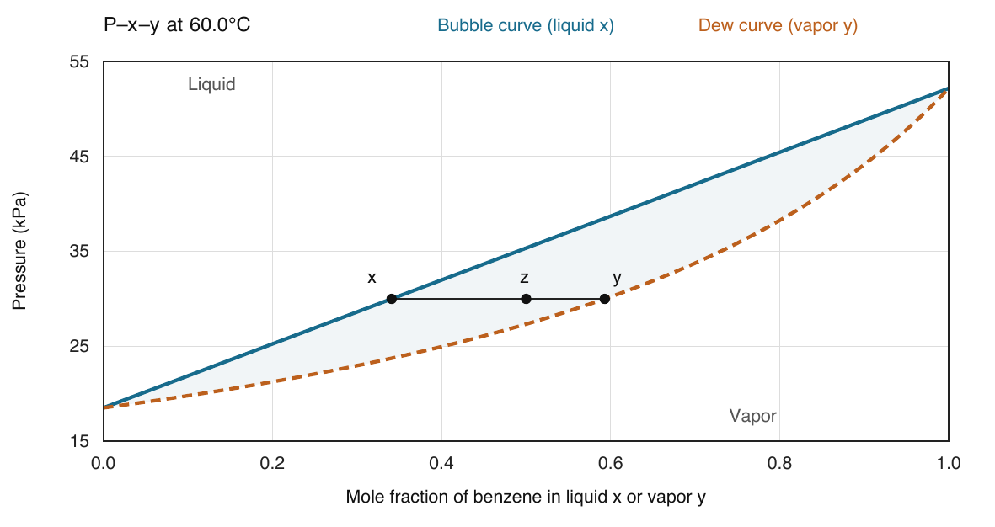
At 60°C, the bubble curve is the upper boundary and the dew curve is the lower boundary. The shaded region is liquid plus vapor. The tie line is at 30 kPa; z marks the overall composition.

Part c Tie line and phase amounts
$$x_{\text{B}}=\frac{30.00−18.52550}{52.18888−18.52550}=0.34086 y_{\text{B}}=\frac{0.34086×52.18888}{30.00}=0.59297$$
$$β=\frac{z_{\text{B}}−x_{\text{B}}}{y_{\text{B}}−x_{\text{B}}}=\frac{0.50000−0.34086}{0.59297−0.34086}=0.63123$$
Thus V = 63.12 mol and L = 36.88 mol. The liquid is (0.34086, 0.65914), and the vapor is (0.59297, 0.40703), in benzene/toluene order. Check: (36.87677)(0.34086) + (63.12323)(0.59297) ≈ 50.000 mol benzene.

Solution 2 Temperature composition diagram
Part b: at each selected liquid composition, solve the following equation for temperature; then use that same temperature to calculate the equilibrium vapor composition.
$$x_{\text{B}}{P_{\text{B}}}^{sat}\left(T\right)+\left(1−x_{\text{B}}\right){P_{\text{T}}}^{sat}\left(T\right)=30.00\text{ then }y_{\text{B}}=\frac{x_{\text{B}}{P_{\text{B}}}^{sat}\left(T\right)}{30.00}$$
$x_{\text{B}}$ | T in °C | $y_{\text{B}}$
0.00 | 72.7130 | 0.00000
0.20 | 64.6158 | 0.40856
0.40 | 58.2674 | 0.65423
0.60 | 53.1189 | 0.81325
0.80 | 48.8293 | 0.92213
1.00 | 45.1776 | 1.00000

For example, at liquid benzene fraction 0.40, the bubble root is 58.26736°C and the vapor benzene fraction is 0.65423. At either pure endpoint, x = y and both curves meet at the pure-component saturation temperature.
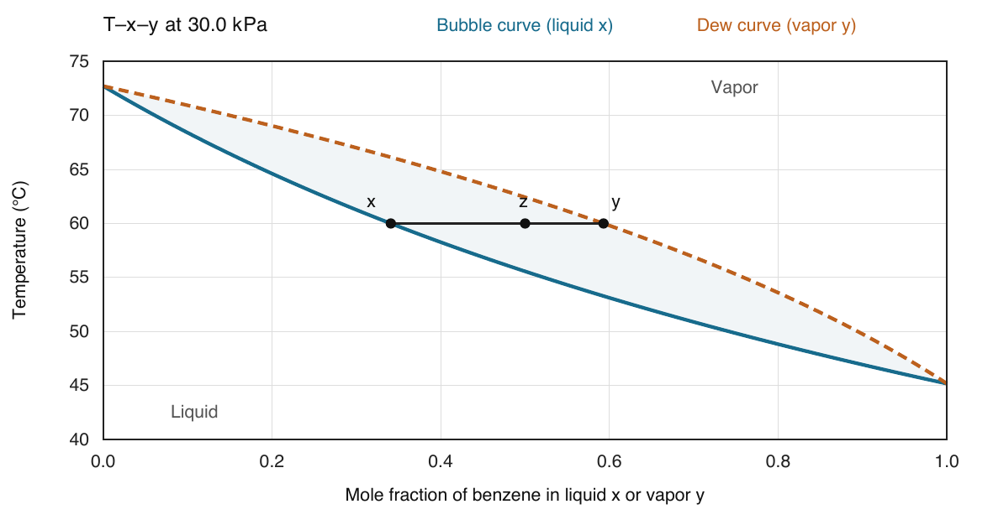
At 30 kPa, the bubble curve is the lower boundary and the dew curve is the upper boundary. The horizontal 60°C tie line has the same endpoint compositions as the P–x–y tie line.

Part d Overall composition and temperature limits
$$0.50{P_{\text{B}}}^{sat}\left(T_{\text{b}}\right)+0.50{P_{\text{T}}}^{sat}\left(T_{\text{b}}\right)=30.00 → T_{\text{b}}=55.56801°\text{C}$$
$$\frac{15.00}{{P_{\text{B}}}^{sat}\left(T_{\text{d}}\right)}+\frac{15.00}{{P_{\text{T}}}^{sat}\left(T_{\text{d}}\right)}=1 → T_{\text{d}}=62.42697°\text{C}$$
Therefore 55.57 < 60.00 < 62.43°C: the state is inside the two-phase region. The overall fraction z is the phase-amount-weighted average of x and y. It generally equals neither phase composition. All tabulated temperatures, including both pure endpoints, are inside the relevant coefficient ranges.

Solution 3 Alkane pressure boundaries
Use n-hexane, n-heptane, n-octane order. At 60.00°C, evaluate the Antoine equation for each species. At a bubble point use x = z; at a dew point use y = z.
Species | ${P_{\text{i}}}^{sat}$ in kPa | $z_{\text{i}}{P_{\text{i}}}^{sat}$ in kPa | $z_{\text{i}}/{P_{\text{i}}}^{sat}$ in kPa⁻¹
n-Hexane | 76.35775 | 30.54310 | 0.0052385
n-Heptane | 28.02271 | 9.80795 | 0.0124899
n-Octane | 10.48082 | 2.62020 | 0.0238531

Part a Bubble pressure
$$P_{\text{b}}=30.54310+9.80795+2.62020=42.97125\text{ kPa}$$
$$y_{\text{i}}=\frac{z_{\text{i}}{P_{\text{i}}}^{sat}}{P_{\text{b}}} → y=\left(0.71078,0.22824,0.06098\right)$$

Part b Dew pressure
$$P_{\text{d}}=\frac{1}{0.005238499+0.012489870+0.023853101}=24.04917\text{ kPa}$$
$$x_{\text{i}}=\frac{z_{\text{i}}P_{\text{d}}}{{P_{\text{i}}}^{sat}} → x=\left(0.12598,0.30037,0.57365\right)$$
The first vapor contains 71.08 mol% n-hexane, compared with 40.00 mol% in the starting liquid. The first liquid contains 57.36 mol% n-octane, compared with 25.00 mol% in the starting vapor. The more volatile component favors vapor, and the less volatile component favors liquid.

Part c Temperature equations at 34 kPa
$$f_{\text{b}}\left(T\right)=0.40{P_{\text{H}}}^{sat}\left(T\right)+0.35{P_{\text{Hp}}}^{sat}\left(T\right)+0.25{P_{\text{O}}}^{sat}\left(T\right)−34.00$$
$$f_{\text{d}}\left(T\right)=\frac{13.60}{{P_{\text{H}}}^{sat}\left(T\right)}+\frac{11.90}{{P_{\text{Hp}}}^{sat}\left(T\right)}+\frac{8.50}{{P_{\text{O}}}^{sat}\left(T\right)}−1$$
Here H, Hp, and O denote n-hexane, n-heptane, and n-octane. Begin with [52.9, 69.5]°C, the common valid interval, and retain a sign-changing bracket at each bisection step.
Iteration | Bubble T °C | Bubble residual kPa | Dew T °C | Dew residual
1 | 61.2000 | 10.808356 | 61.2000 | 0.347320
2 | 57.0500 | 4.711408 | 65.3500 | 0.144478
3 | 54.9750 | 1.924231 | 67.4250 | 0.056800
4 | 53.9375 | 0.592701 | 68.4625 | 0.015978

Convergence gives a bubble temperature of 53.46528°C and a dew temperature of 68.88222°C. Both roots are inside 52.9–69.5°C, so extrapolation is unnecessary.

Solution 3 Alkane phase amounts
Part d: at 60.00°C, the sample pressure satisfies 24.04917 < 34.00 < 42.97125 kPa, so the phase region is liquid plus vapor. At 34.00 kPa, the temperature also satisfies 53.46528 < 60.00 < 68.88222°C.

Flash calculation
$$K_{\text{i}}=\frac{{P_{\text{i}}}^{sat}}{34.00} → K=\left(2.245816,0.824197,0.308259\right)$$
$$g\left(β\right)=Σ_{\text{i}}\frac{z_{\text{i}}\left(K_{\text{i}}−1\right)}{1+β\left(K_{\text{i}}−1\right)}=0$$
Insert z = (0.40, 0.35, 0.25) and the three K values above. For the first trial β = 0.5, the three terms sum to −0.02477755.
Use the same bisection procedure as Solution 1. The first trial values are:
Trial β | Residual g
0.50000 | -0.0247776
0.25000 | 0.1065255
0.37500 | 0.0402675
0.43750 | 0.0078900
0.46875 | -0.0083694

The root is β = 0.45269058. The phase amounts follow directly from the 100.0 mol basis.
$$V=45.26906\text{ mol }L=54.73094\text{ mol}$$
$$x_{\text{i}}=\frac{z_{\text{i}}}{1+β\left(K_{\text{i}}−1\right)}\text{ and }y_{\text{i}}=K_{\text{i}}x_{\text{i}}$$
Species | $K_{\text{i}}$ | $x_{\text{i}}$ | $y_{\text{i}}$ | Liquid mol | Vapor mol
n-Hexane | 2.24582 | 0.25576 | 0.57439 | 13.9980 | 26.0020
n-Heptane | 0.82420 | 0.38026 | 0.31341 | 20.8121 | 14.1879
n-Octane | 0.30826 | 0.36398 | 0.11220 | 19.9208 | 5.0792

Check the component balances: 13.99796 + 26.00204 = 40.00000 mol n-hexane; 20.81215 + 14.18785 = 35.00000 mol n-heptane; 19.92084 + 5.07916 = 25.00000 mol n-octane. Each unrounded composition vector sums to 1.
Answer: 54.73 mol liquid and 45.27 mol vapor. The equilibrium phase compositions are shown in the table.

Solution 4 Ideal alcohol boundaries and flash
The calculations in this solution apply the stated ideal model. M denotes methanol and E denotes ethanol.

Part a Temperature boundaries at 70 kPa
$$0.50{P_{\text{M}}}^{sat}\left(T_{\text{b}}\right)+0.50{P_{\text{E}}}^{sat}\left(T_{\text{b}}\right)=70.00 → T_{\text{b}}=61.51515°\text{C}$$
$$\frac{35.00}{{P_{\text{M}}}^{sat}\left(T_{\text{d}}\right)}+\frac{35.00}{{P_{\text{E}}}^{sat}\left(T_{\text{d}}\right)}=1 → T_{\text{d}}=63.47979°\text{C}$$
Both roots are found by bisection in the shared range 19.6–83.7°C. The first four trial temperatures and residuals are:
Iteration | Bubble T °C | Bubble residual kPa | Dew T °C | Dew residual
1 | 51.6500 | -24.224414 | 51.6500 | 0.683631
2 | 67.6750 | 20.002393 | 67.6750 | -0.160280
3 | 59.6625 | -5.228182 | 59.6625 | 0.177505
4 | 63.6688 | 6.518577 | 63.6688 | -0.007945

Part b Pressure boundaries
The Antoine saturation pressures are 93.42927 kPa for methanol and 52.41188 kPa for ethanol.
$$P_{\text{b}}=0.50\left(93.42927\right)+0.50\left(52.41188\right)=72.92057\text{ kPa}$$
$$P_{\text{d}}=\frac{1}{0.50/93.42927+0.50/52.41188}=67.15256\text{ kPa}$$
Since 67.15256 < 70.00 < 72.92057 kPa, the model predicts liquid plus vapor. The temperature check gives the same result: 61.51515 < 62.50 < 63.47979°C.

Part c Phase compositions and amounts
For a binary mixture, solve the bubble-pressure relation directly at the specified state, then apply the lever rule:
$$x_{\text{M}}=\frac{70.00−52.41188}{93.42927−52.41188}=0.42880 y_{\text{M}}=\frac{x_{\text{M}}93.42927}{70.00}=0.57232$$
$$β=\frac{0.50000−0.42880}{0.57232−0.42880}=0.49612$$
Species | $K_{\text{i}}$ | $x_{\text{i}}$ | $y_{\text{i}}$ | Liquid mol | Vapor mol
Methanol | 1.33470 | 0.42880 | 0.57232 | 21.6062 | 28.3938
Ethanol | 0.74874 | 0.57120 | 0.42768 | 28.7817 | 21.2183

Answer: V = 49.61 mol and L = 50.39 mol. Using unrounded values, the methanol balance is 21.60615 + 28.39385 = 50.00000 mol; the ethanol balance also gives 50.00000 mol.

Solution 4 Ideal alcohol temperature diagram
Part d uses the same row-by-row bubble calculation as Problem 2, now at 70.00 kPa:
$$x_{\text{M}}{P_{\text{M}}}^{sat}\left(T\right)+\left(1−x_{\text{M}}\right){P_{\text{E}}}^{sat}\left(T\right)=70.00\text{ then }y_{\text{M}}=\frac{x_{\text{M}}{P_{\text{M}}}^{sat}\left(T\right)}{70.00}$$
$x_{\text{M}}$ | T in °C | $y_{\text{M}}$
0.00 | 69.2282 | 0.00000
0.20 | 65.9068 | 0.30533
0.40 | 62.9080 | 0.54263
0.60 | 60.1867 | 0.72972
0.80 | 57.7050 | 0.87917
1.00 | 55.4311 | 1.00000

At liquid methanol fraction 0.40, for example, T = 62.90796°C and vapor methanol fraction = 0.54263. The endpoints are the pure ethanol and pure methanol saturation temperatures at 70.00 kPa.
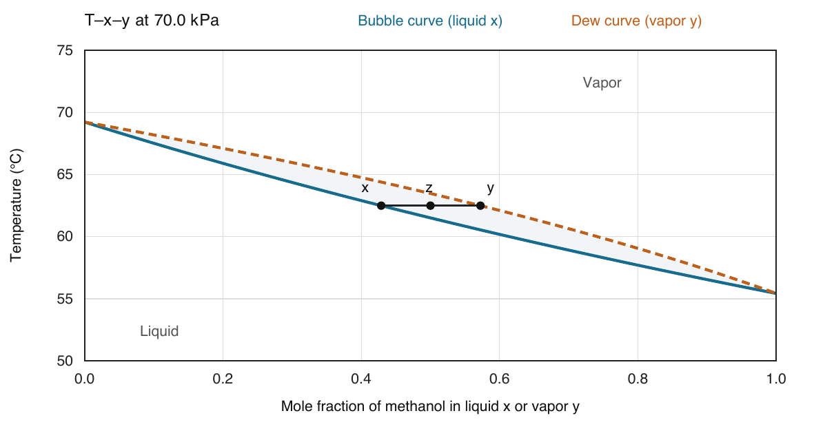
The ideal-model T–x–y diagram at 70 kPa. The 62.5°C tie line joins liquid methanol fraction 0.42880 and vapor methanol fraction 0.57232. The overall fraction is 0.50000.

Interpretation of the assumption
An ideal liquid solution uses an activity coefficient of 1 for every component. Combined with the ideal-vapor approximation, this produces Raoult’s law as used here. These calculations describe that model; the coefficients only supply pure-component vapor pressures and do not establish the accuracy of the liquid-mixture assumption. Real-mixture VLE would require supporting mixture data or a suitable activity-coefficient model.
All values in the table lie inside the selected coefficient ranges, including the two pure endpoints. That validates the use of these vapor-pressure fits at these temperatures; it does not independently validate ideal mixing.

Solution 5 Water table lookup and interpolation

Part a Read and convert
At 4.3°C, the liquid-water row gives 6.230 mmHg. At 25.0°C, it gives 23.756 mmHg. Convert both with the same pressure factor:
$$P^{sat}\left(4.3°\text{C}\right)=6.230×\frac{101.325}{760}=0.830598\text{ kPa}$$
$$P^{sat}\left(25.0°\text{C}\right)=23.756×\frac{101.325}{760}=3.167206\text{ kPa}$$

Part b Linear interpolation
The neighboring pressures are 24.182 mmHg at 25.3°C and 24.326 mmHg at 25.4°C. The target temperature is halfway between them.
$$θ=\frac{25.35−25.30}{25.40−25.30}=0.5000$$
$$ΔP=θ\left(24.326−24.182\right)=0.5000\left(0.144\right)=0.072\text{ mmHg}$$
$$P^{sat}\left(25.35°\text{C}\right)=24.182+0.072=24.254\text{ mmHg}$$
$$P^{sat}=24.254×\frac{101.325}{760}=3.233601\text{ kPa}$$
The interpolated value lies between the two tabulated values, as it should. Linear interpolation assumes the pressure varies linearly over this small 0.1°C interval.

Part c Saturation temperature
$$101.325\text{ kPa}×\frac{760\text{ mmHg}}{101.325\text{ kPa}}=760.00\text{ mmHg}$$
Table B.3 gives 760.00 mmHg at 100.0°C. Therefore the saturation temperature is 100.00°C. For one pure component, x = y = 1, so both the bubble and dew equations reduce to $P=P^{sat}\left(T\right)$. There is one saturation temperature at a specified pressure.

Part d State and phase amount
At 25.00°C, 101.325 kPa exceeds 3.167206 kPa, the pure-water saturation pressure. The equilibrium state is liquid.
At 100.00°C and 101.325 kPa, the fluid is at saturation. Temperature and pressure alone do not determine the phase split. Saturated liquid, saturated vapor, or a mixture can have the same temperature and pressure. An additional property such as total volume or total enthalpy is needed to determine vapor quality.
Answers: 0.83060 kPa at 4.3°C; 3.16721 kPa at 25.0°C; 3.23360 kPa at 25.35°C; saturation temperature 100.00°C at 101.325 kPa.

