Steam Games Multiclass Classification Project Report
Dataset understanding, preprocessing, exploratory analysis, feature engineering, threshold design, model evaluation, and error analysis

1. Project objective
This document summarizes the full analytical workflow used to build and evaluate a multiclass classification pipeline for Steam games. The objective is to predict game reception using three labels derived from player reviews: Bad, Mixed, and Good. The report documents the data exploration stage, preprocessing decisions, engineered features, exploratory data analysis, threshold comparison, model evaluation, and targeted error analysis.

2. Dataset overview and early data exploration
The starting point was the Steam games dataset from Kaggle. In raw form, the working CSV contained 122,611 rows and 39 columns.
During early inspection, one important data-quality issue was detected: some rows were misaligned because CSV parsing split text fields unexpectedly. This was corrected before constructing the final DataFrame, so downstream summaries and modeling steps were based on a repaired tabular structure.
Initial numeric conversion was carried out for variables such as Peak CCU, Positive, Negative, Price, Required age, DiscountDLC count, Achievements, Average playtime forever, Median playtime forever, Recommendations, and Metacritic score.
Columns that were weak, duplicative, or unsuitable for the predictive task were removed before modeling. These included AppID and several media or URL fields such as screenshots, header image, website, review text, support links, and Metacritic URL.
A review-stability filter was then applied. Total reviews were defined as Positive plus Negative, and games with fewer than 10 total reviews were excluded. This reduced the working dataset from 122,611 rows to 56,655 rows and avoided assigning labels to games with unstable reception signals.
Stage | Rows | Columns | Purpose
Raw working CSV | 122,611 | 39 | Initial imported dataset before cleaning
After row repair and weak-column removal | 122,611 | 28 | Cleaned tabular structure before review filter
After review filter (total_reviews >= 10) | 56,655 | 28 | Stable analysis dataset used for target construction

3. Target construction and threshold design
The raw dataset did not provide a direct multiclass reception label. The target was therefore derived from player review data.
Derived variable | Definition | Role in project
total_reviews | Positive + Negative | Filters out games with too few reviews
review_ratio | Positive / total_reviews | Continuous source signal for class assignment
Two threshold schemes were studied. The first scheme used a 0.50 lower boundary and a 0.75 upper boundary. The second scheme used a 0.40 lower boundary and a 0.70 upper boundary. Both were evaluated on the same safe feature space so that threshold choice could be justified empirically rather than only conceptually.
Version | Bad rule | Mixed rule | Good rule | Use
0.50 threshold | Bad < 0.50 | 0.50 <= Mixed < 0.75 | Good >= 0.75 | Project standard after comparison
0.40 threshold | Bad < 0.40 | 0.40 <= Mixed < 0.70 | Good >= 0.70 | Alternative reference threshold evaluated experimentally
The 0.50 threshold was ultimately selected because it produced a more usable multiclass distribution and better overall Macro F1. Most importantly, it nearly doubled the size of the Bad class compared with the 0.40 threshold, which materially improved learnability for the hardest class.
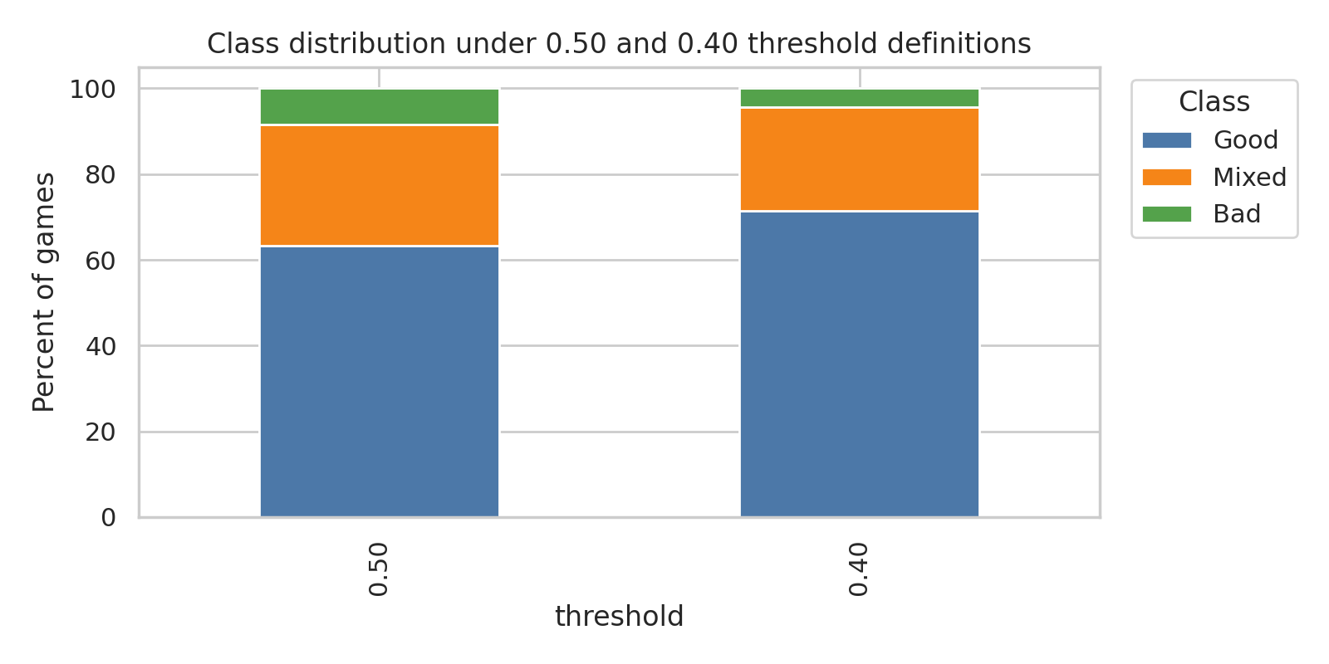
Figure 1. Class distribution under the two threshold definitions.

4. Preprocessing pipeline and saved outputs
The preprocessing notebooks built two parallel versions of the multiclass dataset, one saved under Data0.5 and the other under Data0.4. Both followed the same core pipeline.
- Repair row alignment and convert the main numeric columns.
- Drop weak, non-modeling columns.
- Compute total_reviews and filter out games with fewer than 10 reviews.
- Compute review_ratio and assign the multiclass target.
- Parse Genres, Categories, and Tags and convert them into indicator columns.
- Create engineered metadata features such as log_price, release_year, release_era, platform flags, and n_languages.
- Build two feature sets: a full feature set and a safe feature set.
- Perform stratified train-test split and standardize the continuous safe numeric variables.
The safe feature set was chosen as the main modeling representation. It excluded post-release variables that risked information leakage or were dominated by default values.
Feature decision | Examples |  | Reason
Kept in safe dataset | log_price, Required age, DiscountDLC count, Achievements, Windows, Mac, Linux, n_languages, release era dummies, genres, categories, tags |  | Safer metadata-style predictors available at or close to release time
Removed from safe dataset | Average playtime forever, Median playtime forever, Recommendations, Metacritic score |  | Post-release or leakage-prone variables that could inflate performance unfairly
Saved file |  | Description
X_multiclass_full.csv |  | Full feature matrix
X_multiclass_safe.csv |  | Safe feature matrix used for primary modeling
y_multiclass.csv |  | Multiclass target labels
X_train_multiclass_safe.csv |  | Stratified training features
X_test_multiclass_safe.csv |  | Stratified test features
y_train_multiclass.csv |  | Training labels
y_test_multiclass.csv |  | Test labels
class_summary.csv |  | Class counts and percentages

5. Feature engineering summary
Feature engineering combined structured metadata and parsed store descriptors into a 147-column safe training set.
Feature group | Count | Description
Numeric metadata | 5 | log_price, Required age, DiscountDLC count, Achievements, n_languages
Platform flags | 3 | Windows, Mac, Linux
Release era | 3 | era_pre-2015, era_2015-2019, era_2020+
Genres | 28 | One-hot encoded official genre descriptors
Categories | 58 | Steam store feature labels such as Single-player, Co-op, and controller support
Tags | 50 | Top 50 tags converted to indicator columns
Total | 147 | Final safe training feature count
The feature space is high-dimensional, but most columns are sparse binary indicators. This is an important modeling constraint: the project has many features, but not necessarily many strongly discriminative features. That point later helps explain why Mixed and Bad remain difficult classes.

6. Exploratory data analysis on the revised multiclass-safe dataset
EDA was conducted on the revised multiclass-safe dataset to understand class balance, numeric behavior, descriptor frequencies, and potential risks for modeling.
EDA topic | Result | Interpretation
Class balance | 0.50 threshold produced 63.26% Good, 28.32% Mixed, 8.43% Bad | Still imbalanced, but more learnable than the 0.40 setup
Missing values | No remaining missing values in the safe feature set | No additional imputation required for modeling
Numeric behavior | Achievements, DiscountDLC count, and n_languages showed strong right skew | Large upper-tail values required inspection
Low variation | Required age remained heavily concentrated at zero | Likely weak individual predictor
Category frequencies | Single-player, Family Sharing, and Steam Achievements were common | Many high-frequency features are broad descriptors rather than sharp class separators
Tag frequencies | Singleplayer, Indie, Adventure, Action, Casual, and 2D were frequent | Common tags appear across multiple reception classes
Correlation view | Numeric safe features had weak simple correlations with a Good-vs-rest indicator | Single features do not explain class structure well on their own
Descriptive good-rate analysis suggested that some categories linked to accessibility or player comfort tended to be associated with higher reception, while more competitive or monetization-heavy categories tended to have lower good-reception rates. These findings were treated as descriptive patterns rather than causal claims.

7. Outlier analysis and treatment decision
The main outlier-heavy safe features were Achievements and n_languages. A light-touch robustness check was performed on the 0.50 threshold dataset by capping both features at the 99th percentile, learned from the training set only, and then evaluating Logistic Regression.
Version | Macro F1 | Macro precision | Macro recall
Original safe dataset | 0.3809 | 0.4961 | 0.3949
Capped dataset | 0.3796 | 0.5001 | 0.3939
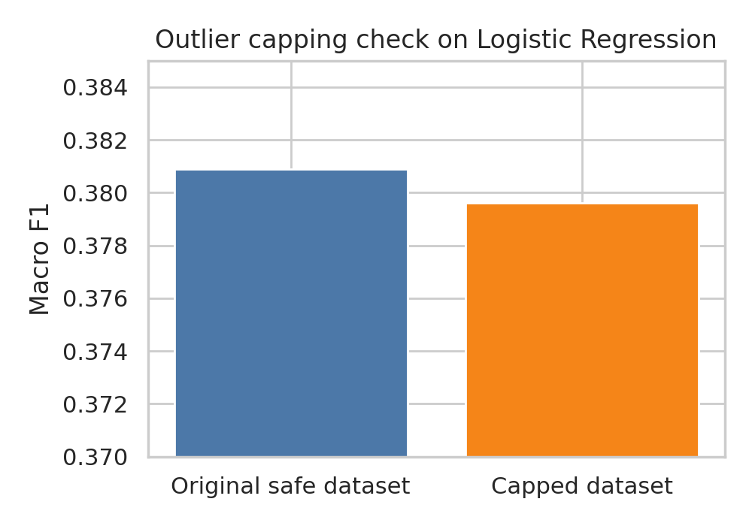
Figure 2. Outlier capping on Achievements and n_languages did not improve Macro F1.
The capped version did not improve Macro F1 and did not improve minority-class recall in a meaningful way. Therefore, explicit outlier capping was not kept in the main preprocessing pipeline. This diagnostic suggested that extreme values in those variables were not the main cause of poor multiclass separation.

8. Modeling setup and hyperparameter optimization
The modeling stage focused on the safe feature set. The main train-test split contained 45,324 training rows and 11,331 test rows.
Nested cross-validation was used in the current notebooks with 5 outer folds and 3 inner folds. Within the inner loop, GridSearchCV selected model-specific hyperparameters. This created tuned models rather than default baselines.
Model | CV setup | Search type | Hyperparameters tested | Imbalance handling
Logistic Regression baseline | 5 outer, 3 inner | GridSearchCV | C in [0.01, 0.1, 1, 10], L2, lbfgs | class_weight='balanced'
Logistic Regression + ROS | 5 outer, 3 inner | GridSearchCV inside ImbPipeline | clf__C in [0.01, 0.1, 1, 10] | RandomOverSampler inside pipeline
Logistic Regression + SMOTE | 5 outer, 3 inner | GridSearchCV inside ImbPipeline | clf__C in [0.01, 0.1, 1, 10] | SMOTE inside pipeline
Random Forest | 5 outer, 3 inner | GridSearchCV | n_estimators in [100, 200], max_depth in [None, 10, 20], min_samples_leaf in [1, 4] | class_weight='balanced'
XGBoost | 5 outer, 3 inner | GridSearchCV | n_estimators in [100, 200], max_depth in [3, 6], learning_rate in [0.05, 0.1] | balanced sample weights
Linear SVM | 5 outer, 3 inner | GridSearchCV | C in [0.01, 0.1, 1, 10] | class_weight='balanced'
KNN | 5 outer, 3 inner | GridSearchCV on 15K subsample | n_neighbors in [5, 11, 21], weights in [uniform, distance], metric in [euclidean, manhattan] | 15K stratified subsample

9. Model comparison results
Model | CV Macro F1 | CV Std | Test Macro F1 | Good F1 | Mixed F1 | Bad F1 | Rank
Random Forest | 0.5093 | 0.0073 | 0.5100 | 0.77 | 0.43 | 0.33 | 1.0
XGBoost | 0.482 | 0.0039 | 0.4799 | 0.73 | 0.39 | 0.31 | 2.0
Linear SVM | 0.468 | 0.0034 | 0.4693 | 0.77 | 0.34 | 0.29 | 3.0
LR + SMOTE | 0.4619 | 0.0064 | 0.4648 | 0.73 | 0.39 | 0.27 | 4.0
KNN | 0.4462 | 0.0066 | 0.4516 | 0.77 | 0.38 | 0.21 | 5.0
LR + class_weight (Baseline) | 0.4385 | 0.0034 | 0.4355 | 0.7 | 0.33 | 0.28 | 6.0
LR + ROS | 0.4376 | 0.0038 | 0.4352 | 0.7 | 0.33 | 0.28 | 7.0
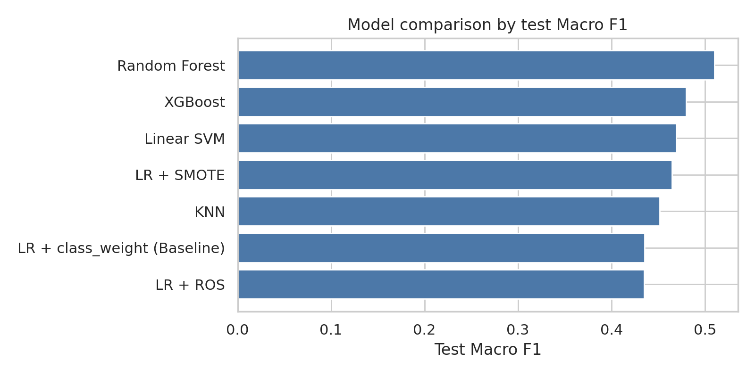
Figure 3. Final model comparison by test Macro F1.
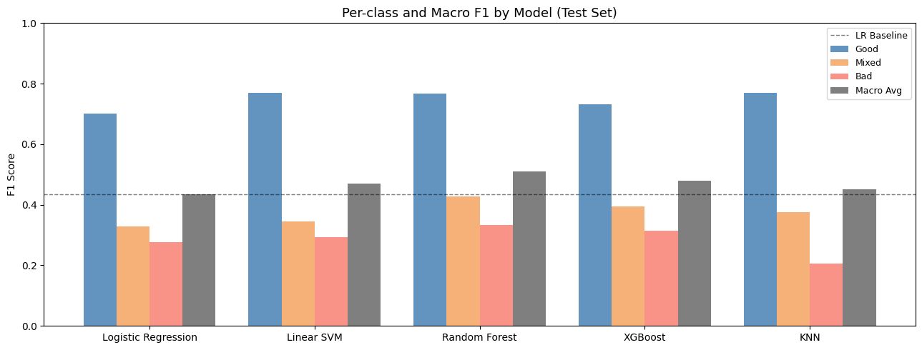
Random Forest was the strongest model overall, with test Macro F1 of 0.5100 and the highest balanced performance across the three classes. XGBoost ranked second, followed by Linear SVM. The best Logistic Regression variant was Logistic Regression with SMOTE, but it remained below the two strongest tree-based methods.
The ranking suggests that the task benefits from non-linear modeling. This is plausible because the feature space contains many overlapping binary metadata indicators, and tree-based models can capture non-linear interactions between them more effectively than purely linear baselines.

10. Imbalance handling comparison
Strategy | CV Macro F1 | CV Std | Test Macro F1 | Good F1 | Mixed F1 | Bad F1 | vs Baseline
LR + SMOTE | 0.4619 | 0.0064 | 0.4648 | 0.73 | 0.39 | 0.27 | +0.0293
LR + class_weight=balanced (BASELINE) | 0.4385 | 0.0034 | 0.4355 | 0.7 | 0.33 | 0.28 | ---
LR + ROS | 0.4376 | 0.0038 | 0.4352 | 0.7 | 0.33 | 0.28 | -0.0003
Balancing strategies were compared systematically on the base model, Logistic Regression. SMOTE was the only approach that gave a meaningful gain over the class_weight baseline, improving Macro F1 from 0.4355 to 0.4648. ROS was essentially identical to the baseline, which suggests that simple duplication added little new information. SMOTE improved overall multiclass balance, although the Bad-class F1 was slightly lower than in the baseline. This supports SMOTE as a promising strategy, but the comparison was documented explicitly on the base model rather than assumed universally.

11. Threshold experiment: why the 0.50 threshold was chosen
Setting | Good % | Mixed % | Bad % | CV Macro F1 | Test Macro F1 | Good F1 | Mixed F1 | Bad F1
0.50 threshold | 63.3% | 28.3% | 8.4% | 0.4385 | 0.4355 | 0.70 | 0.33 | 0.28
0.40 threshold | 71.4% | 24.3% | 4.3% | 0.4173 | 0.4135 | 0.72 | 0.35 | 0.17
Difference (0.50 - 0.40) | -8.1 pp | +4.0 pp | +4.1 pp | +0.0212 | +0.0220 | -0.02 | -0.02 | +0.11
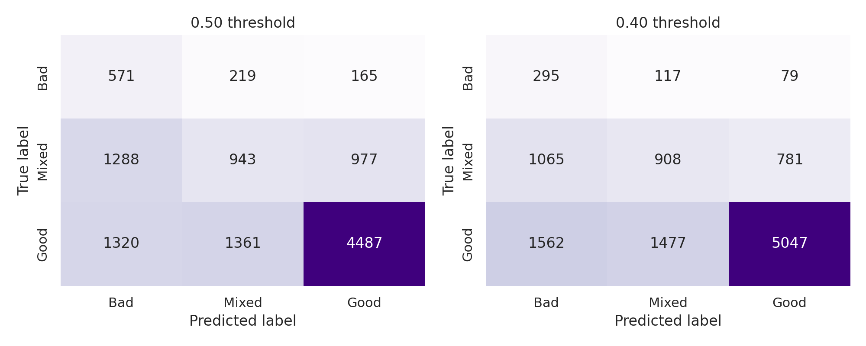
Figure 4. Logistic Regression confusion matrices under the 0.50 and 0.40 thresholds.
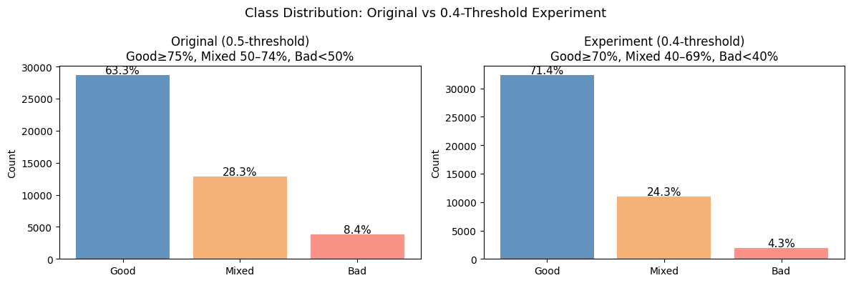
The 0.40 threshold is closer to a Steam-style natural review boundary, but it makes the Bad class too small. Under the 0.40 version, the Bad class falls to only 4.3% of the data. Under the 0.50 version, the Bad class rises to 8.4%. That change nearly doubles the number of Bad examples available for learning.
The threshold comparison shows that 0.40 is slightly better for Good and Mixed F1, but it hurts the Bad class severely. Bad F1 drops from 0.28 under the 0.50 threshold to 0.17 under the 0.40 threshold. Because Macro F1 values all classes equally, this collapse in the Bad class outweighs the small gains in the other two classes.
Additional error profiling showed that the 0.50 threshold also reduced far errors, meaning fewer cases where the model jumped across the full class range, such as Bad predicted as Good or Good predicted as Bad. Therefore, the 0.50 threshold was selected as the project standard because it is better for the multiclass prediction task, even though it is not the more natural Steam-style boundary.

12. Random Forest feature analysis and error analysis
Class | Precision | Recall | F1 | Support
Bad | 0.2971 | 0.3864 | 0.3359 | 955
Good | 0.7758 | 0.7596 | 0.7676 | 7168
Mixed | 0.4423 | 0.4233 | 0.4326 | 3208
Macro average | 0.5051 | 0.5231 | 0.5120 | 11331
Random Forest delivered the best overall multiclass result. Its strongest class remained Good, but it also improved the Bad class substantially compared with Logistic Regression.
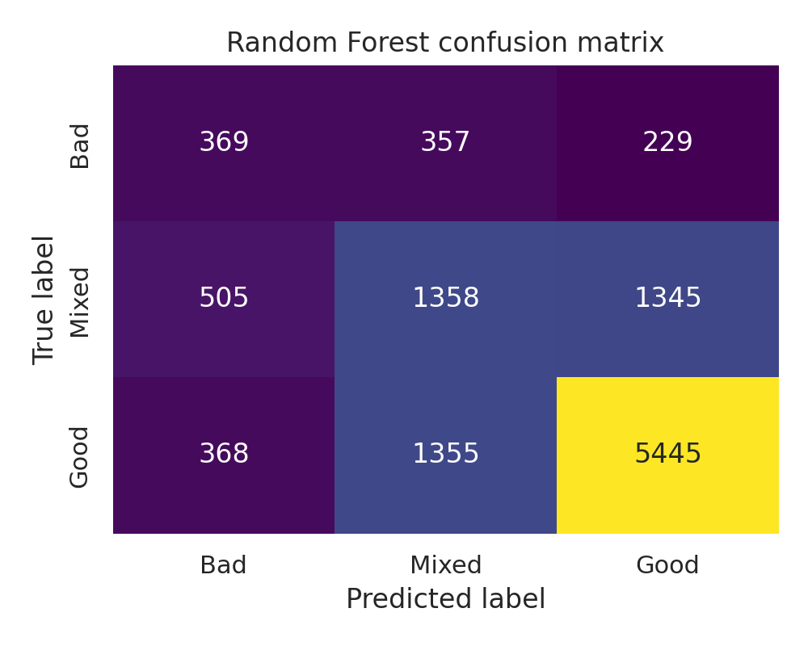
Figure 5. Random Forest confusion matrix on the 0.50-threshold safe test set.
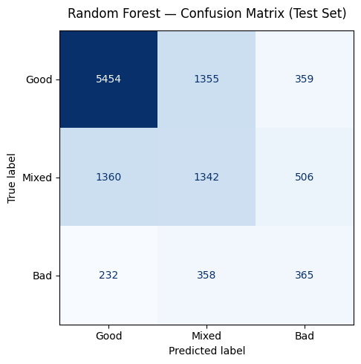
Error type | Count | Percent
Correct predictions | 7172 | 63.30%
Adjacent errors | 3562 | 31.44%
Far errors | 597 | 5.27%
This error-distance analysis is important. Most mistakes were adjacent rather than far. In other words, the model was often slightly off rather than completely wrong. That is consistent with a task where the class boundaries are fuzzy rather than sharply separated.
Most common wrong prediction pair | Count
Good -> Mixed | 1355
Mixed -> Good | 1345
Mixed -> Bad | 505
Good -> Bad | 368
Bad -> Mixed | 357
Bad -> Good | 229
The most frequent mistakes occurred between neighboring classes, especially Good and Mixed. This indicates that the central difficulty in the project is class ambiguity around borderline games, not only a simple majority-class collapse.
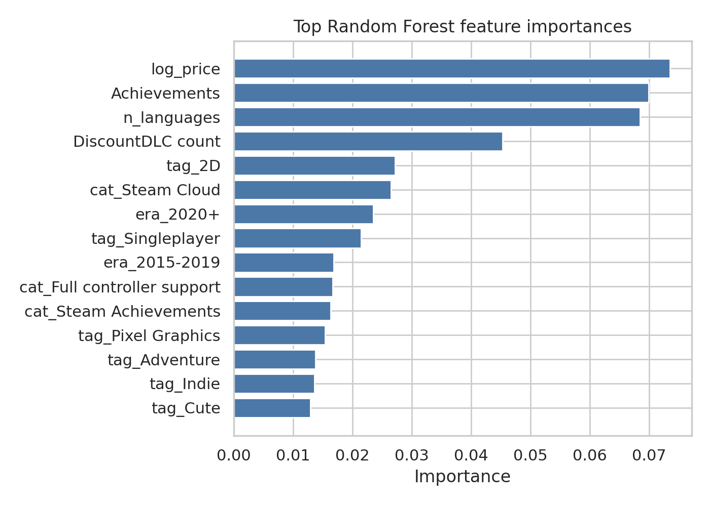
Figure 6. Top Random Forest feature importances.
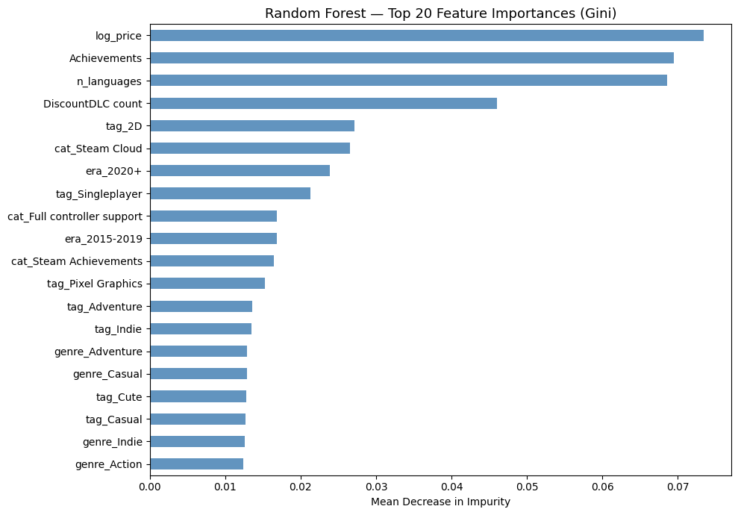
The most influential Random Forest features combined numeric metadata and store descriptors. The top features were log_price, Achievements, n_languages, DiscountDLC count, and a mixture of tags, categories, and release-era indicators. This shows that the project is not suffering from a complete absence of signal. Instead, it has moderate signal spread across many features, but not enough separation to make all class boundaries easy.

13. Interpretation of current limitations
Several findings explain why the project remains challenging even after preprocessing and threshold refinement.
Limitation | What it means
Class imbalance | Good remains the majority class, although the 0.50 threshold alleviates the worst imbalance
Class overlap | Good and Mixed share many similar metadata patterns, and some Mixed and Bad games also overlap
Sparse feature space | Most features are binary indicators with limited variation individually
Leakage-aware design | Using the safe feature set improves validity but makes the task harder than using post-release engagement signals
Boundary ambiguity | Many errors are adjacent, which means the model is often close but lacks sharp class separation

14. Summary and next steps
The full workflow established a valid multiclass prediction pipeline for Steam games and documented the major methodological decisions behind it.
- The raw dataset was repaired, filtered, and converted into a stable working table.
- The multiclass target was derived from review_ratio after excluding low-review games.
- Two threshold schemes were tested, and the 0.50 threshold was selected because it improved overall Macro F1 and substantially improved the Bad class.
- A safe feature set was constructed to avoid leakage from clearly post-release variables.
- The final safe training representation contained 147 features, most of them sparse binary metadata indicators.
- Random Forest was the strongest overall model, followed by XGBoost and Linear SVM.
- On the base Logistic Regression model, SMOTE was the most helpful balancing strategy among the tested methods.
- Error analysis showed that most mistakes are adjacent rather than far, especially around the Mixed class.
- A small outlier-treatment diagnostic showed no measurable benefit, so explicit outlier capping was not adopted in the main pipeline.
The next logical improvement area is feature engineering and richer error analysis rather than further preprocessing complexity. In particular, future work should focus on improving separation between Good and Mixed, studying whether adjacent errors can be reduced, and testing whether new release-time metadata or better text-derived features can strengthen the safe feature space.

15. Satwik Error Analysis inputs (to be completed)

15.1 Purpose and setup
This section investigates why the Mixed class (F1 = 0.43) and Bad class (F1 = 0.33) score significantly below Good (F1 = 0.77). The analysis uses the best-performing Random Forest model: max_depth=None, min_samples_leaf=4, n_estimators=200, class_weight=balanced. The model is fitted on the full training set and evaluated on the held-out test set (11,331 games), giving Test Macro F1 = 0.5100. Rather than running additional cross-validation, the model is fitted once so that every test case can be individually examined.

15.2 Error flow analysis
The row-normalised confusion matrix below shows the fraction of each true class predicted correctly or as one of the other two classes. Mixed → Good is the dominant failure mode across the entire test set.
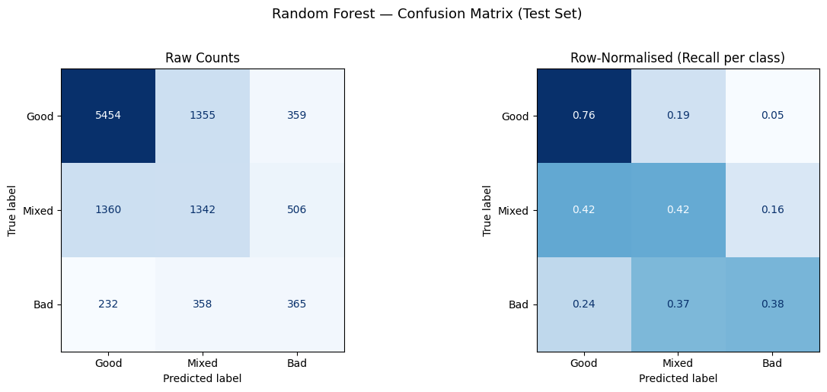
Error type | Count | % of true class
Mixed → Good | 1,360 | 42.4 %
Mixed → Bad | 505 | 16.6 %
Bad → Mixed | 358 | 37.5 %
Bad → Good | 229 | 24.0 %

15.3 Prediction confidence
For each test prediction the model outputs a probability vector; the maximum value is the prediction confidence. The distribution below separates correct from wrong predictions.
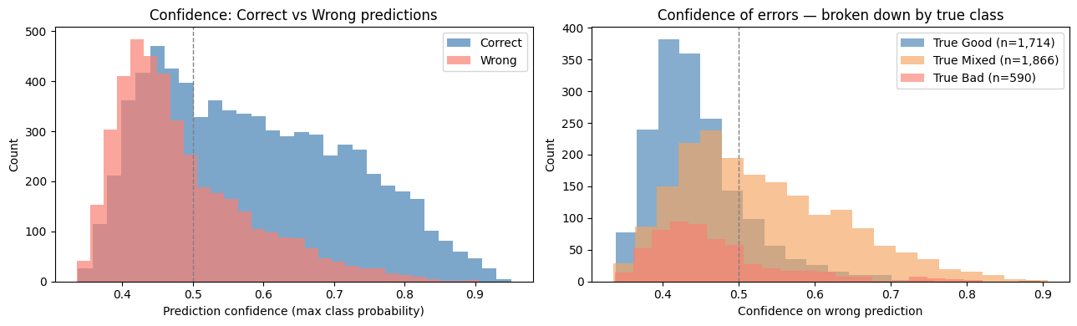
Correct predictions have a median confidence of 0.570; wrong predictions have a median confidence of only 0.460. The model is systematically less certain when it is wrong — most errors are uncertain guesses rather than overconfident misfires.

15.4 Mixed class deep dive
42.4 % of all Mixed games are predicted as Good — the single largest error in the test set. Mixed games have a review ratio between 0.50 and 0.74. Many share the same genre tags, release era, pricing patterns, and platform flags as Good games; the only difference is that their review ratio sits just below the 0.75 threshold. Because that margin is not encoded in any feature, the model has no reliable way to separate them.

15.5 Bad class deep dive
37.5 % of Bad games are predicted as Mixed. Bad games form the smallest class (8.4 % of training data, 955 test cases). With limited training signal the model defaults toward Mixed — the second-largest class — whenever it is uncertain. As a result, Bad recall (0.38) exceeds Bad precision (0.30): the model captures most truly-Bad games but also mislabels many Mixed games as Bad.

15.6 Good vs Mixed feature separation
The chart below shows the features with the largest absolute mean difference between Good and Mixed training examples. A positive value means the feature is more prevalent in Good games; negative means more prevalent in Mixed.
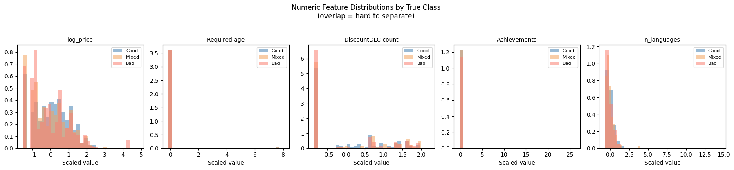
Feature | Mean(Good) − Mean(Mixed)
tag_2D | +0.172
era_2020+ | +0.159
cat_Steam Cloud | +0.145
era_2015-2019 | −0.144
tag_Singleplayer | +0.128
cat_Full controller support | +0.122

The separating power is moderate. Even the strongest signal (tag_2D, diff = +0.172) means 2D games trend toward Good, but many 2D games are still Mixed or Bad. No single feature cleanly separates the classes.

15.7 High-confidence errors
High-confidence errors are predictions where the model assigned a probability of ≥ 0.70 to the wrong class — the model's blind spots rather than borderline uncertainty. There are 320 such cases in total.
Error type | Count | Share of total
Mixed → Good | 243 | 75.9 %
Bad → Good | 20 | 6.3 %
Mixed → Bad | 11 | 3.4 %

Mixed → Good dominates even among the most confident mistakes, confirming that the model has genuinely learned a wrong boundary for a subset of Mixed games — not just that it is uncertain about them.

15.8 Conclusion
The root cause of the low Mixed and Bad F1 is genuine feature-space overlap, not a model deficiency. Current metadata attributes — tags, Steam categories, price, release era, and platform flags — do not encode the signals that actually separate borderline games: execution quality, post-launch developer support, presence of game-breaking bugs, and community sentiment. Most errors are adjacent (Mixed ↔ Good or Bad ↔ Mixed) and made with low confidence, consistent with a task where the class boundaries are genuinely fuzzy in feature space.

16. Additional threshold-distance error analysis
A supplementary deep-dive analysis was carried out to extend the earlier Random Forest error analysis. The main purpose was to connect each test prediction back to the original review_ratio and measure how close each prediction was to the nearest class boundary. This was done to distinguish cases where the model was only slightly off from cases where it was genuinely far from the correct region of the target space.
The original raw CSV was rebuilt, filtered again with the review-stability rule total_reviews >= 10, and relabeled using the selected 0.50/0.75 multiclass rule. The safe feature matrix and the stratified train-test split were then reconstructed. This reconstruction matched the saved modeling files exactly: the rebuilt train and test shapes were 45,324 and 11,331 rows, the rebuilt feature count was 147 columns, and the reconstructed train and test labels matched the saved files exactly. This validation step is important because it confirms that the threshold-distance analysis is attached to the same test cases used in the reported Random Forest model.
The most important findings from this threshold-distance analysis are summarized below.
Finding | Result | Interpretation
Rebuilt split validation | Column match, train-label match, and test-label match were all True. | The threshold-distance study is aligned with the same train/test split used in the model report.
Overall Random Forest performance | Test Macro F1 = 0.5120. | The deep-dive analysis studies the best-performing model under the selected 0.50 threshold.
Distance to threshold | Mean distance to nearest threshold: all test = 0.1129; correct predictions = 0.1282; wrong predictions = 0.0866. | Wrong predictions are, on average, closer to a class boundary than correct predictions. This supports the idea that many mistakes occur in ambiguous regions of the target space.
Wrong-prediction severity mix | Very close to boundary = 20.27%; moderately close = 32.36%; far from boundary = 47.37%. | Boundary ambiguity explains an important part of the errors, but not all of them. Almost half of all mistakes still occur far from a threshold, so there are also genuinely difficult cases that the current features do not separate well.
High-confidence wrong predictions | 158 high-confidence wrong predictions with predicted probability >= 0.70. | These are the strongest blind spots in the current feature space because the model is confidently wrong rather than merely uncertain.
The detailed severity table showed that adjacent mistakes were still the dominant form of error, but a notable number of far errors also remained. Among the wrong predictions, 1,607 adjacent errors and 363 far errors were already in the far_from_boundary group. This means that the model is not only struggling at the exact thresholds; it is also missing some cases that are clearly inside the true class region.
The most frequent true-predicted error pairs are listed below. These rows help separate mildly ambiguous class-border mistakes from more serious failures.
True class | Predicted class | Count | Mean review_ratio | Mean distance to threshold | Mean prediction confidence
Good | Mixed | 1355 | 0.8483 | 0.0983 | 0.4402
Mixed | Good | 1345 | 0.6566 | 0.0590 | 0.5449
Mixed | Bad | 505 | 0.6204 | 0.0622 | 0.4905
Good | Bad | 368 | 0.8594 | 0.1094 | 0.4700
Bad | Mixed | 357 | 0.3680 | 0.1320 | 0.4407
Bad | Good | 229 | 0.3744 | 0.1256 | 0.5164
Two patterns stand out. First, the largest neighboring-class confusions are Good → Mixed and Mixed → Good, which confirms the earlier conclusion that the center of the label space remains fuzzy. Second, the severe two-step errors Good → Bad and Bad → Good do occur less often, but their mean review_ratio values are not always close to the nearest threshold. For example, Bad → Good errors have mean review_ratio around 0.3744 and mean distance to threshold around 0.1256, while Good → Bad errors have mean review_ratio around 0.8594 and mean distance around 0.1094. This shows that some severe errors are not just borderline labeling effects.
High-confidence wrong predictions were also examined separately. The largest high-confidence error cluster was Mixed → Good with 122 cases. The next largest groups were Bad → Good with 20 cases and Mixed → Bad with 11 cases. This pattern suggests that the model sometimes interprets uncertain middle-class cases as clearly positive, and in a smaller number of cases it also pushes difficult negative cases too far upward.
The class-wise boundary analysis provides another useful angle. It shows whether the model’s wrong predictions for each true class are typically near the threshold or further away.
True class | Error count | Mean distance to threshold | Mean prediction confidence
Bad | 586 | 0.1295 | 0.4703
Good | 1723 | 0.1007 | 0.4465
Mixed | 1850 | 0.0598 | 0.5301
This table shows that Mixed has the smallest average distance to threshold among the wrong predictions, with mean distance about 0.0598. That supports the interpretation that many Mixed errors are indeed borderline cases. In contrast, wrong predictions for Bad have mean distance about 0.1295 and for Good about 0.1007. So when the model misses Bad or Good, it is often missing cases that are less boundary-adjacent and therefore more genuinely difficult.
Overall, this extended analysis refines the earlier conclusion. The Random Forest model is often close when it is wrong, especially for the Mixed class, but the threshold-distance results show that boundary ambiguity is only part of the explanation. A substantial share of wrong predictions remain far from the nearest threshold, and some of these are made with high confidence. This suggests that the current metadata-based safe feature set captures broad structure in the target space but does not fully describe the more subtle patterns that separate clearly positive, borderline, and clearly negative games.
For the final report, this section supports two claims at once. First, the current model is not simply making random mistakes; many errors, particularly in Mixed, occur near the threshold and are therefore understandable boundary cases. Second, the remaining hard errors are real and point to the need for richer feature engineering, better class-separation features, and possibly more expressive signals than the current structured metadata alone.

17. Feature Engineering Experiment
Section 15 identified that the dominant error is Mixed → Good (42.4 % of Mixed games) and that the top separating features are tag_2D, era_2020+, cat_Steam Cloud, tag_Singleplayer, and cat_Full controller support. Eight derived features were engineered from those signals and added to the original 147-feature dataset (producing 155 features) to test whether aggregation can push the Random Forest beyond its baseline of Test Macro F1 = 0.5100.

17.1 Motivation
The error analysis showed that the model struggles most with Mixed games that appear identical to Good games in feature space. The hypothesis was that count-level aggregates (number of tags, number of quality-signal features) and interaction terms (recent era × 2D tag, price × recent era) might capture patterns the individual binary columns miss.

17.2 New features (147 → 155)
All count-based features were standardised using StandardScaler fitted on the training set only. Binary interaction features were left unscaled.
Feature | Type | Rationale
n_tags | count (scaled) | Number of tags — more tags = more discoverable, tends toward Good
n_categories | count (scaled) | Number of Steam feature categories — proxy for release polish
n_genres | count (scaled) | Number of genres listed
polish_index | sum (scaled) | Steam Cloud + Full controller support + Achievements + Singleplayer + Mac
recent_2d | binary | tag_2D × era_2020+ — recent 2D games disproportionately Good
price_x_recent | interaction (scaled) | log_price × era_2020+ — expensive recent games almost always Good
solo_only | binary | tag_Singleplayer × (1 − cat_Multi-player) — focused singleplayer indicator
platform_breadth | count (scaled) | Windows + Mac + Linux — multi-platform developer commitment signal

17.3 Cross-validation and test results
The same nested CV setup used throughout the project (5 outer folds, 3 inner folds, GridSearchCV with the same parameter grid) was repeated on the 155-feature dataset. The chart below shows the fold-by-fold Macro F1 for RF+FE alongside the original RF and SVM baselines.
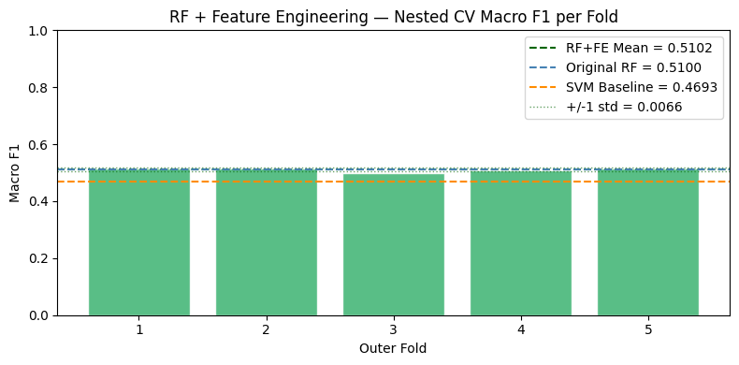
Metric | RF+FE (155 features) | Original RF (147 features) | Change
Nested CV Macro F1 | 0.5102 ± 0.0066 | 0.5093 ± 0.0073 | +0.0009
Test Macro F1 | 0.5093 | 0.5100 | −0.0007
Good F1 (test) | 0.77 | 0.77 | 0
Mixed F1 (test) | 0.43 | 0.43 | 0
Bad F1 (test) | 0.33 | 0.33 | 0

17.4 Confusion matrix comparison
The side-by-side row-normalised confusion matrices below compare the original RF (147 features) against RF+FE (155 features) on the test set. Per-class recall is effectively unchanged: Good +0.001, Mixed +0.002, Bad −0.013.
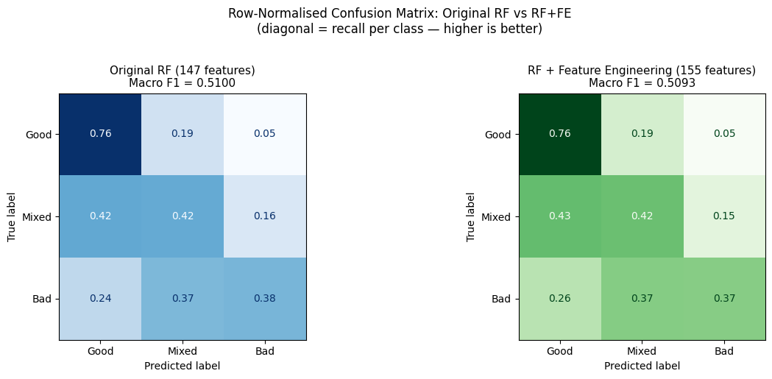

17.5 Feature importance
The Gini importance chart below shows the top 25 features; new engineered features are highlighted in green. Despite no performance gain, 7 of 8 new features rank in the Top 25: n_tags (rank 4), polish_index (rank 5), price_x_recent (rank 7), n_categories (rank 8), n_genres (rank 9), recent_2d (rank 12), platform_breadth (rank 17). The sole exception is solo_only at rank 28.
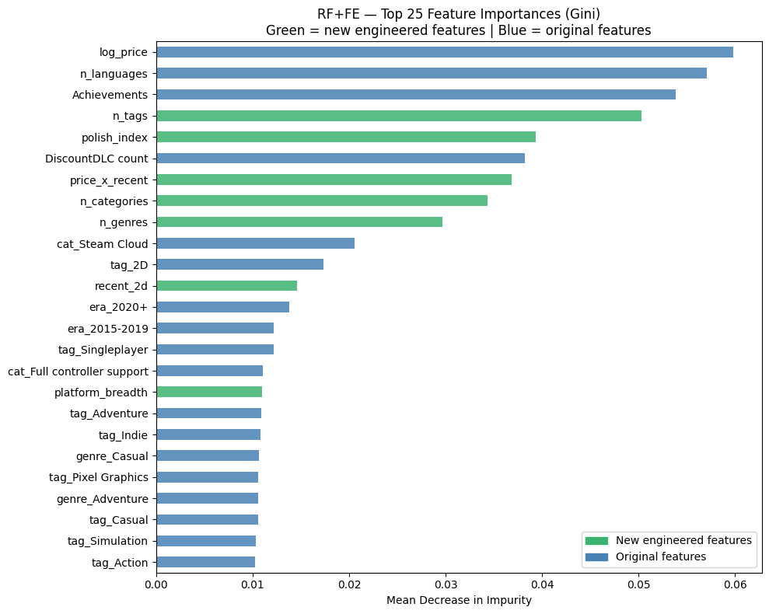

17.6 Conclusion
Feature engineering made no meaningful improvement: Test Macro F1 changed by −0.0007, well within the standard deviation of the nested CV estimate (±0.0066). Although 7 of 8 new features rank highly by Gini importance, they are largely redundant with the existing binary columns. n_tags is simply a sum of the individual tag_* columns; polish_index aggregates features already present one-by-one. The Random Forest was already learning these count-level patterns from the sparse binary feature space. This is an important negative result: the performance ceiling is set by genuine data ambiguity, not by missing features or inadequate engineering. No amount of metadata aggregation can separate games whose review ratio differs by only a few percentage points around the class boundaries.

