

Hotel Booking Data Analysis: Customer Behaviour, Revenue & Cancellation Insights
BY
Ayush Kumar Lohani

Introduction
This report presents an exploratory data analysis of hotel booking transactions from an online travel platform. The primary objective of this study is to understand customer booking behaviour, identify key drivers of cancellations, and analyse how different factors such as booking channels, room types, and hotel ratings influence overall revenue and booking stability.
The analysis focuses on uncovering meaningful patterns in booking value, cancellation rates, and seasonal trends to identify areas where the business is losing potential revenue and where performance remains stable. Special attention has been given to understanding how customer intent varies across different booking channels and property segments.
By combining data-driven insights with behavioural interpretation, this report aims to highlight key problem areas such as high cancellation segments and low-performing channels, while also identifying opportunities to improve profitability, enhance customer retention, and optimize pricing and distribution strategies.
The final outcome of this analysis is a set of actionable recommendations that can help improve booking reliability, reduce cancellations, and support better decision-making for revenue optimization.

Key Observations
How do booking patterns vary across channels, room types, and star ratings?

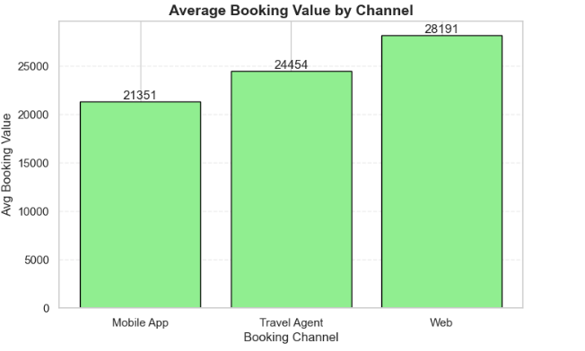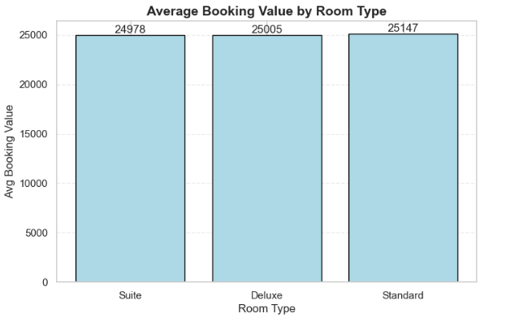

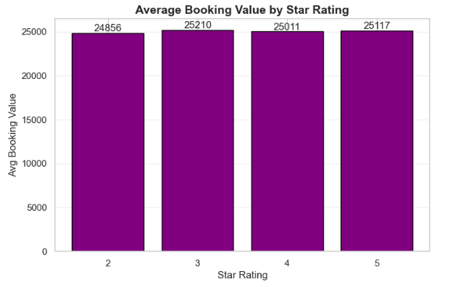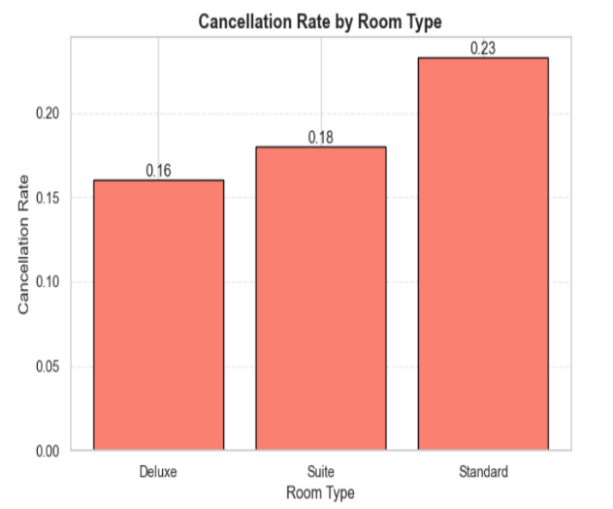

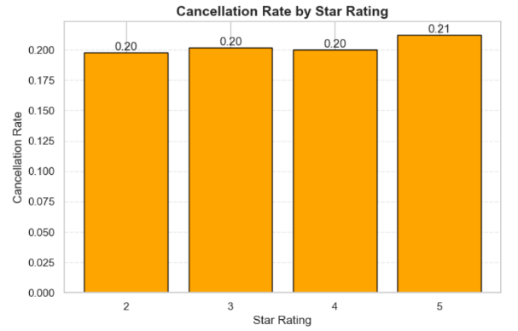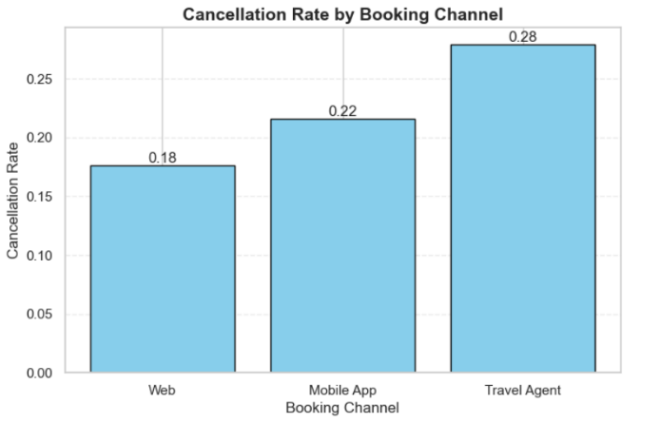

I have looked into the data to see where we are losing bookings and which areas are the most "stable." Here is a simple breakdown of the patterns:

- Where are people booking from?

The biggest takeaway here is that Travel Agents are a major headache. Nearly 28% of the bookings made through agents end up being cancelled. This usually happens because people "shop around" and have an agent hold a room while they look for a better deal elsewhere.

On the flip side, people who book directly through our Website are our most loyal customers. Only about 17% of them cancel. They clearly know what they want
and are more likely to actually show up.

- What kind of rooms are they picking?

The data shows that Standard Rooms are the riskiest. About 23% of these bookings get cancelled. Since these are the most affordable rooms, guests are likely very price-sensitive, if they find a cheaper room at another hotel at the last minute, they jump ship.

Deluxe Rooms are much safer, with a much lower cancellation rate of 16%. People booking these rooms are usually more committed to their travel plans and aren't just looking for the lowest price.

- Does the Star Rating matter?

Surprisingly, our 5-Star properties have the highest cancellation rate (just over 20%). You might expect high-end guests to be more reliable, but it’s actually the opposite. These guests often have more flexible schedules or book multiple options and then pick their favourite one right before the trip.

Our 2-Star and 3-Star bookings are much more "set in stone." Once those guests book, they generally stick to it.

What do you notice about cancellation behaviour?

- The "Middle-Man" Problem

The most obvious trend is that Travel Agents have a massive cancellation rate, nearly 28%. This is much higher than people booking directly through our website (17%). It tells us that when a third party is involved, the commitment level drops significantly. Guests are likely using agents to "hold" rooms while they keep looking for better deals elsewhere

- Budget vs. Premium Guests

There’s a clear split when you look at the Room Types:
Standard Rooms are cancelled about 23% of the time. These guests are likely very price-sensitive; if they see a cheaper deal at a different hotel the next day, they’ll cancel and switch.

Deluxe Rooms are the most "stable" at 16%. People paying more for a premium experience usually have their plans set in stone and aren't just hunting for the lowest price.

- The High-End Flaw

You’d expect 5-Star bookings to be the most reliable, but the data shows the opposite. 5-Star properties actually have the highest cancellation rate (over 20%), while 2-Star properties have the lowest.

This suggests that high-end travellers ,likely corporate or luxury guests, value flexibility. They might book a room "just in case" but have no problem cancelling if their business meeting changes or if a flashier hotel opens up a spot.

Meaningful Trends

Average Booking Value Analysis

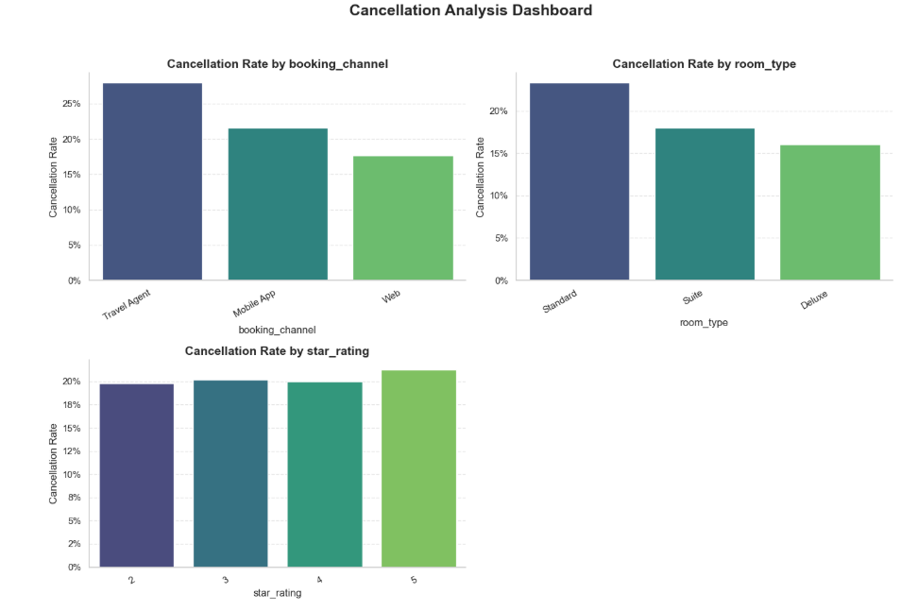
Cancellation Rate Analysis

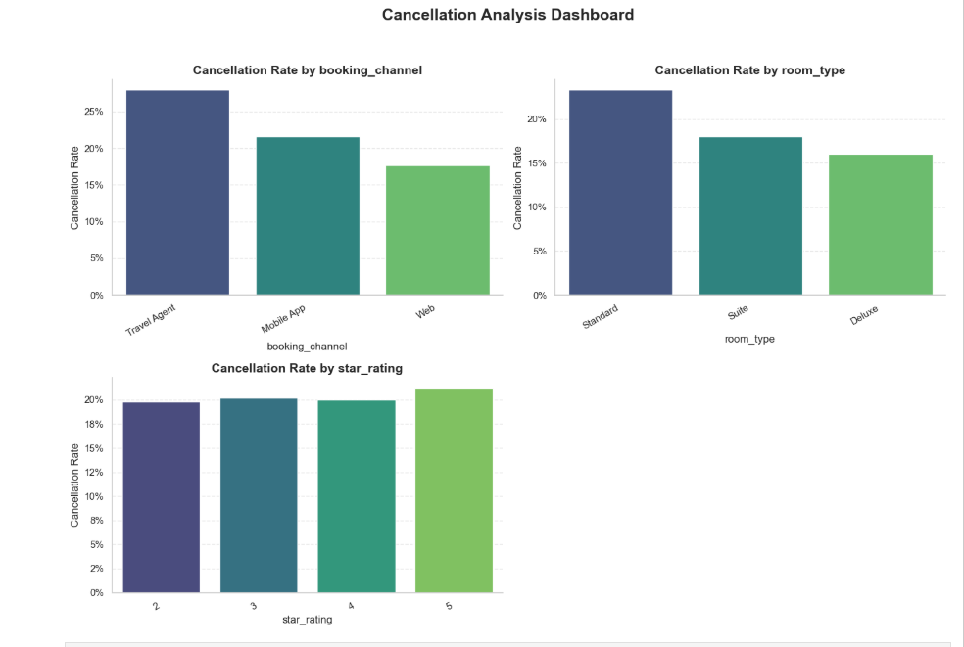
Seasonal Trend

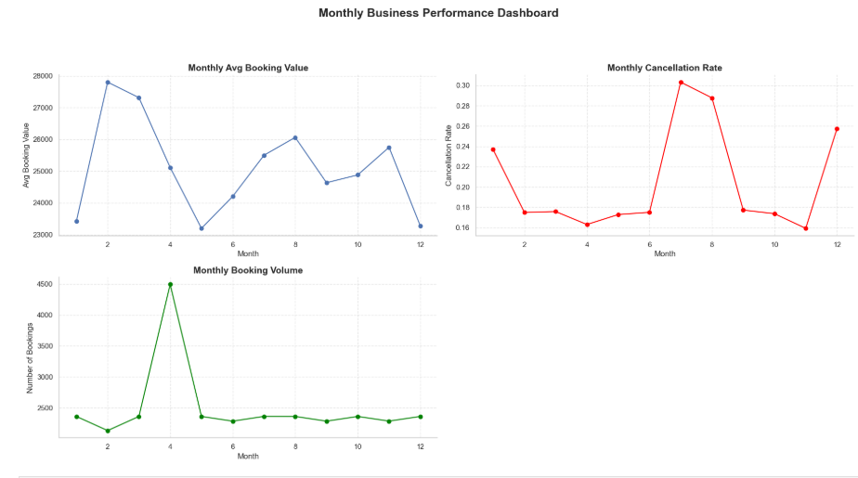

- The April "Volume Spike"

The most striking data point is in April. We see a massive surge in Booking Volume, peaking at 4,500 bookings, nearly double the usual monthly average.

The Catch: While volume is at its highest, the Average Booking Value takes a sharp dive during this same period.

What it means: This suggests that April was likely driven by a high-volume "budget" promotion or a holiday season where we sold many rooms at a discounted rate. We got the quantity, but we sacrificed the profit per room to get it.

- The Summer Cancellation Crisis

July and August show a dangerous trend. The Cancellation Rate sky-rockets to over 30% in July and stays high in August.

The Conflict: Interestingly, the Booking Value is actually rising during these months.

What it means: We are successfully booking higher-priced rooms in the summer, but people aren't sticking to them. This could be due to "vacation shopping," where families book multiple hotels for their summer break and cancel the ones they don't want at the last minute. It’s a high-revenue period on paper, but a high-risk period in reality.

- Year-End Stability vs. Value (Month 11 & 12)

As we hit November, we see the lowest cancellation rate of the entire year (around 16%).

The Shift: However, as soon as December hits, cancellations spike again while the Booking Value drops to its lowest point.

What it means: November seems to be our most "reliable" month—people who book actually show up. December, however, looks like a month of last-minute plan changes and lower-priced holiday travel.

Correlation Maps

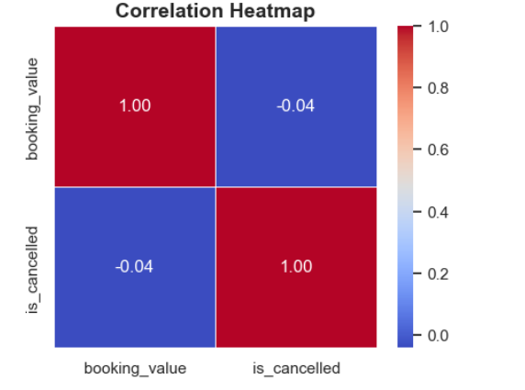
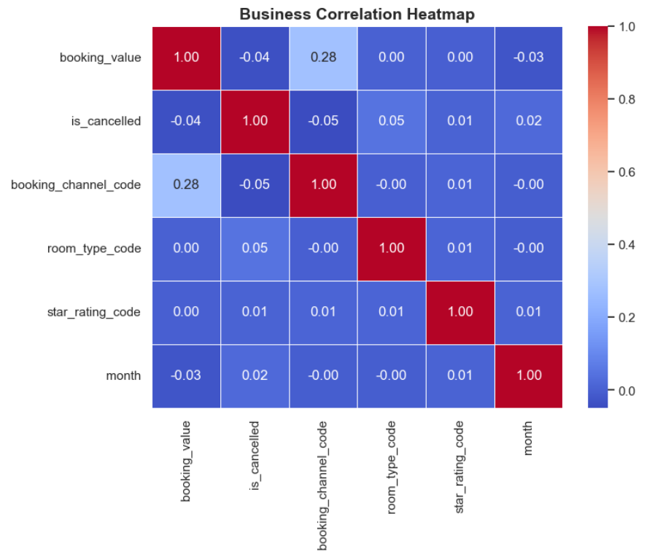
This correlation heatmap illustrates the linear relationship between two specific variables in your dataset: booking value and is cancelled.
1. The Relationship: Booking Value vs. Cancellation
The value shown between these two different variables is -0.04.
- Near Zero: A value is extremely close to zero. This indicates that there is no meaningful linear relationship between the cost of a booking and whether or not it gets cancelled.
- Independence: In practical terms, knowing how much a customer paid (booking value) does not help you predict if they are going to cancel. High-value bookings and low-value bookings appear to be cancelled at roughly the same rate.
2. Understanding the 1.00 Values
The diagonal line from the top-left to the bottom-right shows 1.00 (dark red).
- This represents a perfect correlation because every variable is being compared to itself.
- For example, booking value will always have a perfect relationship with booking value.
3. The Negative Sign (-)
The negative sign on -0.04 technically suggests a "negative correlation," meaning that as one variable goes up, the other tends to go down. However, because the number is so small, this "trend" is statistically insignificant and likely just noise in the data.
Root Cause Analysis
1. Cancellation Patterns
Higher cancellations are driven by price-sensitive customers and low booking value segments.
Booking channels influence behaviour deal-driven platforms see more cancellations, while direct/trusted channels show lower cancellations.
Flexible cancellation policies encourage “just-in-case” bookings, increasing cancellations.
Room type and star rating impact trust lower-tier rooms and lower-rated hotels have higher cancellations.
External factors like plan changes, budget issues, or better alternatives also contribute.

2. Channel & Property Performance
Performance depends on customer quality and intent high-intent users lead to better conversions.
Trusted channels and strong brand perception improve booking reliability.
Premium properties perform better due to higher perceived value and spending capacity.
Better user experience and clear policies increase booking confidence and reduce drop-offs.

3. Seasonal & Temporal Trends
Booking demand is seasonal, with peaks during holidays and low demand in off-season.
Booking value increases in peak seasons and drops in off-peak periods.
Cancellations are higher in off-season due to lower commitment.
Stay length varies longer during vacations, shorter for business travel.
External factors like festivals, weather, and travel cycles influence trends.
Business Recommendations
1. Reduce Cancellations by Targeting Low-Commitment Behaviour
Since Travel Agents show the highest cancellations, instead of completely avoiding them, introduce a “confirmation step” policy where agent bookings require quicker payment confirmation or partial pre-payment. This reduces room blocking.
For Standard Room bookings, treat them as a high-risk segment and push a price-lock advantage message (e.g., price valid only for 6 hours after booking) to reduce comparison-based cancellations.
For 5-star bookings, the issue is not affordability but flexibility. Offer benefit-based retention (spa credits / dining vouchers on non-cancellation) instead of just discounting.
Introduce stricter or tiered cancellation policies, especially for high-risk segments like Standard Rooms and agent bookings.

2. Improving profitability and increase repeat bookings.
The data shows Deluxe rooms are the most stable segment, so instead of pushing volume in Standard rooms, shift marketing emphasis toward mid-tier upgrades (Standard to Deluxe nudging at checkout).
Identify direct website users as “high lifetime value customers” and prioritize them for early access deals or personalized pricing, instead of one-time discounts.
Create a segmentation logic internally:
“High cancellation risk” (Agents + Standard + 5-star)
“Revenue stable core” (Direct + Deluxe + 2–3 star)
Focus retention strategy only on the second group for predictable revenue.

3. Smarter Pricing & Channel Strategy (Not Just Discounts)
Instead of uniform discounts, introduce channel-specific pricing behaviour:
Agents : slightly higher price but stricter confirmation rules
Direct : stable pricing + added benefits
Avoid discounting Standard rooms heavily, the data suggests it increases comparison behaviour rather than conversions.
For 5-star properties, shift from price discounts to value bundling (experience upgrades instead of price cuts) because these users are not price-sensitive but option-sensitive.
During low-demand months, instead of lowering prices blindly, use “limited inventory framing” (only X rooms left at this price) to increase booking commitment.

