SkillSwap
Technical Documentation, System Design & ERD
Version 1.0 · Post-hackathon technical specification

1. Problem Statement
Meet Lebo, a 23-year-old from a township near Johannesburg. She braids hair beautifully and dreams of learning basic web design to start an online booking service. Across town is Kabelo, self-taught in HTML and CSS, looking for a side hustle like haircutting to fund his studies. They both have skills, but no money, no certificates, and no access to formal education.
There are millions like them across Africa — skilled, under-employed, and disconnected. SkillSwap is a mobile platform that connects people based on the skills they can teach and want to learn, using AI to match, mentor, and multiply impact.
Core promise: Teach what you know. Learn what you need. No money, no formal certificates — just people helping people grow.

2. Product Overview
SkillSwap is a React Native mobile app powered by Microsoft AI tools, enabling peer-to-peer skill sharing in underserved communities. MVP-ready in 24 hours, designed to scale across communities.

2.1 Core Features
Feature | Description
Skill profile creation | Users list what they can teach and want to learn, with location, availability, and language.
AI skill matchmaking | Azure OpenAI GPT finds compatible matches, prioritizing local or similar-timezone pairs.
Auto-generated crash courses | GPT builds a custom 5–7 day plan per learner's goal and level, with steps, materials, and practice tasks.
Chat + learning logs | In-app messaging via Firebase, with progress tracking checkboxes.
Language inclusion | Azure Translator auto-translates content into the user's local language.

2.2 Tech Stack
- Frontend: React Native + JavaScript
- AI logic: Azure OpenAI (GPT-4 Turbo)
- Translation: Azure Cognitive Services (Translator)
- Backend: Firebase (Realtime Database, Auth, Hosting)
- Optional: Azure Maps (proximity matching)

3. System Architecture
The mobile app talks to a single API gateway, which authenticates requests and routes to three AI-backed services — matchmaking, course generation, and chat/translation — all reading and writing through Firebase. Azure Maps is an optional add-on for proximity-based matching.
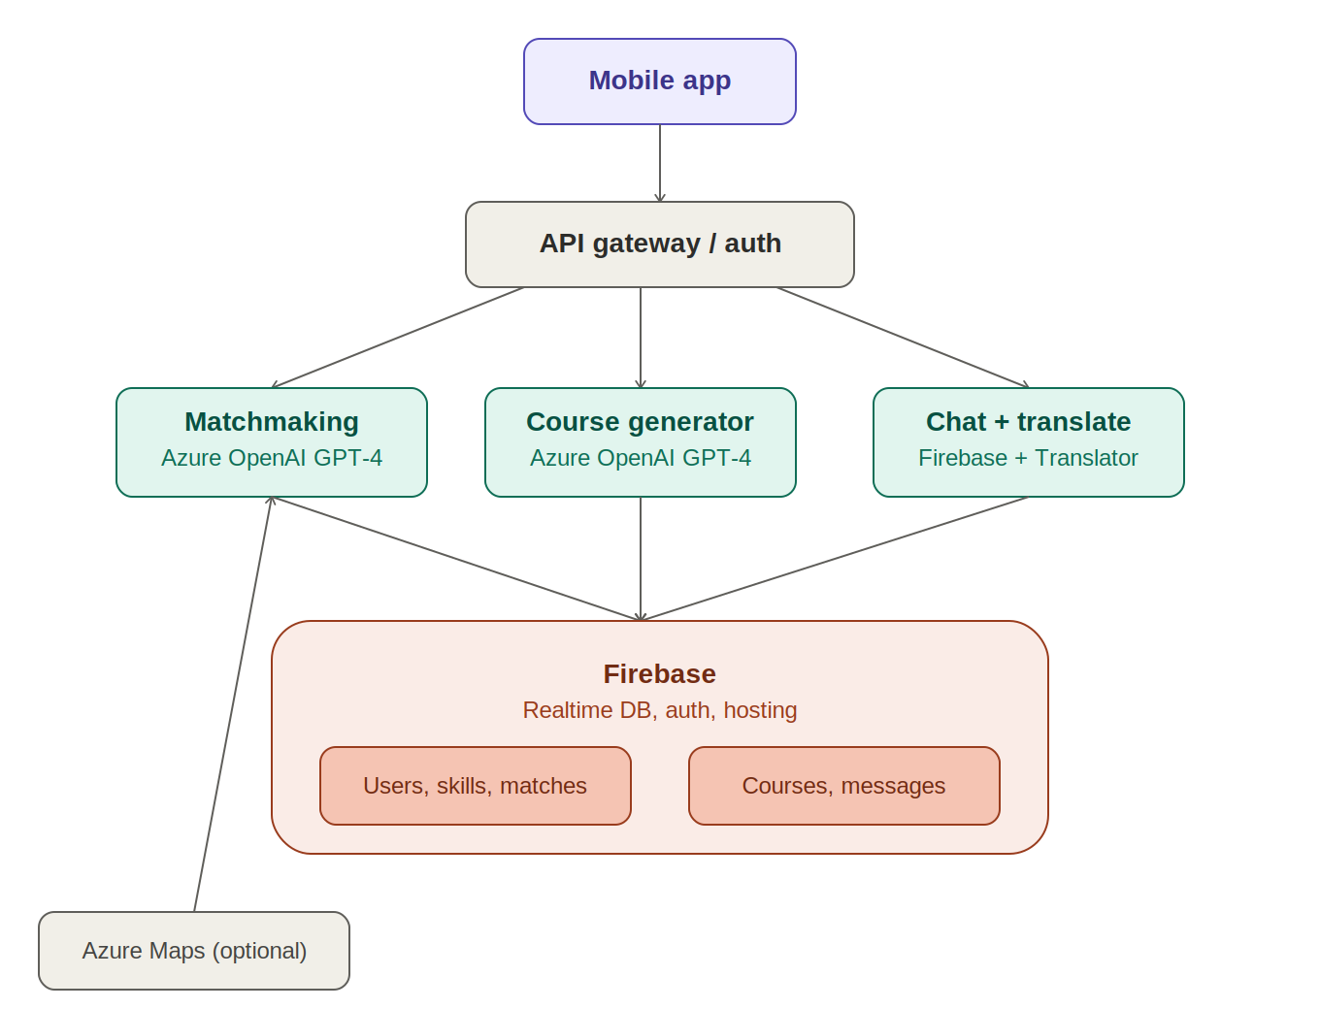
Figure 1. SkillSwap system architecture

3.1 Components
- Mobile app — React Native client; handles onboarding, skill setup, browsing matches, chat UI, and course tracking.
- API gateway / auth — single entry point that authenticates requests (Firebase Auth tokens) and routes to the correct backend service.
- Matchmaking service — calls Azure OpenAI GPT-4 Turbo with a user's teach/learn profile plus candidate pool; returns ranked matches scored by relevance, availability, location, and skill level.
- Course generator service — calls GPT-4 Turbo with the learner's goal and skill level to produce a structured multi-day course, stored against the match.
- Chat + translate service — Firebase-backed real-time messaging; runs messages through Azure Translator when sender and recipient languages differ.
- Firebase — system of record: Realtime Database for users, skills, matches, courses, progress, and messages; Firebase Auth for identity; Firebase Hosting for the web admin/landing surface.
- Azure Maps (optional) — geocoding and proximity queries to support in-person exchanges.

3.2 Data Flow — Matchmaking
- User submits/updates their teach + learn skill profile.
- API gateway writes the profile to Firebase and triggers the matchmaking service.
- Matchmaking service pulls a candidate pool (same skill category, nearby location/timezone) from Firebase.
- Candidate pool + requesting profile sent to Azure OpenAI GPT-4 Turbo for compatibility scoring.
- Scored matches written back to Firebase (matches collection) and pushed to the app.
- User selects a match → course generator is triggered for the agreed skill.
- Generated course is stored and surfaced in the app; chat channel opens between the two users.

4. Data Model / ERD
Firebase Realtime Database is a JSON document store, not a relational database, so in the real implementation these entities become top-level collections/nodes and foreign keys become referenced IDs resolved client-side or via Cloud Functions. The ERD below is the logical model — useful for reasoning about relationships now, and as a blueprint if the platform later migrates to a relational store (e.g. Postgres) for stronger consistency and reporting.
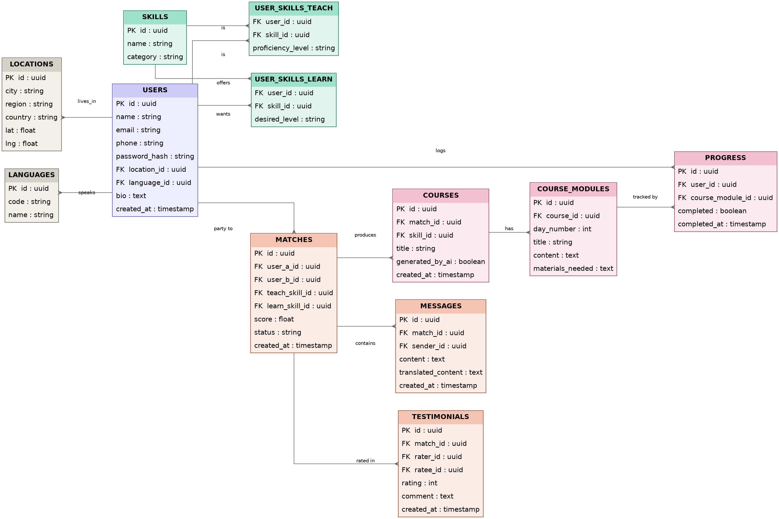
Figure 2. SkillSwap entity-relationship diagram

4.1 Entity Notes
- USERS — core identity record. location_id and language_id are foreign keys rather than free text, so proximity and translation logic can query cleanly.
- SKILLS — a shared taxonomy (e.g. Web design, Hairdressing, Basic English). Both teach and learn intents reference the same table so matching is a straightforward join, not fuzzy string matching.
- USER_SKILLS_TEACH / USER_SKILLS_LEARN — join tables carrying proficiency/desired level, kept separate because their attributes differ and it keeps matchmaking queries simple.
- MATCHES — the central object once two users are paired; carries the AI-generated score and a status (pending, active, completed, ended).
- COURSES / COURSE_MODULES — a course belongs to a match + skill; modules are the day-by-day breakdown GPT generates, kept separate from PROGRESS so AI content and user completion state evolve independently.
- PROGRESS — one row per user per module, so both participants in a match can track completion independently.
- MESSAGES — stores both original and translated content so either party sees the message in their own language without re-calling the Translator API on every read.
- TESTIMONIALS — tied to a match, with separate rater_id/ratee_id so both sides of an exchange can rate each other.
- LOCATIONS / LANGUAGES — normalized lookup tables to keep matching/translation logic fast and consistent.

5. API Design (Indicative)
Endpoint | Method | Purpose
/users | POST | Create user profile
/users/:id/skills | PUT | Update teach/learn skill lists
/matches/suggest | POST | Trigger AI matchmaking for a user
/matches/:id | PATCH | Accept/decline/end a match
/matches/:id/course | POST | Generate AI course for an accepted match
/courses/:id/modules/:moduleId/progress | PUT | Mark a module complete
/matches/:id/messages | POST/GET | Send/fetch chat messages (auto-translated)
/matches/:id/testimonial | POST | Submit a rating/testimonial

6. User Journey
- Onboarding — sign in, select language, brief “What is SkillSwap?” tutorial.
- Skill setup — input what you can teach, what you want to learn, location, and availability.
- Matchmaking — GPT recommends matches; user views profiles and selects a partner.
- Learning plan — view/generate a mini-course; track progress module by module.
- Ongoing exchange — chat with partner; optionally rate each other and leave a testimonial.

7. Business Model
- Freemium — matching, teaching, and learning are always free. Premium (optional): verified skill badges, advanced AI learning paths, offline content packs, priority matching.
- NGO & government partnerships — deployment in underserved communities; white-label or impact-dashboard offerings for partners tracking learning outcomes.
- CSR sponsorships — companies sponsor branded learning hubs or specific skill categories.
- Ethical data insights — aggregated, anonymized skill-demand and learning-trend data for NGOs/policymakers, under strict privacy standards.
- Marketplace (future) — users offer services/products based on learned skills; small commission reinvested into the platform.
- Grants — social innovation grants, AI for Good programs, development funds.

8. Security & Privacy Considerations
- Auth — Firebase Auth (email/phone) with hashed credentials; no plaintext password storage.
- PII minimization — location stored at city/region granularity by default; precise coordinates only captured if the user opts into proximity matching.
- Data sharing — aggregated NGO/policymaker insights must be anonymized before leaving the platform; no raw user records shared externally.
- Messaging — messages are stored per match; access control ensures only the two matched users (and authorized admins, for moderation) can read a thread.
- Translation privacy — Translator API calls should avoid logging message content beyond what's needed for the request/response cycle.
- Abuse/safety — the rating/testimonial system is a lightweight trust signal; a reporting/block mechanism should be added before wider rollout (not yet in MVP scope).

9. Scaling Plan

Short term (post-MVP)
- Offline-first usage support
- Audio-based courses for low-literacy users

Mid term
- NGO / education department partnerships
- Community events & gamification (leaderboards, swap challenges)

Long term
- Integration with job platforms
- Sponsored micro-certifications
- Regional hubs and translation packs for new areas

10. Impact & Judges' Angle
- Innovation — AI used for economic empowerment, not just productivity.
- Inclusivity — designed for low-income, low-literacy, and offline-first users.
- Scalability — the peer-exchange model generalizes to any community, region, or skill category.
- Feasibility — MVP demonstrable within 24 hours.
“We're not building a social app. We're building social capital.”

11. Suggested AI Models
Purpose | Model / Service | Why
Skill matching & course generation | Azure OpenAI GPT-4 Turbo | Fast, cost-effective, nuanced understanding of user intent
Translation & accessibility | Azure Cognitive Services – Translator | 100+ languages/dialects
Voice-to-text / audio learning (future) | Azure Speech-to-Text + Text-to-Speech | Inclusive for low-literacy users
Engagement & feedback analysis | GPT + Text Analytics (Sentiment) | Refines matching quality, flags disengagement
Proximity-based matching | Azure Maps | Enables local, in-person exchanges

12. What Sets SkillSwap Apart
- Zero-cost, peer-to-peer learning — no fees, no degrees.
- AI-generated micro-courses — tailored crash courses per learner.
- Hyperlocal, inclusive matching — timezone, language, and availability aware.
- Offline-first & low-literacy friendly (planned) — audio and offline access.
- Scalable social capital model — built on skill exchange, not credentials.

