**ADO.NET CRUD Operation**

**1**.Run the Application and it will display Connection is established succesfully,and options is displayed for performing opearation.Here we can selete Create option for add new data.

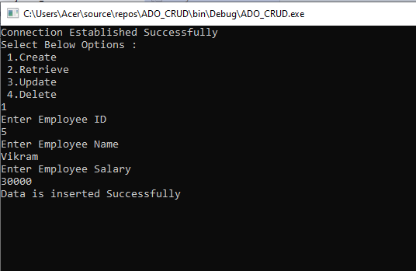

**2**.Here Data will be saved Successfully in the Database.

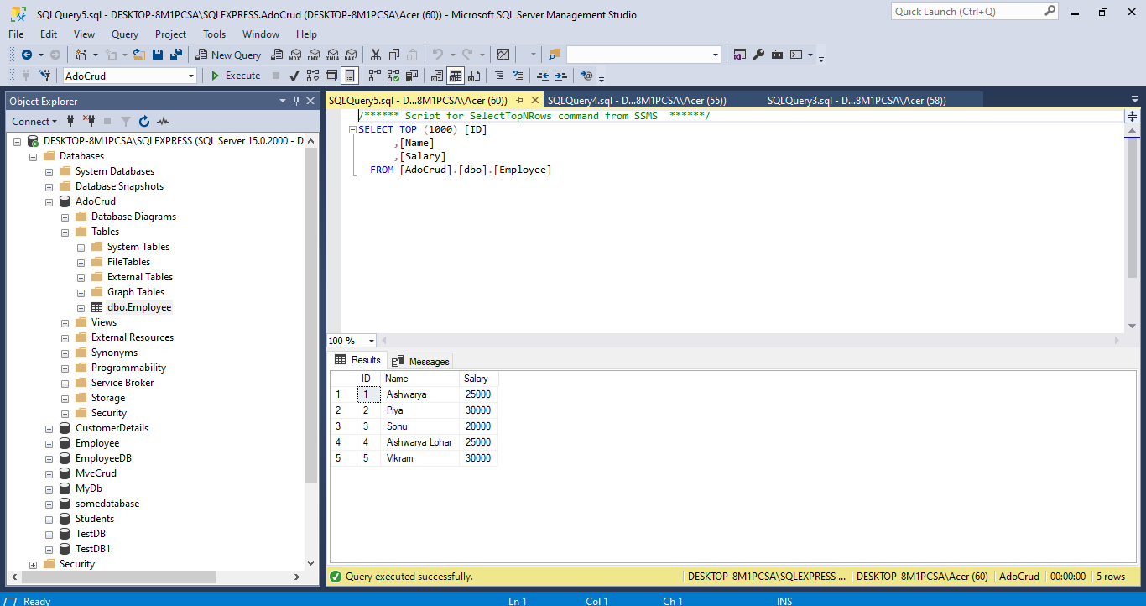

3. After Selecting Retrieve option

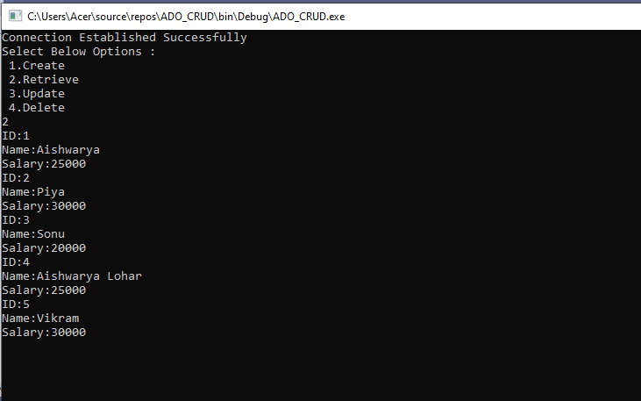

**3**. After selecting Update ,here salary will be updated.

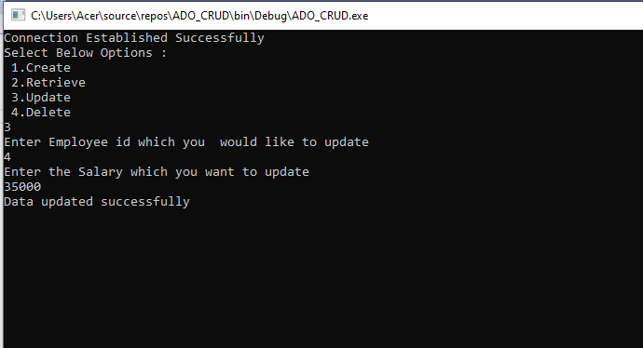

**4.** Here Database will be updated successfully.

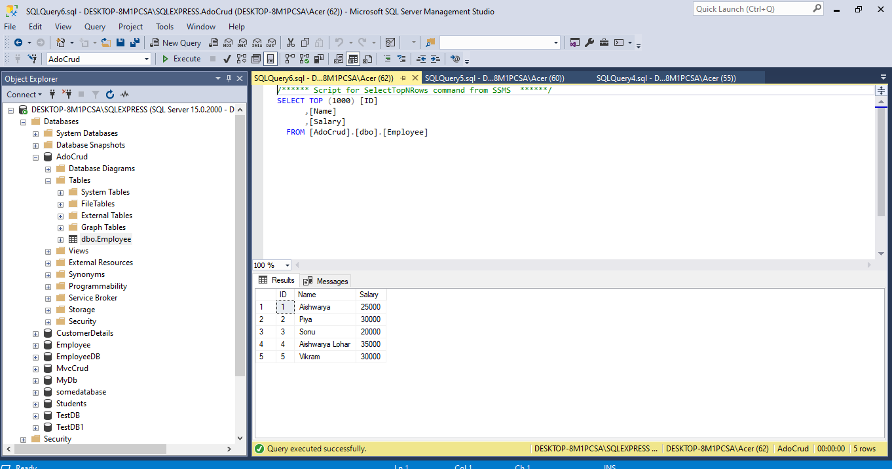

5. Select Delete option for deleting record.

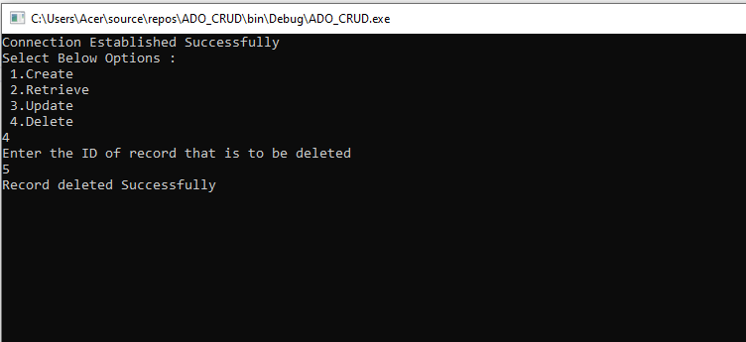

**6.** Here Record will be deleted in database.

