BL.SC.U4CSE24025

DSA LAB2(23/07/2025)

Q1

public class lab3_dsa {

    public static void main(String[] args) {

        int[] arr={12,35,1,10,34,1};

        int temp=0;

        int max=0;

        for(int i=0;i<arr.length;i++){

           if(arr[i]>max){

            max=arr[i];

            }

        }

        for(int i=0;i<arr.length;i++){

            if(arr[i]<max && arr[i]>temp){

                temp=arr[i];

            }

    }

    System.out.println("the second largest element is:"+temp);

}

}



Q2

import java.util.*;

public class lab3_1dsa {

    public static void main(String[] args) {

        int[] arr={1,2,3,4,5,6,7};

        int n=arr.length;

        Scanner sc=new Scanner(System.in);

        System.out.println("enter how many times u want to rotate the array:");

        int k=sc.nextInt();

        for(int i=0;i<k;i++){

            int first=arr[n-1];

            for(int j=n-1;j>0;j--){

                arr[j]=arr[j-1];

            }

            arr[0]=first;

        }

         for(int i=0;i<arr.length;i++){

            System.out.print(" "+arr[i]);

         }

    sc.close();

    }

}

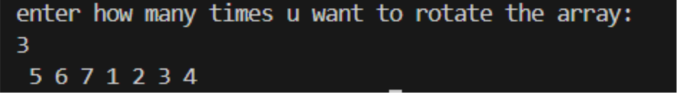

Q3

public class lab3_2dsa {

    public static void main(String[] args) {

         int[] arr={1,5,7,-1,5};

         System.out.println("the pairs are:");

        for (int i=0;i<arr.length-1;i++){

                if(arr[i]+arr[i+1]==6){

                    System.out.println("("+arr[i]+","+arr[i+1]+")");

                }

            }

        }

    }

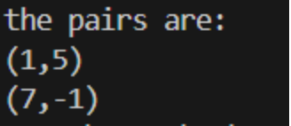

Q4

public class lab3_3dsa {

    public static void main(String[] args) {

        int[] arr={0,1,0,3,12};

        int n=arr.length;

        for (int i=0;i<arr.length;i++){

            if(arr[i]==0){

                int temp=arr[i];

                for(int j=i;j<n-1;j++){

                    arr[j]=arr[j+1];

                }

                arr[n-1]=temp;

            }

        }

        for(int i=0;i<arr.length;i++){

            System.out.print(" "+arr[i]);

         }

    }

}



Q5

public class lab3_4dsa {

    public static void main(String args[]){

        int[] arr={16,17,4,3,5,2};

        int value=1;

        System.out.println("the leader elements are:");

        for (int i=0;i<arr.length;i++){

            for(int j=i+1;j<arr.length;j++){

                if(arr[i]>arr[j]){

                    value=1;

                }

                else{

                    value=0;

                    break;

                }

            }

            if(value==1){

            System.err.println(arr[i]);}

        }

    }

}