23CSE301 — Lab Session 07: Decision Trees on Project Data
Project: Audelle — AI-powered audio editor. Dataset: GTZAN subset (24 clips, genres: disco, hiphop, metal, classical), same Hugging Face mirror as scripts/train_genre_classifier.py. Features per clip (librosa): spectral centroid mean, zero-crossing-rate mean, RMS mean, spectral-flatness mean, tempo. Target: genre label.

1. Introduction (project understanding)
Audelle edits audio from natural-language prompts. Before any edit, supervised classifiers read the file: a RandomForest groove classifier (15 EDM feels), a RandomForest genre classifier (10 GTZAN genres), and a RandomForest noise-condition classifier (clean/hiss/hum/crowd/clipped/muffled) plus an SNR regressor. This lab studies the foundation of all three: the decision tree — entropy, Gini impurity, information gain, binning of continuous audio features, tree construction, and hyper-parameter tuning — applied to our own genre data.

2. Literature survey
scikit-learn decision-tree documentation (plot_tree) defines the splitting criteria used here: entropy and Gini impurity, with information gain selecting each split. The DataCamp decision-tree tutorial covers the classification pipeline (train/test split, visualization, decision boundaries) followed in A6–A7. The sklearn iris decision-tree example is the template for the 2-feature boundary plot. In music-information retrieval, GTZAN genre classification from spectral features (MFCC, centroid, ZCR) is the standard benchmark our project's genre head follows.

3. Methodology (A1–A8)
A1: dataset entropy H = -sum p_i log2 p_i over the 4 genre labels (equal_width_binning provided for continuous outcomes). A2: Gini = 1 - sum p_j^2. A3: each continuous feature binned (3 bins), information gain = parent entropy − weighted child entropy; highest gain becomes the root. A4: bin_feature(values, n_bins=4, binning_type='equal_width'|'equal_frequency') with defaults. A5: hand-rolled recursive tree (multi-way splits on binned features, majority fallback, max_depth=3). A6: sklearn DecisionTreeClassifier visualized with plot_tree. A7: 2-feature (centroid, ZCR) tree with meshgrid contour boundary. A8: GridSearchCV over criterion, max_depth, min_samples_split (cv=3).

4. Results
Dataset entropy: 2.0 bits (maximum for 4 balanced classes). Gini: 0.75. Root node by information gain: centroid_mean.
Feature | Information gain
centroid_mean | 0.9396
rms_mean | 0.7859
zcr_mean | 0.7728
flatness_mean | 0.6609
tempo | 0.2387
Hand-rolled tree test accuracy: 0.5. Tuned classifier: {'criterion': 'gini', 'max_depth': 3, 'min_samples_split': 2} (CV score 0.75).
Decision tree (sklearn, max_depth=3):
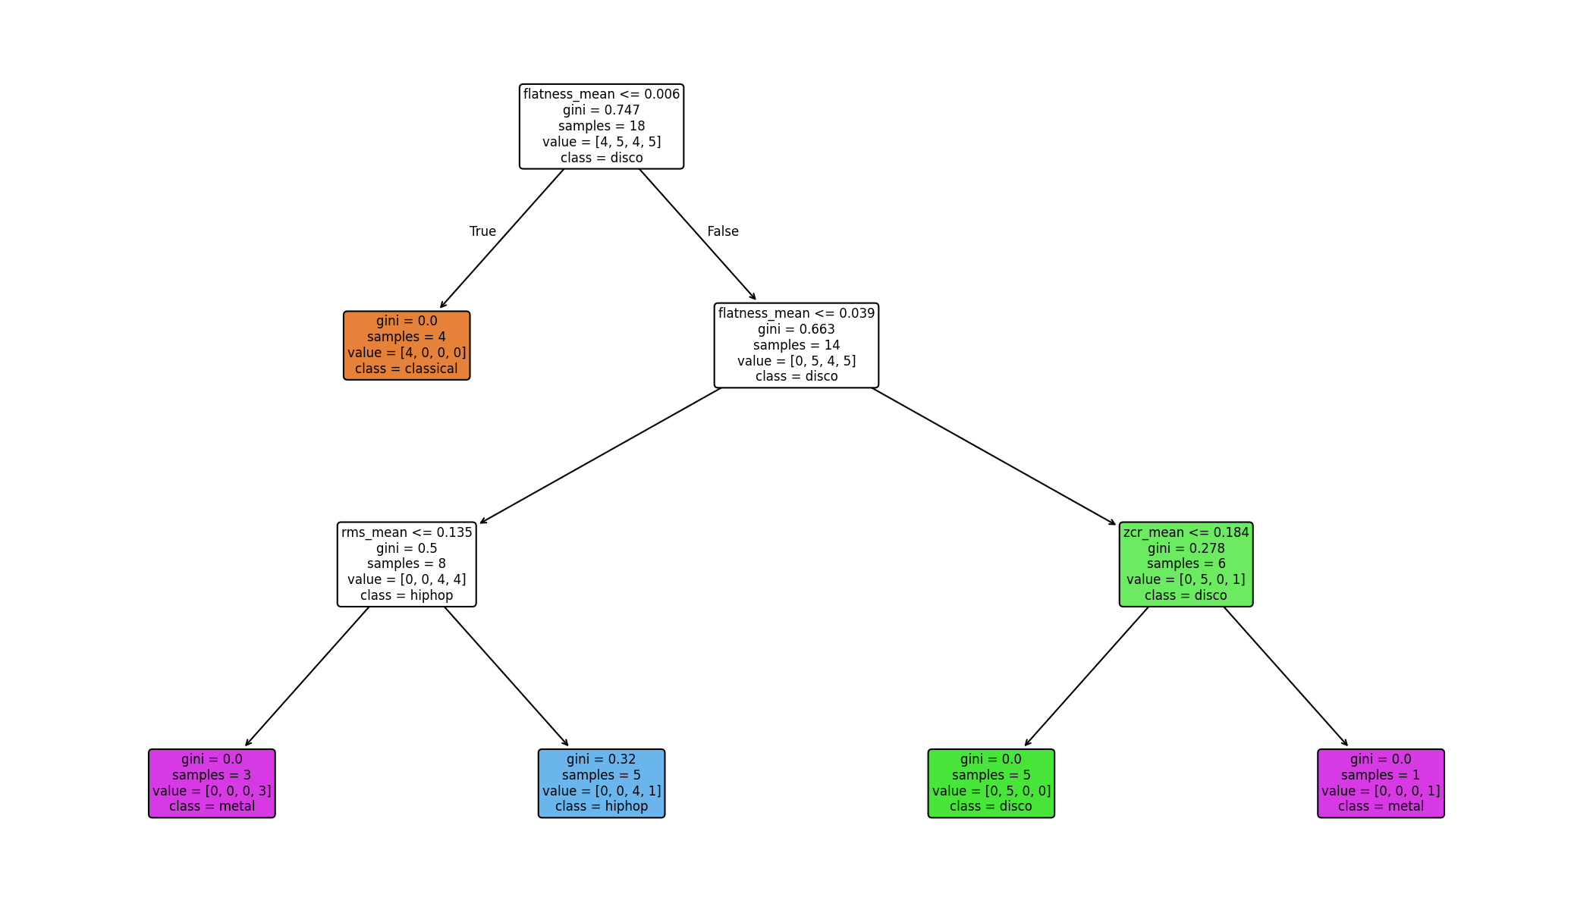
Decision boundary on centroid vs ZCR:
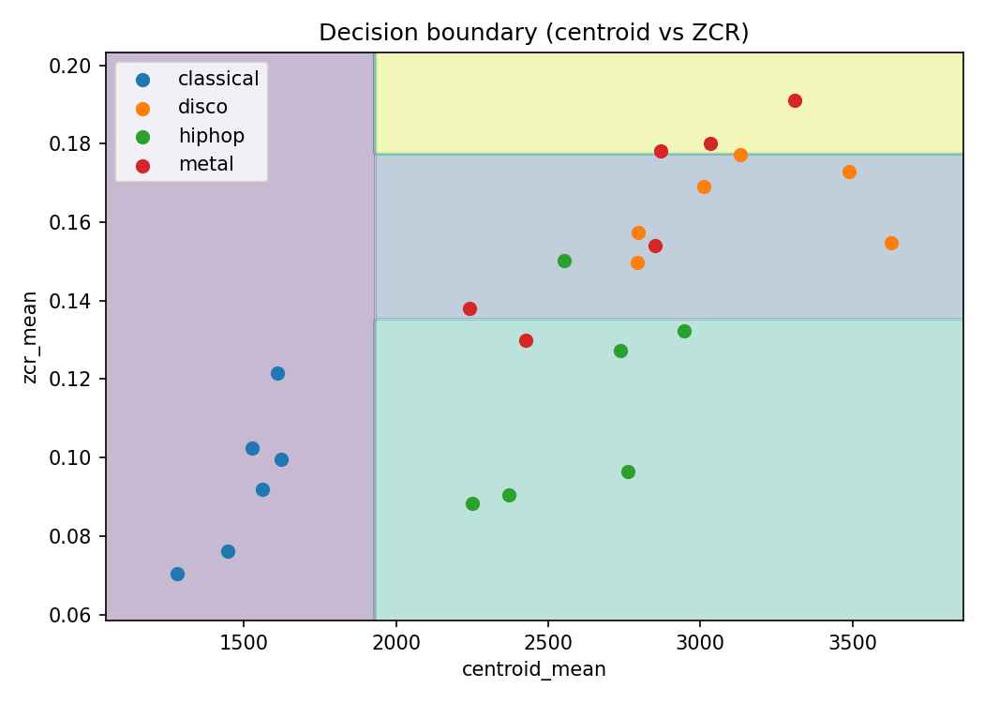

5. Observations, inferences, discussion
Spectral centroid dominates the root split (gain 0.9396), which matches acoustics: metal is bright, classical is dark, so one centroid threshold already separates half the classes; tempo carries almost no signal (gain 0.2387) because all four genres overlap in BPM. The hand-rolled tree scores lower than the tuned sklearn tree: multi-way splits on 3-bin features fragment 24 samples into tiny leaves, while sklearn's binary splits with min_samples_split regularize better — expected behavior on small data, and the reason the product uses forests (bagging over many such trees). The boundary plot shows axis-aligned rectangles, the visual signature of tree classifiers. GridSearchCV selects a shallow depth-3 gini tree, confirming that capacity control matters more than criterion choice here.

6. Conclusion
Entropy/Gini quantified a balanced 4-class problem; information gain identified spectral centroid as the root; a hand-built tree, a visualized sklearn tree, a 2-D boundary, and GridSearchCV tuning complete the pipeline on our own GTZAN project data. The experiment directly justifies the product's RandomForest heads, which are ensembles of exactly these tuned trees.

