1)

<!DOCTYPE html>

<html>

<head>

<title>q1</title>

<script>

function text_to_array() {

try {

inp = prompt('Enter some phrase')

if (inp.length == 0) {

throw "Enter something..don't leave it empty";

}

words = inp.split(" ")

var i = 0;

for (i; i < words.length; i++) {

document.write('Slot:' + i + ' Element:' + words[i] + '<br/>');

}

document.write(words)

} catch (error) {

document.write('<h1>Error:</h1>' + error)

}

}

text_to_array()

</script>

</head>

<body>

</body>

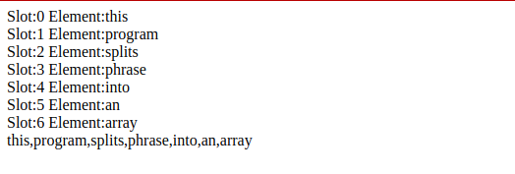</html>

2)

<!DOCTYPE html>

<html>

<head>

<title>q2</title>

</head>

<body>

<script type="text/javascript">

var words=prompt("Enter an array of space separated words to sort it in reverse chronological order");

reverse_sort(words);

function reverse_sort(words)

{

try{

if(words==" ")

{

throw e;

}

else

{

word=words.split(' ');

document.write("Reverse array is: "+word.sort().reverse()+"<br>");

}

}

catch(e)

{

document.write("Enter a valid paragraph");

}

}

</script>

</body>

</html>

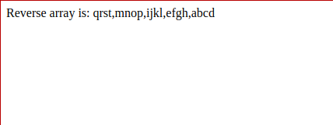

3)

<!DOCTYPE html>

<html>

<head>

<title>Q2</title>

</head>

<body>

<ul id="ul"></ul>

<script>

let arr = []

let x = prompt("Enter a number:")

arr.push(parseInt(x))

while (x) {

x = prompt("Enter a number:")

arr.push(parseInt(x))

}

let ul = document.getElementById('ul')

for (let i = 0; i < arr.length - 1; i++) {

li = document.createElement('li')

li.appendChild(document.createTextNode(hist(arr[i])))

ul.appendChild(li)

}

function hist(x) {

let str = ""

for (let i = 0; i < x; i++) {

str += '*'

}

return str

}

</script>

</body>

</html>

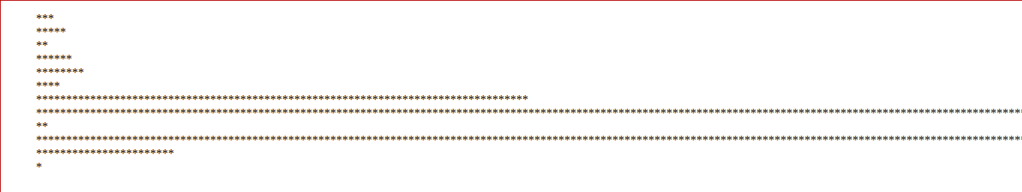

4)

<!DOCTYPE html>

<html>

<head>

<title>q4</title>

<script>

function validator(dob) {

var components, day, month, year, num_day, num_month, num_year;

var flag = 1;

try {

if (dob.length == 0)

throw "Empty date";

components = dob.split('-')

if (components.length != 3)

throw "Missing -";

day = components[0];

month = components[1];

year = components[2];

//document.write(components)

if (year.length != 4)

throw "Year length incorrect";

if (month.length != 2)

throw "Month format incorrect";

if (day.length != 2)

throw "Day format incorrect";

num_day = parseInt(day);

num_month = parseInt(month);

num_year = parseInt(year);

//document.write('<br/>' + num_day + ' ' + num_month + ' ' + num_year + '<br/>');

if (isNaN(num_day) || isNaN(num_month) || isNaN(num_year))

throw ('Value not a number/undefined');

if (num_year > 2020) {

throw "Invalid Year"

} else {

if (num_month > 12 || num_month < 1)

throw "Invalid month"

else {

if ((num_month == 2 && (num_day > 29 || num_day < 1)) || (num_month in [1, 3, 5, 7, 8, 10,

12

] && (num_day > 31 || num_day < 1)) || (num_month in [4, 6, 9, 11] && (num_day > 30 ||

num_day < 1)))

throw "Invalid day"

}

}

} catch (error) {

if (error instanceof TypeError)

document.write('Invalid number- cannot be converted to numeric');

else {

document.write('Error : ' + error)

}

flag = 0;

}

if (flag)

document.write('Valid DOB');

}

dob = prompt('Enter DOB in the format DD-MM-YYYY')

validator(dob);

</script>

</head>

<body>

</body>

</html>

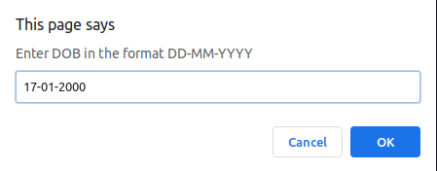



5

<!DOCTYPE html>

<html>

<head>

<title>q5</title>

</head>

<script>

function fizzbuzz(){

try{

var i=1;

for (i; i<=100; i++){

if(i%3==0 && i%5==0){

document.write('FizzBuzz ');

continue;

}

if (i%3==0){

document.write('Fizz ');

continue;

}

if (i%5==0){

document.write('Buzz ');

continue;

}

document.write(i+' ');

}

}

catch(error){

if(error instanceof TypeError)

document.write('Not a number');

else

document.write('Error : '+error);

}

}

fizzbuzz();

</script>

<body>

</body>

</html>

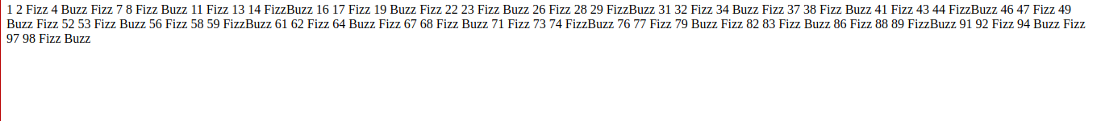

6)

<!DOCTYPE html>

<html>

<head>

<title>q6</title>

<script>

function assignGrade(num){

try{

val=parseInt(num);

if (val<0 || val>100)

throw "Number not in range";

grade="F";

if (val>=90)

grade="A";

else if (val>=80)

grade="B";

else if (val>=70)

grade="C";

else if (val>=60)

grade="D";

return grade;

}

catch(error){

if (error instanceof TypeError)

document.write('Unparseable input');

else

document.write('Error: '+ error);

}

}

var i=0;

var j;

while (i<5){

for (j=60; j<=100; j++){

g=assignGrade(j);

var article;

if (g =="A" || g=="F")

article='an ';

else

article="a ";

document.write('For '+j+' you got '+ article+g+'<br/>');

}

document.write('<br/><hr><br/>')

i++;

}

</script>

</head>

<body>

</body>

</html>

