COMPUTER NETWORKS LABORATORY
COMBINED LAB REPORT
LAB 4 AND LAB 5
Lab 4: IP Addressing and Subnetting (VLSM)
Lab 5: Static and Default Routing

Submitted by: Mallepula Lohith
Registration Number: RA2411030050031
Date: 23/10/2026
Software: Cisco Packet Tracer

Introduction
This combined report documents two Computer Networks laboratory exercises completed in Cisco Packet Tracer. Lab 4 covers IP addressing and subnetting with Variable Length Subnet Masking (VLSM) across three routers. Lab 5 covers static and default routing between two routers and three PCs. Each experiment includes its aim, required devices, addressing plan, configuration commands, verification steps, screenshot placements, and result.

Lab 4 — IP Addressing and Subnetting (VLSM)

1. Aim
To create a three-router triangular network, divide the address space into /30 subnets using VLSM, assign IP addresses to router interfaces, and verify neighboring-link connectivity using ping.

2. Required devices
Device / item | Quantity
Cisco 2911 routers (R1, R2, R3) | 3
Ethernet/Gigabit Ethernet links | 3
Cisco Packet Tracer | 1

3. VLSM addressing plan
Link | Network | Subnet mask | Usable addresses | Broadcast
R1–R2 | 192.168.1.0/30 | 255.255.255.252 | 192.168.1.1–192.168.1.2 | 192.168.1.3
R1–R3 | 192.168.1.4/30 | 255.255.255.252 | 192.168.1.5–192.168.1.6 | 192.168.1.7
R2–R3 | 192.168.1.8/30 | 255.255.255.252 | 192.168.1.9–192.168.1.10 | 192.168.1.11

A /30 subnet contains four total addresses: one network address, two usable host addresses, and one broadcast address. This makes it suitable for a point-to-point router link.

4. Topology and screenshot
Place R1, R2, and R3 in a triangle and connect each router pair. Use the topology screenshot from your Packet Tracer workspace.
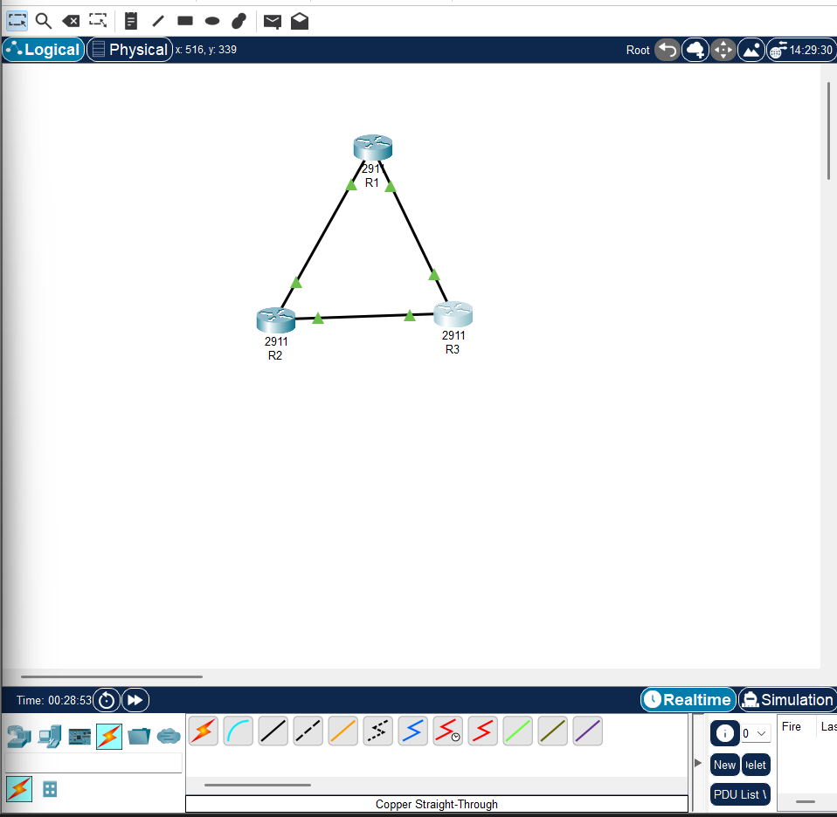
Figure 1. Lab 4 topology / screenshot from the source report.

5. Router configuration commands
R1 — configure the interfaces connected to R2 and R3:
enable
configure terminal
hostname R1
interface gigabitEthernet 0/0
ip address 192.168.1.1 255.255.255.252
no shutdown
exit
interface gigabitEthernet 0/1
ip address 192.168.1.5 255.255.255.252
no shutdown
exit
end
show ip interface brief
copy running-config startup-config
R2 — configure the interfaces connected to R1 and R3:
enable
configure terminal
hostname R2
interface gigabitEthernet 0/0
ip address 192.168.1.2 255.255.255.252
no shutdown
exit
interface gigabitEthernet 0/1
ip address 192.168.1.9 255.255.255.252
no shutdown
exit
end
show ip interface brief
copy running-config startup-config
R3 — configure the interfaces connected to R1 and R2:
enable
configure terminal
hostname R3
interface gigabitEthernet 0/0
ip address 192.168.1.6 255.255.255.252
no shutdown
exit
interface gigabitEthernet 0/1
ip address 192.168.1.10 255.255.255.252
no shutdown
exit
end
show ip interface brief
copy running-config startup-config
Note: If the router model displays different interface names, use the actual interface names shown in Packet Tracer. The IP addresses must match the physical links in the topology.

6. Connectivity testing
Router | Ping commands
R1 | ping 192.168.1.2  ping 192.168.1.6
R2 | ping 192.168.1.1  ping 192.168.1.10
R3 | ping 192.168.1.5  ping 192.168.1.9

Verify the interfaces on each router:
show ip interface brief
The configured interfaces should show the correct IP addresses and should be up/up when the links are connected correctly.
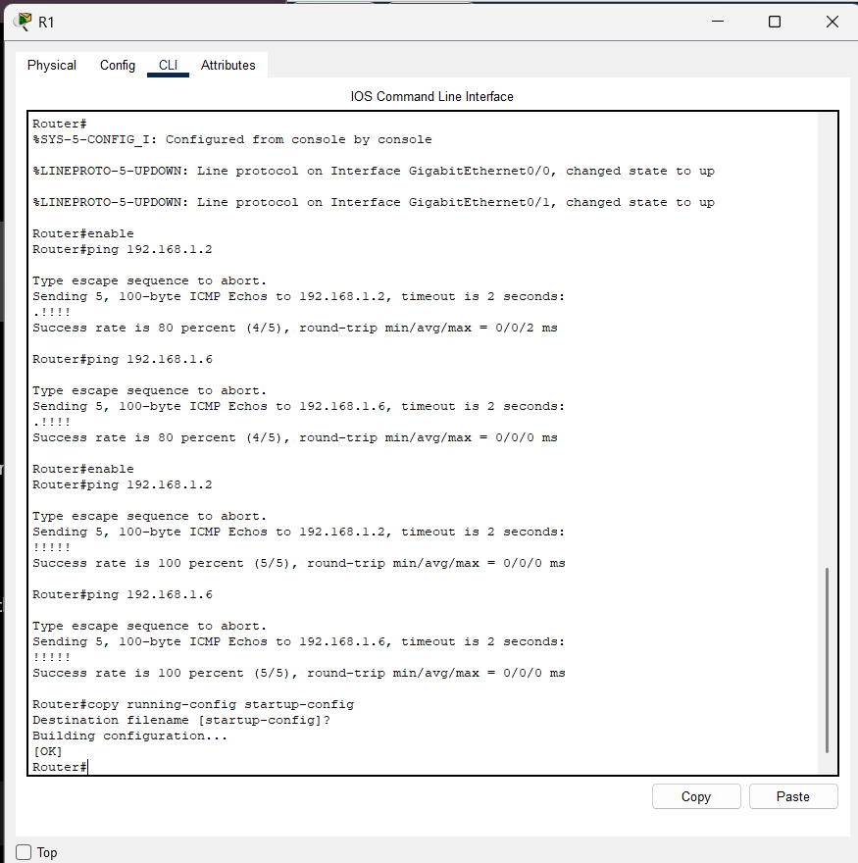
Figure 2. Lab 4 configuration or verification screenshot. Replace with a live CLI capture if required.

7. Lab 4 result
The three-router triangular topology was addressed using three /30 subnets. Router interfaces were configured, interface status was checked, and neighboring router connectivity was tested using ping. The configuration was saved.

Lab 5 — Static and Default Routing

1. Aim
To configure static routing and default routing between two routers in Cisco Packet Tracer and verify connectivity between computers in different LANs using ping.

2. Required devices
Device / item | Quantity
Cisco routers (R1 and R2) | 2
PCs (PC1, PC2, PC3) | 3
Copper straight-through Ethernet cables | As required
Serial DCE/DTE cable | 1

3. IP addressing table
Device | Interface | IP address | Subnet mask | Default gateway
PC1 | FastEthernet0 | 192.168.1.10 | 255.255.255.0 | 192.168.1.1
PC2 | FastEthernet0 | 192.168.1.20 | 255.255.255.0 | 192.168.1.1
PC3 | FastEthernet0 | 192.168.2.10 | 255.255.255.0 | 192.168.2.1
R1 | LAN / G0/0 | 192.168.1.1 | 255.255.255.0 | —
R1 | Serial 0/3/0 | 10.0.0.1 | 255.255.255.252 | —
R2 | Serial 0/3/0 | 10.0.0.2 | 255.255.255.252 | —
R2 | LAN / G0/0 | 192.168.2.1 | 255.255.255.0 | —

4. Topology and screenshot
Connect PC1 and PC2 to R1, PC3 to R2, and connect R1 to R2 using the serial link.
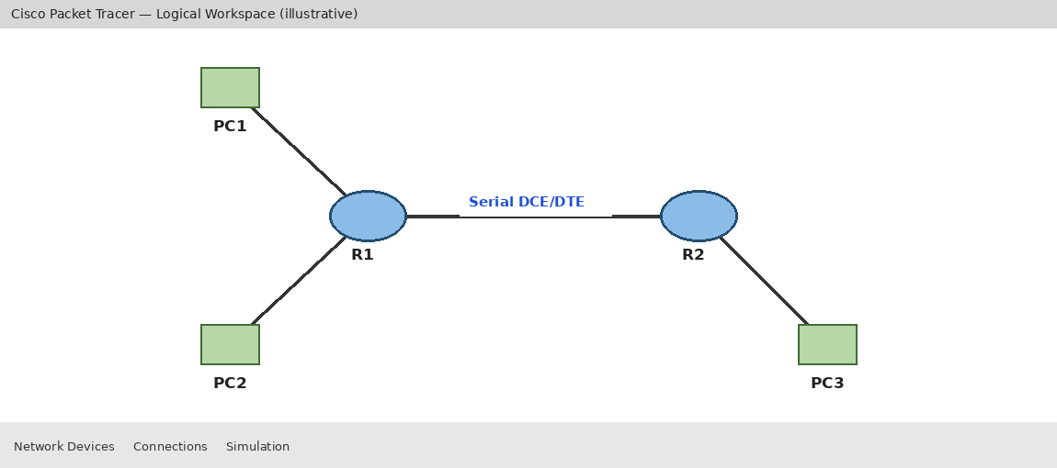
Figure 3. Lab 5 two-router topology. Source report image; replace with your live Packet Tracer screenshot if needed.

5. Configure R1
enable
configure terminal
hostname R1
interface gigabitEthernet 0/0
ip address 192.168.1.1 255.255.255.0
no shutdown
exit
interface serial 0/3/0
ip address 10.0.0.1 255.255.255.252
clock rate 64000
no shutdown
exit
ip route 192.168.2.0 255.255.255.0 10.0.0.2
! Optional default route if required by the lab:
ip route 0.0.0.0 0.0.0.0 10.0.0.2
end
show ip interface brief
show ip route
copy running-config startup-config

6. Configure R2
enable
configure terminal
hostname R2
interface gigabitEthernet 0/0
ip address 192.168.2.1 255.255.255.0
no shutdown
exit
interface serial 0/3/0
ip address 10.0.0.2 255.255.255.252
no shutdown
exit
ip route 192.168.1.0 255.255.255.0 10.0.0.1
! Optional default route if required by the lab:
ip route 0.0.0.0 0.0.0.0 10.0.0.1
end
show ip interface brief
show ip route
copy running-config startup-config
Use clock rate 64000 only on the serial interface that has the DCE end of the cable. If the serial interface is DTE, do not configure a clock rate there. Static routes are needed for the remote LANs; configure default routes only if your lab instructions require them.

7. Configure PC IP addresses
For each PC, open Desktop → IP Configuration, select Static, and enter the IP address, subnet mask, and default gateway shown in the table above.

8. Verification and ping tests
! On R1:
ping 10.0.0.2
show ip route
! On R2:
ping 10.0.0.1
show ip route
! From PC1 Command Prompt:
ping 192.168.2.10
! From PC3 Command Prompt:
ping 192.168.1.10
Expected routing-table entries: R1 should have a route to 192.168.2.0/24 via 10.0.0.2; R2 should have a route to 192.168.1.0/24 via 10.0.0.1. If default routes are configured, the table should also show S* 0.0.0.0/0 via the opposite router.
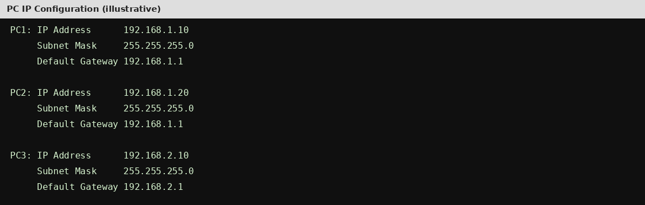
Figure 4. Lab 5 routing or CLI screenshot. Source report illustration.
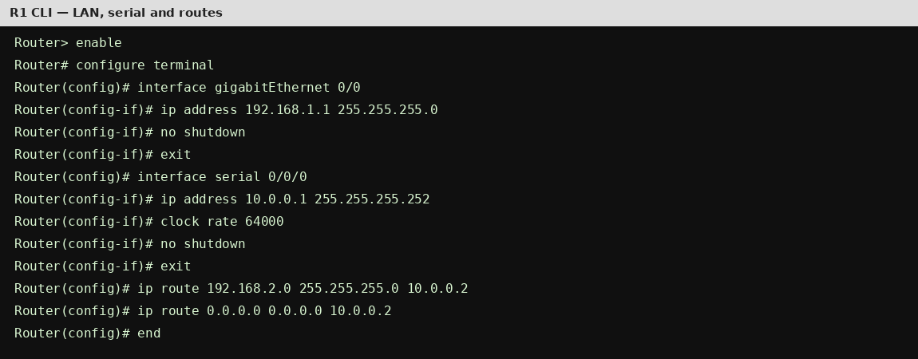
Figure 5. Lab 5 ping verification screenshot. Source report illustration.

9. Lab 5 result
The two LANs were configured on separate routers with a /30 serial network between them. Static routes were added to reach the remote LANs, optional default routes were documented, and router and PC connectivity was tested using ping.

Overall Conclusion
Both laboratory exercises demonstrate key IPv4 networking concepts in Cisco Packet Tracer. Lab 4 applies VLSM to allocate small point-to-point subnets efficiently and verifies directly connected router links. Lab 5 demonstrates how static routes and default routes enable communication between separate LANs through two routers. Interface status, routing tables, ping tests, and saving configurations are important steps in validating and preserving the network setup.

Common verification commands
show ip interface brief
show ip route
ping <destination-ip>
copy running-config startup-config
Screenshot note: This combined document reuses figures embedded in the source reports. Where a figure is illustrative rather than a direct capture from the running Packet Tracer file, replace it with your own actual screenshot if your instructor requires original evidence.

