EXECUTIVE REPORT · DATA ANALYTICS
Vendor Performance
Analysis
An End-to-End Data Analytics Project — presenting analytical findings, dashboard insights, and business recommendations derived from vendor transaction data.
PREPARED BY | Lohith Aryan S
PROJECT DURATION | June 2026 – July 2026

MYSQL | PYTHON | SQL | POWER BI | GIT & GITHUB

VENDOR PERFORMANCE DASHBOARD
Confidential | Prepared for Portfolio Review

Table of Contents
01 Executive Summary3
02 Project Overview3
03 Dashboard Overview3
04 Data Analysis Using Python5
05 Business Insights10
06 Dashboard Insights11
07 Business Recommendations11
08 Future Scope11
09 Conclusion12
A Appendix — Project Workflow12

SECTION 01

Executive Summary
This report summarizes the findings of the Vendor Performance Analysis project, an end-to-end data analytics solution designed to evaluate vendor purchasing, sales, profitability, and delivery performance for a liquor retail business over a one-year period.
The project demonstrates the complete analytics lifecycle by integrating large-scale relational data storage, SQL-based exploratory analysis, Python-based KPI computation, and interactive business intelligence reporting.
Vendor transaction data was loaded into a MySQL database, analyzed using SQL and Python, and visualized through a two-page Power BI dashboard to generate actionable vendor performance insights.
The objective of this report is to present the analytical findings and demonstrate how data-driven visualization can support better vendor prioritization and procurement decision-making.
131  VENDORS ANALYZED | 1 YR  ANALYSIS PERIOD | 2  POWER BI DASHBOARDS | 5  KEY BUSINESS INSIGHTS
SECTION 02

Project Overview
The project analyzed vendor performance for a liquor retail business across six related datasets covering inventory, purchasing, and sales.

Dataset Characteristics
- Opening and closing inventory by store and brand
- Purchase order, receiving, invoice, and pay dates
- Purchase price, quantity, and dollar value
- Sales quantity, sales price, and sales dollar value
- Vendor invoice totals and freight charges
SECTION 03

Dashboard Overview

Executive Overview Dashboard
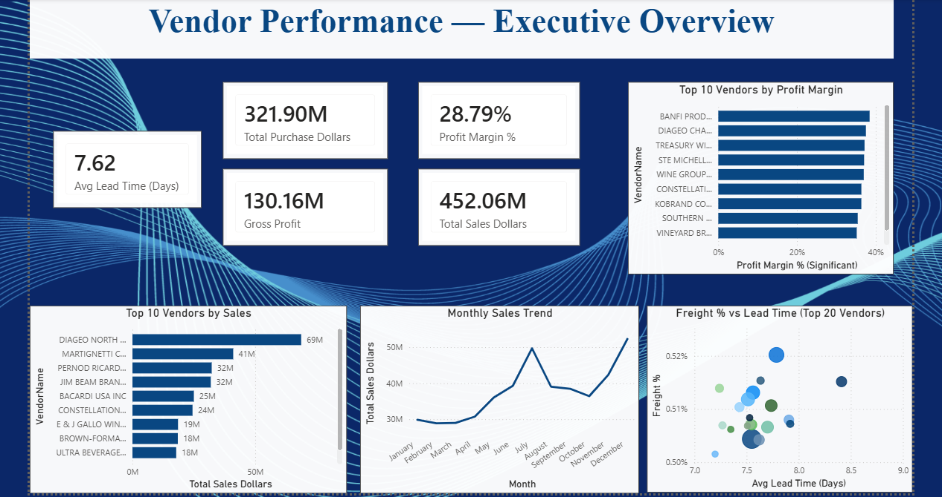
FIGURE 1 Executive Overview Dashboard
The Executive Overview dashboard provides a high-level summary of vendor performance through KPI cards, comparative bar charts, a monthly sales trend line, and a freight-versus-lead-time scatter chart.
The dashboard enables business users to:
- Compare vendor sales revenue and profit margin
- Monitor monthly sales trends
- Evaluate freight cost efficiency against delivery lead time
- Identify top-performing vendors at a glance

Vendor Deep Dive Dashboard
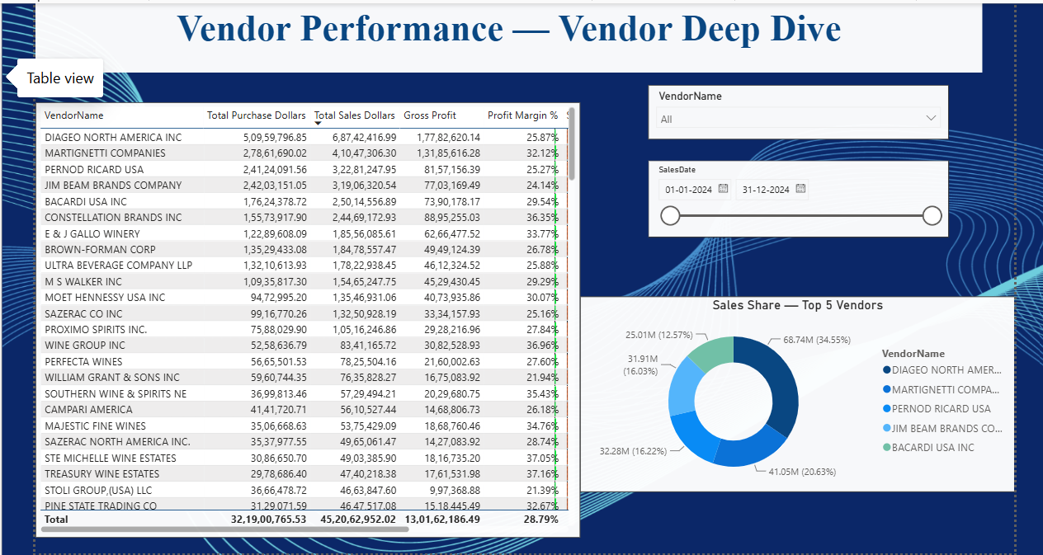
FIGURE 2 Vendor Deep Dive Dashboard
The Vendor Deep Dive dashboard focuses on vendor-level detail through a sortable scorecard table, vendor and date slicers, and a sales-share donut chart, enabling users to:
- Sort and filter the full vendor scorecard by any metric
- Isolate a single vendor's performance across all KPIs
- View sales concentration across the top 5 vendors
SECTION 04

Data Analysis Using Python

4.1 Top Vendors by Sales Revenue
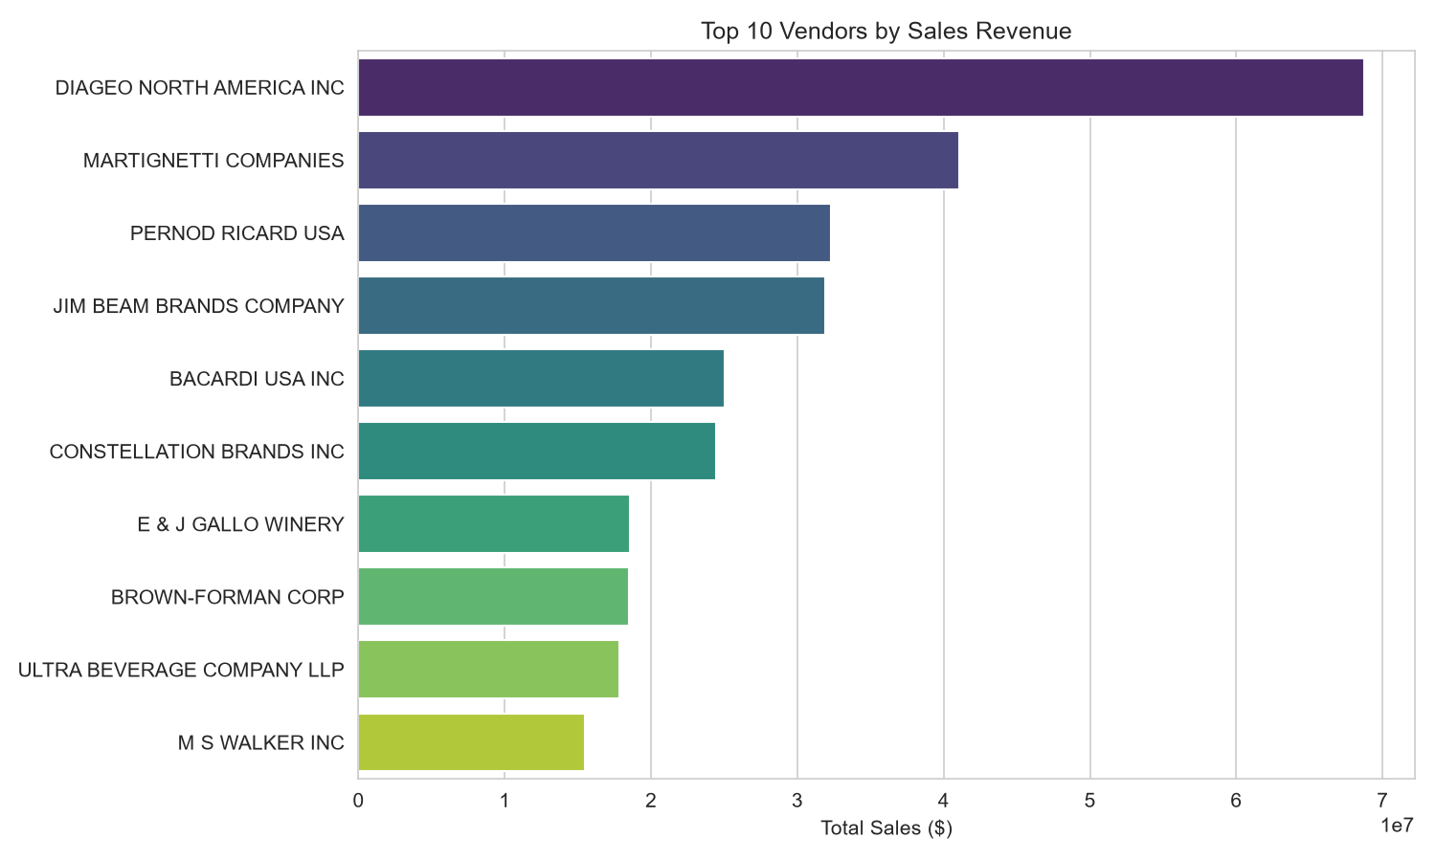
FIGURE 3 Top 10 Vendors by Sales Revenue
This comparison measures total sales dollars generated by each vendor during the analysis period.
KEY FINDINGS
- Diageo North America Inc generated the highest sales revenue by a wide margin.
- Martignetti Companies and Pernod Ricard USA follow as the next-largest vendors by revenue.
- The top 5 vendors account for a substantial share of total vendor revenue.

4.2 Profit Margin Comparison
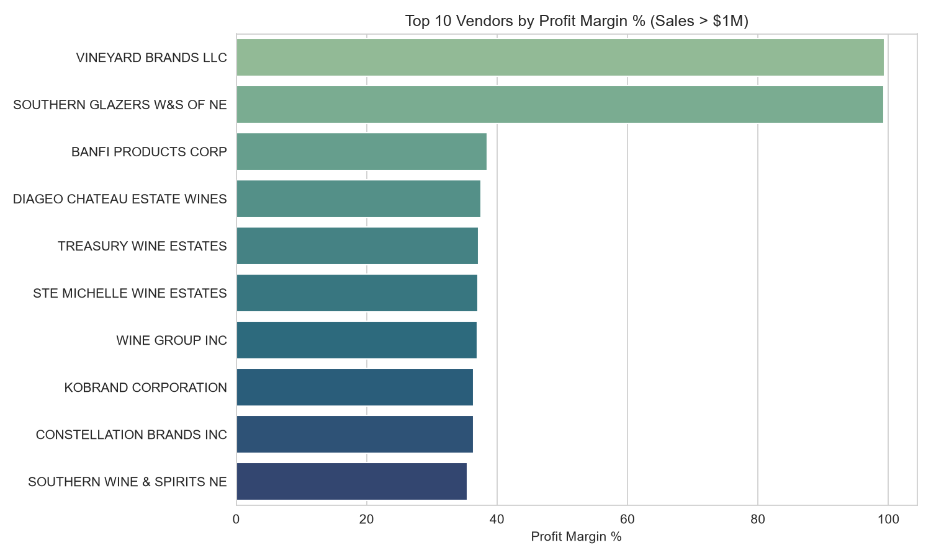
FIGURE 4 Top 10 Vendors by Profit Margin % (Sales > $1M)
Profit margin percentage was calculated only for vendors exceeding $1M in sales, to avoid noise from very small vendors with misleadingly high margins.
KEY FINDINGS
- Vineyard Brands LLC and Southern Glazer's W&S of NE show the highest margins among significant vendors.
- Constellation Brands Inc and E&J Gallo Winery combine strong margins with meaningful sales volume.
- The highest-revenue vendor, Diageo, does not appear in the top-margin list — revenue and profitability do not always move together.

4.3 Distribution of Vendor Profit Margin
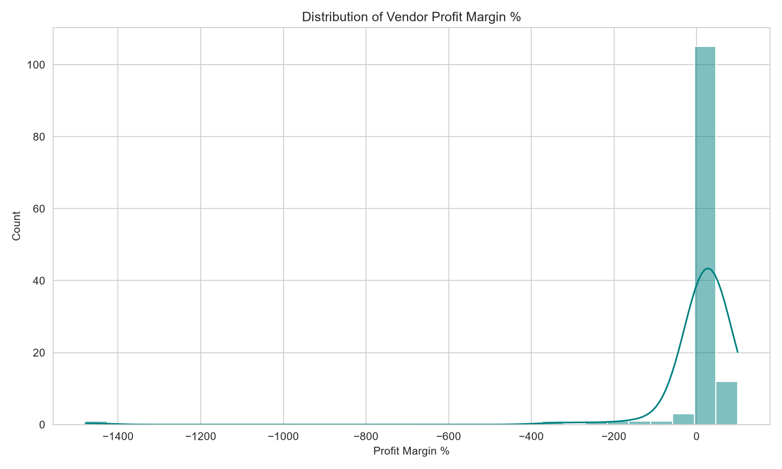
FIGURE 5 Distribution of Vendor Profit Margin %
This distribution shows how profit margin percentage is spread across all 131 vendors.
KEY FINDINGS
- The majority of vendors cluster tightly around a healthy, positive margin.
- A small number of vendors show sharply negative margins, warranting individual review.
- The distribution is left-skewed, meaning most vendors perform well while a minority pull the average down.

4.4 Sell-Through Rate Distribution
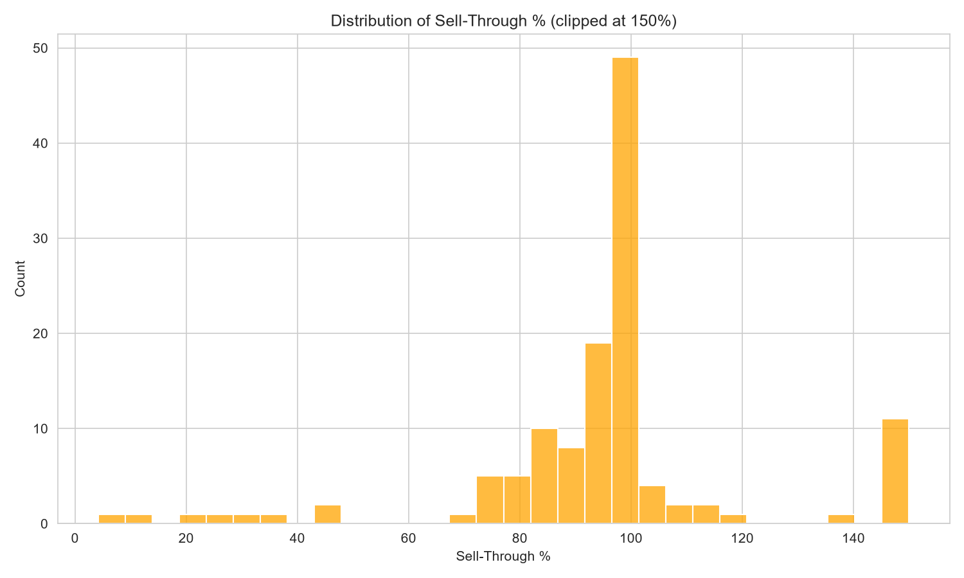
FIGURE 6 Distribution of Sell-Through % (clipped at 150%)
Sell-through rate measures how much of the purchased inventory was actually sold during the period.
KEY FINDINGS
- Most vendors cluster between 80% and 100% sell-through, indicating efficient inventory turnover.
- A secondary cluster near 150% reflects vendors selling more than they purchased in-period, drawing down opening inventory.
- Very few vendors show unusually low sell-through, suggesting minimal dead-stock risk overall.

4.5 Freight % vs Lead Time
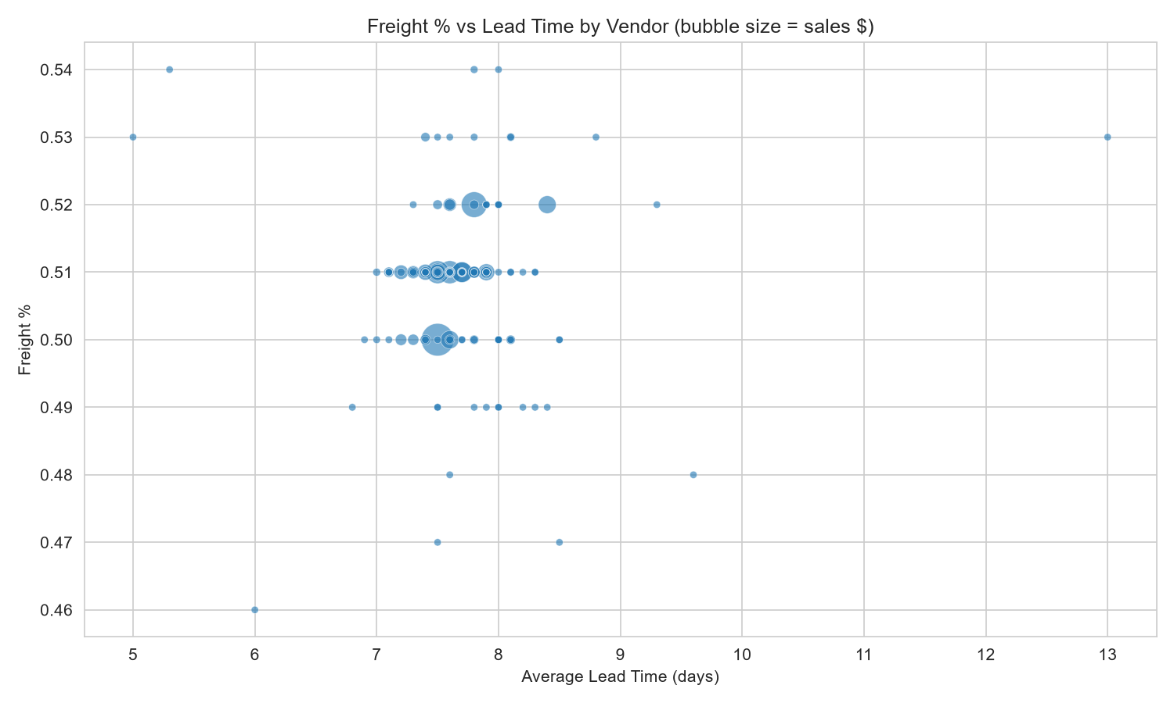
FIGURE 7 Freight % vs Lead Time by Vendor (bubble size = sales $)
This chart compares freight cost efficiency against average delivery lead time, with bubble size representing vendor sales volume.
KEY FINDINGS
- Freight percentage is tightly clustered between 0.49% and 0.53% for nearly all vendors.
- Lead time for most vendors falls between 7 and 8 days, with a small number of outliers reaching 13 days.
- No vendor combines high freight cost with long lead time, indicating a generally well-managed supply base.
SECTION 05

Business Insights
The analytical results provide several meaningful business observations.
01 Diageo Leads on Revenue, Not Margin
Diageo North America generated the highest total sales revenue, but several smaller-volume vendors delivered stronger profit margins — revenue leadership does not equal profitability leadership.
02 Constellation Brands and E&J Gallo Offer the Best Balance
These vendors combine meaningful sales volume with above-average profit margins, making them strong candidates for deeper strategic partnership.
03 Freight Costs Are Well-Controlled
Freight cost as a percentage of invoice value is consistent across nearly all vendors (approximately 0.5%), indicating no vendor is disproportionately burdening the business with shipping costs.
04 Delivery Performance Is Generally Reliable
Average lead times cluster around 7-8 days for most vendors, with only a small number extending to 10-13 days, representing manageable supply chain risk.
05 Inventory Turnover Is Healthy Overall
Most vendors show sell-through rates between 80% and 100%, suggesting efficient inventory management with limited dead-stock exposure.
SECTION 06

Dashboard Insights
The Power BI dashboard transformed raw vendor transaction data into interactive business intelligence by providing:
- Executive KPI cards for sales, purchases, gross profit, margin, and lead time
- Comparative bar charts for top vendors by sales and by margin
- A monthly sales trend line
- A freight percentage vs lead time scatter chart
- A sortable, filterable vendor scorecard table
- Vendor and date-range slicers for interactive exploration
- A sales-share donut chart for the top 5 vendors
The dashboard enables business users to analyze vendor performance without manually querying the underlying database.
SECTION 07

Business Recommendations
1 Prioritize deeper relationships with high-margin vendors such as Constellation Brands and E&J Gallo Winery, even where they are not top-volume vendors.
2 Continue monitoring, rather than renegotiating, freight arrangements, since freight efficiency is already consistent across vendors.
3 Monitor vendors with longer average lead times for potential supply chain risk.
4 Investigate the small subset of vendors showing sharply negative profit margins.
5 Use sell-through rate alongside margin when evaluating vendor performance, since high revenue with poor turnover can mask inventory risk.
SECTION 08

Future Scope
Future enhancements may include:
- A shared date dimension table to enable cross-filtering between purchase dates and sales dates
- Scheduled, automated Power BI data refresh directly from MySQL
- Vendor risk scoring combining margin, lead time, and freight into a single index
- Expansion to additional product categories or store regions
- Forecasting future vendor demand using historical trends
SECTION 09

Conclusion
The Vendor Performance Analysis project successfully demonstrates a complete end-to-end analytics workflow by integrating MySQL, SQL, Python, and Power BI into a unified business intelligence solution.
The project ingests large-scale vendor transaction data, performs analytical calculations, validates data quality, and delivers actionable insights through an interactive dashboard.
Beyond technical implementation, the solution highlights the practical application of data analytics in supporting vendor prioritization and procurement decision-making. The modular design also provides a scalable foundation for future enhancements such as shared date dimensions, automated refresh, and vendor risk scoring.
SECTION A

Appendix — Project Workflow
The end-to-end pipeline that transforms raw vendor transaction data into an executive-ready business insights report:
1 Raw CSV Data
Six related CSV files covering inventory, purchases, purchase prices, sales, and vendor invoices.
2 MySQL Ingestion
Bulk loading via LOAD DATA LOCAL INFILE into a normalized relational schema.
3 SQL Validation & EDA
Checks for missing values, whitespace-driven duplicate groupings, orphaned records, and initial vendor performance queries.
4 Python KPI Analysis
Calculation of profit margin, sell-through rate, freight percentage, and average lead time; chart generation.
5 Star Schema Modeling
Vendor and Brand dimension tables built in Power Query, related to five fact tables.
6 Power BI Dashboard
Two-page interactive dashboard with custom DAX measures and business-ready visuals.
7 Business Insights Report
Consolidated executive findings and recommendations, as presented in this document.

