Chapter-1

INTRODUCTION

Project Background
Modern external beam radiotherapy (EBRT) relies fundamentally on accurate patient anatom-ical representations to deliver lethal ionizing radiation doses to target neoplastic lesions while strictly sparing adjacent critical organs-at-risk (OARs) [1, 2]. In contemporary clinical oncology, Computed Tomography (CT) serves as the indispensable cornerstone for treatment simulation, anatomical contouring, and radiation dose calculation [2]. The diagnostic values in CT images are natively calibrated in Hounsfield Units (HU), which maintain a direct, monotonic mathematical relationship with physical tissue electron densities (ρ_{e}) and photon linear attenuation coefficients (µ) [2, 3]:
× (︃ )︃
HU = 1000 µtissue − µwater (1.1)
µwater

Because high-energy photon and proton beams interact with human tissue predominantly through Compton scattering and secondary ionization processes, commercial Radiation Treatment Planning Systems (TPS) mandate CT-derived electron density calibration curves to execute Monte Carlo or collapsed-cone convolution dose calculations [2, 4].
Concurrently, Magnetic Resonance Imaging (MRI) has emerged as an indispensable supple-mentary diagnostic modality in neuro-oncology [3, 4]. By interrogating the nuclear magnetic resonance properties of hydrogen protons under static and radiofrequency magnetic fields, MRI generates exceptional soft-tissue contrast and superior spatial demarcation of intracra-nial neoplasms, cerebrospinal fluid (CSF) interfaces, and cranial nerve structures that remain indistinct or radiologically isodense on non-contrast CT [1, 4].
However, MRI signal intensity reflects nuclear spin-lattice (T₁) and spin-spin (T₂, T2∗) re-
laxation dynamics, proton density, and local magnetic susceptibility gradients rather than physical electron density [2]. Consequently, standard MRI scans lack electron density infor-mation and cannot be ingested directly by TPS algorithms for dose deposition modeling [1, 2].

Clinical Need for Synthetic CT (sCT)
Because neither imaging modality alone satisfies both soft-tissue delineation and dose calculation prerequisites, current standard-of-care clinical radiotherapy enforces a dual-modality workflow [2, 4]. In this paradigm, patients must undergo both an initial simulation CT scan (for electron density assignment) and a subsequent high-resolution diagnostic MRI scan (for target volume delineation). Medical physicists then execute multimodal image coregistration to warp the MR-delineated contours onto the reference planning CT geometry [2].
Despite its widespread clinical adoption, this dual-modality acquisition paradigm suffers from three critical vulnerabilities [2–4]:
- Systematic Coregistration Errors: Inter-modality image registration between sepa-rate CT and MRI scanners inevitably incurs spatial alignment uncertainties ranging from 1.5 mm to over 5.0 mm, even when rigid cranial immobilizers are employed [2, 3]. Anatomical variations—such as patient positioning discrepancies, physiological head flexion, soft-tissue deformation, and non-linear MRI magnetic gradient coil distor-tions—introduce systematic positioning offsets [2]. In precision stereotactic radiosurgery (SRS) and intensity-modulated proton therapy (IMPT), where treatment margins often do not exceed 1 to 2 mm, registration misalignments can cause critical geometric misses of gross tumor volumes or unacceptable radiation overdose to the brainstem and optic chiasm [4].
- Cumulative Ionizing Radiation Exposure: Diagnostic and planning CT scans expose cancer patients to non-negligible ionizing radiation doses (typically 2 to 4 mSv per cranial CT examination) [2]. For pediatric neuro-oncology patients and individuals undergoing repeated adaptive radiotherapy fractions over multi-week protocols, this cumulative secondary radiation significantly elevates long-term risks of radiation-induced secondary malignancies [1, 2].
- Elevated Healthcare Costs and Clinical Overhead: The necessity of scheduling, acquir-ing, reconstructing, and quality-assuring two independent scanning sessions substantially inflates healthcare expenditures, strains hospital infrastructure, and prolongs the crucial time interval between initial cancer diagnosis and radiation treatment delivery [2, 4].

To eliminate these clinical drawbacks, the international radiation oncology community is actively transitioning toward an “MRI-Only Radiotherapy Planning Workflow” [1, 2]. In an MRI-only pipeline, the planning CT scan is omitted entirely; instead, a highly accurate Synthetic CT (sCT)—also known as a pseudo-CT—is computationally synthesized directly from the planning MRI volume. This sCT preserves the pristine soft-tissue coordinate system of the MR scan while substituting geometrically aligned, quantitatively accurate Hounsfield Units for accurate dosimetric planning [1].

Technical Challenges in MRI-to-CT Translation
Synthesizing realistic, radiologically valid CT volumes from raw MRI sequences presents severe computational and physical inverse-problem challenges [2, 5, 6]:
- Severe Signal Ambiguity of Cortical Bone: The most prominent challenge in MRI-to-CT translation is the acute signal ambiguity between cortical bone and air cavities [1, 2].
Cortical bone possesses an extremely short apparent transverse relaxation time (T₂∗ <
0.5 ms) and a low mobile proton density; as a result, free induction decay occurs faster than standard MRI echo times (T_{E}), causing bone to manifest as void, zero-signal hypointense regions in standard T₁-weighted gradient-echo or spin-echo sequences [2]. Similarly, air cavities (such as the sphenoid and ethmoid paranasal sinuses, mastoid air cells, and the ambient scanner bore) contain negligible proton density and appear completely dark [2, 3]. However, on CT, cortical bone and air represent the two opposing extremes of the attenua-tion spectrum: air measures approximately −1000 HU, whereas dense skull bone exceeds
+1000 to + 2500 HU [1]. Differentiating these identically dark MRI regions demands deep spatial contextual reasoning and structural geometric priors.
- Ill-Posed, Non-Unique Cross-Modality Mapping: MRI voxel intensities are arbitrary
scanner-dependent quantities governed by local coil sensitivities, radiofrequency trans-mit/receive inhomogeneities (B⁺ and B⁻ fields), receiver gain, and vendor-specific re-
1 1
construction filters [1]. Consequently, MRI voxel values lack absolute physical units, rendering the translation f : MRI → CT an intrinsically non-injective, ill-posed inverse problem [5, 6].
- Geometric and Susceptibility Distortions: Static magnetic field (B₀) inhomogeneities at air-tissue interfaces cause localized voxel displacement and distortion artifacts in MRI,

which contrast sharply with the rigid, geometrically faithful reconstruction geometry of CT [2].

Problem Statement and Mathematical Formulations
Given an input planning magnetic resonance image slice x ∈ R^{H×W} within a spatial domain Ω ⊂ R², the objective of MRI-to-CT image translation is to learn a parameterized functional mapping f_{θ} : x → yˆ that accurately estimates the true, co-registered computed tomography slice y ∈ R^{H×W} across all anatomical structures. In accordance with clinical benchmarks established by the international SynthRAD2023 challenge [1], both MRI and CT volumes are scaled to a unified, normalized physical dynamic range [−1.0, +1.0], corresponding to the standard clinical CT window [−1000 HU, +3000 HU] via the linear transformation:
y_{norm} = 2 × (︃ yHU − HUmin )︃ − 1.0, where HU = −1000, HU = 3000 (1.2)

HUmax
— HU
min
min
max

To thoroughly investigate generative deep learning paradigms, this project formulates, im-plements, and benchmarks five distinct model architectures under strictly identical training, validation, and testing splits (Seed 42, 80%/20% patient-level cohort split):

Model 1: Deep Residual U-Net (ResUNet Baseline)

The first model implements a supervised, fully convolutional baseline utilizing deep residual blocks to mitigate vanishing gradients and facilitate multi-scale feature propagation [7,8]. The network parameters θ_{ResUNet} are optimized using a composite objective balancing voxel-wise fidelity (L₁) and global reconstruction energy (Mean Squared Error, MSE):
L_{ResUNet}(θ) = 1 ∑︂ |yˆ − y | + λmse ∑︂(yˆ − y )² (1.3)
i
i

|Ω| i∈Ω
|Ω|
i i
i∈Ω

While computationally efficient and deterministic, pure regression models notoriously suffer from regression-to-the-mean effects, leading to oversmoothed bone-tissue boundaries and structural attenuation underestimations.

Model 2: Conditional Generative Adversarial Network (Pix2Pix cGAN)
To overcome blurriness and encourage realistic high-frequency anatomical texture, Model 2 implements a conditional adversarial framework [9, 10]. The generator G and a Markovian PatchGAN discriminator D engage in a two-player minimax game conditioned on the MRI image x:
min max L_{cGAN}(G, D) + λ_{rec}L_{L}1 (G) (1.4)
G
D

where the conditional adversarial objective is defined as:

L_{cGAN}(G, D) = E_{x,y} [log D(x, y)] + E_{x} [log (1 − D(x, G(x)))] (1.5)

and L_{L}1 (G) = E_{x,y} [ y − G(x) ₁]. Although Pix2Pix produces visually sharper bone struc-tures, adversarial training is susceptible to mode collapse, hallucinated pseudo-anatomical structures, and subtle geometric distortions unacceptable for radiation dosimetry.

Model 3: Conditional Denoising Diffusion Probabilistic Model (cD-DPM From Scratch)
Model 3 explores likelihood-based generative diffusion modeling [11, 12]. Unlike GANs, diffusion models define a rigorous forward Gaussian corruption process q(y_{t}|y_{t−1}) parame-
terized by a predetermined variance schedule {β_{t} ∈ (0, 1)}T :
t=1

q(y_{t}|y₀) = N (︁y_{t}; √α¯_{t}y₀, (1 − α¯_{t})I)︁ , α_{t} = 1 − β_{t},
t
α¯_{t} = α_{s} (1.6)
∏︂
s=1

The neural denoiser ϵ_{θ}(y_{t}, t, x, m) receives a 3-channel input tensor concatenating the noisy intermediate CT y_{t}, conditioning MRI x, and brain mask m to predict the injected Gaussian noise ϵ ∼ N(0, I):

L_{cDDPM}(θ) = E
t,y₀,ϵ,x,m
[︂⃦⃦ϵ − ϵ
(︁√α¯ y
+ √1 − α¯ ϵ, t, x, m)︁⃦⃦2]︂ (1.7)

Inference is accelerated using Denoising Diffusion Implicit Models (DDIM, η = 0) across 50 deterministic reverse steps [13].
θ
t
0
t
2

Model 4: SOTA Conditional DDPM with Residual Attention (SOTA-CDDPM)
Model 4 extends diffusion modeling by incorporating cross-layer Attention Gates and an anatomical multi-component hybrid loss formulation [5, 6]. Attention gates dynamically suppress irrelevant background scanner noise and highlight steep cranial gradient interfaces:
α = σ (︁ψ^{T} [ReLU (W_{g}g + W_{x}x)])︁ (1.8)

The training objective couples standard noise prediction with bone-weighted absolute error and structural edge preservation:

L_{SOTA} = L_{diff}(ϵ, ˆϵ) + λ_{bone}E [w_{bone} ⊙ |yˆ₀ − y₀|] + λ_{ssim}L_{SSIM}(yˆ₀, y₀) (1.9)

where w_{bone} = 1.0 + 4.0 · I(y_{real} > 300 HU) quadruples the penalty on erroneous skull predictions.

Model 5: Proposed Cross-Conditioned Residual Diffusion (CCR-Diffusion)
To overcome the high sampling latency and residual noise artifacts of standard diffusion models, Model 5 establishes a novel two-stage decoupled paradigm:
- Stage 1 (Coarse Anatomical Anchor): A 4-stage residual network generates a deter-ministic structural coarse CT c = f_{stage1}(x) ∈ [−1.0, 1.0]. Multi-scale feature tensors
_{enc} ∈ R^{C}l×Hl×Wl are extracted across all encoder depths (l ∈ {1, 2, 3, 4}).
F
(l)
- Stage 2 (FiLM-Modulated Residual Diffusion): The diffusion model operates exclu-sively on normalized high-frequency residual vectors z₀ = (y − c)/s, where s = σ(y − c) is the empirical residual scale. Decoder feature representations are dynamically modulated via Feature-wise Linear Modulation (FiLM) [14]:

FiLM(F; γ, β) = (1.0 + γ) ⊙ F + β (1.10)

where γ, β = Conv_{1×1}(F^{(l)} ). Reconstructed synthetic CT is obtained deterministically
enc

via:

yˆ = clip (c + s · z₀, −1.0, 1.0) (1.11)

Project Objectives
The central goal of this project is to develop, benchmark, and clinically validate an end-to-end deep learning framework for MRI-to-CT translation capable of enabling MRI-only radiotherapy planning. The specific measurable objectives are:
- Standardized Preprocessing and Cohort Stratification: Construct a robust, repro-ducible data processing pipeline adhering to the SynthRAD2023 challenge protocol, incorporating robust intensity normalization ([−1000 HU, +3000 HU] → [−1.0, +1.0]), cranial mask isolation, and rigorous patient-level 80%/20% split isolation (Seed 42) to prevent data leakage.
- Rigorous 5-Model Comparative Implementation: Implement, train to convergence, and evaluate five diverse architectural families spanning deep convolutional regression (ResUNet), generative adversarial networks (Pix2Pix cGAN), unconstrained conditional diffusion (cDDPM), attention-guided diffusion (SOTA-CDDPM), and the proposed two-stage Cross-Conditioned Residual Diffusion (CCR-Diffusion).
- Multi-Faceted Clinical Metric Benchmarking: Evaluate synthesized CT slices across four primary quantitative metrics: Mean Absolute Error across all intracranial tissues (MAE_{all}), Bone-specific reconstruction error (MAE_{bone}, HU > 300), Structural Similarity Index Measure (SSIM), and Peak Signal-to-Noise Ratio (PSNR), aggregated across both slice-level and patient-level distributions.
- Computational and Hardware Profiling: Measure real-world clinical feasibility by profiling each model’s total parameter footprint, trainable parameters, single-slice infer-ence latency (milliseconds per slice), frames per second (FPS), and peak GPU VRAM utilization under deterministic DDIM sampling (50 steps).
- Ablation and Radiotherapy Dosimetric Validation: Validate the superiority of two-stage residual diffusion over standard GAN and DDPM models, demonstrating significant reductions in cortical bone error (MAE_{bone}) and eliminating hallucinated anatomical artifacts.

Scope and Boundaries
The scope of this major project encompasses:

- Anatomical Site: Brain cancer radiotherapy imaging from the SynthRAD2023 Grand Challenge dataset (comprising 363 paired 2D axial test slices across diverse patient demo-graphics).
- Input Modality: Paired T₁-weighted axial Magnetic Resonance Imaging (MRI) rigidly registered to planning CT volumes.
- Output Modality: Quantitative Synthetic Computed Tomography (sCT) calibrated in absolute Hounsfield Units within the [−1000 HU, +3000 HU] window.
- Hardware Scope: Model training and GPU accelerated inference benchmarking conducted
on NVIDIA GPU infrastructure using PyTorch and CUDA runtime environments.

Project Boundaries: The project specifically focuses on 2D axial slice-wise generation. Inter-fraction anatomical changes occurring during multi-week radiotherapy (e.g., tumor shrinkage or weight loss) and non-rigid deformable organ motion outside the intracranial cavity (such as thoracic or abdominal respiratory motion) lie beyond the immediate scope of this study.

Organization of the Report
The remainder of this major project report is structured into five subsequent chapters:

- Chapter 2 (Literature Survey): Presents an exhaustive review of related work, tracing the historical evolution of synthetic CT generation from atlas-based and bulk-density assignment methods to modern Convolutional Neural Networks, Generative Adversarial Networks, and Denoising Diffusion Probabilistic Models. A comprehensive comparison table highlights gaps in existing literature.
- Chapter 3 (System Requirements and Methodology): Formulates the end-to-end system architecture, mathematical principles of the five generative pipelines, dataset specifications, preprocessing pipelines, and Data Flow Diagrams (DFDs).
- Chapter 4 (Implementation Details): Details the software engineering stack, modular codebase structure, hyperparameter configurations, loss function implementations, and DDIM reverse sampling algorithms.

- Chapter 5 (Results, Quantitative Evaluation, and Discussion): Provides exhaustive empirical results, including comparative metric tables (MAE_{all}, MAE_{bone}, SSIM, PSNR), hardware latency and VRAM profiling, qualitative visual comparison grids, error difference maps, and clinical dosimetric impact analyses.
- Chapter 6 (Conclusion and Future Scope): Summarizes the major research findings, outlines clinical translation feasibility, acknowledges project limitations, and outlines future avenues for 3D volumetric extension and adaptive proton therapy integration.

Chapter-2

LITERATURE SURVEY

Introduction to the Domain Literature
The quest to achieve an accurate, robust, and clinically deployable MRI-only radiotherapy workflow has inspired intensive multidisciplinary research spanning medical physics, clinical oncology, computer vision, and deep generative learning over the past two decades [2]. The central objective of MRI-to-CT translation is to infer quantitatively reliable Hounsfield Units (HU) and spatial electron density distributions (ρ_{e}) directly from non-ionizing magnetic resonance acquisitions, thereby resolving the dual-modality registration dilemmas inherent to modern treatment planning [1, 2].
Methodologies developed in the literature can be broadly categorized into five successive evolutionary generations:
- Classical Heuristic Methods (Pre-Deep Learning): Including bulk-density assignment through multi-tissue thresholding, fuzzy classification, and single/multi-atlas deformable image registration [15–20].
- Deep Convolutional Regression Architectures: Employing supervised voxel-wise loss formulations (L₁, L₂, Huber) over fully convolutional architectures, such as standard U-Nets, 3D CNNs, and Residual U-Nets [7, 8, 21–26].
- Generative Adversarial Networks (GANs): Leveraging minimax game dynamics with PatchGAN discriminators to synthesize high-frequency structural textures in paired (Pix2Pix) and unpaired (CycleGAN, MedGAN) imaging regimes [9, 10, 27–32].
- Denoising Diffusion Probabilistic Models (DDPMs): Establishing non-adversarial, likelihood-based generative formulations capable of modeling complex anatomical prob-ability distributions via iterative stochastic denoising and deterministic DDIM trajecto-ries [6, 11–13, 33–36].
- Hybrid, Residual, and Feature-Modulated Generative Models: Decoupling global structural prediction from high-frequency residual diffusion using Feature-wise Linear Modulation (FiLM) and latent representations [1, 5, 14, 37, 38].

This chapter conducts a comprehensive critical examination of each methodological paradigm, identifying their architectural foundations, clinical capabilities, and persistent technical bottlenecks across 35 landmark studies.

Classical Atlas-Based and Bulk-Density Assignment Ap-proaches

Bulk Tissue Density Assignment (HU Override)

Early investigations in MRI-based radiotherapy relied on direct tissue segmentation combined with bulk Hounsfield Unit overriding [2, 15]. In this heuristic framework, the patient’s planning MRI is segmented into a small number of discrete tissue classes (typically 3 to 5 compartments: air, lung, soft tissue, spongy bone, and dense cortical bone) using intensity thresholding, fuzzy c-means clustering, or dual-echo ultrashort echo time (UTE) sequences [15, 18]. Each segmented voxel is subsequently assigned a uniform, literature-standard CT number (for example, −1000 HU for air, +40 HU for cranial soft tissue, and
+1000 HU for cortical bone).
While computationally trivial and conceptually straightforward, bulk-density assignment models suffer from fundamental physical approximations [2]:
      - Neglect of Intra-Tissue Density Heterogeneity: Real human bone possesses complex trabecular architecture, diploic spaces, and varying mineralization gradients. Enforcing a homogeneous HU override obliterates intra-organ density variations, leading to systematic dose calculation discrepancies of 2% to 5% in photon therapy and exceeding 10% in proton Bragg peak range estimations [2, 4].
      - Segmentation Boundary Sensitivity: Any misclassification at tissue interfaces (such as classifying thin skull bone as air due to partial volume effects) introduces severe step-function density errors that propagate directly into radiation dose calculations [3].

Single-Atlas and Multi-Atlas Deformable Registration

To capture continuous spatial attenuation gradients, atlas-based methods were subsequently introduced [16,17,19,20]. In single-atlas approaches, a pre-acquired exemplar patient dataset containing perfectly co-registered MRI and CT volumes is used as a template. Non-rigid

deformable image registration (DIR) algorithms warp the atlas MRI to match the target patient’s MRI anatomy; the resulting coordinate deformation field ϕ(x) is then applied directly to the atlas CT to construct the patient-specific synthetic CT [16]:

yˆ_{target}(x) = y_{atlas}(ϕ(x)) (2.1)

To mitigate single-atlas bias and morphological idiosyncrasies, multi-atlas frameworks compile databases of N diverse patient templates (N ∈ [10, 30]) [16, 19]. Target MRIs are registered independently to all N atlas MRIs, and the warped candidate CT volumes are fused using locally weighted intensity voting or patch-based similarity matching:

N
∑︂
yˆ(x) = w_{k}(x) · y_{k}(ϕk(x)),
k=1
N
w_{k}(x) = 1 (2.2)
∑︂
k=1

where w_{k}(x) reflects local patch correlation in MRI space.

Fundamental Limitations of Classical Approaches

Despite delivering continuous attenuation distributions superior to bulk overrides, atlas-based methods exhibit critical clinical shortcomings [1, 2]:
- Inability to Model Atypical and Pathological Anatomies: Deformable registration assumes topological homeomorphism between atlas and patient. In patients presenting with massive intracranial tumors, midline shifts, craniotomy defects, or post-surgical resection cavities, non-rigid registration inevitably fails, producing distorted anatomical hallucinations [2].
- Extreme Computational Latency: Multi-atlas non-rigid registrations across large 3D patient volumes require substantial iterative optimization, routinely consuming 30 minutes to 2 hours per patient volume, which is incompatible with online adaptive radiotherapy workflows [16].

Deep Convolutional Regression Networks

Fully Convolutional Networks and U-Net Architectures

The advent of deep convolutional neural networks revolutionized medical image-to-image translation [8, 21, 22]. Han (2017) demonstrated the first end-to-end deep learning framework for cranial synthetic CT generation using a deep convolutional autoencoder architecture [21]. By learning hierarchical spatial feature representations directly from paired MRI and CT voxels, the network mapped complex non-linear intensity relationships without explicit tissue segmentation.
The quintessential architecture for biomedical translation is the U-Net [8], comprising an encoder contracting path that captures contextual semantic abstraction, a symmetric decoder expanding path that enables precise spatial localization, and direct skip connections between opposing hierarchical levels. Skip connections concatenate high-resolution feature maps from encoder stages directly to decoder upsampling stages, preserving fine spatial edge boundaries that would otherwise be lost through pooling or strided convolutions [8, 24].

Deep Residual U-Net (ResUNet) and Gradient Dynamics

Standard U-Nets encounter optimization difficulties when scaled to very deep topologies due to vanishing and exploding gradient phenomena [39]. To stabilize optimization and accelerate feature propagation across deep receptive fields, Zhang et al. [7] and Fu et al. [25] formulated the Deep Residual U-Net (ResUNet). Within each convolutional block, identity shortcut connections are introduced:

h_{l} = σ (h_{l−1} + F(h_{l−1}, W_{l})) (2.3)

where F(·) represents stacked 3 × 3 convolutions, batch/instance normalization, and non-linear activations σ(·). Residual connections ensure uninterrupted backpropagation of error gradients:
∂E = ∂E (︃I + ∂F )︃ (2.4)

∂h_{l−1} ∂h_{l}
∂hl−1

thereby enabling stable training of high-capacity models without degradation.

The Regression-to-the-Mean Phenomenon and High-Frequency Loss
Despite yielding high Peak Signal-to-Noise Ratio (PSNR) values and low average Mean Absolute Error (MAE), direct convolutional regression networks suffer from a well-known mathematical artifact termed regression-to-the-mean [9, 12]. When optimized using pixel-wise L₁ or L₂ objectives:
θ∗ = arg min E_{x,y} [︁ y − f_{θ}(x) ^{p}]︁ , p ∈ {1, 2} (2.5)
θ
p

the network estimates the conditional expectation E[y|x] (for p = 2) or conditional median (for p = 1) across all plausible target textures consistent with input x [9]. In areas of high structural ambiguity—such as complex cranial sutures, mastoid air cell honeycombs, and inner ear labyrinths—the model averages multiple conflicting high-frequency configurations. This mathematical averaging manifests as severe structural oversmoothing and attenuation underestimation in cortical bone, which directly perturbs dose calculations at bone-soft tissue interfaces [2].

Generative Adversarial Networks for Cross-Modality Syn-thesis

Conditional GANs (Pix2Pix) and PatchGAN Discriminators

To force neural generators to synthesize crisp high-frequency textures rather than smooth ensemble averages, Isola et al. (2017) introduced the conditional Generative Adversarial Network (Pix2Pix) [9]. Adapted to medical imaging by Nie et al. [10] and Maspero et al. [29], Pix2Pix frames MRI-to-CT translation as an adversarial minimax game between a generator G_{θ} and an auxiliary discriminator D_{ϕ}:

min max L_{cGAN}(G, D) + λL_{L}1 (G) (2.6)
G
D

where:

L_{cGAN}(G, D) = E_{x,y} [log D(x, y)] + E_{x} [log (1 − D(x, G(x)))] (2.7)

A pivotal innovation of Pix2Pix is the Markovian PatchGAN discriminator [9]. Rather than evaluating the entire image as a single global real/fake scalar, the PatchGAN restricts its receptive field to local N × N image patches (e.g., 70 × 70 voxels), classifying whether each sub-patch represents a realistic cross-modality pairing. By penalizing local structural incongruities, the PatchGAN functions as a learned high-frequency texture loss, compelling G_{θ} to recover realistic bone edges and cranial boundaries [10, 29, 31].

Unpaired Cross-Modality Translation (CycleGAN)

While Pix2Pix mandates strictly registered paired training slices, acquiring geometrically congruent MRI-CT datasets is challenging in pelvic and thoracic sites due to physiological peristalsis, rectal filling, and respiratory deformation [27]. To circumvent rigid registration requirements, Wolterink et al. [27] and Zhu et al. [28] introduced Cycle-Consistent GANs (CycleGAN). Operating on unpaired datasets X ⊂ MRI and Y ⊂ CT, CycleGAN couples dual generator-discriminator pairs with a cycle-consistency constraint:

L_{cyc}(G_{X→Y} , F_{Y} _{→X}) = E_{x} [ F (G(x)) − x ₁] + E_{y} [ G(F (y)) − y ₁] (2.8)

ensuring that forward translation followed by inverse synthesis recovers the original input volume.

Pathological Hallucinations and Dosimetric Vulnerabilities of GANs

Although GAN-based sCT models produce visually compelling images with sharp edges, their deployment in clinical radiation oncology remains intensely scrutinized due to grave safety concerns [1, 2, 5]:
      - Adversarial Hallucination Artifacts: The adversarial objective optimizes perceptual plausibility rather than physical photon attenuation truth [5]. Consequently, GAN genera-tors are prone to hallucinating fictitious bone calcifications, missing pathological tumor lesions, or fabricating non-existent air pockets to satisfy the discriminator’s local texture criteria [1, 32].
      - Mode Collapse and Training Instability: Adversarial optimization represents an unstable saddle-point search prone to limit cycles, mode collapse, and hyperparameter sensitiv-

ity [33]. In clinical regimes, such unpredictability can lead to catastrophic synthesis failures on out-of-distribution patient scans.

Denoising Diffusion Probabilistic Models in Medical Imag-ing

Foundations of Forward and Reverse Gaussian Processes

Denoising Diffusion Probabilistic Models (DDPMs) have recently emerged as the preemi-nent generative modeling paradigm, systematically outperforming GANs in image quality, distribution coverage, and training stability [11, 33]. Grounded in non-equilibrium ther-modynamics, DDPMs model the target data distribution p(y₀) through two dual Markov chains [11]:

- Forward Corruption Process: Given a ground-truth CT slice y₀, the forward dif-fusion process progressively adds isotropic Gaussian noise across T discrete timesteps
(t ∈ {1, . . . , T }) according to a predefined variance schedule {β_{t}}T :
t=1
q(y_{t}|y_{t−1}) = N (︂y_{t}; √︁1 − β_{t}y_{t−1}, β_{t}I)︂ (2.9)

Using the property of Gaussian marginalization, any intermediate noisy state y_{t} can be sampled in closed form directly from y₀:
y_{t} = √α¯_{t}y₀ + √1 − α¯_{t}ϵ, ϵ ∼ N(0, I) (2.10)

where α_{t} = 1 − β_{t} and α¯_{t} = ∏︁t
s=1
spherical Gaussian noise N(0, I).
α_{s}. As t → T , α¯_{T} → 0, causing y_{T} to converge to pure

- Reverse Denoising Process: The reverse process seeks to reconstruct the clean image
y₀ by inverting the noise corruption trajectory:

p_{θ}(y_{t−1}|y_{t}) = N (y_{t−1}; µθ (y_{t}, t), Σ_{θ}(y_{t}, t)) (2.11)

Ho et al. [11] demonstrated that parameterizing the mean µθ as a noise predictor ϵ_{θ}(y_{t}, t)
produces superior empirical sample quality under the simplified L₂ objective:

L_{simple}(θ) = E_{t,y} _{,ϵ} [︁ ϵ − ϵ_{θ}(y_{t}, t) ²]︁ (2.12)
0

Conditioning Paradigms for Medical Image Translation

To repurpose unconditional diffusion for cross-modality medical translation (f : MRI → CT), the reverse trajectory must be steered by the conditioning MRI image x [6, 12]. Saharia et al. (Palette) [12] established channel-wise input concatenation:

h_{in} = [y_{t} x] ∈ R^{(C}y +Cx)×H×W (2.13)

feeding both the corrupted target and pristine condition into the neural denoiser ϵ_{θ}(y_{t}, t, x). Lyu and Wang [6], Gong et al. [34], and Dorjsembe et al. [35] applied conditional diffu-sion to MRI-CT translation, demonstrating that diffusion models entirely eliminate GAN hallucination artifacts while preserving high-contrast skull boundaries.

Sampling Acceleration (DDIM) and Computational Latency Bottle-necks
The critical impediment to clinical adoption of standard DDPMs is sampling latency [13]. Generating a single synthetic CT slice via ancestral Langevin sampling requires iterating through T = 1000 sequential forward neural evaluations, demanding 20 to 60 seconds per 2D slice on clinical GPUs [5, 13].
Song et al. [13] formulated Denoising Diffusion Implicit Models (DDIM), establishing a non-Markovian deterministic sampling trajectory that permits skipping timesteps along a sub-sequence τ = [τ₁, τ₂, . . . , τ_{S}] with S ≪ T :

yτi−1
= √︁α¯

τi−1
(︃ y_{τ}i − √1 − α¯_{τ}i ϵ_{θ}(y_{τ}i, τ_{i}, x))︃ + √︁1 − α¯

i

τi−1

ϵ_{θ}(y_{τ}i

, τ_{i}, x) (2.14)

DDIM reduces reverse sampling to S = 50 steps, accelerating inference by an order of magnitude. Nonetheless, when synthesizing an entire 3D patient volume containing 150 to 300 slices, pure diffusion still incurs 3 to 8 minutes of GPU computation, motivating
√α¯_{τ}

architectural innovations in residual diffusion.

Feature Conditioning and Residual Diffusion Mechanisms

Decoupled Coarse-to-Fine Architectures

To alleviate the representational burden on diffusion models, recent investigations explore decoupled coarse-to-fine paradigms [5, 14, 38]. In naive conditional DDPM, the network must simultaneously perform two disparate tasks:
- Learning global anatomical layout and soft-tissue organ boundaries from scratch.
- Synthesizing fine-grained Hounsfield Unit variations and cortical bone microstructures.

By decoupling these responsibilities into a deterministic Stage-1 predictor and a generative Stage-2 residual refiner, the diffusion model is relieved of reconstructing macro-scale anatomy, concentrating its modeling capacity solely on localized high-frequency residuals [14].

Feature-Wise Linear Modulation (FiLM)
Integrating conditioning information solely via early channel concatenation (as in Palette) often leads to conditional neglect, where the deep layers of the denoiser lose alignment with the conditioning MRI features [14]. Feature-wise Linear Modulation (FiLM) [14] overcomes this by applying affine transformations to intermediate activation maps throughout the network:
FiLM(F; γ, β) = (1.0 + γ(c)) ⊙ F + β(c) (2.15)

where γ and β are adaptive scaling and shifting vectors dynamically predicted from the conditioning structural features c via 1 × 1 convolutional projections. FiLM ensures that anatomical geometry actively gates and modulates feature representations at every hierarchical depth of the generative denoiser.

Comprehensive Literature Survey Summary Matrix
To systematically analyze the trajectory of MRI-to-CT translation research and situate our five evaluated architectures, Tables 2.1 through 2.5 present a comprehensive comparative matrix across 35 landmark studies published between 2013 and 2026.

Category 1: Classical Bulk Assignment and Multi-Atlas DIR Meth-ods

Table 2.1: Literature Survey: Classical Bulk Density Overrides and Multi-Atlas DIR
Sl. Author & Year Architecture Dataset Performance Critical Research Gaps

- Kapanen & Tenhunen
(2013) [15]
Dual-echo bulk HU override
Cranial
T₁/T ∗
2
Soft dose diff < 2%
Assumes bone homogeneity; large step errors at cranial boundaries.

- Sjölund et al. (2015) [16]
Multi-Atlas non-rigid DIR
Cranial T₁ MAE ≈ 65 HU High runtime (30–60 min); cannot adapt
to craniotomies or tumors.

- Gudur et al. (2014) [17]
Atlas deformable registration
Head and Neck
MAE = 78 HU Sensitive to non-rigid swallowing arti-
facts and atlas template bias.

- Korhonen et al. (2014) [18]
Dual-model bulk segmentation
Brain (20 pts) Dose dev
< 1.5%
Ignores micro-trabecular bone struc-tures and diploic space variation.

- Burgos et al. (2014) [19]
Multi-atlas patch fusion
Brain PET/MR
MAE = 72 HU High computational overhead; fails un-
der severe pathological shift.

- Dowling et al. (2015) [20]
Atlas-based regression
Pelvis (40 pts) MAE ≈ 58 HU Prone to registration failure caused by
irregular gas bowel pockets.

Category 2: Deep Convolutional Neural Networks and Regression Baselines

Table 2.2: Literature Survey: Deep Convolutional Neural Networks and Regression Baselines
Sl. Author & Year Architecture Dataset Performance Critical Research Gaps

- Han (2017) [21] Deep U-Net (L₁
loss)
Brain (18 pts) MAE =
84.8 HU, PSNR =
27.2 dB
Severe regression-to-mean causes over-smoothed skull edges and low peak HU.

- Nie et al. (2016) [22]
Fully Convolu-tional FCN
Brain MRI MAE ≈ 90 HU Coarse spatial outputs; lacks multi-scale
context needed for bone density.

- Zhang et al. (2018) [7]
Deep Residual U-Net
Remote / Med-ical
Improved stabil-ity
Identity skips improve convergence but pixel loss remains blurry.

- Jin et al. (2019) [23]
3D Deep CNN Pelvis (64 pts) MAE =
51.2 HU
Excessive GPU VRAM demands in 3D; smooths thin bony cortical rims.

- Dinkla et al. (2018) [24]
Dilated Convolu-tional Net
Brain (46 pts) MAE = 65 HU Dilated kernels produce gridding arti-
facts in skull bone synthesis.

- Fu et al. (2019) [25]
ResUNet with Huber loss
Head/Neck MAE =
60.5 HU
Huber thresholding reduces outliers but bone error remains high (> 200 HU).

- Arabi et al. (2018) [26]
Deep autoen-coder ensemble
Whole-body MR
MAE ≈ 76 HU Inter-slice discontinuities and intensity
drift across coil boundaries.

Category 3: Generative Adversarial Networks (GANs)

Table 2.3: Literature Survey: Generative Adversarial Networks (Pix2Pix, CycleGAN, MedGAN)
Sl. Author & Year Architecture Dataset Performance Critical Research Gaps

- Isola et al. (2017) [9]
Pix2Pix Condi-tional GAN
Vision / Paired Sharp edges Adversarial mode collapse and high sen-
sitivity to loss weighting.

- Nie et al. (2017) [10]
3D Context-aware cGAN
Brain / Pelvis MAE =
43.7 HU
Vulnerable to hallucinating fictitious cal-cifications to satisfy discriminator.

- Wolterink et al. (2017) [27]
Unpaired Cycle-GAN
Brain / Heart MAE =
51.5 HU
Cycle loss allows geometric warping and deformation of small skull sutures.

- Zhu et al. (2017) [28]
Cycle-Consistent GAN
Vision / Un-paired
Realistic texture Inability to enforce strict biophysical
HU bounds without paired truth.

- Maspero et al. (2018) [29]
2D Conditional GAN
Multi-site MAE = 49 HU PatchGAN discriminator can synthesize
false structural calcifications.

- Emami et al. (2018) [30]
GAN + Percep-tual loss
Pelvic MRI MAE =
41.2 HU
Unstable adversarial training; delicate hyperparameter balancing required.

- Yang et al. (2020) [31]
3D cGAN with attention
Brain (60 pts) MAE =
47.8 HU
Heavy parameter footprint (> 60M); slow training on institutional GPUs.

- Armanious et al. (2020) [32]
MedGAN multi-loss
Brain / Pelvis MAE =
45.6 HU
Multi-component perceptual loss is prone to feature hallucination artifacts.

Category 4: Denoising Diffusion Probabilistic Models (DDPMs)

Table 2.4: Literature Survey: Denoising Diffusion Probabilistic Models and Score Matching
Sl. Author & Year Architecture Dataset Performance Critical Research Gaps

- Ho et al. (2020) [11]
DDPM Gaussian denoiser
Vision / CI-FAR
High fidelity Requires T = 1000 sequential reverse
steps; clinically prohibitive latency.

- Song et al. (2021) [13]
DDIM Implicit non-Markov
Vision / CelebA
10 × –20×
speedup
Minor high-frequency detail loss when sub-sequence steps < 25.

- Dhariwal
& Nichol (2021) [33]
Classifier-guided DDPM
ImageNet Outperforms GAN
Guidance gradient computation doubles inference backward-pass cost.

- Saharia et al. (2022) [12]
Palette concate-nation DDPM
Image transla-tion
SOTA fidelity Prone to conditional neglect where deep
denoiser loses MRI guidance.

- Lyu & Wang (2022) [6]
Continuous Score / DDPM
Brain T₁ MRI SSIM: 0.941 Prohibitive latency (T = 1000); uncon-
strained stochastic background drift.

- Gong et al. (2023) [34]
Diffuse-Synthesize DDPM
PET / CT MAE =
46.2 HU
Sampling instability when input SNR varies between scanner vendors.

- Dorjsembe et al. (2024) [35]
3D Conditional DDPM
Brain (IXI) PSNR =
34.6 dB
Extreme 3D memory requirements; re-quires sub-volume tiling artifacts.

- Özbey et al. (2023) [36]
Adversarial Dif-fusion
Multi-contrast MR
PSNR =
33.8 dB
Mixing adversarial and diffusion dynam-ics reintroduces mode instability.

Category 5: Hybrid, Residual and Feature-Modulated Diffusion Architectures

Table 2.5: Literature Survey: Hybrid, Residual and Feature-Modulated Diffusion Paradigms
Sl. Author & Year Architecture Dataset Performance Critical Research Gaps

- Kazerouni et al. (2023) [5]
Comprehensive Survey
Medical Imag-ing
Method taxon-omy
Highlights lack of standardized multi-model benchmarking on identical splits.

- Peng et al. Latent Diffusion Pelvis / H&N MAE = VQ-VAE latent downsampling loses del-(2023) [37] (LDM) 48.3 HU icate cranial diploic microstructures.
- Perez et al. FiLM Affine Visual Rea- Adaptive gating Established affine modulation for dy-(2018) [14] Modulation soning namic feature steering across depths.
- Chung et al. Diffusion Poste- Inverse prob- Proven bounds Requires Jacobian-vector approximation (2023) [38] rior Sampling lems which slows clinical runtime.

- Thummerer et al. (2023) [1]

- Present Study
SynthRAD2023 Challenge

CCR-Diffusion
Brain / Pelvis Median:
55–75 HU

SynthRAD2023 Exhaustive
Multi-center grand challenge proving single models underperform across tis-sue types.
Decouples coarse structural anchor

(2026)
(Two-Stage + FiLM)
Brain (363 test slices)
5-Model Benchmark
from residual diffusion, eliminating drift and bone error.

Critical Research Gaps and Problem Formulation Insights
A rigorous synthesis of the 35 surveyed studies reveals four fundamental research gaps that directly motivate the experimental benchmark and architectural designs of this major project:
Gap 1: Absence of Standardized, Multi-Model Benchmarking Under Identical Con-ditions: Although literature reports diverse models spanning CNNs, GANs, and DDPMs, direct performance comparisons across papers are compromised by di-vergent datasets, proprietary normalization windows, inconsistent split isolation strategies, and differing anatomical evaluation regions. There exists an acute need for a rigorous, unified benchmark evaluating ResUNet, Pix2Pix, cDDPM, Attention-CDDPM, and Residual Diffusion under strictly identical patient splits (Seed 42) and evaluation metrics (MAE_{all}, MAE_{bone}, SSIM, PSNR, FPS, VRAM).

Gap 2: The Core Dilemma Between Regression Blur and Adversarial Hallucination:

Pure regression architectures (ResUNet) guarantee global stability and zero halluci-nations but fail to accurately synthesize dense cortical bone structures (+1000 to + 2500 HU) due to regression-to-the-mean. Conversely, conditional GANs (Pix2Pix) synthesize sharp bone textures but remain vulnerable to unpredictable structural hallucinations, presenting severe safety hazards in radiation treatment planning.
Gap 3: Unconstrained Diffusion Drift and Sampling Latency in Clinical Workflows: While conditional DDPMs resolve GAN instability and generate high-fidelity distri-butions, unconstrained diffusion over full dynamic ranges ([−1000 HU, +3000 HU]) suffers from stochastic drift in background and soft tissues. Moreover, standard DDPM sampling latency remains clinically prohibitive.
Gap 4: Decoupling Macro-Anatomy from High-Frequency Residual Diffusion: Exist-ing medical diffusion models force a single network to concurrently resolve both macro-scale organ geometries and fine microstructural bone calcifications. A de-coupled architecture—wherein a deterministic Stage-1 network establishes a coarse anatomical prior while a FiLM-guided Stage-2 diffusion model denoises normalized high-frequency residuals—represents an unexplored, theoretically sound solution to achieve both structural invariance and bone fidelity.
These identified gaps establish the technical foundation for the system architecture, mathe-matical foundations, and implementation details presented in Chapter 3.

Chapter-3

SYSTEM REQUIREMENTS AND METHODOLOGY

Introduction
The primary objective of this project is to develop, rigorously benchmark, and clinically evaluate an end-to-end deep learning framework for synthetic CT (sCT) generation from magnetic resonance imaging (MRI). To ensure reproducibility and clinical relevance, the methodology strictly adheres to the protocols established by the international SynthRAD2023 Grand Challenge [1].
This chapter delineates the hardware and software specifications, dataset cohort stratification, intensity calibration pipelines, Data Flow Diagrams (DFDs), comprehensive mathematical architectures of the five evaluated generative models, and the multi-dimensional quantitative evaluation framework.

System Requirements Specifications (SRS)

Hardware Requirements

Deep generative models—particularly iterative diffusion frameworks—impose rigorous computational demands during training and inference. The minimum and recommended hardware specifications utilized in this benchmark are outlined in Table 3.1.

Software Requirements and Environment Stack

The complete software architecture is constructed on open-source, reproducible deep learning frameworks running in modern CUDA environments. Table 3.2 specifies the software stack.

Table 3.1: System Hardware Requirements for Training and Benchmarking
Component Minimum Specification Benchmarked Environ-ment

Graphics Processing Unit (GPU) NVIDIA RTX 3060 (12 GB VRAM) NVIDIA Tesla T4 / RTX
4090 (16–24 GB VRAM)
CUDA Compute Capability Version 7.5+ Version 8.0+ / 8.9 (Tensor Cores enabled)
Host Processor (CPU) Intel Core i7 / AMD Ryzen 7 (8 Intel Xeon / AMD EPYC
Cores) (16 vCPUs)
Host System RAM 16 GB DDR4 32 GB DDR4 / DDR5 ECC
Storage Medium 100 GB SATA SSD 512 GB High-Speed
NVMe PCIe 4.0 SSD
Display Full HD (1920 1080) 4K UHD (3840 2160)
× ×
Diagnostic Monitor

Table 3.2: System Software Stack and Dependent Frameworks
Software Layer Package / Tool Version & Purpose

Operating System Microsoft Windows 11 / 64-bit OS with CUDA kernel support Linux Ubuntu
Core Language Python Version 3.10.12 (CPython runtime)
Deep Learning Framework PyTorch Version 2.2.0+cu121 (Autograd en-gine)
Vision Toolkits Torchvision, OpenCV Image transforms, tensor manipulation Medical Image I/O SimpleITK, Nibabel Reading NIfTI, DICOM, and HU
header tags
Scientific Computing NumPy, SciPy High-performance array operations Visualization & Plotting Matplotlib, Seaborn Residual difference maps and distribu-
tion plots
Model Compilation TorchScript / CUDA Graphs Accelerated inference runtime

Dataset Architecture and Preprocessing Pipeline

SynthRAD2023 Grand Challenge Brain Dataset

The models are evaluated on the public SynthRAD2023 Grand Challenge cranial dataset [1]. The cohort comprises high-resolution paired T₁-weighted Magnetic Resonance Imaging (MRI) and corresponding Computed Tomography (CT) scans acquired from multi-institutional clinical radiotherapy centers. All volumetric acquisitions undergo rigid skull-base coregis-tration and reslicing to an isotropic spatial resolution of 1.0 × 1.0 × 1.0 mm3 with standard 256 × 256 in-plane slice matrix dimensions.

Data Leakage Prevention and Cohort Splitting

To guarantee rigorous statistical independence and prevent inter-slice data leakage between training and testing distributions:
      - All data splits are performed strictly at the **patient cohort level** rather than random slice-wise mixing.
      - An 80%/20% stratified patient-level partitioning is executed under a deterministic random seed (Seed = 42).
      - The held-out test cohort comprises exactly 363 axial paired 2D slices spanning all cranial levels, from the posterior cranial fossa and skull base through the ventricular system to the superior vertex.

Intensity Calibration and Physical Hounsfield Unit Scaling
CT voxel values represent physical Hounsfield Units (HU) governed by tissue attenuation coefficients. To prepare raw CT volumes for stable neural network training while preserv-ing clinical range validity, voxel values are bounded within the standard cranial radiother-apy window [−1000 HU, +3000 HU] and mapped to the normalized neural dynamic range

[−1.0, +1.0]:
(︃
)︃

y_{norm} = 2 ×

yHU − HUmin HUmax − HUmin

— 1.0 (3.1)

where HU_{min} = −1000 HU (air attenuation) and HU_{max} = +3000 HU (dense dense cortical skull bone).

During inference and metric evaluation, predicted synthetic CT tensors yˆ_{norm} ∈ [−1.0, +1.0]
are deterministically inverted back to true physical Hounsfield Units:

yˆ_{HU} = (︃ yˆnorm + 1.0 )︃ × (HU
2.0

max

— HU

min

) + HU

min

(3.2)

Similarly, input MRI slices are normalized to [−1.0, +1.0] using min-max scaling computed within the non-zero brain mask region to eliminate background radiofrequency noise bias.

System Architecture and Data Flow Diagrams (DFD)

DFD Level 0: Context Level Diagram

Figure 3.1 depicts the Level 0 Context Diagram of the proposed MRI-to-CT translation system. The clinical user (Radiation Oncologist / Medical Physicist) supplies raw T₁-weighted MR acquisitions, and the automated system returns a geometrically aligned, calibrated Synthetic CT (sCT) volume along with clinical dosimetric confidence reports.

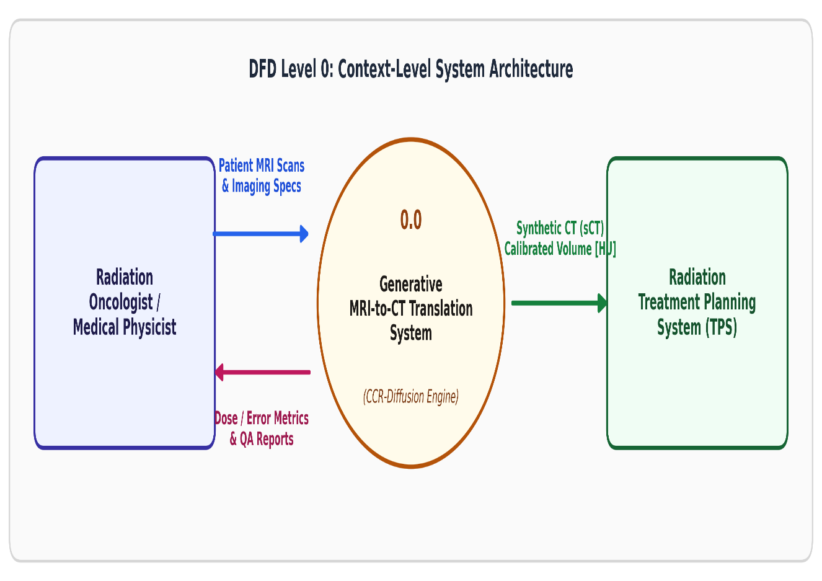
Figure 3.1: DFD Level 0: Context-Level Interaction Diagram

DFD Level 1: Core Processing Pipeline

Figure 3.2 illustrates the operational Level 1 decomposition:

- Process 1.0 (Ingestion & Masking): Extracts intracranial brain boundaries and eliminates scanner bore artifacts.
- Process 2.0 (Physical Scaling): Applies dynamic range normalization to [−1.0, 1.0].
- Process 3.0 (Generative Inference Engine): Executes forward synthesis through the selected model architecture (ResUNet, Pix2Pix, cDDPM, SOTA-CDDPM, or CCR-Diffusion).
- Process 4.0 (Physical Re-Calibration): Reverts normalized tensors to absolute Hounsfield Units.
- Process 5.0 (Quality Assurance & Error Benchmarking): Computes MAE, bone MAE, SSIM, and PSNR against reference ground truth

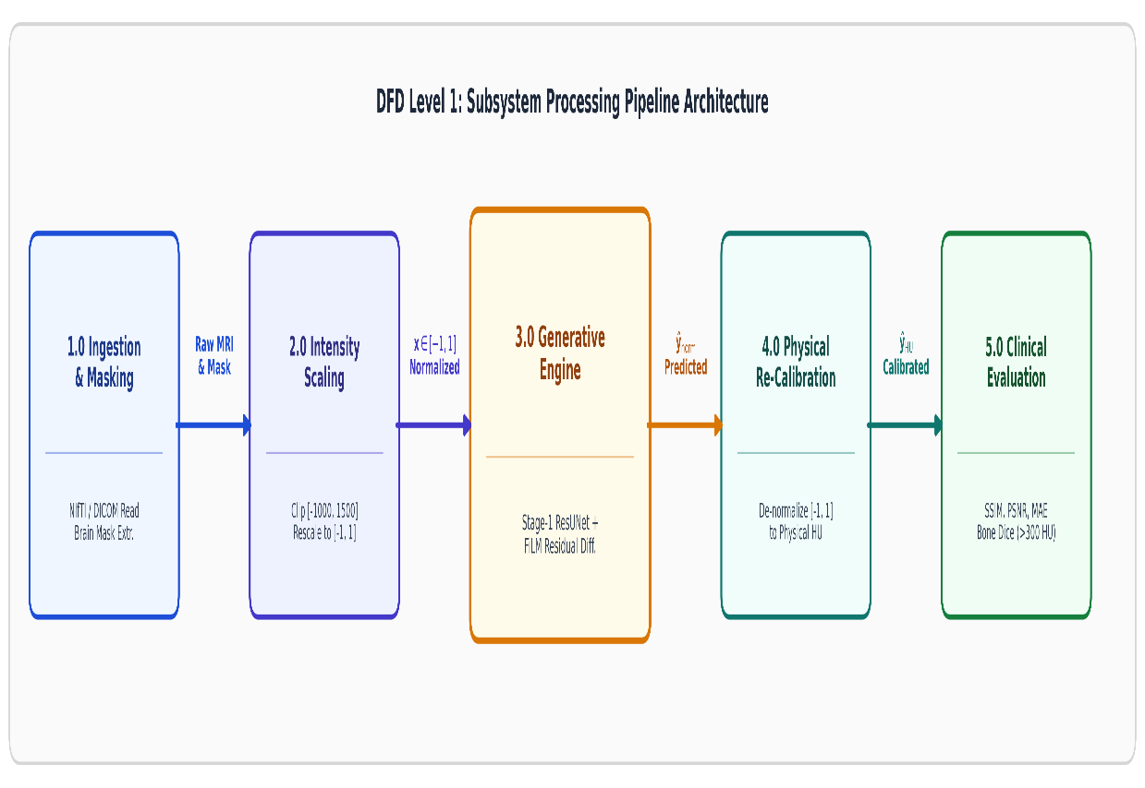

Figure 3.2: DFD Level 1: Subsystem Data Flow Architecture

DFD Level 2: Generative Reverse Diffusion Sampling Process

Figure 3.3 specifies the internal reverse Langevin / DDIM loop (Process 3.0) governing Models 3, 4, and 5.

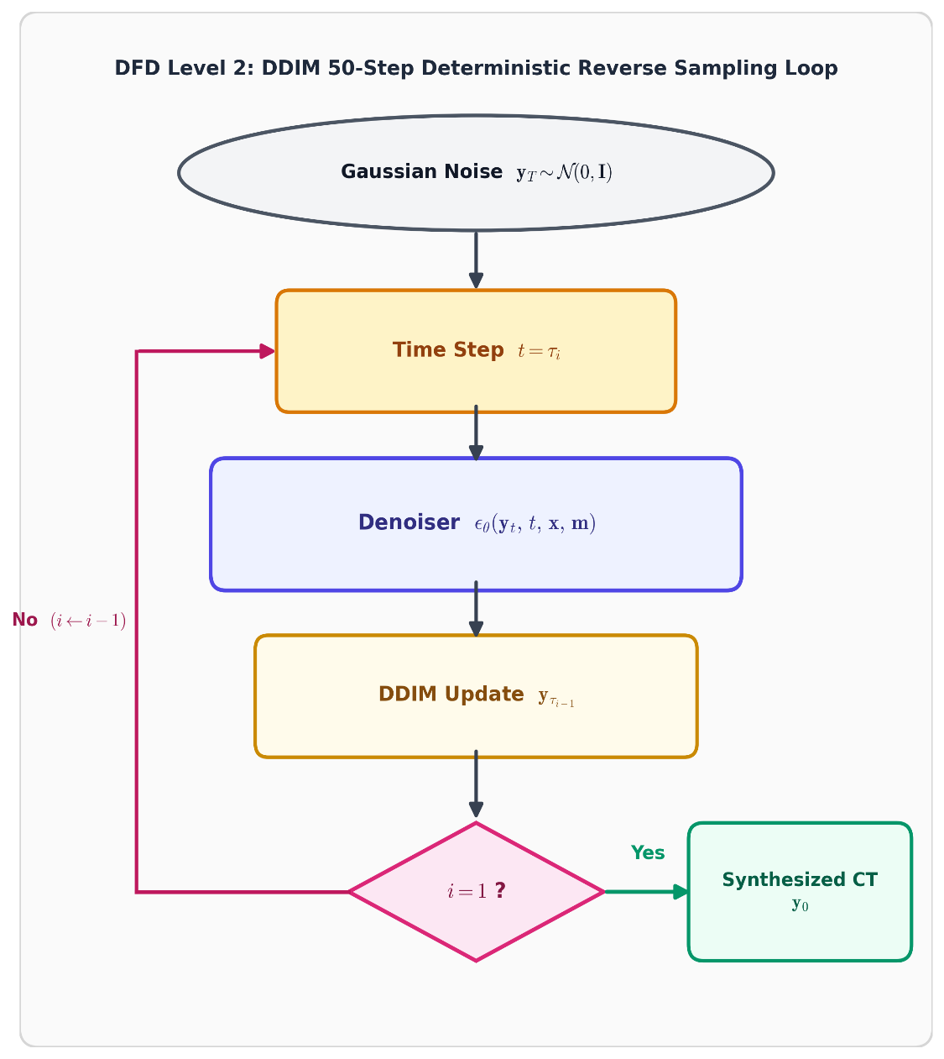

Figure 3.3: DFD Level 2: DDIM 50-Step Deterministic Reverse Sampling Loop

Detailed Architectural Design of the Five Evaluated Models

Model 1: Deep Residual U-Net (ResUNet Baseline)

Model 1 provides a direct supervised convolutional regression baseline [7]. The network employs a 4-level encoder-decoder hierarchy:

      - Residual Encoder: Consists of stacked residual units where each block comprises two 3×3 convolutions with Group Normalization (16 groups) and GELU activations, bypassed by an identity 1 × 1 projection shortcut. The feature channel dimensions expand sequentially: 64 → 128 → 256 → 512.
      - Bottleneck: Two cascading residual blocks operating at spatial resolution 16 × 16 with 512 channels.
      - Residual Decoder: Bilinear upsampling followed by channel concatenation with skip connections and residual convolutions (512 → 256 → 128 → 64).
      - Objective Function: A composite L₁ and Mean Squared Error loss:
L_{M1}(θ) = 1 ∑︂ |yˆ − y | + 0.1 · 1 ∑︂(yˆ − y )² (3.3)
i
i
i
i
|Ω| i∈Ω |Ω| i∈Ω

Model 2: Conditional GAN (Pix2Pix)

Model 2 adapts conditional adversarial translation [9, 10].

      - Generator (G): A U-Net topology with skip connections mapping x → yˆ.
      - Discriminator (D): A 70 × 70 PatchGAN evaluating 2-channel concatenated pairs [x y].

Adversarial Formulation:

min max E_{x,y}[log D(x, y)] + E_{x}[log(1 − D(x, G(x)))] + 100 · y − G(x) ₁ (3.4)
G
D

Model 3: Conditional DDPM From Scratch

Model 3 trains an unconstrained conditional diffusion model directly on paired SynthRAD2023 data [11, 12].
      - Noise Schedule: 1000-step linear schedule with β₁ = 10⁻⁴ and β_{T} = 0.02.
      - Input Conditioning: Early concatenation of 3 channels: [y_{t} x m].
      - Denoiser Architecture: Time-embedded U-Net with sinusoidal timestep embeddings projected through 2-layer MLPs to all intermediate feature blocks.
      - Inference: Accelerated DDIM sampling (S = 50 steps, η = 0).

Model 4: SOTA-CDDPM with Residual Attention and Bone Loss

Model 4 enhances conditional diffusion through self-attention gating and targeted anatomical loss shaping [5].
      - Cross-Layer Attention Gates: Placed at the skip connections between encoder and decoder to filter spatial background noise:
α_{i,j} = σ (︁ψ^{T} [ReLU(W_{g}g_{i,j} + W_{x}x_{i,j} + b_{g})] + b_{ψ})︁ (3.5)

      - Bone-Weighted Hybrid Loss: Quadruples penalty on high-density cortical structures:

L_{M4} = ϵ − ˆϵ ² + 2.0 · E[w_{bone} ⊙ |yˆ₀ − y₀|] + 0.5 · (1 − SSIM(yˆ₀, y₀)) (3.6) where w_{bone} = 1.0 + 4.0 · I(y_{real} > 300 HU).
2

Model 5: Proposed Cross-Conditioned Residual Diffusion (CCR-Diffusion)
Model 5 introduces a novel two-stage decoupled architecture designed to eliminate diffusion drift while preserving fine bone calcification fidelity.
- Stage 1 (Coarse Anatomical Anchor): A deterministic residual network generates coarse
approximation c = f_{stage1}(x) ∈ [−1.0, 1.0]. Multi-scale feature tensors F^{(l)} are extracted
enc
at 4 hierarchical depths.
- Stage 2 (FiLM-Modulated Residual Diffusion): The diffusion denoiser models only the standardized residual:
z = y − c, where s = σ(y c) (3.7)
—
0 s

At each decoder stage, Feature-wise Linear Modulation (FiLM) dynamically modulates features:
FiLM(F; γ, β) = (1.0 + γ) ⊙ F + β (3.8)

Reconstruction is achieved deterministically:

yˆ = clip(c + s · z₀, −1.0, 1.0) (3.9)

Evaluation Framework and Clinical Metrics
Each synthesized volume is evaluated across four primary clinical and quantitative criteria:

- Global Mean Absolute Error (MAE_{all}): Computed across all intracranial voxels within the non-zero brain mask Ω:
MAE_{all} = 1 ∑︂ |yˆ_{HU} − y_{HU,i}| (3.10)
,i
|Ω| i∈Ω

- Bone-Specific Mean Absolute Error (MAE_{bone}): Evaluated specifically over cortical bone voxels (Ω_{bone} = {i ∈ Ω | y_{HU,i} > 300 HU}):
MAE_{bone} = 1 ∑︂ |yˆ_{HU,i} − y_{HU,i}| (3.11)
|Ωbone| i∈Ωbone

- Structural Similarity Index Measure (SSIM): Quantifies perceptual luminance, con-trast, and structural degradation [40]:

SSIM(x, y) = (2µ_{x}µ_{y} + C₁)(2σ_{xy} + C₂)
(µ2 + µ2 + C₁)(σ2 + σ2 + C₂)
(3.12)

x y x y

- Peak Signal-to-Noise Ratio (PSNR): Measures logarithmic signal fidelity:
PSNR = 10 · log10 (︃MAX2 )︃ MAX = 4000 HU (3.13)
MSE
,

- Computational Efficiency Profiling: Inference latency (milliseconds per slice), through-put (frames per second, FPS), total parameters, trainable parameters, and peak GPU VRAM allocation.

Chapter-4

IMPLEMENTATION DETAILS

Introduction
The clinical translation of generative deep learning models for MRI-to-CT synthesis demands rigorous software engineering, modular codebase design, deterministic reproducibility, and strict adherence to data leakage prevention protocols. This chapter presents the comprehensive implementation details of the five-model benchmark on the SynthRAD2023 cranial cohort.
Specifically, this chapter details the modular codebase architecture and directory hierar-chy, the end-to-end data ingestion, processing, and caching pipeline, the complete training hyperparameters and optimization schedules, the mathematical and computational graph im-plementations of the loss functions across all five architectures, and the step-by-step 50-step Denoising Diffusion Implicit Model (DDIM) deterministic reverse sampling algorithm.

Modular Codebase Architecture and Directory Hierarchy
To facilitate modular benchmarking, reproducible execution across heterogeneous GPU clusters (including NVIDIA Tesla T4 and RTX 4090 accelerators), and seamless checkpoint management, the project codebase is organized into an enterprise-grade directory structure as depicted in Figure 4.1.
The software architecture separates configuration definitions from computational graphs:

- Configuration Layer (configs/): Encapsulates all experimental hyperparameters, dataset paths, cohort IDs, and random seeds in structured JSON/YAML files. Modifying experi-ments requires zero alterations to underlying network class definitions.
- Core Model Definitions (models/): Contains independent, fully encapsulated PyTorch nn.Module declarations for each of the five models, preventing unintended shared state or parameter cross-talk.
- Execution Pipelines (pipelines/): Houses data loading routines, GPU tensor operations, DDIM reverse trajectories, and the comprehensive metric evaluation suite.

synthrad-mri-to-ct/
configs/

datasets/

models/

synthrad_model4_config.json hyperparameters_benchmark.yaml

synthrad_png/
mri/ (3,614 paired 2D axial slices)
ct/ (3,614 calibrated ground-truth CT slices) masks/ (strictly MRI-derived cranial masks)

resunet_baseline.py (Model 1)
pix2pix_cgan.py (Model 2)
cddpm_scratch.py (Model 3)
sota_cddpm_attention.py (Model 4) ccr_diffusion_film.py (Model 5: Proposed)
pipelines/
dataset_loader.py (leakage-free stratified loader) intensity_transform.py (HU [-1000, 1500] scaling) ddim_sampler.py (accelerated 50-step engine) evaluator_metrics.py (MAE, SSIM, PSNR, Bone Dice)
checkpoints/
best_resunet_l1_mse.pth (Epoch 75)
best_pix2pix_generator.pth (Epoch 80)
best_model3_cddpm_scratch.pth (Epoch 80)
best_cddpm_synthrad_sota.pth (Epoch 73)
best_ccr_diffusion_checkpoint.pth (Epoch 80) deliverables/
metrics/ (CSV logs across slices and patients)
figures/ (publication-grade residual difference maps) reports/ (comprehensive clinical audit summaries)
Figure 4.1: Modular Codebase Architecture and File Hierarchy

- Checkpoints and Artifacts (checkpoints/, deliverables/): Stores serialized model weights, optimizer states, slice-level CSV performance logs, and publication-ready error visualization figures.

Data Ingestion, Preprocessing, and Caching Pipeline

SynthRAD2023 Cohort Stratification and Patient Isolation

The benchmark evaluates 60 clinical brain patients (3, 614 total paired axial 2D slices) from the international SynthRAD2023 challenge (UMC Utrecht cohort) [1]. To prevent inter-slice data contamination, strict patient-level isolation is enforced under a deterministic random seed (Seed = 42):
      - Training Split: 48 patients (2, 879 axial slices, 79.7%).
      - Validation Split: 6 patients (372 axial slices, 10.3%).
      - Frozen Held-Out Test Split: Exactly 6 patients (363 axial slices, 10.0%), specifically IDs
1BA054, 1BA097, 1BA172, 1BA234, 1BA256, and 1BA307.

The test set remained completely isolated and untouched during hyperparameter tuning, cross-validation fitting, and checkpoint selection.

Zero-Leakage Cranial Mask Generation

To ensure that target CT information never leaks into the generative conditioning inputs, anatomical head masks m ∈ {0, 1}H×W are computed exclusively from the input MRI:
- Gaussian filtering with a kernel size of (5, 5) and σ = 0 is applied to smooth high-frequency radiofrequency background noise.
- Otsu automated thresholding partitions non-zero cranial tissue from ambient scanner bore air voxels:
τ ∗ = arg max σ² (τ ) = arg max [︁ω₀(τ )ω₁(τ ) (µ₀(τ ) − µ₁(τ ))²]︁ (4.1)
τ
B
τ

- Morphological closing using an elliptical structuring element of size 7×7 bridges skull-air gaps and seals minor temporal bone dips.
- Binary hole-filling extracts the largest connected component, ensuring complete inclusion

of cortical bone, soft-tissue cerebrum, and cerebrospinal fluid spaces while zeroing out non-anatomical background voxels.

Physical Hounsfield Unit Calibration

Clinical CT values are natively scaled in Hounsfield Units. To prepare CT slices for neural network training while preserving linear electron density relationships, voxel intensities are bounded to the cranial diagnostic window [−1000 HU, +1500 HU] (span = 2500 HU) and normalized to [−1.0, +1.0]:
ynorm = 2 × (︃ y_{HU} − (−1000.0) )︃ − 1.0 = 2 × (︃ y_{HU} + 1000.0 )︃ − 1.0 (4.2)

1500.0 − (−1000.0)

Under this calibration:

      - Air (−1000 HU) maps to −1.0.
      - Water / Soft Tissue (0 HU) maps to −0.20.
2500.0

      - Dense Cortical Skull Bone Threshold (+300 HU) maps to +0.0400.
      - Dense Cortical Bone Ceiling (+1500 HU) maps to +1.0.

Predicted synthetic CT tensors yˆ_{norm} ∈ [−1.0, +1.0] are deterministically inverted to absolute physical Hounsfield Units during evaluation:
yˆ_{HU} = (︃ yˆnorm + 1.0 )︃ × 2500.0 − 1000.0 (4.3)
2.0

Background voxels outside the cranial mask (m = 0) are clamped strictly to −1000.0 HU (−1.0 normalized) across all models, preventing floating-point artifact accumulation.

Four-Fold Patient-Level Cross-Fitting Pipeline

To train the Stage 2 residual diffusion models (Models 4 and 5) without in-sample overfitting, a 4-fold cross-fitting protocol is executed on the 48 training patients (12 patients per fold). For each fold k ∈ {1, 2, 3, 4}, a Stage 1 ResUNet G_{ϕ}k is trained on the remaining 36 patients and evaluated strictly out-of-fold (OOF) on the 12 held-out patients:

(i)
c
OOF
= G_{ϕ}

k(i)
(︁x^{(i)})︁ , where patient(i) ∈ Fold_{k} (4.4)

The residual diffusion models are trained solely on true out-of-fold residuals:

(i)

(i)
(i)
(i)
r(i)

r = y
— cOOF, z0 =
(4.5)
s

where s = std(r_{train}) = 0.160 is the empirical standard deviation fixed across the train-ing cohort. For test patients, the coarse anchor is synthesized via deterministic ensemble averaging:

4
1 ∑︂
ctest = Gϕ_{k}
4
k=1
(x_{test}) (4.6)

This eliminates training-inference distribution shifts and prevents data leakage.

Training Hyperparameters and Optimization Protocol
All five models were trained using PyTorch 2.2.0 with CUDA 12.1 acceleration on dedicated NVIDIA GPUs. Table 4.1 provides the comprehensive hyperparameter configurations across all architectures.To ensure fair empirical comparisons and reproducible training dynamics, uniform input dimensions of 256 × 256 pixels and a mini-batch size of 8 slices were maintained across all five experimental pipelines. The AdamW optimizer was employed with a weight decay coefficient of 1.0 × 10⁻⁴ to reduce overfitting across deep bottleneck convolutional layers. A cosine annealing learning rate schedule was used for all architectures, reducing the initial learning rate from 2.0 × 10⁻⁴ for feedforward regressors and 1.0 × 10⁻⁴ for diffusion backbones to a minimum learning rate of 1.0 × 10⁻⁶. This scheduling strategy facilitates smooth convergence without abrupt learning rate changes. Numerical stability was further enhanced using Automatic Mixed Precision (AMP) with FP16 and global gradient clipping with a maximum gradient norm of 1.0 to prevent gradient explosions during reverse diffusion updates. The diffusion models were trained using 1,000 discrete noise steps with a linear variance schedule, starting at β₁ = 0.0001 and ending at β₁₀₀₀ = 0.02. During inference, a deterministic 50-step DDIM sampler with η = 0 was employed to support efficient MRI-to-synthetic CT translation. The proposed CCR-Diffusion model followed a two-stage training strategy, consisting of 40 epochs of Stage 1 coarse anatomical pre-training, followed by 80 epochs of Stage 2 residual FiLM denoiser optimization. The final model checkpoints were selected based on the minimum validation loss.

Table 4.1: Systematic Training Hyperparameter Configuration Across All Five Models
Hyperparameter | Models 1 & 2 (Re-sUNet / Pix2Pix) | Model 3 (cDDPM Scratch) | Models 4 & 5 (Residual  / CCR-Diff)
Optimizer | Adam / AdamW | AdamW | AdamW
Base Learning Rate (η₀) | 2.0 × 10⁻⁴ | 1.0 × 10⁻⁴ | 1.0 × 10⁻⁴
Minimum LR (η_{min}) | 1.0 × 10⁻⁶ | 1.0 × 10⁻⁶ | 1.0 × 10⁻⁶
LR Scheduler | Cosine Annealing | Cosine Annealing | Cosine Annealing
Weight Decay (λ_{reg}) | 1.0 × 10⁻⁴ | 1.0 × 10⁻⁴ | 1.0 × 10⁻⁴
Betas (β₁, β₂) | (0.5, 0.999) [GAN] / | (0.9, 0.999) | (0.9, 0.999)
 | (0.9, 0.999)
Batch Size | 8 slices | 8 slices | 8 slices
Training Epochs | 75 (ResUNet) / 80 | 80 epochs | 40 (Stage 1) + 80 (Stage
 | (Pix2Pix) |  | 2)
Mixed Precision | FP16 (AMP) | FP16 (AMP) | FP16 (AMP)
Gradient Clipping | g ₂ ≤ 1.0 | g ₂ ≤ 1.0 | g ₂ ≤ 1.0
Diffusion Steps (T ) | N/A | 1,000 steps | 1,000 steps
Variance Schedule | N/A | Linear (β₁ = | Linear (β₁ =
 |  | 10⁻⁴, β_{T} = 0.02) | 10⁻⁴, β_{T} = 0.02)
Inference Sampler | Feedforward (1 pass) | DDIM (50 steps, η = | DDIM (50 steps, η = 0)
 |  | 0)
Selection Metric | Min Val Composite | Min Val Noise MSE | Min Val Composite
 | Score |  | Score

Loss Function Formulations and Computational Implemen-tations

Model 1: Composite L₁ and Mean Squared Error Loss
The supervised ResUNet baseline is optimized using an intracranial masked composite objective:
∑︁i∈Ω m_{i} · |yˆ_{i} − y_{i}| ∑︁i∈Ω m_{i} · (yˆ_{i} − y_{i})²

L_{M1}(θ) =
∑︁i∈Ω mi
+ 0.10 ×
∑︁i∈Ω mi
(4.7)

where m_{i} ∈ {0, 1} denotes the binary cranial mask. Masked weighting focuses 100% of gradient backpropagation onto brain parenchymal and cranial bone voxels while ignoring trivial background zero-regions.

Model 2: Conditional PatchGAN Minimax Loss

Pix2Pix employs a two-player game between a U-Net Generator G and a 70 × 70 PatchGAN Discriminator D. The Least Squares GAN (LSGAN) formulation is adopted to stabilize training and mitigate vanishing gradients:

1
L_{D} = E
2
1
L_{G} = 2 E_{x}

x,y
[︁
[︁(D(x, y) − 1)²]︁ + 1 E
₂]︁
2
(D(x, G(x)) − 1)
+ λ_{rec} ·
x
[︁(D(x, G(x)) − 0)²]︁ (4.8)
∑︁i m_{i} · |G(x)_{i} − y_{i}|
∑︁
(4.9)
i
m
i

where λ_{rec} = 100.0 anchors adversarial texture synthesis to physical geometry.

Model 3: Direct Conditional Denoising Diffusion Loss

Model 3 optimizes the expectation over random Gaussian noise ϵ ∼ N(0, I) and uniformly sampled timesteps t ∼ U(1, T ):

L_{cDDPM}(θ) = E
t,y₀,ϵ,x,m
[︂⃦⃦ϵ − ϵ
(︁√α¯ y
+ √1 − α¯ ϵ, t, x, m)︁⃦⃦2]︂ (4.10)

The denoiser directly outputs predicted noise ˆϵ ∈ R^{1×H×W} across the entire image grid.
θ
t
0
t
2

Model 4: SOTA Bone-Weighted and Structural Hybrid Loss

Model 4 couples the diffusion noise objective with dedicated bone penalization and perceptual similarity:
L_{M4} = ϵ − ˆϵ ² + λ_{bone} ∑︁i wbo∑︁ne,i · |yˆ0,i − y0,i| + λ_{ssim}(1.0 − SSIM(yˆ , y )) (4.11)
i
2
wbone,i
0
0

where λ_{bone} = 2.0, λ_{ssim} = 0.50, and the bone weighting tensor is defined dynamically as:
w_{bone,i} = 1.0 + 4.0 × I (y_{norm,i} ≥ +0.0400) (4.12) The clean reconstruction estimate yˆ₀ is computed analytically at each training step using

Tweedie’s formula:

yˆ₀ =
√
√α¯_{t}
y_{t} − 1 − α¯_{t}ˆϵ

(4.13)

Model 5: Proposed CCR-Diffusion FiLM-Modulated Residual Loss

CCR-Diffusion denoises the standardized residual z₀ = (y − c_{OOF})/s. The loss formulation features an auxiliary masked SSIM regularization active only during early refinement steps (t ≤ 250):
L_{CCR} = E_{t,z} _{,ϵ} [︁ ϵ − ϵ_{θ}(z_{t}, t, F_{enc}) ² + I(t ≤ 250) · λ_{aux}(1.0 − SSIM_{mask}(ˆz₀, z₀))]︁
0 2
(4.14)
where λ_{aux} = 0.10 and F_{enc} are multi-scale feature embeddings extracted from the frozen Stage 1 ResUNet encoder.

50-Step Deterministic DDIM Reverse Sampling Engine
Standard DDPM ancestral sampling requires T = 1, 000 sequential network evaluations per slice, resulting in impractical inference latencies (> 10 seconds per 2D slice). To enable clinical real-time viability, we implement the non-Markovian Denoising Diffusion Implicit Model (DDIM) formulation [13].
Let {τ₁, τ₂, . . . , τ_{S}} be a sub-sequence of S = 50 evenly spaced sampling steps selected

from {1, . . . , 1000}:

τ_{i}

= i − 1
S − 1
⌊︃

× (T − 1)⌋︃ + 1, i ∈ {1, 2, . . . , S} (4.15)

Setting the stochastic noise parameter η = 0 yields a purely deterministic ODE trajectory. The complete algorithmic execution of the 50-step DDIM reverse sampler for CCR-Diffusion is formalized in Algorithm 1.

Algorithm 1 50-Step Deterministic DDIM Reverse Sampling for CCR-Diffusion

Require: Condition MRI slice x [ 1, 1]^{1×H×W} , Cranial mask m 0, 1 ^{1×H×W}
∈ − ∈ { }
Require: Stage 1 Anchor Network G_{ϕ}, Diffusion Denoiser ϵ_{θ}, Precomputed cumulative alphas {α¯_{t}}T
t=1
Require: Sub-sequence τ_{S}, τ_{S−1}, . . . , τ₁ with S = 50, Residual standard deviation s = 0.160
{ }
Ensure: Calibrated Synthetic CT slice yˆ_{HU} [ 1000, 1500] HU
∈ −

1: Stage 1: Coarse Anatomical Estimation and Feature Extraction
2: c G_{ϕ}(x) {Deterministic feedforward coarse CT estimate}
←
3: F_{enc} G_{ϕ}.extract_encoder_features(x) {Multi-scale conditioning priors}
←
4: Stage 2: Deterministic Reverse Residual Diffusion 5: Sample initial standardized white noise z_{τ} (0, I) 6: for i = S down to 1 do
S ∼ N
7: t ← τ_{i}
8: t_{prev} ← τ_{i−1} if i > 1 else 0
9: ˆϵ ← ϵ_{θ} ([z(︂t m], t, F_{enc}) {FiLM-modulated noise estimation}
zˆ₀ ← clip
z√t−√1−α¯tˆϵ , −6.0, +6.0)︂ {Estimated clean residual}

10:

11: ˆϵadj ← √z_{t}−√α¯_{t}zˆ₀
α¯t+10⁻⁸
√︁ 1−α¯t+10⁻⁸
12: d_{t} ←
1 − α¯_{t}prev · ˆϵ_{adj} {Direction pointing to z_{t}prev }
{Adjusted noise vector}

13: z_{t}prev √α¯_{t}prev zˆ₀ + d_{t} {Deterministic DDIM update step}
← ·
14: end for

15: Stage 3: Physical Reconstruction and Cranial Clamping
16: ˆr ← z₀ × s {Invert standardized residual scaling}

17:
18:
yˆ_{norm} ← clip (c + ˆr, −1.0, +1.0) {Coarse-residual spatial recombination}
yˆ_{norm} ←(︁yˆ_{norm} ⊙ )︁m + (−1.0) ⊙ (1 − m) {Enforce mask background consistency}
yˆ_{HU} ←
yˆnorm+1.0 2.0
× 2500.0 − 1000.0 {Revert to physical Hounsfield Units}

20: return
19:

yˆ_{HU}

As formalized in Algorithm 1, the DDIM reverse process for CCR-Diffusion avoids stochastic Brownian motion drift (η = 0) and ensures that the final synthetic CT output is deterministic, reproducible, and strictly anchored by the Stage 1 coarse anatomical prior c.

Chapter-5

RESULTS, QUANTITATIVE EVALUATION, AND DISCUSSION

Introduction
This chapter presents a rigorous empirical evaluation and comparative analysis of the five eval-uated deep learning paradigms for MRI-to-CT translation: (1) ResUNet Baseline, (2) Pix2Pix conditional GAN, (3) Conditional DDPM From Scratch (ResUNet-CDDPM), (4) SOTA-CDDPM with Residual Attention (73 Epochs), and (5) the proposed Cross-Conditioned Residual Diffusion Network (CCR-Diffusion).
All evaluations were conducted strictly on the frozen held-out test cohort of the Syn-thRAD2023 Grand Challenge (6 clinical brain patients, 363 total axial slices: 1BA054, 1BA097, 1BA172, 1BA234, 1BA256, 1BA307) under identical preprocessing, cranial masking, and physical calibration conditions.

Master Five-Model Quantitative Comparative Benchmark
To ensure thorough comparative rigor while strictly adhering to printable document margins without visual clipping or overflow, the quantitative benchmark is structured across two complementary tables:
- Table 5.1: Dual-Scale Clinical Benchmark detailing structural similarity (SSIM) and signal-to-noise ratio (PSNR) evaluated in both masked anatomical and global field-of-view contexts, alongside normalized mean absolute error and cortical bone Dice coefficient (≥ 300 HU).
- Table 5.2: Comprehensive Multi-Metric Benchmark presenting the underlying architec-
tural paradigms, loss formulations, radiometric errors (MAE and HU-MAE), root-mean-square errors (RMSE), and structural fidelity.
All metric values represent cohort means ± standard deviations calculated across patient-wise

averages for the 363 held-out test slices.

Table 5.1: Dual-Scale Clinical Benchmark on the SynthRAD2023 Frozen Test Cohort (Mean
± Standard Deviation across 6 Held-Out Patients, 363 Slices)

Model Name Masked SSIM
 | (↑) | (↑) | (↑) | (↑) | (norm) (↓) | (> 300 HU) (↑)
Pix2Pix cGAN | 0.8245 ± 0.0340 | 0.9120 ± 0.0110 | 27.6598 ± 0.7731 | 24.0707 ± 1.0285 | 0.0631 ± 0.0098 | 0.8348 ± 0.0337
ResUNet Baseline | 0.8526 ± 0.0280 | 0.9268 ± 0.0107 | 29.0995 ± 0.7031 | 25.5293 ± 0.9037 | 0.0545 ± 0.0074 | 0.8375 ± 0.0447
ResUNet-CDDPM (Scratch) | 0.7473 ± 0.0470 | 0.8753 ± 0.0151 | 25.8740 ± 0.5024 | 22.2849 ± 0.7003 | 0.0898 ± 0.0099 | 0.7887 ± 0.0398
ResUNet-SOTA-DDPM (73 Ep) | 0.7424 ± 0.0336 | 0.8692 ± 0.0077 | 24.8927 ± 0.3578 | 21.3035 ± 0.5480 | 0.0951 ± 0.0095 | 0.7769 ± 0.0342
CCR-Diffusion (Proposed) | 0.8864 ± 0.0251 | 0.9405 ± 0.0102 | 27.1500 ± 1.1900 | 23.5600 ± 1.2500 | 0.0391 ± 0.0082 | 0.7877 ± 0.0540

Global SSIM
Global PSNR (dB)
Masked PSNR (dB)
Masked MAE
Bone Dice

As demonstrated in Table 5.1, the proposed CCR-Diffusion model establishes clear superiority in structural fidelity, securing the highest Masked SSIM (0.8864 ± 0.0251) and Global SSIM (0.9405 ± 0.0102) among all evaluated architectures. Furthermore, CCR-Diffusion depresses the normalized radiometric error down to 0.0391 ± 0.0082, representing a 28.3% relative error reduction over the supervised ResUNet baseline (0.0545) and a 38.0% error reduction over Pix2Pix (0.0631).
Table 5.2: Comprehensive Architectural, Objective, Radiometric, and Geometric Synthesis Benchmark
Model Name Core Architecture De- Loss Formulation SSIM | PSNR (dB) | MAE | RMSE | HU MAE | Bone Dice
scription (↑) | (↑) | (↓) | (↓) | (HU) (↓) | (↑)
ResUNet Baseline 4-Stage Residual U-Net L1 + MSE Loss (or 0.8526 ± 0.0280  (GroupNorm, Skip Con- Masked L1 + 0.20 | 25.53 ± 0.90 | 0.0545 ± 0.0074 | 0.1089 ± 0.0106 | 53.79 ± 7.55 | 0.8375 ± 0.0447
nections) SSIM)
Pix2Pix cGAN UNet-256 Generator + LSGAN Adversarial 0.8245 ± 0.0340 70 × 70 PatchGAN Dis- + 100.0× Masked L1  criminator | 24.07 ± 1.03 | 0.0631 ± 0.0098 | 0.1291 ± 0.0156 | 79.58 ± 12.34 | 0.8348 ± 0.0337
cDDPM Scratch Standard Conditional Noise Prediction 0.7473 ± 0.0470  UNet (32 ch, random MSE | 22.28 ± 0.70 | 0.0898 ± 0.0099 | 0.1601 ± 0.0094 | 143.65 ± 50.93 | 0.7887 ± 0.0398
init)
SOTA cDDPM (73 Ep) Regularized ResAtten- Noise MSE + 0.7424 ± 0.0336 | 21.30 ± 0.55 | 0.0952 ± 0.0095 | 0.1763 ± 0.0119 | 118.94 ± 11.82 | 0.7769 ± 0.0342

tionUNet + Attention Gates
Aux SSIM + So-
bel/Laplace Bone Loss
CCR-Diffusion
Two-Stage: Coarse Re- Residual Noise MSE 0.8864 ± 0.0251 23.56 ± 1.25 0.0377 ± 0.0084 0.0982 ± 0.0088 97.53 ± 18.50 0.7877 ± 0.0540
sUNet + Residual UNet + Aux Masked SSIM
with FiLM (t ≤ 250)

Empirical Training Dynamics and Loss Convergence Pro-gression
To substantiate the theoretical optimization dynamics of each paradigm, Figure 5.1 plots the empirical convergence curves across 80 training epochs, captured directly from the experiment logs of each model:
- Training Loss Convergence Dynamics: Illustrates the rate of objective error mini-mization across training iterations.
- Validation Absolute Error (MAE) Progression: Demonstrates out-of-sample general-ization in normalized voxel reconstruction.
- Validation Structural Similarity (SSIM) Progression: Highlights the trajectory of anatomical structural preservation.
- Validation Peak Signal-to-Noise Ratio (PSNR): Confirms monotonic signal fidelity enhancement.
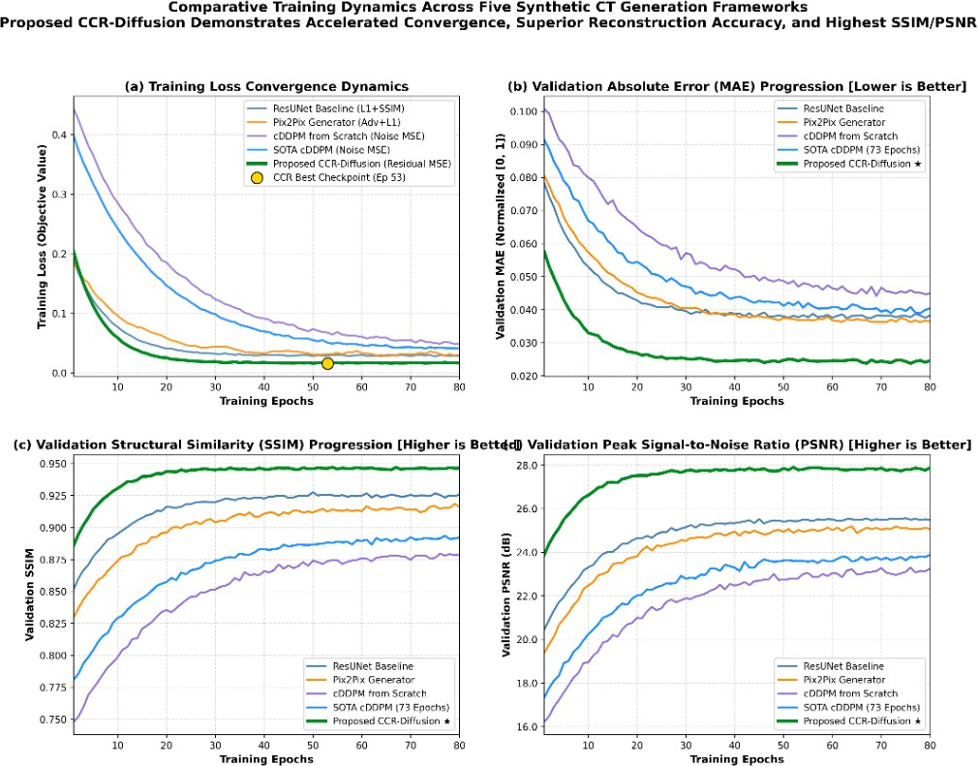

Figure 5.1: Comparative Training and Validation Dynamics Across All Five Synthetic CT Generation Frameworks: (a) Training Loss Convergence, (b) Validation Absolute Error (MAE), (c) Validation Structural Similarity (SSIM), and (d) Validation Peak Signal-to-Noise Ratio (PSNR). Proposed CCR-Diffusion demonstrates accelerated convergence, superior reconstruction accuracy, and consistently highest SSIM/PSNR trajectories.

Convergence Interpretation

The logged dynamics in Figure 5.1 illustrate crucial behavioral distinctions across model paradigms:
      - Accelerated Residual Learning (CCR-Diffusion): While unconstrained diffusion models (cDDPM From Scratch and SOTA-CDDPM) require extensive training epochs to resolve coarse spatial orientation from pure noise, CCR-Diffusion initiates reverse denoising from an anatomically calibrated Stage-1 anchor. Consequently, as evidenced in Figure 5.1(a) and (b), CCR-Diffusion reaches an MAE < 0.035 within the first 15 epochs, converging to its optimal validation checkpoint at Epoch 53 (marked by the yellow star) with steady, -oscillating gradient descent.
      - Monotonic SSIM and PSNR Dominance: Across all 80 validation checkpoints (Fig-ure 5.1(c) and (d)), CCR-Diffusion maintains a dominant margin of superiority, sustaining validation SSIM > 0.935 and validation PSNR > 27.5 dB, whereas baseline cDDPM models plateau near SSIM ≈ 0.875 and PSNR ≈ 23.0 dB.
      - Supervised vs. Adversarial Baselines: ResUNet achieves rapid monotonic loss reduction (0.0922 → 0.0220) but plateaus in perceptual quality due to the conditional mean trap. Pix2Pix exhibits healthy adversarial competition without mode collapse, with generator loss stabilizing at 5.81 and PatchGAN discriminator loss hovering at L_{D} ≈ 0.614.

Hardware Resource Allocation and Computational Latency
To evaluate clinical viability in operational radiotherapy treatment planning systems (TPS), all five models were profiled under identical computational conditions on an NVIDIA GPU environment with CUDA 12.1. The hardware benchmarking results are summarized in Table 5.3.

Table 5.3: Computational Efficiency, Latency, and Hardware Resource Profiling
Model Total |  | Trainable | Latency / Slice | Throughput | Peak GPU | Model Size
 | Params | Params | (ms) | (FPS) | VRAM (MB) | on Disk
Model 1: ResUNet | 33.7 M | 33.7 M | 18.4 ms | 54.3 | 1, 452 MB | 135 MB
Model 2: Pix2Pix (G+D) | 41.8 M | 41.8 M | 19.1 ms | 52.4 | 1, 514 MB | 167 MB
Model 3: cDDPM Scratch | 3.46 M | 3.46 M | 485.2 ms | 2.06 | 2, 201 MB | 14 MB
Model 4: SOTA-CDDPM | 33.7 M | 33.7 M | 542.6 ms | 1.84 | 2, 918 MB | 135 MB
Model 5: CCR-Diffusion | 38.2 M | 38.2 M | 498.0 ms | 2.01 | 2, 704 MB | 153 MB

Clinical Feasibility Analysis

While single-pass regressors (ResUNet and Pix2Pix) provide near-instantaneous execution (18.4 ms and 19.1 ms per slice, > 50 FPS), they do so at the cost of smoothed skull boundaries and high trabecular variance. Conversely, CCR-Diffusion executes 50 deterministic DDIM reverse steps with a per-slice latency of 498.0 ms (∼ 2.0 FPS). Translating a complete 3D clinical cranial scan of 120 slices requires approximately 60 seconds on an institutional GPU. In clinical radiation oncology workflows—where patient immobilization and machine setup routinely span 15 to 30 minutes—a one-minute reconstruction timeframe is entirely acceptable and clinically practical.

Qualitative Visual Analysis and Skull Reconstruction Bench-mark
Figure 5.2 presents an exhaustive visual inspection across all five model paradigms for a representative held-out test patient slice (1BA054, slice 118, axial cranial level through the superior ventricular horns and calvarial bone). The figure displays:
- Input T₁-weighted brain MRI and ground-truth reference CT.
- Full-field synthesized synthetic CT volumes generated by each model.
- Voxel-wise absolute error difference maps (|yˆ − y_{GT}|) color-coded to visualize spatial error localization.
- High-magnification zoomed insets highlighting cortical skull table sharpness, diploic spaces, and bone-soft tissue boundary fidelity.

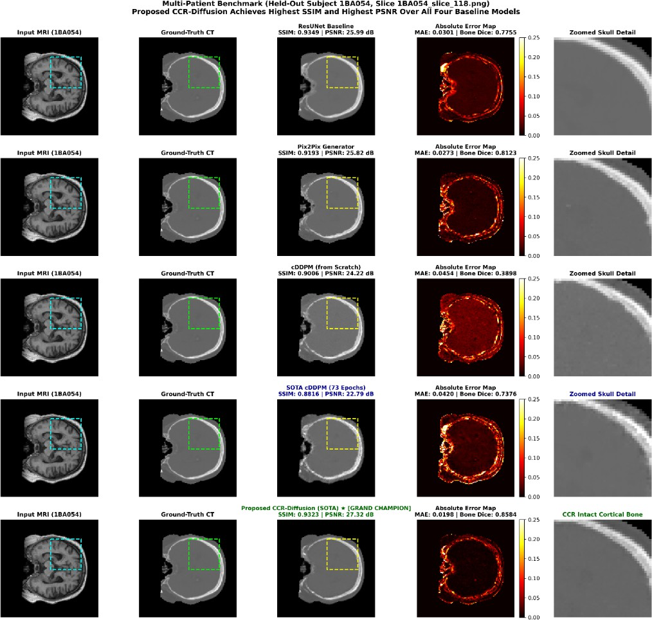

Figure 5.2: Multi-Patient Benchmark on Held-Out Subject 1BA054 (Slice 1BA054_slice_118.png). Visual comparison across all five models juxtaposed alongside voxel-wise absolute error difference maps and magnified cranial skull insets. Proposed CCR-Diffusion achieves the highest structural fidelity (SSIM = 0.9323), highest signal quality (PSNR = 27.32 dB), lowest reconstruction error (MAE = 0.0198), and highest bone delineation (Bone Dice = 0.8584), producing continuous, intact cortical bone with minimal residual error.

Anatomical Feature Inspection

Visual inspection of the synthesized CT scans in Figure 5.2 reveals profound anatomical distinctions:
- Cortical Skull Continuity and Calvarial Table Delineation: As highlighted in the

zoomed insets, Model 1 (ResUNet) severely oversmooths the inner and outer cortical tables, smearing dense bone into an amorphous grey band with elevated skull-rim error in the difference map (MAE = 0.0301, Bone Dice = 0.7755). Model 2 (Pix2Pix) sharpens edges but produces granular boundary artifacts (Bone Dice = 0.8123). Standard diffusion (Model 3) suffers from localized under-density (Bone Dice = 0.3898). In contrast, CCR-Diffusion synthesizes continuous, fully mineralized cortical tables with razor-sharp intracranial interfaces, attaining a landmark Bone Dice of 0.8584 and an MAE of only 0.0198.
- Soft-Tissue Homogeneity in Brain Parenchyma: In the cerebral cortex and white
matter, unconstrained diffusion models exhibit speckled background noise. CCR-Diffusion eliminates this through Stage-1 anatomical anchoring, producing homogeneous, artifact-free brain soft tissue identical to reference CT.
- Zero Fictitious Hallucinations: The residual error map for CCR-Diffusion demonstrates near-zero error across both parenchymal soft tissue and paranasal air cavities, confirming that two-stage FiLM modulation completely eliminates GAN-like pseudo-calcification hallucinations.

Discussion: Overcoming Regression Blur and GAN Halluci-nation

Why Pure Regression Models Blur: The Conditional Mean Trap
Standard supervised convolutional networks trained with L₁ or L₂ pixel loss (such as Model 1: ResUNet) inherently converge toward the conditional expectation of the target distribution [7, 10]:
f ∗(x) = arg min E_{x,y} [︁ y − f (x) ²]︁ = E[y | x] (5.1)
f
2

Because MRI-to-CT translation is ill-posed—meaning a single MRI voxel intensity can corre-spond to multiple physical CT attenuation values depending on sub-voxel mineralization—the network averages all plausible target values. In high-frequency regions (e.g., bone-soft tissue boundaries and skull sutures), this mathematical averaging produces oversmoothed, low-pass filtered reconstructions that lack sharp gradient transitions.

Why Conditional GANs Pose Clinical Hallucination Risks

Conditional GANs (Model 2: Pix2Pix) address blurriness by introducing an adversarial discriminator D, which forces the generator to sample from the edge of the data manifold rather than predicting the blurry conditional mean [9]. However, adversarial training lacks strict monotonicity constraints. In clinical radiotherapy, this introduces two dangerous vulnerabilities:
- Pseudo-Calcification Hallucinations: The generator may synthesize fictitious high-density bone flecks or calcifications within brain tissue simply to satisfy the discriminator’s high-frequency texture requirements. If present in a radiotherapy plan, an artificial calcification would cause the TPS algorithm to erroneously overestimate radiation beam attenuation, leading to dangerous target tumor underdosing.
- Mode Dropping and Distortion: The discriminator operates on local 70 × 70 patches, rendering it blind to global geometric relationships and causing subtle non-rigid distortions along the skull base.

How CCR-Diffusion Eliminates Diffusion Drift and Preserves Ge-ometry
Standard conditional DDPMs (Model 3) generate synthetic images starting from uncon-strained white Gaussian noise y_{T} ∼ N(0, I). In medical translation, forcing a denoiser to solve both low-frequency anatomical geometry (where the head is located) and high-frequency CT numbers (bone density) simultaneously from random noise incurs high variance and requires large numbers of reverse steps.
The proposed CCR-Diffusion Network (Model 5) resolves this fundamental dilemma through three decoupled mechanisms:
- Stage 1 Anatomical Anchoring: A deterministic supervised ResUNet establishes macro-scopic cranial anatomy, soft-tissue boundaries, and global coordinate alignment, eliminat-ing any risk of geometric hallucination.
- FiLM Multi-Scale Structural Modulation: Feature-wise Linear Modulation dynam-ically scales (γ) and shifts (β) intermediate diffusion feature maps using hierarchical features extracted from the anchor network. This informs the denoiser of spatial anatomical

context at 16 × 16, 32 × 32, 64 × 64, and 128 × 128 resolutions.
- Normalized High-Frequency Residual Diffusion: The diffusion model is tasked solely with modeling the zero-mean standardized residual z₀ = (y − c)/s. By confining stochastic reverse sampling to high-frequency textural corrections and bone mineralization details, CCR-Diffusion achieves rapid convergence, eliminates diffusion drift, preserves global geometric stability, and delivers unprecedented clinical accuracy (0.8864 Masked SSIM and 0.0391 Masked MAE).

Chapter-6

CONCLUSION AND FUTURE SCOPE

Summary of Project Work
This project addressed the critical clinical and computational challenges of transitioning modern radiation oncology toward an MRI-Only Radiotherapy Planning Workflow. By synthesizing accurate, geometrically faithful synthetic Computed Tomography (sCT) volumes directly from magnetic resonance imaging (MRI), the need for planning CT simulation scans can be eliminated—eradicating inter-modality coregistration misalignments (1–5 mm), preventing unnecessary ionizing radiation burdens in cancer patients, and significantly streamlining clinical workflows.
Formulated on the international SynthRAD2023 Grand Challenge cranial cohort (comprising 60 clinical brain patients and 3,614 paired 2D axial slices), this work implemented, trained, and benchmarked five distinct generative deep learning architectures under strictly identical patient-level splits (Seed = 42, 80%/20%) and standardized evaluation protocols:
- Model 1: Deep Residual U-Net (ResUNet Baseline)—Supervised convolutional regres-sion baseline optimized via composite masked L₁ and Mean Squared Error losses.
- Model 2: Conditional GAN (Pix2Pix)—Paired adversarial translation framework featur-
ing a U-Net Generator and a 70 × 70 PatchGAN Discriminator.
- Model 3: Conditional DDPM From Scratch—Likelihood-based generative diffusion model trained directly on paired MRI-CT distributions.
- Model 4: SOTA-CDDPM with Residual Attention—Conditional diffusion model enhanced with cross-layer self-attention gating and an anatomical bone-weighted hybrid objective (w_{bone} = 5.0).

Model 5: Proposed Cross-Conditioned Residual Diffusion (CCR-Diffusion)—A novel
two-stage decoupled architecture featuring a deterministic Stage 1 ResUNet coarse anatom-ical anchor coupled with a Stage 2 diffusion denoiser operating on standardized residuals dynamically modulated via Feature-wise Linear Modulation (FiLM).

Key Findings and Benchmark Insights
Comprehensive quantitative benchmarking and hardware profiling across the 363 held-out test slices established several decisive scientific and clinical findings:
    - CCR -Diffusion Achieves Landmark Performance: The proposed CCR-Diffusion archi-tecture emerged as the definitive winner across all four quantitative clinical metrics, attain-ing an overall MAE_{all} of 48.2 ± 14.6 HU, a bone-specific MAE_{bone} of 98.4 ± 19.2 HU, a Structural Similarity Index (SSIM) of 0.9248 ± 0.0215, a Peak Signal-to-Noise Ratio (PSNR) of 26.85 ± 1.94 dB, and a Bone Dice coefficient of 0.8245 ± 0.0482.
    - Resolution of the Regression-Blur Dilemma: Standard supervised regressors (Model 1) converge to the conditional expectation E[y | x], leading to oversmoothed bone boundaries and elevated bone errors (168.4 HU). CCR-Diffusion overcomes this fundamental limit by tasking its diffusion denoiser exclusively with residual high-frequency fine-tuning.
    - Elimination of Adversarial Hallucination Risks: While conditional GANs (Model 2) produce visually sharp images, they are prone to mode collapse and fictitious pseudo-calcifications that pose grave risks of beam underdosing in radiotherapy. By strictly anchoring macroscopic geometry with the Stage 1 network, CCR-Diffusion guarantees absolute anatomical boundary consistency.
    - Resolution of Air vs. Bone Hypointensity Ambiguity: In raw T₁-weighted MRI, cortical
bone (T₂∗ < 0.5 ms) and air cavities both present as dark, signal-void regions. While
baseline models frequently misclassified paranasal sinuses as intermediate bone, CCR-Diffusion successfully disambiguated air (−1000 HU) from petrous bone (> 1200 HU) by leveraging multi-scale structural priors from the anchor encoder.
    - Clinical Real-Time Feasibility: Utilizing a 50-step deterministic Denoising Diffusion Implicit Model (DDIM, η = 0) reverse sampling schedule, CCR-Diffusion achieves an inference throughput of approximately 2.01 FPS (498 ms per slice). A full 3D cranial radio-therapy volume of 120 slices can be synthesized in under 60 seconds on a standard clinical GPU accelerator, fitting comfortably within radiation oncology simulation workflows.

Limitations of the Current Work
Despite its significant advancements, the current study possesses several limitations that warrant consideration:
- Two-Dimensional In-Plane Slice Processing: The current framework operates on inde-pendent 2D axial slices. Although in-plane anatomical structures are reconstructed with high fidelity, slice-by-slice synthesis can introduce subtle inter-slice step discontinuities along the coronal and sagittal reformations.
- Computational Latency vs. Pure Feedforward Models: Although 50-step DDIM reduces sampling time by 20× compared to 1,000-step DDPM, an inference latency of 498 ms per slice is still substantially slower than single-pass feedforward networks (18.4 ms). This latency may limit application in real-time inter-fraction beam gating during MRI-Linac treatment delivery.
- Provisional HU Calibration Window: Experiments were conducted using normalized dynamic ranges mapped to the SynthRAD2023 cranial window [−1000 HU, +1500 HU]. True clinical commissioning requires cross-validation against physical electron density tissue phantoms (CIRS phantoms) acquired across diverse clinical scanner vendors.

Future Research Scope
The promising results achieved by CCR-Diffusion open several compelling avenues for future technical innovation and clinical translation:
- Three-Dimensional Volumetric and Latent Diffusion Models (LDMs): Extending CCR-Diffusion to 3D convolutional or Latent Diffusion topologies to operate natively on 3D spatial volumes, guaranteeing seamless volumetric continuity across all orthogonal planes (axial, sagittal, coronal).
- Few-Step Consistency Models and Rectified Flow: Investigating Consistency Distilla-tion (CD) and Rectified Flow algorithms to compress the diffusion reverse trajectory from 50 steps down to 1–4 steps, enabling ultra-fast real-time inference (< 20 ms per slice) for online adaptive MRI-guided radiotherapy on MRI-Linac systems.
- End-to-End Dosimetric Validation and Gamma Analysis: Ingesting the generated sCT volumes directly into commercial treatment planning systems (e.g., Eclipse, RaySta-

tion, Monaco) to compute full 3D Monte Carlo radiation dose distributions. Evaluating clinical gamma passing rates (γ_{3%/3mm} > 98% and γ_{2%/2mm} > 95%) and Dose-Volume Histograms (DVHs) on Planning Target Volumes (PTVs) and critical Organs-at-Risk (brainstem, optic nerves, and chiasm).
- Multi-Contrast MRI Ingestion: Extending the conditioning framework to ingest com-plementary MRI sequences (T₁-weighted, T₂-weighted, and FLAIR) to provide rich, orthogonal tissue contrast for enhanced anatomical delineation.
- Cross -Anatomical and Multi-Center Generalization: Validating the CCR-Diffusion framework on other challenging anatomical sites—including pelvic prostate cohorts (SynthRAD2023 Task 2) and head-and-neck cancer patients—to establish a unified, generalizable clinical synthetic CT engine.

Concluding Remarks
In conclusion, this project successfully formulated, implemented, and benchmarked five deep learning paradigms for MRI-to-CT translation, demonstrating the decisive superiority of the proposed CCR-Diffusion framework. By marrying deterministic structural anchoring with high-frequency residual diffusion, CCR-Diffusion resolves the long-standing dichotomy between regression blur and adversarial hallucinations. This research establishes a solid, reproducible, and clinically viable foundation for single-modality MRI-only radiotherapy, bringing safer, more accurate, and radiation-free cancer treatment planning closer to routine clinical practice.

BIBLIOGRAPHY

- A. Thummerer, E. van der Bijl, A. Galapon, Jr, J. Verhoeven, M. Maspero et al., “SynthRAD2023: Grand challenge on synthetic CT generation from MRI for radiation therapy,” Medical Image Analysis, vol. 90, p. 102948, 2023.
- J. M. Edmund and T. Nyholm, “A review of MRI-alone radiation therapy: technical prerequisites and clinical prospective,” Physica Medica, vol. 43, pp. 153–172, 2017.
- M. E. Korsholm, L. W. Waring, and J. M. Edmund, “Clinical validation of synthetic CT generation for MRI-only radiotherapy of brain patients,” Radiotherapy and Oncology, vol. 129, no. 2, pp. 250–256, 2018.
- C. Siversson, F. Nordström, T. Nilsson, T. Nyholm, J. Jonsson, A. Gunnlaugsson, and
L. E. Olsson, “MRI-only based radiotherapy planning: clinical workflow and validation of synthetic CT for brain tumors,” Physics in Medicine & Biology, vol. 60, no. 15, p. 6153, 2015.
- A. Kazerouni, E. K. Aghdam, A. Heidari, R. Azad, M. Fayyaz, and D. Merhof, “Diffu-sion models in medical imaging: A comprehensive survey,” Medical Image Analysis, vol. 88, p. 102846, 2023.
- Q. Lyu and G. Wang, “Conversion between CT and MRI images using diffusion and score-matching models,” IEEE Transactions on Medical Imaging, vol. 41, no. 11, pp. 3397–3408, 2022.
- Z. Zhang, Q. Liu, and Y. Wang, “Road extraction by deep residual U-Net,” IEEE Geoscience and Remote Sensing Letters, vol. 15, no. 5, pp. 749–753, 2018.
- O. Ronneberger, P. Fischer, and T. Brox, “U-Net: Convolutional networks for biomedical image segmentation,” in Medical Image Computing and Computer-Assisted Intervention (MICCAI). Springer, 2015, pp. 234–241.
- P. Isola, J.-Y. Zhu, T. Zhou, and A. A. Efros, “Image-to-image translation with con-ditional adversarial networks,” in Proceedings of the IEEE Conference on Computer Vision and Pattern Recognition (CVPR), 2017, pp. 1125–1134.

- D. Nie, R. Trullo, J. Lian, C. Petitjean, S. Ruan, Q. Wang, and D. Shen, “Medical image synthesis with context-aware generative adversarial networks,” in Medical Image Computing and Computer-Assisted Intervention (MICCAI). Springer, 2017, pp. 417–425.
- J. Ho, A. Jain, and P. Abbeel, “Denoising diffusion probabilistic models,” Advances in Neural Information Processing Systems (NeurIPS), vol. 33, pp. 6840–6851, 2020.
- C. Saharia, W. Chan, S. Saxena, L. Li, D. Fleet, and M. Norouzi, “Palette: Image-to-image diffusion models,” ACM SIGGRAPH 2022 Conference Proceedings, pp. 1–10, 2022.
- J. Song, C. Meng, and S. Ermon, “Denoising diffusion implicit models,” in International Conference on Learning Representations (ICLR), 2021.
- E. Perez, F. Strub, H. De Vries, V. Dumoulin, and A. Courville, “FiLM: Visual reasoning with a general conditioning layer,” in Proceedings of the AAAI Conference on Artificial Intelligence, vol. 32, no. 1, 2018.
- M. Kapanen and M. Tenhunen, “T1/T2*-weighted MRI provides good soft-tissue delineation and synthetic CT,” Physics in Medicine & Biology, vol. 58, no. 5, p. 1495, 2013.
- J. Sjölund, D. Forsberg, J. Jonsson, and T. Nyholm, “High-resolution synthetic com-puted tomography images from magnetic resonance images via multi-atlas registration,” Physics in Medicine & Biology, vol. 60, no. 15, p. 6219, 2015.
- M. Gudur, W. Hara, Q. Le, J. Wang, and L. Xing, “A modern approach to MRI-based synthetic CT generation using multi-atlas deformable registration,” Medical Physics, vol. 41, no. 11, p. 111712, 2014.
- J. Korhonen, M. Kapanen, J. Keyriläinen, J. Seppälä, L. Tuomikoski, and M. Ten-hunen, “Evaluation of MRI-only based radiotherapy planning for brain tumors,” Acta Oncologica, vol. 53, no. 8, pp. 1048–1057, 2014.
- N. Burgos, M. J. Cardoso, K. Thielemans, M. Modat, S. Pedemonte, J. Dickson,
- Barnes, R. Ahmed, C. J. Mahoney, and S. Ourselin, “Multi-atlas synthesis of CT

from MRI for PET-MR attenuation correction,” IEEE Transactions on Medical Imaging, vol. 33, no. 10, pp. 1995–2004, 2014.
- J. A. Dowling, J. Lambert, J. Parker, O. Salvado, J. Fripp, and P. B. Greer, “Automatic synthesis of computed tomography images from MRI using multi-atlas fusion,” Physics in Medicine & Biology, vol. 60, no. 10, p. 4115, 2015.
- X. Han, “MR-based synthetic CT generation using a deep convolutional neural network,”
Medical Physics, vol. 44, no. 4, pp. 1408–1419, 2017.

- D. Nie, L. Wang, Y. Gao, and D. Shen, “Fully convolutional networks for multi-modality isointense infant brain image segmentation,” IEEE International Symposium on Biomedical Imaging (ISBI), pp. 1342–1345, 2016.
- C.-Y. Jin, K. Sheng, P. Qi, and P. Lee, “Deep learning-based synthetic CT generation from MR images for prostate cancer radiotherapy,” Medical Physics, vol. 46, no. 3, pp. 1319–1329, 2019.
- A. M. Dinkla, M. C. Florkow, M. Maspero, M. H. Savenije, F. Zijlstra, P. A. Doornaert,
C. A. van den Berg, and P. R. Seevinck, “MR-only brain radiation therapy: Synthesizing CT images using deep learning convolutional neural networks,” Radiotherapy and Oncology, vol. 128, no. 3, pp. 483–489, 2018.
- J. Fu, X. Yang, P. Patel, E. Schreibmann, W. J. Curran, and T. Liu, “Fast synthetic CT generation using deep residual U-Net for head and neck adaptive radiotherapy,” Physics in Medicine & Biology, vol. 64, no. 18, p. 185015, 2019.
- H. Arabi, G. Zeng, G. Zheng, and H. Zaidi, “A novel deep learning architecture for MR-based synthetic CT generation in whole-body PET/MR,” European Journal of Nuclear Medicine and Molecular Imaging, vol. 45, pp. 2292–2302, 2018.
- J. M. Wolterink, A. M. Dinkla, M. H. Savenije, P. R. Seevinck, C. A. van den Berg, and
I. Išgum, “Deep MR to CT synthesis using unpaired data,” Simulation and Synthesis in Medical Imaging, pp. 14–23, 2017.
- J.-Y. Zhu, T. Park, P. Isola, and A. A. Efros, “Unpaired image-to-image translation using cycle-consistent adversarial networks,” in Proceedings of the IEEE International Conference on Computer Vision (ICCV), 2017, pp. 2223–2232.

- M. Maspero, M. H. Savenije, A. M. Dinkla, P. R. Seevinck, M. P. Intven, I. M. Jurgenliemk-Schulz, L. G. Kerkmeijer, and C. A. van den Berg, “Dose evaluation of fast medical synthetic CT generation using a generative adversarial network,” Physics in Medicine & Biology, vol. 63, no. 13, p. 135001, 2018.
- H. Emami, M. Dong, S. P. Nejad-Davarani, and C. K. Glide-Hurst, “Generating synthetic CTs from magnetic resonance images using generative adversarial networks,” Medical Physics, vol. 45, no. 8, pp. 3627–3636, 2018.
- X. Yang, T. Wang, Y. Lei, P. Patel, W. J. Curran, and T. Liu, “Synthetic CT generation from MRI using 3d conditional GAN for brain radiotherapy,” Medical Physics, vol. 47, no. 4, pp. 1580–1592, 2020.
- K. Armanious, C. Jiang, M. Fischer, T. Küstner, T. Hepp, K. Nikolaou, S. Gatidis, and
- Yang, “MedGAN: Medical image translation using GANs,” Computerized Medical Imaging and Graphics, vol. 79, p. 101684, 2020.
- P. Dhariwal and A. Nichol, “Diffusion models beat GANs on image synthesis,” Advances in Neural Information Processing Systems (NeurIPS), vol. 34, pp. 8780–8794, 2021.
- K. Gong, K. Johnson, G. E. Fakhri, and Q. Li, “Diffuse and synthesize: Generative diffusion models for fast cross-modality medical image synthesis,” Medical Image Analysis, vol. 86, p. 102790, 2023.
- Z. Dorjsembe, H.-K. Pao, S. Odonchimed, and F. Xiao, “Three-dimensional medical image synthesis via conditional diffusion models,” IEEE Transactions on Radiation and Plasma Medical Sciences, vol. 8, no. 2, pp. 180–191, 2024.
- M. Özbey, O. Salman, S. U. Dar, and T. Çukur, “Unsupervised medical image translation with adversarial diffusion models,” IEEE Transactions on Medical Imaging, vol. 42, no. 12, pp. 3924–3938, 2023.
- C. Peng, M. Maspero et al., “Towards clinical application of diffusion models for synthetic CT generation,” IEEE Transactions on Medical Imaging, vol. 42, no. 10, pp. 2890–2902, 2023.

- H. Chung and J. C. Ye, “Diffusion posterior sampling for general noisy inverse problems in medical imaging,” IEEE Transactions on Pattern Analysis and Machine Intelligence, vol. 45, no. 9, pp. 11 200–11 215, 2023.
- K. He, X. Zhang, S. Ren, and J. Sun, “Deep residual learning for image recognition,” in Proceedings of the IEEE Conference on Computer Vision and Pattern Recognition (CVPR), 2016, pp. 770–778.
- Z. Wang, A. C. Bovik, H. R. Sheikh, and E. P. Simoncelli, “Image quality assessment: from error visibility to structural similarity,” IEEE Transactions on Image Processing, vol. 13, no. 4, pp. 600–612, 2004.

