Enhanced SDN Controller Placement and Load

Balancing for Campus Network Optimization

Team – 24

Kandibanda Lohith – cse22032

Lakshmi Priya P – cse22034

Joel M Johnson – cse22028

**Manual for Project Implementation**

1. Install Ubuntu version 20.04.6 (Focal)
2. Open terminal and check the version by typing command: lsb_release -a

It should show like this

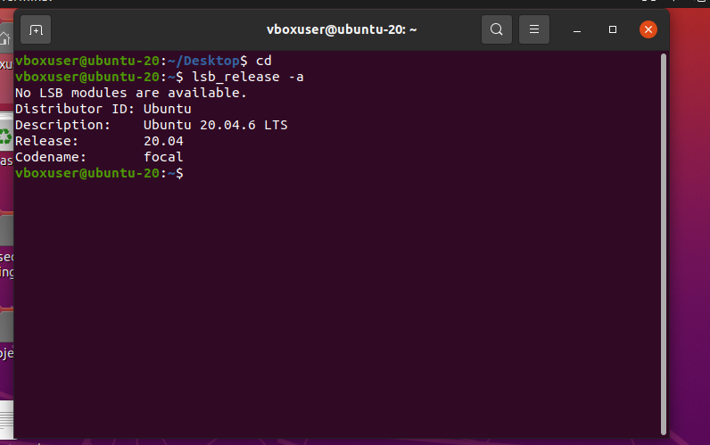

1. Installing Mininet and ryu (SDN Controller):

Type below commands one by one

1. sudo apt update
2. sudo apt install python3-pip
3. sudo pip3 install ryu
4. sudo apt install git
5. git clone <https://github.com/mininet/mininet>
6. cd
7. cd mininet/
8. cd util/
9. sudo ./install.sh -a
10. we have completed installing mininet and ryu. To check if mininet is working properly

type these commands:

1. cd
2. sudo mn
3. pingall (in mininet cli)

If it shows 0% dropped all packets received your mininet is working fine.

1. To make different topologies and run, you can either create then in miniedit.py through visualization or by writing a python script. In my project I have wrote a python script named Campus_topology
2. In my project I have to find a optimum controller placements so I wrote a algorithm which is K-Median Clustering algorithm, when I execute it, it will show me places where placing controllers will give high efficiency. To run type these commands

sudo apt install python3

python3 k_median_clutering.py

output should be like :

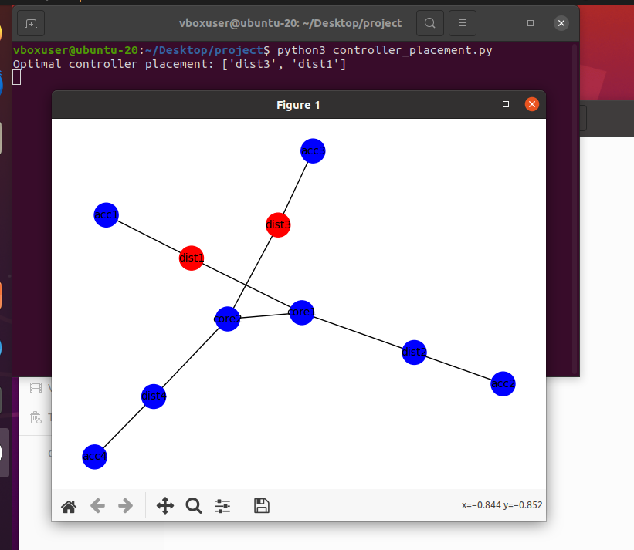

I have used skicit-learn and other libraries. You need to install the used libraries manually by using sudo apt install

1. Now, I will be modifying my campus_topology.py code to make dist1,dist3 as controllers
2. We have to controllers in my network so I have to on two controllers which are sdn, that means I have to switch on two ryu controllers for two different ports command for that is

Terminal -1 type:

ryu-manager --ofp-tcp-listen-port 6633 load_balancer.py

terminal -2 type:

ryu-manager –ofp-tcp-listen-port 6634 load_balancer.py

(if your having any trouble with ryu try degrading the version of eventlet)

here in my project im using dynamic weighted round robin as my load balancer

Go to the directory where your topology is present open terminal there and type:

Sudo python3 campus_topology.py

And type pingall in mininet cli

1. To note performance metrics type other commands like :

h1 ping -c 10 h2

1. The above commans when you type the output should be like:

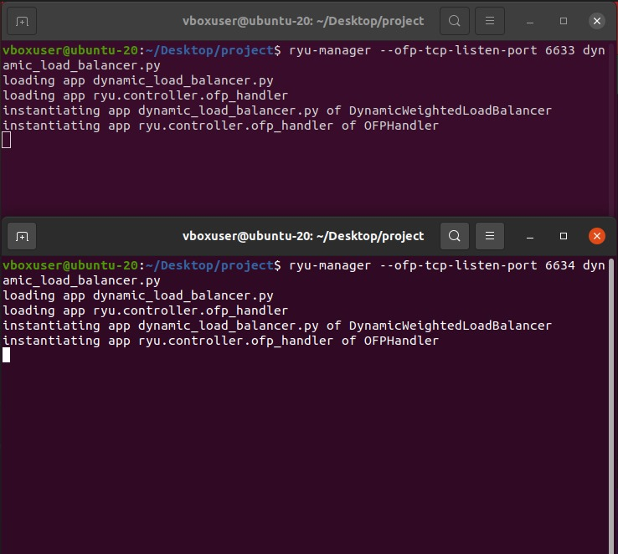

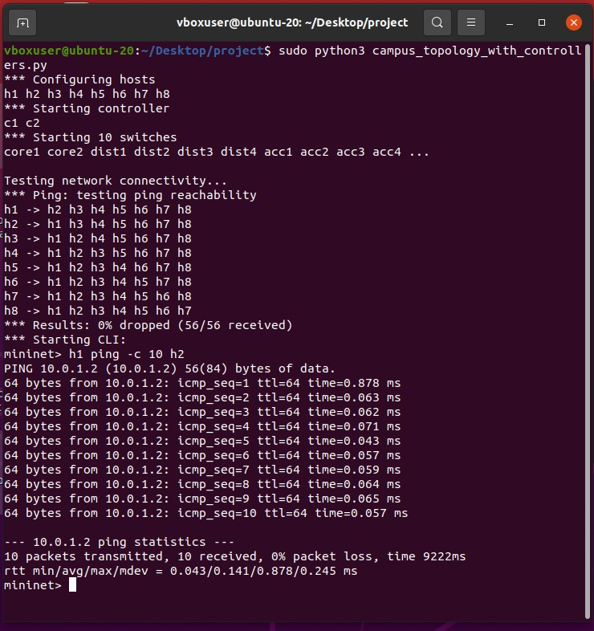

1. Run baseline topology also like these and note performance metrics
2. Analyze the performances

According to study we did and observed we can conclude that Network integrated with SDN, controller placement and load balancing has enhanced the performance of baseline campus network setup