
Converting Your Ideas to Startups
Event Report
- Cover page
Title of the event : SIH -2022(INTERNAL)
Organized by : Idea Lab & IIC
Date and time : 24th March 2022
Venue : Computer Labs
- Event Convener message (about this event) : Yes
- Agenda : Yes
- Brochure (If applicable) : Yes
- Synopsis report of the event :
  - About event : Yes
  - Objectives of the event : Yes
  - About speakers/guests : Yes
  - Scope of the event : Yes
  - Outcome : Yes
- Event image gallery : Yes
- Attendance sheet of participants : Yes
- News clipping (Press note) if available : Yes
- Approval letter : Yes
- Budget approval letter, Statement of income and expenditure, and Copies of bills, Certificates
Copy to:
- Department file with report
- IQAC (vignandata@gmail.com in PDF and Word form)
SIH- 2022(INTERNAL)
Theme of the Event
Smart India Hackathon 2022 is a nationwide initiative to provide students a platform to solve some of the pressing problems we face in our daily lives, and thus inculcate a culture of product innovation and a mindset of problem solving The last edition of the Hackathon saw over 5 million+ students from various colleges compete for the top prize at 65+ locations. In SIH 2022, the students would have the opportunity to work on challenges faced within various Ministries, Departments, Industries, PSUs and NGOs to create world class solutions for some of the top organizations including industries in the world, thus helping the Private sector hire the best minds from across the nation
ROUND 1: IDEATION PHASE
Submission of PPT on or before: 13-01-2020, 10.00am
Shortlisted teams will get mails on 18th Jan 2020

ROUND 2: PROTOTYPE PHASE
Date: 24-03-2022 TIME: 9.00 AM to 4.00 PM
VENUE: COMPUTER LABS

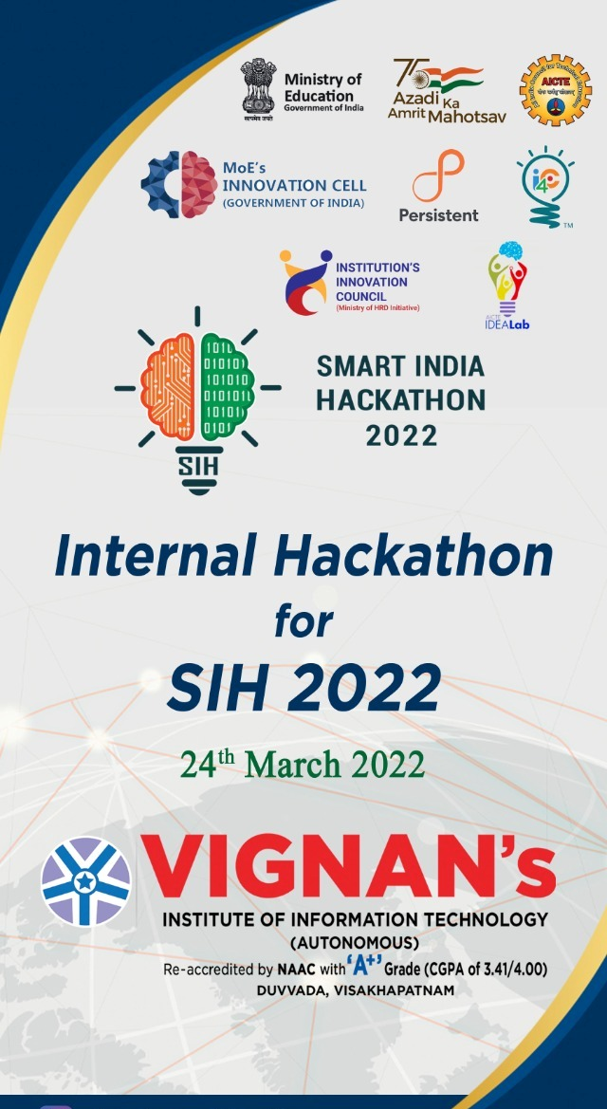
Important Links:
- Problem statements are available at : https://www.sih.gov.in/sih2022PS
- Registration of Teams : https://tinyurl.com/vignansih2022
- PPT template available at : https://www.sih.gov.in

How would it benefit students?
- Create a network of problem solvers.
- Identify distinctive ideas that can make a difference in the larger community.
- Provide a platform for the development of an engaged community that will learn from one another and work toward a shared objective of raising public knowledge about research and the reasons to participate in social trials.

What method will be used to gather issue statements?
The issues were gathered from different engineering areas that had a significant effect on society. Computer, Information Technology, Mechanical, Production, Electrical, Electronics, ICT, Civil & Structure, and Human daily life problems are only a few categories.

What level of involvement do the students plan to have?
Students must register for the Ideathon in teams of no more than four using Google Forms or physical advertising. The problem statements would be made public at some point during the Ideathon. Students must develop a solution to the problem statement and submit it to a panel of experts.

Selection of the Jury
Specialists in respective professions, as well as experts in the domains of the examined sectors of issue statements, were asked to judge the student teams' proposals.

Jury Guidelines
- Each team will be given a maximum of 5 minutes to present. Participants are requested to prepare the slides accordingly.
- The presentation will be followed by 2 minutes of a Q & A session.
- The ideas will be evaluated on the basis of:
  - The idea's quality and originality
  - Does it solve the problem or not?
  - It's likely impact on the target group and the market
- Ideas will be evaluated on the following main criteria:
  - Innovation: How 'innovative' is the idea? Is this idea creative and progressive?
  - Feasibility of Implementation-How feasible is the idea? How can it be executed within 6 months/one year on a defined budget?
  - Sustainability-How sustainable is the idea? Is this idea cost-effective? Where does this does it have market potential and scalability?
  - Impact-How does this idea raise awareness for diverse or vulnerable populations in a range of social conditions?
Total Participants: 240
No of Batch Participants: 56 Batches
Jury Members Details
S.NO | Name of the Jury | Designation of Jury | DEPT | Organization of Jury
1 | Dr. B. ARUNDHATI | PRINCIPAL | EEE | Vignan's institute of Information Technology
2 | Dr. E LAKSHMI LYDIA | PROFESSOR | CSE | Vignan's institute of Information Technology
3 | Dr. G RAJENDRA KUMAR | PROFESSOR | IT | Vignan's institute of Information Technology
4 | Dr. K SRINIVASA NAIK | ASSOCIATE PROFESSOR | ECE | Vignan's institute of Information Technology
5 | Dr. N V S SHANKAR | ASSOCIATE PROFESSOR | MECH | Vignan's institute of Information Technology
6 | Dr. G NARASIMHA RAO | ASSOCIATE PROFESSOR | CSE | Vignan's institute of Information Technology

About the event:
The event started with the inaugural ceremony in the presence of the Rector Dr. V. Madhusudhan Rao, Principal of the college – Dr.B. Arundhathi, Vice principal Dr.K.Madhusudhan Rao, Coordinators of the Idea lab and Institute Innovation cell Dr.K.Srinivasa Naik, Dr.N.V.S.Shankar, Heads of the various department’s faculties and Student coordinators.

Dr. B. Arundhathi madam, the principal of our institution, made an introductory statement regarding SIH-2022. She educated the students by presenting the concept of starting a business in a variety of areas. She hoped to inspire children to be creative and think beyond the boundaries.
The problem statements were distributed at 10:00 a.m., and the event began at that time. At 11:00 a.m., pupils began working on the issue of their choice. The second session of Ideathon then began. From 01:00 PM onwards, the presentation of ideas in different areas began. After all of the presentations were completed, the results were announced, and the winners were given certificates at both the junior and senior student levels.

Outcome of the event
The students demonstrated a great inter-disciplinary approach to solving numerous issues from diverse industries. The judges were pleased that such a large-scale event was held on campus for students. Furthermore, student involvement was considered important. Shortlisted Teams are nominated to Finals of SIH-2022

- No of Teams Participated : 63
- Total no. of Student Participated : 378
- No. Of male Participants : 292
- No. Of female Participants : 86

List of the students registered
S.NO | Student Name | Roll Number | Year | Branch | Email
1 | MEHRUN SHAMSHI | 21L31A05E7 | 1 | CSE | shamshimehrun77@gmail.com
2 | G.Lila Sanjay Kumar | 21L31A0561 | 1 | CSE | gsanjaykumar.1509@gmail.com
3 | Kamsu Ravi Teja | 21L31A0586 | 1 | CSE | ravirt7911@gmail.com
4 | Paidi Anitha | 21L31A05G8 | 1 | CSE | anithaanilpaidi@gmail.com
5 | A Mohith Vishal | 21L31A0506 | 1 | CSE | mohithvishal3@gmail.com
6 | Abhinav BNVS | 21L31A0521 | 1 | CSE | abhinavbathina24@gmail.com
7 | Mankala Vaishnavi | 21L31A05D8 | 3 | CSE | mankalavaishnavi2004@gmail.com
8 | MV KALYAN | 21L31AO5D4 | 1 | CSE | venkatakalyan1000@gmail.com
9 | Gopi.Keerthana | 21L31A0559 | 1 | CSE | keerthana.gopi918@gmail.com
10 | Yogesh Varma | 21L31A05D7 | 1 | CSE | varmamandapati32@gmail.com
11 | Rokkam Lakshmi Amrutha | 21L31A05J6 | 1 | CSE | lakshmiamrutha68@gmail.com
12 | pudu rohitha | 21L31A05J2 | 1 | CSE | rohithapudu@gmail.com
13 | Farhaan Ali | 21L31A0552 | 1 | CSE | fasonu786@gmail.com
14 | B . Sai Ramesh Naidu | 21L31A0526 | 1 | CSE | rameshsai710@gmail.com
15 | Marada Divya Sree | 21L31A05E1 | 1 | CSE | maradadivyasree@gmail.com
16 | mandapalli sai harshitha | 21L31A05D6 | 1 | CSE | saiharshithamandapalli@gmail.com
17 | D.S.V.Himakar | 21L31A0544 | 1 | CSE | himakarhimmu@gmail.com
18 | Kannuri Pavan Sriram | 21L31A0591 | 1 | CSE | shriram_kannuri@outlook.com
19 | D.S.V.Himakar | 21L31A0544 | 1 | CSE | himakarhimmu@gmail.com
20 | G.Dharshini | 21L31A0565 | 1 | CSE | dharshini3102k3@gmail.com
21 | G.Dharshini | 21L31A0565 | 1 | CSE | dharshini3102k3@gmail.com
22 | Keerthana | 21L31A0559 | 1 | CSE | keerthana.gopi918@gmail.com
23 | A. Praveen Kumar | 19L31A0521 | 3 | CSE | praveen8642kumar@gmail.com
24 | K Rehma Neharikha | 19L31A05G2 | 3 | CSE | rehmaneharikhak@gmail.com
25 | A. Kishore | 19L31A0560 | 3 | CSE | krish998239@gmail.com
26 | G Hariraj | 19L31A0574 | 3 | CSE | 19l31a0574@vignaniit.edu.in
27 | D.BHARGAVI | 19L31A05H0 | 3 | CSE | bhargavishilesh@gmail.com
28 | B. Sowmya Lahari | 19L31A05U4 | 3 | CSE | sowmya.badrimahanthi@gmail.com
29 | GUNTREDDI PADMINI | 19L31A05B8 | 3 | CSE | padduguntreddy@gmail.com
30 | M N S Swarup | 19L31A0556 | 3 | CSE | swarupmantripragada@gmail.com
31 | V. Geethika Priya | 19L31A0516 | 3 | CSE | geethikavsr@gmail.com
32 | M Rahul | 19L31A05F9 | 3 | CSE | rahul2002m@gmail.com
33 | A S R V Sriharsha | 19L31A04L6 | 3 | ECE | 19l31a04l6@vignaniit.edu.in
34 | JAJULA VENKATA JYOTHSNA | 19L31A05A9 | 3 | CSE | jyothsnajajula771@gmail.com
35 | N.S.Hema | 20L35A0514 | 2 | CSE | saihema2002@gmail.com
36 | Bhragav Karthik | 19L31A05L2 | 3 | CSE | bhargavkarthik5@gmail.com
37 | K Prasanna | 19L31A05E9 | 3 | CSE | komatipalliprasanna0089@gmail.com
38 | Saikrishna | 19L31A05P8 | 3 | CSE | edupugantisaikrishna@gmail.com
39 | Kartikesh Chatti | 19L31A05G0 | 3 | CSE | karthikchatti003@gmail.com
40 | YALAMANCHILI SUVITH | 20L35A0526 | 3 | CSE | davidking3525@gmail.com
41 | GUDIVADA VARALAKSHMI | 19L31A05A2 | 3 | CSE | varalakshmigudivada114@gmail.com
42 | D N KISHORE AVALA | 19L31A0588 | 3 | CSE | adnk2001@gmail.com
43 | CHINTA.ANURADHA | 19L31A05A5 | 3 | CSE | anuradhachinta29@gmail.com
44 | G.Neeharika | 19L31A05S6 | 3 | CSE | neeharika1281@gmail.com
45 | K.NIHARIKA | 19L31A1273 | 3 | IT | konaniharika2001@gmail.com
46 | B Y Ch Mourya | 20L35A0510 | 3 | CSE | bychmourya3@gmail.com
47 | vijaya narasimha | 19L31A0573 | 3 | CSE | vijayanarasimha2001@gmail.com
48 | Malayath Sai Sanjeev | 19L31A05G5 | 3 | CSE | malayathsaisanjeev@gmail.com
49 | Raghu Vamsi | 19L31A04i0 | 3 | ECE | raghumessi28@gmail.com
50 | A.Bhragava Kiran | 19L31A05O5 | 3 | CSE | 18abkiran5o5@gmail.com
51 | TANGELLA AKSHAY KUMAR | 19L31A05R0 | 3 | CSE | tangellaakshay@gmail.com
52 | Prakash Patro | 19L31A0534 | 3 | CSE | prakashpp0804@gmail.com
53 | Challa Dinesh | 19L31A04H1 | 3 | ECE | dineshsrd18@gmail.com
54 | G Dev Chandu | 19L31A0536 | 1 | CSE | chandudev064@gmail.com
55 | G.HARIKA | 20L35A0513 | 3 | CSE | harikagedala.19@gmail.com
56 | B Tharun | 19L31A04H7 | 3 | ECE | bandaritharun4@gmail.com
57 | Zeba Talat | 19L31A0539 | 3 | CSE | zebatalat28@gmail.com
58 | A Jaya Durga Deekshith | 19L31A05G8 | 3 | CSE | jayadeekshith143@gmail.com
59 | P Sri Varshitha | 19L31A05K8 | 3 | CSE | varshithapedapalli@gmail.com
60 | S.Simhachalam | 19L31A05Q8 | 3 | CSE | simhachalam1315@gmail.com
61 | MD.fiza khanam | 19L31A0584 | 3 | CSE | fizakhanam1803@gmail.com
62 | D Prasanth | 19L31A05H8 | 3 | CSE | prasanthdubbaka516@gmail.com
63 | Baari Bhanu Krishna | 20L31A0508 | 3 | CSE | barribhanukrishna@gmail.com
64 | S S APARNA RAJESWARI | 19L31A05F5 | 3 | CSE | aparnasenapathi8396@gmail.com
65 | G.DHANARAJU | 19L31A04G7 | 3 | ECE | dhanarajugurram@gmail.com
66 | Blessy Georgina | 19L31A0528 | 3 | CSE | georginablessy30@gmail.com
67 | Balaji Yashwant V | 19L31A05T1 | 3 | CSE | balajiyaswanth.v@gmail.com
68 | D. Vyshnavi | 19L31A0506 | 3 | CSE | vyshudeeptimahanti@gmail.com
69 | V.Venkatesh | 19L31A0507 | 3 | CSE | venkateshvanjarapu1622@gmail.com
70 | Akula surya sai harsha sri | 19L31A04O3 | 3 | ECE | harshasri1309@gmail.com
71 | SARATH CHANDRA | 19L31A05U9 | 3 | CSE | sarathchandra1426@gmail.com
72 | P V S Nithin | 19L31A05H4 | 3 | CSE | simhanithinrogers@gmail.com
73 | Sadhik Shaik | 19L31A05N7 | 3 | CSE | sadhikshaik4@gmail.com
74 | P.Mamatha | 19L31A04N2 | 3 | ECE | mamathap923@gmail.com
75 | S. Trisule Kumar Reddy | 19L31A0583 | 3 | CSE | trisulereddy150@gmail.com
76 | Lenka Sai Jyothi swaroop | 19L31A0503 | 3 | CSE | swarooplenka535@gmail.com
77 | V.Chandra sekhar varma | 19L31A05R3 | 3 | CSE | chanduvadapalli445@gmail.com
78 | Sabbiti saathwika | 19L31A05E3 | 3 | CSE | saathwikasabbiti08@gmail.com
79 | P. S. S. Venkata Lakshmi Shalini | 19L31A0537 | 3 | CSE | shalinipssvl@gmail.com
80 | M.Joshitha | 19L31A04N7 | 3 | ECE | joshithameruga@gmail.com
81 | P.Mamatha | 19L31A04N2 | 3 | ECE | mamathap923@gmail.com
82 | Sai venkat dhulipudi | 19L31A05C9 | 3 | CSE | saivenkat7928@gmail.com
83 | V Chandana | 19L31A05H7 | 3 | CSE | vchandanasai1@gmail.com
84 | Padala Vishal | 19L31A05C2 | 3 | CSE | vishalpadala2@gmail.com
85 | S Saathwika | 19L31A05E3 | 3 | CSE | saathwikasabbiti08@gmail.com
86 | Challa Ankitha | 19L31A0J7 | 3 | CSE | ankithachalla33@gmail.com
87 | p prasanth | 19L31305K0 | 3 | CSE | ptnlprasanth06@gmail.com
88 | Gandlapathi Sireesha | 18L31A04C9 | 4 | ECE | sirigandlapathi@gmail.com
89 | M Hari Sai Bhaskar | 18L31A03Q0 | 4 | MECH | harisaibhaskarm2001@gmail.com
90 | Rajana Bharadwaj | 18L31A03G5 | 4 | MECH | bharadwajrajana26@gmail.com
91 | Dasaroju Venkata Akhil Sai Krishna | 18L31A0362 | 4 | MECH | akhil9141@gmail.com
92 | JEERU JAWAHAR REDDY | 18L31A0370 | 4 | MECH | jawaharreddy6@gmail.com
93 | akhilson kandimalla | 18L31A0320 | 4 | MECH | akhilsonkandimalla@gmail.com
94 | SIRIPURAPU TARUN SAI | 18L31A03L4 | 4 | MECH | siripurapu.tarunsai@gmail.com
95 | KOPPADA HEMANTH MEHAR | 18L31A0319 | 4 | MECH | hemanthmehar@gmail.com
96 | Yellapu Pavan Surya | 18L31A0332 | 4 | MECH | suryagangadar10@gmail.com
97 | MADDI DENIMA REDDY | 18L31A0349 | 4 | MECH | mvbreddy999@gmail.com
98 | VOMMI DURGA PRAVEEN | 18L31A03R8 | 4 | MECH | praveenvipo99@gmail.com
99 | V.Keerthi | 19L31A0526 | 3 | CSE | keerthivddv@gmail.com
100 | Chilakamarthi Ashok Abbaye | 18L31A03P2 | 4 | MECH | ashokassy10@gmail.com
101 | KOSURU MURALI | 18L31A0324 | 4 | MECH | muralikosuru666@gmail.com
102 | VUPPALA JAYANTH | 18L31A03Q3 | 4 | MECH | vuppalajayanth@gmail.com
103 | TANKALA NAMRATA | 18L31A0315 | 4 | MECH | namratatankala@gmail.com
104 | JEERU JAWAHAR REDDY | 18L31A0370 | 4 | MECH | jawaharreddy6@gmail.com
105 | VASAM AVINASH | 18L31A03U8 | 4 | MECH | abhivasam0078@gmail.com
106 | KATTA ANUDEEPAK | 18L31A0335 | 4 | MECH | anudeepkatta2001@gmail.com
107 | TELI JHONY MANOJ ISAAC | 18L31A0356 | 4 | MECH | johnymanojisaac@gmail.com
108 | Karada Ravi Teja | 18L31A0359 | 4 | MECH | tejaravi4650@gmail.com
109 | Rambha Sri Hari | 18L31A0386 | 4 | MECH | sriharirambha@gmail.com
110 | PONUGUMATI HARI VARDHANA | 18L31A03G1 | 4 | MECH | vardhana2001@gmail.com
111 | SARVASIDDI AKHIL VARDHAN YADAV | 18L31A03D0 | 4 | MECH | ahkilsarvasiddi95@gmail.com
112 | KARRI JAGADEESH | 18L31A03F3 | 4 | MECH | jagadeesh2102@gmail.com
113 | Tharini Sanjana | 19L31A05D5 | 3 | CSE | sanju.152001s@gmail.com
114 | SARVASIDDI AKHIL VARDHAN YADAV | 18L31A03D0 | 4 | MECH | akhilsarvasiddi95@gmail.com
115 | Shirisha Maddala | 19L31A1201 | 3 | IT | shirishamaddala2002@gmail.com
116 | R Vamsi Krishna | 19L31A1249 | 3 | IT | vamsikrishnashauri@gmail.com
117 | B.Kamalesh varma | 19L31A0301 | 3 | MECH | kamaleshvarma7402@gmail.com
118 | Matha Lova Kumar | 19L31A0329 | 3 | MECH | mathalovakumar@gmail.com
119 | Pilla kiran | 19L31A03G6 | 3 | MECH | pillakiran225@gmail.com
120 | Namburi Avinash Varma | 19L31A0305 | 3 | MECH | 19l31a0305@gmail.com
121 | K DHRAKSHAYANI | 19L31A03A6 | 3 | MECH | Kenguvadhrakshayani2028@gmail.com
122 | Mahadas Vamsi | 19L31A0309 | 3 | MECH | vamsi.mithilesh@gmail.com
123 | P. Bharathi | 20L35A0327 | 3 | MECH | bharathipyla2002@gmail.com
124 | Yamini Korukonda | 19L31A1263 | 3 | IT | yaminikorukonda09@gmail.com
125 | B KIRAN KUMAR | 19L31A1201 | 3 | IT | koradakirankumar478@gmail.com
126 | K Pavan Kalyan | 19L31A1260 | 3 | IT | pavankalyan0105@gmail.com
127 | Valireddy Susmitha | 18L31A03C3 | 4 | MECH | vallireddysusmitha@gmail.com
128 | Vuta.Anmisha | 21L31A05O7 | 1 | CSE | vutaanmisha@gmail.com
129 | SUJAN SAMPATH KUMAR J | 18L31A03E1 | 4 | MECH | srujansampathkumarjetti@gmail.com
130 | Yanna.Lakshmi Subha Ratnanjali | 21L31A05O9 | 1 | CSE | ratnanjalisrinivasrao@gmail.com
131 | JERRIPOTHULA SASI VARDHAN | 18L31A03E2 | 4 | MECH | jsasivardhan@gmail.com
132 | Nemala Venkat Kumar Laxmi Kanth | 19L31A0568 | 3 | CSE | nvklaxmikanth@gmail.com
133 | RAPETI MAHENDRA | 19L31A05R8 | 3 | CSE | mahendrarapeti444@gmail.com
134 | Pinnamaraju Nikhil Varma | 19L31A05S3 | 3 | CSE | pinnamarajunikhilvarma004@gmail.com
135 | Sobhan Dash | 18L31A01F3 | 4 | CIVIL | sobhandash20@gmail.com
136 | NIKHIL PANDA | 19L31A02J7 | 3 | EEE | nikhilpanda2604@gmail.com
137 | MONISHA | 21L31A05J4 | 1 | CSE | plsprakash2003@gmail.com
138 | Sandeep kumar | 21L31A05E4 | 1 | CSE | varmamandapati32@gmail.com
139 | T.Srikar | 19L31A02K4 | 3 | EEE | srikar.tangudu123@gmail.com
140 | YALLA MADHU | 19L31A02C8 | 3 | EEE | madyalla18@gmail.com
141 | Hari Hara Priya Alekhya Nandarapu | 19L31A02A0 | 3 | EEE | alekhyanandarapu@gmail.com
142 | Mutta Mounika | 19L31A02F3 | 3 | EEE | kumarimounika15@gmail.com
143 | Nanepalli venkata pushpa maalika | 19L31A02D5 | 3 | EEE | maalikananepalli@gmail.com
144 | GOLLAVILLI SANJAYKUMAR | 19L31A0249 | 3 | EEE | sanjaykumargollavilli@gmail.com
145 | Yagneswara Naidu | 19L31A05M1 | 3 | CSE | yagneswar.naidu@gmail.com
146 | Jami Yashwanth | 19L31A0581 | 3 | CSE | jamiyashwanth18@gmail.com
147 | Kamminana Chakradhar | 19L31A0504 | 3 | CSE | chakradhar007007kc@gmail.com
148 | M.Sai Srujana | 19L31A0514 | 3 | CSE | srujanamusti@gmail.com
149 | Nithin Gonthina | 19L31A05J2 | 3 | CSE | nithinbhpv@gmail.com
150 | Raziq Ali | 19L31A05D2 | 3 | CSE | raziqali0306@gmail.com
151 | Sai Kalyan Tarun Vadlamudi | 19L31A05G9 | 3 | CSE | saikalyantarun2001@gmail.com
152 | Dinesh Yerra | 19L31A05L1 | 3 | CSE | yerradinesh01@gmail.com

Event image gallery

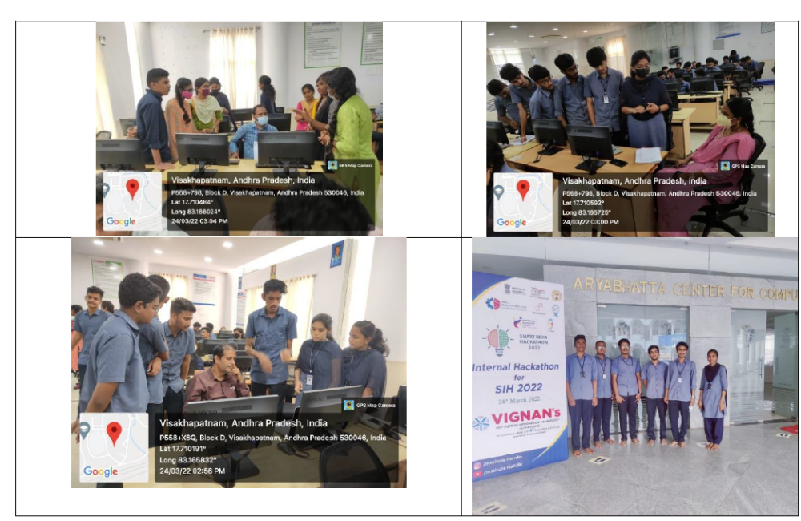
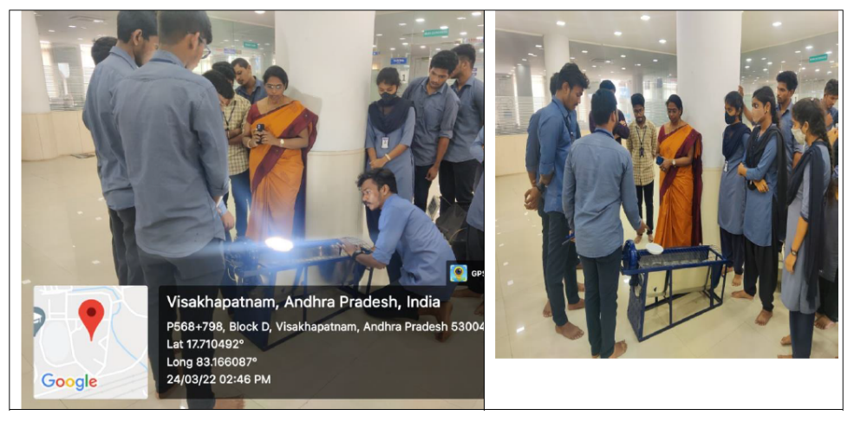

Nominated Teams for SIH-2022
Team | Team Leader Name | Contact Details
Name: 408FOUNDNOW  Status: waitlist  Category: Software | MADARAPU GOHARSHITHA | goharshitha.madarapu@gmail.com  9059172002
Name: BUGBOUNTYHUNTERS  Status: shortlist  Category: Software | PAVAN KALYAN KORUKONDA | pavankalyan0105@gmail.com  6302138298
Name: FUTUREDEVELOPERS  Status: shortlist  Category: Software | B BHANUKRISHNA | barribhanukrishna@gmail.com  6305958425
Name: FUTUREELECTRO  Status: shortlist  Category: Software | KARTHIK DASARI | Karthik.dasari2001@gmail.com  7702329668
Name: GOOGLERS  Status: shortlist  Category: Software | A BHARGAVA KIRAN | 18abkiran5o5@gmail.com  7013642130
Name: HEXCODE  Status: shortlist  Category: Hardware | VISHAL KUMAR SHAH | vkshah2987@gmail.com  7702013472
Name: JALVIDYUTH  Status: shortlist  Category: Hardware | E MANOHAR | manoharemandi49@gmail.com  7660912350
Name: MAXIMUS  Status: shortlist  Category: Software | BALAJI YASHWANTH VANKALA | balajiyashwanth.v@gmail.com  7337518009
Name: MISSILEBOYS  Status: shortlist  Category: Hardware | M VAMSI | mahadasvamsi8170@gmail.com  9391452270
Name: SMARTMINING  Status: shortlist  Category: Hardware | SIRIPURAPU TARUN SAI | siripurapu.tarunsai@gmail.com  8466070339
Name: TECH4PHANTOMS  Status: shortlist  Category: Software | M RAHUL | rahul2002m@gmail.com  6305907534
Name: TECHARMY  Status: shortlist  Category: Software | N S HEMA | saihema2002@gmail.com  9505408918
Name: TONYSLEGACY  Status: shortlist  Category: Software | M N S SWARUP | swarupmantripragada@gmail.com  9390671273
Name: V-2  Status: shortlist  Category: Software | B NISHANTH | bokkanishanth@gmail.com  9676217593
Name: V-6  Status: shortlist  Category: Software | ELLA DHEERAJ | elladheeraj001@gmail.com  6303068002
Name: VIGNANITES  Status: shortlist  Category: Hardware | JEERU JAWAHAR REDDY | jawaharreddy6@gmail.com  9154703247
Name: WEGAVEHOPE  Status: shortlist  Category: Software | V V S SAI KIRAN KOLLI | saikirankolli7@gmail.com  7995463445

Coordinator Principal

