{
"processes": {
"memory": [100, 200, 150, 50],
"burstTime": [10, 20, 15, 5]
}
}

- FCFS with FirstFit memory allocation:

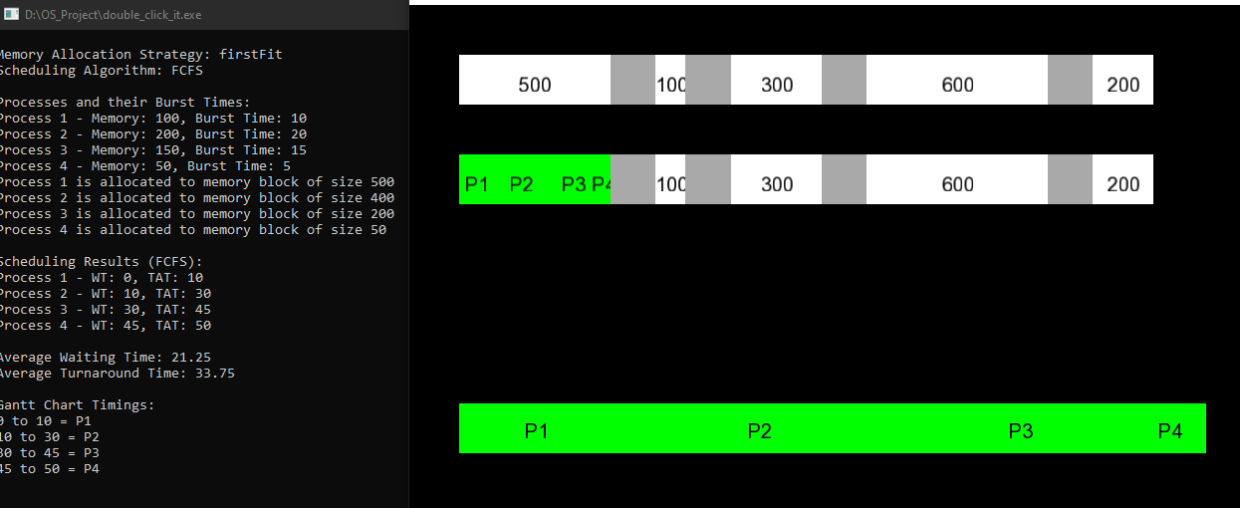

- FCFS with BestFit memory allocation:

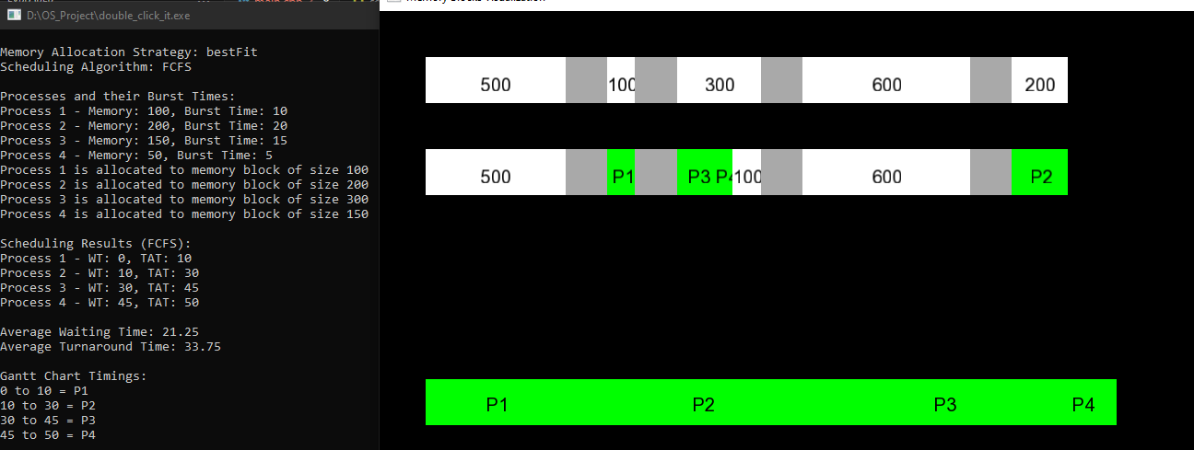
- SJF with FirstFit memory allocation:

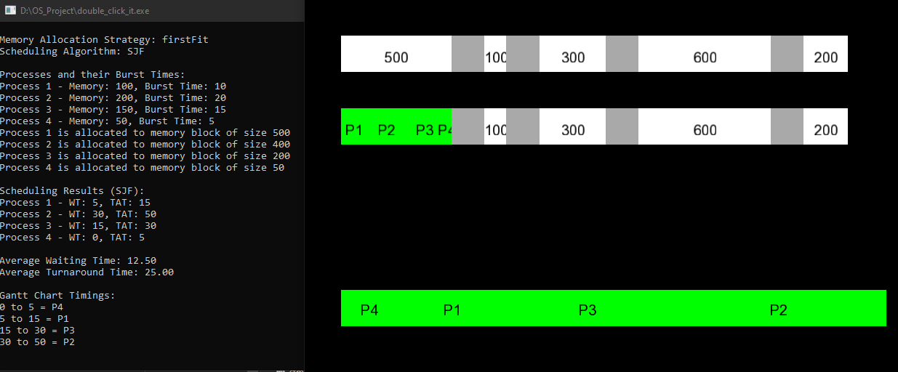

- SJF with BestFit memory allocation:

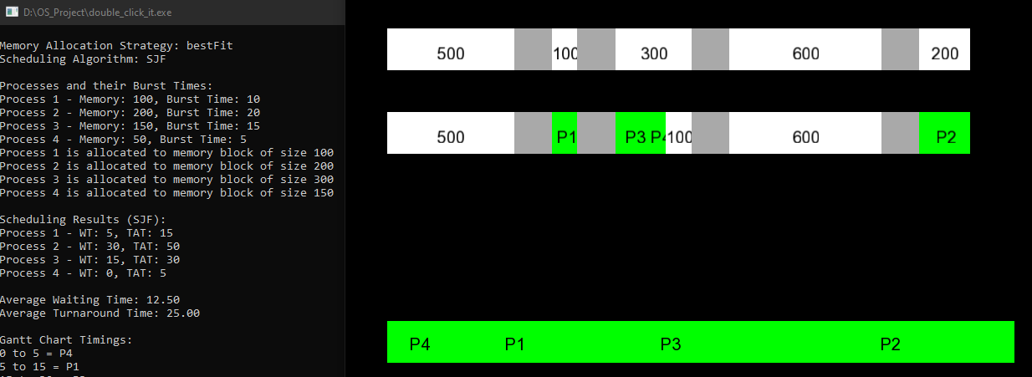

- Round Robin with FirstFit memory allocation:

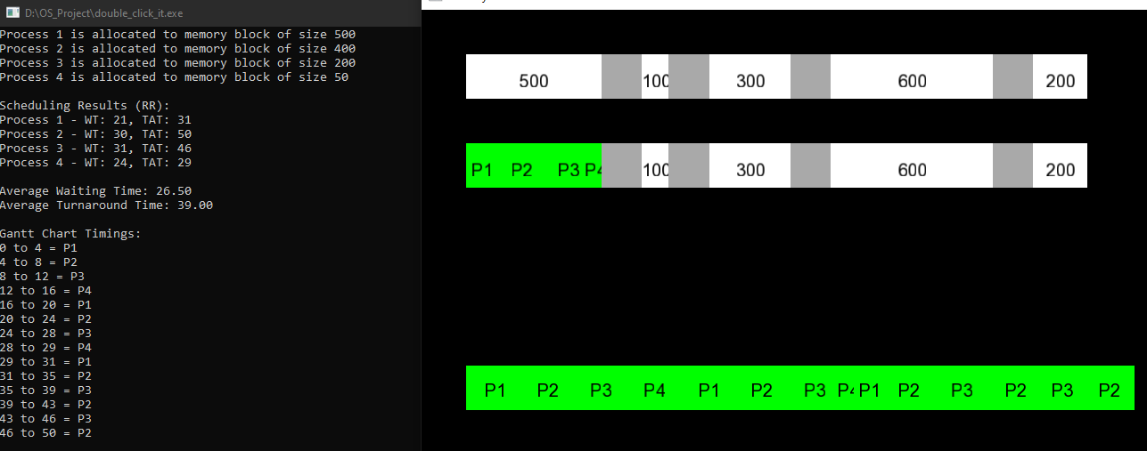

- Round Robin with BestFit memory allocation:

