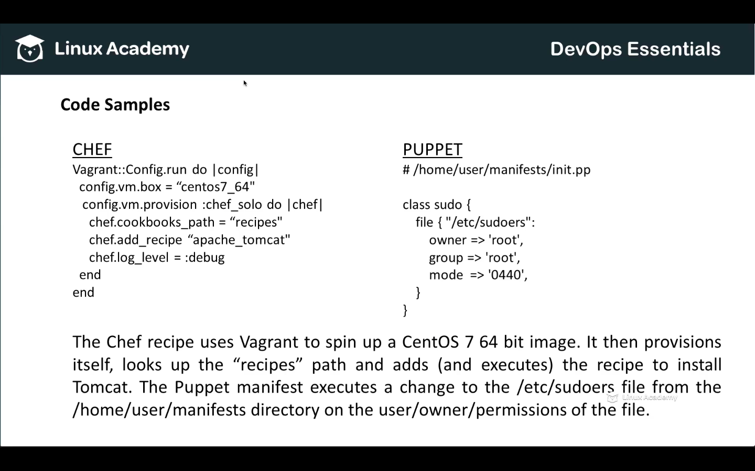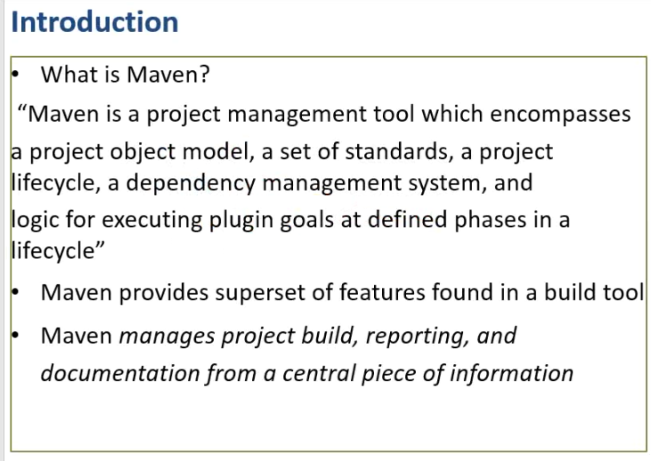

mvn -> goals –>Plugin -> task

pom.xml(project object mgmnt) file acts as build or config file which contains everything about the project.

1. Generates a list
2. Libr,

For Ant we need to tell everything

For compiling 1 file ---- Compiling - Tool – where - target

Maven understands the system

Maven is only for java

