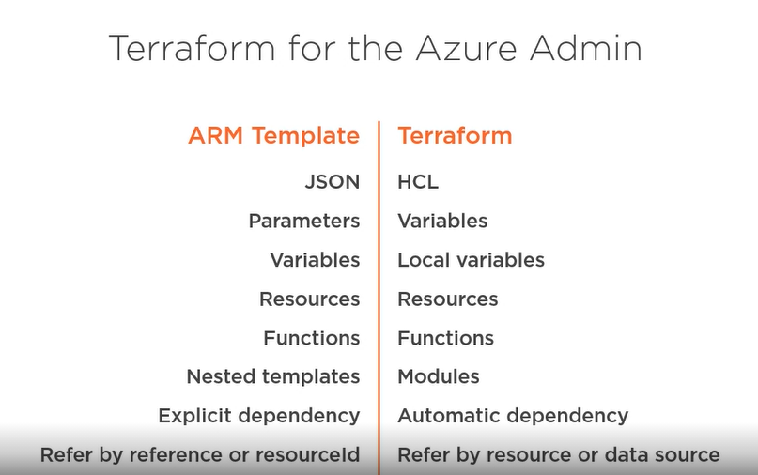

Azure Providers :-

Azure Provider : THsi is the one we will use to interact with Azure Cloud

Azure Stack Provider : It is an on-prem extension of MS Azure and uses the same ARM API but some of the versions and resources are little bit different so it requires it own provider

Azure Active Directory : Due to the complexity of the Azure AD, there is a separate Azure Provider to deal with Azure Active Directory components.

