SDC LAB

NAME-G.LOHITH KUMAR

ROLL.NO-2210030223

Section-AIML-HI

Set-43

1-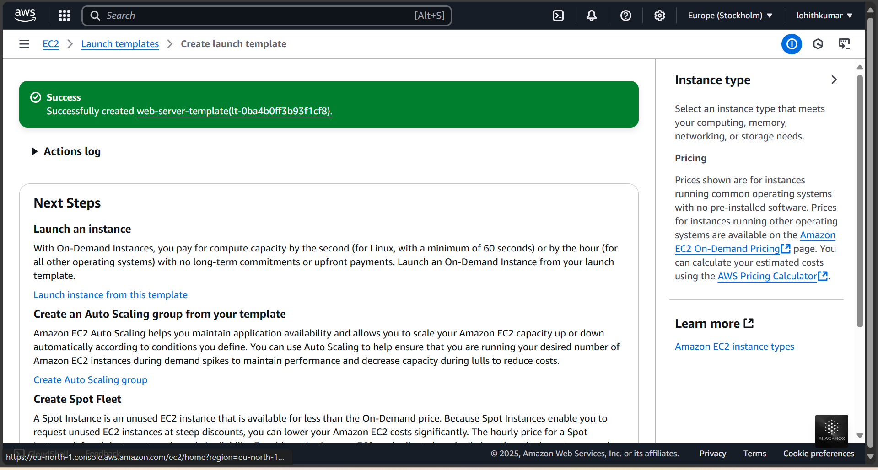

First create the EC2 instance and launch template(I created it with the name web-server-template)

2-Now create an Auto Scaling Group(web-server-asg) and Launch the template(web-server-template)

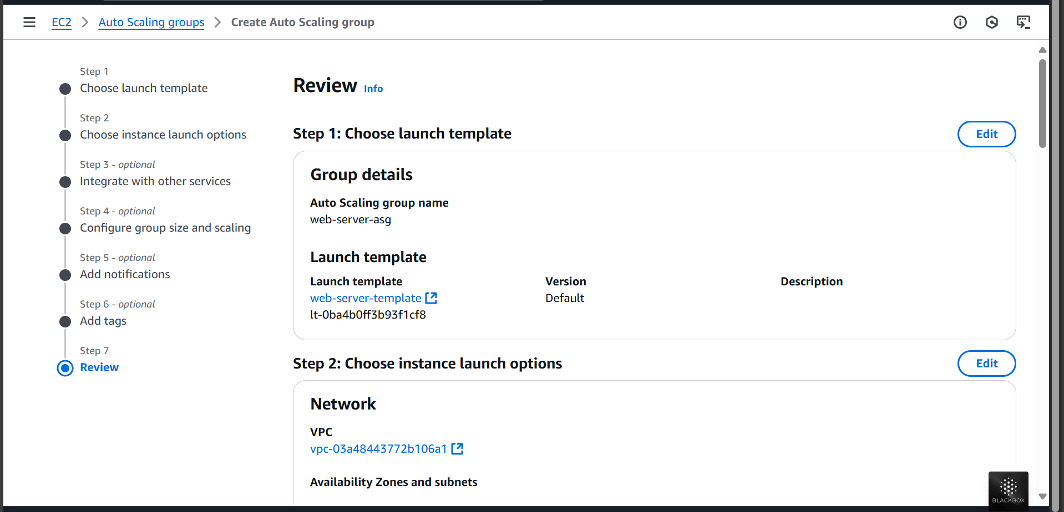

3-Now configure the group size and the scaling policies(Min-1,Max-3)  
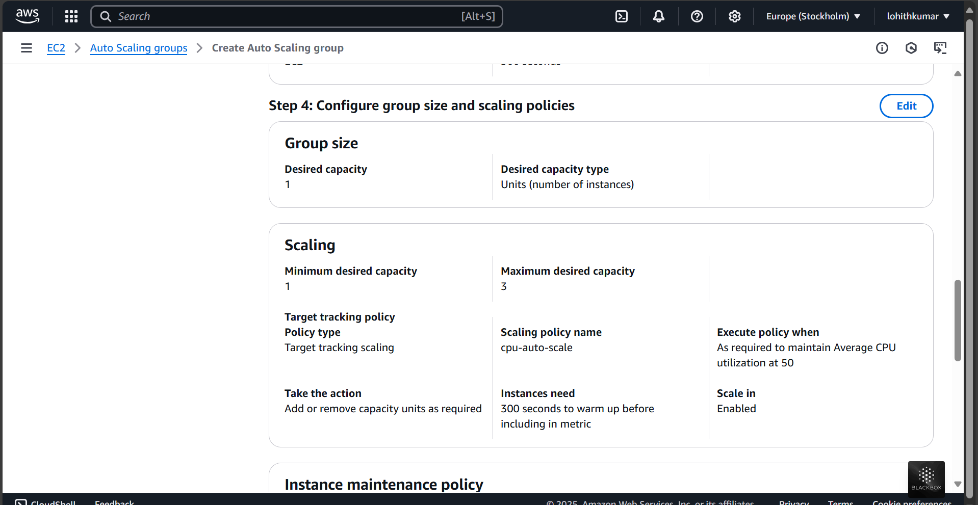

4-Launch the Auto Scaling Groups

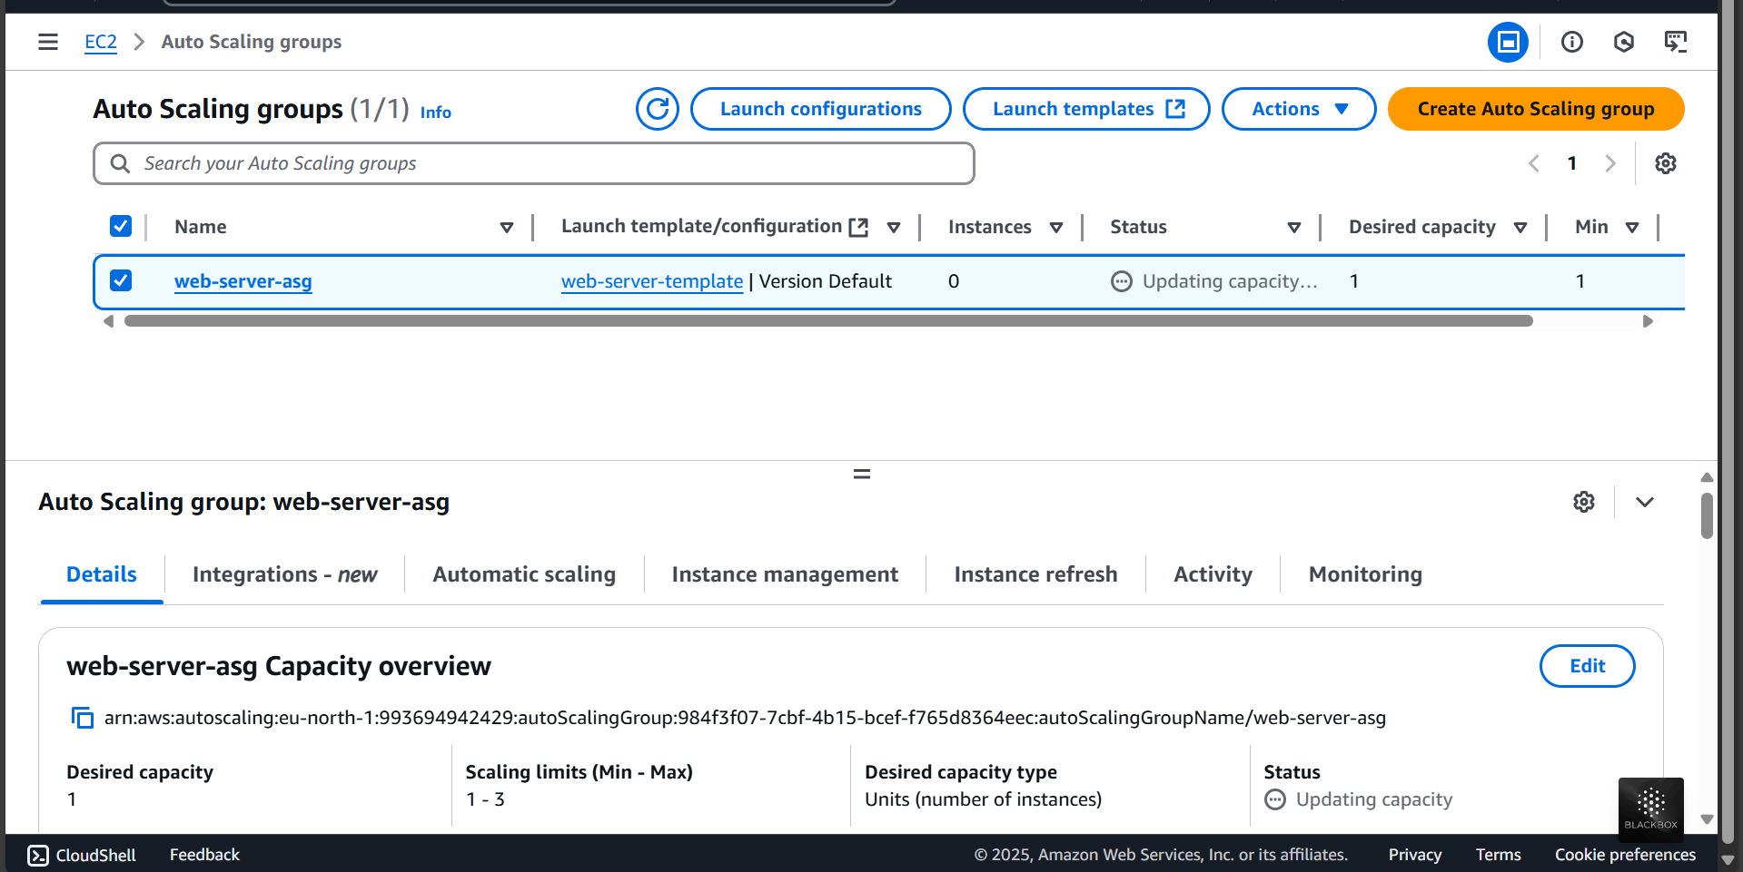

5- Final,Go to EC2 instance and launch the web-server-template

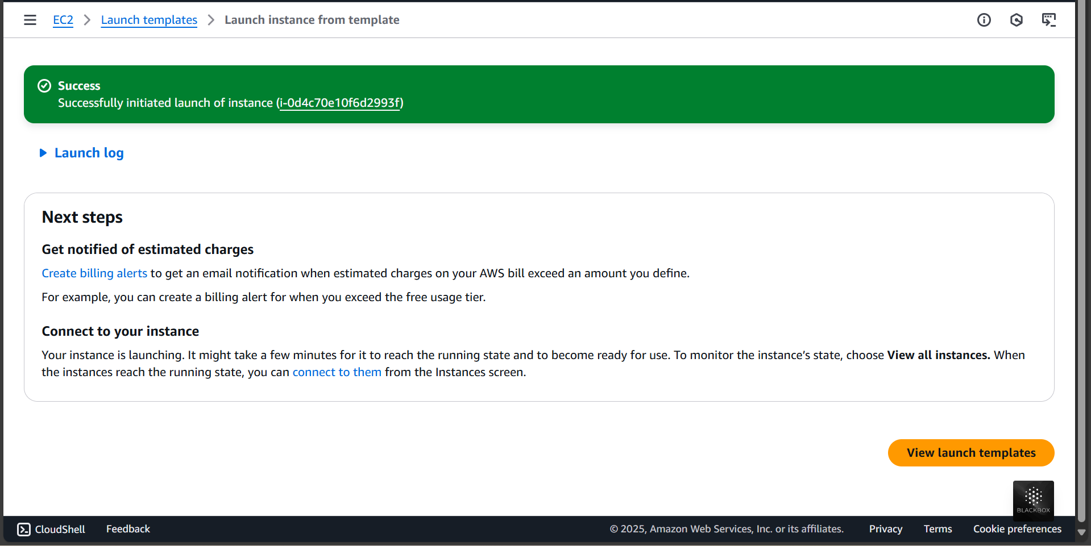

6-View your instance

