# include<stdio.h>

int main()

{

int age;

age=0;

printf("enter your age...:");

scanf("%d",&age);

if(age>=18)

{

printf("you are eligible to voting");

}

Else

printf("you are not eligible for voting");

printf("\nthank you");

}

Output01:

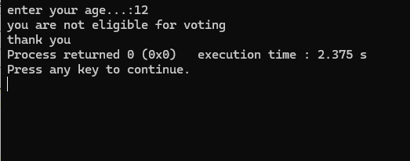

Output02:

