Q.WRITE A PROGRAMME TO READ ALL THE MARKS OF SUBJECTS OF A STUDENT AND CHECK WHETHER THE STUDENT IS PASS OR FAIL

A.# include<stdio.h>

int main()

{

printf(" 10th CLASS MARKS MEMO ");

int m,s,e,t,h,so,T;

m=s=e=t=h=so=T=0;

printf("\nenter your marks in telugu..:");

scanf("%d",&t);

if(t>=40)

{

printf(" status: pass");

}

Else

printf(" status: fail");

printf("\nenter your marks in hindi..:");

scanf("%d",&h);

if(h>=40)

{

printf(" status: pass");

}

Else

printf(" status: fail");

printf("\nenter your marks in english..:");

scanf("%d",&e);

if(e>=40)

{

printf(" status: pass");

}

Else

printf(" status: fail");

printf("\nenter your marks in maths..:");

scanf("%d",&m);

if(m>=40)

{

printf(" status: pass");

}

Else

printf(" status: fail");

printf("\nenter your marks in science..:");

scanf("%d",&s);

if(s>=40)

{

printf(" status: pass");

}

else

printf(" status: fail");

printf("\nenter your marks in social..:");

scanf("%d",&so);

if(so>=40)

{

printf(" status: pass");

}

else

printf(" status: fail");

T = t+h+e+m+s+so;

printf("\ntotal marks...");

printf("%d",T);

if(T>=240)

{printf(" total status: pass");

printf(" \n congratulations you have cleared your exam");}

else

{

printf(" total status: fail");

printf(" \n better luck next time");

}

printf("\nthank you ");

}

Output01:

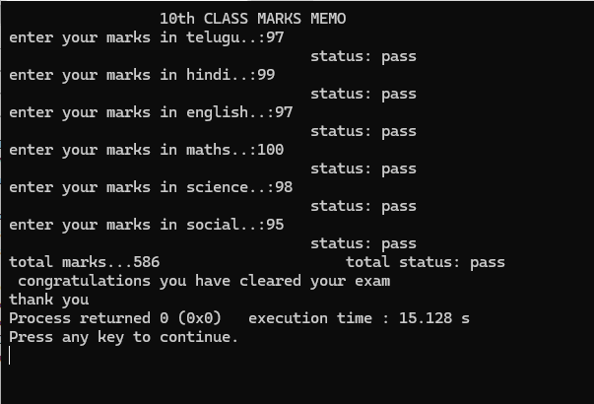

Output2:

